**Clinical Decision Support (CDS) Content and Health Level 7 (HL7)-Compliant Knowledge Artifacts (KNARTs)**

**Mental Health: Iraq & Afghanistan Post-Deployment Screen Clinical Content White Paper**

**Department of Veterans Affairs (VA)**



**Knowledge Based Systems (KBS)**

**Office of Informatics and Information Governance (OIIG)**

**Clinical Decision Support (CDS)**

**Clinical Decision Support (CDS) Content and Health Level 7 (HL7)-Compliant Knowledge Artifacts (KNARTs): Mental Health: Iraq & Afghanistan Post-Deployment Screen Clinical Content White Paper**

by Department of Veterans Affairs (VA)

Publication date May 2018

**Contract: VA118-16-D-1008, Task Order (TO): VA-118-16-F-1008-0007**

**Table 1. Relevant KNART Information - Mental Health: Post-Deployment Screen KNARTs**

| **Mental Health KNART** | **Associated CLIN** |
| --- | --- |
| Iraq & Afghanistan Post-Deployment Screen Reminder – Event Condition Action (ECA) Rule | CLIN0003AA |
| Iraq & Afghanistan Post-Deployment Screen - Rule to Create Appropriate Order Set – ECA Rule | CLIN0007AA |
| Iraq & Afghanistan Post-Deployment Screen – Documentation Template | CLIN0005AB |
| Iraq & Afghanistan Post-Deployment Screen – Order Set | CLIN0008AA |

**Table of Contents**

VA Subject Matter Expert (SME) Panel vi

Introduction vii

Conventions Used viii

1. Mental Health: Iraq & Afghanistan Post-Deployment Screen 1

1.1. Clinical Context 1

1.2. Knowledge Artifacts 1

2. Event Condition Action (ECA) Rule: Iraq & Afghanistan Post-Deployment Screen Reminder 2

2.1. Knowledge Narrative 2

2.2. Iraq & Afghanistan Post-Deployment Screen Reminder 2

3. Event Condition Action (ECA) Rule: Iraq & Afghanistan Post-Deployment Screen – Rule to Create Appropriate Order Set 4

3.1. Knowledge Narrative 4

3.2. Iraq & Afghanistan Post-Deployment Screen – Rule to Create Appropriate Order Set 4

3.2.1. Unexplained Fevers 4

3.2.2. Chronic Diarrhea or Other Gastrointestinal Complaints 5

3.2.3. Persistent Papular or Nodular Rash 6

3.2.4. Possible Embedded Fragment or Shrapnel 6

3.2.5. Possible Traumatic Brain Injury 7

4. Documentation Template: Iraq & Afghanistan Post-Deployment Screen 8

4.1. Knowledge Narrative 8

4.2. Iraq & Afghanistan Post-Deployment Screen 8

4.2.1. Infectious Disease Screen 8

4.2.2. Embedded Fragment Screen 9

4.2.3. TBI Screen 9

5. Order Set: Iraq & Afghanistan Post-Deployment Screen 10

5.1. Knowledge Narrative 10

5.2. Laboratory Tests 10

5.3. Consults and Referrals 10

5.4. Patient and Caregiver Education 11

Bibliography/Evidence 12

A. Existing Sample VA Artifacts 13

B. Logic Diagrams 42

C. Basic Laboratory Panel Definition 43

Acronyms 44

**List of Figures**

A.1. Reminder Dialog Template: Operation Enduring Freedom (OEF)/Operation Iraqi Freedom (OIF) Case Management Screen 23

A.2. Consult Order: Operation Enduring Freedom (OEF)/Operation Iraqi Freedom (OIF) Outpatient Case Management Program 24

A.3. Reminder Resolution: Operation Enduring Freedom (OEF)/Operation Iraqi Freedom (OIF) Post-Deployment Screen (image 1 of 3) 25

A.4. Reminder Resolution: Operation Enduring Freedom (OEF)/Operation Iraqi Freedom (OIF) Post-Deployment Screen (image 2 of 3) 26

A.5. Reminder Resolution: Operation Enduring Freedom (OEF)/Operation Iraqi Freedom (OIF) Post-Deployment Screen (image 3 of 3) 27

A.6. Post-Deployment/Transition Consult Note (image 1 of 13) 28

A.7. Post-Deployment/Transition Consult Note (image 2 of 13) 29

A.8. Post-Deployment/Transition Consult Note (image 3 of 13) 30

A.9. Post-Deployment/Transition Consult Note (image 4 of 13) 31

A.10. Post-Deployment/Transition Consult Note (image 5 of 13) 32

A.11. Post-Deployment/Transition Consult Note (image 6 of 13) 33

A.12. Post-Deployment/Transition Consult Note (image 7 of 13) 34

A.13. Post-Deployment/Transition Consult Note (image 8 of 13) 35

A.14. Post-Deployment/Transition Consult Note (image 8 of 13) 36

A.15. Post-Deployment/Transition Consult Note (image 9 of 13) 37

A.16. Post-Deployment/Transition Consult Note (image 10 of 13) 38

A.17. Post-Deployment/Transition Consult Note (image 11 of 13) 39

A.18. Post-Deployment/Transition Consult Note (image 12 of 13) 40

A.19. Post-Deployment/Transition Consult Note (image 13 of 13) 41

B.1. Iraqi & Afghanistan Post-Deployment Event Condition Action (ECA) Rules 42

**List of Tables**

1. Relevant KNART Information - Mental Health: Post-Deployment Screen KNARTs ii

2. VA Subject Matter Expert (SME) Panel vi

1.1. Clinical Context Domain 1

**VA Subject Matter Expert (SME) Panel**

**Table 2. VA Subject Matter Expert (SME) Panel**

| **Name** | **Title** | **Project Role** |
| --- | --- | --- |
| Rani Hoff, PhD, MPH | Director, Northeast Program Evaluation Center Office of Mental Health and Suicide Prevention (10NC5) VA Central Office (VACO)  Professor of Psychiatry, Yale University School of Medicine | SME, Primary |
| Katy Lysell, MD | National Mental Health Director for Informatics  Honolulu, HI 96819 | SME, Secondary |
| Andrew Pomerantz | National Mental Health Director, Integrated Care | SME |
| John McCarthy | Director, Serious Mental Illness Treatment Resource and Evaluation Center (SMITREC) & National PC-MHI Evaluation | SME |

**Introduction**

The VA is committed to improving the ability of clinicians to provide care for patients while increasing quality, safety, and efficiency. Recognizing the importance of standardizing clinical knowledge in support of this goal, VA is implementing the Health Level 7 (HL7) Knowledge Artifact Specification for a wide range of VA clinical use cases. Knowledge Artifacts, referred to as (KNARTs), enable the structuring and encoding of clinical knowledge so the knowledge can be integrated with electronic health records to enable clinical decision support.

The purpose of this Clinical Content White Paper (CCWP) is to capture the clinical context and intent of KNART use cases in sufficient detail to provide the KNART authoring team with the clinical source material to construct the corresponding knowledge artifacts using the HL7 Knowledge Artifact Specification. This paper has been developed using material from a variety of sources: VA artifacts, clinical practice guidelines, evidence in the body of medical literature, and clinical expertise. After reviewing these sources, the material has been synthesized and harmonized under the guidance of VA subject matter experts to reflect clinical intent for this use case.

Unless otherwise noted, items within this white paper (e.g., documentation template fields, orderable items, etc.) are chosen to reflect the clinical intent at the time of creation. To provide an exhaustive list of all possible items and their variations is beyond the scope of this work.

**Conventions Used**

Conventions used within the knowledge artifact descriptions include:

<obtain>: Indicates a prompt to obtain the information listed

* If possible, the requested information should be obtained from the underlying system(s). Otherwise, prompting the user for information may be required
* The technical and clinical notes associated with a section should be consulted for specific constraints on the information (e.g., time-frame, patient interview, etc.)
* Default Values: Unless otherwise noted, <obtain> indicates to obtain the most recent observation. It is recognized that this default time-frame value may be altered by future implementations

[...]: Square brackets enclose explanatory text that indicates some action on the part of the clinical user, or general guidance to the clinical or technical teams. Examples include, but are not limited to:

[Begin ...], [End ...]: Indicates the start and end of specific areas to clearly delineate them for technical purposes.

[Activate ...]: Initiates another knowledge artifact or knowledge artifact section.

[Section Prompt: ...]: If this section is applicable, then the following prompt should be displayed to the user.

[Section Selection Behavior: ...]: Indicates technical constraints or considerations for the selection of items within the section.

[Attach: ...]: Indicates that the specified item should be attached to the documentation template if available.

[Link: ...]: Indicates that rather than attaching an item, a link should be included in the documentation template.

[Clinical Comment: ...]: Indicates clinical rationale or guidance.

[Technical Note: ...]: Indicates technical considerations or notes.

[If ...]: Indicates the beginning of a conditional section.

[Else, ...]: Indicates the beginning of the alternative branch of a conditional section.

[End if ...]: Indicates the end of a conditional section.

☐: Indicates items that should be selected based upon the section selection behavior.

**Chapter 1. Mental Health: Iraq & Afghanistan Post-Deployment Screen**

**1.1. Clinical Context**

[Begin Clinical Context.]

This section is intended to facilitate identification of patients requiring war on terror Veteran post-deployment screening; support documentation of screening-related findings and decisions; and support initiation of appropriate clinical orders.

**Table 1.1. Clinical Context Domain**

|  |  |
| --- | --- |
| *Target User* | Mental health providers, primary care providers (PCPs) |
| *Patient* | Combat Veterans of the war on terror |
| *Priority* | Routine |
| *Specialty* | Primary Care / Mental Health |
| *Location* | Outpatient |

[End Clinical Context.]

**1.2. Knowledge Artifacts**

[Begin Knowledge Artifacts.]

This section describes the CDS knowledge artifacts that are intended for clinical providers caring for combat Veterans of the war on terror who present to a Primary Care Clinic or Mental Health Clinic.

Four knowledge artifacts define this clinical use case. These artifacts include 2 ECA Rules, a Documentation Template, and an Order Set, which the following sections describe in detail.

* ECA Rules: Iraq & Afghanistan Post-Deployment Screen Reminder and Iraq & Afghanistan Post-Deployment - Rule to Create Appropriate Order Set KNARTs
* Rule logic for post-deployment screening reminder
* Actions may include activating the documentation template or order set
* Documentation Template: Post-Deployment Screen KNART
* Documents post-deployment screening associated findings and decisions
* Includes logic for appropriate display of documentation sections
* Order Set: Post-Deployment Screen KNART
* Orderable items associated with post-deployment screening
* Includes logic for appropriate display of the order set

[End Knowledge Artifacts.]

**Chapter 2. Event Condition Action (ECA) Rule: Iraq & Afghanistan Post-Deployment Screen Reminder**

[Begin Event Condition Action (ECA) Rule: Iraq & Afghanistan Post-Deployment Screen Reminder.]

**2.1. Knowledge Narrative**

[Begin Knowledge Narrative.]

[See Clinical Context in Chapter 1.]

Upon returning from deployment, many combat Veterans of the war on terror successfully reintegrate into society; however, some have greater difficulty doing so. Problems these Veterans face include complex mental and physical problems, as well as financial challenges. Although programs exist for Veterans facing sequelae of deployment, Veterans with ongoing issues must be identified before they can benefit from such programs. Post-deployment Veterans should be screened for mental health–related problems such as posttraumatic stress disorder (PTSD), military sexual trauma, depression, suicidality, and alcohol abuse, as well as social welfare issues such as risk for homelessness and physical problems such as persistent infections, embedded fragments or shrapnel, and traumatic brain injury.

[End Knowledge Narrative.]

**2.2. Iraq & Afghanistan Post-Deployment Screen Reminder**

[Begin Iraq & Afghanistan Post-Deployment Screen Reminder.]

**Events**

[Begin Events.]

1. Any access of the patient record.
2. Upon first visit to a Primary Care or Mental Health provider in the VA system.

[End Events.]

**Conditions**

[Begin Conditions.]

1. Status as a Veteran who served in Iraq or Afghanistan after September 11, 2001 (post-deployment after return from combat service).
2. Absence of record of completed post-deployment screening (all questions answered in the survey).

[End Conditions.]

**Actions**

[Begin Actions.]

1. Create a communication request to the provider that patient is a candidate for post-deployment screening.
2. Open the “Mental Health – Iraq & Afghanistan Post-Deployment Screen” documentation template KNART.

[End Actions.]

[End Iraq & Afghanistan Post-Deployment Screen Reminder.]

[End Event Condition Action (ECA) Rule: Iraq & Afghanistan Post-Deployment Screen Reminder.]

**Chapter 3. Event Condition Action (ECA) Rule: Iraq & Afghanistan Post-Deployment Screen – Rule to Create Appropriate Order Set**

[Begin Event Condition Action (ECA) Rule: Iraq & Afghanistan Post-Deployment Screen – Rule to Create Appropriate Order Set.]

**3.1. Knowledge Narrative**

[Begin Knowledge Narrative.]

[See Clinical Context in Chapter 1.]

[End Knowledge Narrative.]

**3.2. Iraq & Afghanistan Post-Deployment Screen – Rule to Create Appropriate Order Set**

[Begin Iraq & Afghanistan Post-Deployment Screen – Rule to Create Appropriate Order Set.]

**Events**

[Begin Events.]

Submission of the “Mental Health – Iraq & Afghanistan Post-Deployment Screen” documentation template KNART. (This event applies to all branches.)

[End Events.]

**Conditions**

[Begin Conditions.]

Any positive screen or finding recorded in the “Mental Health – Iraq & Afghanistan Post-Deployment Screen” documentation template KNART that indicates a need for initiation of specialty evaluation, care management services, or social work services as described in the branches below.

[End Conditions.]

**Actions**

[Begin Actions.]

1. Linking to clinical practice guidelines.
2. Linking to other KNARTs.
3. Creation of the appropriate orders in the “Mental Health -Iraq & Afghan Post-Deployment Screen” order set KNART as described in the branches below.

[End Actions.]

**3.2.1. Unexplained Fevers**

**Events**

[Begin Events.]

* Submission of the “Mental Health – Iraq & Afghanistan Post-Deployment Screen” documentation template KNART. (This event applies to all branches.)

[End Events.]

**Conditions**

[Begin Conditions.]

* Response of "Yes" to “Unexplained fevers since serving in the area of conflict?”

[End Conditions.]

**Actions**

[Begin Actions.]

1. Provide link to “General Clinical Note” documentation template KNART.
2. Provide link to “Generic E-Consult” documentation template-consult request KNART.
3. Display order for infectious diseases consult for unexplained fevers in the “Consults and Referrals” section of the “Mental Health – Iraq & Afghanistan Post-Deployment Screen” order set KNART.
4. Display order for patient education for unexplained fevers in Veterans who served in Iraq or Afghanistan after September 11, 2001, in the “Patient and Caregiver Education” section of the “Mental Health – Iraq & Afghanistan Post-Deployment Screen” order set KNART.

[End Actions.]

**3.2.2. Chronic Diarrhea or Other Gastrointestinal Complaints**

**Events**

[Begin Events.]

* Submission of the “Mental Health – Iraq & Afghanistan Post-Deployment Screen” documentation template KNART. (This event applies to all branches.)

[End Events.]

**Conditions**

[Begin Conditions.]

* Response of "Yes" to “Chronic diarrhea or other gastrointestinal complaints since serving in the area of conflict?”

[End Conditions.]

**Actions**

[Begin Actions.]

1. Provide link to “General Clinical Note” documentation template KNART.
2. Provide link to “Generic E-Consult” documentation template-consult request KNART.
3. Display order for ova and parasites in the “Laboratory Tests” section of the “Mental Health – Iraq & Afghanistan Post-Deployment Screen” order set KNART.
4. Display order for gastroenterology consult in the “Consults and Referrals” section of the “Mental Health – Iraq & Afghanistan Post-Deployment Screen” order set KNART.
5. Display order for patient education for chronic diarrhea and other gastrointestinal complaints in Veterans who served in Iraq or Afghanistan after September 11, 2001, in the “Patient and Caregiver Education” section of the “Mental Health – Iraq & Afghanistan Post-Deployment Screen” order set KNART.

[End Actions.]

**3.2.3. Persistent Papular or Nodular Rash**

**Events**

[Begin Events.]

* Submission of the “Mental Health – Iraq & Afghanistan Post-Deployment Screen” documentation template KNART. (This event applies to all branches.)

[End Events.]

**Conditions**

[Begin Conditions.]

* Response of "Yes" to “Persistent papular or nodular rash since serving in the area of conflict?”

[End Conditions.]

**Actions**

[Begin Actions.]

1. Provide link to “General Clinical Note” documentation template KNART.
2. Provide link to “Generic E-Consult” documentation template-consult request KNART.
3. Display order for infectious diseases consult for persistent rash in the “Consults and Referrals” section of the “Mental Health – Iraq & Afghanistan Post-Deployment Screen” order set KNART.
4. Display order for patient education for persistent rash in Veterans who served in Iraq or Afghanistan after September 11, 2001, in the “Patient and Caregiver Education” section of the “Mental Health – Iraq & Afghanistan Post-Deployment Screen” order set KNART.

[End Actions.]

**3.2.4. Possible Embedded Fragment or Shrapnel**

**Events**

[Begin Events.]

* Submission of the “Mental Health – Iraq & Afghanistan Post-Deployment Screen” documentation template KNART.(This event applies to all branches.)

[End Events.]

**Conditions**

[Begin Conditions.]

* Response of "Yes" to "Suspected or known embedded fragments or shrapnel as a result of serving in the area of conflict?"

[End Conditions.]

**Actions**

[Begin Actions.]

Provide link to an embedded fragments documentation template when one becomes available. In the interim:

1. Provide link to “General Clinical Note” documentation template KNART.
2. Provide link to “Generic E-Consult” documentation template-consult request KNART.
3. Display order for patient education for embedded fragments or shrapnel in Veterans who served in Iraq or Afghanistan after September 11, 2001, in the “Patient and Caregiver Education” section of the “Mental Health – Iraq & Afghanistan Post-Deployment Screen” order set KNART.

[End Actions.]

**3.2.5. Possible Traumatic Brain Injury**

**Events**

[Begin Events.]

* Submission of the “Mental Health – Iraq & Afghanistan Post-Deployment Screen” documentation template KNART. (This event applies to all branches.)

[End Events.]

**Conditions**

[Begin Conditions.]

* Response of "Yes" to "Suspected or known head injury resulting in alteration or loss of consciousness during deployment?"

[End Conditions.]

**Actions**

[Begin Actions.]

1. Provide link to “Neurology – TBI Screening” ECA Rule KNART.

[End Actions.]

[End Iraq & Afghanistan Post-Deployment Screen – Rule to Create Appropriate Order Set.]

[End Event Condition Action (ECA) Rule: Iraq & Afghanistan Post-Deployment Screen – Rule to Create Appropriate Order Set.]

**Chapter 4. Documentation Template: Iraq & Afghanistan Post-Deployment Screen**

[Begin Documentation Template: Iraq & Afghanistan Post-Deployment Screen.]

**4.1. Knowledge Narrative**

[Begin Knowledge Narrative.]

[See Clinical Context in Chapter 1.]

[End Knowledge Narrative.]

**4.2. Iraq & Afghanistan Post-Deployment Screen**

[Begin Iraq & Afghanistan Post-Deployment Screen.]

[Technical Note: This documentation template should be available to primary care and mental health providers caring for outpatients identified as candidates for the war on terror post-deployment screening.]

[Technical Note: Please auto populate the answers to the post-deployment status questions.]

[Section Prompt: Is the Veteran post-deployment after return from service in Iraq or Afghanistan after September 11, 2001?]

[Section Behavior: Select one. Optional.]

☐ Yes

<obtain> Dates

☐ No

[Link: Provide link to “Mental Health - PTSD Screening and Assessment” documentation template KNART.]

[Link: Provide link to “Mental Health – Military Sexual Trauma” documentation template KNART.]

[Link: Provide link to “Mental Health – Consult for Depression” documentation template-consult request KNART.]

[Link: Provide link to “Mental Health – Suicide Risk Assessment” documentation template KNART.]

[Link: Provide link to future KNART for Screening for Unhealthy Alcohol Use.]

[Link: Provide link to “Mental Health – Homelessness” documentation template KNART.]

**4.2.1. Infectious Disease Screen**

[Section Prompt: Unexplained fevers since serving in the area of conflict?]

[Section Behavior: Select one. Optional.]

☐ Yes

<obtain> Description

☐ No

[Section Prompt: Chronic diarrhea or other gastrointestinal complaints since serving in the area of conflict?]

[Section Behavior: Select one. Optional.]

☐ Yes

<obtain> Description

☐ No

[Section Prompt: Persistent papular or nodular rash since serving in the area of conflict?]

[Section Behavior: Select one. Optional.]

☐ Yes

<obtain> Description

☐ No

**4.2.2. Embedded Fragment Screen**

[Section Prompt: Suspected or known embedded fragments or shrapnel as a result of serving in the area of conflict?]

[Section Behavior: Select one. Optional.]

☐ Yes

<obtain> Description

☐ No

**4.2.3. TBI Screen**

[Technical Note: Note the existence of the “Neurology – TBI Screening” ECA Rule.]

[Section Prompt: Suspected or known head injury resulting in alteration or loss of consciousness during deployment?]

[Section Behavior: Select one. Optional.]

☐ Yes

<obtain> Description

☐ No

<obtain> Additional information

[Technical Note: The screening reminder should not be turned off until all questions have been answered.]

[End Iraq & Afghanistan Post-Deployment Screen.]

[End Documentation Template: Iraq & Afghanistan Post-Deployment Screen.]

**Chapter 5. Order Set: Iraq & Afghanistan Post-Deployment Screen**

[Begin Order Set: Iraq & Afghanistan Post-Deployment Screen.]

**5.1. Knowledge Narrative**

[Begin Knowledge Narrative.]

[See Clinical Context in Chapter 1.]

[End Knowledge Narrative.]

**5.2. Laboratory Tests**

[Begin Laboratory Tests.]

[Technical Note: This section of the order set should be provided to primary care providers and mental health providers following submission of the “Mental Health – Iraq & Afghanistan Post-Deployment Screen” documentation template. Specific orders should be displayed based on the actions described in the related branches of the “Mental Health – Iraq & Afghanistan Post-Deployment Screen - Rule to Create Appropriate Order Set” ECA Rule.]

[Section Selection Behavior: Select one. Optional.]

☐ Ova and parasites stool (routine)

[End Laboratory Tests.]

**5.3. Consults and Referrals**

[Begin Consults and Referrals.]

[Technical Note: This section of the order set should be provided to primary care providers and mental health providers following submission of the “Mental Health – Iraq & Afghanistan Post-Deployment Screen” documentation template. Specific orders should be displayed based on the actions described in the related branches of the “Mental Health – Iraq & Afghanistan Post-Deployment Screen - Rule to Create Appropriate Order Set” ECA Rule.]

[Section Selection Behavior: Select any or none. Optional.]

☐ Referral care management services evaluate need for care management services (now)

☐ Referral social services evaluate need for social services (now)

☐ Consult infectious diseases evaluate chronic unexplained fevers in Veteran who served in Iraq or Afghanistan after September 11, 2001 (now)

☐ Consult gastroenterology evaluate chronic diarrhea/other gastrointestinal complaints in Veteran who served in Iraq or Afghanistan after September 11, 2001 (now)

☐ Consult infectious diseases evaluate persistent rash in Veteran who served in Iraq or Afghanistan after September 11, 2001 (now)

[End Consults and Referrals.]

**5.4. Patient and Caregiver Education**

[Begin Patient and Caregiver Education.]

[Technical Note: This section of the order set should be provided to primary care providers and mental health providers following submission of the “Mental Health – Iraq & Afghanistan Post-Deployment Screen” documentation template KNART. Specific orders should be displayed based on the actions described in the related branches of the “Mental Health – Iraq & Afghanistan Post-Deployment Screen - Rule to Create Appropriate Order Set” ECA Rule.]

[Section Selection Behavior: Select any or none. Optional.]

☐ Unexplained fevers in Veterans who served in Iraq or Afghanistan after September 11, 2001, patient education

☐ Chronic diarrhea and other gastrointestinal complaints in Veterans who served in Iraq or Afghanistan after September 11, 2001, patient education

☐ Persistent rash in Veterans who served in Iraq or Afghanistan after September 11, 2001, patient education

☐ Embedded fragments or shrapnel in Veterans who served in Iraq or Afghanistan after September 11, 2001, patient education

[End Patient and Caregiver Education.]

[End Order Set: Iraq & Afghanistan Post-Deployment Screen.]

**Bibliography/Evidence**

K Bush, DR Kivlahan, MB McDonell, SD Fihn, and KA Bradley. “The AUDIT alcohol consumption questions (AUDIT-C): an effective brief screening test for problem drinking. Ambulatory Care Quality Improvement Project (ACQUIP). Alcohol Use Disorders Identification Test”. *Arch Intern Med*. 1998. 158. 16. 1789-1795.

National Academies Press (US). *Committee on the Assessment of the Readjustment Needs of Military Personnel, Veterans, and Their Families, Board on the Health of Select Populations, Institute of Medicine. Returning Home from Iraq and Afghanistan: Assessment of Readjustment Needs of Veterans, Service Members, and Their Families. Washington (DC):*. March 2013. https://www.ncbi.nlm.nih.gov/books/NBK206857/.

Department of Defense (DoD). *Department of Defense (DoD) Deployment Health Clinical Center. DoD/VA Post-Deployment Health Clinical Practice Guideline (PDH-CPG) Fact Sheet.*. November 2012.

“Department of Veterans Affairs. Screening and Evaluation Protocol for Veterans with Embedded Fragments Who Served in Iraq and/or Afghanistan Post-September 11, 2001. Veterans Health Administration. Washington DC 20420”. *VHA Directive*. Published April 2017. 1303. 01. Transmittal Sheet.

“Department of Veterans Affairs/Department of Defense. VA/DoD Clinical Practice Guideline for the Management of Concussion-Mild Traumatic Brain Injury”. *VA/DoD Clinical Practice Guidelines Website*. Published February 2016. Version 2.0 – 2016. https://www.healthquality.va.gov/guidelines/Rehab/mtbi/mTBICPGFullCPG50821816.pdf.

“Department of Veterans Affairs. VA/DoD Clinical Practice Guideline for the Management of Substance Use Disorders”. *VA/DoD Clinical Practice Guidelines Website*. Published December 2015. Version 3.0 – 2015. https://www.healthquality.va.gov/guidelines/MH/sud/VADoDSUDCPGRevised22216..

**Appendix A. Existing Sample VA Artifacts**

All of the following artifacts/images are referenced from the Portland VA Medical Center (VAMC).

Patients who served in combat in either Operation Iraqi Freedom (Iraq,  
 Kuwait, Saudi Arabia, Turkey) or in Operation Enduring Freedom  
 (Afghanistan, Georgia, Kyrgyzstan, Pakistan, Tajikistan, Uzbekistan, The  
 Philippines) should be screened for illnesses related to their service.   
 Screening for PTSD, depression, problem alcohol use, infectious diseases,  
 and embedded fragments should be part of the initial evaluation of these  
 Veterans.   
   
 COHORT: veterans with separation date after 9/11/01. This finding is part  
 of the reminder term: VA-IRAQ/AFGHAN PERIOD OF SERVICE and is determined by  
 a computed finding.   
   
 An additional reminder term VA-ACTIVE DUTY is also available to cause  
 patients to be part of the cohort. If a site wishes to screen active duty  
 patients then the computed finding for VA-PATIENT TYPE should be added to  
 the term with a condition of I V="ACTIVE DUTY".   
   
 Patients who have OEF/OIF service as recorded in the patient registration  
 data are automatically part of the cohort and patients who did not serve in  
 OEF/OIF are not included in the denominator.   
   
 RESOLUTION: entry of a health factor for NO IRAQ/AFGHAN SERVICE which is  
 found in the reminder term IRAQ/AFGHAN SERVICE NO will resolve the reminder  
 only if the patient does not have an entry of OEF/OIF service in the  
 patient file. If the Veteran is known to have OEF/OIF service, based on  
 the registration data then the location of service is not required.   
   
 If the veteran served in Iraq or Afghanistan as recorded in the patient  
 registration data (File 1), then the patient must be screened or the  
 registration data must be updated.   
   
 For all applicable patients who are not cognitively impaired: all the other  
 items are required to resolve the reminder and must be completed after the  
 date of the most recent service separation:  
 a) screen for PTSD,  
 b) screen for depression,  
 c) screen for alcohol use,  
 d) all 3 screening questions related to infectious diseases.   
 (The 4th question for embedded fragments is new as of the summer of 2008  
 and because of this, cannot be required at this time by the reminder  
 logic).   
   
 The clinical maintenance will display information on which portions of the  
 screen are not yet completed.   
   
 All of the individual elements of the screening tool are exported with  
 attached health factors and reminder terms.   
   
 PTSD, depression and alcohol screening must be recorded in the MH package  
 and the dialog for this reminder requires use of the MH instruments for  
 these screens. Screens done prior to 10/1/08 using health factors will  
 still resolve the reminder since those health factors are in the reminder  
 terms that are part of the logic in this reminder.   
   
 The HFs for all of these screens should be entered in the site parameters  
 as ones that cannot be added outside of a reminder dialog. Use the  
 parameter ORWPCE EXCLUDE HEALTH FACTORS to exclude these from the  
 electronic encounter forms. Entry of these health factors should ONLY  
 occur during reminder dialog use.   
   
 Update October 2008 - patch PXRM*2*11 1. Health factors for PTSD screening,  
 depression screening and alcohol screening are not allowed after 10/1/08  
 per the Office of Mental Health. 2. A HF for done elsewhere is included.   
 3. Combat vets need to be screened 4. The computed finding was removed from  
 the reminder term for VA-ACTIVE DUTY since only a few sites screen active  
 duty patients and patch 11 required an overwrite of this term. 5. Add  
 embedded fragments question and remove other symptoms.   
   
 Update January 2009 - patch PXRM*2*12 1. Change combat vet screening  
 requirement to OEF/OIF service based on recent data that these fields are  
 more accurate. 2. Fix problem that active duty patients who did not serve  
 in OEF/OIF have reminder continue to show as due. 3. Refusals of screening  
 must be done after the most recent service separation.   
   
Technical Description:  
   
   
   
   
Baseline Frequency:  
   
 Do In Advance Time Frame: Wait until actually DUE  
 Sex Specific:   
 Ignore on N/A:   
 Frequency for Age Range: 99Y - Once for all ages  
 Match Text:   
 No Match Text:   
   
   
Findings:   
   
 ---- Begin: VA-IRAQ/AFGHAN SERVICE NO (FI(1)=RT(134)) --------------------  
 Finding Type: REMINDER TERM  
 Use in Resolution Logic: OR  
   
 Mapped Findings: HF.NO IRAQ/AFGHAN SERVICE   
 Health Factor Category: IRAQ/AFGHANISTAN  
   
 ---- End: VA-IRAQ/AFGHAN SERVICE NO --------------------------------------  
   
 ---- Begin: VA-IRAQ/AFGHAN PERIOD OF SERVICE (FI(2)=RT(135)) -------------  
 Finding Type: REMINDER TERM  
 Use in Patient Cohort Logic: AND  
 Beginning Date/Time: SEP 11, 2001  
 Not Found Text: Last Service Separation Date prior to 9/11/01  
 or missing.   
   
 Mapped Findings: CF.VA-SERVICE SEPARATION DATES   
 Beginning Date/Time: SEP 11, 2001  
   
 ---- End: VA-IRAQ/AFGHAN PERIOD OF SERVICE -------------------------------  
   
 ---- Begin: VA-IRAQ/AFGHAN SERVICE (FI(3)=RT(568012)) --------------------  
 Finding Type: REMINDER TERM  
   
 Mapped Findings: HF.IRAQ/AFGHAN SERVICE   
 Health Factor Category: IRAQ/AFGHANISTAN  
 Beginning Date/Time: 9/11/01  
   
 Mapped Findings: CF.VA-OEF SERVICE   
   
 Mapped Findings: CF.VA-OIF SERVICE   
   
 Mapped Findings: CF.VA-UNKNOWN OEF/OIF SERVICE   
   
 ---- End: VA-IRAQ/AFGHAN SERVICE -----------------------------------------  
   
 ---- Begin: VA-DEPRESSION SCREEN OEF/OIF (FI(4)=RT(948)) -----------------  
 Finding Type: REMINDER TERM  
   
 Mapped Findings: MH.PHQ-2   
 MH Scale: 492 - Depression  
   
 Mapped Findings: MH.PHQ9   
 MH Scale: 419 - PHQ9  
   
 Mapped Findings: MH.DOM80   
 Ending Date/Time: 9/30/07  
 MH Scale: 515 - Total  
   
 Mapped Findings: MH.DOMG   
 Ending Date/Time: 9/30/07  
 MH Scale: 365 - Total  
   
 Mapped Findings: MH.BDI   
 Ending Date/Time: 9/30/07  
 MH Scale: 331 - DEPRESSION SCORE  
   
 Mapped Findings: MH.BDI2   
 Ending Date/Time: 9/30/07  
 MH Scale: 332 - Total  
   
 Mapped Findings: HF.DEP SCREEN 2 QUESTION POS   
 Health Factor Category: MENTAL HEALTH  
 Ending Date/Time: 10/1/08  
   
 Mapped Findings: HF.DEP SCREEN 2 QUESTION NEG   
 Health Factor Category: MENTAL HEALTH  
 Ending Date/Time: 10/1/08  
   
 Mapped Findings: MH.ZUNG   
 Ending Date/Time: 9/30/07  
 MH Scale: 453 - DEPRESSION  
   
 Mapped Findings: MH.CRS   
 Ending Date/Time: 9/30/07  
 MH Scale: 347 - CRS TOTAL  
   
 Mapped Findings: HF.PHQ-2 NEGATIVE   
 Health Factor Category: MENTAL HEALTH  
 Ending Date/Time: 10/1/08  
   
 Mapped Findings: HF.PHQ-2 POSITIVE   
 Health Factor Category: MENTAL HEALTH  
 Ending Date/Time: 10/1/08  
   
 Mapped Findings: HF.PC DEPRESSION SCREEN NEGATIVE   
 Health Factor Category: MENTAL HEALTH  
   
 Mapped Findings: HF.PC DEPRESSION SCREEN POSITIVE   
 Health Factor Category: MENTAL HEALTH  
   
 Mapped Findings: HF.DEPRESSION ASSESS COMPLETE   
 Health Factor Category: MENTAL HEALTH  
   
 Mapped Findings: TX.VA-DEPRESSION DIAGNOSIS   
   
 ---- End: VA-DEPRESSION SCREEN OEF/OIF -----------------------------------  
   
 ---- Begin: VA-COMBAT VET (FI(5)=RT(944)) --------------------------------  
 Finding Type: REMINDER TERM  
 Found Text: Combat Vet eligible or prior Combat Vet  
 eligibility found.   
   
 Update the patient's demographic data as  
 needed.   
 \\  
   
   
 Mapped Findings: CF.VA-COMBAT VET ELIGIBILITY   
 Condition: I V="ELIGIBLE"  
 Condition Case Sensitive: NO  
   
 ---- End: VA-COMBAT VET --------------------------------------------------  
   
 ---- Begin: VA-ALCOHOL USE SCREEN (FI(6)=RT(133)) ------------------------  
 Finding Type: REMINDER TERM  
 Not Found Text: Screening for at risk alcohol use using the  
 AUDIT-C screening tool should be performed  
 yearly for any patient who has consumed  
 alcohol in the past year. No record of prior  
 screening for alcohol use was found in this  
 patient's record.   
 \\  
   
   
 Mapped Findings: MH.AUDC   
 MH Scale: 276 - Total  
   
 Mapped Findings: MH.CAGE   
 Ending Date/Time: 10/1/05  
   
 Mapped Findings: HF.NON-DRINKER (NO ALCOHOL FOR >1   
 YR)   
 Health Factor Category: ALCOHOL USE  
 Ending Date/Time: 10/1/08  
   
 Mapped Findings: MH.AUDIT   
 Ending Date/Time: 10/1/07  
 MH Scale: 278 - AUDIT  
   
 Mapped Findings: HF.ETOH-ALCOHOL USE PAST 12 MOS   
 (NO)   
 Health Factor Category: CAGE QUEST  
 Ending Date/Time: 3/1/09  
   
 ---- End: VA-ALCOHOL USE SCREEN ------------------------------------------  
   
 ---- Begin: VA-PTSD SCREEN (FI(7)=RT(568013)) ----------------------------  
 Finding Type: REMINDER TERM  
   
 Mapped Findings: HF.PTSD SCREEN NEGATIVE   
 Health Factor Category: MENTAL HEALTH  
 Ending Date/Time: 10/1/08  
   
 Mapped Findings: HF.PTSD SCREEN POSITIVE   
 Health Factor Category: MENTAL HEALTH  
 Ending Date/Time: 10/1/08  
   
 Mapped Findings: MH.PC PTSD   
 MH Scale: 203 - PC PTSD Total  
   
 Mapped Findings: TX.VA-PTSD DIAGNOSIS   
   
 ---- End: VA-PTSD SCREEN -------------------------------------------------  
   
 ---- Begin: VA-UNEXPLAINED FEVER (IRAQ/AFGHANISTAN) (FI(8)=RT(568015)) ---  
 Finding Type: REMINDER TERM  
 Not Found Text: Screen for unexplained fevers that might  
 represent occult malaria or infection with  
 leishmaniasis.   
 \\  
   
   
 Mapped Findings: HF.UNEXPLAINED FEVERS SCREEN   
 NEGATIVE   
 Health Factor Category: IRAQ/AFGHANISTAN  
   
 Mapped Findings: HF.UNEXPLAINED FEVERS SCREEN   
 POSITIVE   
 Health Factor Category: IRAQ/AFGHANISTAN  
   
 ---- End: VA-UNEXPLAINED FEVER (IRAQ/AFGHANISTAN) ------------------------  
   
 ---- Begin: VA-EMBEDDED FRAGMENTS (IRAQ/AFGHANISTAN) (FI(9)=RT(947)) -----  
 Finding Type: REMINDER TERM  
   
 Mapped Findings: HF.EMBEDDED FRAGMENTS PRESENT   
 Health Factor Category: IRAQ/AFGHANISTAN  
   
 Mapped Findings: HF.NO EMBEDDED FRAGMENTS   
 Health Factor Category: IRAQ/AFGHANISTAN  
   
 ---- End: VA-EMBEDDED FRAGMENTS (IRAQ/AFGHANISTAN) -----------------------  
   
 ---- Begin: VA-GI SYMPTOMS (IRAQ/AFGHANISTAN) (FI(10)=RT(568014)) --------  
 Finding Type: REMINDER TERM  
 Not Found Text: Screen for diarrhea or other GI complaints  
 that might suggest giardia, amoebiasis or  
 other GI infection.   
 \\  
   
   
 Mapped Findings: HF.GI SYMPTOMS SCREEN NEGATIVE   
 Health Factor Category: IRAQ/AFGHANISTAN  
   
 Mapped Findings: HF.GI SYMPTOMS SCREEN POSITIVE   
 Health Factor Category: IRAQ/AFGHANISTAN  
   
 ---- End: VA-GI SYMPTOMS (IRAQ/AFGHANISTAN) ------------------------------  
   
 ---- Begin: VA-PERSISTENT RASH (IRAQ/AFGHANISTAN) (FI(11)=RT(568016)) ----  
 Finding Type: REMINDER TERM  
 Not Found Text: Screen for persistent rash that might  
 represent infection with leishmaniasis.   
 \\  
   
   
 Mapped Findings: HF.SKIN LESION SCREEN NEGATIVE   
 Health Factor Category: IRAQ/AFGHANISTAN  
   
 Mapped Findings: HF.SKIN LESION SCREEN POSITIVE   
 Health Factor Category: IRAQ/AFGHANISTAN  
   
 ---- End: VA-PERSISTENT RASH (IRAQ/AFGHANISTAN) --------------------------  
   
 ---- Begin: VA-PTSD AVOIDANCE ALL (FI(12)=RT(617)) -----------------------  
 Finding Type: REMINDER TERM  
 Within Category Rank: 0  
   
 Mapped Findings: HF.PTSD SCREEN - AVOIDANCE   
 Health Factor Category: PTSD AVOIDANCE  
 Ending Date/Time: 10/1/08  
   
 Mapped Findings: HF.PTSD SCREEN - NO AVOIDANCE   
 Health Factor Category: PTSD AVOIDANCE  
 Ending Date/Time: 10/1/08  
   
 ---- End: VA-PTSD AVOIDANCE ALL ------------------------------------------  
   
 ---- Begin: VA-PTSD DETACHMENT ALL (FI(13)=RT(620)) ----------------------  
 Finding Type: REMINDER TERM  
 Within Category Rank: 0  
   
 Mapped Findings: HF.PTSD SCREEN - DETACHED   
 Health Factor Category: PTSD DETACHMENT  
 Ending Date/Time: 10/1/08  
   
 Mapped Findings: HF.PTSD SCREEN - NO DETACHMENT   
 Health Factor Category: PTSD DETACHMENT  
 Ending Date/Time: 10/1/08  
   
 ---- End: VA-PTSD DETACHMENT ALL -----------------------------------------  
   
 ---- Begin: VA-PTSD NIGHTMARES ALL (FI(14)=RT(618)) ----------------------  
 Finding Type: REMINDER TERM  
 Within Category Rank: 0  
   
 Mapped Findings: HF.PTSD SCREEN - NIGHTMARES   
 Health Factor Category: PTSD NIGHTMARES  
 Ending Date/Time: 10/1/08  
   
 Mapped Findings: HF.PTSD SCREEN - NO NIGHTMARES   
 Health Factor Category: PTSD NIGHTMARES  
 Ending Date/Time: 10/1/08  
   
 ---- End: VA-PTSD NIGHTMARES ALL -----------------------------------------  
   
 ---- Begin: VA-PTSD ON GUARD ALL (FI(15)=RT(619)) ------------------------  
 Finding Type: REMINDER TERM  
 Within Category Rank: 0  
   
 Mapped Findings: HF.PTSD SCREEN - ON GUARD   
 Health Factor Category: PTSD ON GUARD  
 Ending Date/Time: 10/1/08  
   
 Mapped Findings: HF.PTSD SCREEN - NO ON GUARD   
 Health Factor Category: PTSD ON GUARD  
 Ending Date/Time: 10/1/08  
   
 ---- End: VA-PTSD ON GUARD ALL -------------------------------------------  
   
 ---- Begin: VA-REFUSED PTSD SCREEN (FI(16)=RT(631)) ----------------------  
 Finding Type: REMINDER TERM  
 Found Text: Refused PTSD Screen  
   
 Mapped Findings: HF.REFUSED PTSD SCREEN   
 Health Factor Category: MENTAL HEALTH  
   
 ---- End: VA-REFUSED PTSD SCREEN -----------------------------------------  
   
 ---- Begin: VA-REFUSED ALCOHOL SCREENING (FI(17)=RT(568018)) -------------  
 Finding Type: REMINDER TERM  
 Found Text: Refused Alcohol Screening  
   
 Mapped Findings: HF.REFUSED ALCOHOL USE SCREENING   
 Health Factor Category: ALCOHOL USE  
   
 ---- End: VA-REFUSED ALCOHOL SCREENING -----------------------------------  
   
 ---- Begin: VA-REFUSED DEPRESSION SCREENING (FI(18)=RT(81)) --------------  
 Finding Type: REMINDER TERM  
 Found Text: Refused Depression Screening  
   
 Mapped Findings: HF.REFUSED DEPRESSION SCREENING   
 Health Factor Category: MENTAL HEALTH  
   
 Mapped Findings: HF.PHQ-2 REFUSED   
 Health Factor Category: DEPRESSION SCREEN  
 Within Category Rank: 0  
   
 ---- End: VA-REFUSED DEPRESSION SCREENING --------------------------------  
   
 ---- Begin: VA-ACTIVE DUTY (FI(19)=RT(568019)) ---------------------------  
 Finding Type: REMINDER TERM  
 Use in Patient Cohort Logic: OR  
 RT Mapped Finding: No Reminder Finding Found  
 ---- End: VA-ACTIVE DUTY -------------------------------------------------  
   
 ---- Begin: VA-REFUSED ID & OTHER SX SCREEN (FI(20)=RT(568020)) ----------  
 Finding Type: REMINDER TERM  
 Beginning Date/Time: T-1Y  
 Within Category Rank: 0  
 Found Text: The patient declined to answer some or all of  
 the infectious disease and other symptom  
 questions. Please ask these screening  
 questions again if they remain unaddressed.   
   
 Mapped Findings: HF.REFUSED ID & OTHER SX SCREEN   
 Health Factor Category: IRAQ/AFGHANISTAN  
   
 ---- End: VA-REFUSED ID & OTHER SX SCREEN --------------------------------  
   
 ---- Begin: VA-COGNITIVE IMPAIRMENT (FI(21)=RT(806)) ---------------------  
 Finding Type: REMINDER TERM  
 Beginning Date/Time: T-2Y  
   
 Mapped Findings: HF.SEVERE CHRONIC COGNITIVE   
 IMPAIRMENT   
 Health Factor Category: MENTAL HEALTH  
   
 ---- End: VA-COGNITIVE IMPAIRMENT ----------------------------------------  
   
 ---- Begin: VA-OEF/OIF SCREEN DONE ELSEWHERE (FI(22)=RT(945)) ------------  
 Finding Type: REMINDER TERM  
   
 Mapped Findings: HF.OEF/OIF SCREEN COMPLETED OUTSIDE  
 Health Factor Category: IRAQ/AFGHANISTAN  
   
 ---- End: VA-OEF/OIF SCREEN DONE ELSEWHERE -------------------------------  
   
 ---- Begin: VA-OTHER SYMPTOMS (IRAQ/AFGHANISTAN) (FI(23)=RT(568017)) -----  
 Finding Type: REMINDER TERM  
   
 Mapped Findings: HF.OTHER PHYSICAL SYMPTOMS SCREEN   
 NEGATIVE   
 Health Factor Category: IRAQ/AFGHANISTAN  
   
 Mapped Findings: HF.OTHER PHYSICAL SYMPTOMS SCREEN   
 POSITIVE   
 Health Factor Category: IRAQ/AFGHANISTAN  
   
 ---- End: VA-OTHER SYMPTOMS (IRAQ/AFGHANISTAN) ---------------------------  
   
 Function Findings:  
   
 ---- Begin: FF(1)---------------------------------------------------------  
 Function String: MRD(1)>MRD(2)  
 Expanded Function String:  
 MRD(VA-IRAQ/AFGHAN SERVICE NO)>MRD(VA-IRAQ/AFGHAN PERIOD OF SERVICE)  
 ---- End: FF(1) ----------------------------------------------------------  
   
   
 ---- Begin: FF(2)---------------------------------------------------------  
 Function String:  
 MRD(7,12,13,14,15)>MRD(2)!(DIFF_DATE(7,2)<120)!(DIFF_DATE(12,2)<120)  
 Expanded Function String:  
 MRD(VA-PTSD SCREEN,VA-PTSD AVOIDANCE ALL,VA-PTSD DETACHMENT ALL,  
 VA-PTSD NIGHTMARES ALL,VA-PTSD ON GUARD ALL)>MRD(  
 VA-IRAQ/AFGHAN PERIOD OF SERVICE)!(DIFF_DATE(VA-PTSD SCREEN,  
 VA-IRAQ/AFGHAN PERIOD OF SERVICE)<120)!(DIFF_DATE(VA-PTSD AVOIDANCE ALL,  
 VA-IRAQ/AFGHAN PERIOD OF SERVICE)<120)  
 Found Text: 1. PTSD Screening completed since service  
 discharge  
 Not Found Text: 1. PTSD Screen NEEDED  
 ---- End: FF(2) ----------------------------------------------------------  
   
   
 ---- Begin: FF(3)---------------------------------------------------------  
 Function String: MRD(4)>MRD(2)!(DIFF_DATE(4,2)<120)  
 Expanded Function String:  
 MRD(VA-DEPRESSION SCREEN OEF/OIF)>MRD(VA-IRAQ/AFGHAN PERIOD OF SERVICE)!  
 (DIFF_DATE(VA-DEPRESSION SCREEN OEF/OIF,  
 VA-IRAQ/AFGHAN PERIOD OF SERVICE)<120)  
 Found Text: 2. Depression Screening completed since  
 service discharge  
 Not Found Text: 2. Depression Screening NEEDED  
 ---- End: FF(3) ----------------------------------------------------------  
   
   
 ---- Begin: FF(4)---------------------------------------------------------  
 Function String: MRD(6)>MRD(2)!(DIFF_DATE(6,2)<120)  
 Expanded Function String:  
 MRD(VA-ALCOHOL USE SCREEN)>MRD(VA-IRAQ/AFGHAN PERIOD OF SERVICE)!(  
 DIFF_DATE(VA-ALCOHOL USE SCREEN,VA-IRAQ/AFGHAN PERIOD OF SERVICE)<120)  
 Found Text: 3. Alcohol Screening completed since service  
 discharge  
 Not Found Text: 3. Alcohol Screening NEEDED  
 ---- End: FF(4) ----------------------------------------------------------  
   
   
 ---- Begin: FF(5)---------------------------------------------------------  
 Function String:  
 MRD(10,20)>MRD(2)!'(FI(2)!FI(19))!(DIFF_DATE(10,2)<120)!(DIFF_DATE(20,2)<120)  
 Expanded Function String:  
 MRD(VA-GI SYMPTOMS (IRAQ/AFGHANISTAN),VA-REFUSED ID & OTHER SX SCREEN)>  
 MRD(VA-IRAQ/AFGHAN PERIOD OF SERVICE)!'(FI(  
 VA-IRAQ/AFGHAN PERIOD OF SERVICE)!FI(VA-ACTIVE DUTY))!(DIFF_DATE(  
 VA-GI SYMPTOMS (IRAQ/AFGHANISTAN),VA-IRAQ/AFGHAN PERIOD OF SERVICE)<120)  
 !(DIFF_DATE(VA-REFUSED ID & OTHER SX SCREEN,  
 VA-IRAQ/AFGHAN PERIOD OF SERVICE)<120)  
 Found Text: 4A. Screen for GI symptoms done or not  
 required.   
 Not Found Text: 4A. Screen for GI symptoms NEEDED  
 ---- End: FF(5) ----------------------------------------------------------  
   
   
 ---- Begin: FF(6)---------------------------------------------------------  
 Function String:  
 MRD(8,20)>MRD(2)!'(FI(2)!FI(19))!(DIFF_DATE(8,2)<120)!(DIFF_DATE(20,2)<120)  
 Expanded Function String:  
 MRD(VA-UNEXPLAINED FEVER (IRAQ/AFGHANISTAN),  
 VA-REFUSED ID & OTHER SX SCREEN)>MRD(VA-IRAQ/AFGHAN PERIOD OF SERVICE)!'  
 (FI(VA-IRAQ/AFGHAN PERIOD OF SERVICE)!FI(VA-ACTIVE DUTY))!(DIFF_DATE(  
 VA-UNEXPLAINED FEVER (IRAQ/AFGHANISTAN),  
 VA-IRAQ/AFGHAN PERIOD OF SERVICE)<120)!(DIFF_DATE(  
 VA-REFUSED ID & OTHER SX SCREEN,VA-IRAQ/AFGHAN PERIOD OF SERVICE)<120)  
 Found Text: 4B. Screen for Fevers done or not required.   
 Not Found Text: 4B. Screen for Fevers NEEDED  
 ---- End: FF(6) ----------------------------------------------------------  
   
   
 ---- Begin: FF(7)---------------------------------------------------------  
 Function String:  
 MRD(11,20)>MRD(2)!'(FI(2)!FI(19))!(DIFF_DATE(11,2)<120)!(DIFF_DATE(20,2)<120)  
 Expanded Function String:  
 MRD(VA-PERSISTENT RASH (IRAQ/AFGHANISTAN),  
 VA-REFUSED ID & OTHER SX SCREEN)>MRD(VA-IRAQ/AFGHAN PERIOD OF SERVICE)!'  
 (FI(VA-IRAQ/AFGHAN PERIOD OF SERVICE)!FI(VA-ACTIVE DUTY))!(DIFF_DATE(  
 VA-PERSISTENT RASH (IRAQ/AFGHANISTAN),VA-IRAQ/AFGHAN PERIOD OF SERVICE)<  
 120)!(DIFF_DATE(VA-REFUSED ID & OTHER SX SCREEN,  
 VA-IRAQ/AFGHAN PERIOD OF SERVICE)<120)  
 Found Text: 4C. Screen for Skin Rash done or not required.   
 Not Found Text: 4C. Screen for Skin Rash NEEDED  
 ---- End: FF(7) ----------------------------------------------------------  
   
   
 ---- Begin: FF(8)---------------------------------------------------------  
 Function String: MRD(9,20)>MRD(2)!'(FI(2)!FI(19))  
 Expanded Function String:  
 MRD(VA-EMBEDDED FRAGMENTS (IRAQ/AFGHANISTAN),  
 VA-REFUSED ID & OTHER SX SCREEN)>MRD(VA-IRAQ/AFGHAN PERIOD OF SERVICE)!'  
 (FI(VA-IRAQ/AFGHAN PERIOD OF SERVICE)!FI(VA-ACTIVE DUTY))  
 Found Text: 4D. Screen for Embedded Fragments done or not  
 required.   
 Not Found Text: 4D. Screen for Embedded Fragments NEEDED  
 ---- End: FF(8) ----------------------------------------------------------  
   
   
 ---- Begin: FF(9)---------------------------------------------------------  
 Function String: MRD(2)>MRD(1,8,10,11,22)  
 Expanded Function String:  
 MRD(VA-IRAQ/AFGHAN PERIOD OF SERVICE)>MRD(VA-IRAQ/AFGHAN SERVICE NO,  
 VA-UNEXPLAINED FEVER (IRAQ/AFGHANISTAN),  
 VA-GI SYMPTOMS (IRAQ/AFGHANISTAN),VA-PERSISTENT RASH (IRAQ/AFGHANISTAN),  
 VA-OEF/OIF SCREEN DONE ELSEWHERE)  
 Found Text: The patient's most recent service separation  
 date is more recent than their last screening  
 - rescreening is needed after any new period  
 of service.   
 ---- End: FF(9) ----------------------------------------------------------  
   
   
 ---- Begin: FF(10)--------------------------------------------------------  
 Function String: MRD(22)>MRD(2)  
 Expanded Function String:  
 MRD(VA-OEF/OIF SCREEN DONE ELSEWHERE)>MRD(  
 VA-IRAQ/AFGHAN PERIOD OF SERVICE)  
 Found Text: OEF/OIF Post-Deployment Screening was  
 completed at another site.   
 ---- End: FF(10) ---------------------------------------------------------  
   
   
 ---- Begin: FF(16)--------------------------------------------------------  
 Function String: MRD(16)>MRD(2)  
 Expanded Function String:  
 MRD(VA-REFUSED PTSD SCREEN)>MRD(VA-IRAQ/AFGHAN PERIOD OF SERVICE)  
 ---- End: FF(16) ---------------------------------------------------------  
   
   
 ---- Begin: FF(17)--------------------------------------------------------  
 Function String: MRD(17)>MRD(2)  
 Expanded Function String:  
 MRD(VA-REFUSED ALCOHOL SCREENING)>MRD(VA-IRAQ/AFGHAN PERIOD OF SERVICE)  
 ---- End: FF(17) ---------------------------------------------------------  
   
   
 ---- Begin: FF(18)--------------------------------------------------------  
 Function String: MRD(18)>MRD(2)  
 Expanded Function String:  
 MRD(VA-REFUSED DEPRESSION SCREENING)>MRD(  
 VA-IRAQ/AFGHAN PERIOD OF SERVICE)  
 ---- End: FF(18) ---------------------------------------------------------  
   
   
 ---- Begin: FF(20)--------------------------------------------------------  
 Function String: MRD(3)>MRD(1)  
 Expanded Function String:  
 MRD(VA-IRAQ/AFGHAN SERVICE)>MRD(VA-IRAQ/AFGHAN SERVICE NO)  
 ---- End: FF(20) ---------------------------------------------------------  
   
   
General Patient Cohort Found Text:  
 Patients who served in combat in either Iraq (Operation Iraqi Freedom) or  
 in Afghanistan (Operation Enduring Freedom) should be screened for  
 illnesses related to their service. Screening for PTSD, depression,  
 problem alcohol use, infectious diseases, and chronic symptoms should be  
 part of the initial evaluation of these Veterans.  
   
Customized PATIENT COHORT LOGIC to see if the Reminder applies to a patient:  
 ((FI(2)!FI(19))&'FF(1))!(FI(3)&FF(20))&'FI(21)  
   
Expanded Patient Cohort Logic:  
 ((FI(VA-IRAQ/AFGHAN PERIOD OF SERVICE)!FI(VA-ACTIVE DUTY))&'FF(1))!  
 (FI(VA-IRAQ/AFGHAN SERVICE)&FF(20))&'FI(VA-COGNITIVE IMPAIRMENT)  
   
Customized RESOLUTION LOGIC defines findings that resolve the Reminder:  
 ((FI(16)&FF(16))!(FF(2)&(FI(16)!FI(7)!(FI(12)&FI(13)&FI(14)&FI(15)))))&  
 (((FF(3)&FI(4))!(FI(18)&FF(18))))&((FF(4)&FI(6))!(FI(17)&FF(17)))&  
 ((FI(20)&FF(5))!(FF(5)&FI(10)&FF(6)&FI(8)&FF(7)&FI(11)))!(FI(22)&FF(10))  
   
Expanded Resolution Logic:  
 ((FI(VA-REFUSED PTSD SCREEN)&FF(16))!(FF(2)&(FI(VA-REFUSED PTSD SCREEN)!  
 FI(VA-PTSD SCREEN)!(FI(VA-PTSD AVOIDANCE ALL)&  
 FI(VA-PTSD DETACHMENT ALL)&FI(VA-PTSD NIGHTMARES ALL)&  
 FI(VA-PTSD ON GUARD ALL)))))&(((FF(3)&FI(VA-DEPRESSION SCREEN OEF/OIF))!  
 (FI(VA-REFUSED DEPRESSION SCREENING)&FF(18))))&((FF(4)&  
 FI(VA-ALCOHOL USE SCREEN))!(FI(VA-REFUSED ALCOHOL SCREENING)&FF(17)))&  
 ((FI(VA-REFUSED ID & OTHER SX SCREEN)&FF(5))!(FF(5)&  
 FI(VA-GI SYMPTOMS (IRAQ/AFGHANISTAN))&FF(6)&  
 FI(VA-UNEXPLAINED FEVER (IRAQ/AFGHANISTAN))&FF(7)&  
 FI(VA-PERSISTENT RASH (IRAQ/AFGHANISTAN))))!  
 (FI(VA-OEF/OIF SCREEN DONE ELSEWHERE)&FF(10))  
   
   
Web Sites:  
   
 Web Site URL: http://www.oqp.med.va.gov/cpg/cpg.htm  
 Web Site Title: VA/DOD Guidelines - Office of Quality and Performance  
 Description:  
   
   
   
 Web Site URL: http://www.oqp.med.va.gov/cpg/MDD/MDD_Base.htm  
 Web Site Title: VA/DOD Depression Guideline  
 Description:  
   
   
   
 Web Site URL: http://www.oqp.med.va.gov/cpg/cpgn/mus/mus_base.htm  
 Web Site Title: VA/DOD Medically Unexplained Symptoms: Pain and Fatigue  
 Description:  
   
   
   
 Web Site URL: http://www.oqp.med.va.gov/cpg/PDH/PDH_base.htm  
 Web Site Title: Post Deployment Health Evaluation and Management  
 Description:  
   
   
   
 Web Site URL: http://www.oqp.med.va.gov/cpg/SUD/SUD_Base.htm  
 Web Site Title: VA/DOD Substance Abuse Guideline  
 Description:  
   
   
   
 Web Site URL: http://vaww.va.gov/environagents/  
 Web Site Title: VA Environmental Agents Service  
 Description:

**Figure A.1. Reminder Dialog Template: Operation Enduring Freedom (OEF)/Operation Iraqi Freedom (OIF) Case Management Screen**

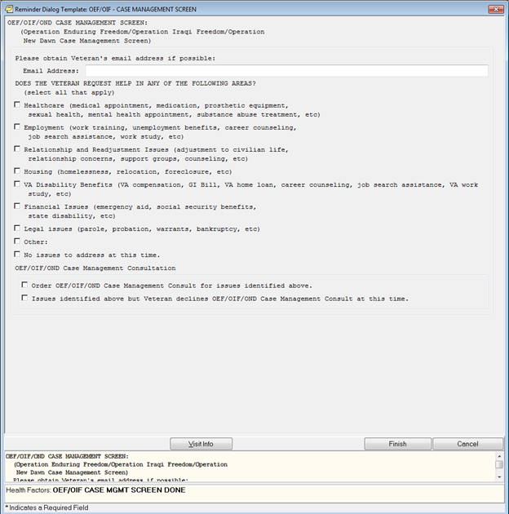

**Figure A.2. Consult Order: Operation Enduring Freedom (OEF)/Operation Iraqi Freedom (OIF) Outpatient Case Management Program**

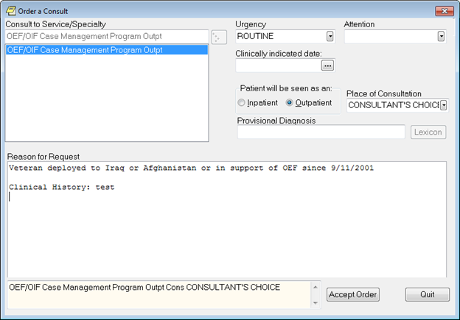

**Figure A.3. Reminder Resolution: Operation Enduring Freedom (OEF)/Operation Iraqi Freedom (OIF) Post-Deployment Screen (image 1 of 3)**

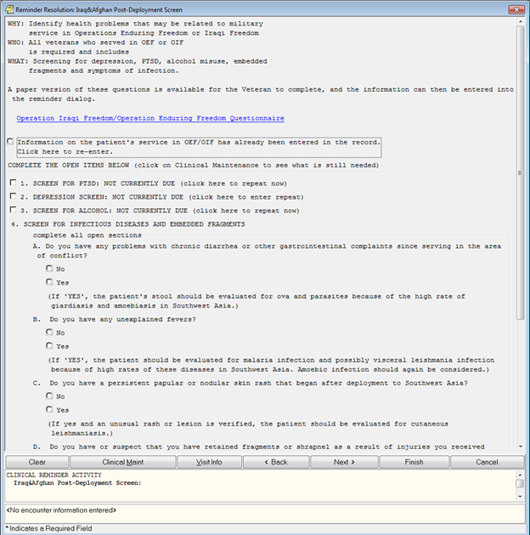

**Figure A.4. Reminder Resolution: Operation Enduring Freedom (OEF)/Operation Iraqi Freedom (OIF) Post-Deployment Screen (image 2 of 3)**

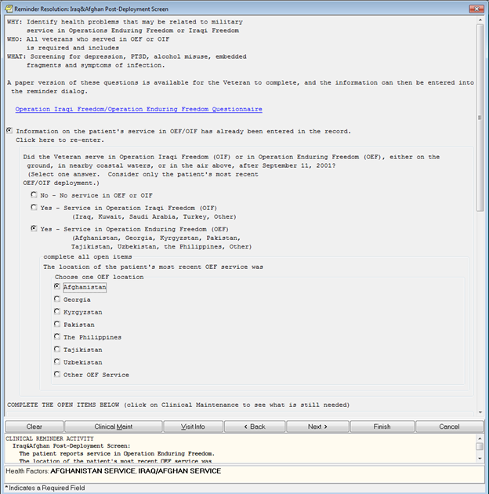

**Figure A.5. Reminder Resolution: Operation Enduring Freedom (OEF)/Operation Iraqi Freedom (OIF) Post-Deployment Screen (image 3 of 3)**

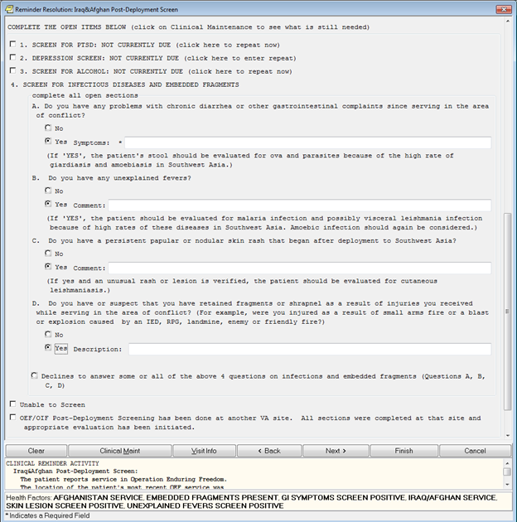

**Figure A.6. Post-Deployment/Transition Consult Note (image 1 of 13)**

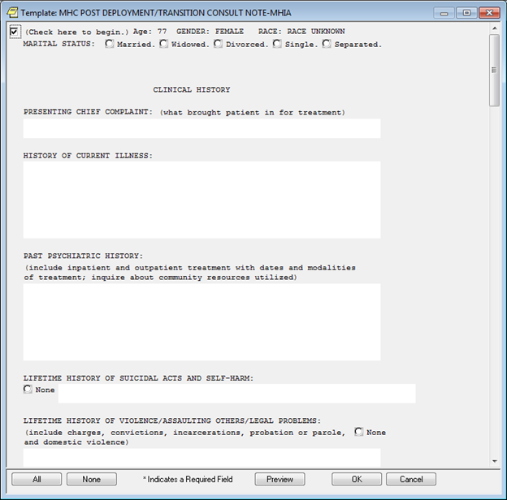

**Figure A.7. Post-Deployment/Transition Consult Note (image 2 of 13)**

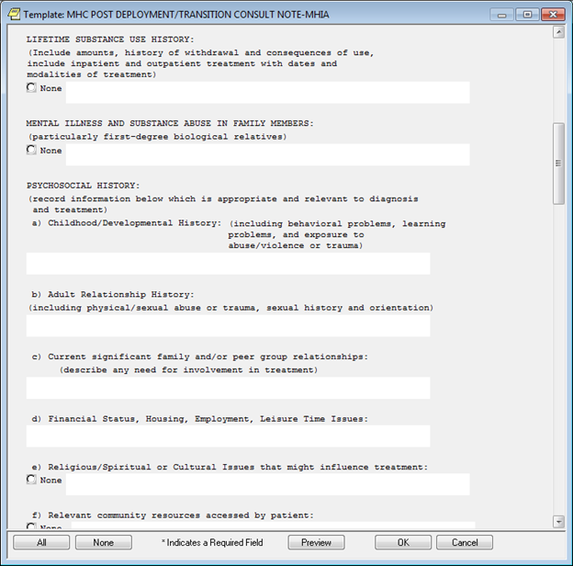

**Figure A.8. Post-Deployment/Transition Consult Note (image 3 of 13)**

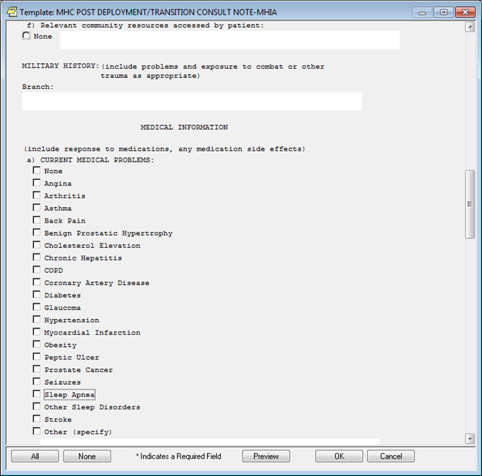

**Figure A.9. Post-Deployment/Transition Consult Note (image 4 of 13)**

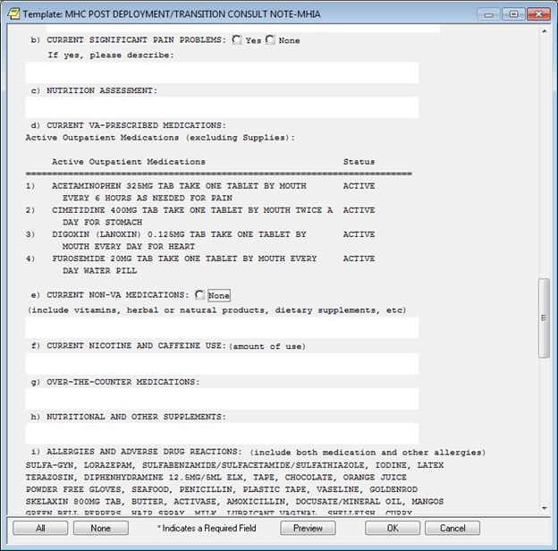

**Figure A.10. Post-Deployment/Transition Consult Note (image 5 of 13)**

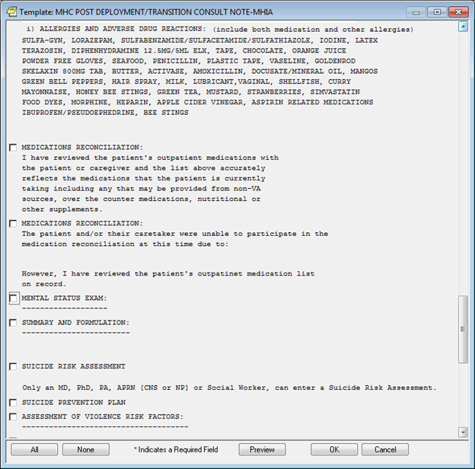

**Figure A.11. Post-Deployment/Transition Consult Note (image 6 of 13)**

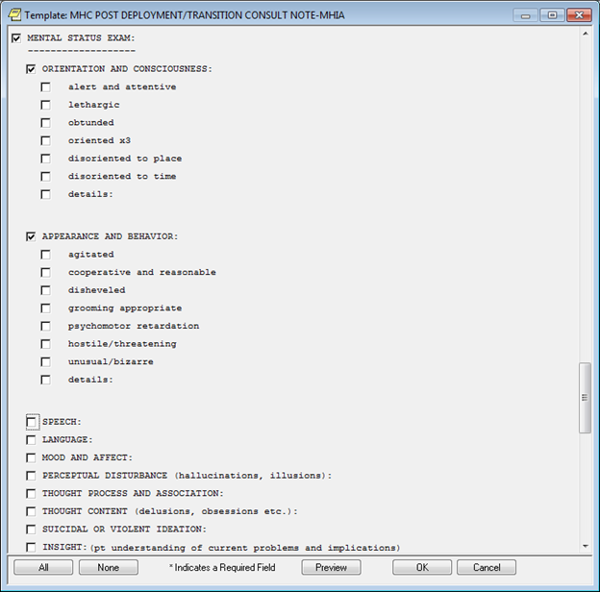

**Figure A.12. Post-Deployment/Transition Consult Note (image 7 of 13)**

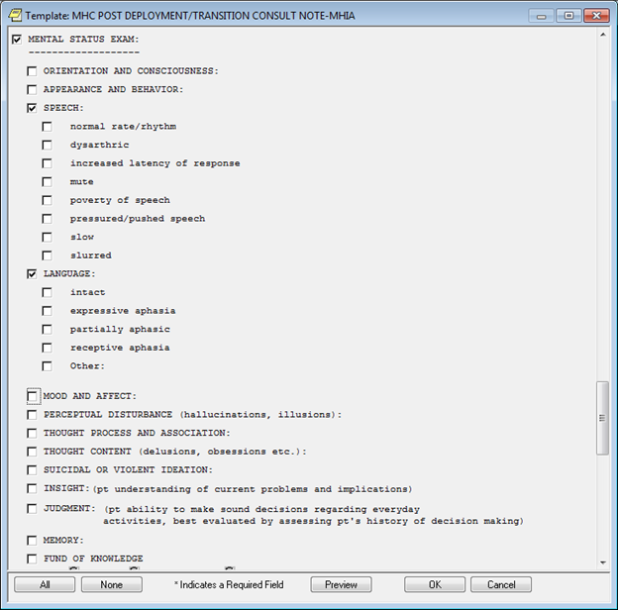

**Figure A.13. Post-Deployment/Transition Consult Note (image 8 of 13)**

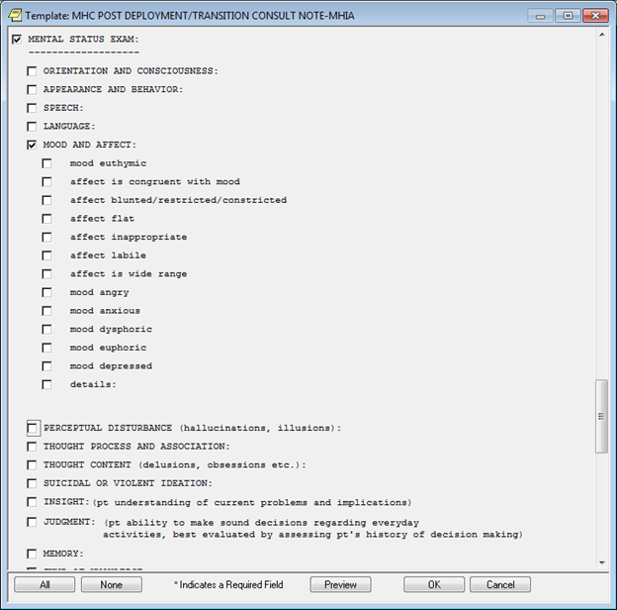

**Figure A.14. Post-Deployment/Transition Consult Note (image 8 of 13)**

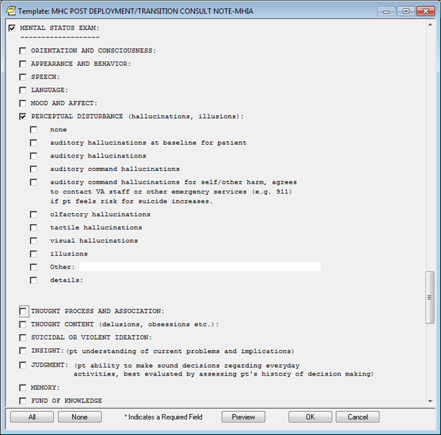

**Figure A.15. Post-Deployment/Transition Consult Note (image 9 of 13)**

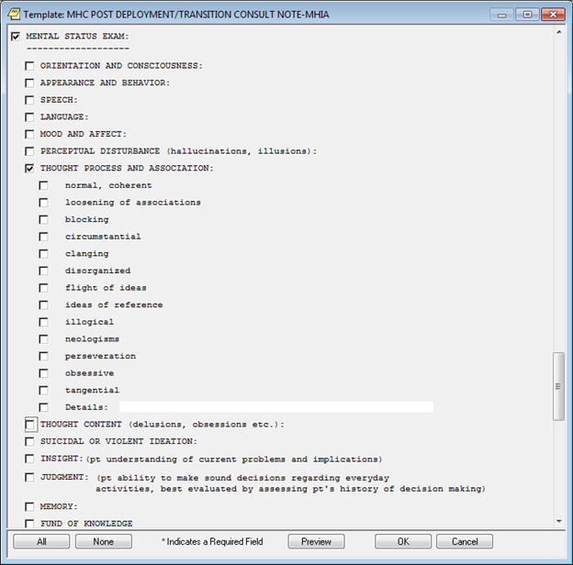

**Figure A.16. Post-Deployment/Transition Consult Note (image 10 of 13)**

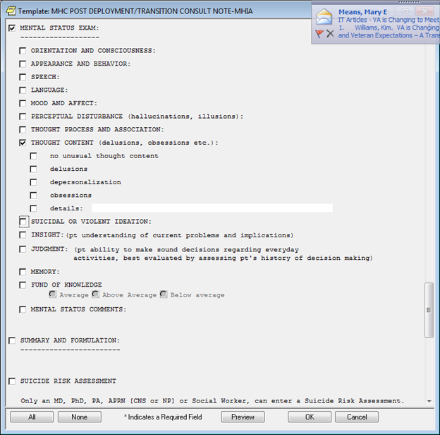

**Figure A.17. Post-Deployment/Transition Consult Note (image 11 of 13)**

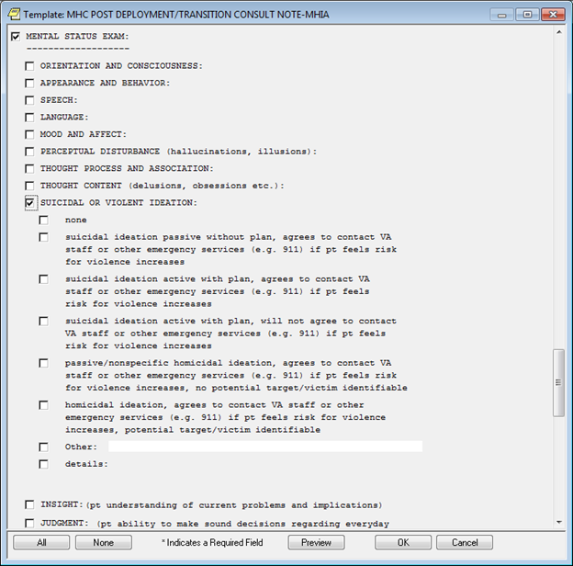

**Figure A.18. Post-Deployment/Transition Consult Note (image 12 of 13)**

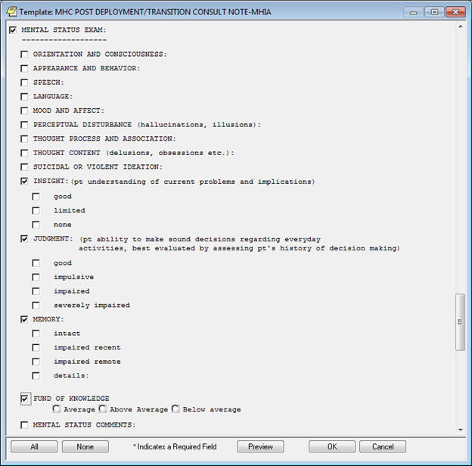

**Figure A.19. Post-Deployment/Transition Consult Note (image 13 of 13)**

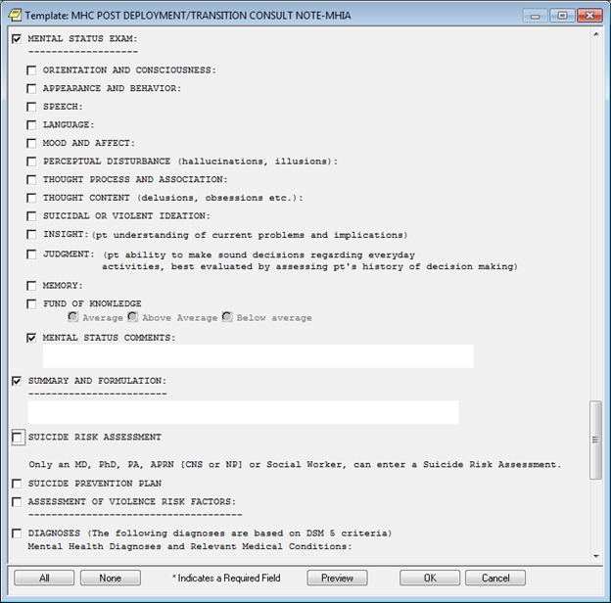

**Appendix B. Logic Diagrams**

**Figure B.1. Iraqi & Afghanistan Post-Deployment Event Condition Action (ECA) Rules**

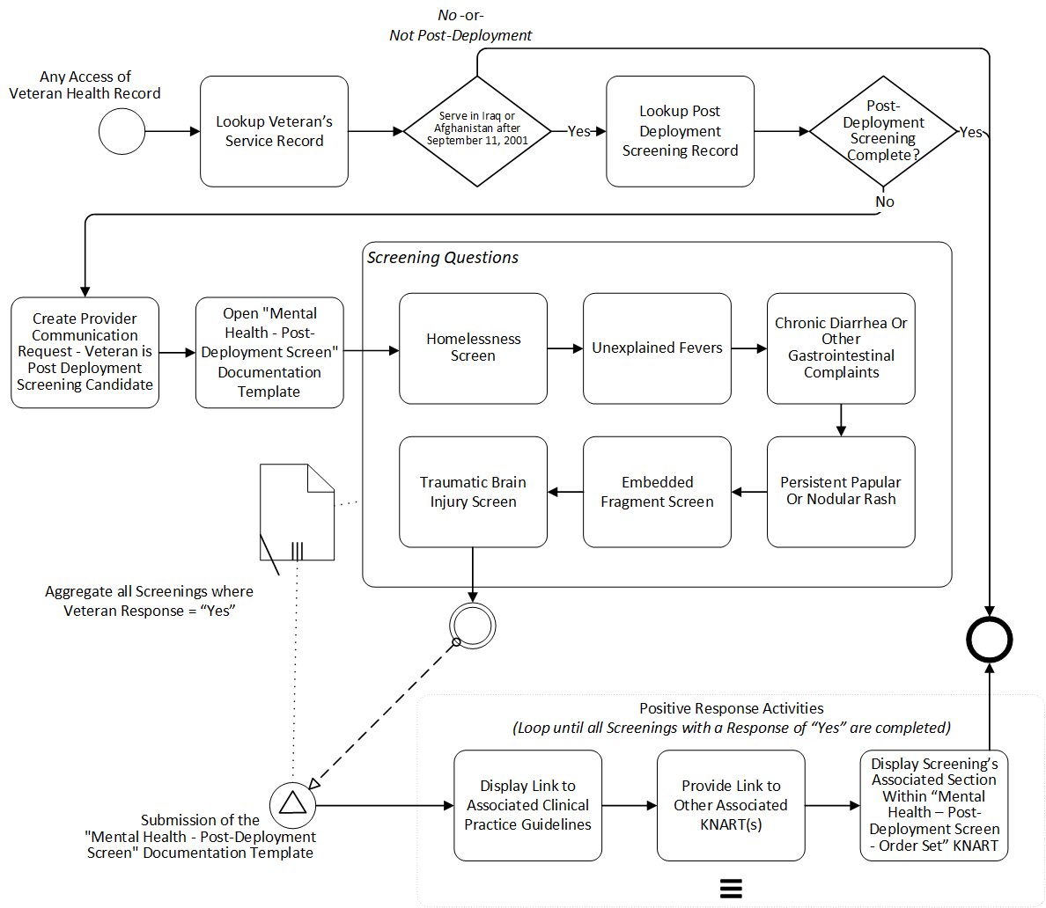

**Appendix C. Basic Laboratory Panel Definition**

* Blood Urea Nitrogen
* Calcium
* Chloride
* CO2 (Carbon Dioxide, Bicarbonate)
* Creatinine
* Glucose
* Potassium
* Sodium

**Acronyms**

|  |  |
| --- | --- |
| CCWP | Clinical Content White Paper |
| CDS | Clinical Decision Support |
| CO2 | Carbon Dioxide |
| DoD | Department of Defense |
| ECA | Event-Condition-Action |
| HL7 | Health Level 7 |
| KBS | Knowledge Based Systems |
| KNART | Knowledge Artifact |
| OEF | Operation Enduring Freedom |
| OIF | Operation Iraqi Freedom |
| OIIG | Office of Informatics and Information Governance |
| PCP | Primary Care Provider |
| PDH-CPG | Post-Deployment Health Clinical Practice Guideline |
| PTSD | Post-Traumatic Stress Disorder |
| SME | Subject Matter Expert |
| SMITREC | Serious Mental Illness Treatment Resource and Evaluation Center |
| TO | Task Order |
| VA | Department of Veterans Affairs |
| VACO | VA Central Office |
| VAMC | VA Medical Center |