**Clinical Decision Support (CDS) Content and Health Level 7 (HL7)-Compliant Knowledge Artifacts (KNARTs)**

**Mental Health: Posttraumatic Stress Disorder (PTSD) Screening and Assessment Clinical Content White Paper**

**Department of Veterans Affairs (VA)**



**Knowledge Based Systems (KBS)**

**Office of Informatics and Information Governance (OIIG)**

**Clinical Decision Support (CDS)**

**Clinical Decision Support (CDS) Content and Health Level 7 (HL7)-Compliant Knowledge Artifacts (KNARTs): Mental Health: Posttraumatic Stress Disorder (PTSD) Screening and Assessment Clinical Content White Paper**

by Department of Veterans Affairs (VA)

Publication date May 2018

**Contract: VA118-16-D-1008, Task Order (TO): VA-118-16-F-1008-0007**

**Table 1. Relevant KNART Information: Mental Health: Posttraumatic Stress Disorder (PTSD) Screening and Assessment**

| **Mental Health KNART** | **Associated CLIN** |
| --- | --- |
| Posttraumatic Stress Disorder (PTSD) Screening and Assessment - Documentation Template | CLIN0009CA |

**Table of Contents**

VA Subject Matter Expert (SME) Panel vi

Introduction vii

Conventions Used viii

1. Mental Health: Posttraumatic Stress Disorder (PTSD) Screening and Assessment 1

1.1. Clinical Context 1

1.2. Knowledge Artifacts 1

2. Documentation Template: Posttraumatic Stress Disorder (PTSD) Screening and Assessment 2

2.1. Knowledge Narrative 2

2.2. Initial Screening 2

2.3. Evaluation 7

2.4. Assessment 14

2.5. Plan 14

Bibliography/Evidence 16

A. Existing Sample VA Artifacts 17

B. Acronyms 31

**List of Figures**

A.1. Veterans Integrated Service Network (VISN) 1 (V-1) PTSD Screen Provider Only 17

A.2. Why the Changes? 18

A.3. Initial Options for Reminder Resolution: Posttraumatic Stress Disorder (PTSD) Screen 19

A.4. Server Cognitive Impairment Option Screen 20

A.5. Posttraumatic Stress Disorder (PTSD) Screen 21

A.6. Posttraumatic Stress Disorder (PTSD) Questions 22

A.7. Positive Posttraumatic Stress Disorder (PTSD) Screen 23

A.8. Reminder Dialog for both Negative and Positive Posttraumatic Stress Disorder (PTSD) Screens 24

A.9. Negative Posttraumatic Stress Disorder (PTSD) Screen 25

A.10. Suicide Risk Evaluation Screen - Positive 26

A.11. Positive Posttraumatic Stress Disorder (PTSD) Evaluation and Follow Up Transition Plan 27

A.12. Completion of Reminders 28

A.13. Final Progress Note Test 29

A.14. Greater Los Angeles VA Medical Center (VAMC) (PTSD) Screen 29

**List of Tables**

1. Relevant KNART Information - Mental Health: PTSD Screening and Assessment CCWP ii

2. VA Subject Matter Expert (SME) Panel vi

1.1. Clinical Context Domains 1

**VA Subject Matter Expert (SME) Panel**

**Table 2. VA Subject Matter Expert (SME) Panel**

| **Name** | **Title** | **Project Role** |
| --- | --- | --- |
| Rani Hoff, PhD MPH | Director, Northeast Program Evaluation Center Office of Mental Health and Suicide Prevention (10NC5) VA Central Office (VACO)  Professor of Psychiatry, Yale University School of Medicine | SME, Primary |

**Introduction**

The VA is committed to improving the ability of clinicians to provide care for patients while increasing quality, safety, and efficiency. Recognizing the importance of standardizing clinical knowledge in support of this goal, VA is implementing the Health Level 7 (HL7) Knowledge Artifact Specification for a wide range of VA clinical use cases. Knowledge Artifacts, referred to as (KNARTs), enable the structuring and encoding of clinical knowledge so the knowledge can be integrated with electronic health records to enable clinical decision support.

The purpose of this Clinical Content White Paper (CCWP) is to capture the clinical context and intent of KNART use cases in sufficient detail to provide the KNART authoring team with the clinical source material to construct the corresponding knowledge artifacts using the HL7 Knowledge Artifact Specification. This paper has been developed using material from a variety of sources: VA artifacts, clinical practice guidelines, evidence in the body of medical literature, and clinical expertise. After reviewing these sources, the material has been synthesized and harmonized under the guidance of VA subject matter experts to reflect clinical intent for this use case.

Unless otherwise noted, items within this white paper (e.g., documentation template fields, orderable items, etc.) are chosen to reflect the clinical intent at the time of creation. To provide an exhaustive list of all possible items and their variations is beyond the scope of this work.

**Conventions Used**

Conventions used within the knowledge artifact descriptions include:

<obtain>: Indicates a prompt to obtain the information listed

* If possible, the requested information should be obtained from the underlying system(s). Otherwise, prompting the user for information may be required
* The technical and clinical notes associated with a section should be consulted for specific constraints on the information (e.g., time-frame, patient interview, etc.)
* Default Values: Unless otherwise noted, <obtain> indicates to obtain the most recent observation. It is recognized that this default time-frame value may be altered by future implementations

[...]: Square brackets enclose explanatory text that indicates some action on the part of the clinical user, or general guidance to the clinical or technical teams. Examples include, but are not limited to:

[Begin ...], [End ...]: Indicates the start and end of specific areas to clearly delineate them for technical purposes.

[Activate ...]: Initiates another knowledge artifact or knowledge artifact section.

[Section Prompt: ...]: If this section is applicable, then the following prompt should be displayed to the user.

[Section Selection Behavior: ...]: Indicates technical constraints or considerations for the selection of items within the section.

[Attach: ...]: Indicates that the specified item should be attached to the documentation template if available.

[Link: ...]: Indicates that rather than attaching an item, a link should be included in the documentation template.

[Clinical Comment: ...]: Indicates clinical rationale or guidance.

[Technical Note: ...]: Indicates technical considerations or notes.

[If ...]: Indicates the beginning of a conditional section.

[Else, ...]: Indicates the beginning of the alternative branch of a conditional section.

[End if ...]: Indicates the end of a conditional section.

☐: Indicates items that should be selected based upon the section selection behavior.

**Chapter 1. Mental Health: Posttraumatic Stress Disorder (PTSD) Screening and Assessment**

**1.1. Clinical Context**

[Begin Clinical Context.]

[Technical Note: This documentation template supports documentation of findings and decisions from screening for posttraumatic stress disorder (PTSD), including brief annual primary care screening, as well as follow-up evaluation using the full PTSD checklist or mental health specialty evaluation. VA clinical practice guidelines for PTSD screening are regarded as the preferred source.]

**Table 1.1. Clinical Context Domains**

|  |  |
| --- | --- |
| Target User | Mental Health Providers; Primary Care Providers |
| Patient | All patients |
| Priority | Routine |
| Specialty | Mental Health; Primary care |
| Location | Outpatient |

[End Clinical Context.]

**1.2. Knowledge Artifacts**

[Begin Knowledge Artifacts.]

This CDS knowledge artifact targets both Mental Health and Primary Care clinical providers. Patient cohort includes all outpatients identified as candidates for PTSD screening.

The knowledge artifact defines the clinical use case. The artifact is a Documentation Template and is described in detail in the following sections.

A Documentation Template: PTSD Screening and Assessment KNART

* Documents the information required to identify significant functional difficulties, reduction in quality of life, and physical sequelae associated with PTSD. Supports timely identification and therapy for PTSD.
* Includes logic for appropriate display of documentation sections

[End Knowledge Artifacts.]

**Chapter 2. Documentation Template: Posttraumatic Stress Disorder (PTSD) Screening and Assessment**

[Begin Documentation Template: Posttraumatic Stress Disorder (PTSD) Screening and Assessment.]

**2.1. Knowledge Narrative**

[Begin Knowledge Narrative.]

[See Clinical Context in Chapter 1.]

Many Veterans have experienced traumatic events in which they were personally or indirectly exposed to death, injury, or sexual violence. Reactions to such exposures may include temporary and non-debilitating symptoms; acute and potentially debilitating but transient symptoms; or persistent, debilitating symptoms, as seen with PTSD.

The diagnostic criteria for PTSD is included in the Diagnostic and Statistical Manual of Mental Disorders, Fifth Edition (DSM-5). The diagnostic criteria for PTSD include eight individual criteria, one of which requires that symptoms must have persisted for at least one month. DSM-5 also identifies that diagnosis may be rendered even when full diagnostic criteria (all 8 criteria) are not met until six months or more after the trauma(s), although onset of some symptoms may occur immediately ("Delayed Specification" PTSD). https://www.ptsd.va.gov/professional/PTSD-overview/dsm5_criteria_ptsd.asp

PTSD is often accompanied by other DSM-5 diagnoses, such as mood or anxiety disorder or substance use disorder. PTSD can be associated with significant functional difficulties, reduction of quality of life, and physical sequelae; therefore, timely identification and therapy are essential [VA; Department of Defense (DoD), 2017].

[Clinical Comment: This documentation template is intended to be available to staff such as primary care and mental health providers caring for outpatients identified as candidates for PTSD screening. Candidates for PTSD screening include new patients, patients who have not been screened routinely as per VA policy, patients with a recent trauma exposure, patients with a past history of PTSD, and patients clinically suspected of having PTSD.]

[End Knowledge Narrative.]

**2.2. Initial Screening**

[Begin Initial Screening.]

[Section Prompt: Primary Care Posttraumatic Stress Disorder Screen for DSM-5 (PC-PTSD-5)]

[Section Prompt: The PC-PTSD-5 score is calculated by totaling the numbers following each response option below. A score of >= 3 on any of the five questions about how the traumatic event(s) have affected him or her over the past month is a positive result.]

[Technical Note: The Primary Care Posttraumatic Stress Disorder Screen for DSM-5 (PC-PTSD-5) must be calculated by totaling the form label values (indicated by a number following each response option) for the form labels selected by the user. A score of >= 3 on any of the five questions about how the traumatic event(s) have affected him or her over the past month is a positive result. Note that the following form components are adapted from Prins, 2016.]

[Section Prompt: Ask the patient the following questions:]

[Section Prompt: Sometimes things happen to people that are unusually or especially frightening, horrible, or traumatic. For example: a serious accident or fire; a physical or sexual assault or abuse; an earthquake or flood; a war; seeing someone be killed or seriously injured; having a loved one die through homicide or suicide. Have you ever experienced this kind of event?]

[Section Selection Behavior: Select one. Required.]

☐ Yes (score = 1)

☐ No (score = 0)

[Technical Note: If the patient answered “No” to the first question, the PC-PTSD-5 ends here with a PC-PTSD-5 screen score of 0.]

[Technical Note: If the patient answered “Yes” to the first question, the remainder of the PC-PTSD-5 should be made available for completion.]

[Section Prompt: In the past month, have you:]

[Section Prompt: Had nightmares about the event(s) or thought about the event(s) when you did not want to?]

[Section Selection Behavior: Select one. Required.]

☐ Yes (score = 1)

☐ No (score = 0)

[Section Prompt: Tried hard not to think about the event(s) or went out of your way to avoid situations that reminded you of the event(s)?]

[Section Selection Behavior: Select one. Required.]

☐ Yes (score = 1)

☐ No (score = 0)

[Section Prompt: Been constantly on guard, watchful, or easily startled?]

[Section Selection Behavior: Select one. Required.]

☐ Yes (score = 1)

☐ No (score = 0)

[Section Prompt: Felt numb or detached from people, activities, or your surroundings?]

[Section Selection Behavior: Select one. Required.]

☐ Yes (score = 1)

☐ No (score = 0)

[Section Prompt: Felt guilty or unable to stop blaming yourself or others for the event(s) or any problems the event(s) may have caused?]

[Section Selection Behavior: Select one. Required.]

☐ Yes (score = 1)

☐ No (score = 0)

[Section Prompt: PC-PTSD-5 screening score]

<obtain> PC-PTSD-5 screening score

[Section Prompt: PC-PTSD-5 screening results - positive (>= 3 points) or negative]

[Technical Note: determine “positive” or “negative” results for the PC-PTSD-5 as per the technical note at the beginning of this section.]

<obtain> PC-PTSD-5 screen results (positive or negative)

[Technical Note: Upon completion of the PC-PTSD-5, display for the user the Patient Health Questionnaire-Plus (PHQ-plus), as well as the PTSD Checklist for DSM-5 (PCL-5) which is found in the Evaluation section, section 2.3 of this document. Both of these additional screening tools should still be available in this documentation template in the event that the patient declines to complete the PC-PTSD-5]

[Section Prompt: Patient Health Questionnaire-Plus (PHQ-plus)

[Technical Note: Patient Health Questionnaire-plus (PHQ-plus) must be calculated by totaling the form label values (indicated by a number following each response option) for the form labels selected by the user. Note that the following form components are adapted from Kroenke 2001.]

[Technical Note: PHQ-plus is defined as questions 1, 2, and 9 from PHQ-9.]

[Section Prompt: Patient Health Questionnaire-Plus (PHQ-plus) is 3 questions, and the score is calculated by totaling the numbers following each response option below. A positive screen is defined as either (a) a total score of 3 or more, or (b) a score above 0 on the third question (regardless of the score from the other questions)." More information on the PHQ-plus is available here: https://www.apa.org/pi/about/publications/caregivers/practice-settings/assessment/tools/patient-health.aspx.

[Section Prompt: Ask patient the following questions:]

[Section Prompt: Over the past two weeks, how often have you been bothered by any of the following problems:]

[Section Prompt: Little interest or pleasure in doing things?]

[Section Selection Behavior: Select one. Required.]

☐ Not at all (score = 0)

☐ Several days (score = 1)

☐ More than half the days (score = 2)

☐ Nearly every day (score = 3)

[Section Prompt: Feeling down, depressed, or hopeless?]

[Section Selection Behavior: Select one. Required.]

☐ Not at all (score = 0)

☐ Several days (score = 1)

☐ More than half the days (score = 2)

☐ Nearly every day (score = 3)

[Technical Note: A score weighting > 0 on the following question constitutes a positive result on the PHQ-plus screen.]

[Section Prompt: Thoughts that you would be better off dead or of hurting yourself in some way?]

[Section Selection Behavior: Select one. Required.]

☐ Not at all (score = 0)

☐ Several days (score = 1)

☐ More than half the days (score = 2)

☐ Nearly every day (score = 3)

[Section Prompt: PHQ-plus total score]

<Obtain> PHQ-plus total score

[Section Prompt: PHQ-plus results (positive or negative)]

<Obtain> PHQ-plus results (positive or negative)

[Technical Note: Results are calculated as per the section prompt at the beginning of this section.]

[Section Prompt: For positive responses to depressive symptom questions consider the following:]

[Technical Note: Upon completion of the PHQ-plus, if the initial screening was positive and there were positive responses to questions about depressive symptoms, the user should be presented with links to the following:

* Order Set: Mental Health Consult for Depression KNART
* Documentation Template Consult Request: Mental Health Consult for Depression KNART]

[Section Prompt: For positive responses to suicidal ideation questions consider the following:]

[Technical Note: Upon completion of the PHQ-plus, if the initial screening above was positive, and there were positive responses to question about suicidal ideation, the user should be presented with links to the following:

* Documentation Template: Mental Health Suicide Risk Assessment KNART
* Order Set: Mental Health Positive Suicide Risk Screening KNART.]

[Technical Note: PHQ-plus responses and scores from this documentation template should be used to prepopulate the corresponding questions in the PHQ-9 if it is accessed in another KNART.]

[Section Prompt: GAD-2 (Optional Screening Tool for Generalized Anxiety Disorder):]

[Section Prompt: 2 item (GAD-2) screen score is calculated by totaling the numbers following each response option below; a positive screen is 3 or more.]

[Technical Note: The Generalized Anxiety Disorder – 2 item (GAD-2) screen must be calculated by totaling the form label values (indicated by a number following each response option) for the form labels selected by the user. Note that the following form components are adapted from Kroenke, 2010.]

[Section Prompt: Over the last 2 weeks, how often have you been bothered by any of the following problems:]

[Section Prompt: Feeling nervous anxiety or on edge?]

[Section Selection Behavior: Select one. Required.]

☐ Not at all (score = 0)

☐ Several days (score = 1)

☐ More than half the days (score = 2)

☐ Nearly every day (score = 3)

[Section Prompt: Not being able to stop or control worrying?]

[Section Selection Behavior: Select one. Required.]

☐ Not at all (score = 0)

☐ Several days (score = 1)

☐ More than half the days (score = 2)

☐ Nearly every day (score = 3)

[Section Prompt: GAD-2 score]

<Obtain: GAD-2 score

[Section Prompt: GAD-2 score result (positive or negative)]

<Obtain: GAD-2 score result (positive or negative)

[Technical Note: Upon completion of the GAD-2 with a positive screen score (3 or more) the user should be presented with a link to a KNART (to be developed in the future) that contains the GAD-7.]

[Technical Note: GAD-2 responses and scores from this documentation template should be used to prepopulate the corresponding questions in the GAD-7 if it is accessed in another KNART.]

[Section Prompt: (Optional Screening Tool) Alcohol Use Disorders Identification Test—Consumption (AUDIT-C)]

[Technical Note: Alcohol Use Disorders Identification Test—Consumption (AUDIT-C) must be calculated by totaling the form label values (indicated by a number following each response option) for the form labels selected by the user. Note that the following form components are adapted from Bush 1998.]

[Section Prompt: Males with a score of 4 or more are at increased risk of harm from drinking, Females with a score of 3 or more are at increased risk of harm from drinking. Scores are calculated by totaling the numbers following each response]

[Section Prompt: (Optional Screening Tool) Alcohol Use Disorders Identification Test—Consumption (AUDIT-C) <AUDIT-C score calculated based on weighting for responses below>]

[Section Prompt: “How often did you have a drink containing alcohol in the past year? Consider a drink to be a can or bottle of beer, a glass of wine, a wine cooler, or one cocktail or a shot of hard liquor (like scotch, gin, or vodka)?]

[Section Selection Behavior: Select one. Required.]

☐ Never (score = 0)

☐ Monthly or less (score = 1)

☐ 2 to 4 times a month (score = 2)

☐ 2 to 3 times a week (score = 3)

☐ 4 or more times a week (score = 4)

[Section Prompt: How many drinks did you have on a typical day when you were drinking in the past year?]

☐ 0 drinks (score = 0)

☐ 1 to 2 drinks (score = 0)

☐ 3 to 4 drinks (score = 1)

☐ 5 to 6 drinks (score = 2)

☐ 7 to 9 drinks (score = 3)

☐ 10 or more drinks (score = 4)

[Section Prompt: How often did you have 6 or more drinks on one occasion in the past year?]

☐ Never (score = 0)

☐ Less than monthly (score = 1)

☐ Monthly (score = 2)

☐ Weekly (score = 3)

☐ Daily or almost daily (score = 4)

[Section Prompt: AUDIT-C score]

<obtain> AUDIT-C score

[Section Prompt: AUDIT-C score results (positive or negative)]

<Obtain> AUDIT-C score results (positive or negative)

[Technical Note: Calculate AUDIT-C score based upon technical note at the beginning of this section.]

[Technical Note: Upon completion of the AUDIT-C, the user should be presented with a link to a KNART (to be developed in the future) that contains a suite of addiction tools, including but not limited to the Brief Addiction Monitor (BAM); specific assessments may be recommended for patients with opiate prescriptions.]

[Technical Note: Upon completion of the Initial Screening section, the user should have the option to complete the Plan section without being required to complete any other sections.]

[End Initial Screening.]

**2.3. Evaluation**

[Begin Evaluation.]

[Section Prompt: PCL-5 with Criterion A.]

[Section Prompt: The PCL-5 may be used either for monitoring the severity of symptoms of PTSD or as a screening tool. The recommended screening threshold (for diagnosis of PTSD) is 33 points.]

[Technical Note: For either VA or DoD facilities, the PCL-5 with Criterion A should be activated for PC-PTSD-5 scores >= 3 points.]

[Section Prompt: The instructions and questions on the PCL-5 with Criterion A may be read to the patient and answers recorded by the tool administrator or may be printed, read, and completed by the patient.]

[Section Prompt: Note that the following form components are adapted from Weathers, 2013.]

[Section Prompt: The following written or verbal instructions should be provided to the patient with administration of the Criterion A questions: “This questionnaire asks about problems you may have had after a very stressful experience involving actual or threatened death, serious injury, or sexual violence. It could be something that happened to you directly, something you witnessed, or something you learned happened to a close family member or close friend. Some examples are a serious accident; fire; disaster such as a hurricane, tornado, or earthquake; physical or sexual attack or abuse; war; homicide; or suicide. First, please answer a few questions about your worst event, which for this questionnaire means the event that currently bothers you the most. This could be one of the examples above or some other very stressful experience. Also, it could be a single event (for example, a car crash) or multiple similar events (for example, multiple stressful events in a war-zone or repeated sexual abuse).”]

[Section Prompt: Ask the patient the following questions:]

[Section Prompt: Briefly identify the worst event (if you feel comfortable doing so).]

<obtain> Patient response

[Section Prompt: How long ago did it happen? (please estimate if you are not sure).]

<obtain> Patient response

[Section Prompt: Did it involve actual or threatened death, serious injury, or sexual violence?]

[Section Selection Behavior: Select one. Required.]

☐ Yes

☐ No

[Section Prompt: How did you experience it?]

[Section Selection Behavior: Select one. Required.]

☐ It happened to me directly

☐ I witnessed it

☐ I learned about it happening to a close family member or close friend

☐ I was repeatedly exposed to details about it as part of my job (for example, paramedic, police, military, or other first responder)

☐ Other (Please Describe)

<obtain> Patient response

[Section Prompt: If the event involved the death of a close family member or close friend, was it due to some kind of accident or violence, or was it due to natural causes?]

[Section Selection Behavior: Select one. Required.]

☐ Accident or violence

☐ Natural causes

☐ Not applicable (the event did not involve the death of a close family member or close friend)

[Technical Note: The PCL-5 must be calculated by totaling the form label values (indicated by a number following each response option below) for the form labels selected by the user.]

[Section Prompt: The following written or verbal instructions should be provided to the patient with administration of the PCL-5 questions: “Second, below is a list of problems that people sometimes have in response to a very stressful experience. Keeping your worst event in mind, please read each problem carefully and then select one of the answers to indicate how much you have been bothered by that problem in the past month.”]

[Section Prompt: PTSD Checklist for DSM-5 (PCL-5)

[Section Prompt: The PCL-5 score is calculated by adding the numbers following each response option below]

[Section Prompt: In the past month, how much were you bothered by:]

[Section Prompt: Repeated, disturbing, and unwanted memories of the stressful experience?]

[Section Selection Behavior: Select one. Required.]

☐ Not at all (score = 0)

☐ A little bit (score = 1)

☐ Moderately (score = 2)

☐ Quite a bit (score = 3)

☐ Extremely (score = 4)

[Section Prompt: Repeated, disturbing dreams of the stressful experience?]

[Section Selection Behavior: Select one. Required.]

☐ Not at all (score = 0)

☐ A little bit (score = 1)

☐ Moderately (score = 2)

☐ Quite a bit (score = 3)

☐ Extremely (score = 4)

[Section Prompt: Suddenly feeling or acting as if the stressful experience were actually happening again (as if you were actually back there reliving it)?]

[Section Selection Behavior: Select one. Required.]

☐ Not at all (score = 0)

☐ A little bit (score = 1)

☐ Moderately (score = 2)

☐ Quite a bit (score = 3)

☐ Extremely (score = 4)

[Section Prompt: Feeling very upset when something reminded you of the stressful experience?]

[Section Selection Behavior: Select one. Required.]

☐ Not at all (score = 0)

☐ A little bit (score = 1)

☐ Moderately (score = 2)

☐ Quite a bit (score = 3)

☐ Extremely (score = 4)

[Section Prompt: Having strong physical reactions when something reminded you of the stressful experience (for example, heart pounding, trouble breathing, sweating)?]

[Section Selection Behavior: Select one. Required.]

☐ Not at all (score = 0)

☐ A little bit (score = 1)

☐ Moderately (score = 2)

☐ Quite a bit (score = 3)

☐ Extremely (score = 4)

[Section Prompt: Avoiding memories, thoughts, or feelings related to the stressful experience?]

[Section Selection Behavior: Select one. Required.]

☐ Not at all (score = 0)

☐ A little bit (score = 1)

☐ Moderately (score = 2)

☐ Quite a bit (score = 3)

☐ Extremely (score = 4)

[Section Prompt: Avoiding external reminders of the stressful experience (for example, people, places, conversations, activities, objects, or situations)?]

[Section Selection Behavior: Select one. Required.]

☐ Not at all (score = 0)

☐ A little bit (score = 1)

☐ Moderately (score = 2)

☐ Quite a bit (score = 3)

☐ Extremely (score = 4)

[Section Prompt: Trouble remembering important parts of the stressful experience?]

[Section Selection Behavior: Select one. Required.]

☐ Not at all (score = 0)

☐ A little bit (score = 1)

☐ Moderately (score = 2)

☐ Quite a bit (score = 3)

☐ Extremely (score = 4)

[Section Prompt: Having strong negative beliefs about yourself, other people, or the world (for example, having thoughts such as: I am bad, there is something seriously wrong with me, no one can be trusted, the world is completely dangerous)?]

[Section Selection Behavior: Select one. Required.]

☐ Not at all (score = 0)

☐ A little bit (score = 1)

☐ Moderately (score = 2)

☐ Quite a bit (score = 3)

☐ Extremely (score = 4)

[Section Prompt: Blaming yourself or someone else for the stressful experience or what happened after it?]

[Section Selection Behavior: Select one. Required.]

☐ Not at all (score = 0)

☐ A little bit (score = 1)

☐ Moderately (score = 2)

☐ Quite a bit (score = 3)

☐ Extremely (score = 4)

[Section Prompt: Having strong negative feelings such as fear, horror, anger, guilt, or shame?]

[Section Selection Behavior: Select one. Required.]

☐ Not at all (score = 0)

☐ A little bit (score = 1)

☐ Moderately (score = 2)

☐ Quite a bit (score = 3)

☐ Extremely (score = 4)

[Section Prompt: Loss of interest in activities that you used to enjoy?]

[Section Selection Behavior: Select one. Required.]

☐ Not at all (score = 0)

☐ A little bit (score = 1)

☐ Moderately (score = 2)

☐ Quite a bit (score = 3)

☐ Extremely (score = 4)

[Section Prompt: Feeling distant or cut off from other people?]

[Section Selection Behavior: Select one. Required.]

☐ Not at all (score = 0)

☐ A little bit (score = 1)

☐ Moderately (score = 2)

☐ Quite a bit (score = 3)

☐ Extremely (score = 4)

[Section Prompt: Trouble experiencing positive feelings (for example, being unable to feel happiness or have loving feelings for people close to you)?]

[Section Selection Behavior: Select one. Required.]

☐ Not at all (score = 0)

☐ A little bit (score = 1)

☐ Moderately (score = 2)

☐ Quite a bit (score = 3)

☐ Extremely (score = 4)

[Section Prompt: Irritable behavior, angry outbursts, or acting aggressively?]

[Section Selection Behavior: Select one. Required.]

☐ Not at all (score = 0)

☐ A little bit (score = 1)

☐ Moderately (score = 2)

☐ Quite a bit (score = 3)

☐ Extremely (score = 4)

[Section Prompt: Taking too many risks or doing things that could cause you harm?]

[Section Selection Behavior: Select one. Required.]

☐ Not at all (score = 0)

☐ A little bit (score = 1)

☐ Moderately (score = 2)

☐ Quite a bit (score = 3)

☐ Extremely (score = 4)

[Section Prompt: Being “super alert” or watchful or on guard?]

[Section Selection Behavior: Select one. Required.]

☐ Not at all (score = 0)

☐ A little bit (score = 1)

☐ Moderately (score = 2)

☐ Quite a bit (score = 3)

☐ Extremely (score = 4)

[Section Prompt: Feeling jumpy or easily startled?]

[Section Selection Behavior: Select one. Required.]

☐ Not at all (score = 0)

☐ A little bit (score = 1)

☐ Moderately (score = 2)

☐ Quite a bit (score = 3)

☐ Extremely (score = 4)

[Section Prompt: Having difficulty concentrating?]

[Section Selection Behavior: Select one. Required.]

☐ Not at all (score = 0)

☐ A little bit (score = 1)

☐ Moderately (score = 2)

☐ Quite a bit (score = 3)

☐ Extremely (score = 4)

[Section Prompt: Trouble falling or staying asleep?]

[Section Selection Behavior: Select one. Required.]

☐ Not at all (score = 0)

☐ A little bit (score = 1)

☐ Moderately (score = 2)

☐ Quite a bit (score = 3)

☐ Extremely (score = 4)

[Section Prompt: PCL-5 score]

<Obtain> PCL-5 score

[Section Prompt: PCL-5 PTSD screening results (positive or negative)]

<Obtain> PTSC screening results (positive or negative)

[Technical Note: Calculate positive or negative results based on the section prompt at the beginning of the PCL-5 section.]

[End Evaluation.]

**2.4. Assessment**

[Begin Assessment.]

[Section Prompt: Assessment]

[Section Selection Behavior: Select One. Required.]

☐ Provisional diagnosis of PTSD

☐ Established diagnosis of PTSD

☐ Other diagnosis

<obtain> Details

<obtain> History

<obtain> Symptom concerns

<obtain> Comorbidities

<obtain> Additional information

[End Assessment.]

**2.5. Plan**

[Begin Plan.]

[Section Prompt: Plan]

[Section Selection Behavior: Select One or More. Optional.]

☐ Risks and benefits of recommended treatment(s) discussed with patient

☐ Patient expresses understanding and agrees with plan

☐ Patient education

<obtain> Details

[Section Prompt: Specific therapeutic modalities]

[Section Selection Behavior: Select One or More, Optional]

☐ Individual trauma-focused psychotherapy

☐ Individual non–trauma-focused psychotherapy

☐ Pharmacotherapy

☐ Selective serotonin reuptake inhibitors

☐ Serotonin and norepinephrine reuptake inhibitors (e.g., sertraline, paroxetine, fluoxetine, or venlafaxine)

☐ Other antidepressants (e.g., nefazodone, imipramine, or phenelzine)

☐ Other Pharmacotherapy

<obtain> Details

☐ Other Specific therapeutic modalities

<obtain> Details

[Section Prompt: Principal Treatment Setting]

[Section Selection Behavior: Select one. Required.]

☐ Mental health clinic

☐ General mental health

☐ PTSD clinic

☐ Primary care clinic

☐ Mental health provider embedded in primary care practice setting

☐ Primary care provider

☐ Other

<obtain> Details

[Section Prompt: Arrangements and timing for follow-up]

<obtain> Details

☐ Consult mental health for PTSD

<obtain> Details

☐ Consult mental health for substance use disorder

<obtain> Details

☐ Other

<obtain> Details

[Technical Note: Provide links to Documentation Template Consult Request: Mental Health Consult for Depression KNART, Documentation Template: Mental Health Suicide Risk Assessment KNART, Documentation Template: Mental Health Military Sexual Trauma KNART, Documentation Template: Mental Health Homelessness KNART, and Documentation Template: Mental Health Iraq & Afghanistan Post-Deployment Screen KNART.]

[End Plan.]

[End Documentation Template: Posttraumatic Stress Disorder (PTSD) Screening and Assessment.]

**Bibliography/Evidence**

K Bush, DR Kiylahan, MB McDonell, SD Fihn, and KA Bradley. “The AUDIT alcohol consumption questions (AUDIT-C): an effective brief screening test for problem drinking. Ambulatory Care Quality Improvement Project (ACQUIP). Alcohol Use Disorders Identification Test”. *Arch Intern Med*. 1998. 158. 16. 1789-1795.

“Committee on the Assessment of the Readjustment Needs of Military Personnel, Veterans, and Their Families; Board on the Health of Select Populations; Institute of Medicine. Returning Home from Iraq and Afghanistan: Assessment of Readjustment Needs of Veterans, Service Members, and Their Families”. *Washington (DC): National Academies Press (US);*. March 2013. https://www.ncbi.nlm.nih.gov/books/NBK206857/.

K Kroenke, RL Spitzer, JB Williams, and B Lowe. “The Patient Health Questionnaire Somatic, Anxiety, and Depressive Symptom Scales: a systematic review”. *Gen Hosp Psychiatry*. 2010. 32. 4. 345-359.

K Kroenke, RL Spitzer, and JB Williams. “The PHQ-9: validity of a brief depression severity measure”. *J Gen Intern Med*. 2001. 16. 9. 606-613.

A Prins, MJ Bovin, and DJ Smolenski. “The primary care PTSD screen for DSM-5 (PC-PTSD-5): development and evaluation within a Veteran primary care sample”. *J Gen Intern Med*. 2016. 31. 10. 1206-1211.

“Tri-Service Workflow (TSWF). TSWF-CORE AIM Form Version Jan-Apr 2017”. *TSWF CORE Paper Backup Jan Apr 2017.pdf.*. September 21, 2017. Veterans Administration, materials provided in Mental Health-20170921T220116Z-001.zip.

“U.S. Department of Defense. Department of Defense Instruction Number 6490.15: Integration of Behavioral Health Personnel (BHP) Services into Patient-Centered Medical Home (PCMH) Primary Care and Other Primary Care Service Settings”. *Executive Services Directorate website*. Effective November 2014. http://www.esd.whs.mil/Portals/54/Documents/DD/issuances/dodi/649015p.pdf.

“U.S. Department of Veterans Affairs National Center for PTSD. Using the PTSD Checklist for DSM-5 (PCL-5).”. *U.S. Department of Veterans Affairs National Center for PTSD website*. Accessed October 19, 2017. https://www.ptsd.va.gov/professional/assessment/documents/using-PCL5.pdf.

“U.S. Department of Veterans Affairs National Center for PTSD. DSM-5 Criteria for PTSD.”. *U.S. Department of Veterans Affairs National Center for PTSD website*. Accessed February 8, 2018. https://www.ptsd.va.gov/professional/PTSD-overview/dsm5_criteria_ptsd.asp.

“U.S. Department of Veterans Affairs; U.S. Department of Defense. VA/DoD Clinical Practice Guideline for the Management of Posttraumatic Stress Disorder and Acute Stress Disorder”. *VA/DoD Clinical Practice Guidelines website*. Published June 2017. Version 3.0 – 2017. https://www.healthquality.va.gov/guidelines/MH/ptsd/VADoDPTSDCPGFinal082917.pdf.

“U.S. Department of Veterans Affairs National Center for PTSD. Primary Care PTSD Screen for DSM-5 (PC-PTSD-5).”. *U.S. Department of Veterans Affairs National Center for PTSD website*. Accessed March 15, 2018. https://www.ptsd.va.gov/professional/assessment/screens/pc-ptsd.asp.

“Weathers FW, Litz BT, Keane TM, Palmieri PA, Marx BP, and Schnurr PP. The PTSD Checklist for DSM-5 (PCL-5) – Extended Criterion A [Measurement instrument].”. *U.S. Department of Veterans Affairs National Center for PTSD website.* August 2013. https://www.ptsd.va.gov/professional/assessment/documents/PCL-5_criterionA.pdf.

**Appendix A. Existing Sample VA Artifacts**

**Figure A.1. Veterans Integrated Service Network (VISN) 1 (V-1) PTSD Screen Provider Only**

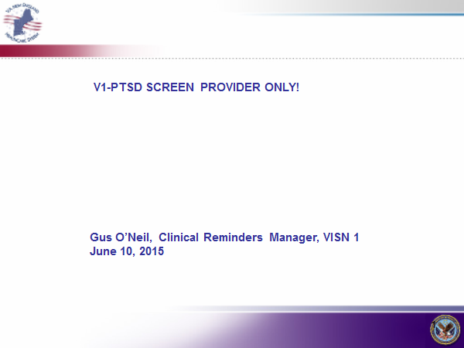

**Figure A.2. Why the Changes?**

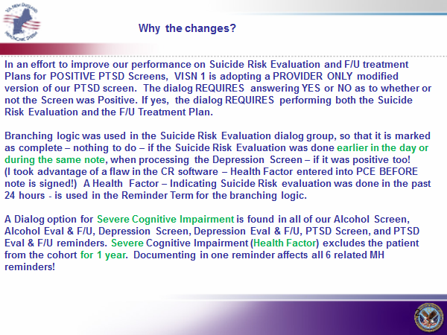

**Figure A.3. Initial Options for Reminder Resolution: Posttraumatic Stress Disorder (PTSD) Screen**

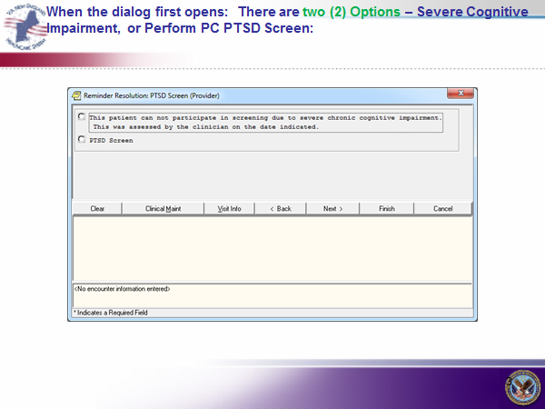

**Figure A.4. Severe Cognitive Impairment Option Screen**

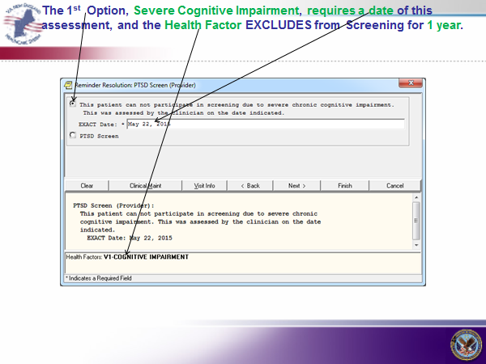

**Figure A.5. Posttraumatic Stress Disorder (PTSD) Screen**

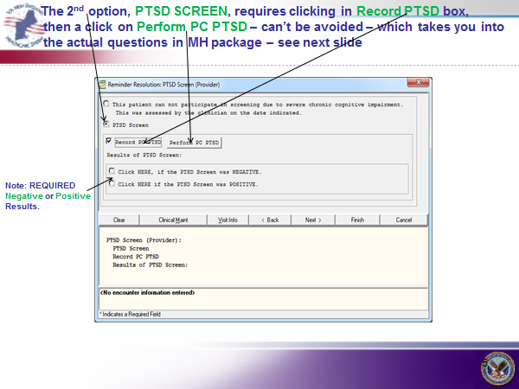

**Figure A.6. Posttraumatic Stress Disorder (PTSD) Questions**

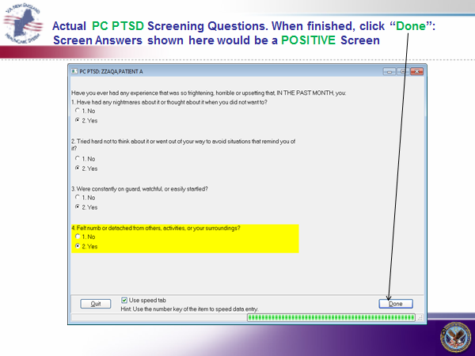

**Figure A.7. Positive Posttraumatic Stress Disorder (PTSD) Screen**

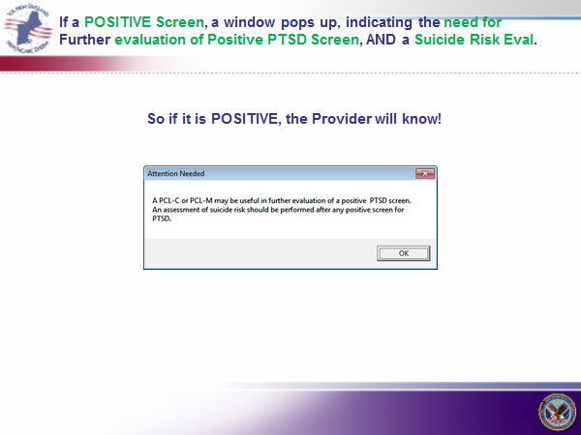

**Figure A.8. Reminder Dialog for both Negative and Positive Posttraumatic Stress Disorder (PTSD) Screens**

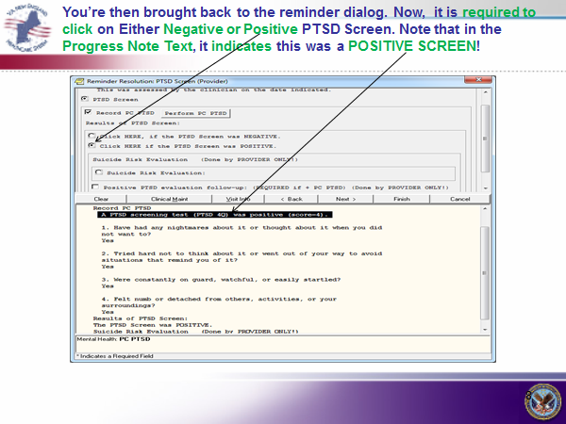

**Figure A.9. Negative Posttraumatic Stress Disorder (PTSD) Screen**

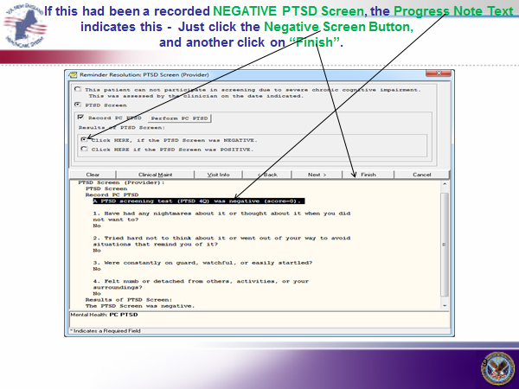

**Figure A.10. Suicide Risk Evaluation Screen - Positive**

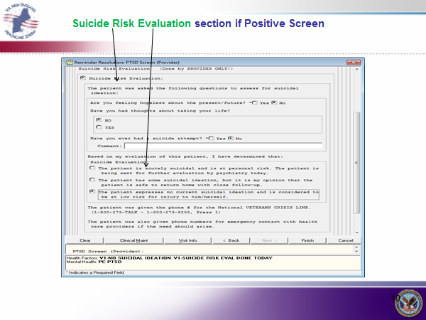

**Figure A.11. Positive Posttraumatic Stress Disorder (PTSD) Evaluation and Follow Up Transition Plan**

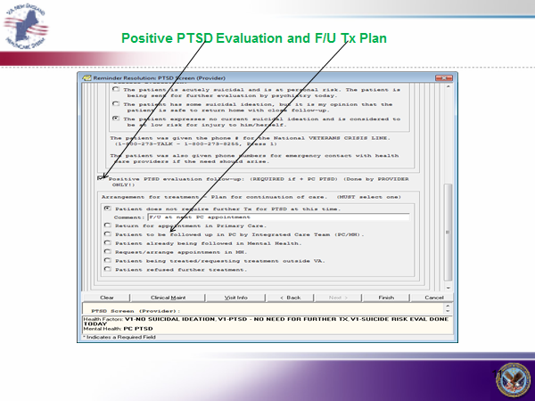

**Figure A.12. Completion of Reminders**

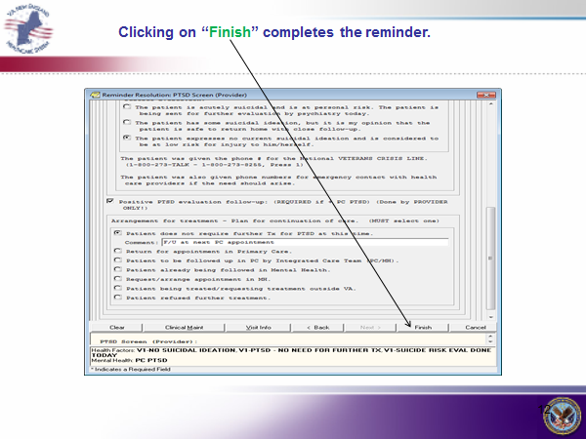

**Figure A.13. Final Progress Note Test**

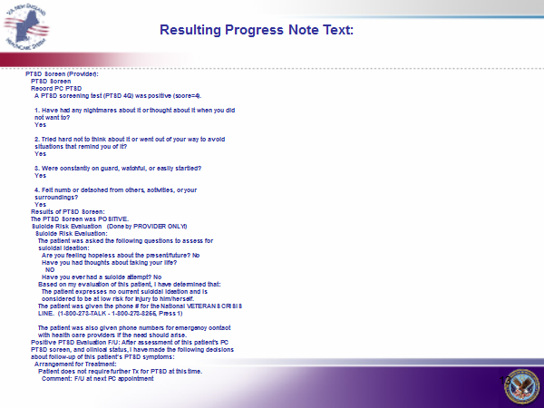

**Figure A.14. Greater Los Angeles VA Medical Center (VAMC) Posttraumatic Stress Disorder (PTSD) Screen**

Greater LA VAMC  
2. ---- Begin: VA-PTSD AVOIDANCE ALL (FI(12)=RT(617)) -----------------------  
3. Finding Type: REMINDER TERM  
4. Within Category Rank: 0  
5.   
6. Mapped Findings: HF.PTSD SCREEN - AVOIDANCE   
7. Health Factor Category: PTSD AVOIDANCE  
8. Ending Date/Time: 10/1/08  
9.   
10. Mapped Findings: HF.PTSD SCREEN - NO AVOIDANCE   
11. Health Factor Category: PTSD AVOIDANCE  
12. Ending Date/Time: 10/1/08  
13.   
14. ---- End: VA-PTSD AVOIDANCE ALL ------------------------------------------  
15.   
16. ---- Begin: VA-PTSD DETACHMENT ALL (FI(13)=RT(620)) ----------------------  
17. Finding Type: REMINDER TERM  
18. Within Category Rank: 0  
19.   
20. Mapped Findings: HF.PTSD SCREEN - DETACHED   
21. Health Factor Category: PTSD DETACHMENT  
22. Ending Date/Time: 10/1/08  
23.   
24. Mapped Findings: HF.PTSD SCREEN - NO DETACHMENT   
25. Health Factor Category: PTSD DETACHMENT  
26. Ending Date/Time: 10/1/08  
27.   
28. ---- End: VA-PTSD DETACHMENT ALL -----------------------------------------  
29.   
30. ---- Begin: VA-PTSD NIGHTMARES ALL (FI(14)=RT(618)) ----------------------  
31. Finding Type: REMINDER TERM  
32. Within Category Rank: 0  
33.   
34. Mapped Findings: HF.PTSD SCREEN - NIGHTMARES   
35. Health Factor Category: PTSD NIGHTMARES  
36. Ending Date/Time: 10/1/08  
37.   
38. Mapped Findings: HF.PTSD SCREEN - NO NIGHTMARES   
39. Health Factor Category: PTSD NIGHTMARES  
40. Ending Date/Time: 10/1/08  
41.   
42. ---- End: VA-PTSD NIGHTMARES ALL -----------------------------------------  
43.   
44. ---- Begin: VA-PTSD ON GUARD ALL (FI(15)=RT(619)) ------------------------  
45. Finding Type: REMINDER TERM  
46. Within Category Rank: 0  
47.   
48. Mapped Findings: HF.PTSD SCREEN - ON GUARD   
49. Health Factor Category: PTSD ON GUARD  
50. Ending Date/Time: 10/1/08  
51.   
52. Mapped Findings: HF.PTSD SCREEN - NO ON GUARD   
53. Health Factor Category: PTSD ON GUARD  
54. Ending Date/Time: 10/1/08  
55.   
56. ---- End: VA-PTSD ON GUARD ALL -------------------------------------------  
57.   
58. ---- Begin: VA-REFUSED PTSD SCREEN (FI(16)=RT(631)) ----------------------  
59. Finding Type: REMINDER TERM  
60. Found Text: Refused PTSD Screen  
61.   
62. Mapped Findings: HF.REFUSED PTSD SCREEN   
63. Health Factor Category: MENTAL HEALTH  
64.   
 ---- End: VA-REFUSED PTSD SCREEN -----------------------------------------

**Appendix B. Acronyms**

|  |  |
| --- | --- |
| ACQUIP | Ambulatory Care Quality Improvement Project |
| AUDIT-C | Alcohol Use Disorders Identification Test – Consumption |
| BAM | Brief Addiction Monitor |
| BHP | Behavioral Health Personnel |
| CCWP | Clinical Content White Paper |
| CDS | Clinical Decision Support |
| DoD | Department of Defense |
| DSM-5 | Diagnostic and Statistical Manual of Mental Disorders, Fifth Edition |
| GAD | Generalized Anxiety Disorder |
| HL7 | Health Level 7 |
| KBS | Knowledge Based System |
| KNART | Knowledge Artifact |
| OIIG | Office of Informatics and Information Governance |
| PCMH | Patient-Centered Medical Home |
| PC-PTSD-5 | Primary Care Posttraumatic Stress Disorder Screen for DSM-5 |
| PCL-5 | PTSD Checklist for DSM-5 |
| PHQ | Patient Health Questionnaire |
| PHQ-plus | Patient Health Questionnaire-plus |
| PTSD | Posttraumatic Stress Disorder |
| SME | Subject Matter Expert |
| TO | Task Order |
| TSWF | Tri-Service Workflow |
| V-1 | VISN 1 |
| VA | Department of Veterans Affairs |
| VACO | VA Central Office |
| VISN | Veterans Integrated Service Network |