**Clinical Decision Support (CDS) Content and Health Level 7 (HL7)-Compliant Knowledge Artifacts (KNARTs)**

**Mental Health: Suicidality Clinical Content White Paper**

**Department of Veterans Affairs (VA)**



**Knowledge Based Systems (KBS)**

**Office of Informatics and Information Governance (OIIG)**

**Clinical Decision Support (CDS)**

**Clinical Decision Support (CDS) Content and Health Level 7 (HL7)-Compliant Knowledge Artifacts (KNARTs): Mental Health: Suicidality Clinical Content White Paper**

by Department of Veterans Affairs (VA)

Publication date May 2018

Copyright © 2018 B3 Group, Inc.

Copyright © 2018 Cognitive Medical Systems, Inc.

**B3 Group, Inc.**

NOTICE OF GOVERNMENT COPYRIGHT LICENSE AND UNLIMITED RIGHTS LICENSE

Licensed under the Apache License, Version 2.0 (the "License"); you may not use this file except in compliance with the License.

You may obtain a copy of the License at http://www.apache.org/licenses/LICENSE-2.0

Unless required by applicable law or agreed to in writing, software distributed under the License is distributed on an "AS IS" BASIS, WITHOUT WARRANTIES OR CONDITIONS OF ANY KIND, either express or implied. See the License for the specific language governing permissions and limitations under the License.

Portions of this content are derivative works from content produced by Cognitive Medical Systems, Inc. licensed under the Apache License, Version 2.0.

Additional portions of this content are derivative works from content contributed by Motive Medical Intelligence Inc., under Creative Commons Attribution-ShareAlike 4.0.

Contributions from 2013-2018 were performed either by US Government employees, or under US Veterans Health Administration contracts.

US Veterans Health Administration contributions by government employees are work of the U.S. Government and are not subject to copyright protection in the United States. Portions contributed by government employees are USGovWork (17USC §105). Not subject to copyright.

See: https://www.usa.gov/government-works

Contribution by contractors to the US Veterans Health Administration during this period are contractually contributed under the Apache License, Version 2.0 and US Government sponsorship is acknowledged under Contract VA118-16-D-1008, Task Order VA11817F10080007.

**Cognitive Medical Systems, Inc.**

Licensed under the Apache License, Version 2.0 (the "License"); you may not use this file except in compliance with the License.

You may obtain a copy of the License at http://www.apache.org/licenses/LICENSE-2.0

Unless required by applicable law or agreed to in writing, software distributed under the License is distributed on an "AS IS" BASIS, WITHOUT WARRANTIES OR CONDITIONS OF ANY KIND, either express or implied. See the License for the specific language governing permissions and limitations under the License.

This and related content produced by Cognitive Medical Systems, Inc. licensed under the Apache License, Version 2.0 is available at: https://bitbucket.org/cogmedsys/hl7-kas-examples

Additional portions of this content are derivative works from content contributed by Motive Medical Intelligence Inc., under Creative Commons Attribution-ShareAlike 4.0. https://bitbucket.org/cogmedsys/kas-source-material

Contributions from 2013-2018 were performed either by US Government employees, or under US Veterans Health Administration contracts.

US Veterans Health Administration contributions by government employees are work of the U.S. Government and are not subject to copyright protection in the United States. Portions contributed by government employees are USGovWork (17USC §105). Not subject to copyright. See: https://www.usa.gov/government-works

Contribution by contractors to the US Veterans Health Administration during this period are contractually contributed under the Apache License, Version 2.0 and US Government sponsorship is acknowledged under Contract VA118-16-D-1008-0007.

**Contract: VA118-16-D-1008, Task Order (TO): VA-118-16-F-1008-0007**

**Table 1. Relevant KNART Information - Mental Health: Suicidality**

| **Mental Health KNART** | **Associated CLIN** |
| --- | --- |
| Suicide Risk Screen – Documentation Template | CLIN0005AB |
| Positive Suicide Risk Screening – Order Set | CLIN0008BA |

**Table of Contents**

VA Subject Matter Expert (SME) Panel vii

Introduction viii

Conventions Used ix

1. Mental Health: Suicidality 1

1.1. Clinical Context 1

1.2. Knowledge Artifacts 1

2. Documentation Template – Suicide Risk Assessment 2

2.1. Knowledge Narrative 2

2.2. Reason for Visit 2

2.3. Screening 2

2.4. Secondary Screen [Columbia-Suicide Severity Rating Scale (C-SSRS) Screen] 4

2.5. Plan 6

2.6. Patient and Caregiver Education 6

3. Order Set: Positive Suicide Risk Screening 7

3.1. Knowledge Narrative 7

3.2. Consults 7

3.3. Follow up 7

Bibliography/Evidence 8

A. Existing Sample VA Artifacts 9

A.1. Future Artifacts 40

A.1.1. Document 1 - DRAFT: VA Comprehensive Suicide Risk with options for New or Updating Existing Assessment 40

A.1.2. Document 2 – Draft: Suicide Behavior and Overdose Report 63

A.1.3. Document 3 – Suicide Risk Screeners Primary and Secondary Tools 71

B. Acronyms 74

**List of Figures**

A.1. Reminder Dialog Template: Suicide Risk Assessment (Image 1 of 5) 9

A.2. Reminder Dialog Template: Suicide Risk Assessment (Image 2 of 5) 10

A.3. Reminder Dialog Template: Suicide Risk Assessment (Image 3 of 5) 11

A.4. Reminder Dialog Template: Suicide Risk Assessment (Image 4 of 5) 12

A.5. Reminder Dialog Template: Suicide Risk Assessment (Image 5 of 5) 13

A.6. Template: MHC Same Day Operation Enduring Freedom/Operation Iraqi Freedom (OEF/OIF) Initial Screen Consult Note - Mental Health Impact Assessment (MHIA) (Image 1 of 6) 14

A.7. Template: MHC Same Day Operation Enduring Freedom/Operation Iraqi Freedom (OEF/OIF) Initial Screen Consult Note - Mental Health Impact Assessment (MHIA) (Image 2 of 6) 15

A.8. Template: MHC Same Day Operation Enduring Freedom/Operation Iraqi Freedom (OEF/OIF) Initial Screen Consult Note - Mental Health Impact Assessment (MHIA) (Image 3 of 6) 16

A.9. Template: MHC Same Day Operation Enduring Freedom/Operation Iraqi Freedom (OEF/OIF) Initial Screen Consult Note - Mental Health Impact Assessment (MHIA) (Image 4 of 6) 17

A.10. Template: MHC Same Day Operation Enduring Freedom/Operation Iraqi Freedom (OEF/OIF) Initial Screen Consult Note - Mental Health Impact Assessment (MHIA) (Image 5 of 6) 18

A.11. Template: MHC Same Day Operation Enduring Freedom/Operation Iraqi Freedom (OEF/OIF) Initial Screen Consult Note - Mental Health Impact Assessment (MHIA) (Image 6 of 6) 19

A.12. Safety Plan (Image 1 of 20) 20

A.13. Safety Plan (Image 2 of 20) 21

A.14. Safety Plan (Image 3 of 20) 22

A.15. Safety Plan (Image 4 of 20) 23

A.16. Safety Plan (Image 5 of 20) 24

A.17. Safety Plan (Image 6 of 20) 25

A.18. Safety Plan (Image 7 of 20) 26

A.19. Safety Plan (Image 8 of 20) 27

A.20. Safety Plan (Image 9 of 20) 28

A.21. Safety Plan (Image 10 of 20) 29

A.22. Safety Plan (Image 11 of 20) 30

A.23. Safety Plan (Image 12 of 20) 31

A.24. Safety Plan (Image 13 of 20) 32

A.25. Safety Plan (Image 14 of 20) 33

A.26. Safety Plan (Image 15 of 20) 34

A.27. Safety Plan (Image 16 of 20) 35

A.28. Safety Plan (Image 17 of 20) 36

A.29. Safety Plan (Image 18 of 20) 37

A.30. Safety Plan (Image 19 of 20) 38

A.31. Safety Plan (Image 20 of 20) 39

**List of Tables**

1. Relevant KNART Information - Mental Health: Suicidality iii

2. VA Subject Matter Expert (SME) Panel vii

1.1. Clinical Context Domains 1

**VA Subject Matter Expert (SME) Panel**

**Table 2. VA Subject Matter Expert (SME) Panel**

| **Name** | **Title** | **Project Role** |
| --- | --- | --- |
| Rani Hoff | PhD, MPH  Director, Northeast Program Evaluation Center Office of Mental Health and Suicide Prevention (10NC5) VA Central Office  Professor of Psychiatry  Yale University School of Medicine | SME, Primary |
| Bridget Matarazzo | Director of Clinical Services  Rocky Mountain Mental Illness Research, Education and Clinical Center (MIRECC)  Denver, CO 80220 | SME, Secondary |
| Ira Katz | Senior Consultant for Mental Health Program Analysis | SME |
| Edd Post | VA HSR&D  2215 Fuller Road  Ann Arbor, MI 48105 | SME |

**Introduction**

The VA is committed to improving the ability of clinicians to provide care for patients while increasing quality, safety, and efficiency. Recognizing the importance of standardizing clinical knowledge in support of this goal, VA is implementing the Health Level 7 (HL7) Knowledge Artifact Specification for a wide range of VA clinical use cases. Knowledge Artifacts, referred to as (KNARTs), enable the structuring and encoding of clinical knowledge so the knowledge can be integrated with electronic health records to enable clinical decision support.

The purpose of this Clinical Content White Paper (CCWP) is to capture the clinical context and intent of KNART use cases in sufficient detail to provide the KNART authoring team with the clinical source material to construct the corresponding knowledge artifacts using the HL7 Knowledge Artifact Specification. This paper has been developed using material from a variety of sources: VA artifacts, clinical practice guidelines, evidence in the body of medical literature, and clinical expertise. After reviewing these sources, the material has been synthesized and harmonized under the guidance of VA subject matter experts to reflect clinical intent for this use case.

Unless otherwise noted, items within this white paper (e.g., documentation template fields, orderable items, etc.) are chosen to reflect the clinical intent at the time of creation. To provide an exhaustive list of all possible items and their variations is beyond the scope of this work.

**Conventions Used**

Conventions used within the knowledge artifact descriptions include:

<obtain>: Indicates a prompt to obtain the information listed

* If possible, the requested information should be obtained from the underlying system(s). Otherwise, prompting the user for information may be required
* The technical and clinical notes associated with a section should be consulted for specific constraints on the information (e.g., time-frame, patient interview, etc.)
* Default Values: Unless otherwise noted, <obtain> indicates to obtain the most recent observation. It is recognized that this default time-frame value may be altered by future implementations

[...]: Square brackets enclose explanatory text that indicates some action on the part of the clinical user, or general guidance to the clinical or technical teams. Examples include, but are not limited to:

[Begin ...], [End ...]: Indicates the start and end of specific areas to clearly delineate them for technical purposes.

[Activate ...]: Initiates another knowledge artifact or knowledge artifact section.

[Section Prompt: ...]: If this section is applicable, then the following prompt should be displayed to the user.

[Section Selection Behavior: ...]: Indicates technical constraints or considerations for the selection of items within the section.

[Attach: ...]: Indicates that the specified item should be attached to the documentation template if available.

[Link: ...]: Indicates that rather than attaching an item, a link should be included in the documentation template.

[Clinical Comment: ...]: Indicates clinical rationale or guidance.

[Technical Note: ...]: Indicates technical considerations or notes.

[If ...]: Indicates the beginning of a conditional section.

[Else, ...]: Indicates the beginning of the alternative branch of a conditional section.

[End if ...]: Indicates the end of a conditional section.

☐: Indicates items that should be selected based upon the section selection behavior.

**Chapter 1. Mental Health: Suicidality**

**1.1. Clinical Context**

[Begin Clinical Context.]

[Clinical Comment: Intended to support documentation of screening-related findings and decisions; and support initiation of appropriate clinical orders. The documentation template supports documentation of findings and decisions from screening for suicide risk, including options for using the Patient Health Questionnaire (PHQ), suicidality-related components of a mental health intake assessment, and suicide risk assessment.

VA clinical practice guidelines for suicide risk screening and management are regarded as the preferred source.]

**Table 1.1. Clinical Context Domains**

|  |  |
| --- | --- |
| Target User | Mental health providers; other physicians and nurses performing screening |
| Patient | Patients identified as being at risk for suicide; members of patient cohorts identified for suicide risk screening |
| Priority | Routine |
| Specialty | Mental Health Primary Care |
| Location | Outpatient |

[End Clinical Context.]

**1.2. Knowledge Artifacts**

[Begin Knowledge Artifacts.]

This section describes the CDS knowledge artifacts that are specific to the Suicide Risk Screening clinical use case. These artifacts include the Documentation Template and the Order Set and are described in detail in the following sections.

* A Documentation Template: Mental Health: Suicide Risk Assessment KNART
* Documents the results of screening for suicide risk
* Includes logic for appropriate display of documentation sections
* An Order Set: Positive Suicide Risk Screening KNART
* Orderable items determined to be appropriate based on the findings and decisions recorded in the Suicide Risk Screening documentation template KNART

[End Knowledge Artifacts.]

**Chapter 2. Documentation Template – Suicide Risk Assessment**

[Begin Documentation Template – Suicide Risk Assessment.]

**2.1. Knowledge Narrative**

[Begin Knowledge Narrative.]

[See Clinical Context in Chapter 1.]

Suicide and self-directed violence are prevalent problems among veterans, who account for a significant proportion of deaths by suicide in the United States. In light of this, the VA has established the VA-Suicide Prevention and Application Network (SPAN) to coordinate the identification and reporting of suicide-related events, to facilitate the identification of individuals at high risk, to target interventions, and to support program planning and evaluation. Further efforts to address the problem systematically have the potential to improve the identification and treatment of veterans who are at increased risk of suicide.

[Technical Note: This documentation template should be available to mental health providers and other physicians and nurses caring for patients identified as being at risk for suicide or identified for suicide risk screening.]

[End Knowledge Narrative.]

**2.2. Reason for Visit**

[Begin Reason for Visit.]

<obtain> Reason for patient encounter in the VA today

[End Reason for Visit.]

**2.3. Screening**

[Begin Screening.]

[Technical Note: Patient Health Questionnaire-9 (PHQ-9) and primary screen (PHQ-plus) scores from the past 1 year should be presented to the user, with the dates of those scores, from available data.]

[Section Prompt: Primary Screen - Patient Health Questionnaire – Plus (PHQ-plus). Responses to the PHQ-plus are interpreted using the numbers following each response option below. Any score greater than 0 on the third question is a positive result for suicide risk. A score >=3 on the combined responses from the first 2 questions is considered a positive screen for depression.]

[Section Prompt: Primary screen (PHQ-plus) is defined as questions 1, 2, and 9 from PHQ-9, and the PHQ-2 is defined as questions 1 and 2 from the PHQ-9. Information on the PHQ-9 is available here: https://www.apa.org/pi/about/publications/caregivers/practice-settings/assessment/tools/patient-health.aspx or here: https://www.ncbi.nlm.nih.gov/pmc/articles/PMC2906530/. Components of this form below are adapted from Kroenke 2001.]

[Section prompt: Ask the patient the following questions:]

[Section Prompt: “Over the past two weeks, how often have you been bothered by any of the following problems?”]

[Section Prompt: Little interest or pleasure in doing things?]

[Section Selection Behavior: Select one. Required.]

☐ Not at all (score =0)

☐ Several days (score =1)

☐ More than half the days (score =2)

☐ Nearly every day (score =3)

[Section Prompt: Feeling down, depressed, or hopeless?]

[Section Selection Behavior: Select one. Required.]

☐ Not at all (score =0)

☐ Several days (score =1)

☐ More than half the days (score =2)

☐ Nearly every day (score =3)

[Section Prompt: Thoughts that you would be better off dead or of hurting yourself in some way?]

[Section Selection Behavior: Select one. Required.]

☐ Not at all (score =0)

☐ Several days (score =1)

☐ More than half the days (score =2)

☐ Nearly every day (score =3)

[Section Prompt: PHQ-plus results for suicide risk]

<obtain> PHQ-plus result: indicate if negative or positive screen for suicide risk

[Technical Note: If the score is > 0 on the question “Thoughts that you would be better off dead or of hurting yourself in some way” Then display the following section prompt.]

[Section Prompt: This screen has resulted in a positive result for suicide risk on the primary screen (PHQ-plus). The secondary screen [Columbia-Suicide Severity Rating Scale (C-SSRS) screen] is required.]

[Technical Note: In accordance with policy in place at the time of implementation of this documentation template, the user completing the PHQ-plus screen may or may not be the person who is allowed to complete the C-SSRS.]

[Technical Note: If the score = 0 on the question “Thoughts that you would be better off dead or of hurting yourself in some way” Then display the following section prompt:]

[Section Prompt: This screen has resulted in a negative result on the primary screen (PHQ-plus) for suicide risk. The secondary screen (C-SSRS screen) is not required.]

[Technical Note: A score weighting > 0 on the question “Thoughts that you would be better off dead or of hurting yourself in some way” constitutes a positive result for suicide risk on the primary screen (PHQ-plus). If the primary screen (PHQ-plus) is positive for suicide risk, then the secondary screen [Columbia-Suicide Severity Rating Scale (C-SSRS) screen] is required; if the primary screen (PHQ-plus) is negative for suicide risk, then the secondary screen (C-SSRS screen) is optional and the following statement should be displayed to users: “The secondary screen (C-SSRS screen) is not required.” No restriction should be placed on the availability of the secondary screen (C-SSRS screen), but it should be required if the primary screen (PHQ-plus) is positive for suicide risk and optional if the primary screen (PHQ-plus) is negative for suicide risk.]

[Section Prompt: PHQ-plus results for depressive symptoms]

<obtain> PHQ-plus result: indicate if negative or positive screen for depressive symptoms

[Section Prompt: For a positive score for depressive symptoms on the PHQ-plus consider:]

[Technical Note: For a combined score of =>3 on questions 1 and 2 of the PHQ-plus, the user should be presented with links to the following:

* Order Set: Mental Health Consult for Depression KNART
* Documentation Template Consult Request: Mental Health Consult for Depression KNART]

[Technical Note: PHQ-plus responses and scores from this documentation template should be used to prepopulate the corresponding PHQ-9 questions in any other KNART that is accessed subsequently.]

**2.4. Secondary Screen [Columbia-Suicide Severity Rating Scale (C-SSRS) Screen]**

[Technical Note: The secondary screen (C-SSRS screen) must be evaluated based on a step-wise analysis of question answers as described in the behaviors below. Adapted from Posner 2009 and Tri-Service Workflow 2017.]

[Section Selection Behavior: Select one response per question. Required.]

[Section Prompt: The timeframe for questions 1 through 5 is within the past month]

[Section Prompt: Wish to be dead: Person endorses thoughts about a wish to be dead or not alive anymore or wish to fall asleep and not wake up.]

1. [Section Prompt: Patient response to “Have you wished you were dead or wished you could go to sleep and not wake up?”]

☐ Yes

☐ No

[Section Prompt: Suicidal thoughts: General non-specific thoughts of wanting to end one’s life/die by suicide, “I’ve thought about killing myself” without general thoughts of ways to kill oneself/associated methods, intent, or plan.]

2. [Section Prompt: Patient response to “Have you actually had any thoughts of killing yourself?”]

☐ Yes

☐ No

[Technical Note: Skip to question 6 if answer to question 2 is “No.” Continue to question 3 if answer to question 2 is “Yes.”]

[Section Prompt: Suicidal thoughts with method (without specific plan or intent to act: Person endorses thoughts of suicide and has thought of at least one method during the assessment period. This is different than a specific plan with time, place or method details worked out. “I thought about taking an overdose, but I never made a specific plan as to when where or how I would actually do it....and I would never go through with it.”]

3. [Section Prompt: Patient response to “Have you been thinking about how you might do this?”]

☐ Yes

☐ No

[Section Prompt: Suicidal intent (without specific plan): Active suicidal thoughts of killing oneself and patient reports having some intent to act on such thoughts, as opposed to “I have the thoughts, but I definitely will not do anything about them.”]

4. [Section Prompt: Patient response to “have you had these thoughts and had some intention of acting on them?”]

☐ Yes

☐ No

[Section Prompt: Suicide intent with specific plan: Thoughts of killing oneself with details of plan fully or partially worked out and person has some intent to carry it out.]

5. [Section Prompt: Patient response to “Have you started to work out or worked out the details of how to kill yourself? Do you intend to carry out this plan?”]

☐ Yes

☐ No

[Section Prompt: The timeframe for question 6a is the patient’s entire lifetime]

6. [Section Prompt: Suicidal behavior question:]

6a. [Section Prompt: Patient response to “Have you ever done anything, started to do anything, or prepared to do anything to end your life? Examples: Collected pills, obtained a gun, gave away valuables, wrote a will or suicide note, took out pills but didn’t swallow any, held a gun but changed your mind or it was grabbed from your hand, went to the roof but didn’t jump; or actually took pills, tried to shoot yourself, cut yourself, tried to hang yourself, etc.”]

☐ Yes

☐ No

[Technical Note: Display question 6b if answer to question 6a is “Yes.”]

[Section Prompt: The timeframe for question 6b is the past 3 months]

6b. [Section Prompt: Patient response to “Were any of these in the past 3 months?”]

☐ Yes

☐ No

[Technical Note If: The answer to question 3, question 4, question 5, or question 6b is “Yes,” then display the following section prompt.]

[Section Prompt: This screen has resulted in a positive result on the C-SSRS and the VA Comprehensive Suicide Risk Assessment should be administered and used for risk factors and warning signs, protective factors, history of suicide attempts, and assessment and plan.]

[Clinical Note: Note that, as of January 2018, the VA Comprehensive Suicide Risk Assessment was being developed; when it becomes available, a link to it should be made available to users here if the screen is positive for suicide risk.]

<obtain> Additional information

[If: The answer to question 3, question 4, question 5, and question 6b are all “No,” then display the following section prompt.]

[Section Prompt: This screen has resulted in a negative result on the C-SSRS.]

[Technical Note: Provide link to Documentation Template-Consult Request: Mental Health - Consult for Depression KNART.]

[Link: Provide link to depression screen.]

[End Screening.]

**2.5. Plan**

[Begin Plan.]

☐ Continue routine ambulatory care

<Obtain> details

☐ Refer to mental health provider (routine)

☐ Refer to mental health provider now (same day)

[End Plan.]

**2.6. Patient and Caregiver Education**

[Begin Patient and Caregiver Education.]

[Technical Note: Allow users to set the default local VA facility telephone number in the space provided.]

[Section Prompt: Provide the following information to the Veteran: “We know that suicidal thoughts and urges can come on quick. If that happens for you, please reach out for some support by calling either the Veterans Crisis Line (1-800-273-TALK) or your local VA facility (___).”]

[End Patient and Caregiver Education.]

[Technical Note: Upon completion of this documentation template, with a positive screen for suicide risk, activate the Order Set: Mental Health - Positive Suicide Risk Screening KNART.]

[End Documentation Template –Suicide Risk Assessment.]

**Chapter 3. Order Set: Positive Suicide Risk Screening**

[Begin Order Set: Positive Suicide Risk Screening.]

**3.1. Knowledge Narrative**

[Begin Knowledge Narrative.]

[See Clinical Context in Chapter 1.]

[Technical Note: This order set is intended for use by providers caring for patients in outpatient settings.]

[Link: Provide link to the VA Comprehensive Suicide Risk Assessment. Note that, as of January 2018, the VA Comprehensive Suicide Risk Assessment was being developed; when it becomes available, a link to it should be added here.]

[Link: Provide link to diagram "Algorithm A: Assessment and management of Risk for Suicide in Primary Care" on page 18 of https://www.healthquality.va.gov/guidelines/MH/srb/VADODCP_SuicideRisk_Full.pdf (VA/DoD 2013).]

[End Knowledge Narrative.]

**3.2. Consults**

[Begin Consults.]

☐ Refer to mental health provider (routine)

☐ Refer to mental health provider now (same day)

[End Consults.]

**3.3. Follow up**

[Begin Follow up.]

☐ Return to clinic in

<obtain> number of time intervals

☐ Days

☐ Weeks

☐ Month

<Obtain> details

[End Follow up.]

[End Order Set: Positive Suicide Risk Screening.]

**Bibliography/Evidence**

[Technical Note: Once the links for the new VA/screening guidelines/protocols are made available they will be inserted here.]

“Columbia Lighthouse Project. Columbia–Suicide Severity Rating Scale Screen Version – Recent. Columbia”. *Lighthouse Project website*. Accessed October 2017. https://cssrs.columbia.edu/the-columbia-scale-c-ssrs/cssrs-for-communities-and-healthcare.

“Committee on the Assessment of the Readjustment Needs of Military Personnel, Veterans, and Their Families, Board on the Health of Select Populations, Institute of Medicine. Returning Home from Iraq and Afghanistan: Assessment of Readjustment Needs of Veterans, Service Members, and Their Families”. *Washington (DC): National Academies Press (US);*. Mar 2013. https://www.ncbi.nlm.nih.gov/books/NBK206864/..

K Kroenke, RL Spitzer, and JB Williams. “The PHQ-9: validity of a brief depression severity measure”. *J Gen Intern Med.*. 2001. 16. 9. 606-613.

“Office of Mental Health and Suicide Prevention. Suicide Among Veterans and Other Americans 2001–2014”. *. U.S. Department of Veterans Affairs Mental Health website*. Updated August 2017. https://www.mentalhealth.va.gov/docs/2016suicidedatareport.pdf.

*Title 42 - Public Health. Condition of participation: Patient's rights*. 71 FedRegist 71426, Dec. 8, 2006, as amended at 75 FedRegist 70844, Nov. 19, 2010; 77 FedRegist 29074, May 16, 2012. 42 CFR §482.13.

“Tri-Service Workflow (TSWF). TSWF-CORE AIM Form Version Jan-Apr 2017”. *TSWF CORE Paper Backup Jan Apr 2017.pdf*. Veterans Administration, materials provided in Mental Health-20170921T220116Z-001.zip, September 21, 2017.

“U.S. Department of Veterans Affairs. VA Suicide Prevention Program Facts about Veteran Suicide. U.S.”. *Department of Veterans Affairs Office of Public and Intergovernmental Affairs website*. Published July 2016. https://www.va.gov/opa/publications/factsheets/Suicide_Prevention_FactSheet_New_VA_Stats_070616_1400.pdf.

“U.S. Department of Veterans Affairs; U.S. Department of Defense (DoD). VA/DoD Clinical Practice Guideline for the Assessment and Management of Patients at Risk for Suicide. Version 1.0 – June 2013”. *VA/DoD Clinical Practice Guidelines website*. Published June 2013. https://www.healthquality.va.gov/guidelines/MH/srb/VADODCP_SuicideRisk_Full.pdf.

“U.S. Department of Veterans Affairs; U.S. Department of Defense. VA/DoD Clinical Practice Guideline for the Management of Major Depressive Disorder”. *VA/DoD Clinical Practice Guidelines website*. Published April 2016. Version 3.0 – 2016. https://www.healthquality.va.gov/guidelines/MH/mdd/VADoDMDDCPGFINAL82916.pdf.

**Appendix A. Existing Sample VA Artifacts**

The following images are referenced from the Portland VA Medical Center (VAMC).

**Figure A.1. Reminder Dialog Template: Suicide Risk Assessment (Image 1 of 5)**

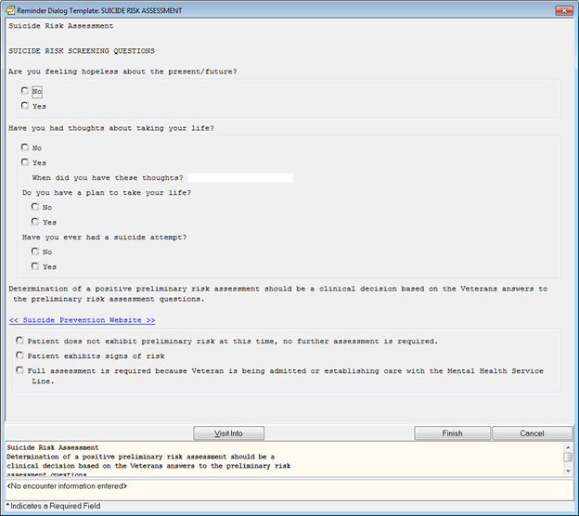

**Figure A.2. Reminder Dialog Template: Suicide Risk Assessment (Image 2 of 5)**

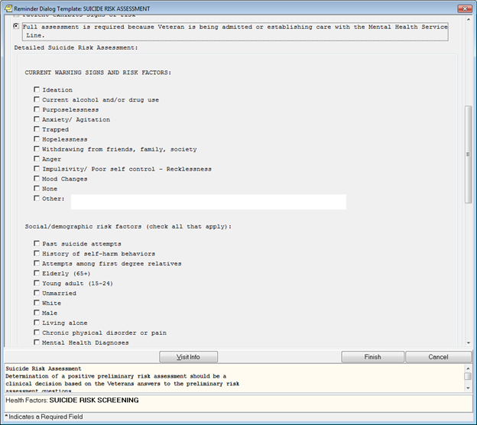

**Figure A.3. Reminder Dialog Template: Suicide Risk Assessment (Image 3 of 5)**

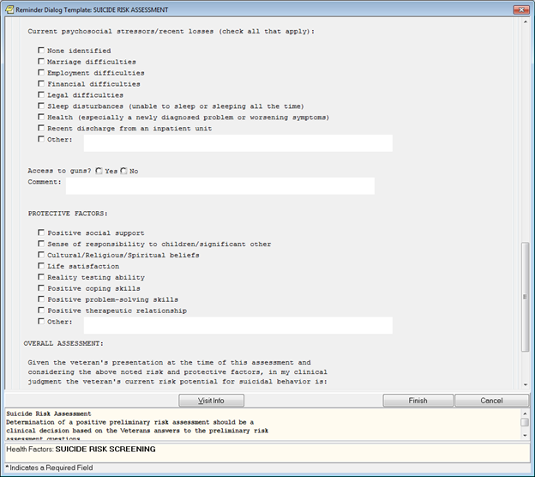

**Figure A.4. Reminder Dialog Template: Suicide Risk Assessment (Image 4 of 5)**

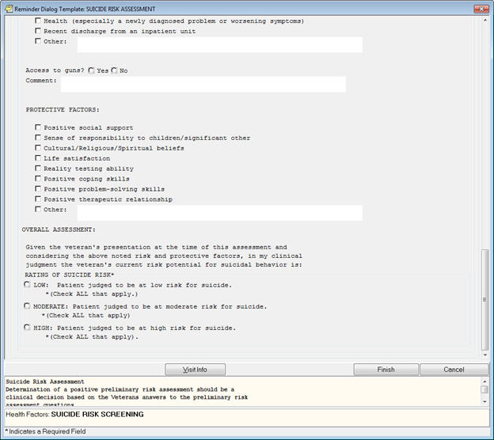

**Figure A.5. Reminder Dialog Template: Suicide Risk Assessment (Image 5 of 5)**

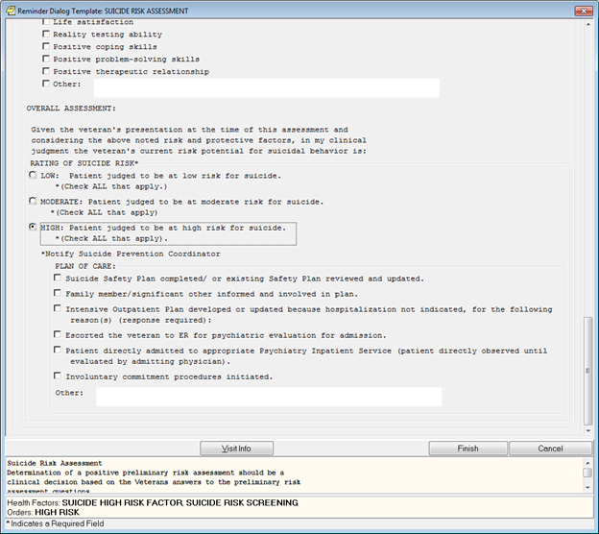

**Figure A.6. Template: MHC Same Day Operation Enduring Freedom/Operation Iraqi Freedom (OEF/OIF) Initial Screen Consult Note - Mental Health Impact Assessment (MHIA) (Image 1 of 6)**

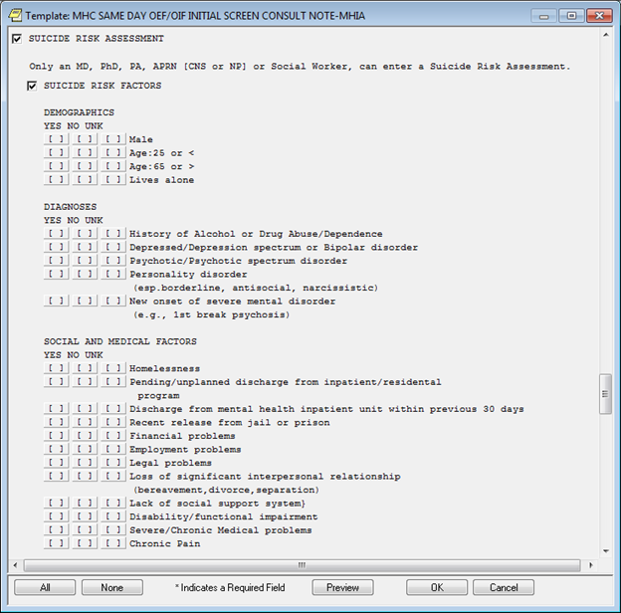

**Figure A.7. Template: MHC Same Day Operation Enduring Freedom/Operation Iraqi Freedom (OEF/OIF) Initial Screen Consult Note - Mental Health Impact Assessment (MHIA) (Image 2 of 6)**

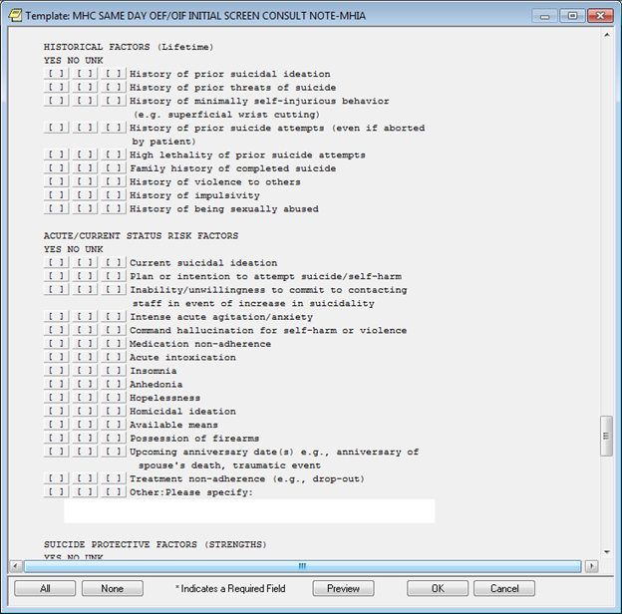

**Figure A.8. Template: MHC Same Day Operation Enduring Freedom/Operation Iraqi Freedom (OEF/OIF) Initial Screen Consult Note - Mental Health Impact Assessment (MHIA) (Image 3 of 6)**

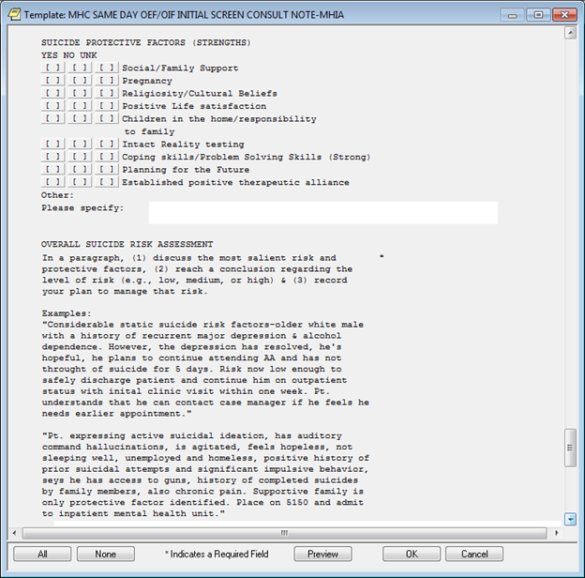

**Figure A.9. Template: MHC Same Day Operation Enduring Freedom/Operation Iraqi Freedom (OEF/OIF) Initial Screen Consult Note - Mental Health Impact Assessment (MHIA) (Image 4 of 6)**

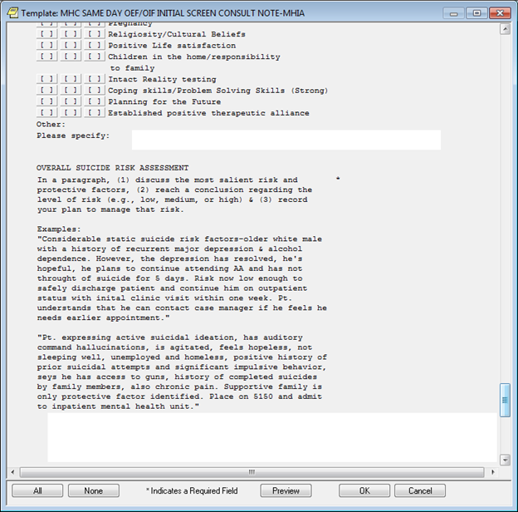

**Figure A.10. Template: MHC Same Day Operation Enduring Freedom/Operation Iraqi Freedom (OEF/OIF) Initial Screen Consult Note - Mental Health Impact Assessment (MHIA) (Image 5 of 6)**

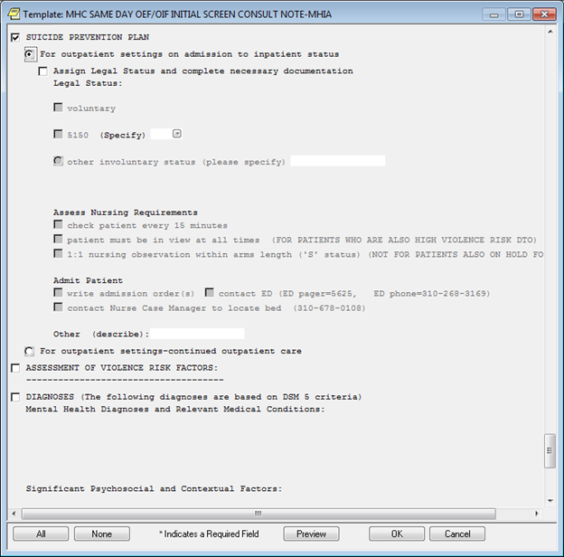

**Figure A.11. Template: MHC Same Day Operation Enduring Freedom/Operation Iraqi Freedom (OEF/OIF) Initial Screen Consult Note - Mental Health Impact Assessment (MHIA) (Image 6 of 6)**

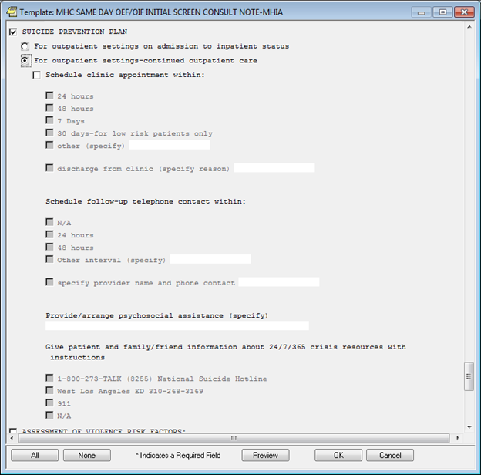

**Figure A.12 – Safety Plan (Image 1 of 20)**

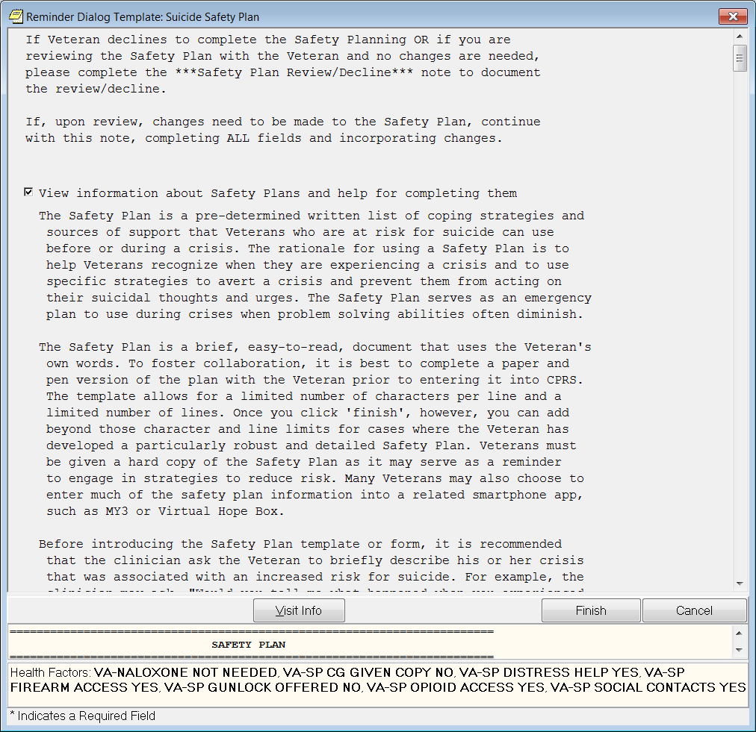

**Figure A.13 – Safety Plan (Image 2 of 20)**

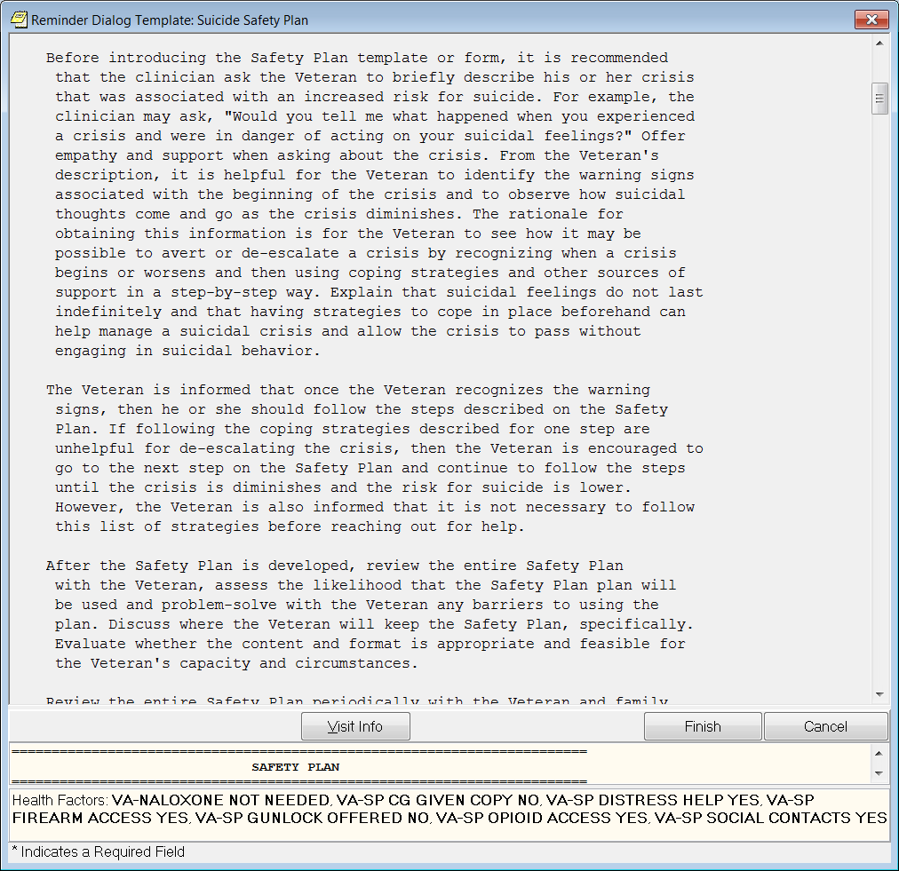

**Figure A.14 – Safety Plan (Image 3 of 20)**

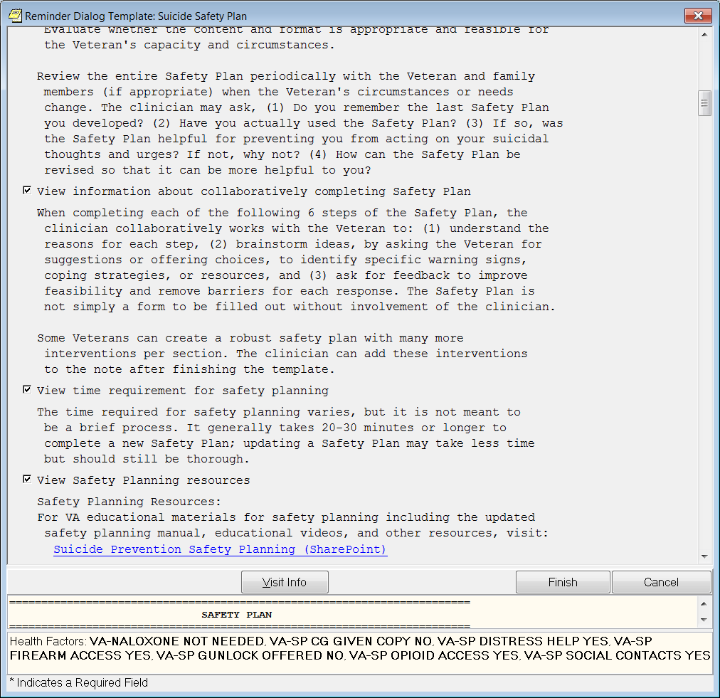

**Figure A.15 – Safety Plan (Image 4 of 20)**

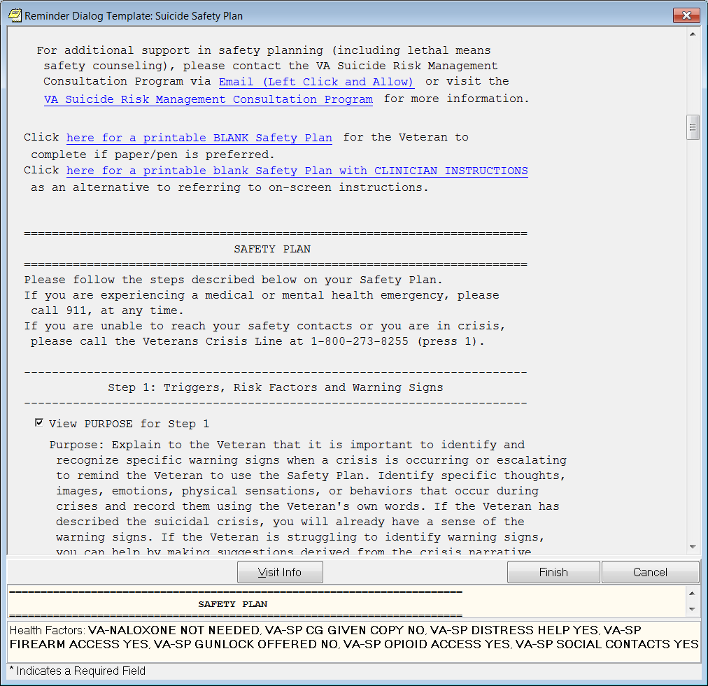

**Figure A.16 – Safety Plan (Image 5 of 20)**

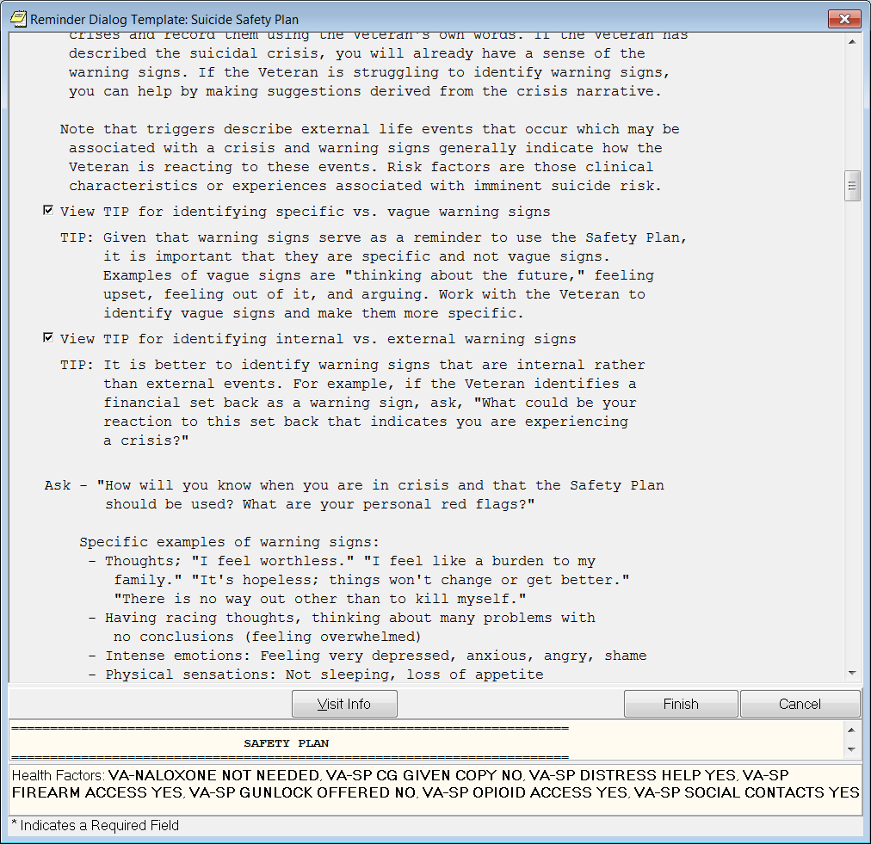

**Figure A.17 – Safety Plan (Image 6 of 20)**

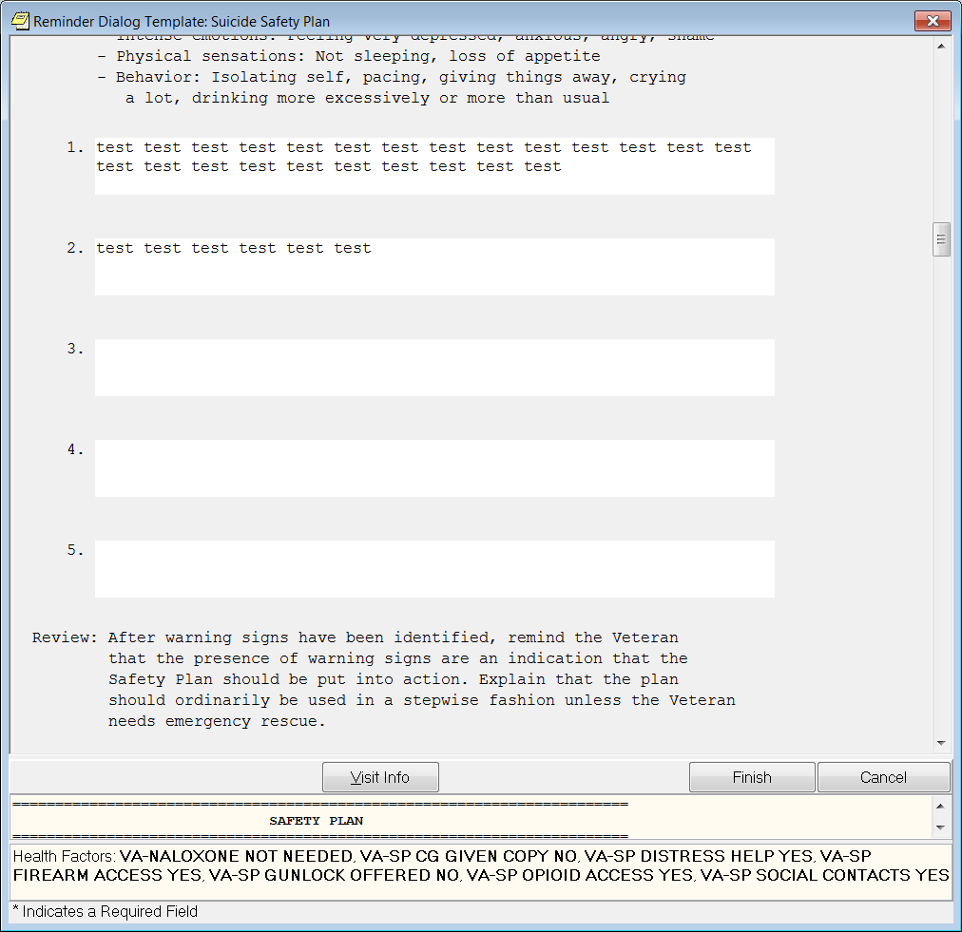

**Figure A.18 – Safety Plan (Image 7 of 20)**

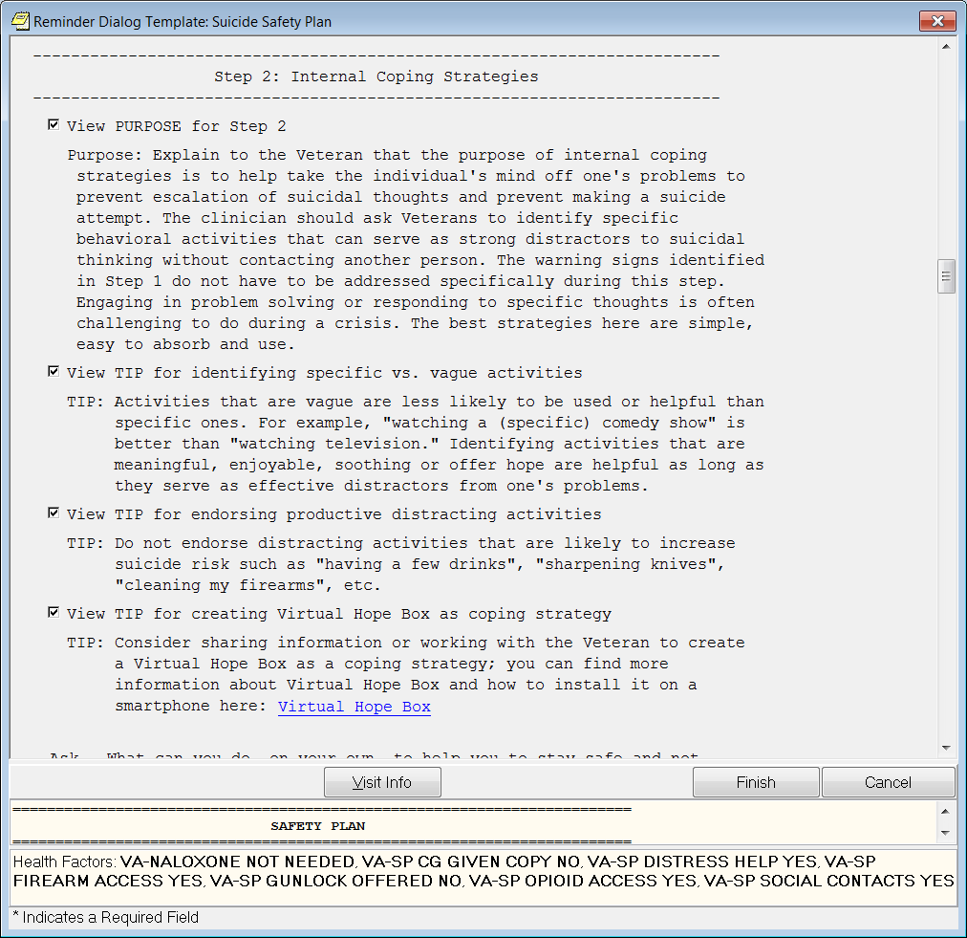

**Figure A.19 – Safety Plan (Image 8 of 20)**

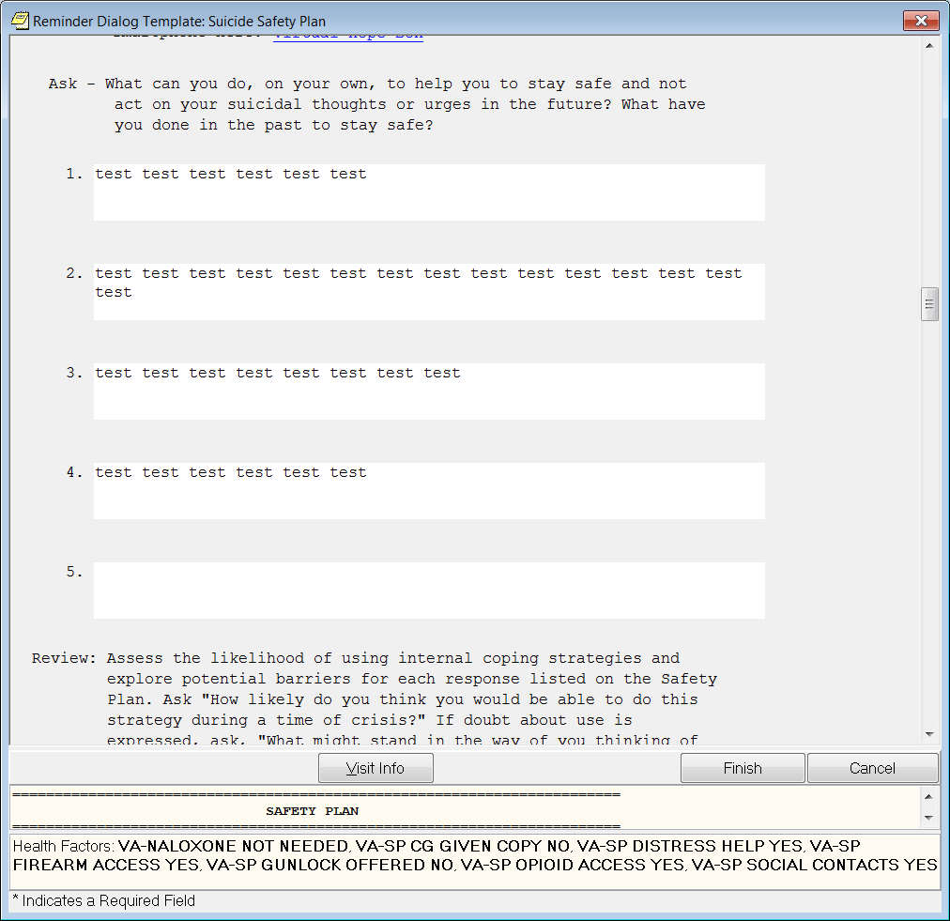

**Figure A.20 – Safety Plan (Image 9 of 20)**

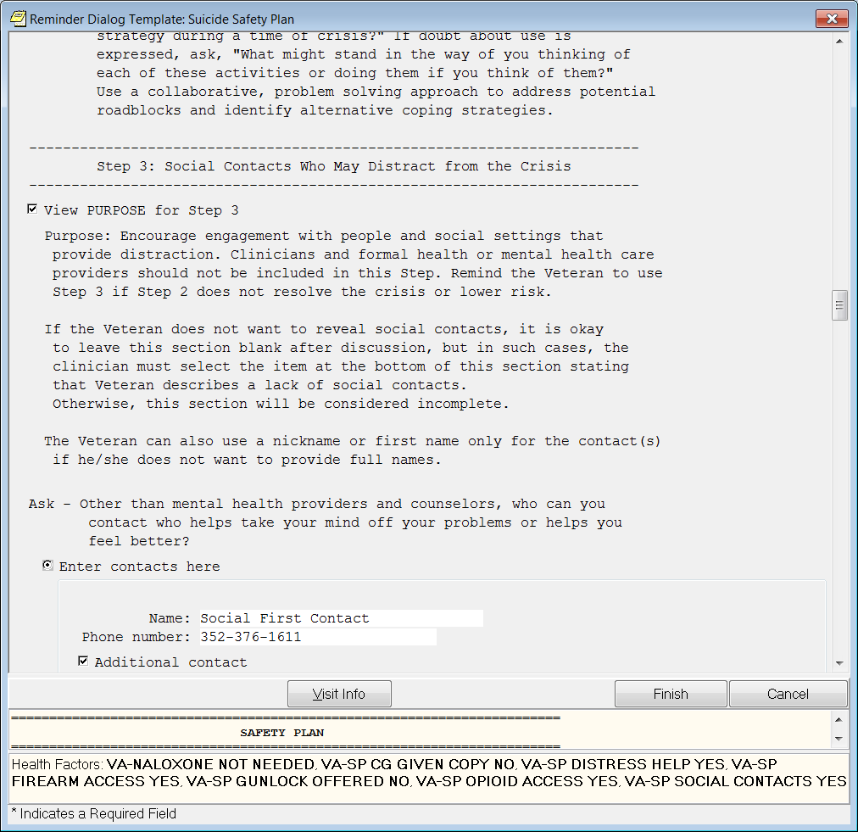

**Figure A.21 – Safety Plan (Image 10 of 20)**

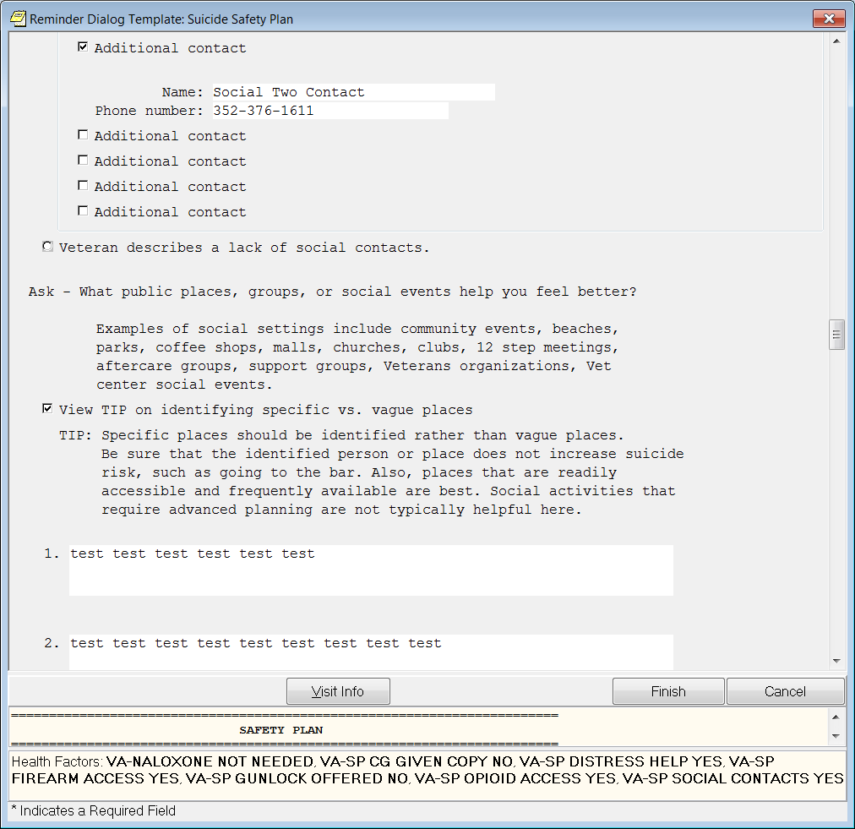

**Figure A.22 – Safety Plan (Image 11 of 20)**

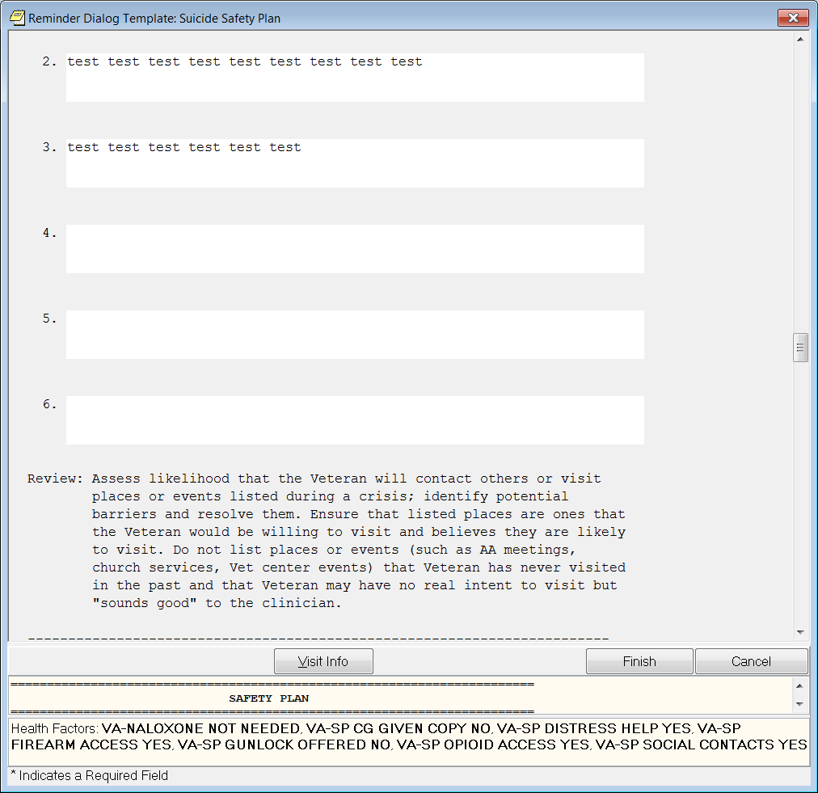

**Figure A.23 – Safety Plan (Image 12 of 20)**

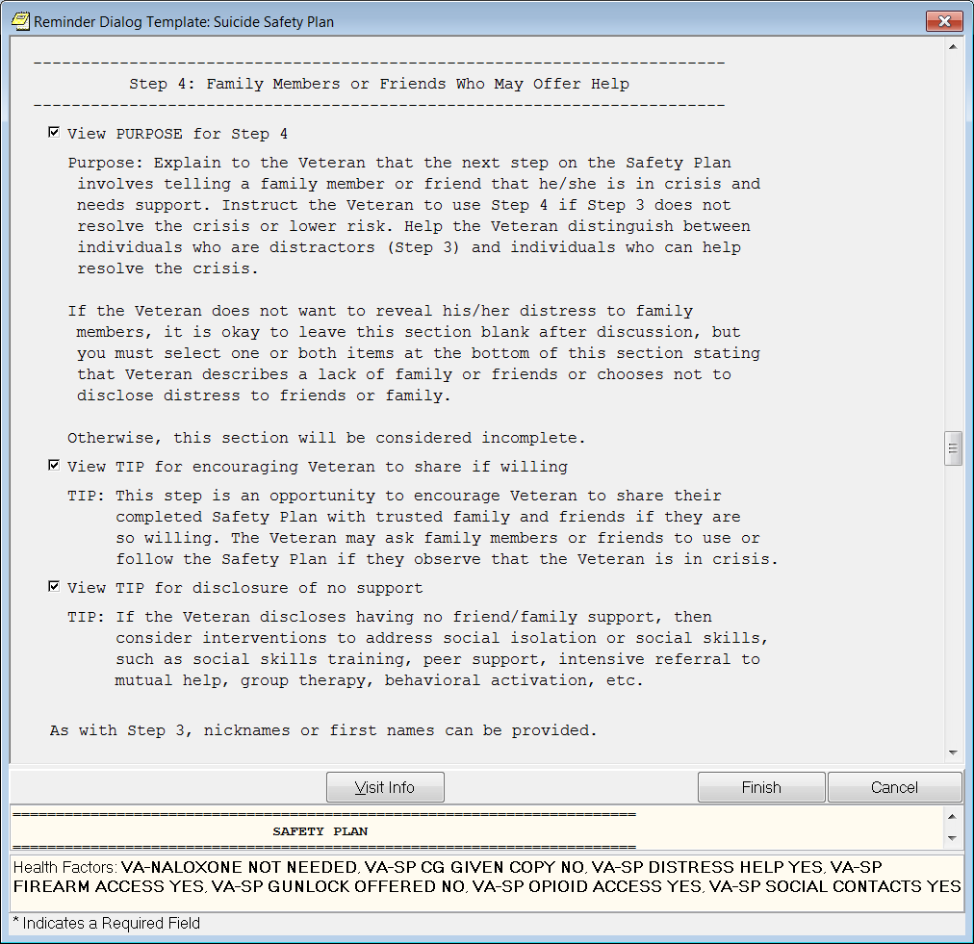

**Figure A.24 – Safety Plan (Image 13 of 20)**

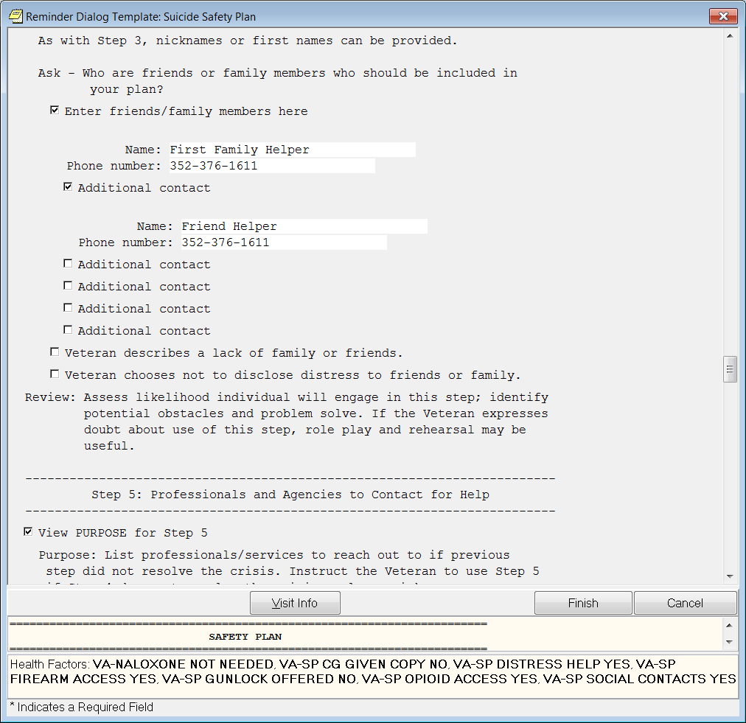

**Figure A.25 – Safety Plan (Image 14 of 20)**

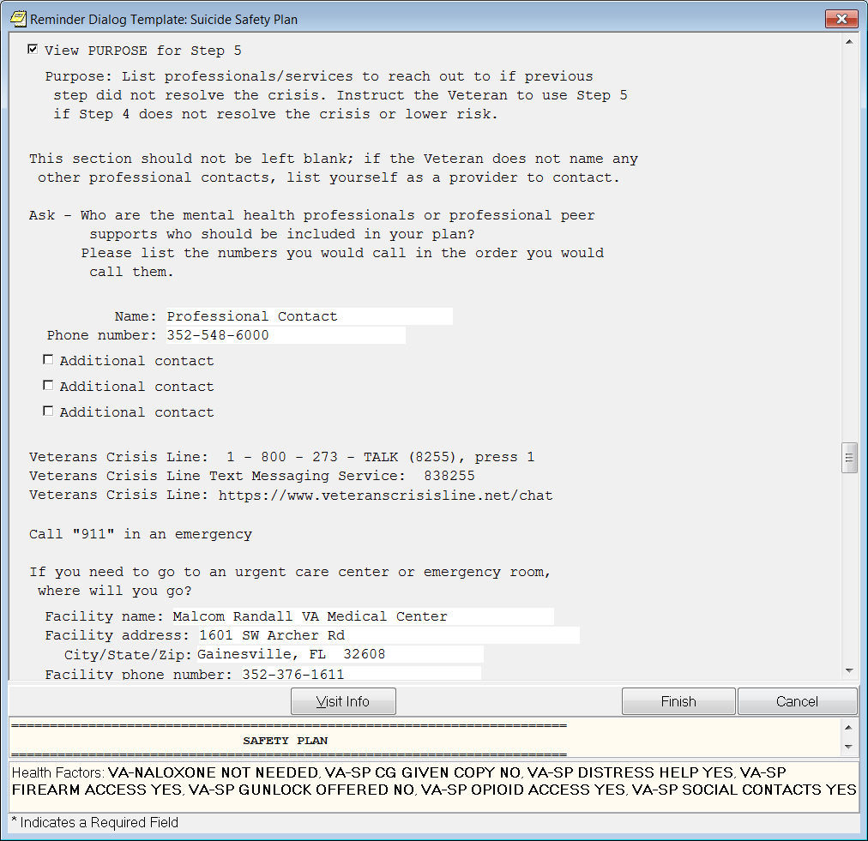

**Figure A.26 – Safety Plan (Image 15 of 20)**

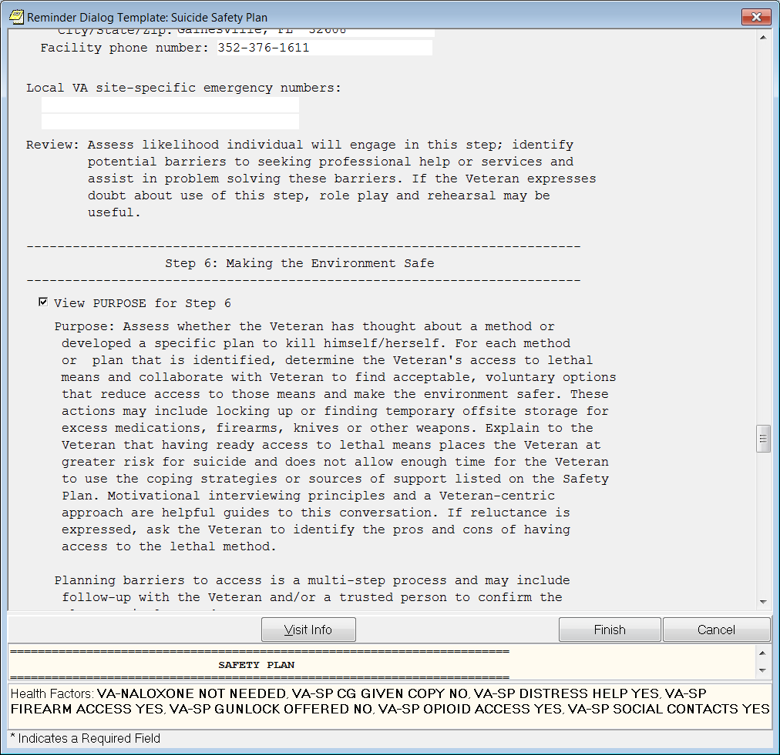

**Figure A.27 – Safety Plan (Image 16 of 20)**

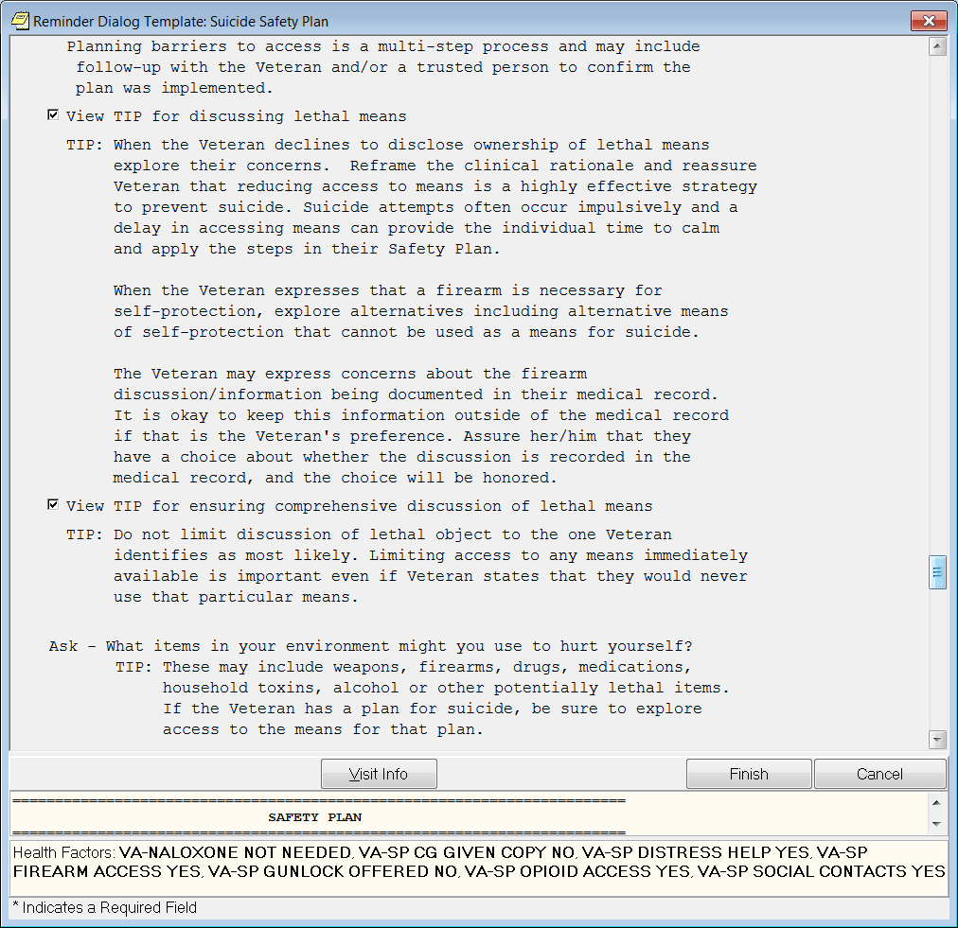

**Figure A.28 – Safety Plan (Image 17 of 20)**

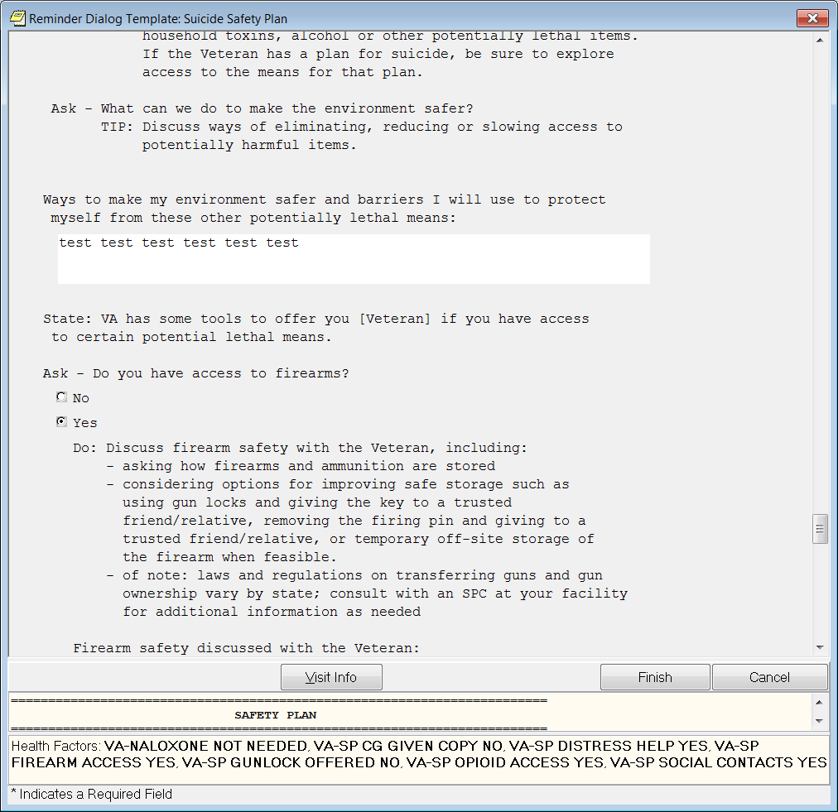

**Figure A.29 – Safety Plan (Image 18 of 20)**

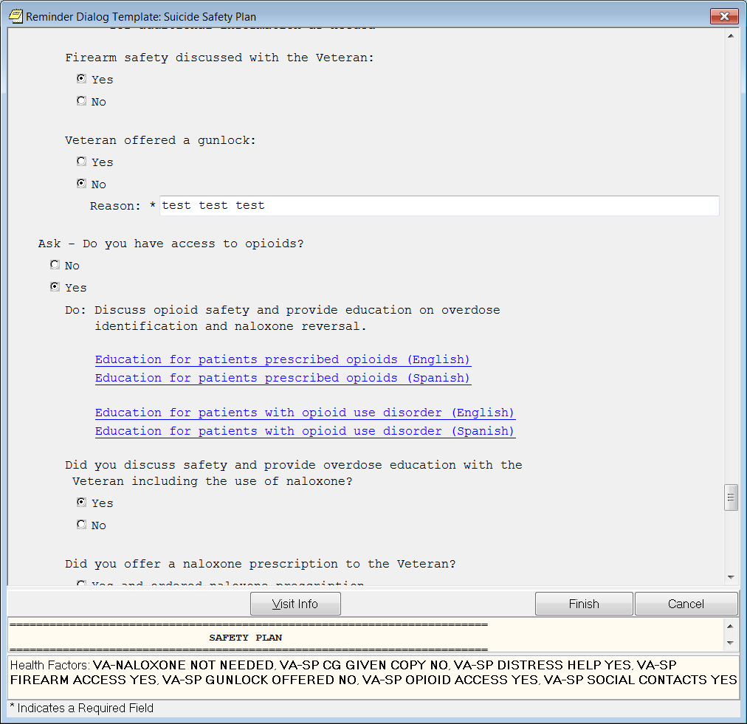

**Figure A.30 – Safety Plan (Image 19 of 20)**

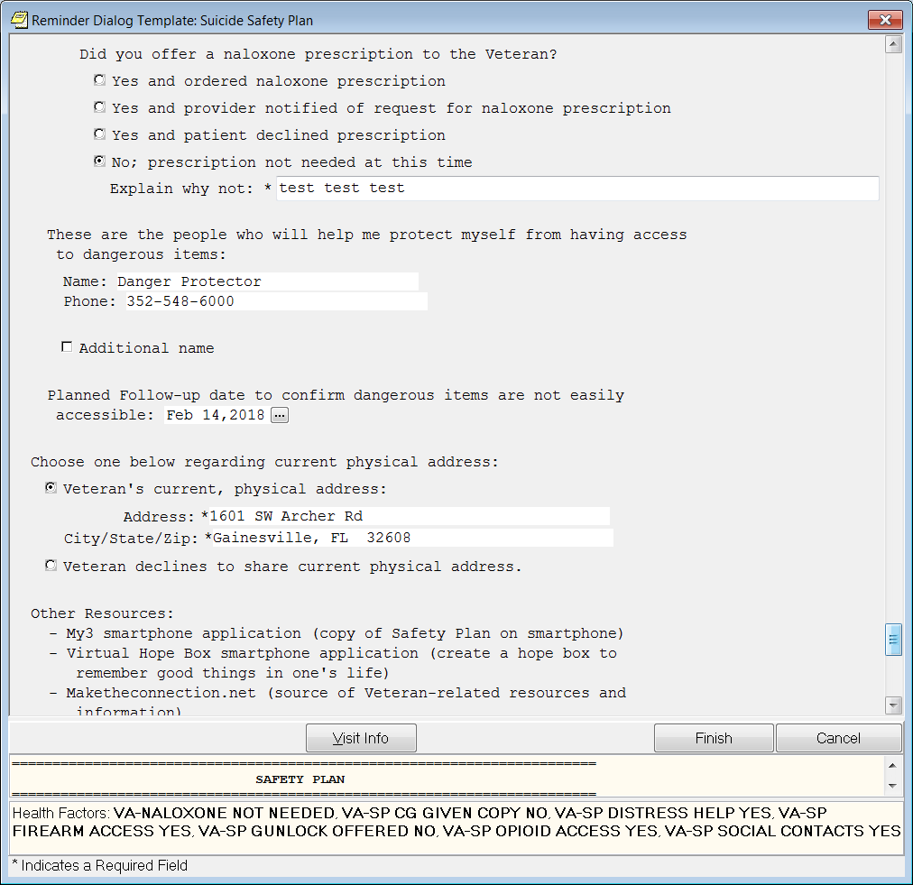

**Figure A.31 – Safety Plan (Image 20 of 20)**

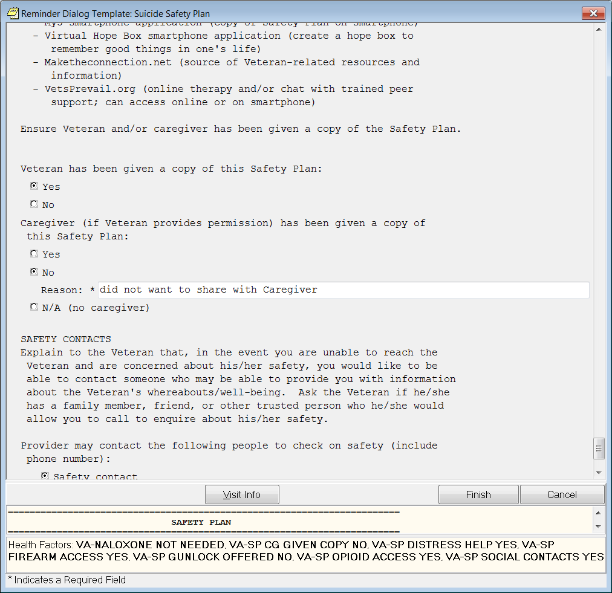

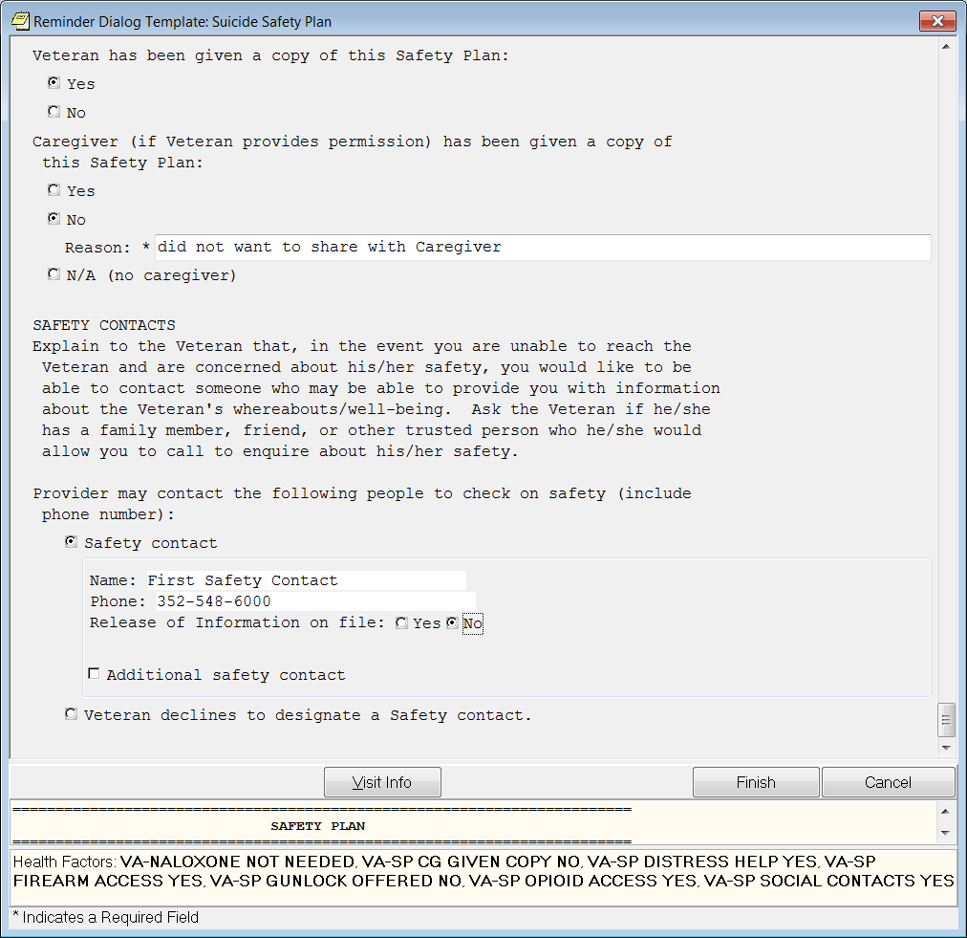

**A.1. Future Artifacts**

Note: Documents 1-3, and Figure 12 are draft future artifacts provided by Dr. Catherine Barry/Dr. Jodie Trafton as of 2018-03-08; they are expected to be available 2018-2019. They have not been included in the clinical content above, as they are not yet available enterprise-wide. It is recommended that they either be integrated into the clinical content in this paper once they are available to users, or in separate KNART(s) that are developed accordingly.

**A.1.1. Document 1 - DRAFT: VA Comprehensive Suicide Risk with options for New or Updating Existing Assessment**

**PLEASE NOTE:** We plan to turn each of the responses into Health Factors, so they can be easily pulled from CDW and used for aggregate analysis

**Is this a new assessment or an update to an existing assessment?**

* **New assessment**
* **Update to existing assessment**

**In what Setting is this Assessment Occurring?** *(Select only one response.) [Design note: originally we thought it best to remove this because it can be pulled from administrative data, but at the end of the template, we do have some specific strategies that should only display for MH Inpatient or MH Residential settings, so this may be useful to keep. Elizabeth G, I’m open to your suggestion here]*

* Emergency Department
* Primary Care
* PCMHI
* Other Outpatient Med/Surg
* Inpatient Med/Surg
* Psychiatric Emergency Services
* MH Outpatient
* MH Inpatient
* MH Residential/Domiciliary
* Other [text box]

**Suicidal Ideation**

**Does the Veteran have a history of or current suicidal ideation?**

* No [Design note: if no, skip the rest of the questions in this Suicide Ideation section]
* Yes

**How recently has the Veteran had thoughts of engaging in suicide-related behavior?** *(Select only one response.)*

* Within the last 24 hours
* within the past 1 to 7 days
* within the past 8 to 30 days
* within the past 2 to 6 months
* within the past 7 to 12 months
* More than a year ago (13 or more months ago)

**How frequent are/were the thoughts?** *(Select only one response.)*

* Less than once a week
* Once a week
* 2-5 times a week
* Daily or almost daily
* Many times each day

**Does/did the Veteran have a plan?** *(Select only one response.)*

* No
* Yes – Describe [add text box]

**Does the Veteran have access to lethal means to enact the plan described above?** *(Select only one response.)*

* No
* Yes – Describe [add text box]

**Does the Veteran have access to other lethal means?** *(Select only one response.)*

* No
* Yes – Describe [add text box]

**Does/did the Veteran have suicidal intent?** *(Select only one response.)*

*Suicidal intent: There is past or present evidence (implicit or explicit) that an individual wishes to die, means to kill him/herself, and understands the probable consequences of his/her actions or potential actions. Suicidal intent can be determined retrospectively and in the absence of suicidal behavior.*

* No
* Yes

**History of Suicide Attempts**

**[Design note: If a ‘New Assessment’] Has the Veteran ever made a prior suicide attempt?** *(Select only one response.)*

*Suicide Attempt: A non-fatal self-inflicted potentially injurious behavior with any intent to die as a result of the behavior.*

* No
* Yes

**[Design note: If a ‘New Assessment’] If yes, how many suicide attempts has the Veteran made?** *(Select only one response.)*

[drop down list with a selection for each number from 1 to 10; then a ‘11+’ response]

**[Design note: If an ‘Update to existing Assessment’] Has the Veteran made a suicide attempt since the last documented VA Comprehensive Suicide Risk Assessment? (CSRA; xx/xx/xxxx) [Design note: pull in the date of the last CSRA here]**

*Suicide Attempt: A non-fatal self-inflicted potentially injurious behavior with any intent to die as a result of the behavior.*

* No [Design note: If ‘no’, this section is complete]
* Yes

**[Design note: If an ‘Update to existing Assessment’] If yes, how many suicide attempts has the Veteran made since the last CSRA?** *(Select only one response.)*

[drop down list with a selection for each number from 1 to 10; then a ‘11+’ response]

**When was the most recent attempt?** *(Select only one response.)*

* Within the last 24 hours
* within the past 1 to 7 days
* within the past 8 to 30 days
* within the past 2 to 6 months
* within the past 7 to 12 months
* More than a year ago (13 or more months ago)

**What was the method/were the methods used for this event?** *(Select all that apply.)*

* **Overdose** *(Select all that apply.)*

[design note: expand to the items below only if Overdose is selected]

* Alcohol
* What type of alcohol did the Veteran drink? (Select all that apply)
* Beer
* Wine
* Liquor
* How many drinks did the Veteran have?
* Amphetamine/other psychostimulants
* How much did the Veteran take (e.g, # of pills, mg)?
* *[add text box]*

[Design note: I’m trying to determine if it makes sense to add option to select ‘mg’ or ‘# pills’ to ensure we know what measurement the responder means; also if there are other standard measures to offer as an option]

* Barbiturates
* How much did the Veteran take (e.g, # of pills, mg)?
* Benzodiazepine
* How much did the Veteran take (e.g, # of pills, mg)?
* Cocaine
* How much did the Veteran take (e.g, # of pills, mg)
* Fentanyl
* How much did the Veteran take (e.g, # of pills, mg)?
* Heroin
* How much did the Veteran take (e.g, # of pills, mg)?
* Lithium
* How much did the Veteran take (e.g, # of pills, mg)?
* Methadone
* How much did the Veteran take (e.g, # of pills, mg)?
* Pills (NOS)
* How much did the Veteran take (e.g, # of pills, mg)?
* Rx Meds
* How much did the Veteran take (e.g, # of pills, mg)?
* Suboxone, Subutex, Buprenorphine
* How much did the Veteran take (e.g, # of pills, mg)?
* Tylenol
* How much did the Veteran take (e.g, # of pills, mg)?
* Opioids other than listed above
* How much did the Veteran take (e.g, # of pills, mg)?
* Other (NOS), describe [add text box]
* How much did the Veteran take (e.g, # of pills, mg)?
* **Physical Injury**  *(Select all that apply.)*

[design note: expand to the items below only if Physical Injury is selected]

* Attempted Drowning
* Where did this occur?
* Bathtub
* Bucket
* Swimming pool
* Natural body of water
* How far from shore or safety was the Veteran (in feet)?

*(Round to nearest foot and enter as a whole number e.g. 1, 25, 52, 1000 etc.)*

* *[add text box] Feet*
* Was the water?
* warm
* cold
* Can the Veteran swim?
* Yes
* No
* Other
* Electrocution
* What was used?
* Wall outlet
* Light socket
* Home electrical wire
* Utility wire
* Other [add text box]
* Where on the body?
* Wrists/arms
* Torso
* Legs
* Other [add text box]
* Ingest Poison/Chemical/Caustic Substance
* What type of substance was ingested?
* Rat poison
* Bleach
* Ammonia
* Other [add text box]
* How much was ingested (in mL or ounces)?
* Hanging
* What was used?
* String
* Rope
* Sheet
* Belt/strap
* Towel
* Other
* Jump from Height
* On what did the Veteran land?
* Solid ground
* Water
* Other [add text box]
* From how high did the Veteran jump (in feet)?
* [Add text box] Feet
* Jump in front of Auto/Train
* Was the Veteran struck or did the vehicle stop before hitting the Veteran?
* Struck
* Not struck
* Burnt Self
* Was caused the burn?
* Cigarette
* Lighter/match
* Oven/stove
* Curling iron/flat iron
* Candle
* Boiling water
* Other [add text box]
* Where on the body was burned?
* Wrists/arms
* Torso
* Legs
* Other [add text box]
* Were you able to verify the injuries by seeing scars?
* Yes
* No
* Stabbed/Cut Self
* Where on the body was cut?
* Head
* Neck
* Torso
* Arms
* Wrists
* Legs
* Other [add text box]
* What was used?
* Razor
* Kitchen knife
* Box cutter
* Scissors
* Other [add text box]
* How severe was the cut?
* Scratch
* Cut(s) with no tendon, artery or nerve damage
* Cut(s) with tendon, artery or nerve damage
* Were stitches required?
* If so, how many?
* Were you able to verify the injuries by seeing scars?
* Yes
* No
* Suffocation
* What was used?
* Carbon monoxide
* Plastic bag
* Pillow
* Other [add text box]
* Stopped required medical treatments or medications
* What did the Veteran stop?
* Needed medical treatment(s)
* Medication(s)
* Other [add text box]
* For how long was treatment/medication stopped (hours/days)?
* [add text box] [add option to select ‘hours’ or ‘days’]
* Other, describe [add text box]
* **Firearm**  *(Select all that apply.)*

[design note: expand to the items below only if Gun is selected]

* What kind of firearm did the Veteran use?
* BB gun
* Pistol
* Rifle
* Shot gun
* Dart gun
* Other [add text box]
* Where did the Veteran shoot themselves? (Select all that apply)
* Head
* Chest
* Lower torso
* Limbs
* Other [add text box]
* Were you able to verify the injuries by seeing scars?
* Yes
* No
* **Auto** *(Select all that apply.)*

[design note: expand to the items below only if Auto is selected]

* Run into Object
* Run off Road
* Other (NOS), describe [add text box]
* **Other method used**  *(Select all that apply.)*

[design note: expand to the items below only if Other is selected]

* Other (NOS), describe [add text box]

*Obtain details of the attempt (extent of injuries, methods used, etc.)*

* Not Provided

**As a result of this attempt, was the Veteran taken to any of these places or did Veteran seek help at any of these places?**

* Physician/nurse
* Without treatment or assessment and went home
* Medically treated and went home
* Medical treated and admitted to psychiatry unit
* Crisis outreach/after-hours team/mental health professional
* Police/wellness check
* Paramedics/ambulance/aid car
* Hospital emergency room
* Without assessment (e.g., talked to social worker or resident and went home)
* Without medical treatment
* Medically treated and went home
* Medically treated and admitted to psychiatry unit
* Inpatient, psychiatric unit
* For how many days?
* Was the visit voluntary?
* Yes, voluntary
* Voluntary, but threatened with legal commitment if not agreed to
* Legally detained on a 24-48 hour hold
* Legally detained on a 72+ hour hold
* Medically treated while on inpatient psychiatric unit, without going to emergency room
* While on psychiatric unit, went to emergency room for medical treatment and then returned to psychiatric unit
* Hospital medical unit, whether or not via emergency room, for observation (hours to overnight)
* Hospital medical unit, whether or not via emergency room, for required treatment
* For how many days?
* Intensive care unit, whether or not via emergency room or medical unit
* For how many days?

**Was the suicide attempt interrupted?** *(Select only one response.)*

* No
* Yes, by self. Explain: [add text box]
* Yes, by other. Explain: [add text box]

**Did the attempt result in injury?** *(Select only one response.)*

* No
* Yes. Explain: [add text box]

**When was the most lethal attempt?** *(Select only one response.)*

* Within the last 24 hours
* within the past 1 to 7 days
* within the past 8 to 30 days
* within the past 2 to 6 months
* within the past 7 to 12 months
* More than a year ago (13 or more months ago)

**What was the method/were the methods used for this event?** *(Select all that apply.)*

* **Overdose** *(Select all that apply.)*

[design note: expand to the items below only if Overdose is selected]

* Alcohol
* What type of alcohol did the Veteran drink? (Select all that apply)
* Beer
* Wine
* Liquor
* How many drinks did the Veteran have?
* Amphetamine/other psychostimulants
* How much did the Veteran take (e.g, # of pills, mg)?
* *[add text box]*

[Design note: I’m trying to determine if it makes sense to add option to select ‘mg’ or ‘# pills’ to ensure we know what measurement the responder means; also if there are other standard measures to offer as an option]

* Barbiturates
* How much did the Veteran take (e.g, # of pills, mg)?
* Benzodiazepine
* How much did the Veteran take (e.g, # of pills, mg)?
* Cocaine
* How much did the Veteran take (e.g, # of pills, mg)
* Fentanyl
* How much did the Veteran take (e.g, # of pills, mg)?
* Heroin
* How much did the Veteran take (e.g, # of pills, mg)?
* Lithium
* How much did the Veteran take (e.g, # of pills, mg)?
* Methadone
* How much did the Veteran take (e.g, # of pills, mg)?
* Pills (NOS)
* How much did the Veteran take (e.g, # of pills, mg)?
* Rx Meds
* How much did the Veteran take (e.g, # of pills, mg)?
* Suboxone, Subutex, Buprenorphine
* How much did the Veteran take (e.g, # of pills, mg)?
* Tylenol
* How much did the Veteran take (e.g, # of pills, mg)?
* Opioids other than listed above
* How much did the Veteran take (e.g, # of pills, mg)?
* Other (NOS), describe [add text box]
* How much did the Veteran take (e.g, # of pills, mg)?
* **Physical Injury**  *(Select all that apply.)*

[design note: expand to the items below only if Physical Injury is selected]

* Attempted Drowning
* Where did this occur?
* Bathtub
* Bucket
* Swimming pool
* Natural body of water
* How far from shore or safety was the Veteran (in feet)? *(Round to nearest foot and enter as a whole number e.g. 1, 25, 52, 1000 etc.)*
* *[add text box] Feet*
* Was the water?
* warm
* cold
* Can the Veteran swim?
* Yes
* No
* Other
* Electrocution
* What was used?
* Wall outlet
* Light socket
* Home electrical wire
* Utility wire
* Other [add text box]
* Where on the body?
* Wrists/arms
* Torso
* Legs
* Other [add text box]
* Ingest Poison/Chemical/Caustic Substance
* What type of substance was ingested?
* Rat poison
* Bleach
* Ammonia
* Other [add text box]
* How much was ingested (in mL or ounces)?
* Hanging
* What was used?
* String
* Rope
* Sheet
* Belt/strap
* Towel
* Other
* Jump from Height
* On what did the Veteran land?
* Solid ground
* Water
* Other [add text box]
* From how high did the Veteran jump (in feet)?
* *[add text box] Feet*
* Jump in front of Auto/Train
* Was the Veteran struck or did the vehicle stop before hitting the Veteran?
* Struck
* Not struck
* Burnt Self
* Was caused the burn?
* Cigarette
* Lighter/match
* Oven/stove
* Curling iron/flat iron
* Candle
* Boiling water
* Other [add text box]
* Where on the body was burned?
* Wrists/arms
* Torso
* Legs
* Other [add text box]
* Were you able to verify the injuries by seeing scars?
* Yes
* No
* Stabbed/Cut Self
* Where on the body was cut?
* Head
* Neck
* Torso
* Arms
* Wrists
* Legs
* Other [add text box]
* What was used?
* Razor
* Kitchen knife
* Box cutter
* Scissors
* Other [add text box]
* How severe was the cut?
* Scratch
* Cut(s) with no tendon, artery or nerve damage
* Cut(s) with tendon, artery or nerve damage
* Were stitches required?
* If so, how many?
* Were you able to verify the injuries by seeing scars?
* Yes
* No
* Suffocation
* What was used?
* Carbon monoxide
* Plastic bag
* Pillow
* Other [add text box]
* Stopped required medical treatments or medications
* What did the Veteran stop?
* Needed medical treatment(s)
* Medication(s)
* Other [add text box]
* For how long was treatment/medication stopped (hours/days)?
* [add text box] [add option to select ‘hours’ or ‘days’]
* Other, describe [add text box]
* **Firearm**  *(Select all that apply.)*

[design note: expand to the items below only if Gun is selected]

* Attempted to induce police into shooting her/him [Design note: if selected this option by itself, do not show the other ‘firearm questions’]
* What kind of firearm did the Veteran use?
* BB gun
* Pistol
* Rifle
* Shot gun
* Dart gun
* Other [add text box]
* Where did the Veteran shoot themselves? (Select all that apply)
* Head
* Chest
* Lower torso
* Limbs
* Other [add text box]
* Were you able to verify the injuries by seeing scars?
* Yes
* No
* **Auto** *(Select all that apply.)*

[design note: expand to the items below only if Auto is selected]

* Run into Object
* Run off Road
* Other (NOS), describe [add text box]
* **Other method used**  *(Select all that apply.)*

[design note: expand to the items below only if Other is selected]

* Other (NOS), describe [add text box]

*Obtain details of the attempt (extent of injuries, methods used, etc.)*

* Not Provided

**As a result of this attempt, was the Veteran taken to any of these places or did Veteran seek help at any of these places?**

* Physician/nurse
* Without treatment or assessment and went home
* Medically treated and went home
* Medical treated and admitted to psychiatry unit
* Crisis outreach/after-hours team/mental health professional
* Police/wellness check
* Paramedics/ambulance/aid car
* Hospital emergency room
* Without assessment (e.g., talked to social worker or resident and went home)
* Without medical treatment
* Medically treated and went home
* Medically treated and admitted to psychiatry unit
* Inpatient, psychiatric unit
* For how many days?
* Was the visit voluntary?
* Yes, voluntary
* Voluntary, but threatened with legal commitment if not agreed to
* Legally detained on a 24-48 hour hold
* Legally detained on a 72+ hour hold
* Medically treated while on inpatient psychiatric unit, without going to emergency room
* While on psychiatric unit, went to emergency room for medical treatment and then returned to psychiatric unit
* Hospital medical unit, whether or not via emergency room, for observation (hours to overnight)
* Hospital medical unit, whether or not via emergency room, for required treatment
* For how many days?
* Intensive care unit, whether or not via emergency room or medical unit
* For how many days?

**Was the suicide attempt interrupted?** *(Select only one response.)*

* No
* Yes, by self. Explain: [add text box]
* Yes, by other. Explain: [add text box]

**Did the attempt result in injury?** *(Select only one response.)*

* No
* Yes. Explain: [add text box]

**Has the Veteran engaged in any preparatory behavior aside from behavior associated with any suicide attempts documented above?** *(Select only one response.)*

*Preparatory Behavior: Acts or preparation towards engaging in Self-Directed Violence, but before potential for injury has begun. Note: ask this question about preparatory behavior of all Veterans, even in cases where there has never been a suicide attempt.*

* No
* Yes. Explain: [add text box]

**Warning Signs**

*Warning Signs: Individual factors which signal an acute increase in risk that the patient may engage in suicidal behavior in the immediate future (i.e., minutes and days). These can be assessed by asking the Veteran to describe thoughts, feelings, and behaviors experienced prior to most recent exacerbation of suicidal ideation or behavior. This information can inform safety planning, if indicated.*

**[Design note: If an ‘Update to existing Assessment’]** Are updates to this section needed? [Design note: Hide remaining questions in this section until a response is given]

* No [Design note: If ‘no’ skip the rest of the questions in this warnings signs section]
* Yes

**Direct:**

* **N/A**

[design note: if select N/A, cannot choose the other items]

* **Select direct warning signs:**

*(Select all that apply.)*

* Suicidal Communication
* Preparations for Suicide
* Seeking Access or Recent Use of Lethal Means
* Other/Comments: [add text box]

**Indirect:**

* **N/A**

[design note: if select N/A, cannot choose anything else ]

* **Select indirect warning signs** *(Select all that apply.)*
* Anger
* Anxiety
* Feeling trapped
* Guilt or shame
* Hopelessness
* Mood changes
* Purposelessness
* Recklessness
* Sleep disturbance
* Social withdrawal
* Substance abuse
* Other/Comments: [add text box]

**[check box 1]** Risk and protective factors have been collected previously for this individual

**[check box 2]** I have reviewed risk and protective factors previously collected for this individual

**Risk Factors**

*Risk factors may increase the likelihood of engaging in suicidal self-directed violence. They may be modifiable or non-modifiable and both inform the formulation of risk for suicide. Modifiable risk factors may also be targets of intervention.*

**[Design note: If an ‘Update to existing Assessment’]** Are updates to this section needed? [Design note: Hide remaining questions in this section until a response is given]

* No [Design note: If ‘no’ skip the rest of the questions in this warnings signs section]
* Yes

*(Select all that apply.)*

* History of Suicide Attempt(s)
* Additional comments[add text box]
* History of Psychiatric Hospitalization(s): (Please include dates, reasons for hospitalization and duration of stay in the additional comments section.)
* Additional comments [add text box]
* History of non-suicidal self-directed violence (e.g., cutting, burning)
* Additional comments[add text box]
* Preexisting Risk Factors (e.g., history of trauma, family history of suicide attempt)
* Additional comments[add text box]
* Losses (e.g., loss of a loved one or relationship)
* Additional comments[add text box]
* Financial Problems (e.g., unemployment, homelessness)
* Additional comments[add text box]
* Legal Problems (e.g., DUI, incarceration, civil vs. criminal)
* Additional comments[add text box]
* Social/Systemic Problems (e.g., poor interpersonal relationships, barriers to accessing care, recent change in level of care)
* Additional comments [add text box]
* Psychological Conditions (e.g., mood or affective disorder, personality disorder, substance use disorder, psychosis)
* Additional comments [add text box]
* Medical Conditions and Health-Related Problems (e.g., TBI, HIV/AIDS, insomnia, chronic pain)
* Additional comments [add text box]
* Access to Lethal Means (e.g., firearms, large quantities of medications)
* Additional comments [add text box]
* Other: [add text box]
* Additional comments [add text box]

**Protective Factors and Reasons for Living**

*Protective factors are capabilities, qualities, environmental and personal resources that drive individual toward growth, stability, and health and may reduce the risk for suicide. Enhancing protective factors can be a target of intervention.*

**[Design note: If an ‘Update to existing Assessment’]** Are updates to this section needed? [Design note: Hide remaining questions in this section until a response is given]

* No [Design note: If ‘no’ skip the rest of the questions in this warnings signs section]
* Yes

*(Select all that apply.)*

* Interpersonal Relationship (e.g., child-related responsibilities, strong bond to family members)
* Additional comments [add text box]
* Positive Personal Traits or Beliefs (e.g., help seeking, religious or cultural beliefs against suicide, cognitive flexibility)
* Additional comments [add text box]
* Access To and Engagement With Health Care (e.g., supportive medical and mental health care relationships; motivated for treatment)
* Additional comments [add text box]
* Social Context Support System:(e.g., community support, family responsibilities)
* Additional comments [add text box]
* Other: [add text box]

**[clickable] TIP: Clinical Impressions:**

**Clinical Impressions**

Stratify the Veteran’s acute (minutes to days) and chronic (long-term) risk to inform disposition planning. Provide evidence for the acute and chronic risk levels, utilizing information documented above, and pay particular attention to the presence of warning signs and risk and protective factors. In some circumstances (e.g., acute intoxication) acute and/or chronic risk may be difficult to determine. In these cases, consider a high acute risk level and detail the relevant circumstance in evidence section provided.

**Clinical Impression of Acute Risk**: *(Select only one.) [Design note: this section is required]*

* High Risk - (as evidenced by): [add text box]
* Intermediate Risk – (as evidenced by): [add text box]
* Low Risk – (as evidenced by): [add text box]

**[clickable] TIP: Acute Risk Levels [opening the tip displays the box below]**

**Acute Risk Levels**:

**High Acute Risk Essential Features**: Suicidal ideation with intent to die by suicide and inability to maintain safety independent external support/help.

Note: Warning signs and risk factors that may also be present include: plan; access to means; recent (e.g., 90 days) or ongoing preparatory behaviors and/or suicide attempt; acute psychological condition(s) or symptom(s) (e.g., MDD episode, acute mania, acute psychosis, recent/current drug relapse, exacerbation of personality disorder symptomatology); acute psychosocial stressors (e.g., job loss, relationship with dissolution, relapse on alcohol); insufficient protective factors and inability to identify reasons for living.

**Intermediate Acute Risk Essential Features**: Current suicidal ideation without intent and ability to maintain safety independent of external support/help.

Note: These individuals may present quite similarly to those at high acute risk, often sharing many of the above features (e.g., warning signs, risk factors, limited protective factors). The only difference may be lack of intent, based upon identified reasons for living (e.g., children), meaningful protective factors (e.g., faith), and an ability to utilize a safety plan and maintain their own safety. Preparatory behaviors are likely to be absent.

**Low Acute Risk Essential Features**: No current suicidal intent AND no suicidal plan AND no preparatory behaviors AND collective high confidence (e.g., patient, care provider, family member) in the ability of the patient to independently maintain safety.

Note: Individuals at low acute risk may have suicidal ideation, but it will be without intent or plan. If a plan is present, the plan is general and/or vague, and without any associated preparatory behaviors (e.g., "I'd shoot myself if things got bad enough, but I don't have a gun."). These patients will be capable of engaging appropriate coping strategies and willing and able to utilize a safety plan in the event of heightened intent.

**Clinical Impression of Chronic Risk**: *(Select only one.) [Design note: this section is required]*

* High Risk - (as evidenced by): [add text box]
* Intermediate Risk – (as evidenced by): [add text box]
* Low Risk – (as evidenced by): [add text box]

**[clickable] TIP: Chronic Risk Levels [opening the tip displays the box below]**

**Chronic Risk Levels**:

**High Chronic Risk Essential Features**: Chronic psychological conditions; history of prior suicide attempt(s); history of substance abuse/dependence; chronic pain; chronic suicidal ideation; chronic medical condition; limited coping skills; unstable or turbulent psychosocial status (e.g., unstable housing, erratic relationships, marginal employment); limited ability to identify reasons for living.

**Intermediate Chronic Risk Essential Features**: These individuals may feature similar chronicity of psychiatric, substance-abuse, medical, and painful conditions. However, protective factors, coping skills, reasons for living, and relative psychosocial stability suggest a fairly enhanced ability to endure future crisis without resorting to self-directed violence and/or suicide.

**Low Chronic Risk Essential Features**: These individuals may range from persons with no or little in the way of mental health or substance abuse problems, to persons with significant mental illness that is associated with the relative abundance of strengths/resources. Stressors historically have typically been endured absent suicidal ideation. The following factors will generally be missing: history of self-directed violence; chronic suicidal ideation; tendency towards highly impulsive, risky behaviors; severe, persistent mental illness; marginal psychosocial functions.

**[clickable] TIP:Disposition/Risk Mitigation Plan**: **[opening the tip displays the box below]**

**Disposition/Risk Mitigation Plan**:

**Disposition Guidance:** Clinical disposition and risk mitigation plan should be consistent with the risk levels determined. The plan should also incorporate relevant modifiable risk and protective factors. Action plans for consideration are detailed below.

**High Acute Risk**: Typically requires psychiatric hospital admission to maintain safety and aggressively target modifiable factors driving acute spike in suicide risk. These individuals may need to be directly observed until on a secure unit, and maintained in an environment with limited access to lethal means, (e.g., keep away from sharps, chords/tubing, toxic substances). During such hospitalization co-occurring psychiatric symptoms which may or may not be driving suicide thoughts and/or behaviors should also be addressed.

**Intermediate Acute Risk**: Outpatient management of suicidal thoughts and/or behaviors should occur in a mental health setting. Management should be intensive, with frequent contact, regular re-assessment of risk, and well-articulated safety plan, including consideration of lethal means safety. Consider psychiatric hospital to address suicidal thoughts and/or behaviors, especially if pertinent modifiable factors driving risk are amendable to inpatient treatment (e.g., acute psychosis). Intermediate acute risk does not necessarily preclude admission for residential treatment and should be considered if appropriate.

**Low Acute Risk**: Patients at low acute risk for suicide can be managed in primary care. Mental health outpatient or residential treatment may also be indicated, particularly if suicidal ideation and psychiatric symptoms are co-occurring.

**High Chronic Risk**: These individuals are at chronic risk for becoming acutely suicidal, often in the context of unpredictable situational contingencies (e.g., job loss, relationship disillusioned, and relapse on alcohol). Hence, they require routine mental health follow up, as well as a well-articulated safety plan, and routine screening regarding risk of suicide. Lethal means safety should be part of the risk management strategy (e.g., safe firearm storage practices, limited medication supply). Coping skills building will be important to mitigate chronic risk. Outpatient mental health treatment should also address current psychiatric symptoms which may or may not be driving suicidal thoughts and behaviors. Residential treatment may be appropriate. High chronic risk does not necessarily preclude admission for residential treatment and should be considered if appropriate.

**Intermediate Chronic Risk**: Routine mental health care to optimize psychiatric conditions and maintain/enhance coping skills and protective factors as indicated. Safety plan, including consideration of lethal means safety, should be in place. Outpatient mental health treatment should also address current psychiatric symptoms which may or may not be driving suicidal thoughts and behaviors. Intermediate chronic risk does not necessarily preclude admission for residential treatment and should be considered if appropriate.

**Low Chronic Risk**: Many persons at low risk will be appropriate for mental health care on an as needed basis. As such, some may be managed in primary care settings. Others may require mental-health follow-up to continue successful.

Please indicate your course of action (within your scope of practice and following local policy) from the following list of interventions, add additional comment/interventions as needed and consult with other providers as appropriate. [Design note: this section is required]

1. **General Strategies for Managing Risk in any setting:**

* Initiate 9-1-1/Emergency Response Rescue
* Involuntary Hospitalization
* Voluntary Hospitalization
* Initiate one-on-one monitoring
* Initiate Health and Welfare Check
* Initiate a Hospital Transportation Plan with:
* Alert Suicide Prevention Coordinator for consideration of a Patient Record Flag Category I High Risk for Suicide
* Complete or Update Safety Plan
* Increase frequency of outpatient contacts
* Lethal Means Safety Counseling
* Obtain additional information from collateral sources
* Address barriers to treatment engagement by: [add text box]
* Address psychosocial needs by: [add text box]
* Address medical conditions by: [add text box]
* Connection/Referral to additional support: [add text box for user to enter a name]
* Consult submitted to: [add text box for user to enter a name]
* Continue to see assigned Primary Care Provider for care
* Discussion with Veteran regarding enhancement of a sense of purpose and meaning
* Educate on smartphone VA applications (e.g. Virtual Hope Box, PTSD Coach, and Breathe2Relax)
* Education on emergency services
* Follow-up appointments: [text box]
* Initiate/refer for evidence based psychotherapy
* Involve family/support system in: [text box]
* Medication reconciliation
* Pharmacotherapy intervention to reduce suicide risk (e.g., consideration of medications shown to reduce suicide risk)
* Provide Veteran with phone number for Veteran's Crisis Line: 1-800-273-8255 (press 1)
* Reevaluate current treatment plan
* Referral to Chaplaincy/pastoral care
* Referral to peer support
* Other/Comments: [add text box]
* **Strategies for Managing Risk if the Veteran is Currently in RESIDENTIAL Treatment:** [Design note: only display if MH Residential setting was selected at the beginning of note]
* Monitoring for recent substance use using urine toxicology screens
* Placed on dependent status for management of medications
* Required check-in by Veteran with staff beyond standard bed checks
* Admission to patient bedroom that has been assessed to be at reduced risk based on facility assessment of environmental risks
* Admission to patient bedroom adjacent to central staff monitoring
* Review therapeutic passes for clinical appropriateness and changes as needed Describe [TXT BOX]
* Limitations on access to personal vehicle during admission
* Introduce Veteran to a “Recovery Buddy” or peer
* Increased frequency of Suicide Risk Screening. Describe [TXT BOX]
* Increased frequency of individual meetings with case manager/therapist
* Review personal items available to the Veteran during admission for potential self-harm risk
* Review of currently prescribed medications for risk for self-harm
* Increased symptom monitoring. Describe [TXT Box]
* Other [ add text box]
* **Strategies for Managing Risk if the Veteran is Currently in INPATIENT Treatment:**

[Design note: only display if MH inpatient setting was selected at the beginning of note]

[Design note: Currently no list; waiting on these from Inpt]

**Re-assessment:**

Due to the dynamic nature of some warning signs, risk and protective factors, suicide risk should be routinely re-assessed. These risk management strategies were chosen to address Veteran’s current presentation and feasible treatment options within the system of care. This plan should be re-evaluated over time.

Please consider adding treatment provider(s) as additional progress note signers.

**A.1.2.** **Document 2 – Draft: Suicide Behavior and Overdose Report**

**[BEGIN Note draft]**

**DRAFT – Suicide Behavior and Overdose Report**

***[Question 1]* Event Type Being Reported** *(Select only one.)*

[design note: We would like for some questions to appear/not appear (see notes throughout) depending if suicide attempt vs. overdose event is selected here.]

* Overdose-Suicide attempt
* Overdose- Accidental, other (non-suicidal)
* Suicide attempt (but NOT including suicide-related overdoses)

Note: Use this template to report behaviors with suicidal or undetermined intent as well as accidental, intentional and undetermined overdoses. For this note template, suicidal ideation is not considered a behavior; only behaviors (including preparatory behaviors) should be reported.

***[Question 3]*For the event being reported, did the Veteran have suicidal intent?** *(Select only one.)*

*Suicidal intent: There is past or present evidence (implicit or explicit) that an individual wishes to die, means to kill him/herself, and understands the probable consequences of his/her actions or potential actions. Suicidal intent can be determined retrospectively and in the absence of suicidal behavior.*

* No [only an option if Event Type = Overdose; not an option for Event Type = Suicide attempt]
* Yes
* Undetermined/unknown to author

**Reporting source**

Person(s) reporting information: *(Select all that apply.)*

* Patient self-report
* Patient family member
* Outside agent
* VA staff
* Other:

Name & phone of person(s) reporting information:

____________________________________________________________________

Reporting method: *(Select all that apply.)*

* Face-to-face
* Telephone
* Written

**Patient status at time of event**

**Patient status at time of event:** *(Select only one.)*

* Outpatient
* Inpatient

**Event to Report:**

**Location of event** Did this event occur on VA property? (Select only one).

* No
* Yes

Reminder: if ‘Yes’ this attempt occurred within the last 12 months and on VA property, you must directly notify the SPC and supervisor, by phone or IM, to initiate mandated reporting within 1 hour.

1. Unknown to author/don’t know

**[Question 6] Outcome of event** *(Select all that apply).*

* Died
* Hospitalization: indicate where [add text box]
* Remained outpatient
* Other [add text box]
* Unknown to author/don’t know

**Date of event** (enter as MM/DD/YYYY e.g., 02/01/2017): [add text box]

* Date is approximate

**Time of event (enter as HH:MM am/pm e.g., 02:30 pm)** [add text box]

1. Time is approximate

**[Question 2] Was the behavior being reported preparatory only?**

*Preparatory Behavior: Acts or preparation towards engaging in Self-Directed Violence, but before potential for injury has begun.*

*TIP: Examples of preparatory behaviors include practicing with an unloaded firearm, stockpiling medications, writing a suicide note.]*

* *No*
* *Yes*
* *Unknown to author/Don’t know*

**[Question 4] Was the event interrupted?** *(Select only one.)*

*Interrupted by self or other is defined as: a person takes steps to injure self but is stopped by self/another person prior to fatal injury. The interruption may occur at any point.*

*TIP: Overdose interruption: In the case of accidental, intentional, or undetermined overdose, naloxone administration counts as an interruption.*

* No
* Yes, by self. Explain: [add text box]
* Yes, by other. Explain: [add text box]

**[Question 5] Did the event result in injury?**  *(Select only one.)*

*An injury is defined as a bodily lesion resulting from acute overexposure to energy (this can be mechanical, thermal, electrical, chemical, or radiant) interacting with the body in amounts or rates that exceed the threshold of physiological tolerance (e.g., bodily harm due to suffocation, poisoning or overdoses, lacerations, gunshot wounds, etc.).*

* No
* Yes. Explain: [add text box]

**What was the method/were the methods used for this event?** *(Select all that apply.) [Design note: Associate each of these methods with Health Factors]*

* **Overdose**

*(Select all that apply.)*

[design note: expand to the items below only if Overdose is selected]

* Alcohol
* Amphetamine/other psychostimulants
* Barbiturates
* Benzodiazepine
* Cocaine
* Fentanyl
* Heroin
* Lithium
* Methadone
* Suboxone, Subutex, Buprenorphine
* Tylenol
* Opioids other than listed above
* Pills (NOS)
* Rx Meds (NOS)
* Other (NOS), describe [add text box]
* Unknown to author/don’t know
* **Physical Injury**  *(Select all that apply.)*

[design note: expand to the items below only if Physical Injury is selected]

* Cut Neck
* Slit Wrist
* Stabbed/Cut Self (not neck or wrist)
* Drowning
* Electrocution
* Explosion
* Ingest Poison/Chemical
* Hanging
* Jump from Height
* Jump in front of Auto/Train
* Self-Immolation
* Suffocation
* Other, describe [add text box]
* Unknown to author/don’t know
* **Firearm**  *(Select all that apply.)*

[design note: expand to the items below only if Firearm is selected]

* Firearm to Body
* Firearm to Head
* Attempted to induce police into shooting her/him
* Other, describe [add text box]
* Unknown to author/don’t know
* **Auto** *(Select all that apply.)*

[design note: expand to the items below only if Auto is selected]

* Carbon Monoxide
* Run into Object
* Run off Road
* Other (NOS), describe [add text box]
* Unknown to author/don’t know
* **Other method used**  *(Select all that apply.)*

[design note: expand to the items below only if Other is selected]

* Other (NOS), describe [add text box]
* Veteran refused to describe suicide attempt
* Unknown to author/don’t know

**Was naloxone reported to be administered to patient?**

* No
* Yes [Health factor VA-Naloxone administered to patient (from existing Naloxone Use (NU) note)]

----------

[Begin Naloxone Yes section – only to display if ‘Yes’ to naloxone administration question above was selected.]

[Design note: Use all the same health factors for the responses as are found in the NU note]

**Which were the sources of naloxone that were reportedly administered to the patient?** (*Select all that apply.)*

* Patient’s outpatient naloxone prescription
* VA facility-stocked naloxone (including VA Police)
* Emergency Department/Urgent Care Center (ED/UCC)
* Mental Health Residential Rehabilitation Treatment Program (MH RRTP)
* Outpatient Clinic/Community Based Outpatient Clinic (CBOC)
* Automated External Defibrillator (AED) cabinet
* VA Police
* Other VA facility-stocked naloxone (specify)
* Non-VA naloxone (specify, e.g., Emergency Medical Services, Fire Department)
* Other (specify)

**Approximate date naloxone was reportedly used (enter as MM/DD/YYYY e.g., 02/01/2017**): [enter text box]

**Naloxone was reportedly administered by:**

* Self (patient)
* VA facility staff (including VA Police) Comment: [add text box]
* Layperson bystander
* Non-VA emergency responder
* Other
* Declined to answer

**What was the reported outcome of the naloxone use?**

* The patient survived
* The patient died
* Unknown
* N/A was not an opioid overdose
* Other: [add text box]

**Was the overdose reported as?**

* Accidental
* Intentional
* Assault
* Undetermined
* Adverse effect (e.g., after using prescribed dose as instructed)
* N/A was not an overdose

[The NU note has a question about the substances involved in the overdose, but we can include all those substances in the general part of the note.]

**Are there any negative consequences reported in relation to the naloxone use/opioid overdose event?**

* Profound opioid withdrawal Explain [text box]
* Rare or other life threatening injuries (e.g., seizures, arrhythmias, severe hypertension, cardiac arrest)
* Comment: [text box]
* Falls
* Arrest/incarceration of patient
* Arrest/incarceration of person administering naloxone or bystander
* Issues with the police/paramedics/fire department Comment [text box]
* Anger
* Other (specify) [text box]
* Unknown Comment [text box]
* None
* Additional Comments [large text box]

**[Design note: ignore this paragraph; it’s here as a placeholder so I can determine if we need to include more information in the note template]** The NU note continues with a section to be completed by the patient’s treatment provider. The section asks questions about risk factors that are present that could increase the risk of overdose; it asks about previous overdoses, periods of abstinence from opioids, opioid tapering, SUDs, MH, use of sedatives, use of non-prescribed opioids, use of prescribed opioids, treatment consideration and changes, opioid prescriptions from non-VA and treatment considerations, opioid prescriptions from both VA and non-VA and treatment considerations; medical, history of falls, ED visits, HIV history, homelessness, family stressors, others; referral for immediate care (Yes/No); education provided to patient and/or caregiver or other designee, sharing of educational resources and finally:

**Naloxone prescription**

* Order naloxone prescription [add same health factor from NU note]
* Provider notified of request for naloxone prescription [add same health factor from NU note]
* Patient declined naloxone prescription [add same health factor from NU note]
* Naloxone prescription not needed at this time [add same health factor from NU note]

[end of Naloxone: Yes section]

----------

**Self-directed violence classification (auto-populated based on answers to other sections; see question logic below) [**Design note: For the purposes of this report, only overdoses can be reported as non-suicidal; other non-suicidal behaviors should not be reported within his note; only known suicidal or undetermined (not sure if suicidal or not) should be reported; VA guidance on SDV Classification, based on CDC recommendations: <https://www.mirecc.va.gov/visn19/docs/Clinical_tool.pdf>**;** <https://www.mirecc.va.gov/visn19/docs/SDVCS.pdf>]

* **Suicidal SDV, preparatory**

; Q6=Not ‘Died’; Q5=no injury; Q2=yes; Q3=yes

* **Non-Suicidal SDV, preparatory;**

Q1= Overdose;

Q6=Not ‘Died’; Q5=no injury; Q2=yes; Q3=no

* **Undetermined SDV, preparatory;**

Q6=Not ‘Died’; Q5=no injury; Q2=yes; Q3=undetermined

* **Suicide Attempt without injury, interrupted by Self/other;**

Q6=Not ‘Died’; Q5=no injury; Q2=no; Q4=yes; Q3=yes

* **Non-Suicidal SDV without injury, interrupted by Self/other;**

Q1=overdose;

Q6=Not ‘Died’; Q5=no injury; Q2=no; Q4=yes; Q3=no

* **Undetermined SDV without injury, interrupted by Self/other;**

Q6=Not ‘Died’; Q5=no injury; Q2=no; Q4=yes; Q3=Undetermined

* **Suicide Attempt without injury;**

Q6=Not ‘Died’; Q5=no injury; Q2=no; Q4=no; Q3=yes

* **Non-Suicidal SDV without injury;**

Q1= Overdose;

Q6=Not ‘Died’; Q5=no injury; Q2=no; Q4=no; Q3=no

* **Undetermined SDV without injury;**

Q6=Not ‘Died’; Q5=no injury; Q2=no; Q4=no; Q3=undetermined

* **Suicide Attempt with injury;**

Q6=Not ‘Died’; Q5=yes injury; Q4=no; Q3=yes

* **Non-Suicidal SDV with injury;**

Q1= Overdose

**;**

Q6=Not ‘Died’; Q5=yes injury; Q4=no; Q3=no

* **Undetermined SDV with injury;**

Q6=Not ‘Died’; Q5=yes injury; Q4=no; Q3=undetermined

* **Suicide Attempt with injury, interrupted by self/other;**

Q6=Not ‘Died’; Q5=yes injury; Q4=yes; Q3=yes

* **Non-Suicidal SDV with injury, interrupted by self/other;**

Q1= Overdose;

Q6=Not ‘Died’; Q5=yes injury; Q4=yes; Q3=no

* **Undetermined SDV with injury, interrupted by self/other;**

Q6=Not ‘Died’; Q5=yes injury; Q4=yes; Q3=undetermined

* **Suicide;**

Q6=Died; Q5=yes injury; Q3=yes

* **Non-Suicidal SDV, fatal;**

Q1= Overdose;

Q6=Died; Q5=yes injury; Q3=no

* **Undetermined SDV, fatal;**

Q6=Died; Q5=yes injury; Q3=undetermined

**Was treatment plan modified because of the event?** *(Select only one.)* **[from SPAN]**

* No
* Yes
* Unknown

**SBOR review to be completed within 24 hours of submitting this report by:** [Design note: create this as an ‘order’ to trigger sending to SPC team members, Opioid Safety Initiative review team members, or both]

* Suicide Prevention Coordination team - for any event involving suicidal or undetermined intent.
* Opioid Safety Initiative Review team - for any event involving an overdose (intentional or accidental).
* Both SPC and Opioid Safety Initiative Review teams – for any event involving both suicidal intent and overdose.

**[END Note draft]**

**A.1.3. Document 3 – Suicide Risk Screeners Primary and Secondary Tools**

Appendix A

**PRIMARY SCREEN FOR SUICIDE RISK** *[PHQ-9 item 9]*

***Over the past two weeks, how often have you been bothered by thoughts that you would be better off dead or of hurting yourself in some way?***

☐ Not At All

☐ Several Days

☐ More Than Half the Days

☐ Nearly Every Day

**PRIMARY SCREEN SCORING**

Response of greater than “Not at all” is a positive screen

**SECONDARY SCREEN FOR SUICIDE RISK** *[C-SSRS Screener]*

Answer both questions 1 & 2

* **1. Wish to be Dead:**

Person endorses thoughts about a wish to be dead or not alive anymore, or wish to fall asleep and not wake up.

***[Over the past MONTH], have you wished you were dead or wished you could go to sleep and not wake up?***

☐ NO

☐ YES

* **2. Suicidal Thoughts:**

General non-specific thoughts of wanting to end one’s life/die by suicide, “*I’ve thought about killing myself” without general thoughts of ways to kill oneself/associated methods, intent, or plan*.”

***[Over the past MONTH], have you had any actual thoughts of killing yourself?***

☐ NO (If NO, skip to question 6)

☐ YES (If YES, ask questions 3, 4, 5, and 6)

* **3. Suicidal Thoughts with Method (without Specific Plan or Intent to Act):**

Person endorses thoughts of suicide and has thought of a least one method during the assessment period. This is different than a specific plan with time, place or method details worked out. “*I thought about taking an overdose but I never made a specific plan as to when where or how I would actually do it….and I would never go through with it.*”

***[Over the past MONTH], have you been thinking about how you might do this?***

☐ NO

☐ YES

* **4. Suicidal Intent (without Specific Plan):**

Active suicidal thoughts of killing oneself and patient reports having some intent to act on such thoughts, as opposed to “*I have the thoughts but I definitely will not do anything about them*.”

***[Over the past MONTH], have you had these thoughts and had some intention of acting on them?***

☐ NO

☐ YES

* **5. Suicide Intent (with Specific Plan):**

Thoughts of killing oneself with details of plan fully or partially worked out and person has some intent to carry it out.

***[Over the past MONTH], have you started to work out or worked out the details of how to kill yourself? Do you intend to carry out this plan?***

☐ NO

☐ YES

* **6. Suicide Behavior Question**

***Have you ever done anything, started to do anything, or prepared to do anything to end your life?***

Examples: Collected pills, obtained a gun, gave away valuables, wrote a will or suicide note, took out pills but didn’t swallow any, held a gun but changed your mind or it was grabbed from your hand, went to the roof but didn’t jump; or actually took pills, tried to shoot yourself, cut yourself, tried to hang yourself, etc.

☐ NO

☐ YES

**If YES, ask: *Was this within the past 3 months?***

☐ NO

☐ YES

**SECONDARY SCREEN SCORING**

Positive Screen: YES to 3, 4, 5 in the past month and/or 6 in the past three months

Appendix B

The following procedures will be completed according to facility work flow. Primary and secondary screening should be completed within staff scope of practice. The VA Comprehensive Suicide Risk Assessment should be completed by a licensed independent provider (LIP).

1. For primary care settings, the primary screen for suicide risk will be completed at least annually in the following manner.
2. The primary screen for suicide risk will be incorporated into annual screening for Depression and Posttraumatic Stress Disorder (PTSD) by adding PHQ-9 item 9 to the PHQ-2 and Primary Care PTSD Screen.
3. These enhanced assessment instruments are being added to the Mental Health Assistant (MHA) to support this effort. The national clinical reminders sponsored by the Office of Mental Health and Suicide Prevention (OMHSP), presently named Screening for Depression, Screening for PTSD, and Evaluation of Positive Depression or PTSD Screen, will also be modified to require administration of the secondary screen (C-SSRS Screener) following a positive score on the primary screen for suicide risk (PHQ-9 item 9). Availability of the enhanced clinical reminders is planned for fourth quarter FY18.

2. For emergency departments, the primary screen will be incorporated into existing triage evaluations.

3. In outpatient mental health services, the secondary level screen (C-SSRS) will be completed on all patients as part of their mental health intake evaluation and at least annually thereafter.

1. The rationale to administer the secondary level screen in this setting is that identified mental health concerns raise the level of risk beyond that of the general primary care population, so the higher level of specificity is preferred.
2. For those patients with a positive score on the C-SSRS, the comprehensive suicide risk assessment will also be required as part of the mental health intake evaluation.

4. Screening and assessment should also be conducted for patients within 1 calendar day after admission and before discharge from inpatient mental health, rehabilitation and medical-surgical care as well as residential rehabilitation programs and long term care facilities (e.g., RRTP’s, DOM’s, and CLC’s).

5. Sleep clinics are similar to mental health in the sense that they serve patients characterized by the presence of specific risk factors. For sleep clinics, patients should be screened for depression and suicide as part of their intake evaluations.

6. Pain clinics are similar to mental health in the sense that they serve patients characterized by the presence of specific risk factors. For pain clinics, patients should be screened for depression and suicide as part of their intake evaluation and annually if receiving ongoing care.

7. Screening and assessment as described above should also be administered based on clinical judgment, when there are stressors, warning signs for suicide, or worsening in clinical conditions.

**Appendix B. Acronyms**

|  |  |
| --- | --- |
| CDS | Clinical Decision Support |
| CCWP | Clinical Content White Paper |
| C-SSRS | Columbia-Suicide Severity Rating Scale |
| DoD | Department of Defense |
| HL7 | Health Level 7 |
| KBS | Knowledge Based Systems |
| KNART | Knowledge Artifacts |
| MHIA | Mental Health Impact Assessment |
| MIRECC | Mental Illness Research, Education, and Clinical Center |
| OEF | Operation Enduring Freedom |
| OIF | Operation Iraqi Freedom |
| OIIG | Office of Informatics and Information Governance |
| PHQ | Patient Health Questionnaire |
| SME | Subject Matter Expert |
| SPAN | Suicide Prevention and Application Network |
| TO | Task Order |
| TSWF | Tri-Service Workflow |
| VA | Department of Veteran Affairs |
| VAMC | VA Medical Center |