**Clinical Decision Support (CDS) Content and Health Level 7 (HL7)-Compliant Knowledge Artifacts (KNARTs)**

**Neurology: Traumatic Brain Injury (TBI) Clinical Content White Paper**

**Department of Veterans Affairs (VA)**



**Knowledge Based Systems (KBS)**

**Office of Informatics and Information Governance (OIIG)**

**Clinical Decision Support (CDS)**

**Clinical Decision Support (CDS) Content and Health Level 7 (HL7)-Compliant Knowledge Artifacts (KNARTs): Neurology: Traumatic Brain Injury (TBI) Clinical Content White Paper**

by Department of Veterans Affairs (VA)

Publication date May 2018

**Contract: VA118-16-D-1008, Task Order (TO): VA-118-16-F-1008-0007**

**Table 1. Relevant KNART Information: Neurology: Traumatic Brain Injury (TBI)**

| **Neurology KNART** | **Associated CLIN** |
| --- | --- |
| Traumatic Brain Injury (TBI) Screening – Event Condition Action (ECA) Rule | CLIN0003AA |
| Traumatic Brain Injury (TBI) Screening - Documentation Template | CLIN0005AB |
| Traumatic Brain Injury (TBI) Screening - Documentation Template/Consult Request | CLIN0005AB |
| Traumatic Brain Injury (TBI) Polytrauma Interdisciplinary Rehabilitation Clinic - Order Set | CLIN0004AA |
| Traumatic Brain Injury (TBI) Polytrauma Concussion - Order Set | CLIN0004AA |
| Traumatic Brain Injury (TBI) Rehabilitation Medicine Spasticity Clinic - Order Set | CLIN0004AA |
| Traumatic Brain Injury (TBI) Screening - Composite/Consult Request | N/A |

**Table of Contents**

A Subject Matter Expert (SME) Panel vi

Introduction vii

Conventions Used viii

1. Neurology: Traumatic Brain Injury (TBI) Screening 1

1. Clinical Context 1

2. Knowledge Artifacts 1

2. Composite: Traumatic Brain Injury Screening 3

1. Knowledge Narrative 3

2. Consult Request 3

3. Event Condition Action (ECA) Rule - Traumatic Brain Injury (TBI) Screening 4

1. Knowledge Narrative 4

1.1. Mild Traumatic Brain Injury/Concussion 4

4. Documentation Template: Traumatic Brain Injury (TBI) Screening 6

1. Knowledge Narrative 6

2. Reason for Presentation 7

3. History of Present Illness 7

4. Neuropsychological Testing 8

5. Imaging and Electroencephalogram 9

6. Deployment History 11

7. Psychosocial History 11

8. Additional Medical History 12

9. Surgical History 13

10. Treatment History 13

11. Exam 13

12. Plan 14

5. Documentation Template/Consult Request: Traumatic Brain Injury (TBI) Screening 15

1. Knowledge Narrative 15

2. Consults and Referrals 15

6. Order Sets: Polytrauma Interdisciplinary Rehabilitation Clinic, Concussion, Rehabilitation Medicine Spasticity Clinic 17

1. Knowledge Narrative 17

2. Consults and Referrals 17

3. Patient and Caregiver Education 18

Bibliography/Evidence 19

A. Existing VA Artifacts 20

B. Basic Laboratory Panel Definition 23

C. Logic Diagrams 24

D. Acronyms 25

**List of Figures**

A.1. Rehabilitation Medicine Spasticity Clinic 20

A.2. Polytrauma Concussion Traumatic Brain Injury (TBI) Eval/Education 21

A.3. Reason for Request: Physical Medicine and Rehabilitation (PM&R) Traumatic Brain Injury/Polytrauma (Image 1 of 2) 22

A.4. Reason for Request: Physical Medicine and Rehabilitation (PM&R) Traumatic Brain Injury/Polytrauma (Image 2 of 2) 22

C.1. ECA Rule: Traumatic Brain Injury Screening 24

**List of Tables**

1. Relevant KNART Information: Neurology: Traumatic Brain Injury (TBI) ii

2. VA Subject Matter Expert (SME) Panel vi

**A Subject Matter Expert (SME) Panel**

**Table 2. VA Subject Matter Expert (SME) Panel**

| **Name** | **Title** | **Project Role** |
| --- | --- | --- |
| Donald Higgins, MD | National Program Director of Neurology 810 Vermont Ave NW Rm 668 Washington, DC 20420 | SME, Primary |
| Glenn Graham, MD | Deputy National Director of Neurology 810 Vermont Ave NW Rm 670 Washington, DC 20420 | SME, Secondary |
| Ellis Boudreau, MD | Staff Neurologist, Portland VAMC Portland VA Medical Center (VAMC) 3710 SW US Veterans Hospital Road Portland, OR 97239 | SME |
| Jason Sico, MD | Physician, VAMC Connecticut VAMC Connecticut 950 Campbell Ave West Haven, CT 06516 | SME |
| Michael Phipps, MD | Neurologist, VAMC Baltimore, Baltimore VAMC 10 N Greene St Baltimore, MD 21201 | SME |
| Sarah Maulden, MD | Assistant Professor of Neurology 550 Foothill Dr, Ste 400 SLC, UT 84113 | SME |
| Joel Scholten, MD | National Director, Physical Medicine and Rehabilitation, 50 Irving St NW Washington, DC 20422 | SME |
| Lisa Perla | Rehabilitation Planning Specialist, 31 Hopkins Plaza, Room 1250 Baltimore, MD 21201 | SME |

**Introduction**

The VA is committed to improving the ability of clinicians to provide care for patients while increasing quality, safety, and efficiency. Recognizing the importance of standardizing clinical knowledge in support of this goal, VA is implementing the Health Level 7 (HL7) Knowledge Artifact Specification for a wide range of VA clinical use cases. Knowledge Artifacts, referred to as (KNARTs), enable the structuring and encoding of clinical knowledge so the knowledge can be integrated with electronic health records to enable clinical decision support.

The purpose of this Clinical Content White Paper (CCWP) is to capture the clinical context and intent of KNART use cases in sufficient detail to provide the KNART authoring team with the clinical source material to construct the corresponding knowledge artifacts using the HL7 Knowledge Artifact Specification. This paper has been developed using material from a variety of sources: VA artifacts, clinical practice guidelines, evidence in the body of medical literature, and clinical expertise. After reviewing these sources, the material has been synthesized and harmonized under the guidance of VA subject matter experts to reflect clinical intent for this use case.

Unless otherwise noted, items within this white paper (e.g., documentation template fields, orderable items, etc.) are chosen to reflect the clinical intent at the time of creation. To provide an exhaustive list of all possible items and their variations is beyond the scope of this work.

**Conventions Used**

Conventions used within the knowledge artifact descriptions include:

<obtain>: Indicates a prompt to obtain the information listed

* If possible, the requested information should be obtained from the underlying system(s). Otherwise, prompting the user for information may be required
* The technical and clinical comments associated with a section should be consulted for specific constraints on the information (e.g., time-frame, patient interview, etc.)
* Default Values: Unless otherwise noted, <obtain> indicates to obtain the most recent observation. It is recognized that this default time-frame value may be altered by future implementations

[...]: Square brackets enclose explanatory text that indicates some action on the part of the clinical user, or general guidance to the clinical or technical teams. Examples include, but are not limited to:

[Begin ...],[End ...]: Indicates the start and end of specific areas to clearly delineate them for technical purposes.

[Activate ...]: Initiates another knowledge artifact or knowledge artifact section.

[Section Prompt: ...]: If this section is applicable, then the following prompt should be displayed to the user.

[Section Selection Behavior: ...]: Indicates technical constraints or considerations for the selection of items within the section.

[Attach: ...]: Indicates that the specified item should be attached to the documentation template if available.

[Link: ...]: Indicates that rather than attaching an item, a link should be included in the documentation template.

[Clinical Comment: ...]: Indicates clinical rationale or guidance.

[Technical Note: ...]: Indicates technical considerations or notes.

[If ...]: Indicates the beginning of a conditional section.

[Else, ...]: Indicates the beginning of the alternative branch of a conditional section.

[End if ...]: Indicates the end of a conditional section.

☐: Indicates items that should be selected based upon the section selection behavior.

**Chapter 1. Neurology: Traumatic Brain Injury (TBI) Screening**

**1. Clinical Context**

[Begin Clinical Context.]

Mild traumatic brain injury with symptomatology is a highly prevalent condition, whose incidence is especially high within the VA population, and among those returning from deployment in particular. As such, it is a significant cause of morbidity and disability. It is therefore essential that best practices for post deployment screening and treatment be standardized across the VA in accordance with evidence-based guidelines.

Clinical Context Domains

|  |  |
| --- | --- |
| Target User | Provider to include Primary Care |
| Patient | Adult patients |
| Priority | Routine unless otherwise identified |
| Specialty | Primary Care |
| Location | Outpatient |

[End Clinical Context.]

**2. Knowledge Artifacts**

[Begin Knowledge Artifacts.]

This section describes the CDS knowledge artifacts that are part of the Neurology Traumatic Brain Injury (TBI) group, and that are intended for clinical providers caring for adult patients who may require TBI screening. Target clinical users include Primary Care clinical providers. Patient cohort includes adult outpatients.

The intent of these artifacts is to ensure screening for and proper treatment of patients with persistent symptoms who sustained head trauma resulting in alteration or loss of consciousness during deployment.

Seven knowledge artifacts define this clinical use case. These are described in detail in the following sections.

* Event Condition Action (ECA) Rule - Neurology: Traumatic Brain Injury Screening KNART
* Rule logic for activation of the screening documentation template
* Action includes activating the TBI screening documentation template
* Documentation Template - Neurology: Traumatic Brain Injury Screening KNART
* Documents information provided by the clinician screening the patient for TBI
* Includes logic for appropriate display of documentation sections
* Composite/Consult Request - Neurology: Traumatic Brain Injury Screening KNART
* High-level, encompassing artifact which uses the Documentation Template, the Documentation Template/Consult Request and the 3 Order Set KNARTs in the Neurology Traumatic Brain Injury (TBI) group.
* Documentation Template/Consult Request - Neurology: Traumatic Brain Injury Screening KNART
* Documents the information provided by the referring provider, in conjunction with information provided in the standalone documentation template
* Includes logic for appropriate display of documentation sections
* Order Sets - Neurology: Traumatic Brain Injury - Polytrauma Interdisciplinary Rehabilitation Clinic, Concussion, and Rehabilitation Medicine Spasticity KNARTs
* Orderable items associated with related consult requests
* Include logic for appropriate display of the order sets

[End Knowledge Artifacts.]

**Chapter 2. Composite: Traumatic Brain Injury Screening**

[Begin Composite: Traumatic Brain Injury Screening.]

**1. Knowledge Narrative**

[Begin Knowledge Narrative.]

[See Clinical Context in Chapter 1.]

[End Knowledge Narrative.]

**2. Consult Request**

[Begin Consult Request.]

[Technical Note: The following list provides the basic components of the consult request. This is the high-level, encompassing artifact, and must be combined with the documentation templates and 3 order sets to form a fully functional knowledge artifact. The information for the consult request can be obtained as part of the composite or within the corresponding order set component in the consult section. If obtained within the composite, this information should pre-populate the respective order set component.]

[Section Prompt: In order to initiate a Traumatic Brain Injury consult, please provide the following information.]

[Section Prompt: Reason for Consult]

<obtain> Consult reason details

[Section Prompt: Goal of Consult: Please provide your recommendations and:

☐ Return to Primary Care Provider (PCP) for therapy

☐ Start treatment and return to PCP for follow up and maintenance

☐ Start treatment, monitor for effect and when on stable therapy return to PCP

☐ Treat as long as necessary (or indefinitely)

[Section Prompt: Consult Specialty]

<obtain> Consult Specialty

Priority: Routine

[Section Prompt: Referring Physician Information]

<obtain> Referring Physician Name

<obtain> Referring Physician Contact Information

[End Consult Request.]

[End Composite: Traumatic Brain Injury Screening.]

**Chapter 3. Event Condition Action (ECA) Rule: Traumatic Brain Injury (TBI) Screening**

[Begin Event Condition Action (ECA*)* Rule: Traumatic Brain Injury (TBI) Screening.]

**1. Knowledge Narrative**

[Begin Knowledge Narrative.]

[See Clinical Context in Chapter 1.]

[End Knowledge Narrative.]

**Events**

1. Any access of the patient record

**Conditions**

Patient meets the following criteria:

1. Adult
2. Outpatient
3. Injured with head trauma resulting in alteration or loss of consciousness during deployment.

Patients should be excluded if any of the following criteria are met:

1. A referral is in process for evaluation of mild traumatic brain injury with current symptomatology
2. A traumatic brain injury screening has been completed since the most recent deployment.

**1.1. Mild Traumatic Brain Injury/Concussion**

[Begin Mild Traumatic Brain Injury/Concussion.]

**Conditions**

Patient has history of traumatic brain injury that met any of the following criteria:

1. Injured with head trauma resulting in alteration or loss of consciousness during deployment.

2. Persistent symptoms which may include headache, dizziness/balance disorder, nausea, sleep disturbance, vision changes/ light sensitivity, tinnitus, numbness and/or tingling, memory/cognitive problems, behavioral changes

Patients should be excluded if any of the following criteria are met:

1. Meets condition criteria for Emergency Evaluation and Treatment
2. Meets condition criteria for Severe Traumatic Brain Injury
3. Meets condition criteria for Moderate Traumatic Brain Injury

**Actions**

1. Identify the patient as a candidate for “mild traumatic brain injury with current symptomatology” screening
2. Open Documentation Template: Traumatic Brain Injury (TBI) Screening KNART
3. Make sure guideline recommendations are available to care team.

[End Mild Traumatic Brain Injury/Concussion.]

[End Event Condition Action (ECA*)* Rule: Traumatic Brain Injury (TBI) Screening.]

**Chapter 4. Documentation Template: Traumatic Brain Injury (TBI) Screening**

[Begin Documentation Template: Traumatic Brain Injury (TBI) Screening.]

[Section Prompt: This documentation template is not applicable for use with patients who: require emergency evaluation and treatment, suffer from severe traumatic brain injury, or suffer from moderate traumatic brain injury.

Requires emergency evaluation and treatment:

1. Progressively declining neurological exam
2. Pupillary asymmetry
3. Seizures
4. Repeated vomiting
5. Neurological deficit (motor or sensory)
6. Double vision
7. Worsening headache
8. Cannot recognize people or disoriented to place
9. Slurred speech
10. Unusual behavior.

Severe traumatic brain injury:

1. Post-traumatic loss of consciousness > 24 hours
2. Posttraumatic amnesia > 7 days
3. Best available score in first 24 hours post traumatic brain injury for Glasgow Coma Scale < 9

Moderate traumatic brain injury:

1. Post-traumatic loss of consciousness > 30 minutes but < 24 hours
2. Alteration of consciousness/mental state related to head trauma > 24 hours
3. Posttraumatic amnesia > 1 day but < 7 days
4. Best available score in first 24 hours post traumatic brain injury for Glasgow Coma Scale 9-12
5. Abnormal structural brain imaging]

**1. Knowledge Narrative**

[Begin Knowledge Narrative.]

[See Clinical Context in Chapter 1.]

[Technical Note: This documentation template should be activated when indicated by the Traumatic Brain Injury (TBI) ECA rule (section 3.1.1).]

[End Knowledge Narrative.]

**2. Reason for Presentation**

[Begin Reason for Presentation.]

<obtain> Chief Complaint

[End Reason for Presentation.]

**3. History of Present Illness**

[Begin History of Present Illness.]

[Begin Instances of Mild Traumatic Brain Injury]

[Section Prompt: Describe each instance of mild traumatic brain injury with symptomatology in chronological order.]

<obtain> Description of Instance of Mild Traumatic Brain Injury with Symptomatology

<obtain> Date

<obtain> Loss of Consciousness?

☐ Yes

<obtain> Duration[Technical Note: Indicate Time Units]

☐ No

☐ Unknown

<obtain> Alterations in Consciousness or Mental State?

☐ Yes

<obtain> Duration [Technical Note: Indicate Time Units]

☐ No

☐ Unknown

<obtain> Amnesia?

☐ Yes

<obtain> Duration [Technical Note: Indicate Time Units]

☐ No

☐ Unknown

<obtain number> Best Glasgow Coma Score in First 24 Hours

<obtain> Treatment (Including Any Surgery and/or Rehabilitation Therapy)

<obtain> Additional Details

[Section Prompt: Additional Mild Traumatic Brain Injury Event/s?]

☐ Yes

☐ No

[Technical Note: If “yes” is selected, present another instance of the “Instances of Mild Traumatic Brain Injury” section. If “no” is selected, display next section.]

[End Instances of Mild Traumatic Brain Injury]

[Section Prompt: Persistent Symptoms.]

☐ Headache

☐ Dizziness/Balance Disorder

☐ Nausea

☐ Sleep Disturbance

☐ Vision Changes/ Light Sensitivity

☐ Tinnitus

☐ Numbness and/or Tingling

☐ Memory/Cognitive Problems

☐ Behavioral Changes

<obtain> Other/Additional Details

[Section Prompt: Do Symptoms Impact Function?]

☐ Yes

<obtain> Details

☐ No

☐ No symptoms

[End History of Present Illness.]

**4. Neuropsychological Testing**

[Begin Neuropsychological Testing.]

[Section Prompt: Neuropsychological Testing?]

☐ Yes

<obtain> Date

<obtain> Details

☐ No

☐ Unknown

[Section Prompt: Additional Neuropsychological Testing?]

☐ Yes

☐ No

[Section Prompt: Add a new set of “Neuropsychological Testing” questions if “Yes” is selected.]

[End Neuropsychological Testing.]

**5. Imaging and Electroencephalogram**

[Begin Imaging and Electroencephalogram.]

[Technical Note: Auto Populate this section and allow updates. Include date of most recent update]

[Section Prompt: Head Computed Tomography (CT)?]

☐ Yes

<obtain> Date

<obtain> Head CT Interpretation

[Technical Note: Link to Full Report and Images: Head CT]

☐ No

☐ Unknown

[Section Prompt: Additional Head Computed Tomography (CT)?]

☐ Yes

☐ No

[Technical Note: Display a new set of “Head CT” questions if “Yes” is selected.]

[Section Prompt: Head Magnetic Resonance Imaging (MRI)?]

☐ Yes

<obtain> Date

<obtain> Head MRI Interpretation

[Technical Note: Link to Full Report and Images: Head MRI]

☐ No

☐ Unknown

[Section Prompt: Additional Head MRI?]

☐ Yes

☐ No

[Technical Note: Display a new set of “Head MRI” questions if “Yes” is selected.]

[Section Prompt: Other Relevant Imaging?]

☐ Yes

<obtain> Date

<obtain> Interpretation

[Technical Note: Link to Full Report and Images: Other Relevant Imaging]

☐ No

☐ Unknown

[Section Prompt: Additional Other Imaging Study?]

☐ Yes

☐ No

[Technical Note: Add a new set of “Other Imaging” questions if “Yes” is selected.]

[Section Prompt: Electroencephalogram?]

☐ Yes

<obtain> Date

<obtain> Electroencephalogram Interpretation

[Technical Note: Link to Full Report: Electroencephalogram]

☐ No

☐ Unknown

[Section Prompt: Additional Electroencephalogram?]

☐ Yes

☐ No

[Section Prompt: Add a new set of “Electroencephalogram” questions if “Yes” is selected.]

[End Imaging and Electroencephalogram.]

**6. Comorbid Conditions**

[Begin Comorbid Conditions.]

☐ Depression

☐ Anxiety

☐ Pain

☐ Posttraumatic Stress Disorder (PTSD)

☐ Sleep Disorder

☐ Substance Use Disorder

☐ Suicidality

<obtain> Additional Details

[End Comorbid Conditions.]

**7. Deployment History**

[Begin Deployment History.]

[Section Prompt: Did the veteran serve in Operation Iraqi Freedom (OIF) or in Operation Enduring Freedom (OEF), either on the ground, in nearby coastal waters, or in the air above, after September 11, 2001? (Consider most recent OIF/OEF deployment only.)]

☐ Yes

☐ Operation Iraqi Freedom

☐ Operation Enduring Freedom

☐ No

<obtain> Details of deployment history

[End Deployment History.]

**8. Psychosocial History**

[Begin Psychosocial History.]

[Section Prompt: Spouse/Caregiver in the home?]

☐ Yes

<obtain> Details

☐ No

[Section Prompt: Children in the home?]

☐ Yes

<obtain> Details

☐ No

[Section Prompt: Homeless?]

☐ Yes

<obtain> Details

☐ No

[Section Prompt: Other Social, Living Situation, or Support Instability?]

☐ Yes

<obtain> Details

☐ No

[Section Prompt: Currently Employed?]

☐ Yes

<obtain> Details

☐ No

[Section Prompt: Currently Attending School?]

☐ Yes

<obtain> Details

☐ No

[Section Prompt: Highest Level of Education Completed/Degree Attained?]

☐ High School Graduate

☐ General Equivalency Development (GED) or Equivalent

☐ Some College, No Degree

☐ Associate Degree: Occupational, Technical, or Vocational Program

☐ Associate Degree: Academic Program

☐ Bachelor's Degree (e.g., BA, AB, BS)

☐ Master's Degree (e.g., MA, MS, MEng, MEd, MSW, MBA)

☐ Professional School Degree (e.g., MD, DDS, DVM, JD)

☐ Doctoral Degree (e.g., PhD, EdD)

<obtain> Details

[Section Prompt: Caffeine Use]

<obtain> details

[Section Prompt: Alcohol Use]

<obtain> details

[Section Prompt: Tobacco Use]

<obtain> details

[Section Prompt: Other Substance Use]

<obtain> Details

[End Psychosocial History.]

**9. Additional Medical History**

[Begin Additional Medical History.]

[Section Prompt: Additional medical history not captured above that the screening provider feels is important:]

<obtain> Additional medical history

[End Medical History.]

**10. Surgical History**

[Begin Surgical History.]

[Section Prompt: Additional surgical history not captured above that the screening provider feels is important:]

<obtain> Additional surgical history

[End Surgical History.]

**11. Treatment History**

[Begin Treatment History.]

[Section Prompt: Additional treatment history not captured above that the screening provider feels is important:]

<obtain> Additional treatment history

[End Treatment History.]

**12. Exam**

[Begin Exam.]

[Section Prompt: Cognitive Examination (e.g., Montreal Cognitive Assessment)]

<obtain> Details

[Section Prompt: Neurological Findings?]

☐ Aphasia

☐ Pupillary Asymmetry

☐ Vision Loss

☐ Hearing Loss

☐ Extraocular Muscle Movement Abnormality

☐ Muscle Weakness

☐ Pronator Drift

☐ Spasticity

☐ Clasp-Knife Response

☐ Gross Sensory Loss

☐ Hyperreflexia

☐ Babinski Sign

☐ Impaired Balance

☐ Impaired Coordination

<obtain> Additional Neurological Findings

<obtain> Other Findings

[End Exam.]

**13. Plan**

[Begin Plan.]

☐ Patient Education

☐ Family Education

☐ Symptom Management

☐ Polytrauma Rehabilitation Clinic Referral

☐ Physical Therapy Referral

☐ Occupational Therapy Referral

☐ Speech-Language Pathology Referral

☐ Neurology Referral

☐ Mental Health Referral

☐ Social Work Referral

☐ Integrative Health Consult

☐ Rehabilitation Medicine Spasticity Clinic

☐ Other

<obtain> Details

[End Plan.]

[End Documentation Template: Traumatic Brain Injury (TBI) Screening.]

**Chapter 5. Documentation Template/Consult Request: Traumatic Brain Injury (TBI) Screening**

[Begin Documentation Template/Consult Request: Traumatic Brain Injury (TBI) Screening.]

**1. Knowledge Narrative**

[Begin Knowledge Narrative.]

[See Clinical Context in Chapter 1.]

[Technical Note: This Documentation Template/Consult Request should be completed automatically based on selections made in the TBI Screening Documentation KNART (section 4.13), and only when any of the following components of the plan are selected: Polytrauma Rehabilitation Clinic Referral, Physical Therapy Referral, Occupational Therapy Referral, Speech-Language Pathology Referral, Neurology Referral, Mental Health Referral, Social Work Referral, Integrative Health Consult.]

[Technical Note: Include Documentation Template: Traumatic Brain Injury (TBI) Screening with this Documentation Template/Consult Request.]

[End Knowledge Narrative.]

**2. Consults and Referrals**

[Begin Consults and Referrals.]

[Section Prompt: Referral Request: Polytrauma Rehabilitation Clinic.]

☐ Reason for Referral: Evaluate and Manage Rehabilitation needs for Mild Traumatic Brain Injury with Current Symptomatology

☐ Priority: Routine

[Section Prompt: Referral Request: Physical Therapy.]

☐ Reason for Referral: Evaluate and Manage Mobility Issues Related to Mild Traumatic Brain Injury with Current Symptomatology

☐ Priority: Routine

[Section Prompt: Referral Request: Occupational Therapy.]

☐ Reason for Referral: Evaluate and Manage Activities of Daily Living Issues Related to Mild Traumatic Brain Injury with Current Symptomatology

☐ Priority: Routine

[Section Prompt: Referral Request: Speech-Language Pathology.]

☐ Reason for Referral: Evaluate and Manage Speech, Language, and Cognitive Issues Related to Mild Traumatic Brain Injury with Current Symptomatology

☐ Priority: Routine

[Section Prompt: Referral Request: Neurology.]

☐ Reason for Referral: Evaluate for Mild Traumatic Brain Injury with Current Symptomatology

☐ Priority: Routine

[Section Prompt: Referral Request: Mental Health.]

☐ Reason for Referral: Evaluate and Manage Mental Health Issues Related to Mild Traumatic Brain Injury with Current Symptomatology

☐ Priority: Routine

[Section Prompt: Consult Request: Social Services.]

☐ Reason for Referral: Evaluate Need for Social Services Related to Mild Traumatic Brain Injury with Current Symptomatology

☐ Priority: Routine

[Section Prompt: Consult Request: Integrative Health.]

☐ Reason for Referral: Evaluate Wellness Needs Related to Mild Traumatic Brain Injury with Current Symptomatology

☐ Priority: Routine

<obtain> Referring Physician

<obtain> Referring Physician Contact Information

[End Consults and Referrals.]

[End Documentation Template/Consult Request: Traumatic Brain Injury (TBI) Screening.]

**Chapter 6. Order Sets: Polytrauma Interdisciplinary Rehabilitation Clinic, Concussion, Rehabilitation Medicine Spasticity Clinic**

[Begin Order Sets: Polytrauma Interdisciplinary Rehabilitation Clinic, Concussion, Rehabilitation Medicine Spasticity Clinic]

**1. Knowledge Narrative**

[Begin Knowledge Narrative.]

[See Clinical Context in Chapter 1.]

[End Knowledge Narrative.]

**2. Consults and Referrals**

[Begin Consults and Referrals.]

[Technical Note: Include Consults and Referrals for Concussion, Polytrauma Interdisciplinary Rehabilitation Clinic, and Rehabilitation Medicine Spasticity Clinic.]

[Technical Note: This section should be available for all patients.]

[Section Prompt: Consults and Referrals:]

☐ Referral to Neurology: Evaluate for mild traumatic brain injury with current symptomatology (routine)

☐ Referral Polytrauma/Physical Medicine and Rehabilitation: Evaluate and manage rehabilitation needs for mild traumatic brain injury with current symptomatology (routine)

☐ Referral Physical Therapy: Evaluate and manage mobility issues related to mild traumatic brain injury (routine)

☐ Referral Occupational Therapy: Evaluate and manage activities of daily living issues related to mild traumatic brain injury (routine)

☐ Referral Speech–Language Pathology: Evaluate and manage speech, language, and cognitive issues related to mild traumatic brain injury (routine)

☐ Referral Mental Health: Evaluate and manage mental health issues related to mild traumatic brain injury (routine)

☐ Consult Social Work/Case Management: Evaluate need for social services related to mild traumatic brain injury (routine)

☐ Consult Integrative Health: Evaluate wellness needs related to mild traumatic brain injury (routine)

☐ Referral Rehabilitation Medicine Spasticity Clinic: Evaluate for mild traumatic brain injury with current symptomatology that includes spasticity (routine)

☐ Referral Polytrauma Interdisciplinary Rehabilitation Clinic: Evaluate for mild traumatic brain injury with current symptomatology (routine)

[Section Prompt: Psychiatry referral is suggested for patient being referred to the Polytrauma Interdisciplinary Rehabilitation Clinic]

☐ Consult Psychiatry: Evaluate for psychiatric comorbidity for patients with mild traumatic brain injury with current symptomatology (routine)

[End Consults and Referrals.]

**3. Patient and Caregiver Education**

[Begin Patient and Caregiver Education.]

☐ Mild traumatic brain injury with symptomatology education (routine)

[Technical Note: Provide a link to relevant educational materials that may be specific to the implementing institution.]

[End Patient and Caregiver Education.]

[End Order Sets: Polytrauma Interdisciplinary Rehabilitation Clinic, Concussion, Rehabilitation Medicine Spasticity Clinic]

**Bibliography/Evidence**

Army Medical Department Center and School (AMEDDC&S). U.S. Army Health Readiness Center of Excellence (HRCoE) website. *Mild Traumatic Brain Injury Rehabilitation Toolkit.*. <http://www.cs.amedd.army.mil/borden/Portlet.aspx?ID=065de2f7-81c4-4f9d-9c85-75fe59dbae13>. Accessed August 28, 2017.

Management of Concussion/mTBI Working Group. *Management of Concussion-mild Traumatic Brain Injury (mTBI), Version 2.0 – 2016. VA/DoD Clinical Practice Guidelines website*. <https://www.healthquality.va.gov/guidelines/Rehab/mtbi/mTBICPGFullCPG50821816.pdf>. Published February 2016.

**Appendix A. Existing VA Artifacts**

The following reference is from the Portland VAMC.

**Figure A.1. Rehabilitation Medicine Spasticity Clinic**

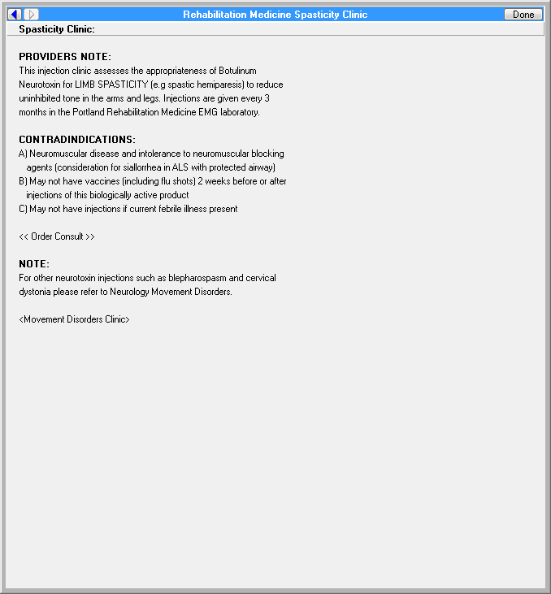

The following reference is from the Portland VAMC.

**Figure A.2. Polytrauma Concussion Traumatic Brain Injury (TBI) Eval/Education**

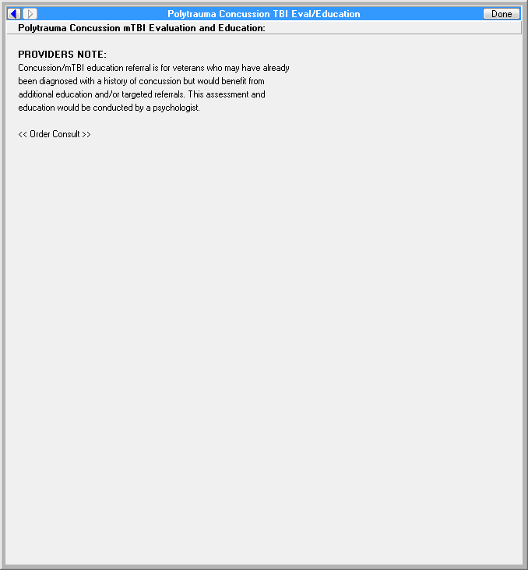

The following reference is from the Greater Los Angeles VAMC.

**Figure A.3. Reason for Request: Physical Medicine and Rehabilitation (PM&R) Traumatic Brain Injury/Polytrauma (Image 1 of 2)**

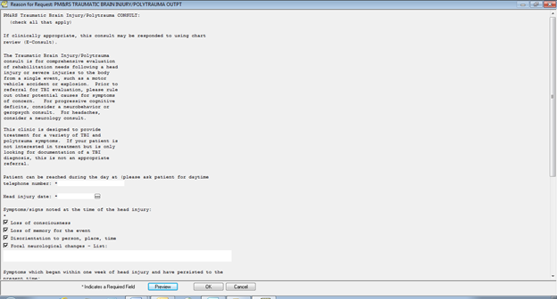

The following reference is from the Greater Los Angeles VAMC.

**Figure A.4. Reason for Request: Physical Medicine and Rehabilitation (PM&R) Traumatic Brain Injury/Polytrauma (Image 2 of 2)**

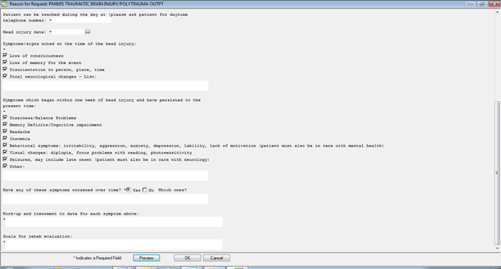

**Appendix B. Basic Laboratory Panel Definition**

* Blood Urea Nitrogen
* Calcium
* Chloride
* CO2 (Carbon Dioxide, Bicarbonate)
* Creatinine
* Glucose
* Potassium
* Sodium

**Appendix C. Logic Diagrams**

**Figure C.1. ECA Rule: Traumatic Brain Injury Screening**

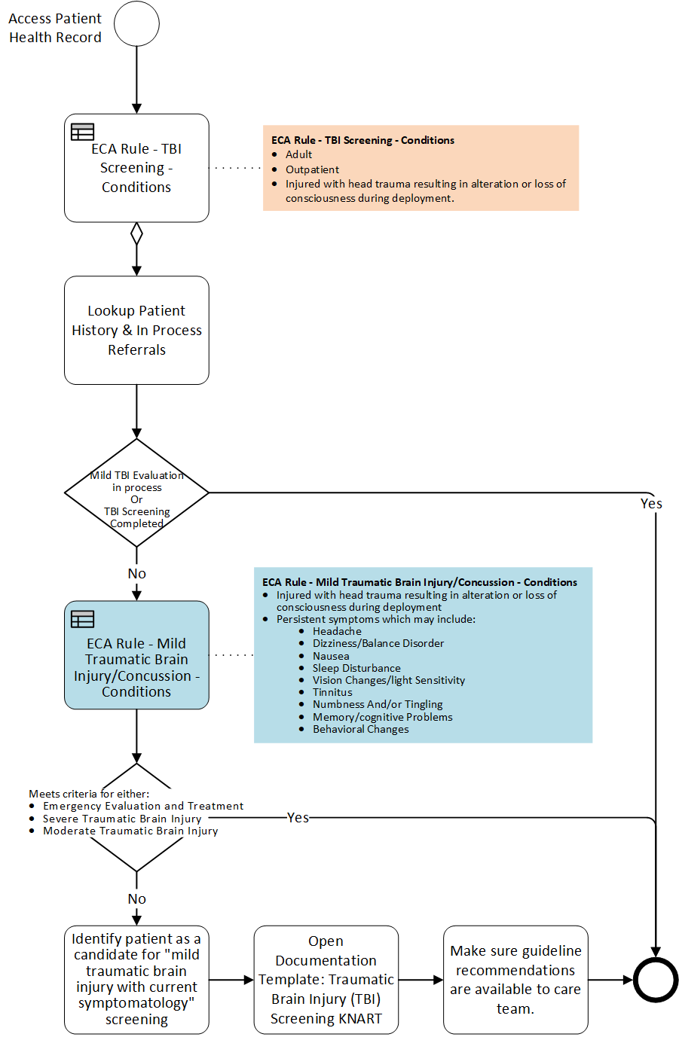

**Appendix D. Acronyms**

AMEDDC&S Army Medical Department Center and School

CCWP Clinical Content White Paper

CDS Clinical Decision Support

CO2 Carbon Dioxide

CT Computed Tomography

ECA Event Condition Action

GED General Equivalency Development

HL7 Health Level 7

HRCoE U.S. Army Health Readiness Center of Excellence

KBS Knowledge Based Systems

KNART Knowledge Artifact

OEF Operation Enduring Freedom

OIIG Office of Informatics and Information Governance

OIF Operation Iraqi Freedom

MRI Magnetic Resonance Imaging

mTBI Mild Traumatic Brain Injury

PCP Primary Care Provider

PM&R Physical Medicine and Rehabilitation

PTSD Posttraumatic Stress Disorder

SME Subject Matter Expert

TBI Traumatic Brain Injury

TO Task Order

VA Department of Veteran Affairs

VAMC Veteran Affairs Medical Center