**Clinical Decision Support (CDS) Content and Health Level 7 (HL7)-compliant Knowledge Artifacts (KNARTs)**

**Rheumatology: Rheumatoid Arthritis Clinical Content White Paper - Order Set (B14, CLIN0004AB), Consult Request Documentation Template (B38, CLIN0005AB), Composite (B59)**

Contract: VA118-16-D-1008, Task Order (TO): VA-118-16-F-1008-0007

Department of Veterans Affairs (VA)

(VA color seal image)

Knowledge Based Systems (KBS)

Office of Informatics and Information Governance (OIIG)

Clinical Decision Support (CDS)

October, 2017

Version 1.0

**Clinical Decision Support (CDS) Content and Health Level 7 (HL7)-compliant Knowledge Artifacts (KNARTS): Rheumatology: Rheumatoid Arthritis Clinical Content White Paper**

Order Set (B14, CLIN0004AB), Documentation Template (B38, CLIN0005AB), Consult Request (B59)

Publication date October, 2017

Copyright © 2017, Cognitive Medical Systems, Inc.

**Licensed under the Apache License, Version 2.0 (the "License")**

You may obtain a copy of the License at http://www.apache.org/licenses/LICENSE-2.0

Unless required by applicable law or agreed to in writing, software distributed under the License is distributed on an "AS IS" BASIS, WITHOUT WARRANTIES OR CONDITIONS OF ANY KIND, either express or implied. See the License for the specific language governing permissions and limitations under the License.

Portions of this content are derivative works from content contributed by Motive Medical Intelligence Inc., under Creative Commons Attribution-ShareAlike 4.0.

Contributions from 2013-2018 were performed either by US government employees, or under US Veterans Health Administration contracts.

US Veterans Health Administration contributions by government employees are work of the U.S. Government and are not subject to copyright protection in the United States. Portions contributed by government employees are U.S. Government works (17 USC §105). Not subject to copyright. See: https://www.usa.gov/government-works

**Table of Contents**

VA Subject Matter Expert (SME) Panel 0

Introduction 0

1. Rheumatoid Arthritis 0

1. Clinical Context 0

2. Knowledge Artifacts 0

2. Composite 0

1. Knowledge Narrative 0

2. Consult Request 0

3. Documentation Template 0

1. Knowledge Narrative 0

2. History 0

3. Physical Exam 0

4. Medication History 0

5. Laboratory Studies 0

6. Imaging and Diagnostic Studies 0

4. Order Set 0

1. Knowledge Narrative 0

2. Medications 0

3. Laboratory Studies 0

4. Baseline Testing 0

5. Imaging and Diagnostic Services 0

6. Evidence 0

A. Appendix: Existing VA Artifacts 0

**List of Figures**

A.1. Figure 1 0

A.2. Figure 2 0

A.3. Figure 3 0

A.4. Figure 4 0

A.5. Figure 5 0

**List of Tables**

1.1. Clinical Context Domains 0

**VA Subject Matter Expert (SME) Panel**

| **Name** | **Title** | **Project Role** |
| --- | --- | --- |
| Amy Joseph, MD | Chief of Rheumatology, St Louis VAMC; Professor of Medicine, Washington University School of Medicine | Subject Matter Expert, Primary |
| J. Steuart Richards, MD | Chief of Rheumatology, Pittsburgh VAMC | Subject Matter Expert, Secondary |

**Introduction**

The VA is committed to improving the ability of clinicians to provide care for patients while increasing quality, safety, and efficiency. Recognizing the importance of standardizing clinical knowledge in support of this goal, VA is implementing the HL7 Knowledge Artifact Specification for a wide range of VA clinical use cases. Knowledge Artifacts, referred to as KNARTs, enable the structuring and encoding of clinical knowledge so the knowledge can be integrated with electronic health records to enable clinical decision support.

The purpose of this Clinical Content White Paper is to capture the clinical context and intent of KNART use cases in sufficient detail to provide the KNART authoring team with the clinical source material to construct the corresponding knowledge artifacts using the HL7 Knowledge Artifact Specification. This paper has been developed using material from a variety of sources: VA artifacts, clinical practice guidelines, evidence in the body of medical literature, and clinical expertise. After reviewing these sources, the material has been synthesized and harmonized under the guidance of VA subject matter experts to reflect clinical intent.

Unless otherwise noted, items within this white paper (e.g., documentation template fields, orderable items, etc.) are chosen to reflect the clinical intent at the time of creation. To provide an exhaustive list of all possible items and their variations is beyond the scope of this work.

**Conventions Used**

Conventions used within the knowledge artifact descriptions include:

• <obtain>: Indicates a prompt to obtain the information listed.

• If possible, the requested information should be obtained from the underlying system(s). Otherwise, prompting the user for information may be required.

• The technical and clinical notes associated with a section should be consulted for specific constraints on the information (e.g., time-frame, patient interview, etc.).

• Default values: unless otherwise noted, <obtain> indicates to obtain the most recent observation within the past 2 years. It is recognized that this default time-frame value may be altered by future implementations.

• [...]: Square brackets enclose explanatory text that indicates some action on the part of the user, or general guidance to the clinical or technical teams. Examples include, but are not limited to:

• [Begin …], [End …]: Indicate the start and end of specific areas to clearly delineate them for technical purposes.

• [Activate …]: Initiates another knowledge artifact or knowledge artifact section.

• [Section Prompt: ...]: If this section is applicable, then the following prompt should be displayed to the user.

• [Section Selection Behavior: ...]: Indicates technical constraints or considerations for the selection of items within the section.

• [Attach: ...]: Indicates that the specified item should be attached to the documentation template if available.

• [Link: ...]: Indicates that, rather than attaching, a link to the item should be included in the documentation template.

• [Clinical Comments: …]: Indicates clinical rationale or guidance.

• [Technical Note: ...]: Indicates technical considerations or notes.

• [If …]: Indicates the beginning of a conditional section.

• [Else, …]: Indicates the beginning of the alternative branch of a conditional section.

• [End if …] Indicates the end of a conditional section.

• Check boxes: Indicates items that should be selected based upon the section selection behavior.

**Rheumatoid Arthritis**

**1. Clinical Context**

Rheumatoid arthritis is the most prevalent autoimmune inflammatory arthritis. It is associated with substantial disability and impacts quality of life, morbidity, and mortality. Its diagnosis and management, however, remain unclear to many primary care physicians, who generate the majority of referrals to rheumatologists. Exposing the basic American College of Rheumatology recommendations to primary care physicians and integrating the recommendations into the primary care workflow can decrease practice variability and increase the efficiency and appropriateness of subspecialty management (Singh 2016).

**Clinical Context Domains**

|  |  |
| --- | --- |
| Target User | Provider to include Primary Care |
| Patient | Adult Patients |
| Priority | Routine |
| Specialty | Primary Care |
| Location | Outpatient |

**2. Knowledge Artifacts**

This section describes the CDS KNARTs that are intended for users caring for adult patients who present to a Primary Care Clinic with joint pain or inflammatory arthritis. The intent of these artifacts is to ensure a minimum workup is initiated prior to a Rheumatology Consultation.

Three knowledge artifacts define this clinical use case and are described in detail in the following sections. They are:

* Consult Request
* This is a high-level, encompassing artifact meant to communicate the request for a rheumatology consultation.
* It relies upon the documentation template and order set artifacts.
* Documentation Template
* This is a template used to document the information provided by the referring provider.
* It includes logic for appropriate display of documentation sections.
* Order Set
* This is the set of orderable items associated with the consult request.
* It includes logic for appropriate display of the order set.

**Composite**

[Begin Composite.]

**1. Knowledge Narrative**

[See Clinical Context in Chapter 1.]

**2. Consult Request**

[Technical Note: The following list provides the basic components of the consult request. This is the high-level, encompassing artifact, and must be combined with the documentation template and order set to form a fully functional knowledge artifact. The information for the consult request can be obtained as part of the composite or within the corresponding order set component in the consult section If obtained within the composite, this information should pre-populate the respective order set component.]

[Section Prompt: In order to initiate a rheumatology consult, please provide the following information.]

* Reason for Consult: Joint Pain
* Consult Specialty: Rheumatology
* Priority: Routine
* <obtain> Referring Physician
* <obtain> Referring Physician Contact Information

[Activate Documentation Template.]

[End Composite.]

**Documentation Template**

[Begin Documentation Template.]

**1. Knowledge Narrative**

[See Clinical Context in Chapter 1.]

[Section Prompt: This documentation template is intended for primary care physicians documenting findings for outpatients with joint pain or inflammatory arthritis in preparation for their referral to rheumatology.]

**2. History**

[Begin History section.]

[Section Selection Behavior: Select Yes or No for each question.]

[Section Prompt: Please ask the patient the following questions.]

Is the duration of joint pain greater than 6 weeks?

* ☐ Yes
* ☐ No

Are hands or wrists involved?

* ☐ Yes
* ☐ No

Is morning stiffness present?

* ☐ Yes
* ☐ No

Did the pain have a gradual onset?

* ☐ Yes
* ☐ No

<obtain> Optional additional information

[End History section.]

**3. Physical Exam**

[Begin Physical Examination section.]

[Section Selection Behavior: Select Yes or No for each question.]

[Section Prompt: Please answer the following questions and provide any additional required details.]

Are more than four joints involved?

* ☐ Yes <obtain> Specific Joints Affected
* ☐ No

Are there signs of joint inflammation (e.g., warmth, soft tissue swelling, or tenderness)?

* ☐ Yes <obtain> Specific Joints Affected
* ☐ No

[If yes, then present the list of signs.]

[Begin list of signs.]

[Section Prompt: Check all signs that are applicable.]

[Selection Behavior: Select any or none. Optional.]

* ☐ Warmth
* ☐ Soft Tissue Swelling
* ☐ Tenderness

[End list of signs.]

[End if Yes.]

[End Physical Exam section.]

**4. Medication History**

[Begin Medication History section.]

[Technical Note: Consider automatically including the information in this section if it is available.]

[Section Prompt: Please answer the following questions and provide any required additional details.]

[Section Selection Behavior: Select Yes or No for each question. If Yes to a given question, then display the subcategories that follow it.]

Was there prior use of disease-modifying antirheumatic drugs?

* ☐ Yes

[If Yes to “Was there prior use of disease-modifying antirheumatic drugs?” then display the subcategories of medications.]

* ☐ adalimumab
* <obtain> Date initiated
* <obtain> Dose
* ☐ etanercept
* <obtain> Date initiated
* <obtain> Dose
* ☐ hydroxychloroquine
* <obtain> Date initiated
* <obtain> Dose
* ☐ infliximab
* <obtain> Date initiated
* <obtain> Dose
* ☐ leflunomide
* <obtain> Date initiated
* <obtain> Dose
* ☐ methotrexate
* <obtain> Date initiated
* <obtain> Dose
* ☐ rituximab
* <obtain> Date initiated
* <obtain> Dose
* ☐ sulfasalazine
* <obtain> Date initiated
* <obtain> Dose
* ☐ other
* <obtain> Date initiated
* <obtain> Dose

[End if Yes.]

* ☐ No

Was there prior use of prednisone or other glucocorticoids?

* ☐ Yes

[If Yes to “Was there prior use of prednisone or other glucocorticoids?” then display the subcategories of information related to the prior use.]

* <obtain> Drug name
* <obtain> Date initiated
* <obtain> Date ended

[End if Yes.]

* ☐ No

[End Medication History section.]

**5. Laboratory Studies**

[Begin Laboratory Studies section.]

[Technical Note: If available, the most recent results and dates within the past 3 months should be included for the following: C-reactive protein, erythrocyte sedimentation rate, hepatitis C antibody screen, complete blood count, and complete metabolic panel. If available, the most recent results and dates from any time should be included for the following: rheumatoid factor and anti-cyclic citrullinated peptide antibody (ACPA/Anti-CCP).]

* Anti-cyclic Citrullinated Peptide Antibody (ACPA/Anti-CCP) <obtain> Results and date
* C-Reactive Protein <obtain> Results and date
* Erythrocyte Sedimentation Rate <obtain> Results and date
* Rheumatoid Factor <obtain> Results and date
* Hepatitis C Antibody Screen <obtain> Results and date
* Complete Blood Count <obtain> Results and date
* Complete Metabolic Panel <obtain> Results and date
* Other <obtain> Test <obtain> Results <obtain> Date

[End Laboratory Studies section.]

**6. Imaging and Diagnostic Studies**

[Begin Imaging and Diagnostic Studies section.]

[Technical Note: Results text should be attached automatically if it is provided for the hand radiograph interpretation field. Include any studies performed within the past year.]

* <obtain> Hand Radiograph Interpretation
* [Link Images: Hand Radiograph]

[End Imaging and Diagnostic Studies section.]

[End Documentation Template.]

**Order Set**

[Begin Order Set.]

**1. Knowledge Narrative**

[See Clinical Context in 1.]

[Clinical Comment: This order set applies to any adult outpatients presenting to a primary care provider with joint pain or equivalent symptoms of inflammatory arthritis. All orders are routine unless otherwise specified.]

**2. Medications**

[Begin Medications section.]

[Section Prompt: No medications are required prior to a rheumatology consult. However, if prednisone is considered prior to the rheumatology consult, be aware that prednisone can potentially mask symptoms that would be evaluated by rheumatology.]

[End Medications section.]

**3. Laboratory Studies**

[Begin Laboratory Studies section.]

[Section Prompt: Consider ordering the following laboratory studies if they have not been ordered within the last three months. Note: The ANA test is not considered appropriate to be ordered for suspected rheumatoid arthritis.]

[Section Selection Behavior: Select any or none. Optional.]

* ☐ Rheumatoid factor
* ☐ Anti-cyclic citrullinated peptide antibody (ACPA/Anti-CCP)
* ☐ Hepatitis C antibody screen
* ☐ Complete blood count
* ☐ Complete metabolic panel
* ☐ C-reactive protein
* ☐ Erythrocyte sedimentation rate

[End Laboratory Studies section.]

**4. Imaging and Diagnostic Services**

[Begin Imaging and Diagnostic Studies section.]

[Section Prompt: Consider ordering the following imaging study if it has not been done within the past year.]

[Section Selection Behavior: Optional.]

* ☐ x-ray hands, bilateral, to evaluate for possible rheumatoid arthritis

[End Imaging and Diagnostic Studies section.]

[End Order Set.]

**Bibliography/Evidence**

[Aletaha, 2010] D Aletaha, T Neogi, and AJ Silman. “2010 Rheumatoid arthritis classification criteria: an American College of Rheumatology/European League Against Rheumatism collaborative initiative.” *Arthritis Rheum*. 2010. 62. (9). 2569-2581.

[Singh, 2016] JA Singh, KG Saag, and SL Bridges. “American College of Rheumatology. 2015 American College of Rheumatology Guideline for the Treatment of Rheumatoid Arthritis.” *Arthritis and Rheumatology (Hoboken, NJ)*. 2016. 68. (1). 1-26.

**Appendix A: Existing VA Artifacts**

**Figure A.1. Figure 1**

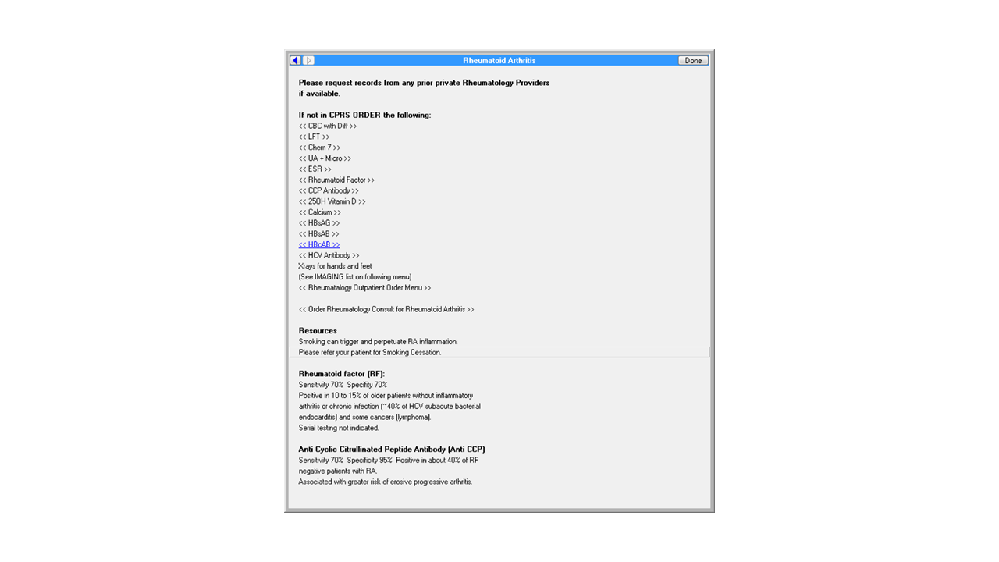

**Figure A.2. Figure 2**

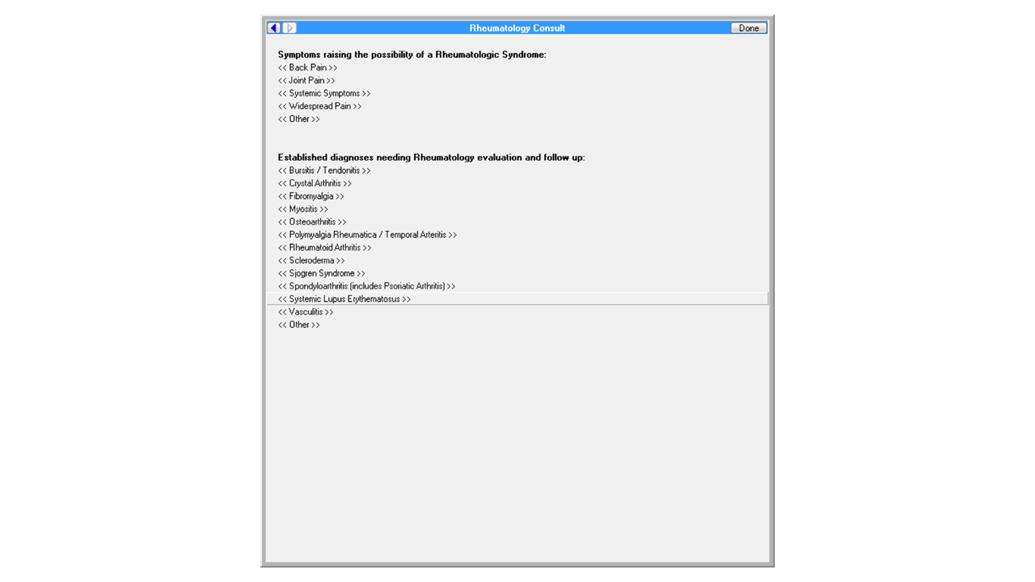

**Figure A.3. Figure 3**

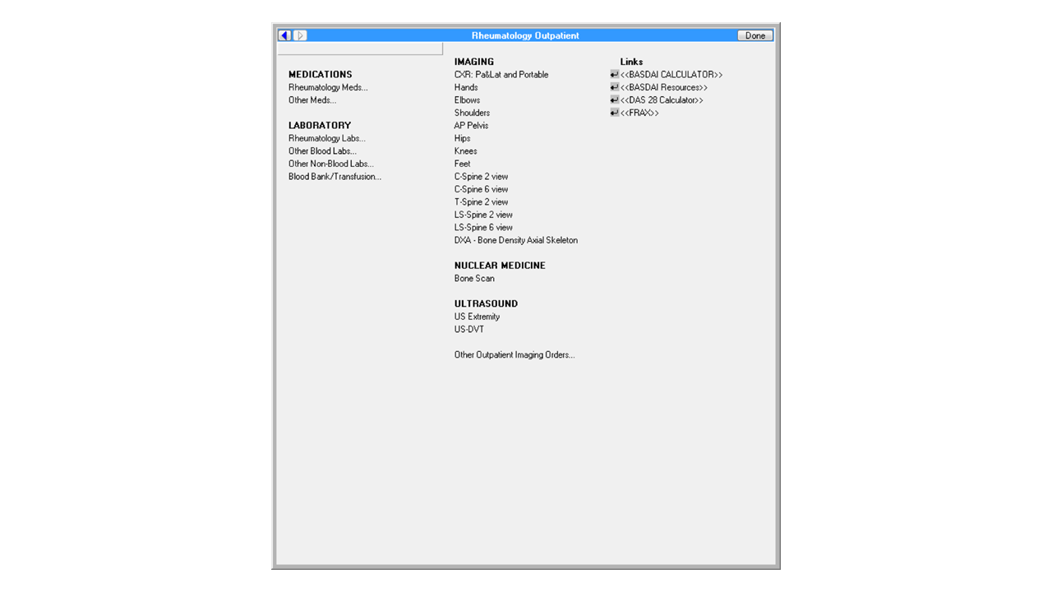

**Figure A.4. Figure 4**

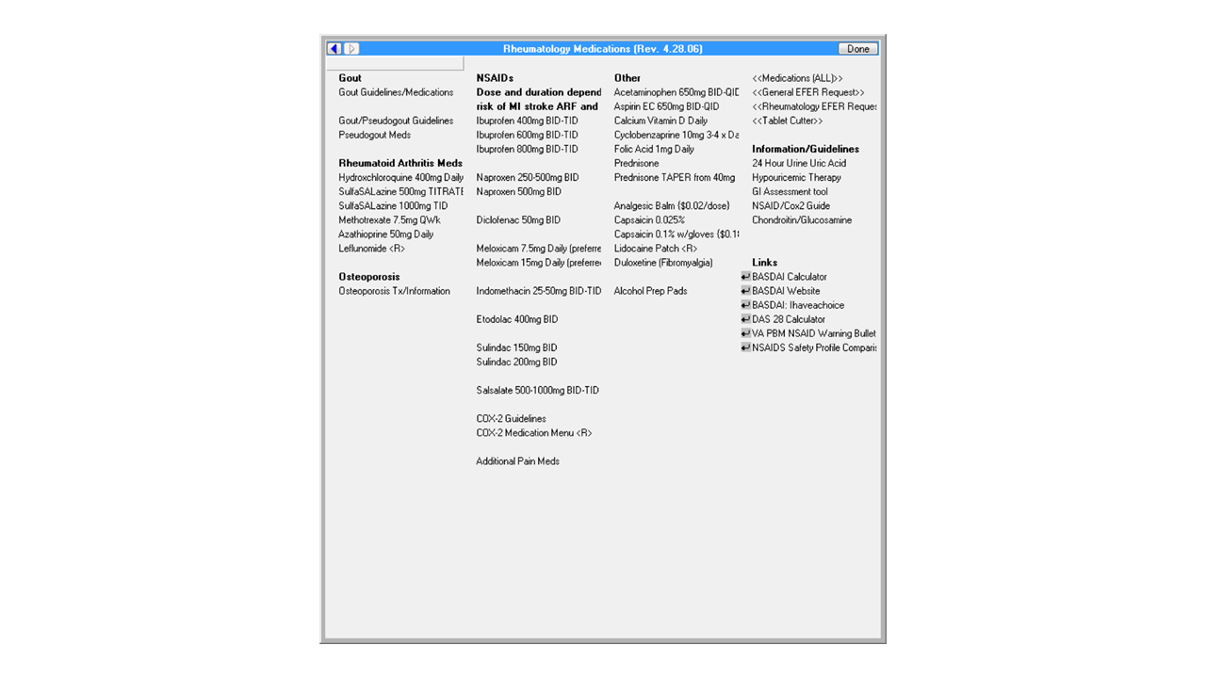

**Figure A.5. Figure 5**

