MapGuide Open Source

Web Service
MapGuide Open Source is a web-based platform that enables users to develop and deploy web mapping applications and geospatial web services. MapGuide features an interactive viewer that includes support for feature selection, property inspection, map tips, and operations such as buffer, select within, and measure.
MapGuide includes an XML database for managing content, and supports most popular geospatial file formats, databases, and standards. MapGuide can be deployed on Linux or Windows, supports Apache and IIS web servers, and offers extensive PHP, .NET, Java, and JavaScript APIs for application development. MapGuide Open Source is licensed under the LGPL.
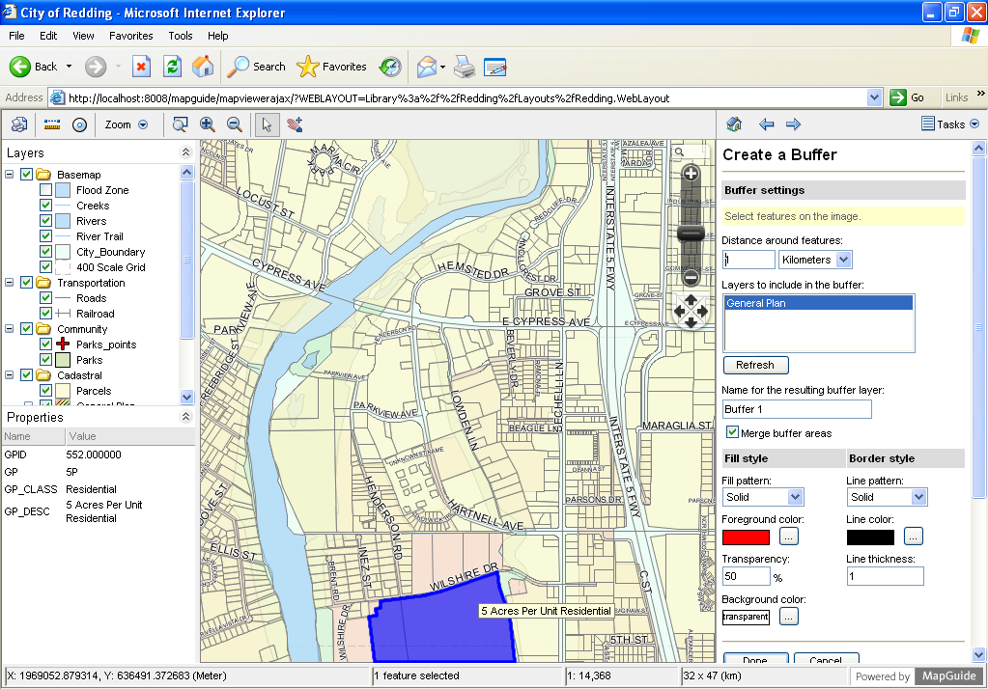

Core Features:
Interactive Map Viewing
- Ajax viewer
- Feature selection and properties
- Buffering, querying
- Printing and Plotting
Quality Cartographic Output
- Scale-dependent detail
- Rule-driven thematic stylization
- Anti-aliased image rendering
- True color support
Built-in Resource Database for Manageability
- Heirarchical storage of XML resources for maps, layers, data connections
- Define data sources and layers once and use them in multiple maps
- Access based security model
Uniform Data Access
- Exclusive use of Feature Data Objects (FDO) API for vector and raster data
Flexible Application Development
- Develop your applications in PHP, .Net, or Java
Extensive Server-Side APIs
- Create, query, read, and write permanent and session based XML resources
- Query and update feature data
- Perform coordinate reprojection
- Create, manipulate, and analyse geometry
- Manipulate runtime maps and layers
Fast, Scalable, Secure Server Platform
- Fully multi-threaded to take advantage of multi-core servers
- Load balancing between servers
- Pooled database connections
- Integrated tile caching
Multiple Platform Support
- Deploy on Microsoft Windows or Linux
- Serve applications with Microsoft IIS or Apache
- Browse with Microsoft Internet Explorer, Mozilla Firefox, Safari and Google Chrome

Implemented Standards:
OGC Web Map Service 1.1.1

Details:
Home: http://mapguide.osgeo.org
License: LGPL
Maturity: 4 stars (mature)
Supported Platforms: Windows, Linux
API Interfaces for: PHP, .Net, Java
Commercial Support:
http://www.osgeo.org/search_profile

