
gvSIG
Quick Start
gvSIG is a Desktop GIS application designed for capturing, storing, handling, analyzing and deploying geographic information which has a similar feel to ArcView.
To load map layers in ArcView:

- Start up gvSIG from the desktop icon.

- Click through the initial warning about this being a development version.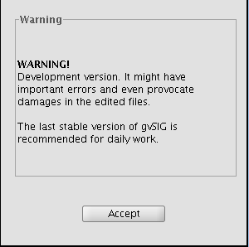
- From the initial Project manager; choose “View” as the Document type. And press the New button.
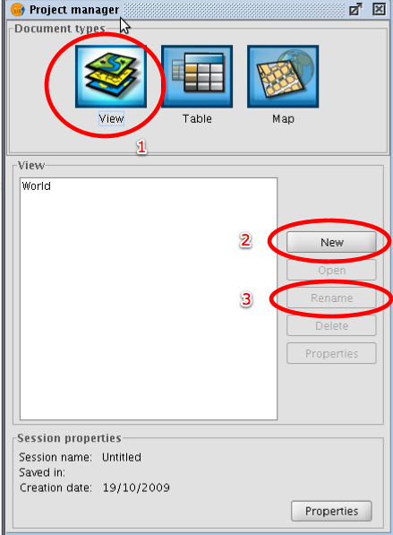
- Use the Rename button to call your Map “World” and press Open.
- From here we are going to use the “Add Layer” button in the toolbar to open the Add Layer Dialog.
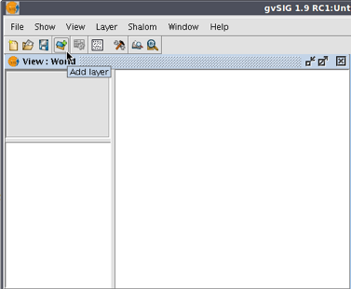
- The first Tab is devoted to loading files; press the Add button.
- Use the open dialog to locate countries.shp in the udig data directory.
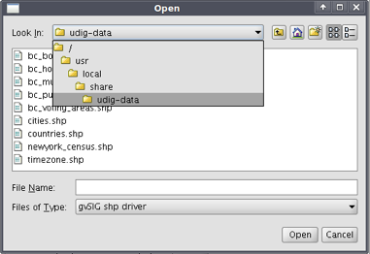
- Use the Add button again to pull in the background image.
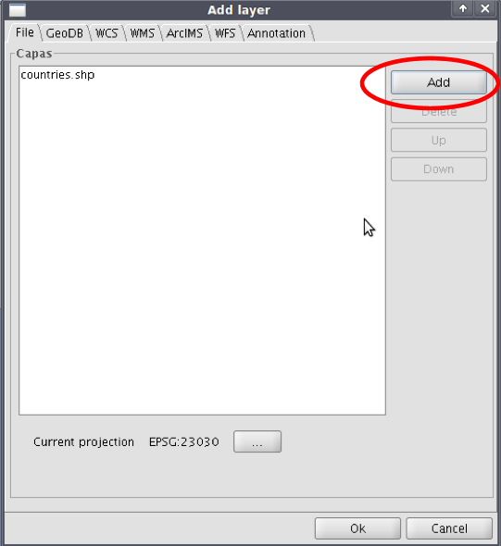
- This time we need to go down to Files of Type and change it to “gvSIG Raster Driver”.
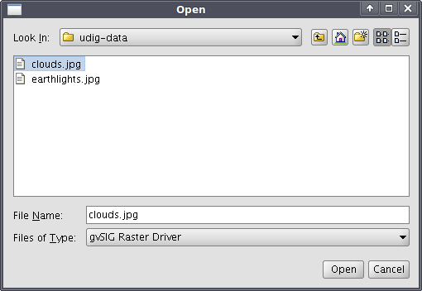
- And then we can choose clouds.jpg.
- Congratulations you have created a Map in gvSIG.
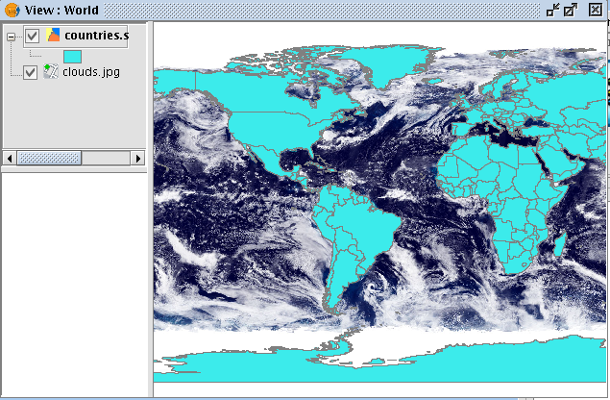
You may need to shuffle the layers around in the correct order to see the above image.

For further tutorials, refer to http://tbd

