GRASS GIS: An Overview
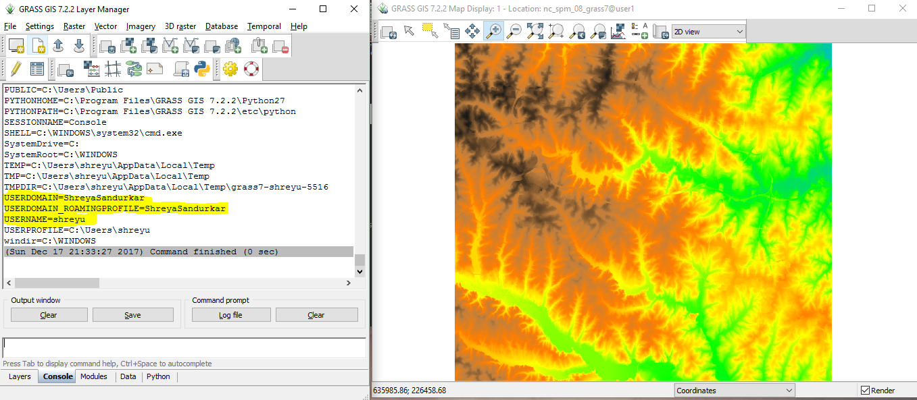

The usage of paper maps has been quite extensive since olden days. There have been incidents in the past where people got lost due to little mistakes in formatting of maps and changes in scales, for example Christopher Columbus. He planned to travel to India, to gain riches, however he kept sailing west and discovered America!
However, to reduce the number of accidents created by mistakes in formatting of maps, geographic scientists and computer programmers found a solution....

GIS (Geographic Information System) was a system developed to store, capture and present spatial or geographic data. This data could later be modified, analyzed and managed as well. One of the best software used for geospatial data management and analysis is GRASS GIS.

History
GRASS (Geographic Resources Analysis Support System) GIS is a free, open-source GIS software. It is one of the most popular and user-friendly GIS software. It was originally developed as a tool for land management and environmental planning by the U.S Army Construction Engineering Research Laboratories. It has now become more useful as it is being used in academic and commercial studies around the world. Not only this, it has also been used by government agencies including NASA, NOAA, USDA,DLR,CSIRO, the National Park Service, the U.S Census Bureau, USGS and many other environmental consulting companies due to the wide range of applications required in scientific research. GRASS GIS now has developers at different locations in the world. It has been undergoing development since 1982. From its initial release in 1985, GRASS has undergone exponential growth in functionality.
GRASS is licensed under the GNU General Public License. GRASS gives the freedom for any user to use the software for any purpose. Not only are you allowed to use it yourself, but you can also share it with other people like your friends, family, etc. Along with this, you can also make changes to suit your needs and can share the changes you made with others.

Developments
In the past thirty years GRASS GIS has improved and expanded its boundaries. It now has over 400 modules to render maps and image data. GRASS GIS not only developed a new modern graphical user interface which has more interactive tools that can be used for full-fledged topological vector support for editing and tools for topological analysis, hundreds of modules to analyze raster and vector data of all scales and types has been developed. Not only this, a new Python interface to the core C geoprocessing libraries which permits python developers to create powerful new modules in a quick way has been developed. Also, GRASS can now support massive data processing. It's codebase is portable to all of today's major Operating Systems (Microsoft, Mac, Linux, etc.).

Capabilities
GRASS GIS now, can superimpose raster images into geographic coordinates. It can convert raster images into approximate vector and point data formats, and also analyze the data. Not only this, but a 2D images can be viewed into 3D models, and can also import those images. Apart from raster images, GRASS can view and analyze vector images, and can also superposition the vector layers. A cheaper way of storing data where there is comparatively lesser space required is the Delaunay triangulation process. GRASS point data analyses the data and can store it in the format which you require. In cases of UAVs where the images are not processed, GRASS can still support it and helps in analyzing, managing and modifying the data. It is also possible to geocode the raster and vector maps.
GRASS is capable of visualizing 3D surfaces, color assignments, present Histograms, overlay maps, etc. It is also capable of creating new image maps and modifying existing data.
GRASS is also used in temporal framework where in GRASS can analyze the features of a place with a time gap and display the analyzed framework. Not only this, but GRASS can be used to view different visualizations such as streams, terrains, etc.

An example of the usage of GRASS GIS can be that of a civil engineer. He might want to build a road on a hill which leads to a spot of attraction. There might be a cliff on the other side of the hill, thus he would devise a road path which is safe and away from the cliff. To assess the terrains he would use GRASS to view the contour lines. He could also use GRASS GIS to view the existing path ways and look at the images in a period of time, thus judging the most durable pathway.

GRASS GIS is expanding its boundaries and there are more modules and add-ons being created. It is becoming more user-friendly.

