A DC-18 GHz SMA Transition for OSH Park’s 4-Layer PCB Process
Harrison Statham

INTRODUCTION
At higher frequencies, one must pay more attention to the geometry of the SMA footprint - often referred to as the "transition" since the electromagnetic fields are transitioning from a coaxial distribution in the SMA connector to a microstrip, stripline, etc. distribution on the PCB. The transition on the PCB aids the fields while they change distribution ensuring the process is as smooth as possible.
The consequence of a poor transition at RF is a lower Return Loss (RL), and higher Insertion Loss (IL). With a poor transition, we won't be able to deliver power to the load (the PCB and subsequent RF circuitry), and thus we won't be able to do useful work. The RF transition, while not very glamourous, is an incredibly important aspect of RF design.
I have been using OSH Park for a while, and I wanted to take the time to design a nice RF transition for their 4-layer process that everyone could potentially use.
I am using CST electromagnetic software to do all my simulation work. I wouldn’t consider myself a power user, but I am proficient with the software. This is by no means a CST tutorial, nor should you blindly trust any of the CST results herein 😊

Specifications

Simulation Specifications
Table 1 lists the desired specifications of the simulated transition. Note that due to imperfections in the model that I will build (using CST), we will not achieve these results on PCB. These are goals to shoot for in the model and we will get what we get in real life – such is the nature of RF design.

Specification | Minimum | Maximum
Frequency Range | DC | 18 GHz
Insertion Loss | 0 dB | 1.5 dB
Return Loss (|S11|) | 20 dB | -

Frequency Range
Typical 3.5mm SMA connectors "work" from DC - 18 GHz / 26.5 GHz depending on the quality of the connector. I use the word "work" very loosely, because SMA connectors will work to much higher frequencies; the upper frequency is really the "moding frequency" - the upper frequency where other modes (field distributions) are excited in the SMA connector. We typically want to avoid moding, so we only use the connector to its specified max frequency.
When we need to go to higher frequencies, we move to smaller coaxial connectors which go to higher frequencies before they start moding. e.g. 2.92 mm, 2.4mm, 1.85 mm, 1 mm, and smaller.

Insertion Loss
Any real RF device has Insertion Loss (IL) - the loss we must account for when we insert an element into our circuit. Good connectors and transitions are virtually transparent - you see very little loss by using the connector and transition. This means we deliver most of the power to the RF circuitry while wasting very little in the connector and transition.
The lossy-ness of the transition is dependent on the geometry as well as the PCB substrate material. In this case we are using the OSH Park 4-layer process which is an FR408 material with a high loss tangent of ~0.011 at 1 GHz and ~0.013 at 10 GHz. Nice RF substrates have very low loss tangents (~ 0.001 to 10s of GHz).
In this project, we are shooting for 0-1.5 dB of loss across frequency. Naturally, we will always have some loss around DC (milli-dB) and higher loss at 18 GHz (~3-4 dB on FR408). Some of the higher loss will be due to imperfections in my model, but most of it will be due to the lossy FR408 substrate. There is a reason that the datasheet doesn't specify loss tangent higher than 10 GHz - it’s not meant to be used up there.

Return Loss
In our project, the Return Loss (RL) describes how well matched the 50 Ohm SMA connector is to the PCB. RL is equivalent to |S11|, and we often specify RL at min & max frequencies. We want RL to be as high as possible (S11 is as small as possible), which means that we are delivering most of the RF power to the load!
The RL depends highly on the geometry of the transition to the PCB, and I will spend most of my energy trying to improve the RL in my model. Good transitions have excellent RL across the frequency range with RL figures of 20+ dB.
An RL of 10+ dB is considered good and will be what we shoot for at 18 GHz in our physical measurements. Again, reality strikes, and at 18GHz, we will probably see around ~8-9 dB RL if we are fortunate.

CST Model
We need some basic information about the OSH Park 4-layer stackup, the datasheet of the substrate material, and the SMA connector datasheet.

Modelling the PCB
The PCB model is a simple sandwich of metal and substrate layers distributed according to the OSH Park 4-layer stackup on their website. I have disregarded the solder mask layers for simplicity as I don’t want to include those in the model.
The white looking layers are the FR-408 material, and the dark gray layers the metal. For the substrate material, I started with traditional FR-4, and then modified the dielectric constant (DK) and the loss tangent (DF) according to the linked datasheet above.
See Appendix A for a transmission line test of the PCB model.
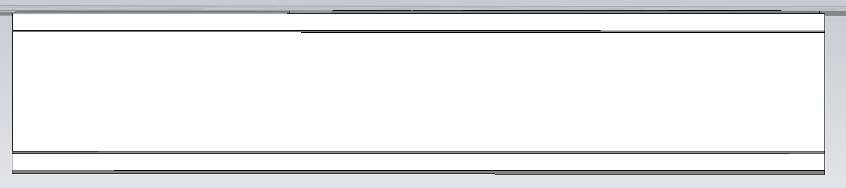
Image 1. PCB model in CST showing the various dielectric and metal layers.

Modelling the SMA Connector
The geometry of the connector can be pulled straight from the datasheet. Of main importance are the center pin of the connector, the inner diameter of the coax, the outer diameter of the coax, and the location of the ground connections to the PCB. As with every model, we should add as much detail as needed and no more. Adding extraneous detail only increases the simulation time, and workload on your computer (or server in my case).
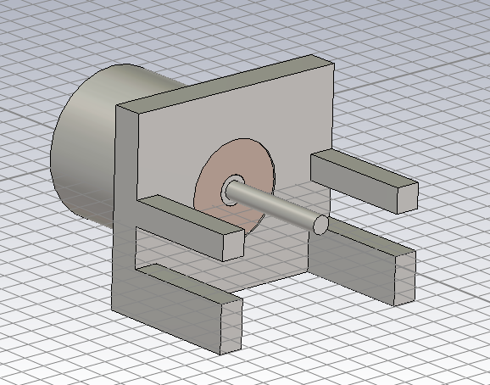
Image 2. CST model of the SMA connector. Not shown in the image are the vias that will stitch the two ground connections together on the PCB.

Modelling the Transition – Transition 0
Once we have the basic pieces – the SMA connector and PCB – we can start designing the transition. Our starting point begins with the manufacturers recommended geometry over a solid ground plane. You can see a top view of the geometry in Image X below. We should note two things:
- I have added a blob that protrudes off the center conductor pad – this is to model the solder that will connect the connector to the PCB.
- Instead of a basic rectangle for the center conductor, you can see that I have already tapered the width down to that of the transmission line. A good rule of thumb is to avoid right angles in RF designs – energy will either reflect off or coalesce on a right angle instead of propagating towards the load.
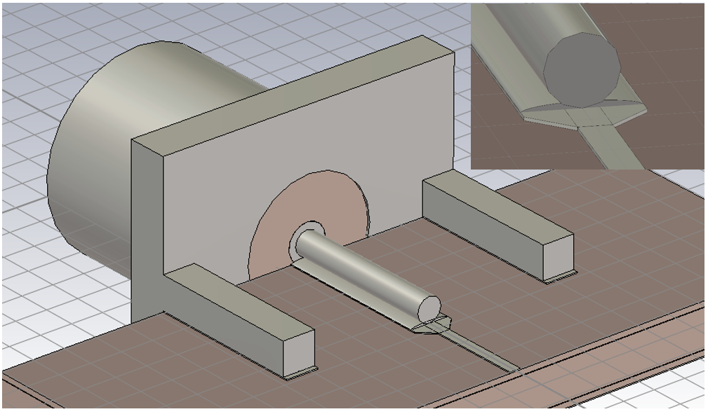
Image X. 3D view of the starting geometry. The solder blob which connects the connector to the PCB is visible.

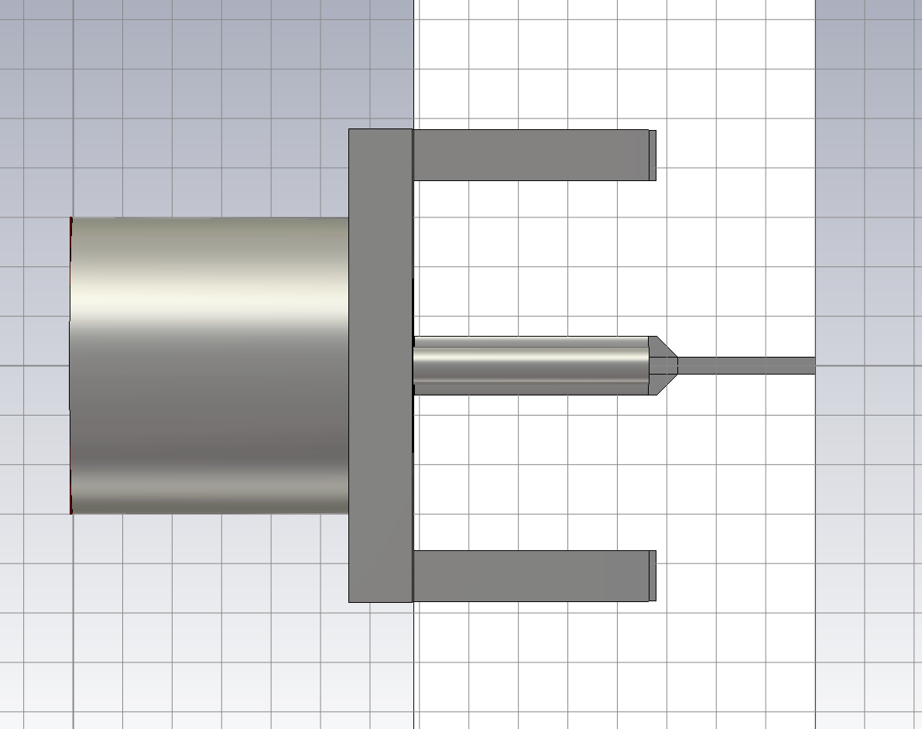
Image X. Top view of our starting geometry. Note the tapered width of the center conductor down to the width of the transmission line. This is always preferable to no taper (right angle) which will cause reflections.
The initial simulation results are not pretty. The design barely works to 2 GHz and has a lot of loss. Oh no, transition design isn’t easy! The s-parameters of the initial design is shown in Image X.
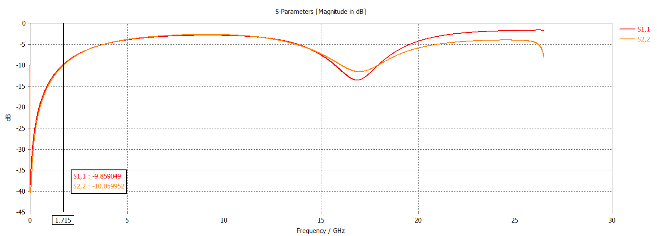
Image X. S11 of the initial design. The RL is 10 dB at 1.7 GHz.

We started with the recommended manufacturer footprint and now what do we do? Unless you know which tool to turn to, it’s very hard to know how to modify the geometry of the transition to achieve good results. Furthermore, just looking at s-parameters will lead to a very tedious guess-and-check routine – no thank you. We need to look at TDR!

Time Domain Reflectometry (TDR) will be a useful tool for visualizing where (spatially) in our transition we have a poor match. A TDR of the transition is shown below in Image X. We can see that the impedance looks like a nice 50 Ohms until around 50 ps and then by 100 ps has dropped to 20 Ohms! The large step in impedance occurs between the start of the transition (~40-50 ps) and the end of the tapered line (~100 ps) – so it all occurs in the PCB footprint of the connectors center conductor.
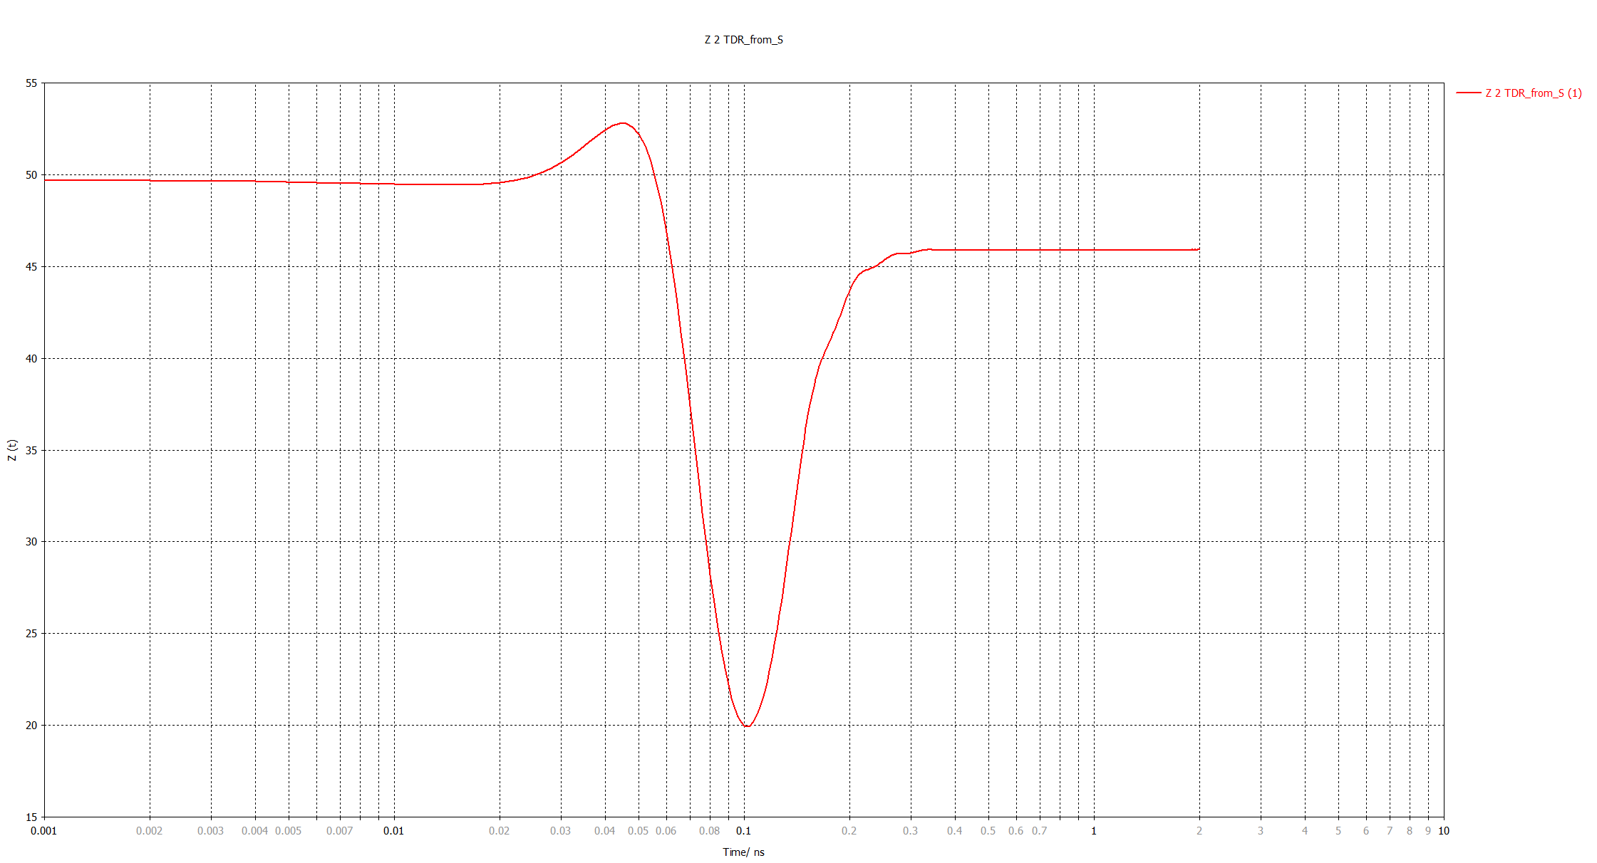
Image X. TDR of the initial design. Ideally the impedance would be 50 Ohms versus time (time is related to the physical location in the transition).

What is going on here? The answer lies in the solid ground plane. The solid ground plane looks highly capacitive to ground to the incident wave. A large capacitor at RF looks like a short circuit, so we should expect the impedance to drop, and then recover once the capacitance drops.

Refining the Transition – Transition 1
Using TDR we discovered that our initial design was highly capacitive. We need to decrease the capacitance which can be easily achieved by removing the ground plane underneath the center pad of the SMA connectors footprint. In the image below you can see that I have removed a chunk of the ground plane underneath the SMA connectors’ center conductor. I blindly chose the size of the rectangle cutout to see what the effect would be.

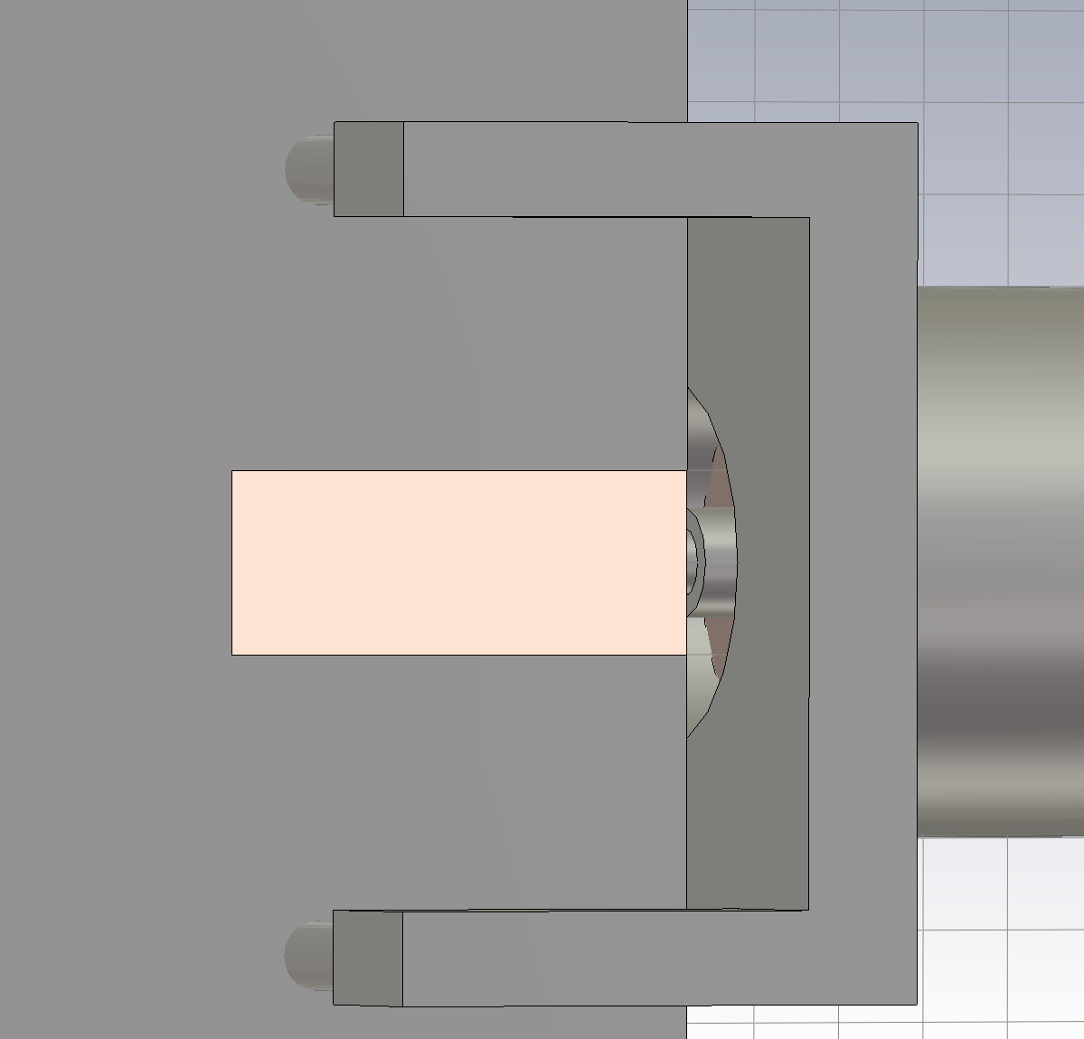
Image X. Ground plane cutout underneath the SMA connecter footprint.

Below you can see the RL and IL of the transition with cutout. By removing the ground plane, we have significantly improved the design! The RL is ~13 dB at 18 GHz and 18+ dB from DC – 15 GHz. Furthermore, the IL is 1.1 dB at 18 GHz.
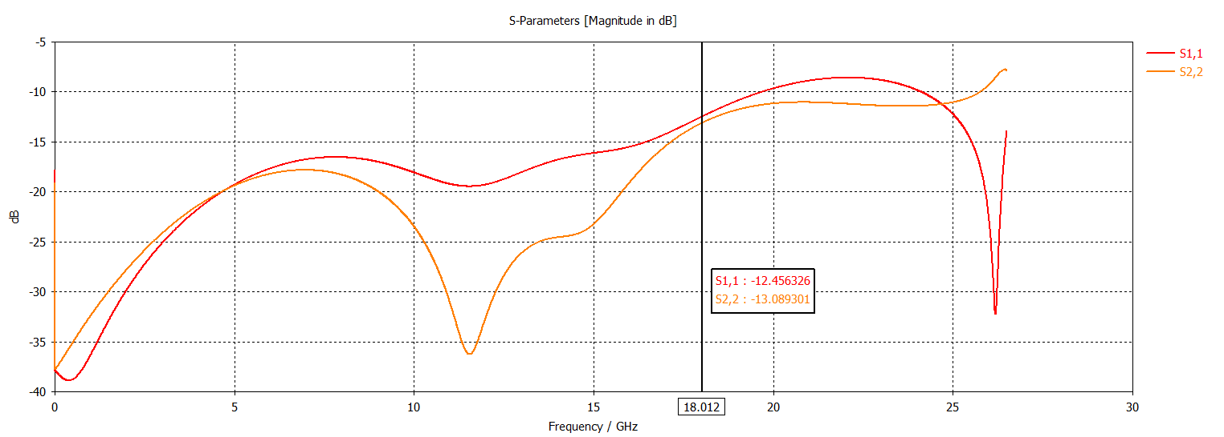
Image X. RL of the first design variation with ground plane cutout. The RL is 13 dB at 18 GHz.

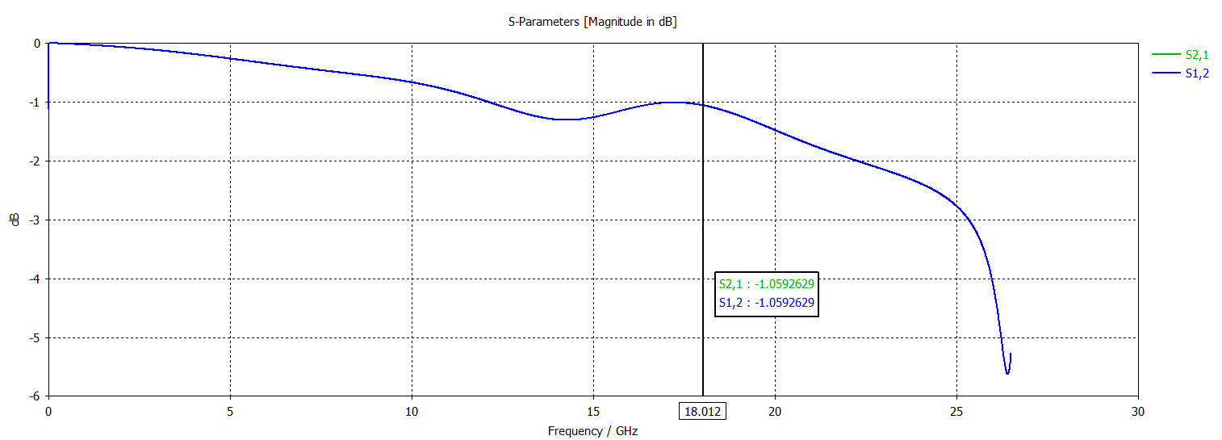
Image X. IL of the first design variation with ground plane cutout. The IL is 1.1 dB at 18 GHz.

Looking at the TDR plot we can see that the impedance takes a large increase before returning to ~46 Ohms. By removing the capacitance, we have inadvertently made our design inductive! The variation in impedance is not nearly as large as the initial design (30 Ohm step vs. 8 Ohm step)

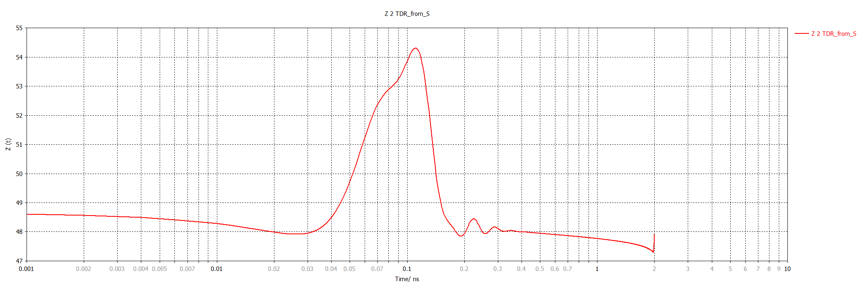
Image X. TDR of the first design variation with ground plane cutout. The impedance increases by ~6 Ohms before dropping.

Refining the Transition – Transition 2

By adding a ground plane cutout, we were able to reduce the capacitance of the design thus increasing the performance of the transition. We see an RL of 15+ dB up to 15 GHz and an RL of 13 dB at 18 GHz. In this design variation, we will use CST to optimize the size of the cutout in the ground plane.

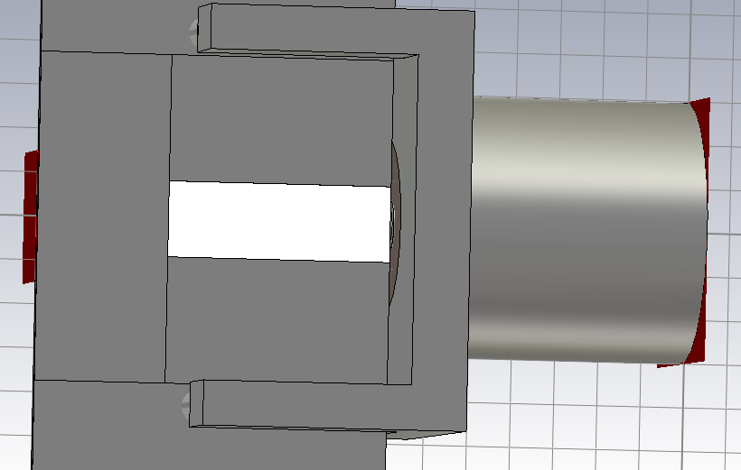
Image X. Variable ground plane cutout. CST can modify the size of the cutout (shown in white) and calculate the s-parameters accordingly.

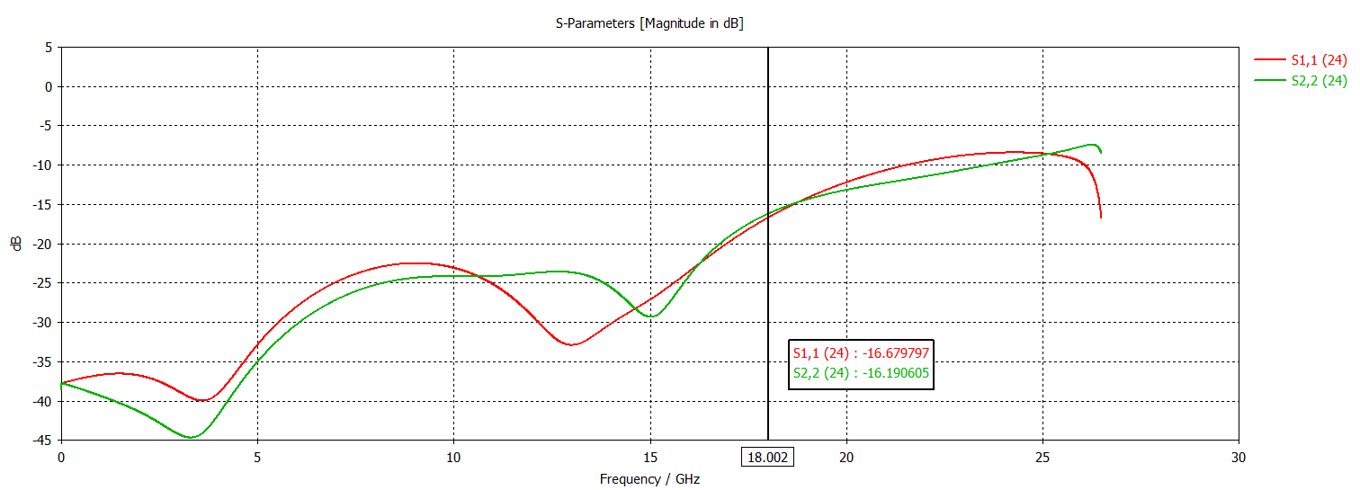
Image X. RL of the second design variation after optimization. The RL is 20 + dB from DC – 15 GHz and 16.7 dB at 18 GHz.

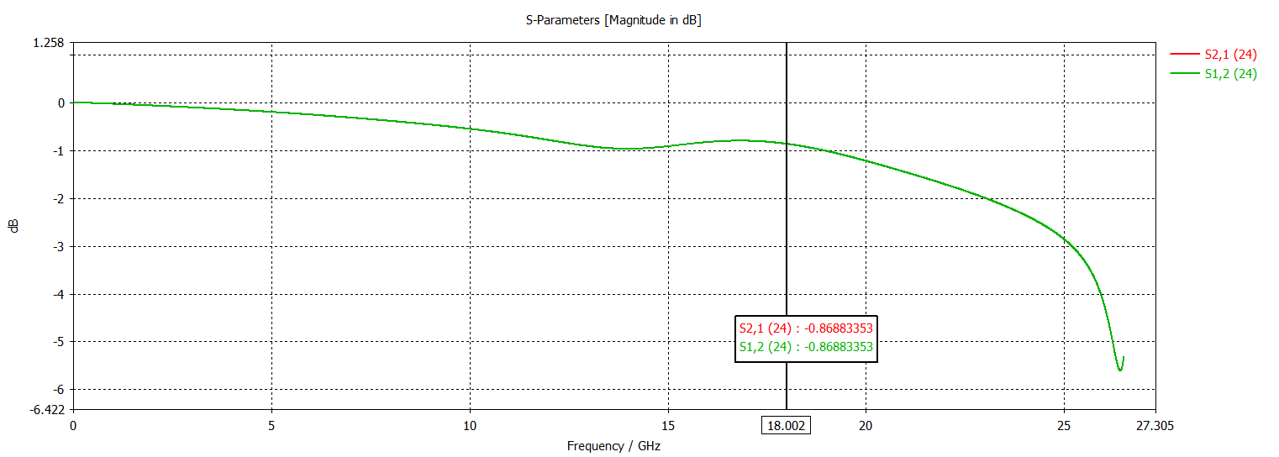
Image X. IL of the second design variation after optimization. The IL is less than 1 dB across the band and 0.86 dB at 18 GHz.

The performance of the optimized transition is excellent. We will build the first three transitions and calculate their performance.

Measurements

Transition 0

Transition 1

Transition 2

Conclusion
A conclusion section is not required. Although a conclusion may review the main points of the paper, do not replicate the abstract as the conclusion. A conclusion might elaborate on the importance of the work or suggest applications and extensions.
Appendix
Appendixes, if needed, appear before the acknowledgment.
Acknowledgment
The preferred spelling of the word “acknowledgment” in American English is without an “e” after the “g.” Use the singular heading even if you have many acknowledgments. Avoid expressions such as “One of us (S.B.A.) would like to thank ... .” Instead, write “F. A. Author thanks ... .” Sponsor and financial support acknowledgments are placed in the unnumbered footnote on the first page, not here.
References
- G. O. Young, “Synthetic structure of industrial plastics (Book style with paper title and editor),” in Plastics, 2nd ed. vol. 3, J. Peters, Ed. New York: McGraw-Hill, 1964, pp. 15–64.

ALL BIOS ARE REQUIRED

Harrison Statham is an Electrical Engineer. He makes stuff; Sometimes they work.

