Adaptive power-aware routing algorithms for wireless networks with dynamic topology

Aleksandra Alekseeva
Open Source and Linux lab
Computer science dept.
Saint Petersburg Electrotechnical University “LETI”
Saint Petersburg, Russia
kronshtein78rus@gmail.com

Eugene Kalishenko
Open Source and Linux lab
Computer science dept.
Saint Petersburg Electrotechnical University “LETI”
Saint Petersburg, Russia
ydginster@gmail.com
Abstract
Wireless ad-hoc and mesh networks are a great help for people in situations in which there is no network installed in advance. For example in such situations like an earthquake, when the lines of wired connection can be demolished, one can use an ad-hoc self-organized network to establish communication. Here comes the theme of conserving the energy of host-routers. We must take in account that the efficient energy consumption increases the lifetime of the whole network.
Some projects already do concentrate on this theme. Although all of them are not perfect. Most of them use energy consumption as the metrics for routing. Let's see what are the main ideas in energy-concerned package delivery:
- using the min-hop metrics (Dijkstra algorithm, Minimum Total Transmission Power Routing, finds minimum hop count for the path)
- using the battery remaining capacity of a host as metrics (leading to minimization of using a host with low residual capacity, implemented in Minimum Battery Cost Routing protocol)
- using the intensity of current energy consumption of a host as metrics (Minimum Drain Rate algorithm)
- using complicated battery models (Battery Lifetime Optimization Scheduling, i.e. dividing the lifetime to recovery and energy-loss periods and scheduling them)
- using threshold for switching from one algorithm to another to minimize the whole energy consumption of the network (Conditional Min-Max Battery Capacity Routing, switching from MTTPR to MBCR)
- minimizing the energy consumption while escaping the low-capacity hosts usage
The main intention of the planned work is to combine somehow the best aspects of the described below protocols to achieve a better lifetime of the network and modify them in a such way: any host can simultaneously forward packages for a request and deny to forward for another. This must be performed according to the circumstances. Let's see which parameters afford a host to forward or to reject a request:
- battery residual capacity
- intensity of the host usage (current and expected speed of discharging)
- minimization of the energy consumption of the whole network
- delivery time and delivery guarantee
The challenge is to simulate most of the existing models and metrics using NS-3 and to decide which features are the most convenient for the further usage. After the mathematical model is configured, it must be implemented and simulated in NS-3 project. This model must be one of two variants at least: proactive or reactive. According to the existing articles on ad-hoc and wireless networks, there exists proactive and reactive routing. One of the aspects of our goal is to decide whether we want to use one or another algorithm. Also we want our protocol to have the guarantee of the package delivery. We must also to take in account the speed of package delivery and other non-depending on energy factors. In our work we'd like to use the groundwork of AODV protocol.
The best existing for now protocol for energy aware ad-hoc and mesh networks is HWMP, but is not perfect. The illustration of the lifetime of HWMP is given below (pic. 1).We think we can increase the networks' lifetime up to all nodes die simultaneously.
In conclusion we must say that ad-hoc and mesh networks have a big and fruitful future and we will try to be a catalyst for that.

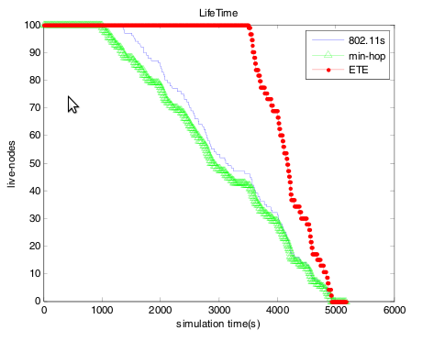
pic. 1. The lifetime of a network that uses HWMP protocol

Literature Survey

[1] Performance Evaluation of Battery-life-Aware Routing Schemes for Wireless Ad Hoc Networks –
C-K. Toh, Hiroshi Cobb, and David A. Scott Mobile Multimedia & High Speed Networking Laboratory
Georgia Institute of Technology

[2] Non-Blocking, Localized Routing Algorithm for Balanced Energy Consumption in Mobile Ad Hoc Networks – Kyungtae Woo, Chansu Yu, and Dongman Lee

[3] Routing Mechanisms for Mobile Ad Hoc Networks Based on the Energy Drain Rate
Dongkyun Kim, J.J. Garcia-Luna-Aceves, Senior Member, IEEE, Katia Obraczka, Member, IEEE, Juan-Carlos Cano, and Pietro Manzoni, Member, IEEE

[4] Energy Consumption Speed-Based Routing for Mobile Ad Hoc Networks
Lamia Romdhani and Christian Bonnet Eurécom Institute - Mobile Communications Department BP 193 - F 06904 Sophia-Antipolis

[5] Battery-Aware Router Scheduling in Wireless Mesh Networks
Chi Ma, Zhenghao Zhang and Yuanyuan Yang
State University of New York, Stony Brook, NY 11794, USA

[6] Expected Transmission Energy Routing Metric for Wireless Mesh Senor Network
HuiJun Miao, YanLiang Jin, Quan Ge, Yun He Shanghai University Key Laboratory of Special Fiber Optics and Optical Access Networks of Ministry of Education China, Shanghai

