Task review:
  - Develop N900 (or other Linux based device) support for mobility between 3GPP/WiFi, where application sees same IP address despite of used access network.
  - IPv4 and IPv6 support preferred, IPv4 support is ok.
  - SW shall be as modular as possible and avoid Linux Kernel dependencies
  - Implementation and SW development has been documented including SW architecture and description, interfaces description, Kernel changes and dependencies, installation instructions and test system.

Architecture review:

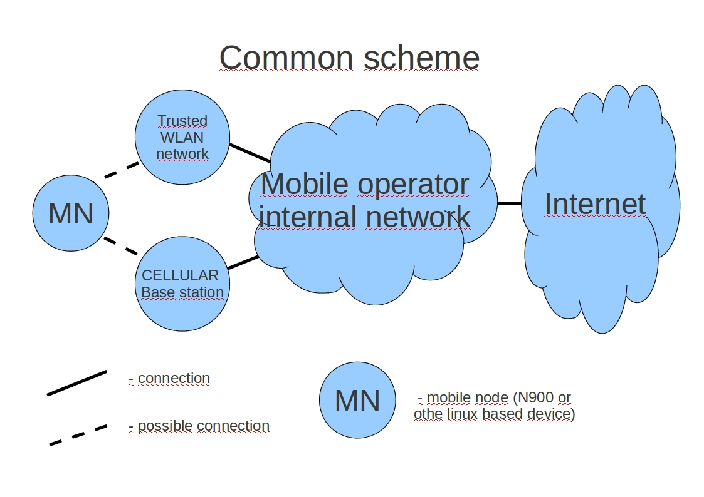
Usecase may be represented this scheme:

Mobile node in this scheme must have opportunity to transparent switching between WLAN network and CELLULAR network, clarify scheme:

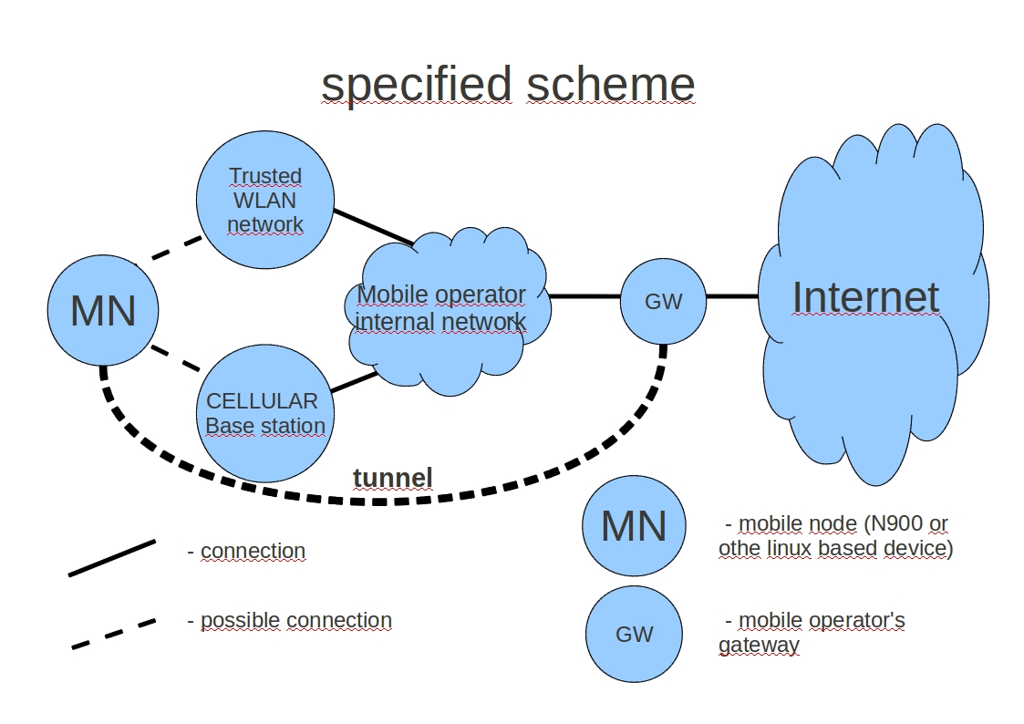

Tunnel in this scheme provide same IP (tunnel IP address) for application despite access network.
The next scheme represent mobile node application network access through tunnel interface:

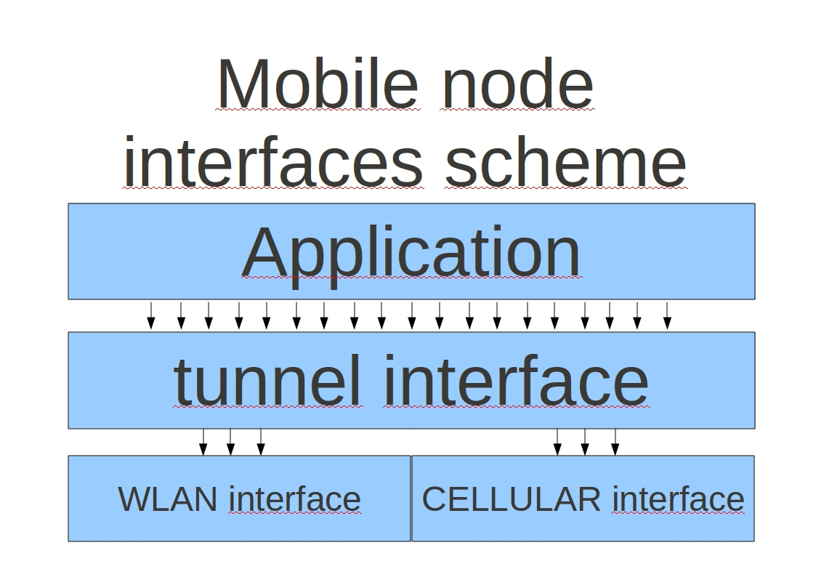

Kernel decide to use specific access network by routing table, so switching between access network is full transparent for applications.
This architecture can be realized using standard Linux kernel module TUN. Open VPN can be used for management TUN interface.
Advantages:
    - This decision don't need any kernel changes
    - This decision is suitable for most Linux based devices
    - Simple management

Of course, we cannot implement CELLULAR network for testing, for this reason of practical implementation and testing, make some changes in scheme:

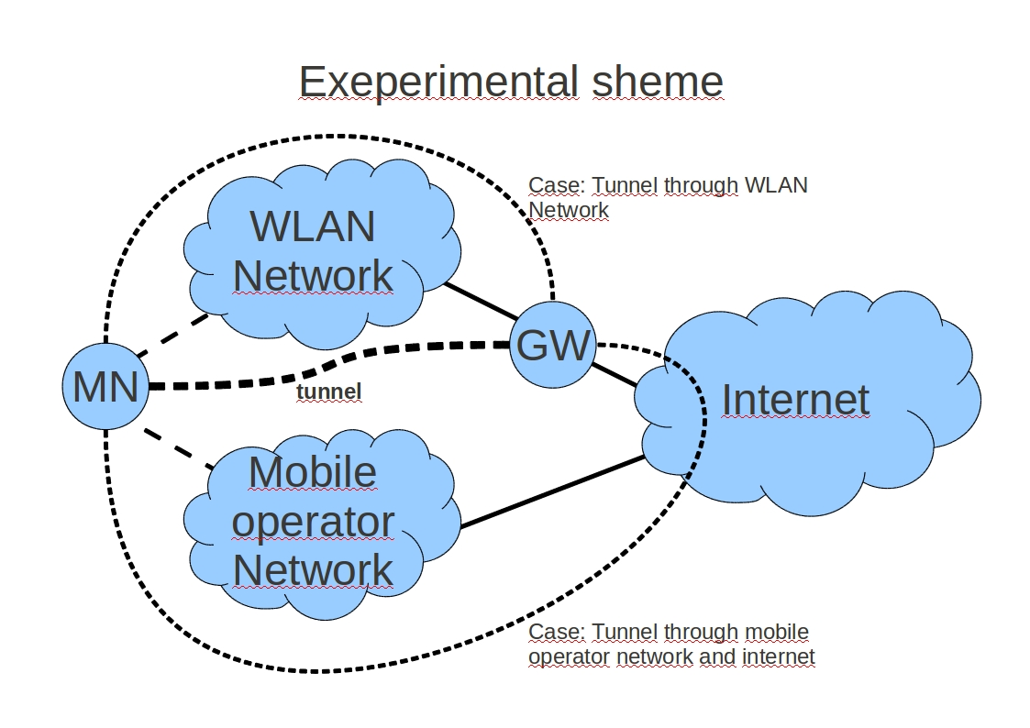

Testing scenario:
    - Setup OpenVPN to N900 and GW devices
    - Setup OpenVPN tunnel between N900 and GW
      - N900 configuration file example:
remote <GW Internet IP address> <GW port>
dev tun ;use tunnel interface
ifconfig <Mobile node tunnel address> <GW tunnel address>

cipher AES-256-CBC ;encryption properties
secret <key file with path> ;key file

keepalive 10 60 ;connection properties (keep alive and so on)
ping-timer-rem
persist-tun
persist-key

daemon ;run as linux deamon
      - GW configuration file example:
dev tun ;use tunnel interface
port <GW port> ;listen port
ifconfig <GW tunnel address> <Mobile node tunnel address>

cipher AES-256-CBC ;encryption properties
secret <key file with path> ;key file (same as on N900 device)

keepalive 10 60 ;connection properties
ping-timer-rem
persist-tun
persist-key

daemon ;run as linux deamon
    - Setup tunnel route (used access network)
route add -host <GW Internet IP address> dev gprs0
route add -net default dev tun0
NOTE: gprs0 – CELLULAR network interface
tun0 - tunnel interface created by OpenVPN
    - Run application (FTP client, for example)
    - Switch access network:
route add -host <GW Internet IP address> gw <WLAN gateway> dev wlan0
route del -host <GW Internet IP address> dev gprs0

Advantages:
  - IPSec encryption can be set above OpenVPN tunnel.
  - OpenVPN tunnel allow contraction
  - Simplicity
  - Supported difference Linux based devices
  - Any kernel modifications are no need
  - Independently of access network (not only 3GPP/WLAN)

