**3. Simulation**

A TE-mode normal incident electromagnetic wave propagates through the air/silicon gratings along x axis as shown in figure 2 with corresponding coordinates. Regions 1 and 4 are air. Region 2 and 3 are silicon. (We propose FSEM to deal with this kind of problem.)

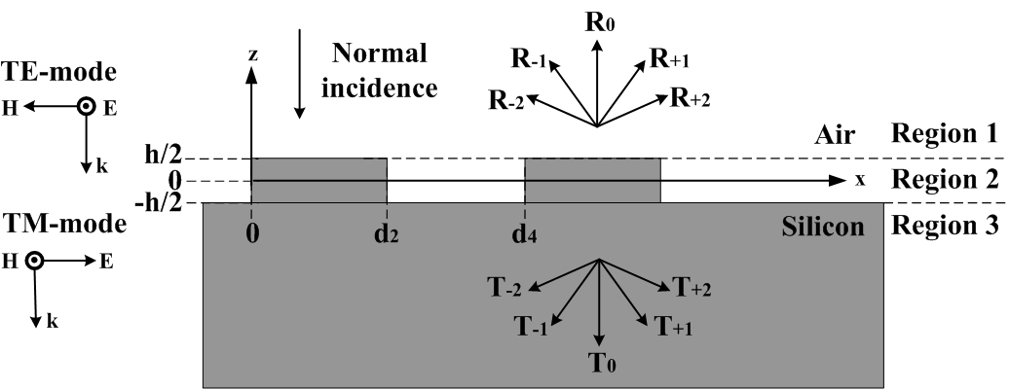

**Figure 2.** Schematic of TE-mode, TM-mode and fragment of a grating structure. *(show d2 & d4 labels, periodic structure, y axis)*

The electric fields in region 1 () can be expressed as

 (1)

where we assume the incident wave has a unit amplitude and *Rt* is the relative amplitude of the *t*th-order reflected wave. (The first and second terms in right side of (1) are the incident wave and reflected waves, respectively.) The transmitted waves in region 3 () can be expressed as

 *(modify to square brakets)* (2)

where  for any integer *t*;  for *j* = 1, 3 (the region index);  is the grating period;  is the free-space wavelength;  is the relative dielectric constant in region *j*. 不影響一般性we choose the same number of terms for the reflected and transmitted components.

In region 2 (), the electric field can be expressed as







 (3)

 (4)

 (5)

The first two terms in right side of (3) are the expansion of the horizontal direction and the last two terms are the expansion of the vertical direction.

In Eq. 4, kz2 can be real (propagating mode along ±z) for small n, while kz2 can be imaginary for large n (decaying mode along ±z). Similarly from Eq. 5, kx2 covers modes with real and imaginary propagation constants, i.e. propagating and decaying modes, respectively. *(The effect of n/t ratio on the calculation efficiency should be further investigated.)*

In the same way, the electric field in region 4 can be expressed as







 (6)

 (7)

 (8)

In Eqs. 3-8,         and         are the unknown parameters within region 2 and region 4, respectively.

Next, the electric and magnetic fields should match the point-to-point electromagnetic boundary conditions (BC’s) [REF] at the two horizontal interfaces at and  as Eqs. 9-16; at the vertical interface at  as Eqs. 17 and 19; and at the periodically vertical interface at and  as Eqs. 18 and 20 to determine the unknown parameters. Along the boundary, we can choose many points to make the number of the BC equations more than the number of undetermined parameters so that the least square error method can be employed to obtain the best estimation of these parameters [REF].

Here we summarize the BC’s : (i) Horizontal boundary conditions:

  (9)

  (p) (10)

  (11)

  (p) (12)

  (13)

  (p) (14)

  (15)

  (16)

(ii) Vertical boundary conditions:

  (17)

  (18)

  (19)

  (20)

Besides, the commercial software, analytical method is RCWA, was used to verify the results calculated by FSEM. Then we use the FSEM to study the transmission behavior of air/silicon grating. To get different transmission values, in the case of 4 um period gratings, the wavelength was calculated once every 1 um from 14 um to 28 um. For each wavelength, the duty cycle was calculated once every 0.01 from 0.05 nm to 0.95 and the groove depth was calculated once every 10 nm from 100 nm to 6 μm.

    

 代表在區域1跟區域2 在z=h/2的交界處，從  取的點。



上述第一列方程式詳細說明:

 

 代表為 n* 1的矩陣。矩陣的長度與  的大小相同。

Ci 代表區域 i 的傅立葉展開係數。

1. *Rewrite the formulas to make them more readable. Make sure the size of the matrix to be clear.*
2. *Make the matrix element more transparent. Point out the important parameters.*
3. *Describe how to get the coefficient eq.*
4. *How to apply the LSEM method to the eq. to obtain the best estimation of the parameters. Need refs.*