**Open Source Programming Committee**

July 3rd 2023

Respected Principal Sir,

It is with great pleasure that we write to invite you to the disclosure of the Open Source Programming Committee on July 7th, 2023 to be our chief guest. The afternoon will commence with a lamp lighting, followed by the introduction of the committee and the showcase of all the projects done in the previous semesters, with ample time being given for Q&A and discussion during the formal proceedings.

I hope you are able to accept this invitation and we look forward to hearing from you.

Thanking You

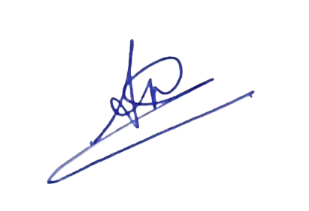Yours Sincerely,

Committee Members

Open Source Programming Committee

Anil Karaniya

*(Head)*

Prof. Shaikh Mohammad Umar Prof. Savita Loke Dr. Sharadkumar Shah

Co-ordinator IQAC Coordinator Principal