Ethical and Environmental Analysis

Year: 2019 Semester: Fall Team: 01 Project: IntelliFace

Creation Date: ­November 8, 2019 Last Modified: November 8, 2019

Author: Ishaan Ahuja Email: ahujai@purdue.edu

Assignment Evaluation:

|  |  |  |  |  |
| --- | --- | --- | --- | --- |
| **Item** | **Score (0-5)** | **Weight** | **Points** | **Notes** |
| **Assignment-Specific Items** | | | | |
| **Environmental Impact** |  | x6 |  |  |
| **Ethical Challenges** |  | x6 |  |  |
| **Writing-Specific Items** | | | | |
| **Spelling and Grammar** |  | x2 |  |  |
| **Formatting and Citations** |  | x1 |  |  |
| **Figures and Graphs** |  | x2 |  |  |
| **Technical Writing Style** |  | x3 |  |  |
| **Total Score** |  | | |  |

5: Excellent 4: Good 3: Acceptable 2: Poor 1: Very Poor 0: Not attempted

Comments:

1. Environmental Impact Analysis

The physical construction of the Intelligent Interface comprises of a lightweight acrylic reflective sheet, a wooden frame made from recycled wood, and ancillary support items such as steel nails. The inner components of the interface consist of a soldered Printed Circuit Board (PCB), an LCD monitor, and an NVIDIA Jetson Nano, along with smaller peripherals such as a camera, and individual sensor components used by the PCB including an infrared emitter and detector, a photocell, and a temperature sensor. All individual components used in the module are readily available for consumer purchase and use and have passed environmental standards as imposed by the producer and supplier. However, production of the interface may have a negative impact on the environment and can potentially result in biohazards if materials and waste are not disposed of properly, as well as improper discard of the system after its life. The concerns can be classified as assembly and post-service hazards.

1.1 Assembly Hazards

The LCD monitor and the Jetson Nano in use consists of plastic, glass and internal circuitry comprising of but not limited to potential carcinogens including lead, sulphates of iron and copper, and plastic usage. These are industry standard, and there is little room to mitigate risks of improper material usage in this component. However, as a precaution, producers that adhere to rigorous standards as imposed by the Environmental Protection Agency (EPA) are in consideration for usage in the interface.

Prior to the assembly of the system, the individual components that are used in the assembly such as the wooden panels that are sawed into a frame may yield splinters that if not handled and disposed of properly, may result in serious harm to an individual that comes into contact with these [1]. As the wood is made from recycled sources, the recycling stage of this involves crushing and re-purposing old wood, which could not only yield emissions that can be classified as hazardous, but also result in leftover shards of wood that can cut users and assemblers if not polished properly. As a result, the wood has to be sourced from vendors that offer a polished finish in order to reduce assembly hitches.

Acrylate polymer is a thermoplastic polymer that is used to produce the reflective surface needed for the system, and its production involves the usage of potentially harmful catalysts and the release of microfibers that contribute to oceanic pollution due to improper disposal [2]. The end product of this also yields a sheet with sharp edges that can wear over time, releasing acrylate particles that do not degrade easily. To mitigate these, this part needs to be sourced from vendors that practice safe production and disposal standards and avoid sheets with excessively sharp edges.

Production of the PCB involves chemical etching of wire traces, potentially involving lead acid and copper, the improper disposal of either considered a significant biohazard [3]. Cheaper PCB options result in acid deposits on the board and at the production site, both of which are harmful in the long run as they can reduce the life of the product and causes hazards at the production facility. Lead exposure in particular has been linked to increased risk of high blood pressure, heart and kidney diseases, and reduced fertility, and have been determined by the EPA as carcinogenic to humans [4]. To mitigate these risks, PCB vendors that opt for LeadFree packages and the practice of safe production with acid management are to be chosen for production.

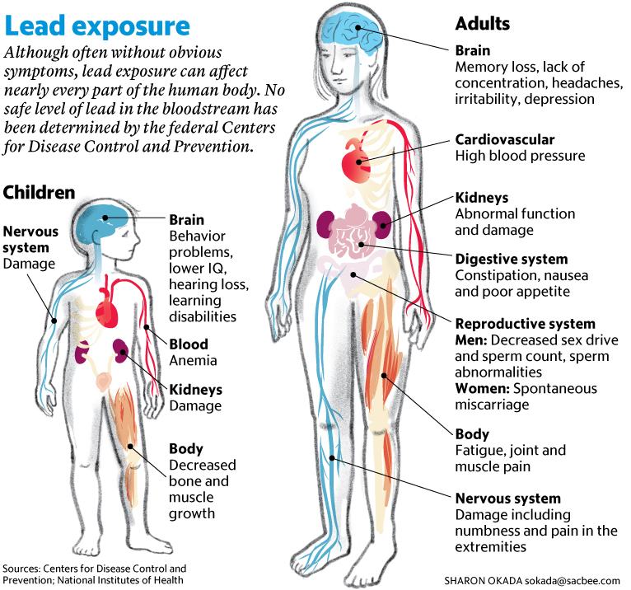

Figure 1: Effects of Lead Exposure on Adults and Children

1.2 Post-Service Hazards

After the device has served its life, its disposal is of critical importance to ensure that the residue of internal components and device construction materials do not degrade and leave traces of harmful chemicals into the environment. The acrylic sheet in particular, being a plastic polymer is not biodegradable and leaves traces of microfibers into the environment that can result in poisoned food sources to the local wildlife. The wooden components of the device can be disposed of easily as it does not house any circuitry in between divots and can be recycled.

The display, the PCBs and the Jetson all consist of electronic components, and potentially acid, lead deposits which cannot be disposed of as easily. The package will as a result have to be collapsible and insulated so the user can dismantle the package and separate these components from the rest of the system and can be either recycled or disposed of. However, proper care will need to be taken when disposing these as they contain lead deposits. As the individual components in use can be salvaged by most electronic stores, garbage disposals for scrap parts, these will need to be taken apart and disposed of individually.

1. Ethical Challenges

Production of parts and subjecting each part to software and hardware stressors will cause accompanying failures, some of which may cause physical harm to individuals, during production and usage alike. Production of these may also have ethical issues concerning safety practices. Outsourcing the PCB production out of the United States, for example, will cause ethical issues that stem from the labor practices that are standard in these countries that may be illegal in the U.S, issues like runoff disposal, safety precautions in use by the laborers, and even the usage of child labor, issues that are prevalent in economically developing countries. As a result, one such mitigation would be to either source the PCBs from American manufacturers that adhere to EPA and Department of Labor (DOL) standards [5], or to identify overseas vendors that manufacture at a lower cost but also follow standards that are comparable to American laws.

Ethical issues stemming from the usage of a camera to detect the user’s identity and unlock the dashboard are expected. In anticipation of these, the current system has been designed to run a local neural network and a facial feature identifier using the Haar Cascade Filter, as a result of which no user data is uploaded to the cloud and is preserved locally. The user’s data on the mirror dashboard that may be sensitive is also thus protected using the Face ID system [6] and warns the users of unauthorized accesses through an online API that is encrypted. Unencrypted transactions on the system are all public information, specifically the news and stocks data. The mail feature on the dashboard currently retrieves data from the ECE477 Postfix Mail server, and all transactions are done through the Secure Communication Protocol (SCP), with AES data encryption prior to transmission. These security measures are standard across most software companies, and it stands to reason that the system should also bear the load of industry standards.

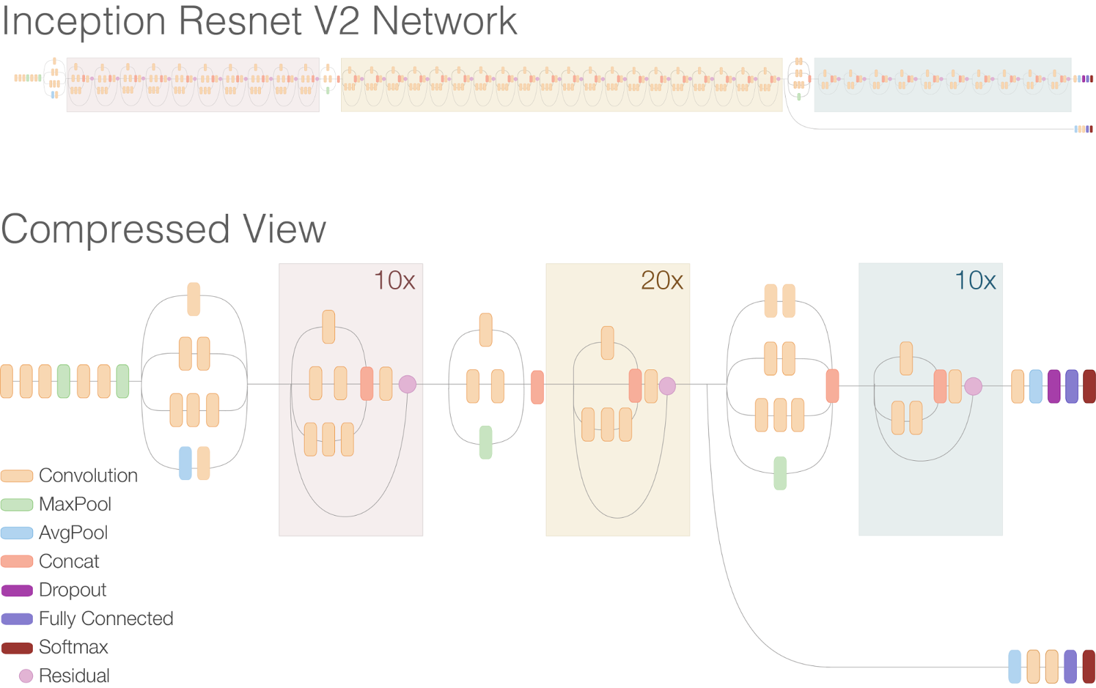

Figure 2: Current Face ID Network Model (based on Inception)

The presence of a camera on the Jetson is a security vulnerability that may compromise the user’s privacy post a successful security breach. As a result, this can be used to monitor the user’s activity, and as a result needs to be properly secured through the usage of proper security protocols. One particular way of doing this is to secure the webcam’s permissions as accessible by the superuser (sudo) only and securing sudo access with a 2FA Hardware authentication method such as a Yubikey [7] that would ensure that only in-situ users have Jetson interactivity access, thereby sealing network breaches. The same procedure can be implemented for the other components of the mirror, such as API Calls, Mail transactions, and the dashboard operations.

Physical harm can result as a result of poor production standards, and an ethical consideration to be made is increasing production cost to meet more safety standards, especially when handling woodwork and the acrylic surface. Failure to spend adequate resources on polishing sharp edges can result in a proportional increase in cuts during factory production, as well as a plausible risk to users. As a result, it is best to avoid sharp edges entirely in favor of a rounded edge approach which will drive up costs of production and purchase but mitigate future problems.

1. Sources Cited

[1] United States Department of Agriculture, “Successful Approaches to Recycling Urban Wood Waste,” *General Technical Report FPL-GTR-133*, Oct. 2002.

[2] A. Meghan. J., “What are Acrylates: Chemical Free Living,” *Force of Nature*, 24-Jan-2017. [Online]. Available: https://www.forceofnatureclean.com/chemical-free-living-acrylates/.

[3] D. Xiang, P. Mou, J. Wang, G. Duan, and H. C. Zhang, “Printed circuit board recycling process and its environmental impact assessment,” *The International Journal of Advanced Manufacturing Technology*, vol. 34, no. 9-10, pp. 1030–1036, Jun. 2006.

[4] CDC, “CDC - Lead: Health Problems Caused by Lead - NIOSH Workplace Safety and Health Topic,” *Centers for Disease Control and Prevention*, 18-Jun-2018. [Online]. Available: https://www.cdc.gov/niosh/topics/lead/health.html.

[5] DOL, “Summary of the Major Laws of the Department of Labor,” *U.S. Department of Labor*. [Online]. Available: https://www.dol.gov/general/aboutdol/majorlaws.

[6] M. Z. Alom, M. Hasan, C. Yakopcic, T. M. Taha, and V. K. Asari, “Improved inception-residual convolutional neural network for object recognition,” *Neural Computing and Applications*, Apr. 2018.

[7] R. Künnemann and G. Steel, “YubiSecure? Formal Security Analysis Results for the Yubikey and YubiHSM,” *Security and Trust Management Lecture Notes in Computer Science*, pp. 257–272, 2013.