Mechanical Overview

Year: 2019 Semester: Fall Team: 1 Project: IntelliFace

Creation Date: September 19, 2019 Last Modified: September 19, 2019

Author: Pratyaksh Sharma Email: sharm235@purdue.edu

Assignment Evaluation:

|  |  |  |  |  |
| --- | --- | --- | --- | --- |
| **Item** | **Score (0-5)** | **Weight** | **Points** | **Notes** |
| **Assignment-Specific Items** | | | | |
| **Commercial Packaging Analysis 1** |  | x2 |  |  |
| **Commercial Packaging Analysis 2** |  | x2 |  |  |
| **CAD Model Illustrations** |  | x4 |  |  |
| **Project Packaging Specifications** |  | x2 |  |  |
| **PCB Footprint Layout** |  | x2 |  |  |
| **Writing-Specific Items** | | | | |
| **Spelling and Grammar** |  | x2 |  |  |
| **Formatting and Citations** |  | x1 |  |  |
| **Figures and Graphs** |  | x2 |  |  |
| **Technical Writing Style** |  | x3 |  |  |
| **Total Score** |  | | |  |

5: Excellent 4: Good 3: Acceptable 2: Poor 1: Very Poor 0: Not attempted

Comments:

1. Commercial Product Packaging

We have analyzed three products that are functional intelligent mirror interfaces performing tasks similar to our product, for sale in the market currently. These are MIRROR Home Gym and Embrace Smart Mirror. Below are their individual analyses.

* 1. Product #1: Embrace Smart Mirror

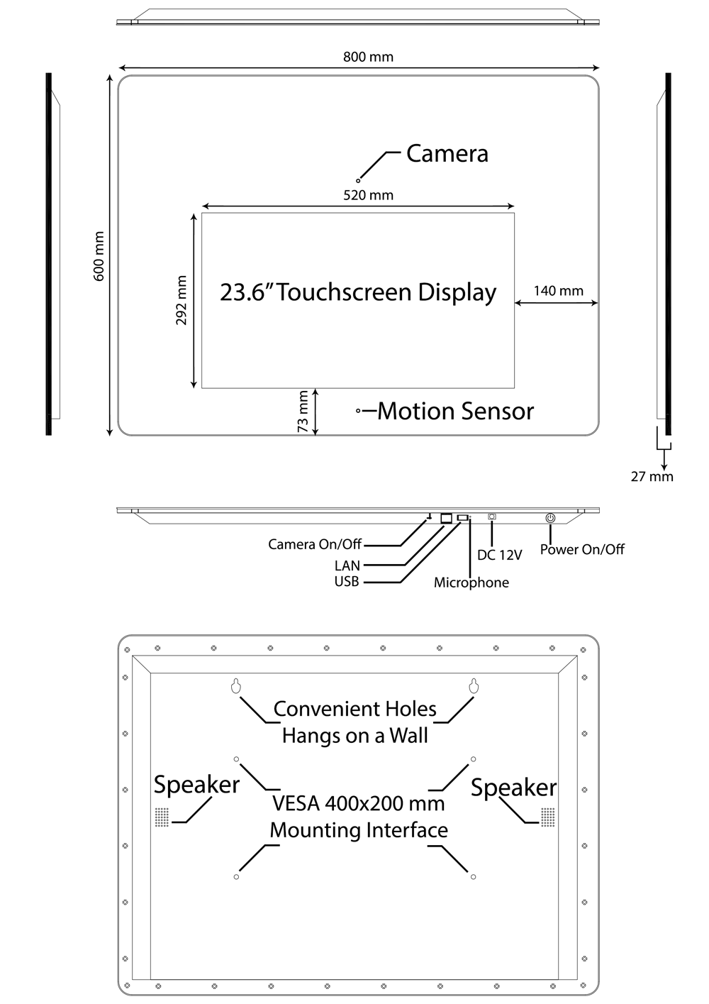

*Figure 1: Packaging for Embrace Smart Mirror [1]*

The Embrace Smart Mirror is packaged within a wooden package, with edges carved out for easy insertion and removal of a 31x24” mirror panel, with a 23.6” touchscreen display mounted into the mirror, blending in with the reflective surface. It also features holes in the back for wall-mounting, speaker slots for sound exit from the speakers packaged behind the mirror surface.

The wooden packaging, with silicone edges was designed to limit moisture inflow into the mirror gaps, as this could damage the internal circuitry. The primary purpose of this being a bathroom mirror replacement, this is not required on our packaging, but due inspiration can be derived from the monitor and camera placement, as well as the hole drill areas.

The mirror surface itself being a monitor-mirror fuse [Figure 1], this allows the user to operate the mirror surface using a touchscreen which could seriously lower the life of mirror interactivity especially after repeated usage of the touch panel under humid or moist conditions. Our choice of a series of infrared sensors to read gestures is a less power intensive solution, as well as being better suited for long-term usage.

* 1. Product #2: MIRROR Home Gym

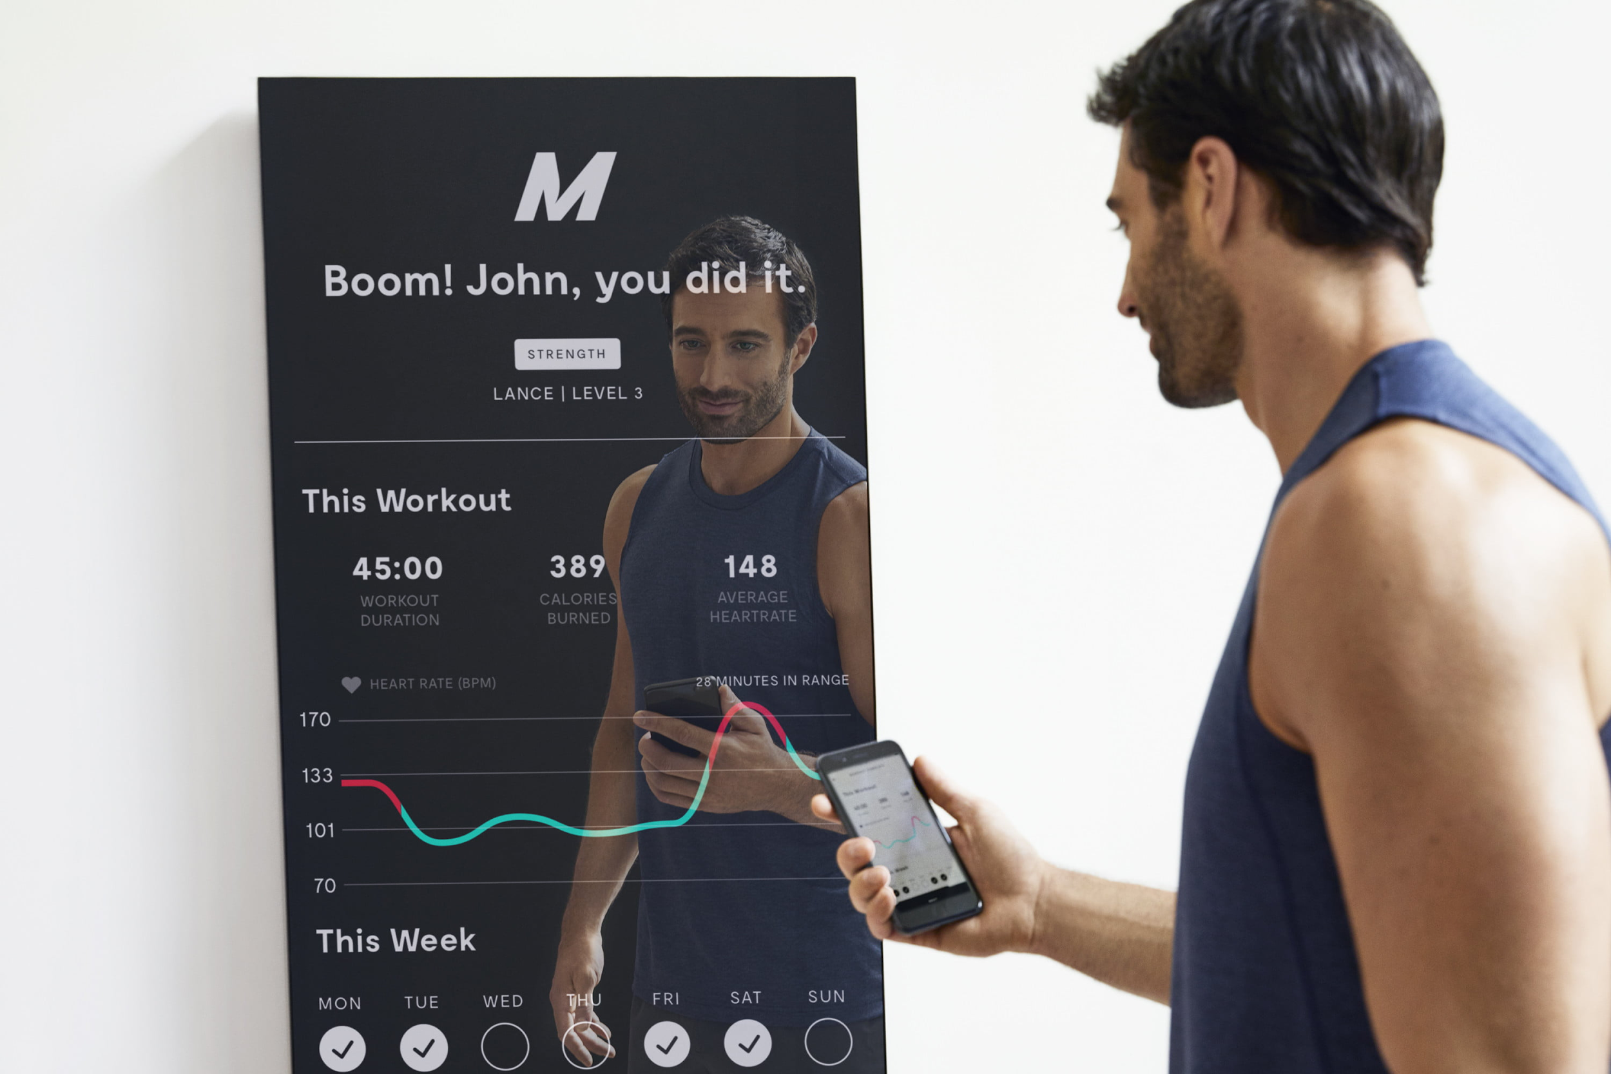

*Figure 2: MIRROR Home Gym Packaging and function [2]*

The MIRROR Home Gym is packaged within a wooden case with minimal visible rims at face value, the mirror surface being glued into a carefully etched panel in the frame. This offers the appearance of seeming “borderless”, with the mirror concealing a 23” monitor with true-tone dark display to only display metrics without obstructing the user’s reflection.

As this mirror’s purpose is to compete with the likes of smart-gym equipment such as the Peloton Cycle, this is operable in conditions that are optimal for electronic functioning, non-arid, non-humid zones in the house similar to our mirror’s use case. This features a stand for table-top placement, and heavy-duty hinges to handle the large weight from the mirror and the monitor it hides. The interactivity on the mirror surface is completely from a smart-home control system, recommended devices being the Amazon Alexa and through the appropriate applications on iPhone and Android devices.

The mirror is not intended to take any damage from the likes of harsh room conditions, and drops, and its developers have hence attempted to maximize the aesthetics of this product, building a thin, large frame cleverly concealing a monitor similar to what we plan to do. The lack of any input devices besides the user’s personal gadgets is the primary reason for a lack of etches and holes besides the hinges, which will differ from our construction. Like the previous product, the usage of an actual glass mirror also weighs down this product, whereas opting for a cheaper acrylic mirror like what we plan on going with offers a lighter solution.

3.0 Sources Cited

[1] Mirror.co. (2019). *The Nearly Invisible Interactive Home Gym | MIRROR*. [online] Available at: https://www.mirror.co/ [Accessed 19 Sep. 2019].

[2] Embrace The Smart Mirror. (2019). *Embrace™ Smart Mirror. The First Full-featured Touchscreen Smart Mirror*. [online] Available at: https://www.embracesmartmirror.com/ [Accessed 19 Sep. 2019].

[3] Piltch, A. (2019). *Nvidia Jetson Nano: the Raspberry Pi of AI?*. [online] Tom's Hardware. Available at: https://www.tomshardware.com/news/jetson-nano-features-price,38856.html [Accessed 19 Sep. 2019].

Appendix 1: CAD Model Illustrations

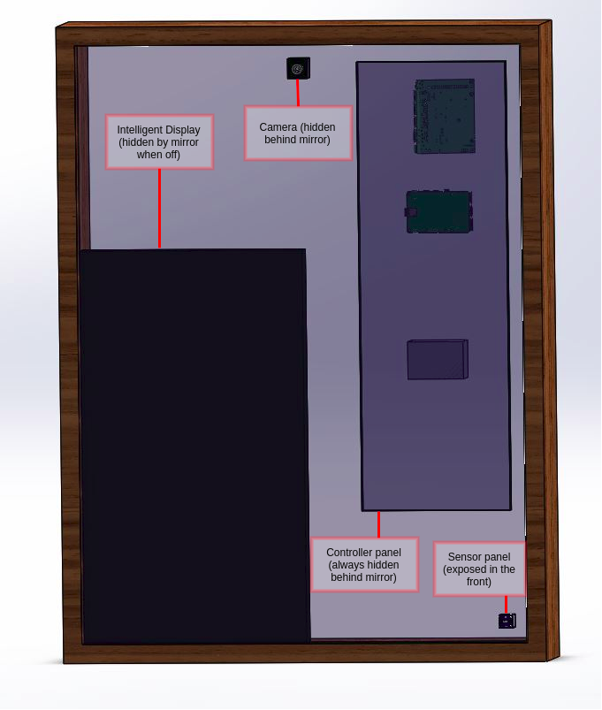

*Figure 3: Device Front View*

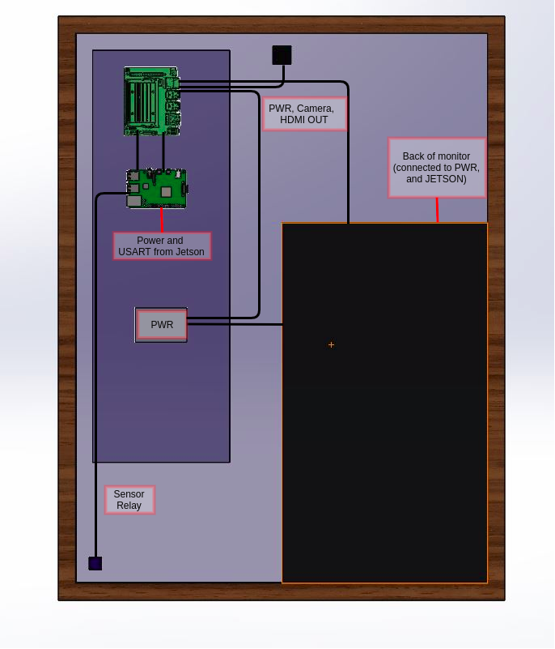

*Figure 4: Device Back View*

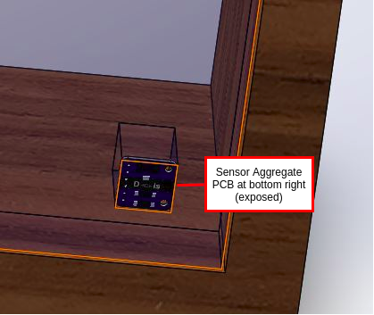

*Figure 5: Sensor Attachments*Appendix 2: Project Packaging Specifications

|  |  |  |  |
| --- | --- | --- | --- |
| **Component** | **Dimension** | **Weight** | **Cost (USD)** |
| Acrylic Mirror | 32’’ x 24’’ | < 6 lbs | $25 |
| HDMI Monitor | 21’’ x 12” | 3.6 lbs | $75 |
| Wooden Frame | 32’’ x 24’’ | 2.2 lbs | $25 |
| STM32F0 PCB | 3.15” x 3.15” | 0.1 lbs | $30 |
| Nvidia Jetson Nano | 3.8” x 3” | 0.3 lbs | $99 |
| Power cord and adapter | 2” x 1.5” | 0.4 lbs | $9 |
| MIPI CSI2 Camera | 1” x 1” | ~0 lbs | $15 |

*Table 1: Components, Dimension, Weight, and cost [3]*

Appendix 3: PCB Footprint Layout

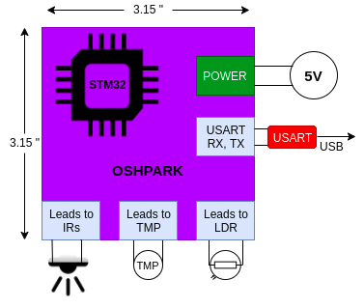

*Figure 6: Primary PCB Basic Footprint Layout*