Component Analysis

Year: 2019 Semester: Fall Team: 1 Project: IntelliFace

Creation Date: 09/05/2019 Last Modified: 12/09/2019

Member 1: Rtvik Sriram Bharadwaj Email: bharadwr@purdue.edu

Member 2: Ishaan Ahuja Email: ahujai@purdue.edu

Member 3: Pratyaksh Sharma Email: sharm235@purdue.edu

Member 4: Abhay Sasidharan Email: asasidh@purdue.edu

Assignment Evaluation:

|  |  |  |  |  |
| --- | --- | --- | --- | --- |
| **Item** | **Score (0-5)** | **Weight** | **Points** | **Notes** |
| **Assignment-Specific Items** | | | | |
| **Analysis of Component 1** | 3.5 | x2 | 7 |  |
| **Analysis of Component 2** | 5 | x2 | 10 |  |
| **Analysis of Component 3** | 5 | x2 | 10 |  |
| **Bill of Materials** | 4 | x6 | 24 |  |
| **Writing-Specific Items** | | | | |
| **Spelling and Grammar** | 5 | x2 | 10 |  |
| **Formatting and Citations** | 5 | x1 | 5 |  |
| **Figures and Graphs** | 5 | x2 | 10 |  |
| **Technical Writing Style** | 5 | x3 | 15 |  |
| **Total Score** | 91 | | |  |

5: Excellent 4: Good 3: Acceptable 2: Poor 1: Very Poor 0: Not attempted

General Comments:

1.0 Component Analysis:

The team has converged on using the STM32F0 microcontroller in order to read data from the different sensors. The TMP36 temperature sensor will be used to measure the room temperature, which will then be displayed on the mirror. A GM5539 light dependent resistor will be used to read the light intensity of the room and it will be used to adjust the contrast of the mirror’s monitor. A GP2Y0A21YK0F IR sensor will be used to detect the presence of the user and will activate the display upon interaction. The Jetson Nano will be used as the main brain of the project as it can be used to train the facial recognition models and to display the user interface. The images will be read through a MIPI camera.

1.1 Analysis of Component 1: STM32F0 Microcontroller

The functional specifications suggests that project requires a microcontroller with adequate general purpose input and output pins and different timer channels. All team members have prior experience with microcontrollers from the STM32 family and the MSP430 family; hence, we decided to conduct comparisons between the STM32F051R8T6 and MSP430FR.

It is noted that the MSP430FR is a more expensive microcontroller unit, with a similar clock speed, same amount of RAM, but significantly more timer channels and UART channels. The STM32F0 has a 48 megahertz clock, 8 KB of RAM, 9 timer channels and 2 UART channels [1]. Nevertheless, the team decided to go with the STM32F0 because it is far more financially feasible and it will get the job done, as well as prior experience for all team members. The team needs a microcontroller that will allow us to interact with the temperature, light and infrared sensors seamlessly and it will not be conducting any computationally difficult task. The STM32F0 fulfills the requirements of the project’s functional specifications.

|  |  |  |
| --- | --- | --- |
| MCU | STM32F0 | MSP430FR |
| Clock Speed | 48 MHz | 48 MHz |
| RAM | 8 KB | 8 KB |
| Operating Voltage | 2.0V to 3.6 V | 1.8V to 3.6V |
| Timer | 8 | 12 |
| UART | 2 | 4 |

*Table 1: STM32F0 and* MSP430FR *side-by-side comparison [1]*

The presence of 8 timers and 2 UARTs on the STM32F0 was deemed as sufficient for our operations on the STM32F0, as they handle the data aggregated from 3 sensors running asynchronously on an interrupt-enabled timer. The presence of three sensors to integrate (primarily) has also removed the need for a clock speed greater than 48 MHz.

1.2 Analysis of Component 2: TMP36 Temperature Sensor

The team looked into the options of using the TMP36 temperature sensor from Analog Devices and the LM34 sensor from TI. Our research suggested that the TMP36 has a temperature range between -40°C to 125°C while the LM34 has a range between -45.56°C to 148.9°C. The operating voltage of the TMP36 is between 2.7V to 5.5V while the operating voltage of the LM34 is between 5V to 30V [2]. While the range of the temperature sensor is of a great deal of importance, it should be noted that the project is designed to be stationed indoors, where large temperature fluctuations are atypical. The team decided to go with TMP36 because it is a far more economical choice and it is paramount that power consumption is minimized.

|  |  |  |
| --- | --- | --- |
| Model | TMP36 | LM34 |
| Range | -40°C to 125°C | -45°C to 150°C |
| Error Margin | ±2°C | ±2.0°C |

*Table 2:* TMP36 *and* LM34 *side-by-side comparison [2]*

1.3 Analysis of Component 3: MIPI Camera IMX219-160

MIPI is an organization that develops interfaces for microcontroller based mobile projects [5]. The MIPI CSI-2 is a protocol interface that the IMX219-160 camera we have chosen depends upon [4]. This chosen camera features an 8 MP 3280x2464 resolution which we have deemed as sufficient for our needs. We have elected to use MIPI over USB Cameras due to the presence of a dedicated MIPI port in the Jetson Nano to which it is to be connected. Although the Jetpack OS that the Jetson uses does not support native camera compatibility for MIPI using legacy apps, this can be handled using Python Tkinter libraries and existing open-source projects to achieve results [3].

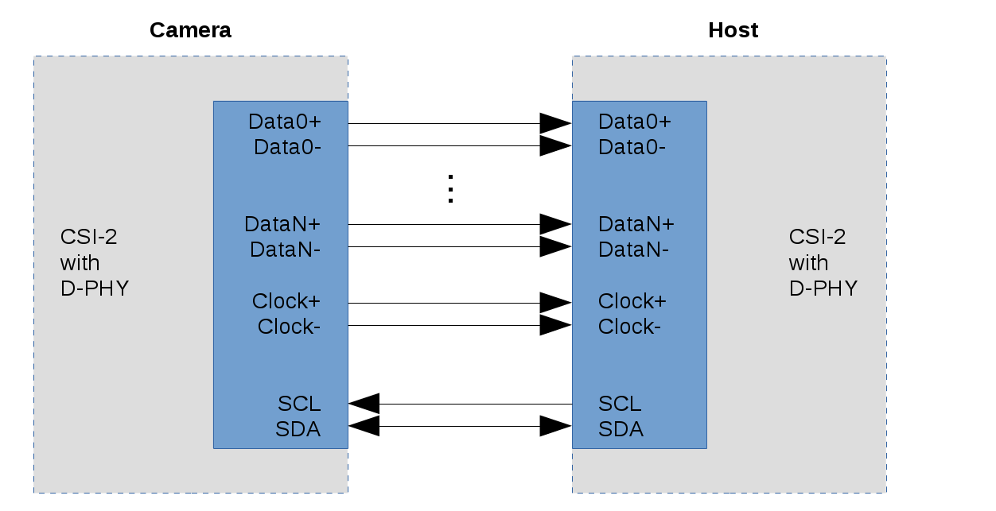

*Figure 1: MIPI Camera interfacing with Host*

Competing products offered from the same MIPI camera line all offer features that are not necessary for our product, tabulated below. By process of elimination, we selected IMX219-160 for its lower price and barebones features.

|  |  |  |  |
| --- | --- | --- | --- |
| Model | Resolution | Features | Price (USD) |
| IMX219-160 | 8MP 3280x2464p | 160° FOV | 29.96 |
| IMX219-160IR | 8MP 3280x2464p | 160° FOV, IR Detection | 31 |
| IMX219-170 | 8MP 3280x2464p | 170° FOV | 31.95 |

*Table 3: MIPI Camera Line and feature list [4]*

1.4 Analysis of Component 4: GP2Y0A21YK0F IR Sensor

The IR Sensor that we plan to use is the GP2Y0A21YK0F sensor. The other option was the HC SR504 PIR. The GP2Y0A21YK0F has a higher power consumption, the GP2Y0A21YK0F seemed like a far more feasible choice because of its through-hole technology and its seamless integration with our PCB design. There were several other potential candidates for the IR sensor, such as the ones that came in pairs. For example, the KY-005 and KY-022 is a transmitter-receiver pair that is used for a fairly long range of detection (up to 7 meters). This is not necessary for our use case since the user will be extremely close to the mirror while interacting with it. Moreover, all the other sensors add unnecessary overhead to the PCB design, which is alleviated by using the GP2Y0A21YK0F IR sensor.

|  |  |  |
| --- | --- | --- |
|  | GP2Y0A21YK0F | HC SR504 PIR |
| Power Consumption | 100 mW | 65 mW |

*Table 4: GP2Y0A21YK0F and HC SR504 PIR side-by-side comparison [10]*

1.5 Analysis of Component 5: Jetson Nano

The Nvidia Jetson Nano was chosen as a supplemental board to complement the functions of the STM32F0, primarily handling the dashboard and image operation component of the project. This segment of the project required a high resolution display combined with available neural networking libraries which are predominantly available on Golang and Python [6]. The Jetson is compatible with a MIPI alliance camera, which we have chosen for our needs. The high computational power of the Jetson Nano deemed it a suitable contestant for this role in our project, beating the likes of the more expensive, powerful Jetson TX2 which would have driven up our budget significantly. The newer Raspberry Pi 3B+ and 3A+ were also omitted in favor of the Jetson Nano, as we chose to compromise a slightly higher price for performance, as well as the Pi’s base purpose being unsuitable for our image analysis needs [8].

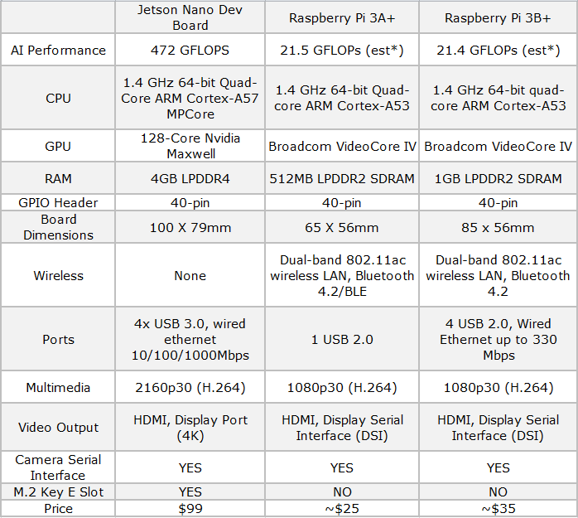

*Figure N: Jetson Nano with competitor devices*

The availability of 4 USB ports and a 4K HDMI port allows us to push the essential requirements of the project beyond what was intended, and deliver a better product, while allowing the leeway to experiment with other technology, namely a more sensitive wireless gesture reader, high-quality cameras for crisper images when performing image filter operations, as well as using the extra ports for a mouse and keyboard that would allow us to program onto the Jetson Nano directly.

**1.6 Analysis of Component 6: GM5539 Light Dependent Resistor**

The team has decided to use a GM5539 Photo Light Sensitive Resistor. The other possible candidate was the 4N35 phototransistor. The resistor has to be sensitive to electromagnetic radiation in the visible spectrum, because its purpose is to detect fluctuations in the room’s light intensity. Hence, the resistor’s sensitivity to other frequencies such as UV or IR are irrelevant. The GM5539 and the 4N35 meet the requirements of the functional specifications in this regard. However, the 4N35 has a power consumption of 150 mW while the GM5539 is expected to consume 100 mW [9]. It is in the team’s best interest to keep power consumption from the sensors as low as possible to make room for the other computationally heavy tasks.

2.0 Sources Cited:

[1] ST.com. (2018). STM32F0 Series. [online] Available at: https://www.st.com/en/microcontrollers/stm32f0-series.html?querycriteria=productId=SS1574 [Accessed 6 Sep. 2019].

[2]Analog.com. (2018). TMP35/TMP36/TMP37. [online] Available at: http://www.analog.com/media/en/technical-documentation/data-sheets/TMP35_36_37.pdf [Accessed 6 Sep. 2019].

[3] JetsonHacks. (2019). *Jetson Nano + Raspberry Pi Camera - JetsonHacks*. [online] Available at: https://www.jetsonhacks.com/2019/04/02/jetson-nano-raspberry-pi-camera/ [Accessed 6 Sep. 2019].

[4] Amazon.com. (2019). *IMX219-160 Jetson Camera*. [online] Available at: https://www.amazon.com/gp/product/B07T43K7LC/ref=ppx_yo_dt_b_asin_title_o03_s00?ie=UTF8&psc=1 [Accessed 6 Sep. 2019].

[5] MIPI. (2019). *MIPI Camera Serial Interface 2 (MIPI CSI-2)*. [online] Available at: https://www.mipi.org/specifications/csi-2 [Accessed 6 Sep. 2019].

[6] Expert, D. (2019). *Golang Vs Python: Which Language Is Best for AI Programming*. [online] QArea Blog. Available at: https://qarea.com/blog/golang-vs-python-which-language-is-best-for-ai-programming [Accessed 6 Sep. 2019].

[7] Offsky, M. (2019). *10 Uses for Nvidia Jetson Nano Developer Kit - Maks Surguy's blog on Technology Innovation, IoT, Design and Code*. [online] Maks Surguy's blog on Technology Innovation, IoT, Design and Code. Available at: https://maxoffsky.com/code-blog/10-uses-for-nvidia-jetson-nano-developer-kit/ [Accessed 6 Sep. 2019].

[8] Make Tech Easier. (2019). *Nvidia Jetson Nano vs. Raspberry Pi - Make Tech Easier*. [online] Available at: https://www.maketecheasier.com/nvidia-jetson-nano-vs-raspberry-pi/ [Accessed 6 Sep. 2019].

[9] “Optocoupler, Phototransistor Output, with Base Connection,” Arduino. [Online]. Available: https://www.arduino.cc/documents/datasheets/opto-4n35.pdf. [Accessed: 06 Sep 2019].

[10] “HC-SR501 PIR MOTION DETECTOR,” Marlin P Jones & Assoc Inc. [Online]. Available: https://www.mpja.com/download/31227sc.pdf. [Accessed: 06 Sep 2019].