User Manual

Year: 2019 Semester: Fall Team: 01 Project: IntelliFace

Creation Date: 11/15/2019 Last Modified: 12/09/2019

Author: Abhay Sasidharan Email: asasidh@purdue.edu

Assignment Evaluation:

|  |  |  |  |  |
| --- | --- | --- | --- | --- |
| **Item** | **Score (0-5)** | **Weight** | **Points** | **Notes** |
| **Assignment-Specific Items** | | | | |
| **Product Description** | 5 | x1 | 5 |  |
| **Product Illustration** | 5 | x2 | 10 |  |
| **Setup Instructions** | 5 | x3 | 15 |  |
| **Usage Instructions** | 5 | x3 | 15 |  |
| **Troubleshooting Instructions** | 4.5 | x3 | 13.5 |  |
| **Writing-Specific Items** | | | | |
| **Spelling and Grammar** | 5 | x2 | 10 |  |
| **Formatting and Citations** | 5 | x1 | 5 |  |
| **Figures and Graphs** | 5 | x2 | 10 |  |
| **Technical Writing Style** | 5 | x3 | 15 |  |
| **Total Score** | 98.5 | | |  |

5: Excellent 4: Good 3: Acceptable 2: Poor 1: Very Poor 0: Not attempted

Comments:

1. Product Description

The Intelligent Interface is a product designed for indoor use and it is built to provide the user an interface with the necessary information needed to start the day, such as email highlights, stock updates, major news events and weather forecasts. Additional functionality include a passive fire alarm monitor and an auxiliary face filter function akin to Snapchat filters, all controlled using an infrared gesture detector. The interface hence combines Internet-of-Things concepts to augment a daily essential, the mirror.

1. Product Illustrations

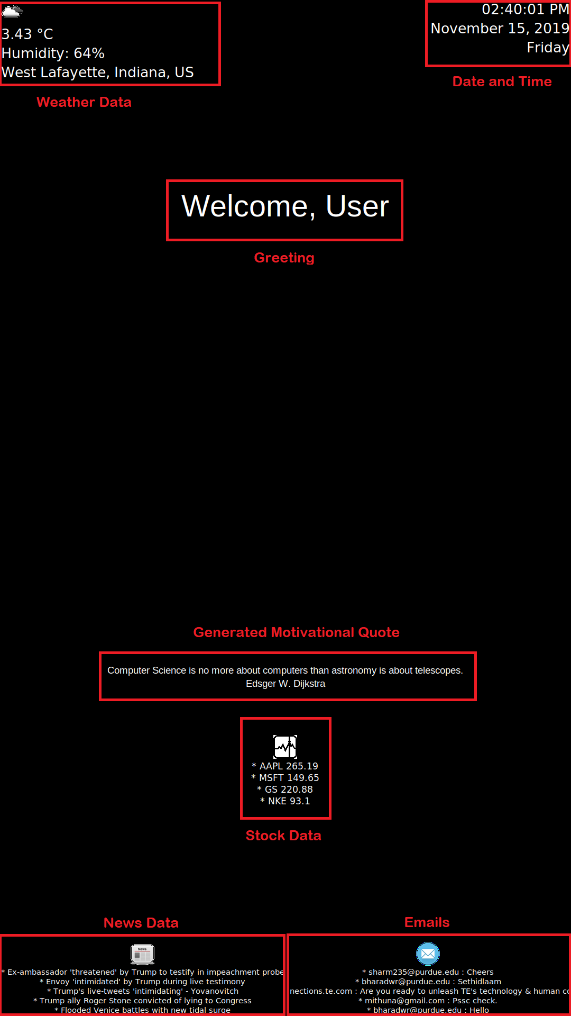

*Figure 1. Dashboard Interface*

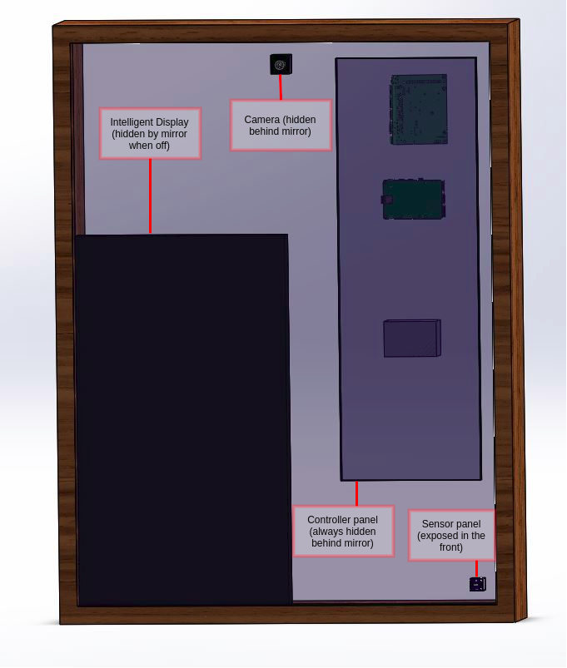

*Figure 2. Intelligent Interface Front*

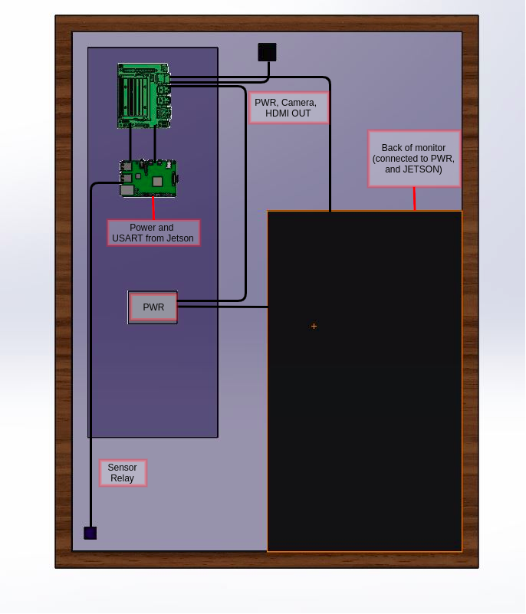

*Figure 3. Intelligent Interface Back*

1. Setup Instructions

Find an ideal location for the Intelligent Interface, such as a dressing table with nearby wall outlets and ethernet ports. The setup instructions are fairly simple.

1. Plug in the Intelligent Interface to a power outlet.
2. Ensure that the Intelligent Interface is able to connect to the internet using the ethernet cable.
3. Usage Instructions

After the interface has been successfully set up, it will wait for the user to follow the first time setup instructions as displayed, namely gesture sensor practice by testing the long and short wave gesture.

1. Open the interface from shutdown mode by holding your hand near the bottom right of the system in close proximity to the infrared sensor.
2. Wait for the orange ring around the camera to glow, indicating that the facial recognition is active, and look at the camera to open the interface dashboard. If the orange ring vanishes and the dashboard does not open, repeat Step 1. Else, move on to Step 3.
3. With the dashboard open, ensure that the dashboard displays all information as shown in Figure 1. Use the short wave gesture to use the auxiliary feature which opens the Facial Filter Module.
4. Use the long hold gesture to shut down the device from the auxiliary state or the dashboard state.
5. Troubleshooting Instructions

|  |  |  |
| --- | --- | --- |
| **Common Problems** | **Likely Cause** | **Solution Steps** |
| IntelliFace does not power up | No power | Connect IntelliFace to power |
| Dashboard widgets do not work | Poor internet connection | Ensure proper internet connection with ethernet cable |
| IntelliFace does not recognize or find users | Poor lighting or disconnected webcam | Ensure reliable lighting conditions and proper webcam connection |
| Brightness is fluctuating | Faulty connection with sensor panel | Ensure sensor panel is connected to system properly |
| Erratic temperature data | Faulty connection with sensor panel | Ensure sensor panel is connected to system properly |
| Gestures are not being recognised | Faulty connection with sensor panel | Ensure sensor panel is connected to system properly |

Safety Precautions

If the Intelligent Interface is used as a bathroom or dressing table mirror, it is possible that it may come into contact with different liquids. Ensure that the power cables are securely stowed away in order to minimize contact with liquids. The system uses gestures to recognize requests; hence, the appearance of fingerprints on the glass is not an issue. However, if the mirror gets foggy or dirty, use a dry microfiber cloth to wipe the surface in order to ensure that no scratches appear on the surface. Do not place the surface on precarious ledges or any areas with a potential to drop, which will cause glass fragments to scatter.

**Contact**

We would love to hear about your experience with IntelliFace!

If you have any comments or complaints, feel free to contact us and send your feedback to [ece477@ecn.purdue.edu](mailto:ece477@ecn.purdue.edu).