哈尔滨工业大学 计算学部
2024年秋季学期《开源软件开发实践》
Lab4：开源软件开发中的DevOps

学号 | 姓名 | 联系方式
2022112030 | 母运泽 | muyunze2009@outlook.com

目 录

1 实验要求 1
2 实验内容1 Github Actions DevOps实践 1
3 实验内容2 Jenkins DevOps实践 1
4 小结 1

实验要求
本次实验训练开源软件开发中的基本 DevOps 操作，具体来说：
·掌握开源软件开发中的基本 DevOps 流程和工具的使用
·熟悉利用 Github Actions 进行 DevOps
·熟悉利用 Jenkins 进行 DevOps

实验内容1 Github Actions DevOps实践
- 项目的目录结构：
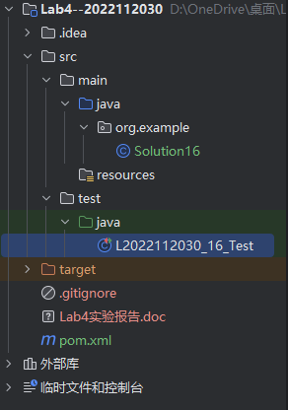
- 执行自动化测试成功界面：
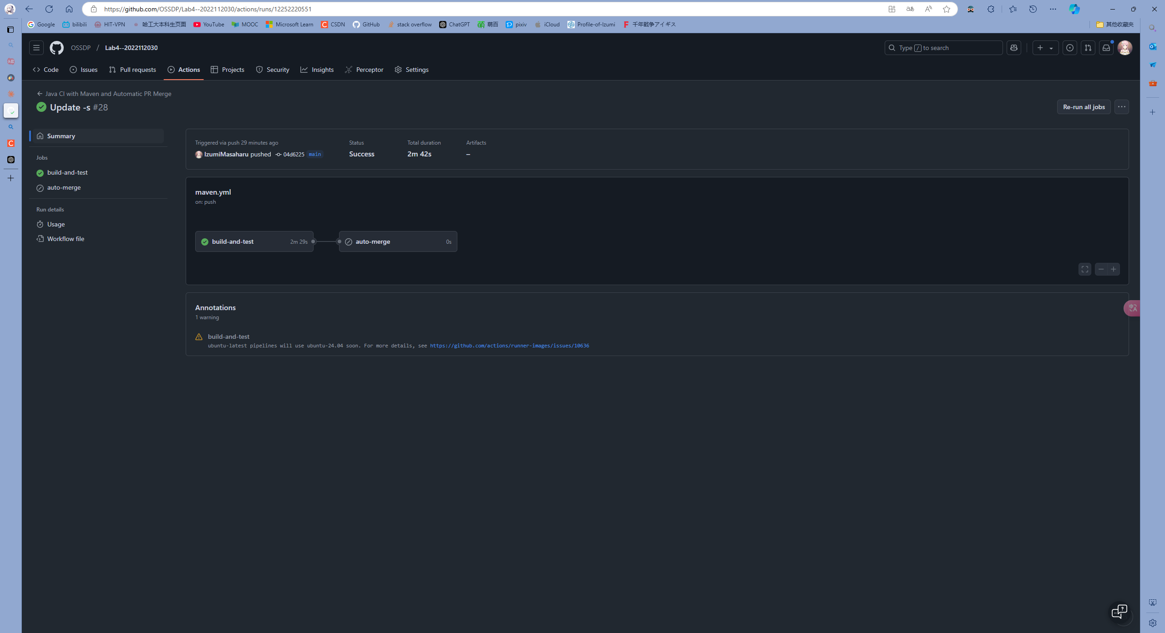
执行自动化测试失败界面：
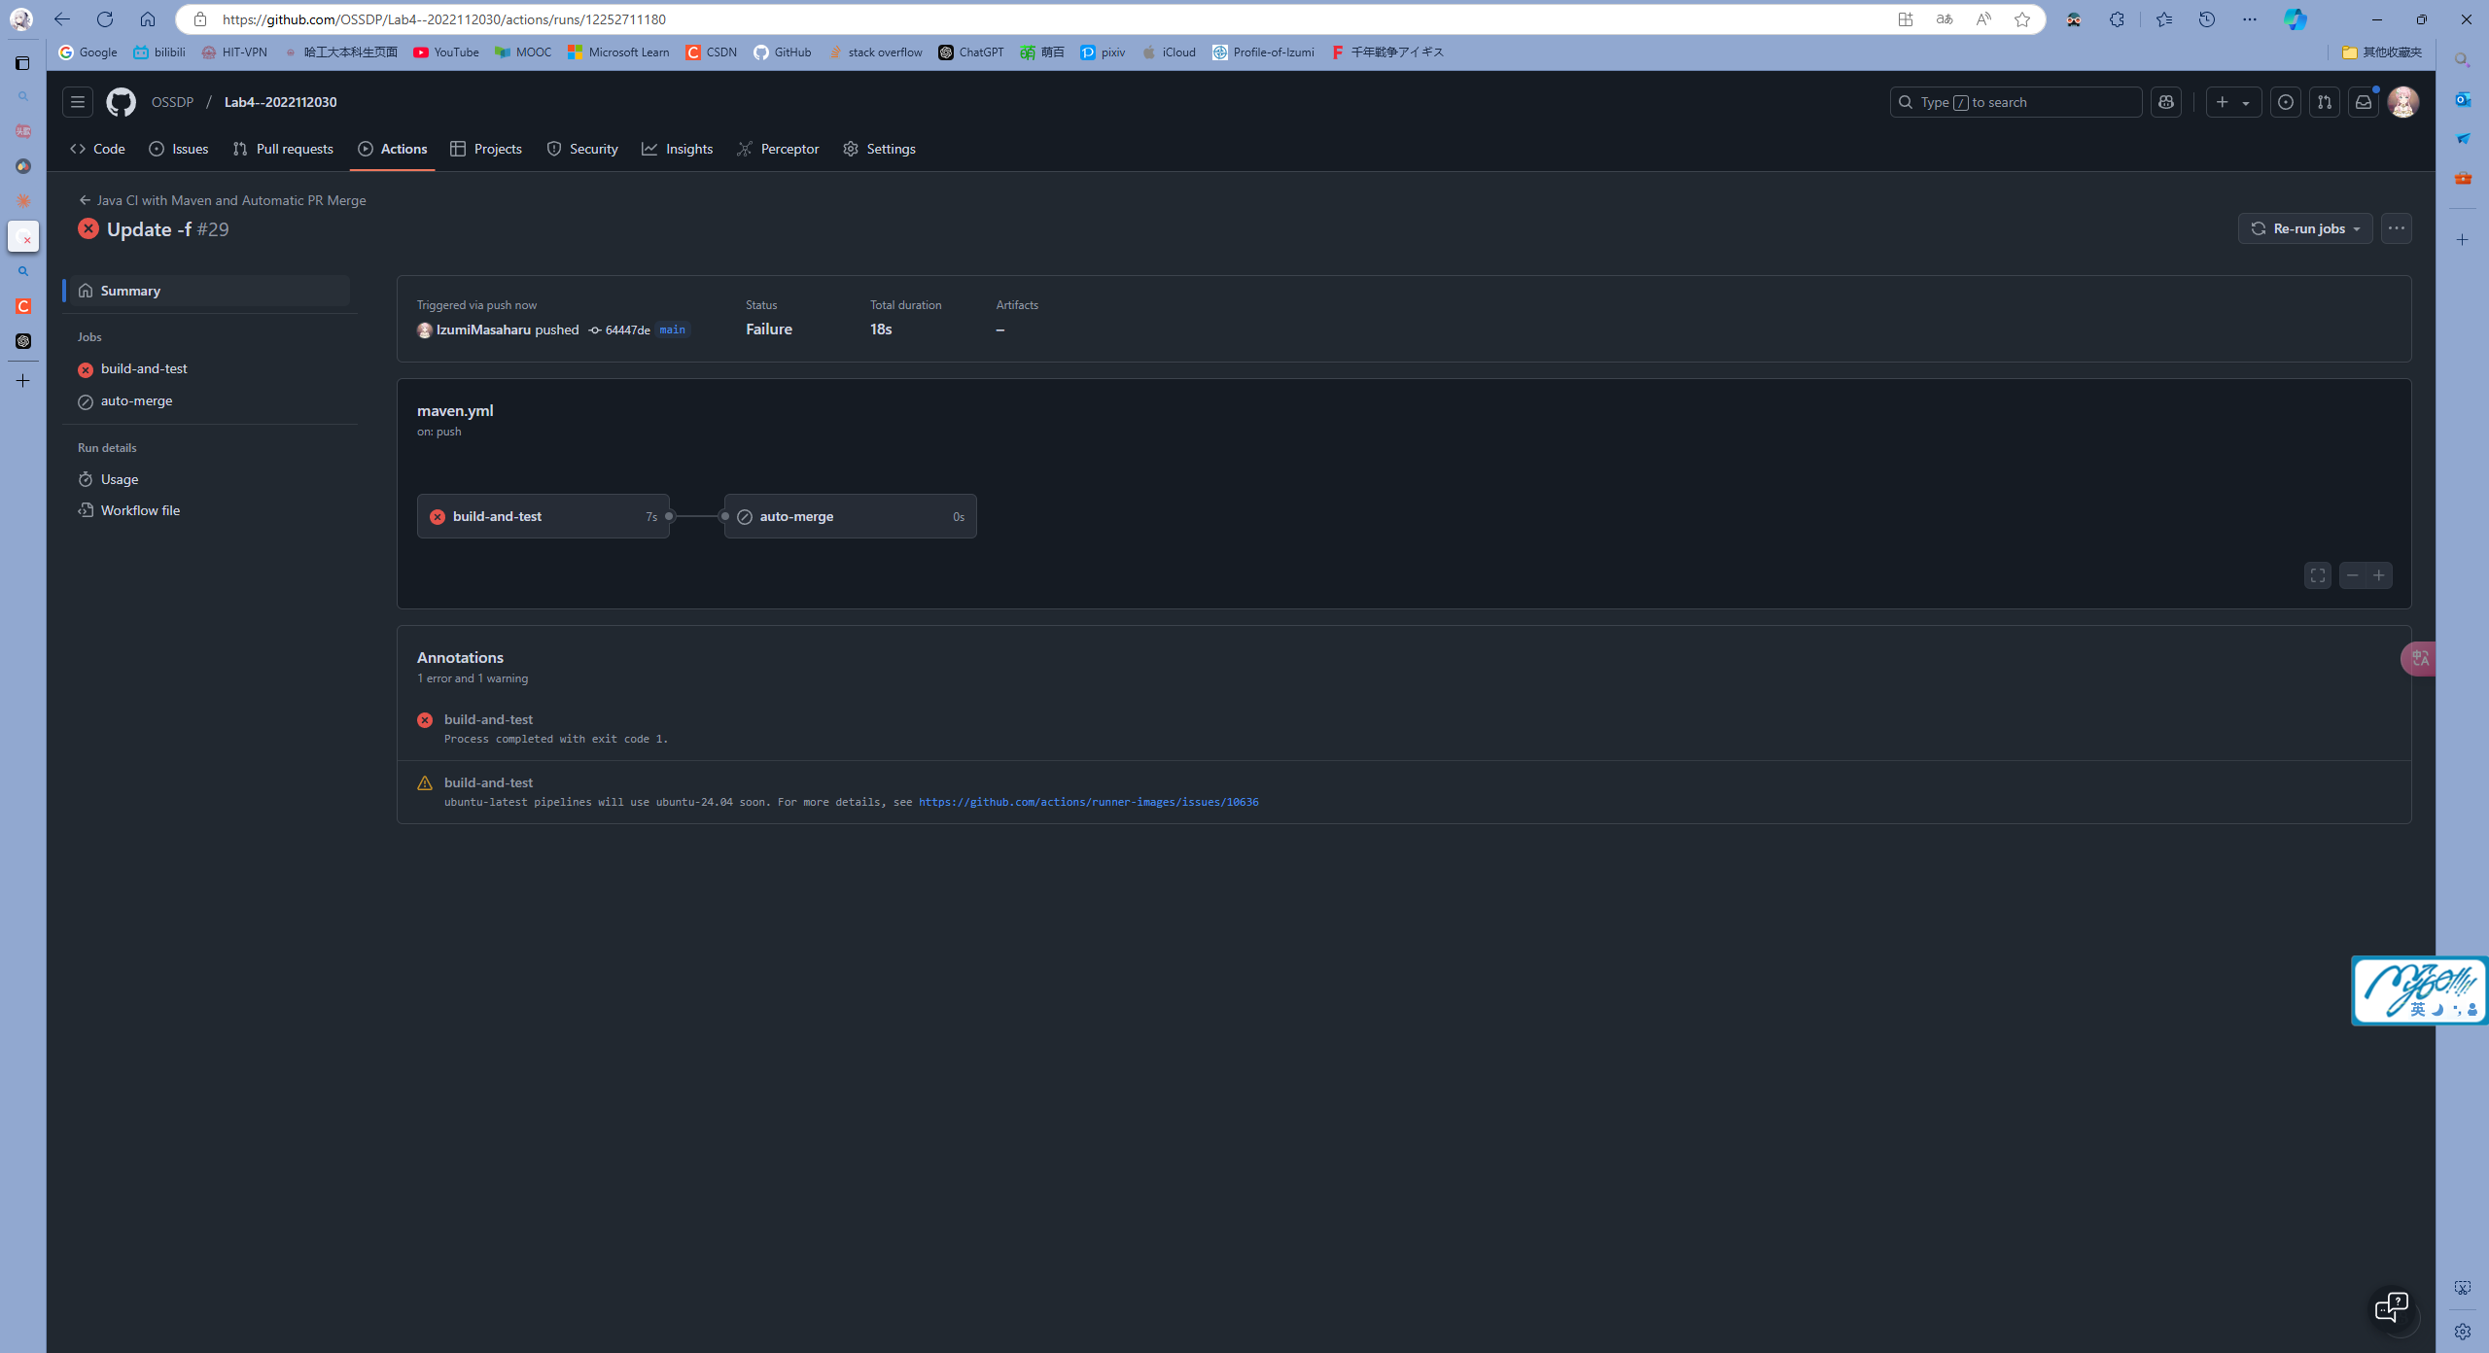
具体错误信息：
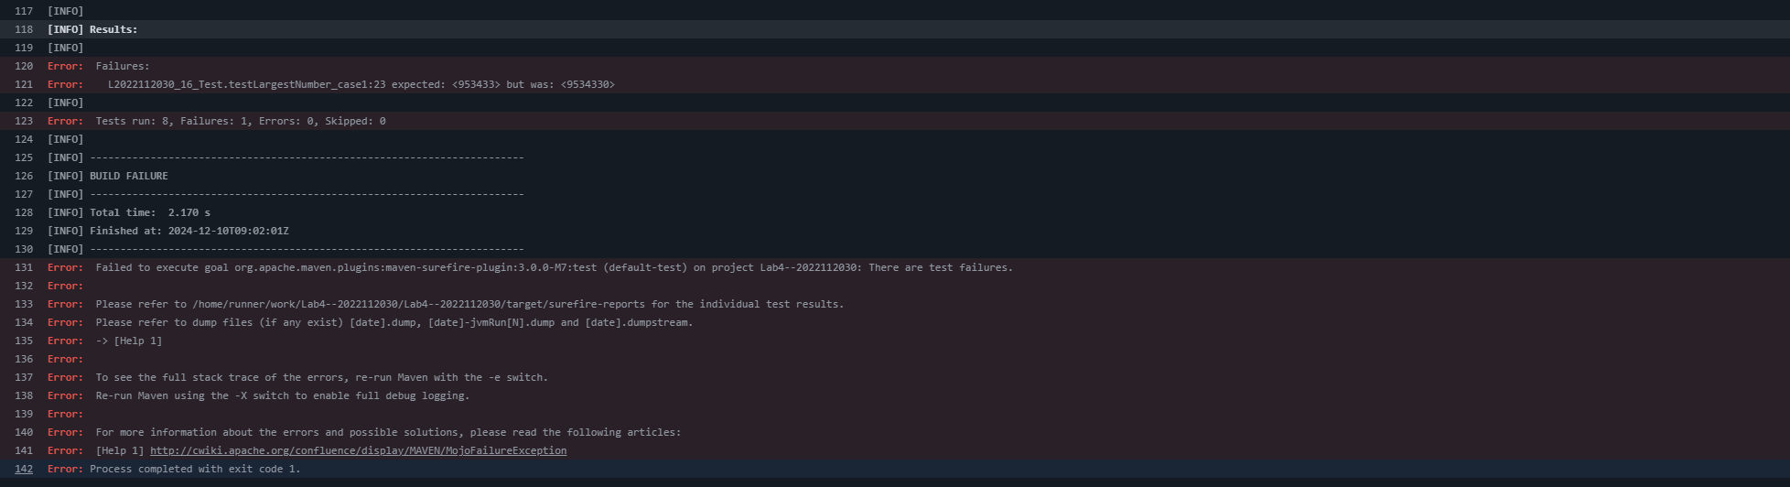
- 实现自动PR MERGE的YML代码：
- name: Java CI with Maven and Automatic PR Merge

- on:
- push:
- branches: [ "main" ]
- pull_request:
- branches: [ "main" ]

- jobs:
- build-and-test:
- runs-on: ubuntu-latest

- steps:
- - uses: actions/checkout@v3
- - name: Set up JDK 17
- uses: actions/setup-java@v3
- with:
- java-version: '17'
- distribution: 'temurin'
- cache: maven
- - name: Cache Maven packages
- uses: actions/cache@v4
- with:
- path: ~/.m2
- key: ${{ runner.os }}-m2-${{ hashFiles('**/pom.xml') }}
- restore-keys: ${{ runner.os }}-m2
- - name: Run tests with Maven
- run: mvn -B test --file pom.xml

- auto-merge:
- needs: build-and-test
- runs-on: ubuntu-latest
- if: github.event_name == 'pull_request' && github.actor != 'dependabot[bot]'

- steps:
- - name: Auto Merge
- uses: actions/github-script@v6
- with:
- github-token: ${{secrets.GITHUB_TOKEN}}
- script: |
- const { owner, repo } = context.repo;
- const pullNumber = context.issue.number;

- const { data: prChecks } = await github.rest.checks.listForRef({
- owner,
- repo,
- ref: context.payload.pull_request.head.sha
- });

- const allChecksPassed = prChecks.check_runs.every(
- check => check.conclusion === 'success'
- );

- const { data: prDetails } = await github.rest.pulls.get({
- owner,
- repo,
- pull_number: pullNumber
- });

- const canBeMerged = prDetails.mergeable && allChecksPassed;

- if (canBeMerged) {
- await github.rest.pulls.merge({
- owner,
- repo,
- pull_number: pullNumber,
- merge_method: 'squash'
- });

- console.log(`Automatically merged PR #${pullNumber}`);
- } else {
- console.log(`PR #${pullNumber} cannot be merged automatically`);
- }

实验内容2 Jenkins DevOps实践
- 给出实验步骤六和步骤七的操作截图
- 给出实验中各步骤结果的截图

小结
对本次实验过程和结果的思考、对本次实验的收获、对本次实验的建议等。

