**Graphs:**

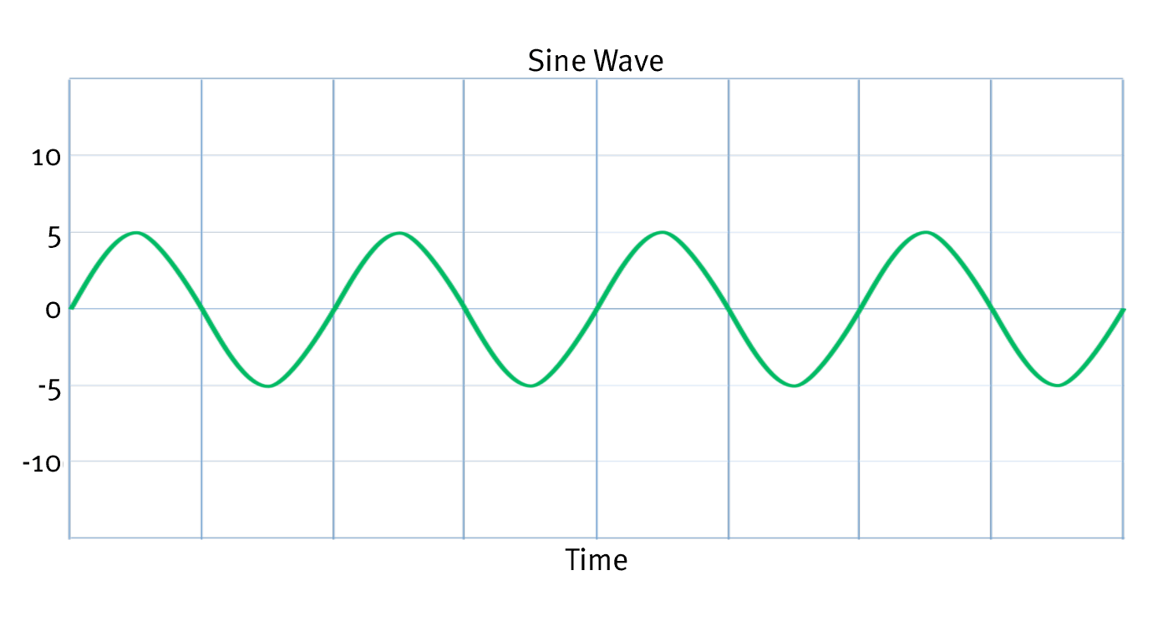

Input Waveform (AC)

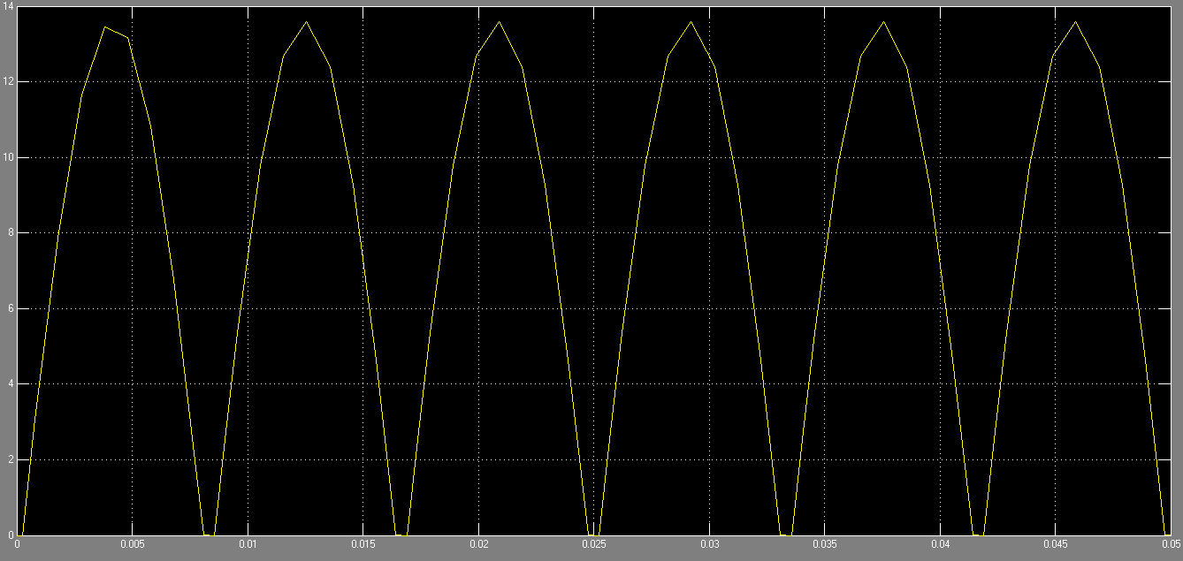

Output Waveform (DC)