Permanent Magnet Synchronous Motor Controller

Hall Universal Edition

IPWSW controller ND72680

ND72680_24_A_H84

**1.Overview**

The ND series Hall one-line pass-through controller is a high-end high-power permanent magnet synchronous motor controller with the advantages of high quality, high efficiency, and intelligence. It is suitable for vehicle applications of various Hall motors. It is suitable for middle

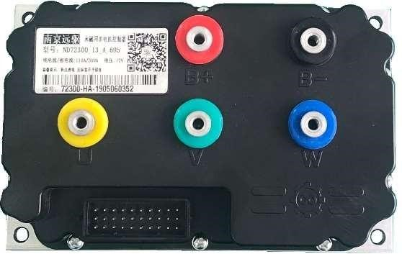and high speed motorcycles with in-wheel motors, midmounted motors, and high-end electric tricycles. Using high-quality fully imported MOS core, full metal shielding and aluminum die heat dissipation structure, the hardware architecture and software implementation are perfectly matched and refined.

# Precise matching control function：

Using 32-bit intelligent microprocessor, matching high-precision motor angle encoder, and innovative vector control algorithm and intelligent control technology, the motor efficiency is maximized. The wide dynamic range of high efficiency enables the driving vehicle to still obtain strict cruising range requirements under comprehensive road conditions. Expand and highlight the advantages of comfort performance and weak magnetic field expansion. Anti-slipping function, maximum speed limit, electronic brake, energy feedback, current limit, host computer communication and other functions are all available. To meet various needs.

# Rich software parameter configuration：

* 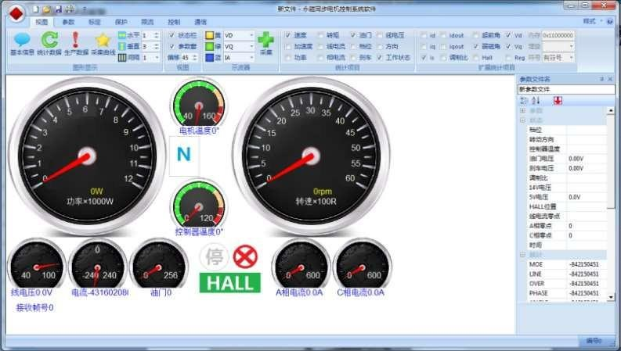Monitor and configure the controller through the visual computer interface, and update and upgrade online.
* The current at different speeds can be adjusted online.
* The maximum speed of forward and backward, economic speed can be set.
* The overall bus current and phase current can be set.
* The accelerator pedal threshold can be set to adjust the response sensitivity of the pedal.
* **Perfect protection function：**

Monitor working voltage, current, temperature, motor, gear, accelerator pedal, brake, etc.

Ensure the safety of vehicle driving control:

# 1.Indicator parameters

|  |  |  |  |  |  |  |  |  |  |
| --- | --- | --- | --- | --- | --- | --- | --- | --- | --- |
| Model | Maximum  BUS  Current | Maximu m Phase  Current | | Operating Voltage | Size | Weight | | Max.  Voltage | |
| 72240 | 80A | 300A | | 48V~72V | 189mm*121mm*63  .5mm | 1.7kg | | 88V | |
| 72330 | 120A | 400A | | 48V~72V | 189mm*121mm*63  .5mm | 1.7kg | | 88V | |
| 72490 | 180A | 660A | | 48V~72V | 189mm*121mm*63  .5mm | 2.0kg | | 88V | |
| 72800 | 220A | 800A | | 48V~72V | 189mm*121mm*63  .5mm | 2.0kg | | 88V | |
| 84330 | 110A | 400A | | 72V -84V | 189mm*121mm*63  .5mm | 2.0kg | | 100v | |
| 84490 | 180A | 660A | | 72V~84V | 189mm*121mm*63  .5mm | 2.0kg | | 100V | |
| 96240 | 90A | 240A | | 48V~72V | 189mm*121mm*63  .5mm | 2.0kg | | 110V | |
| 96330 | 110A | 400A | | 48V~72V | 189mm*121mm*63  .5mm | 2.0kg | | 110V | |
| 96490 | 470 | 660 | | 60V-96V | 189mm*121mm*63  .5mm | 2.1kg | | 110V | |
| 721200 | 600A | 1200A | | 52V~90V | 238*155*88mm | 4.0kg | | 88V | |
| 721800 | 800A | 1800A | | 52V~90V | 238*155*88mm | 4.0kg | | 88V | |
| Insulation class | | | DC1000V Leakage current 0.05 | | | |  | |
| Working temperature | | | -30℃～+55℃ | | | |
| Storage temperature | | | -45℃～+85℃ | | | |
| Efficiency | | | 99% | | | |
| Cooling method | | | Natural Cooling | | | |
| Vibration standard | | | GB/T2423 | | | |
| Heat release requirements | | | Good ventilation or increase air cooling | | | |

# 3.Wiring diagram

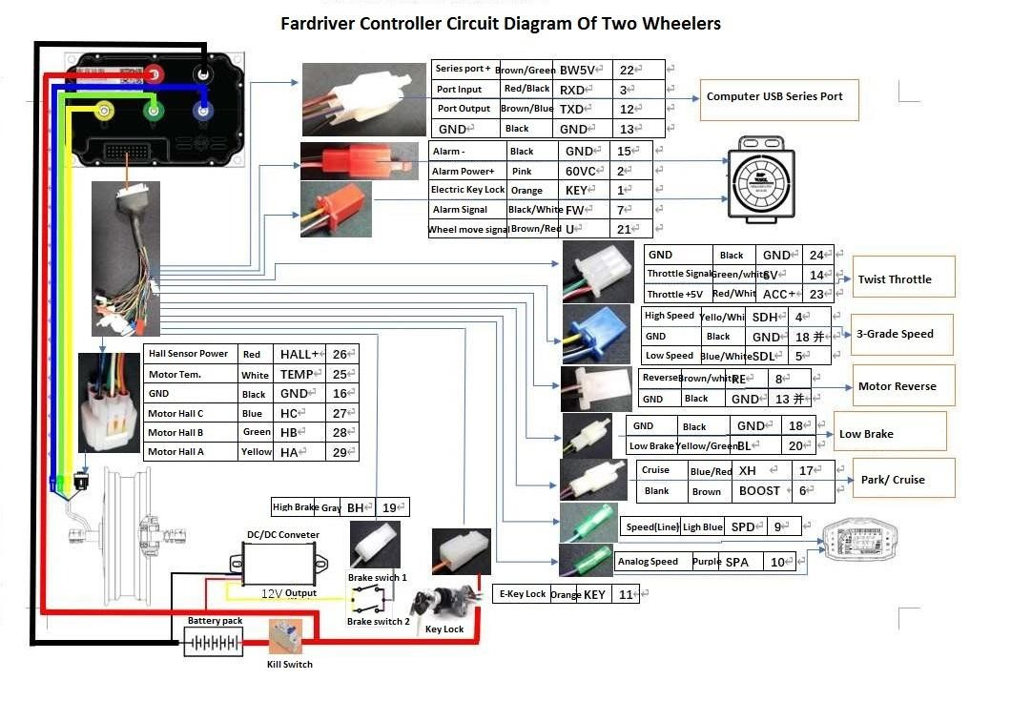

#  Dimensions

S24 controller size chart

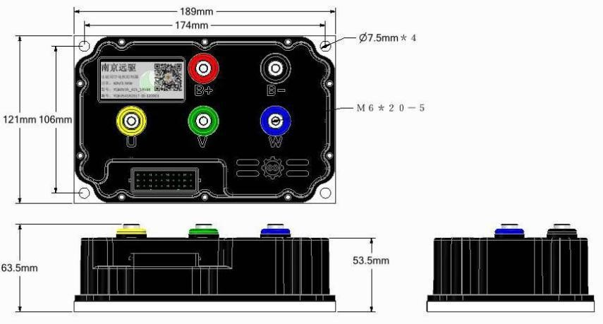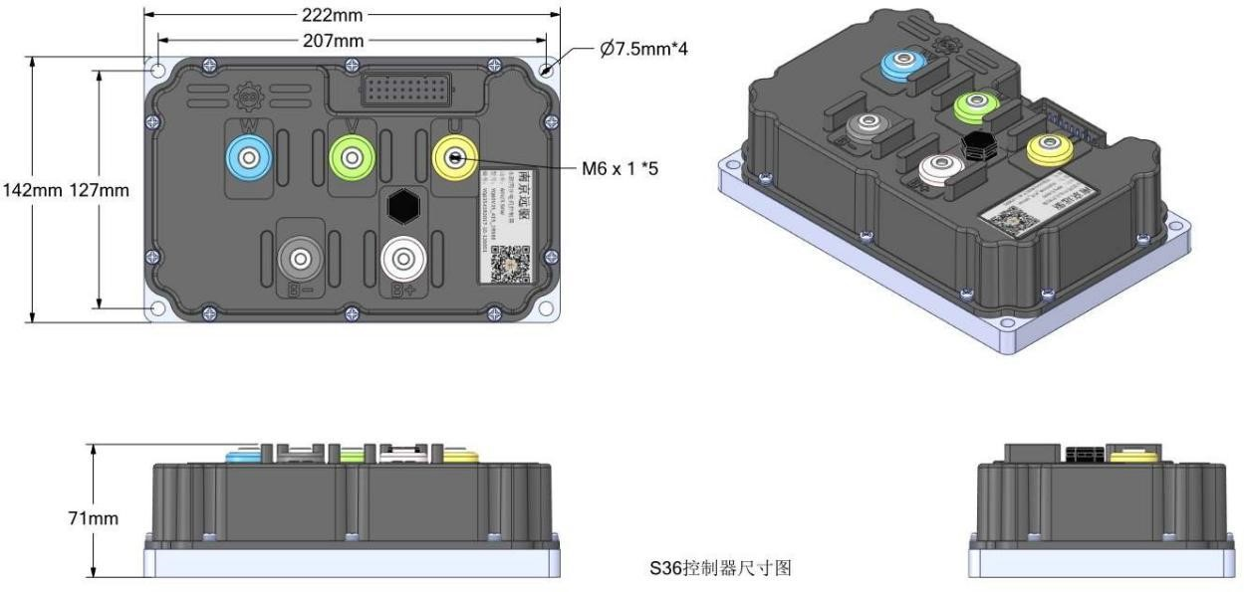

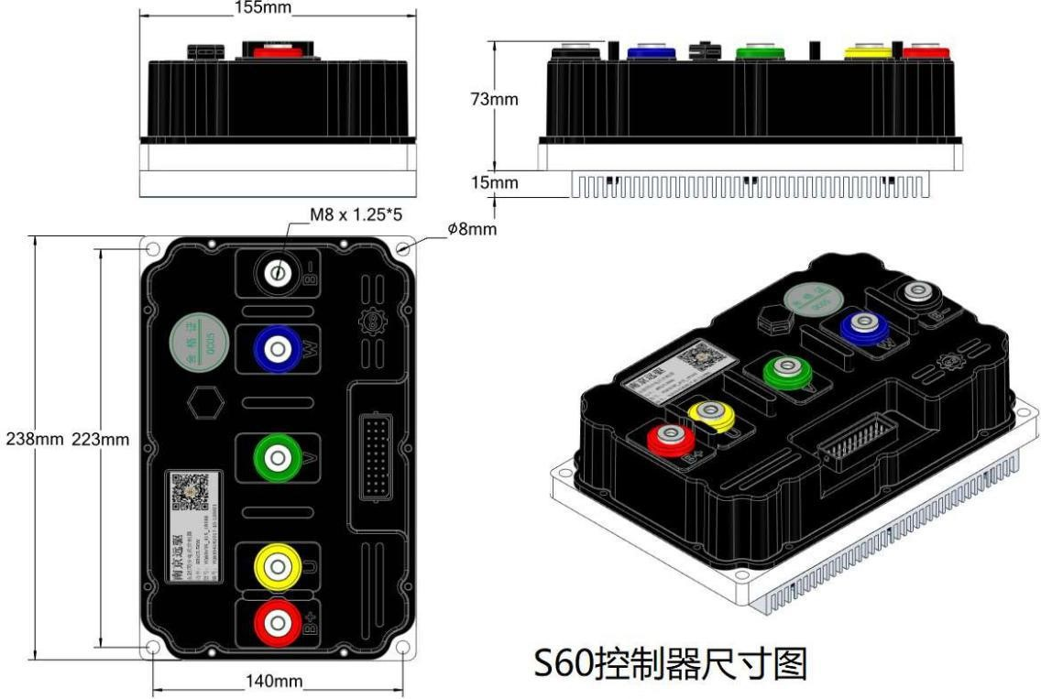

#  Electrical parameters:

|  |  |  |  |
| --- | --- | --- | --- |
| No. | Items |  |  |
| 1 | Motor HALL+ | 14V（No load） 8V/30mA load |  |
| 2 | Accelerator power supply 5V | 5.1V | optional |
| 3 | Accelerator pedal signal | 0.5V~4.3V  1.1V~3.9V | Setting on the computer |
| 4 | BW5V | Bluetooth 5V，To power the Bluetooth module |  |
| 5 | High gear/low gear | Dangling invalid  Effective GND(ground) wire |  |
| 6 | Back gear | Dangling invalid  GND or positive electricity connection is valid |  |
| 7 | Alarm signal | Dangling invalid  GND or battery connection is valid |  |
| 8 | Low-voltage brake | Hanging driving and GND parking  Hanging parking and GND driving | Setting on the computer |
| 9 | High-voltage brake | Hanging driving and positive electricity or 12V connection parking  Hanging parking and positive electricity or 12V connection driving | Setting on the computer |
| 10 | Small key switch output | That is, the electric door lock signal supplies power to the controller |  |
| 11 | RX | Computer receiving signal, controller output, TTL level |  |
| 12 | TX | Computer sending signal, controller input, TTL level |  |
| 13 | GND | GND |  |

**Outgoing interface description**

6.1 Plastic Shell Controller Hall One-line Pass Version Outlet Diagram, It is suitable for Hall one-line communication controller.

30PIN connector recommended color definition

|  |  |  |  |  |  |
| --- | --- | --- | --- | --- | --- |
| Connector |  | Description | color | Definition | pin |
| Hall wire length:290mm |  | Motor 12V | red | HALL + | 26 |
| Motor temperature | white | TEMP | 25 |
| Motor wire GND | black | GND | 16 |
| Motor wire C | blue | HC | 27 |
| Motor wire B | green | HB | 28 |
| Motor wire A | yellow | HA | 29 |
| Electric door lock length: 290mm |  | Electric Key Lock | orange | KEY | 11 |
| Cruise BOOST  Length: 290mm |  | Cruise | Blue and red | XH | 17 |
| BOOST | brown | BOOS T | 6 |
| Low-voltage:  Length: 290mm |  | GND | black | GND | 18 |
| Low-voltage brake | Yellow and green | BL | 20 |

|  |  |  |  |  |  |
| --- | --- | --- | --- | --- | --- |
| Analog speedometer  wire  Length: 290mm |  | Analog speedometer | purple | SPA | 10 |
| High voltage brake  Length: 290mm |  | High voltage brake | Grey | BH | 19 |
| Throttle length:  290mm |  | GND | black | GND | 24 |
| Throttle signal | Green and white | SV | 14 |
| Throttle power | Red and white | ACC+ | 23 |
| Anti-theft signal length: 290mm |  | Anti-theft | White and black | FW | 7 |
| Phase wire | brown | U | 21 |
| Electric door lock | orange | KEY | 1 |
| Anti-theft power supply  Length: 290mm |  | Electricity + | Pink and red | 60VC | 2 |
| Electricity - |  | GND | 15 |
| High and low Level Speed length: 290mm | Three-core female  headgear 1 short-circuited three-core male head (high speed by default) | High speed | White and yellow | SDH | 4 |
| GND | black | GND | 18  （together） |
| Low speed | Blue and white | SDL | 5 |
| Reverse  Length:290mm |  | Back gear | Brown and white | RE | 8 |
| GND | black | GND | 13(together) |

|  |  |  |  |  |  |
| --- | --- | --- | --- | --- | --- |
| Speed Velocity pulse signal  Length: 290mm |  | Speed pulse / one wire | Light blue | SPD | 9 |
| Program port  Length: 190m m |  | Serial power supply | brown and green | BW5V | 22 |
| Serial port | Black and red | RXD | 3 |
| Serial port | Brown and  blue | TXD | 12 |
| GND | black | GND | 13 |

**Buzzer alarm**

The controller is equipped with a buzzer. When an alarm occurs, the buzzer will send out corresponding alarm information.

7.1 Description of the number of buzzer alarm sounds:

* + 1. When the machine is turned on normally, the buzzer will sound once and then stop.
    2. If there is a long beep, please check whether the brake and accelerator are effective at the same time. With this function, you can check whether the brakes and accelerators are normal: step on the buzzer at the same time, and let go of any one of them will not sound.
    3. If there are 2 short beeps and 1 long beep, the cycle repeats, indicating that the controller is in the self-learning state, and the self-learning should be completed according to the self-learning operation steps. 7.1.4 If there are 2 short beeps, pause for a while, and then a short beep, repeating again and again, it means that the controller program verification has failed. In this case, update the program again.
    4. If there are 4 short beeps, 1 long beep, and 5 short beeps, the cycle repeats, indicating that the upgraded program does not match the controller. Please check whether the program is consistent with the model on the controller label. If it does not, find the matching program again upgrade.
    5. If there are 1 to 15 beeps, judge the fault based on the number of sounds. The fault table is as follows:

|  |  |  |  |
| --- | --- | --- | --- |
|  | Fault description | Number of sounds |  |
| 1 | Motor Hall fault | 1 | The signal wire between the controller and the motor is not connected properly. |
| 2 | Accelerator pedal failure | 2 | The accelerator does not return to zero, or the accelerator pedal is broken. Note that the fault will be displayed by default when the controller is restarted, and the fault will disappear after the self-check is passed. |
| 3 | Current protection restart | 3 | Abnormal protection alarm |
| 4 | phase current overcurrent | 4 | Abnormal protection alarm |
| 5 | Voltage failure | 5 | The voltage is too low or too high, which exceeds the allowable range of the controller. |
| 6 | Anti-theft alarm signal | 6 | reserved |
| 7 | Motor over temperature | 7 | Motor temperature is too low or too high beyond the scope of use |
| 8 | Controller over temperature | 8 | The temperature of the controller is too low or too high beyond the use range |
| 9 | phase current overflow | 9 | Abnormal protection alarm |
| 10 | 10-phase current zero point fault | 10 | Controller internal alarm |
| 11 | Phase line short circuit fault | 11 | The phase line is short-circuited, or the motor is faulty. |
| 12 | wire current zero point fault | 12 | Controller internal alarm |
| 13 | MOSFET upper | 13 | The upper bridge of the controller is damaged |

|  |  |  |  |
| --- | --- | --- | --- |
|  | bridge fault |  |  |
| 14 | MOSFET lower  bridge fault | 14 | The lower bridge of the controller is damaged |
| 15 | Peak line current protection | 15 | Hardware overcurrent protection alarm |