Women in Agriculture

Introduction
Women play an essential role in the global agricultural workforce, participating in a variety of activities from planting to marketing of crops.
Despite their contribution, women often face significant barriers, including restricted land rights, limited access to credit, and less access to agricultural training and technology.
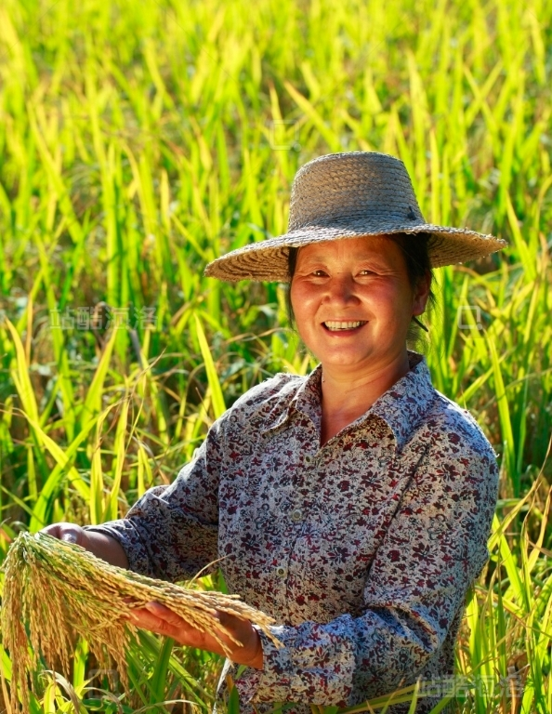

Method
Women’s involvement in agriculture not only boosts rural economies, but also enhances food security for entire communities.
The gender gap in agricultural productivity is largely attributable to inequalities in access to resources, not ability or potential.
Policies aimed at increasing women's access to agricultural inputs and land could result in substantial productivity gains.
Organizations and initiatives around the world are addressing gender disparities in agriculture through advocacy and programming.
Education and training tailored to women farmers have proven effective in improving yields and incomes in numerous countries.
Women are also leaders in sustainable agriculture, often advocating for practices that protect the land and support community well-being.
International agencies, such as the Food and Agriculture Organization (FAO), have resources and reports dedicated to understanding and supporting women in agriculture.
Empowering women in the agricultural sector presents an opportunity to solve broader issues of poverty, hunger, and environmental sustainability.

Resources
FAO: Women in Agriculture
Note: Empowering women farmers can increase agricultural productivity and lift communities out of poverty.

Organizations and initiatives

