**©2021 Credits**

LOGO Home Scratch Projects Downloads

HERE

Hi there!

Here are some things to try!

Check out some of our scratch projects!

Download useful software!

[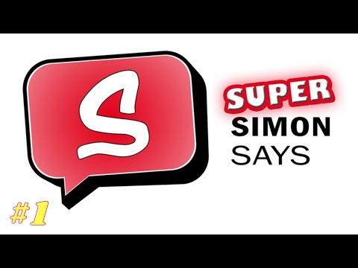](https://www.youtube.com/embed/ho-YmNv3RO4?feature=oembed) Here’s our latest video!