**1.FCFS Program:**

#include<stdio.h>

void main()

{

int bt[50],wt[80],at[80],wat[30],ft[80],tat[80];

int i,n;

float awt,att,sum=0,sum1=0;

char p[10][5];

printf("\nenter the number of process ");

scanf("%d",&n);

printf("\nEnter the process name and burst-time:");

for(i=0;i<n;i++)

scanf("%s%d",p[i],&bt[i]);

printf("\nEnter the arrival-time:");

for(i=0;i<n;i++)

scanf("%d",&at[i]);

wt[0]=0;

for(i=1;i<=n;i++)

wt[i]=wt[i-1]+bt[i-1];

ft[0]=bt[0];

for(i=1;i<=n;i++)

ft[i]=ft[i-1]+bt[i];

printf("\n\n\t\t\tGANTT CHART\n");

printf("\n \n");

for(i=0;i<n;i++)

printf("|\t%s\t",p[i]);

printf("|\t\n");

printf("\n \n");

printf("\n");

for(i=0;i<n;i++)

printf("%d\t\t",wt[i]);

printf("%d",wt[n]+bt[n]);

printf("\n \n");

printf("\n");

for(i=0;i<n;i++)

wat[i]=wt[i]-at[i];

for(i=0;i<n;i++)

tat[i]=ft[i]-at[i];

printf("\n FIRST COME FIRST SERVE\n");

printf("\n Process Burst-time Arrival-time Waiting-time Finish-time Turnaroundtime\n");

for(i=0;i<n;i++)

printf("\n\n %d%s \t %d\t\t %d \t\t %d\t\t %d \t\t%d",i+1,p[i],bt[i],at[i],wat[i],ft[i],tat[i]);

for(i=0;i<n;i++)

sum=sum+wat[i];

awt=sum/n;

for(i=0;i<n;i++)

sum1=sum1+tat[i];

att=sum1/n;

printf("\n\nAverage waiting time:%f",awt);

printf("\n\nAverage turnaround time:%f",att);

}

**OUTPUT:**

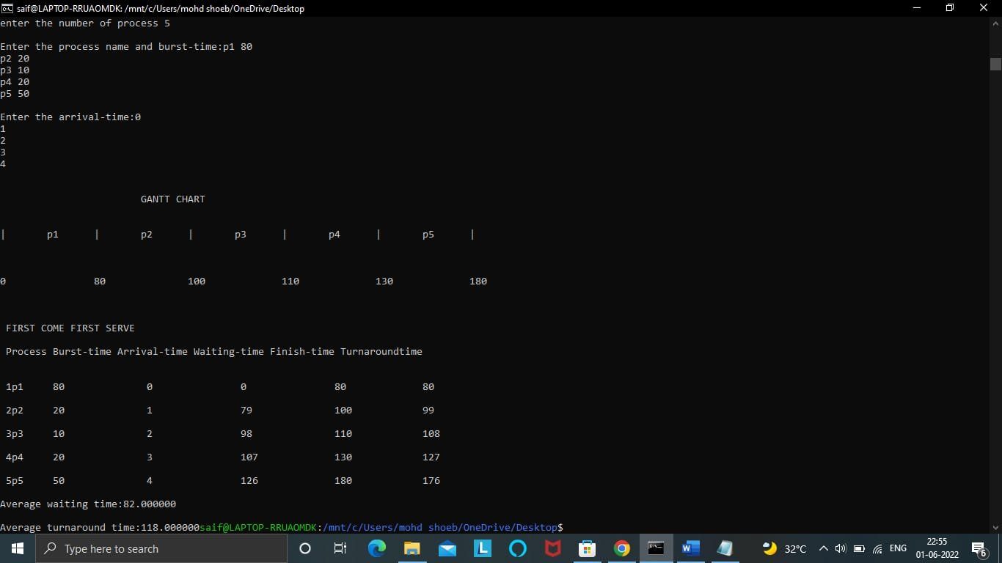

**ii) Write a C program to illustrate the following IPC mechanisms**

**a) Pipes b) FIFOs c) Message Queue d)Shared Memory**

**a)Pipes**

#include<stdio.h>

#include<unistd.h>

int main() {

int pipefds[2];

int returnstatus;

int pid;

char writemessages[2][20]={"Hi", "Hello"};

char readmessage[20];

returnstatus = pipe(pipefds);

if (returnstatus == -1) {

printf("Unable to create pipe\n");

return 1;

}

pid = fork();

 if (pid == 0) {

read(pipefds[0], readmessage, sizeof(readmessage));

printf("Child Process - Reading from pipe – Message 1 is %s\n", readmessage);

read(pipefds[0], readmessage, sizeof(readmessage));

printf("Child Process - Reading from pipe – Message 2 is %s\n", readmessage);

} else { //Parent process

printf("Parent Process - Writing to pipe - Message 1 is %s\n", writemessages[0]);

write(pipefds[1], writemessages[0], sizeof(writemessages[0]));

printf("Parent Process - Writing to pipe - Message 2 is %s\n", writemessages[1]);

write(pipefds[1], writemessages[1], sizeof(writemessages[1]));

}

return 0;

}

**OUTPUT:**

**b)FIFO**

**fifo1.c:**

#include <stdio.h>

#include <string.h>

#include <fcntl.h>

#include <sys/stat.h>

#include <sys/types.h>

#include <unistd.h>

int main()

{

int fd;

char * myfifo = "/tmp/myfifo";

mkfifo(myfifo, 0666);

char arr1[80], arr2[80];

while (1)

{

fd = open(myfifo, O_WRONLY);

fgets(arr2, 80, stdin);

write(fd, arr2, strlen(arr2)+1);

close(fd);

fd = open(myfifo, O_RDONLY);

read(fd, arr1, sizeof(arr1));

printf("User2: %s\n", arr1);

close(fd);

}

return 0;

}

**Fifo2.c:**

 #include <stdio.h>

#include <string.h>

#include <fcntl.h>

#include <sys/stat.h>

#include <sys/types.h>

#include <unistd.h>

int main()

{

int fd1;

char * myfifo = "/tmp/myfifo";

mkfifo(myfifo, 0666);

char str1[80], str2[80];

while (1)

{

fd1 = open(myfifo,O_RDONLY);

read(fd1, str1, 80);

printf("User1: %s\n", str1);

close(fd1);

fd1 = open(myfifo,O_WRONLY);

fgets(str2, 80, stdin);

write(fd1, str2, strlen(str2)+1);

close(fd1);

}

return 0;

}

**OUTPUT:**

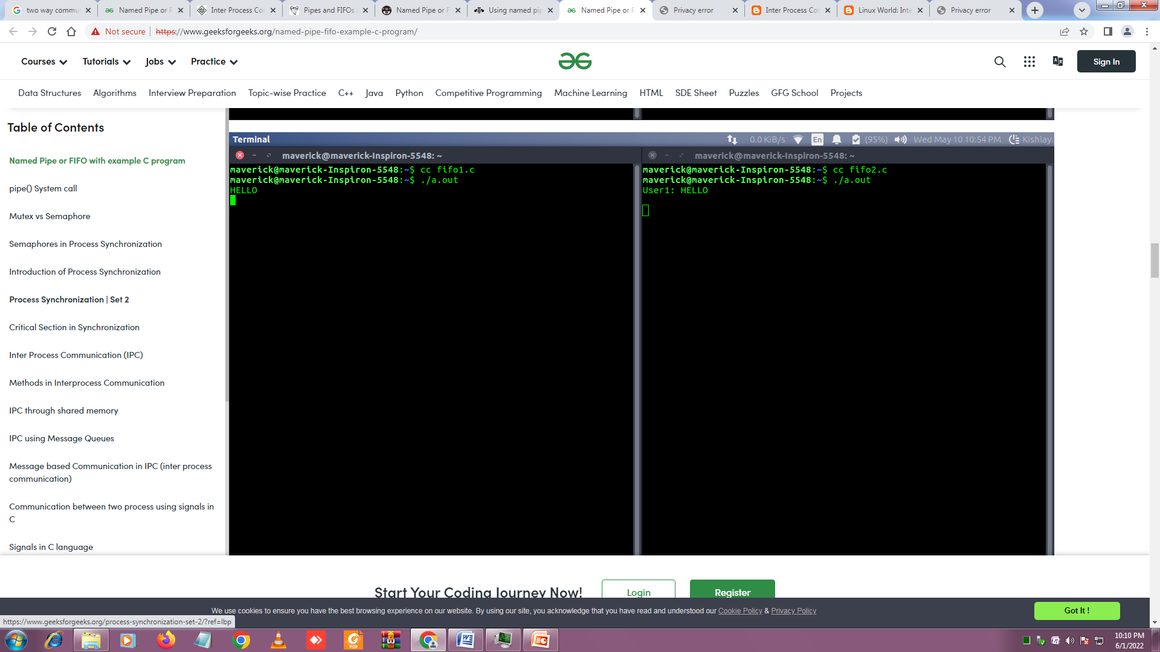

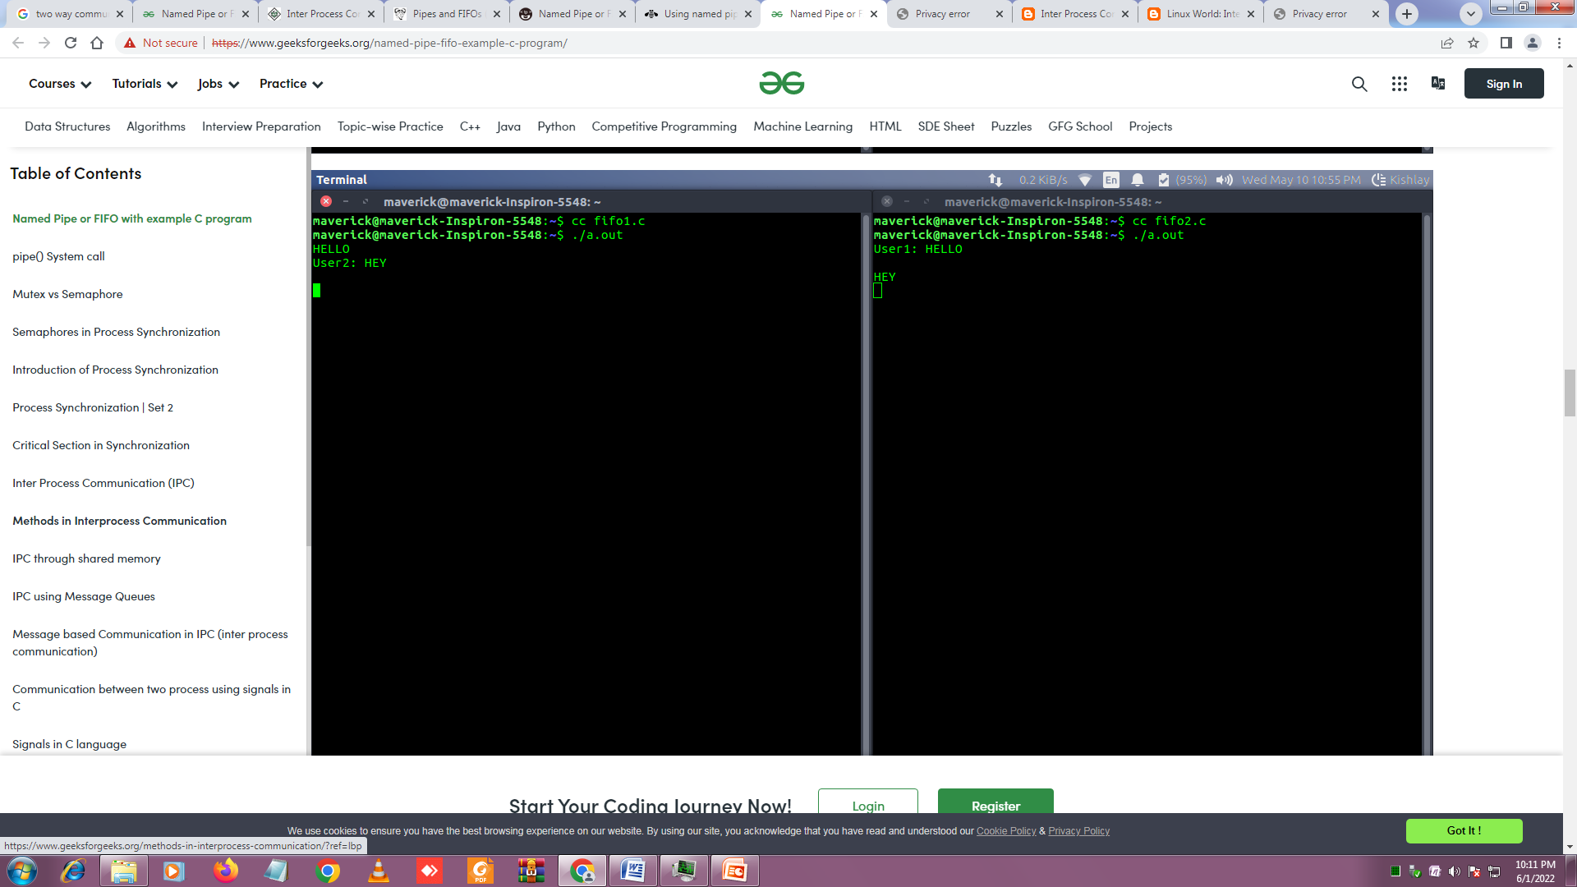

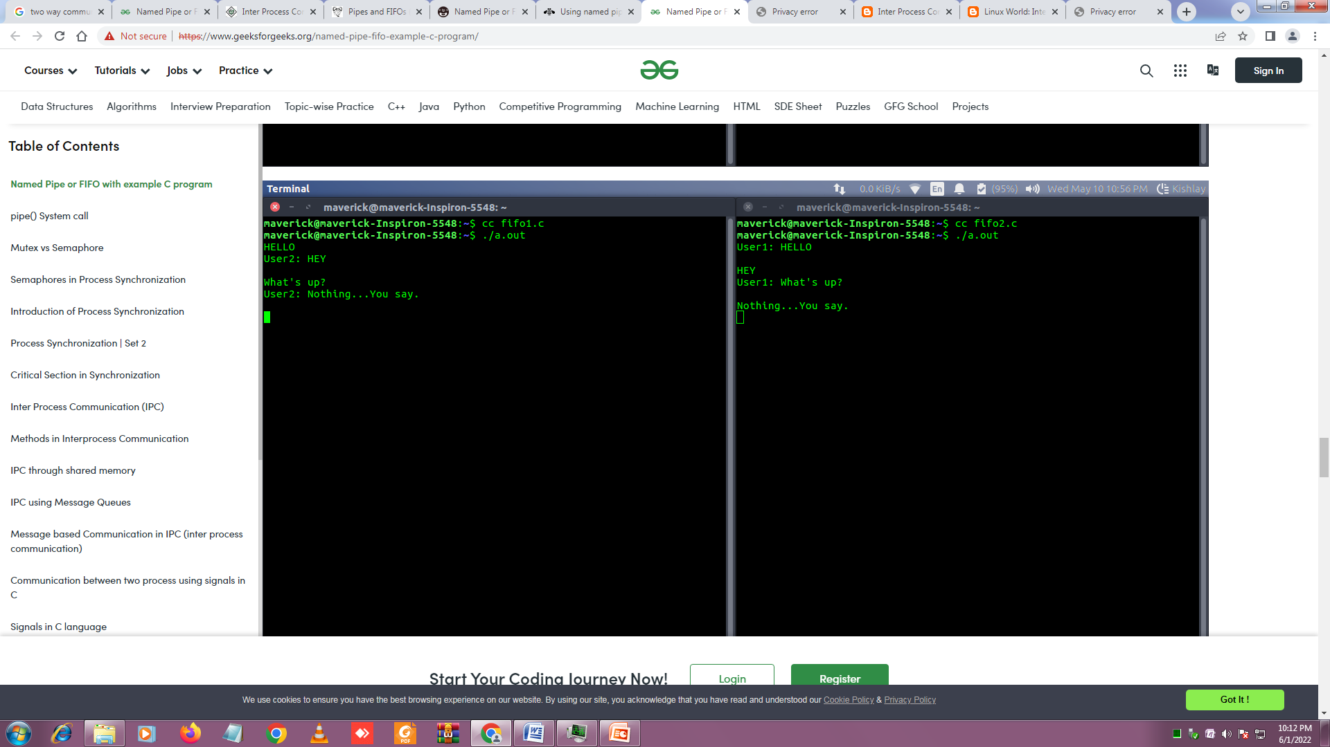

**C. Message Queues**

**(i)Message_send**

#include <stdio.h>

#include <sys/ipc.h>

#include <sys/msg.h>

struct mesg_buffer {

long mesg_type;

char mesg_text[100];

} message;

int main()

{

key_t key;

int msgid;

key = ftok("somefile", 65);

msgid = msgget(key, 0666 | IPC_CREAT);

message.mesg_type = 1;

printf("Insert message : ");

gets(message.mesg_text);

msgsnd(msgid, &message, sizeof(message), 0);

printf("Message sent to server : %s\n", message.mesg_text);

return 0;

}

**OUTPUT:**

**(ii) message_recieve**

#include <stdio.h>

#include <sys/ipc.h>

#include <sys/msg.h>

struct mesg_buffer {

long mesg_type;

char mesg_text[100];

} message;

int main()

{

key_t key;

int msgid;

key = ftok("somefile", 65);

msgid = msgget(key, 0666 | IPC_CREAT);

printf("Waiting for a message from client...\n");

msgrcv(msgid, &message, sizeof(message), 1, 0);

printf("Message received from client : %s\n",message.mesg_text);

msgctl(msgid, IPC_RMID, NULL);

return 0;

}

**OUTPUT:**

**d) SHARED MEMORY FOR WRITER PROCESS**

|  |
| --- |
| #include <stdio.h>  #include <stdlib.h>  #include <unistd.h>  #include <sys/shm.h>  #include <string.h>    int main()  {  void *shared_memory;  char buff[100];  int shmid;  shmid=shmget((key_t)1122,1024,0666|IPC_CREAT);  printf("Key of Shared Memory is %d\n",shmid);  shared_memory=shmat(shmid,NULL,0);  printf("Process attached at %p\n",shared_memory);  read(0,buff,100);  strcpy(shared_memory,buff);  printf("You wrote : %s\n",(char*)shared_memory);  }  **OUTPUT:** |

**SHARED MEMORY FOR READER PROCESS**

#include <stdio.h>

#include <stdlib.h>

#include <unistd.h>

#include <sys/shm.h>

#include <string.h>

int main()

{

void *shared_memory;

char buff[100];

int shmid;

shmid=shmget((key_t)1122,1024,0666);

printf("Key of shared memory is %d\n",shmid);

shared_memory=shmat(shmid,NULL,0);

printf("Process attached at %p\n",shared_memory);

printf("Data read from the shared memory is : %s\n",(char*)shared_memory);

}

**OUTPUT:**

**EXPERIMENT-3**

1. **Write a c program to solve producer-consumer problem using mutex and semaphore.**

**PRODUCER_CONSUMER ** For compiling->(gcc producer_consumer.c -pthread)**

#include <pthread.h>

#include <semaphore.h>

#include <stdlib.h>

#include <stdio.h>

#define MaxItems 5

#define BufferSize 5

sem_t empty;

sem_t full;

int in = 0;

int out = 0;

int buffer[BufferSize];

pthread_mutex_t mutex;

void *producer(void *pno)

{

int item;

for(int i = 0; i < MaxItems; i++) {

item = rand();

sem_wait(&empty);

pthread_mutex_lock(&mutex);

buffer[in] = item;

printf("Producer %d: Insert Item %d at %d\n", *((int *)pno),buffer[in],in);

in = (in+1)%BufferSize;

pthread_mutex_unlock(&mutex);

sem_post(&full);

}

}

void *consumer(void *cno)

{

for(int i = 0; i < MaxItems; i++) {

sem_wait(&full);

pthread_mutex_lock(&mutex);

int item = buffer[out];

printf("Consumer %d: Remove Item %d from %d\n",*((int *)cno),item, out);

out = (out+1)%BufferSize;

pthread_mutex_unlock(&mutex);

sem_post(&empty);

}

}

int main()

{

pthread_t pro[5],con[5];

pthread_mutex_init(&mutex, NULL);

sem_init(&empty,0,BufferSize);

sem_init(&full,0,0);

int a[5] = {1,2,3,4,5};

for(int i = 0; i < 5; i++) {

pthread_create(&pro[i], NULL, (void *)producer, (void *)&a[i]);

}

for(int i = 0; i < 5; i++) {

pthread_create(&con[i], NULL, (void *)consumer, (void *)&a[i]);

}

for(int i = 0; i < 5; i++) {

pthread_join(pro[i], NULL);

}

for(int i = 0; i < 5; i++) {

pthread_join(con[i], NULL);

}

pthread_mutex_destroy(&mutex);

sem_destroy(&empty);

sem_destroy(&full);

return 0;

}

**FIRST FIT**

#include<stdio.h>

void main()

{

int bsize[10], psize[10], bno, pno, flags[10], allocation[10], i, j;

for(i = 0; i < 10; i++)

{

flags[i] = 0;

allocation[i] = -1;

}

printf("Enter no. of blocks: ");

scanf("%d", &bno);

printf("\nEnter size of each block: ");

for(i = 0; i < bno; i++)

scanf("%d", &bsize[i]);

printf("\nEnter no. of processes: ");

scanf("%d", &pno);

printf("\nEnter size of each process: ");

for(i = 0; i < pno; i++)

scanf("%d", &psize[i]);

for(i = 0; i < pno; i++)

for(j = 0; j < bno; j++)

if(flags[j] == 0 && bsize[j] >= psize[i])

{

allocation[j] = i;

flags[j] = 1;

break;

}

printf("\nBlock no.\tsize\t\tprocess no.\t\tsize");

for(i = 0; i < bno; i++)

{

printf("\n%d\t\t%d\t\t", i+1, bsize[i]);

if(flags[i] == 1)

printf("%d\t\t\t%d",allocation[i]+1,psize[allocation[i]]);

else

printf("Not allocated");

}

}

##### **Output:**

Enter the number of blocks: 3  
Enter the size of each block: 12  
7  
4  
Enter the number of processes: 3  
Enter the size of each process: 7  
4  
9  
Block no. Size Process No. Size  
1 12 1 7  
2 7 2 4  
3 4 Not Allocated

**BEST FIT**

#include<stdio.h>

void main()

{

int fragment[20],b[20],p[20],i,j,nb,np,tem,low=9999;

static int barray[20],parray[20];

printf("Memory Management Scheme - Best Fit");

printf("Enter the number of processes:");

scanf("%d",&np);

printf("\nEnter the number of blocks:");

scanf("%d",&nb);

printf("\nEnter the size of the blocks:-\n");

for(i=1;i<=nb;i++)

{

printf("Block no.%d:",i);

scanf("%d",&b[i]);

}

printf("\nEnter the size of the processes :-\n");

for(i=1;i<=np;i++)

{

printf("Process no.%d:",i);

scanf("%d",&p[i]);

}

for(i=1;i<=np;i++)

{

for(j=1;j<=nb;j++)

{

if(barray[j]!=1)

{

tem=b[j]-p[i];

if(tem>=0)

if(low>tem)

{

parray[i]=j;

low=tem;

}

}

}

fragment[i]=low;

barray[parray[i]]=1;

low=10000;

}

printf("\nProcess_number \tProcess_size\tBlock_number \tBlock_size\tFragment");

for(i=1;i<=np && parray[i]!=0;i++)

printf("\n%d\t\t%d\t\t%d\t\t%d\t\t%d",i,p[i],parray[i],b[parray[i]],fragment[i]);

}

**Output**

Enter the number of blocks: 5

Enter the number of processes: 4

Enter the size of the blocks:

Block number 1: 10

Block number 2: 15

Block number 3: 5

Block number 4: 9?

Block number 5: 3

Enter the size if the process

Process number 1: 1

Process number 2: 4

Process number 3: 7

Process number 4: 12

Process number Process size Block number Block size Fragment

1 1 5 3 2

2 4 3 5 1

3 7 4 9 2

4 12 2 15 3

**EXPERIMENT 5**

**Write a C program to simulate following memory management techniques.**

**a)Paging b)segmentation**

**a)Paging**

#include<stdio.h>

void main()

{

int ms, ps, nop, np, rempages, i, j, x, y, pa, offset;

int s[10], fno[10][20];

printf("\nEnter the memory size -- ");

scanf("%d",&ms);

printf("\nEnter the page size -- ");

scanf("%d",&ps);

nop = ms/ps;

printf("\nThe no. of pages available in memory are -- %d ",nop);

printf("\nEnter number of processes -- ");

scanf("%d",&np);

rempages = nop;

for(i=1;i<=np;i++)

{

printf("\nEnter no. of pages required for p[%d]-- ",i);

scanf("%d",&s[i]);

if(s[i] >rempages)

{

printf("\nMemory is Full");

break;

}

rempages = rempages - s[i];

printf("\nEnter pagetable for p[%d] --- ",i);

for(j=0;j<s[i];j++)

scanf("%d",&fno[i][j]);

}

printf("\nEnter Logical Address to find Physical Address ");

printf("\nEnter process no. and pagenumber and offset -- ");

scanf("%d %d %d",&x,&y, &offset);

if(x>np || y>=s[i] || offset>=ps)

printf("\nInvalid Process or Page Number or offset");

else

{

pa=fno[x][y]*ps+offset;

printf("\nThe Physical Address is -- %d",pa);

}

}

**INPUT**

Enter the memory size -- 1000

Enter the page size -- 100

The no. of pages available in memory are -- 10

Enter number of processes -- 3

Enter no. of pages required for p[1]-- 4

Enter pagetable for p[1] --- 8 6 9 5

Enter no. of pages required for p[2]-- 5

Enter pagetable for p[2] --- 1 4 5 7 3

Enter no. of pages required for p[3]-- 5

**OUTPUT**

Memory is Full

Enter Logical Address to find Physical Address

Enter process no. and page number and offset -- 2 3 60

The Physical Address is – 760

**b)Segmentation: For compiling 🡪 (gcc segmentation.c -lm)**

#include <stdio.h>

#include <math.h>

int sost;

void gstinfo();

void ptladdr();

struct segtab

{

int sno;

int baddr;

int limit;

int val[10];

}st[10];

void gstinfo()

{

int i,j;

printf("\n\tEnter the size of the segment table: ");

scanf("%d",&sost);

for(i=1;i<=sost;i++)

{

printf("\n\tEnter the information about segment: %d",i);

st[i].sno = i;

printf("\n\tEnter the base Address: ");

scanf("%d",&st[i].baddr);

printf("\n\tEnter the Limit: ");

scanf("%d",&st[i].limit);

for(j=0;j<st[i].limit;j++)

{

printf("Enter the %d address Value: ",(st[i].baddr + j));

scanf("%d",&st[i].val[j]);

}

}

}

void ptladdr()

{

int i,swd,d=0,n,s,disp,paddr;

printf("\n\n\t\t\t SEGMENT TABLE \n\n");

printf("\n\t SEG.NO\tBASE ADDRESS\t LIMIT \n\n");

for(i=1;i<=sost;i++)

printf("\t\t%d \t\t%d\t\t%d\n\n",st[i].sno,st[i].baddr,st[i].limit);

printf("\n\nEnter the logical Address: ");

scanf("%d",&swd);

n=swd;

while (n != 0)

{

n=n/10;

d++;

}

s = swd/pow(10,d-1);

disp = swd%(int)pow(10,d-1);

if(s<=sost)

{

if(disp < st[s].limit)

{

paddr = st[s].baddr + disp;

printf("\n\t\tLogical Address is: %d",swd);

printf("\n\t\tMapped Physical address is: %d",paddr);

printf("\n\tThe value is: %d",( st[s].val[disp] ) );

}

else

printf("\n\t\tLimit of segment %d is high\n\n",s);

}

else

printf("\n\t\tInvalid Segment Address \n");

}

void main()

{

char ch;

gstinfo();

do

{

ptladdr();

printf("\n\t Do U want to Continue(Y/N)");

scanf("%c",&ch);

}while (ch == 'Y' || ch == 'y' );

}

**OUTPUT**

INPUT AND OUTPUT:

Enter the size of the segment table: 3

Enter the information about segment: 1

Enter the base Address: 4

Enter the Limit: 5

Enter the 4 address Value: 11

Enter the 5 address Value: 12

Enter the 6 address Value: 13

Enter the 7 address Value: 14

Enter the 8 address Value: 15

Enter the information about segment: 2

Enter the base Address: 5

Enter the Limit: 4

Enter the 5 address Value: 21

Enter the 6 address Value: 31

Enter the 7 address Value: 41

Enter the 8 address Value: 51

Enter the information about segment: 3

Enter the base Address: 3

Enter the Limit: 4

Enter the 3 address Value: 31

Enter the 4 address Value: 41

Enter the 5 address Value: 41

Enter the 6 address Value: 51

SEGMENT TABLE

SEG.NO BASE ADDRESS LIMIT

1 4 5

2 5 4

3 3 4

Enter the logical Address: 3

Logical Address is: 3

Mapped Physical address is: 3

The value is: 31

Do U want to Continue(Y/N)

SEGMENT TABLE

SEG.NO BASE ADDRESS LIMIT

1 4 5

2 5 4

3 3 4

Enter the logical Address: 1

Logical Address is: 1

Mapped Physical address is: 4

The value is: 11

Do U want to Continue(Y/N)

**BANKERS ALGORITHM:**

#include<stdio.h>

#include <stdbool.h>

bool check(int resources,int need[resources],int available[resources]);

void getSafeSequence(int processors,int resources,int allocated[processors][resources],int max[processors][resources],int need[processors][resources],int *available);

void check_request(int process_number,int processors,int resources,int request[resources],int allocated[processors][resources],int max[processors][resources],int need[processors][resources],int available[resources]);

int main(){

int processors,resources;

printf("Enter number of processors : "); scanf("%d",&processors);

printf("Enter number of resources : "); scanf("%d",&resources);

int allocated[processors][resources],max[processors][resources];

printf("Enter Allocation Matrix\n");

for(int i=0;i<processors;i++){

for(int j=0;j<resources;j++){

scanf("%d",&allocated[i][j]);

}

}

printf("Enter Max Matrix\n");

for(int i=0;i<processors;i++){

for(int j=0;j<resources;j++){

scanf("%d",&max[i][j]);

}

}

int available[resources];

for(int i=0;i<resources;i++){

printf("\nEnter available of resource %c :",(i+65));

scanf("%d",&available[i]);

}

printf("\nThe Number Of Instances Of Resource Present In The System Under Each Type Of Resource are :\n");

int instances[resources];

for(int i=0;i<resources;i++){instances[i]=0;}

for(int i=0;i<processors;i++){

for(int j=0;j<resources;j++){

instances[j]+=allocated[i][j];

}

}

for(int i=0;i<resources;i++){instances[i]+=available[i];}

for(int i=0;i<resources;i++){printf("%c = %d\n",(i+65),instances[i]);}

printf("\nThe Need Matrix is \n");

int need[processors][resources];

for(int i=0;i<processors;i++){

for(int j=0;j<resources;j++){

need[i][j]=max[i][j]-allocated[i][j];

printf("%d ",need[i][j]);

}

printf("\n");

}

int current_available[processors];

for(int i=0;i<processors;i++){current_available[i]=available[i];}

getSafeSequence(processors,resources,allocated,max,need,current_available);

printf("\n\nIf a request from process p1 arrives for (1,1,0,0), can the request be granted?");

int request1[4];

request1[0]=1; request1[1]=1;

int current_available1[processors];

for(int i=0;i<processors;i++){current_available1[i]=available[i];}

check_request(1,processors,resources,request1,allocated,max,need,current_available1);

printf("\n\nIf a request from process p4 arrives for (0,0,2,0), can the request be granted?\n");

int request2[4];

request2[2]=2;

int current_available2[processors];

for(int i=0;i<processors;i++){current_available2[i]=available[i];}

check_request(4,processors,resources,request2,allocated,max,need,current_available2);

}

void getSafeSequence(int processors,int resources,int allocated[processors][resources],int max[processors][resources],int need[processors][resources],int available[resources]){

int computed=0;

int computed_order[processors];

int pointer_to_computed=0;

bool processed[processors];

for(int i=0;i<processors;i++){processed[i]=false;}

while(computed<processors){

bool any_process_computed=false;

for(int i=0;i<processors;i++){

if(processed[i]){continue;}

if(check(resources,need[i],available)){

for(int j=0;j<resources;j++){

available[j]+=allocated[i][j];

}

processed[i]=true;

any_process_computed=true;

computed_order[pointer_to_computed++]=i;

computed+=1;

}

}

if(!any_process_computed){break;}

}

if(computed==processors){

printf("\nThe System is in safe state and the safe sequence is :\n");

for(int i=0;i<processors;i++){printf("P%d ",computed_order[i]);}

}

else{

printf("The System is not in safe state and the processes will be in deadlock\n");

}

}

bool check(int resources,int need[resources],int available[resources]){

for(int i=0;i<resources;i++){

if(need[i]>available[i]){return false;}

}

return true;

}

void check_request(int process_number,int processors,int resources,int request[resources],int allocated[processors][resources],int max[processors][resources],int need[processors][resources],int available[resources]){

if(check(resources,request,available)){

if(check(resources,request,need[process_number])){

for(int i=0;i<resources;i++){

available[i]-=request[i];

allocated[process_number][i]+=request[i];

need[process_number][i]=max[process_number][i]-allocated[process_number][i];

}

getSafeSequence(processors,resources,allocated,max,need,available);

return;

}

}

printf("Request cannot be granted\n");

}

**OUTPUT**

Enter number of processors : 5

Enter number of resources : 4

Enter Allocation Matrix

2 0 0 1

3 1 2 1

2 1 0 3

1 3 1 2

1 4 3 2

Enter Max Matrix

4 2 1 2

5 2 5 2

2 3 1 6

1 4 2 4

3 6 6 5

Enter available of resource A :3

Enter available of resource B :3

Enter available of resource C :2

Enter available of resource ❑ :1

The Number of Instances of Resource Present In The System Under Each Type of

Resource are

A = 12

B = 12

C = 8

D = 10

The Need Matrix is

2 2 1 1

2 1 3 1

0 2 1 3

0 1 1 2

2 2 3 3

The System is in safe state and the safe sequence is

P0 P3 P4 P1 P2

If a request from process p1 arrives for (1,1,0,0) can the request be granted?

The System is in safe state and the safe sequence is :

P0 P3 P4 P1 P2

If a request from process p4 arrives for (0,0,2,0) can the request be

granted? The System is not in safe state and the processes will be in deadlock