Orthogonal GARCH (O-GARCH) Volatility Analysis

GROUP 1:

EM DJUIDJE

MSS SITHOMO

US SIGEBETSHU

MO SEEPAMORE

Date: 24th June 2025

1. Problem Statement and Motivation

Financial markets are constantly changing, and their unpredictable nature makes risk management a top priority for investors and portfolio managers. Traditional risk models often fall short because they struggle to capture the underlying forces that drive asset volatility. In this report, we explore a more advanced approach that combines Principal Component Analysis (PCA) with the Orthogonal GARCH (O-GARCH) model to better understand and forecast portfolio risk. The objective is to identify hidden risk factors and model their evolving volatility using GARCH(1,1). The resulting model provides valuable insights into asset co-movements and portfolio-level risk exposure.

# 2. Methodology and Implementation

# 2.1 Data Collection and Preprocessing

We started by selecting five well-known South African companies listed on the Johannesburg Stock Exchange (JSE), each representing a different sector of the economy: MCG.JO (Media), SOL.JO (Energy), FSR.JO (Banking), SHP.JO (Retail), and MTN.JO (Telecommunications). Our aim was to build a diversified portfolio that captures a broad range of market influences. By including companies from different industries, we reduce the likelihood that all stocks will respond in the same way to economic events, which helps spread and manage risk more effectively. Additionally, these stocks are included in major indices like the JSE Top 40, which ensures both liquidity and the availability of high-quality historical price data.

We began by plotting the raw stock prices overtime to visually assess trends and potential structural changes.

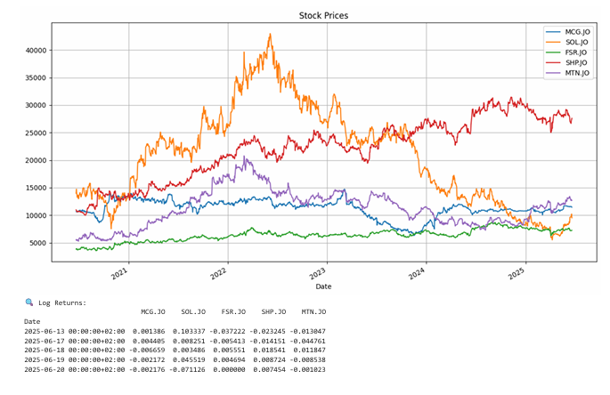

Figure 1: Stock prices over time. This shows the historical trend of each stock's closing price.

From this initial inspection, it was evident that the price series of each stock displayed trends and volatility shifts, suggesting non-stationarity. To confirm this, we applied the Augment Dickey-fuller (ADF) test to each stock’s price series. In every case, the ADF test failed to reject the null hypothesis of a unit root, indicating that the price data is indeed non-stationary.

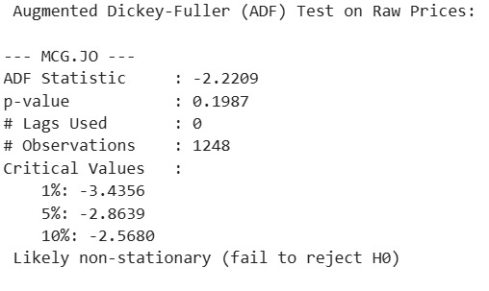

Non-stationarity presents a problem in time series modelling because it violates the assumption of models like PCA and GARCH, which rely on the statistical properties (like mean and variance) remaining constant over time.

To address this, we calculated the logarithmic returns for each stock, defined as:

This transformation stabilizes the variance and converts the price series into return series that more accurately reflects the daily percentage changes and are better suited for statistical modelling.

We then plotted the log return series for each stock.

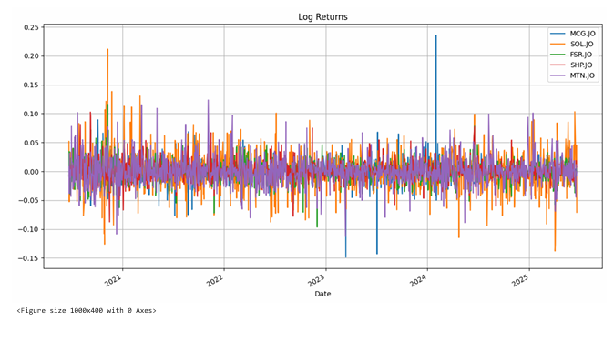

Figure 2: Log returns of the stocks. These highlight the day-to-day fluctuations in percentage terms.

Finally, we repeated the ADF test on the return series. This time, the test rejected the null hypothesis for all five stocks, confirming that the return series are stationary. Stationarity is a key requirement for both Principal Component Analysis (PCA) and GARCH-based volatility models, as it ensures that the underlying data has a stable mean and variance over time, an essential property for reliable factor extraction and volatility forecasting.

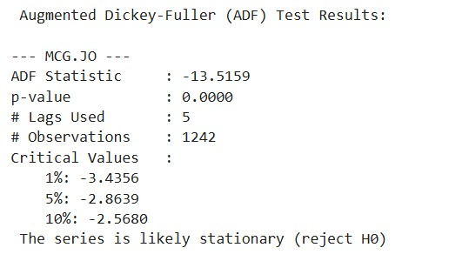

## 2.2 Principal Component Analysis (PCA): Concept, Assumptions and Application

To understand how the selected stocks in our portfolio move together, we applied Principal Component Analysis (PCA), a technique that reduces the dimensionality of financial data by transforming correlated asset returns into a smaller set of uncorrelated components. Before applying PCA, we standardized the log return data so that each series had a mean of zero and a standard deviation of one. This ensures comparability across stocks with different volatilities. The standardized value of a return series is given by:

Where X is the return, is the mean, and is the standard deviation.

PCA was then performed on the covariance matrix of the standardized returns, defined as

where is the return of stock i at time t, is the mean return of stock i and n is the number of time periods. This matrix is symmetric and positive semi-definite, which is a key assumption.

The first principal component (PC1) captured the dominant movement across all five stocks, effectively representing a market-wide risk factor. According to Kaiser’s Rule, only PC1 had an eigenvalue greater than 1, making it the most significant. The scree plot confirmed this by showing a sharp drop in explained variance after PC1. However, we retained PC2 and PC3 because they offered meaningful economic interpretation, such as contrasting behaviour between MCG and SOL. Together, the first three components explained over 76% of the total variance, which is an accepted threshold in financial modelling.

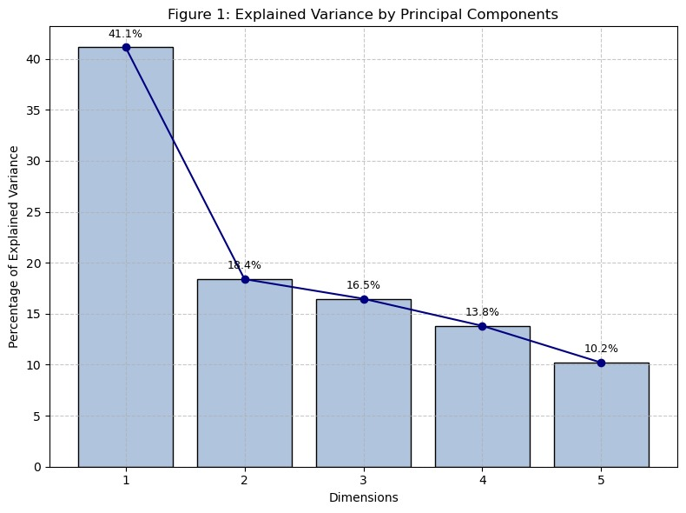

Figure 3: Scree plot showing how much variance each principal component explains.

## 2.3 GARCH Modeling of Principal Components

Once the principal components were identified using PCA, we wanted to understand how the *risk* associated with each of these hidden factors changes over time. To do this, we used a GARCH (1,1) model, short for *Generalized Autoregressive Conditional Heteroskedasticity*.

In simpler terms, GARCH is a model that looks at patterns in **volatility**, not just returns. It is based on the idea that financial markets often go through periods of calm and turbulence. For example, when markets are calm, price changes are small and stable. However, during periods of uncertainty, prices fluctuate more dramatically. GARCH captures this "clustering" effect where high volatility tends to be followed by more high volatility and low volatility by low volatility.

The GARCH (1,1) model, developed by Robert Engle and Tim Bollerslev, is given by the formula:

Where Is the conditional variance (volatility) at time n, are the previous period’s squared residual, Are the previous period’s variance, Is the long-run average variance and .

Each GARCH model gave us a time series showing how volatile that factor was at each point in time. This is called the conditional volatility. It changes over time and gives us a dynamic view of risk. For example, if PC1 shows a spike in volatility, it means the overall market (or the main driver of returns) was becoming riskier during that period.

By doing this, we didn't just look at past returns; we were able to model and forecast how unstable each component might become in the future. This is essential for building the next step: a time-varying risk model for the entire portfolio.

In short, GARCH helped us answer the question: “How does the risk of each underlying factor evolve over time?”, a key insight for risk managers and investors.

Figure 4: GARCH model fit and conditional volatility for PC1, PC2 and PC3.

The GARCH (1,1) model includes three parameters: omega (ω), alpha (α), and beta (β). Omega represents the long-run average volatility. Alpha measures how much recent shocks affect current volatility, capturing short-term clustering. Beta shows how past volatility influences current levels, reflecting long-term persistence.

For PC1, alpha is 0.108 and beta is 0.750, indicating moderate responsiveness and strong persistence. The baseline volatility (omega = 0.295) suggests a relatively stable component. PC2 has a higher alpha of 0.168 and beta of 0.832, showing it reacts more strongly to shocks and remains volatile for longer. Its lower omega of 0.0276 points to a lower base level. PC3 displays very low alpha (0.024) and very high beta (0.969), meaning it is barely affected by new shocks but highly persistent. With the lowest omega (0.0067), PC3 reflects a stable and defensive risk profile.

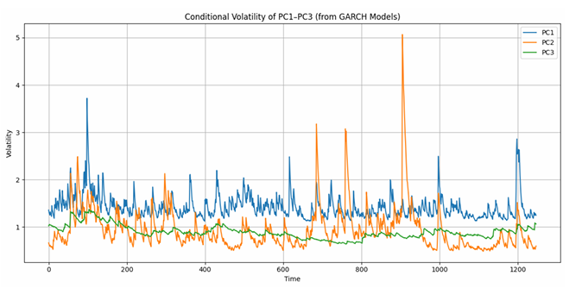

Figure 5: Comparison of GARCH conditional volatility for PC1, PC2, and PC3.

The graph illustrates the evolution of conditional volatility over time for the first three principal components based on the GARCH (1,1) model. PC1, represented by the blue line, exhibits moderate and consistent fluctuations, reflecting a balanced combination of responsiveness and persistence, consistent with medium values for both alpha and beta. PC2, represented by the orange line, exhibits frequent and pronounced spikes in volatility, indicating high sensitivity to new information and prolonged effects, which are likely to capture sector-specific or event-driven risks. Finally, PC3, depicted by the green line, shows a much smoother and flatter pattern, indicating very low responsiveness to shocks but high persistence. This suggests that PC3 represents a more stable and defensive component of risk, evolving gradually over time and less affected by short-term market noise. These distinct patterns help distinguish between dynamic high-risk factors and more stable sources of risk, offering crucial guidance for portfolio construction and risk management.

## 2.4 Reconstruction of the Covariance Matrix

After modelling the volatility of each principal component using GARCH, the next step was to translate that information back to the **original stocks** in the portfolio. To do this, we reconstructed what’s called the **conditional covariance matrix**, a powerful tool that shows how the risks and relationships between stocks evolve over time.

Here’s how it works:

When we applied PCA, we transformed the original stock returns into principal components, new variables that summarize the major patterns of movement. Each original stock was linked to the principal components through a **PCA loading matrix**, which tells us how much each stock “contributes” to each principal component.

At the same time, GARCH gave us the **time-varying variance** (i.e., changing risk levels) for each principal component. By combining the loading matrix with these variances, we can work backward and estimate the **dynamic covariance between each pair of stocks** in the portfolio.

This reconstructed covariance matrix is not fixed; it changes daily based on how the underlying factors behave. That's important because **the relationship between assets isn’t constant**. For example, during a financial crisis, normally unrelated stocks may suddenly move together, increasing correlation and portfolio risk. The reconstructed matrix captures this kind of behaviour.

So, instead of assuming a single, static measure of how risky each stock is or how closely two stocks are linked, this method gives us a **time-varying view** of both individual and joint risks. It allows us to model a more realistic and responsive risk environment, just like what investors face in the real world.

In essence, this step connects everything:

* PCA gives us the structure,
* GARCH gives us the changing risk levels, and
* The covariance matrix brings it all together to understand how **the portfolio’s internal dynamics change over time**.

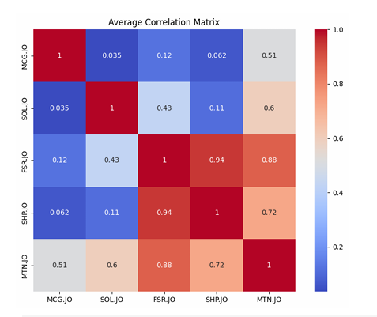

Figure 6: Average correlation matrix between the assets. Warmer colors indicate stronger correlation.

## 2.5 Portfolio Volatility Forecasting

With the time-varying covariance matrix in place, the final step was to use it to forecast how risky the **overall portfolio** would be at each point in time. To do this, we constructed an **equal-weighted portfolio**, meaning each of the five stocks contributes the same share (20%) to the portfolio.

Using the covariance matrix and these weights, we calculated the **conditional portfolio variance**, which tells us how much the portfolio’s value is expected to fluctuate over time. Taking the square root of this variance gave us the **conditional portfolio volatility**, a measure of total portfolio risk that evolves day by day.

This approach is very different from traditional models that assume portfolio volatility is constant. Instead, our method reflects the reality that market conditions change. For example, during stable periods, the model might show low expected volatility. During uncertain times, such as financial shocks or political crises, it identifies rising correlations and increased variance, resulting in higher predicted volatility.

This dynamic forecasting is valuable for investors and risk managers. It allows them to:

* Identify periods of high or low risk,
* adjust investment strategies or hedge positions accordingly,
* allocate capital more efficiently based on expected risk.

In short, this final step brings everything together. It translates all the underlying analysis, PCA, GARCH, and covariance reconstruction into a single, practical measure: *“How risky is my portfolio today, and how might that risk change tomorrow?”*

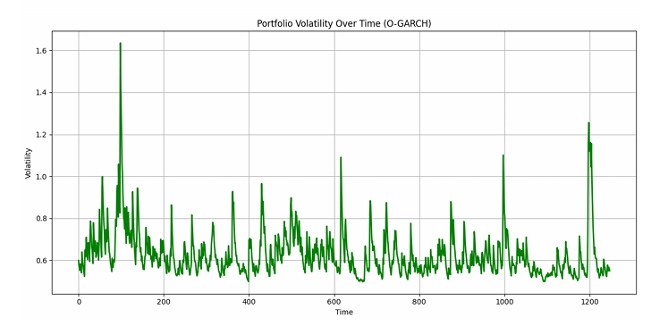

Figure 7: Forecasted portfolio volatility over time using the O-GARCH model.

# 3. Interpretation in Risk and Investment Context

The results of our O-GARCH model reveal that a small number of hidden factors, especially the first principal component (PC1), drive most of the risk in the portfolio. This is significant because it shows that even though the portfolio contains five different stocks from various sectors, much of their movement can be explained by common underlying forces, such as broad market conditions or economic events.

The GARCH model applied to PC1 shows several periods where volatility increases sharply, indicating that the overall market was experiencing instability. These spikes in PC1’s conditional volatility act as a warning signal of elevated systemic risk, which could affect all assets simultaneously. This is a key insight for investors, as it highlights moments where a diversified portfolio may still face high overall risk due to market-wide shocks.

When comparing the volatilities of PC1, PC2, and PC3, we observe that PC1 consistently exhibits the highest and most persistent volatility, indicating that it captures the largest and most influential source of risk. PC2 shows more abrupt spikes, which may represent sector-specific or event-driven risks. PC3 is relatively stable, possibly reflecting smaller residual effects. Together, these components allow us to see not just the level of risk but the *nature* of where that risk is coming from.

The correlation matrix also helps us understand how individual assets relate to one another. For example, FSR.JO and SHP identify rising correlations and increased variance during uncertain times, such as financial shocks or political crises, which results in higher predicted volatility. This dynamic forecasting is invaluable for investors and risk managers.JO shows a very high correlation, meaning they tend to move closely together.

In contrast, MCG.JO has much lower correlations with other stocks, offering better diversification. Understanding these relationships is important for building portfolios that effectively spread risk.

Lastly, the dynamic portfolio volatility forecast gives a real-time view of how overall risk changes. During normal periods, the model shows relatively low and stable volatility. However, during stressful events, such as market downturns or global uncertainty, the model detects rising co-movement and variance, resulting in higher portfolio risk. This helps investors anticipate periods of instability and take proactive steps, such as rebalancing portfolios, increasing hedges, or reducing exposure.

In summary, this interpretation confirms that portfolio risk is not constant; it evolves with the market. The O-GARCH framework helps us not only measure that risk but also understand where it's coming from and how it behaves. This makes it a valuable tool for smarter, risk-aware investment decisions.

# 4. Conclusion and Strategic Insights

This analysis demonstrates the usefulness of combining Principal Component Analysis (PCA) with GARCH modelling to understand better and forecast portfolio risk. PCA reduced complex asset returns into a few key uncorrelated components, while GARCH captured how the volatility of these hidden factors changed over time, highlighting periods of market stress.

The Orthogonal GARCH (O-GARCH) model enabled us to reconstruct the dynamic covariance matrix, anticipate shifts in asset correlations, and forecast total portfolio risk. This is valuable in financial environments where risk is constantly evolving.

That said, the model assumes linear relationships and symmetric volatility, which may oversimplify real-world dynamics. Markets often respond more strongly to negative shocks than positive ones. Future improvements could involve nonlinear techniques, such as kernel PCA or asymmetric GARCH models, including EGARCH or GJR-GARCH.

Still, this approach provides meaningful insights. It supports better risk management by helping investors understand how portfolio volatility arises and changes, guiding smarter decisions around diversification, hedging, and asset allocation.

# 5. References

Reference list

Aielli, G.P. and Caporin, M. (2015). Dynamic Principal Components: A New Class of Multivariate GARCH Models. *SSRN Electronic Journal*. doi:<https://doi.org/10.2139/ssrn.2559758>.

Engle, R. (2001). *GARCH 101: An Introduction to the Use of ARCH/GARCH Models in Applied Econometrics*. [online] Available at: <https://web-static.stern.nyu.edu/rengle/GARCH101.PDF> [Accessed 23 Jun. 2025].

Matei, M. (2012). PERSPECTIVES ON RISK MEASUREMENT: A CRITICAL ASSESSMENT OF PC-GARCH AGAINST THE MAIN VOLATILITY FORECASTING MODELS. *Romanian Journal of Economic Forecasting*, [online] 15(1), pp.95–115. Available at: <https://ipe.ro/rjef/rjef1_12/rjef1_2012p95-115.pdf> [Accessed 23 Jun. 2025].

Portfolio Optimizer (2024). *Volatility Forecasting: GARCH(1,1) Model*. [online] Portfolio Optimizer. Available at: <https://portfoliooptimizer.io/blog/volatility-forecasting-garch11-model/> [Accessed 23 Jun. 2025].