1-

2-

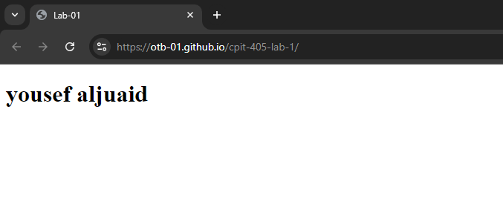

3-



4-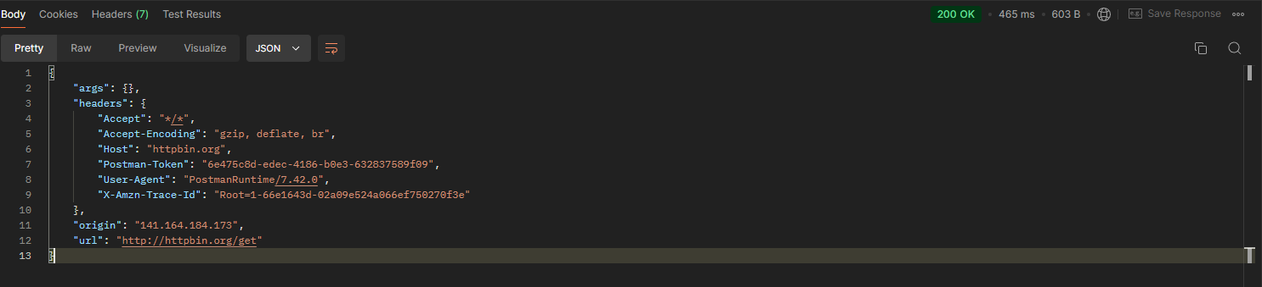

5-