Unit Code: 10300

Undergraduate Graduation Thesis (Design)

Title: Design and Implementation of a Smart Campus Navigation System
Student Name: [To be filled]
Student ID: [To be filled]
Major: [To be filled]
College: [To be filled]
Supervisor: [To be filled]
May 2026

Design and Implementation of a Smart Campus Navigation System
[Student Name]
[College Name], NUIST, Nanjing 210044, China
Abstract: With the development of smart campus construction, campus navigation services have become an important part of digital campus applications. This thesis designs and implements a Smart Campus Navigation Web system based on Spring Boot 3.5.13, Java 21, Maven, MyBatis, MySQL, Thymeleaf, HTML, CSS, native JavaScript, AMap (Gaode Map), QWeather API, and an Intelligent Assistant backend proxy. The system supports POI retrieval, place detail display, route planning, weather display, travel suggestions, Saved Places, Route History Records, and Intelligent Assistant Q&A. The design emphasizes real campus scenarios, clear system boundaries, maintainable module structure, shared data persistence, and practical exception handling.
Key Words: Smart Campus; Campus Navigation; AMap; QWeather API; Spring Boot

Contents
Chapter 1 Introduction ................................................................
Chapter 2 Development Tools and Related Technologies ................................................................
Chapter 3 System Analysis and Design ................................................................
Chapter 4 System Implementation ................................................................
Chapter 5 System Testing ................................................................
Chapter 6 Conclusion and Future Work ................................................................

Chapter 1 Introduction
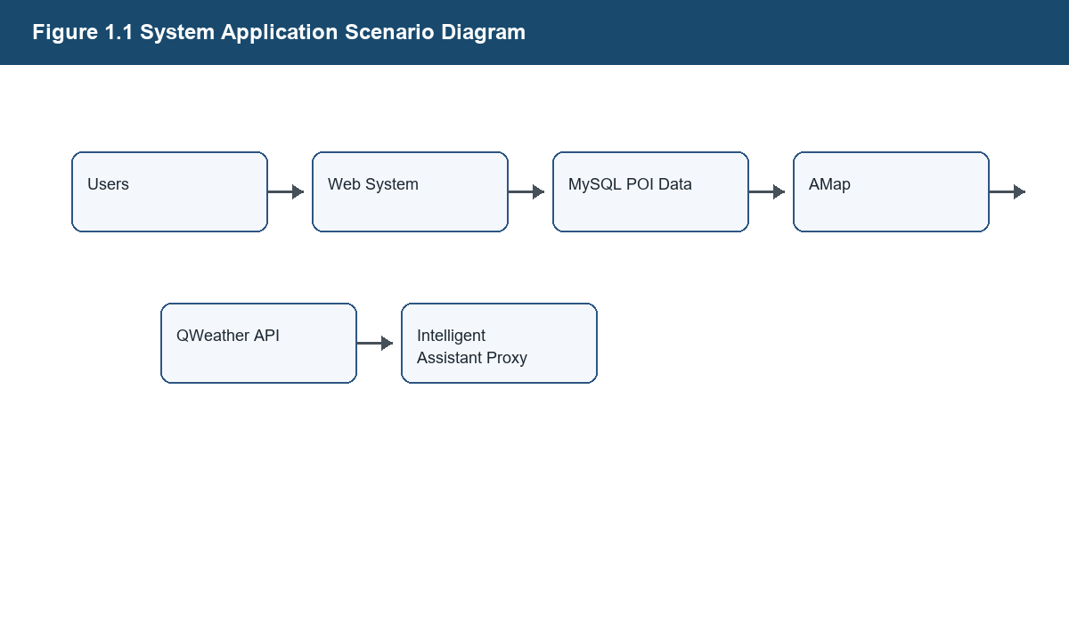
Figure 1.1 System Application Scenario Diagram

1.1 Research Background and Significance
This section explains the corresponding part of the Smart Campus Navigation Web system according to the implemented project. The writing should stay close to the real technology stack and avoid adding functions that are not present in the codebase.

1.1.1 Background of Smart Campus Development
This section explains the corresponding part of the Smart Campus Navigation Web system according to the implemented project. The writing should stay close to the real technology stack and avoid adding functions that are not present in the codebase.

1.1.2 Demand for Campus Navigation Services
This section explains the corresponding part of the Smart Campus Navigation Web system according to the implemented project. The writing should stay close to the real technology stack and avoid adding functions that are not present in the codebase.

1.1.3 Influence of Weather on Campus Travel
The weather-related module obtains current weather data from QWeather API through backend request processing. The system converts weather conditions into practical campus travel prompts and provides exception fallback when the third-party weather service is unavailable.

1.2 Research Status at Home and Abroad
This section explains the corresponding part of the Smart Campus Navigation Web system according to the implemented project. The writing should stay close to the real technology stack and avoid adding functions that are not present in the codebase.

1.2.1 Research Status of Map Navigation and Location-Based Services
This section explains the corresponding part of the Smart Campus Navigation Web system according to the implemented project. The writing should stay close to the real technology stack and avoid adding functions that are not present in the codebase.

1.2.2 Research Status of Campus Navigation Systems
This section explains the corresponding part of the Smart Campus Navigation Web system according to the implemented project. The writing should stay close to the real technology stack and avoid adding functions that are not present in the codebase.

1.2.3 Research Status of Weather-Aware Travel Services
The weather-related module obtains current weather data from QWeather API through backend request processing. The system converts weather conditions into practical campus travel prompts and provides exception fallback when the third-party weather service is unavailable.

1.3 Main Work of This Thesis
This section explains the corresponding part of the Smart Campus Navigation Web system according to the implemented project. The writing should stay close to the real technology stack and avoid adding functions that are not present in the codebase.

1.3.1 Campus POI Retrieval and Place Detail Display
The POI module retrieves campus place data from MySQL through MyBatis and displays search results and place details in the frontend sidebar. Place detail rendering includes name, type, description, opening hours, status, and coordinate-based map location display.

1.3.2 Route Planning and Map Interaction Based on AMap (Gaode Map)
Route planning is implemented by validating the selected start point, optional waypoints, and destination, invoking AMap route services, parsing the returned route data, and rendering the route result on the frontend map. The thesis must not describe this function as a self-developed A*, Dijkstra, or route optimization algorithm.

1.3.3 Weather Display, Travel Suggestions, and Intelligent Assistant Q&A
The weather-related module obtains current weather data from QWeather API through backend request processing. The system converts weather conditions into practical campus travel prompts and provides exception fallback when the third-party weather service is unavailable.

1.4 Organization of the Thesis
This section explains the corresponding part of the Smart Campus Navigation Web system according to the implemented project. The writing should stay close to the real technology stack and avoid adding functions that are not present in the codebase.

Chapter 2 Development Tools and Related Technologies
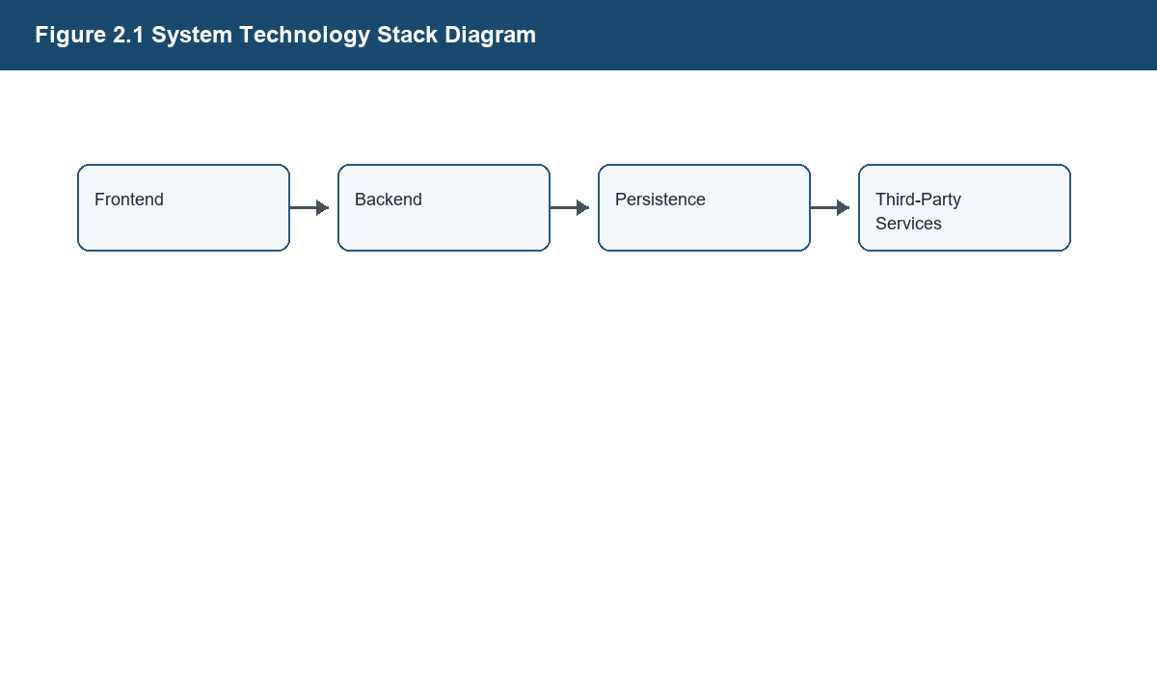
Figure 2.1 System Technology Stack Diagram

2.1 Development Environment
Table 2.1 Development Environment Table
Item | Description
JDK | Java 21
Backend Framework | Spring Boot 3.5.13
Build Tool | Maven
IDE | IntelliJ IDEA
Database | MySQL
Frontend | Thymeleaf, HTML, CSS, Native JavaScript

This section explains the corresponding part of the Smart Campus Navigation Web system according to the implemented project. The writing should stay close to the real technology stack and avoid adding functions that are not present in the codebase.

2.1.1 Java 21 and Maven
This section explains the corresponding part of the Smart Campus Navigation Web system according to the implemented project. The writing should stay close to the real technology stack and avoid adding functions that are not present in the codebase.

2.1.2 IntelliJ IDEA Development Tool
This section explains the corresponding part of the Smart Campus Navigation Web system according to the implemented project. The writing should stay close to the real technology stack and avoid adding functions that are not present in the codebase.

2.1.3 MySQL Database Environment
The database design is based on the implemented tables poi, saved_place, route_history, and covered_path_node. The current design does not introduce a user table because the project does not implement a user account system.

2.2 Backend Development Technologies
This section explains the corresponding part of the Smart Campus Navigation Web system according to the implemented project. The writing should stay close to the real technology stack and avoid adding functions that are not present in the codebase.

2.2.1 Spring Boot 3.5.13
This section explains the corresponding part of the Smart Campus Navigation Web system according to the implemented project. The writing should stay close to the real technology stack and avoid adding functions that are not present in the codebase.

2.2.2 Spring MVC Request Processing Mechanism
This section explains the corresponding part of the Smart Campus Navigation Web system according to the implemented project. The writing should stay close to the real technology stack and avoid adding functions that are not present in the codebase.

2.2.3 MyBatis Persistence Framework
This section explains the corresponding part of the Smart Campus Navigation Web system according to the implemented project. The writing should stay close to the real technology stack and avoid adding functions that are not present in the codebase.

2.2.4 Unified Response and Exception Handling Mechanism
This section explains the corresponding part of the Smart Campus Navigation Web system according to the implemented project. The writing should stay close to the real technology stack and avoid adding functions that are not present in the codebase.

2.3 Frontend Development Technologies
This section explains the corresponding part of the Smart Campus Navigation Web system according to the implemented project. The writing should stay close to the real technology stack and avoid adding functions that are not present in the codebase.

2.3.1 Thymeleaf Template Engine
This section explains the corresponding part of the Smart Campus Navigation Web system according to the implemented project. The writing should stay close to the real technology stack and avoid adding functions that are not present in the codebase.

2.3.2 HTML, CSS, and Native JavaScript
This section explains the corresponding part of the Smart Campus Navigation Web system according to the implemented project. The writing should stay close to the real technology stack and avoid adding functions that are not present in the codebase.

2.3.3 Map Interaction and Sidebar State Management
This section explains the corresponding part of the Smart Campus Navigation Web system according to the implemented project. The writing should stay close to the real technology stack and avoid adding functions that are not present in the codebase.

2.4 Third-Party Service Technologies
Table 2.2 Main Technology Description Table
Technology | Role
AMap JavaScript API | Map display and frontend map interaction
AMap Web Service | Route planning service invoked by backend logic
QWeather API | Current campus weather data provider
Intelligent Assistant Proxy | Backend proxy invocation for campus scenario Q&A

This section explains the corresponding part of the Smart Campus Navigation Web system according to the implemented project. The writing should stay close to the real technology stack and avoid adding functions that are not present in the codebase.

2.4.1 AMap JavaScript API
Route planning is implemented by validating the selected start point, optional waypoints, and destination, invoking AMap route services, parsing the returned route data, and rendering the route result on the frontend map. The thesis must not describe this function as a self-developed A*, Dijkstra, or route optimization algorithm.

2.4.2 AMap Web Service Route Service
Route planning is implemented by validating the selected start point, optional waypoints, and destination, invoking AMap route services, parsing the returned route data, and rendering the route result on the frontend map. The thesis must not describe this function as a self-developed A*, Dijkstra, or route optimization algorithm.

2.4.3 QWeather API
The weather-related module obtains current weather data from QWeather API through backend request processing. The system converts weather conditions into practical campus travel prompts and provides exception fallback when the third-party weather service is unavailable.

2.4.4 Backend Proxy Interface for the Intelligent Assistant
The Intelligent Assistant is described only as backend proxy invocation, campus scenario context construction, answer display, and exception prompt. The project does not train a large model, build a knowledge base system, use vector retrieval, or implement RAG.

2.5 System Testing Methods
Testing focuses on functional behavior, interface responses, and exception scenarios. Test case tables use the fields test ID, test module, test content, input data, expected result, actual result, and pass or fail.

2.5.1 Functional Testing
Testing focuses on functional behavior, interface responses, and exception scenarios. Test case tables use the fields test ID, test module, test content, input data, expected result, actual result, and pass or fail.

2.5.2 Interface Testing
Interface paths must be checked against the real Controller classes before final submission. The interface table in this draft uses implemented Controller paths only and should be rechecked after any code change.

2.5.3 Exception Testing
Testing focuses on functional behavior, interface responses, and exception scenarios. Test case tables use the fields test ID, test module, test content, input data, expected result, actual result, and pass or fail.

Chapter 3 System Analysis and Design

3.1 System Feasibility Analysis
This section explains the corresponding part of the Smart Campus Navigation Web system according to the implemented project. The writing should stay close to the real technology stack and avoid adding functions that are not present in the codebase.

3.1.1 Technical Feasibility
This section explains the corresponding part of the Smart Campus Navigation Web system according to the implemented project. The writing should stay close to the real technology stack and avoid adding functions that are not present in the codebase.

3.1.2 Economic Feasibility
This section explains the corresponding part of the Smart Campus Navigation Web system according to the implemented project. The writing should stay close to the real technology stack and avoid adding functions that are not present in the codebase.

3.1.3 Operational Feasibility
This section explains the corresponding part of the Smart Campus Navigation Web system according to the implemented project. The writing should stay close to the real technology stack and avoid adding functions that are not present in the codebase.

3.2 System Boundary Description
This section defines the implemented scope of the current Web system. The system does not include login, registration, permission management, a multi-user system, user profiles, model training, deep learning algorithms, vector retrieval, or RAG. Saved Places and Route History Records are stored as shared datasets, so no user table or user_id is designed.

3.2.1 User System Boundary
This section defines the implemented scope of the current Web system. The system does not include login, registration, permission management, a multi-user system, user profiles, model training, deep learning algorithms, vector retrieval, or RAG. Saved Places and Route History Records are stored as shared datasets, so no user table or user_id is designed.

3.2.2 Data Storage Boundary
This section defines the implemented scope of the current Web system. The system does not include login, registration, permission management, a multi-user system, user profiles, model training, deep learning algorithms, vector retrieval, or RAG. Saved Places and Route History Records are stored as shared datasets, so no user table or user_id is designed.

3.2.3 Functional Extension Boundary
This section defines the implemented scope of the current Web system. The system does not include login, registration, permission management, a multi-user system, user profiles, model training, deep learning algorithms, vector retrieval, or RAG. Saved Places and Route History Records are stored as shared datasets, so no user table or user_id is designed.

3.3 Requirement Analysis
This section explains the corresponding part of the Smart Campus Navigation Web system according to the implemented project. The writing should stay close to the real technology stack and avoid adding functions that are not present in the codebase.

3.3.1 Functional Requirement Analysis
Table 3.1 Functional Requirement Table
ID | Requirement | Description
FR-01 | POI Retrieval | Search campus POIs by keyword and type
FR-02 | Route Planning | Plan walking or cycling routes by invoking AMap route services
FR-03 | Weather Display | Display current campus weather through QWeather API
FR-04 | Travel Suggestions | Generate scene-based campus travel suggestions
FR-05 | Saved Places | Add, display, rename, and delete shared saved places
FR-06 | Route History Records | Store, display, reuse, delete, and clear shared route records
FR-07 | Intelligent Assistant | Use backend proxy invocation for campus scenario Q&A

This section explains the corresponding part of the Smart Campus Navigation Web system according to the implemented project. The writing should stay close to the real technology stack and avoid adding functions that are not present in the codebase.

3.3.2 Non-Functional Requirement Analysis
Table 3.2 Non-Functional Requirement Table
Requirement | Description
Response Speed | Search and common interface responses should remain smooth under normal conditions
Ease of Use | Map, sidebar, and route point selection should be clear
Maintainability | Controller, service, mapper, DTO, VO, and resource layers should remain separated
Security | External API keys should be encapsulated by backend configuration where applicable
Stability | External failures and empty results should be handled with controlled prompts

This section explains the corresponding part of the Smart Campus Navigation Web system according to the implemented project. The writing should stay close to the real technology stack and avoid adding functions that are not present in the codebase.

3.4 Overall System Architecture Design
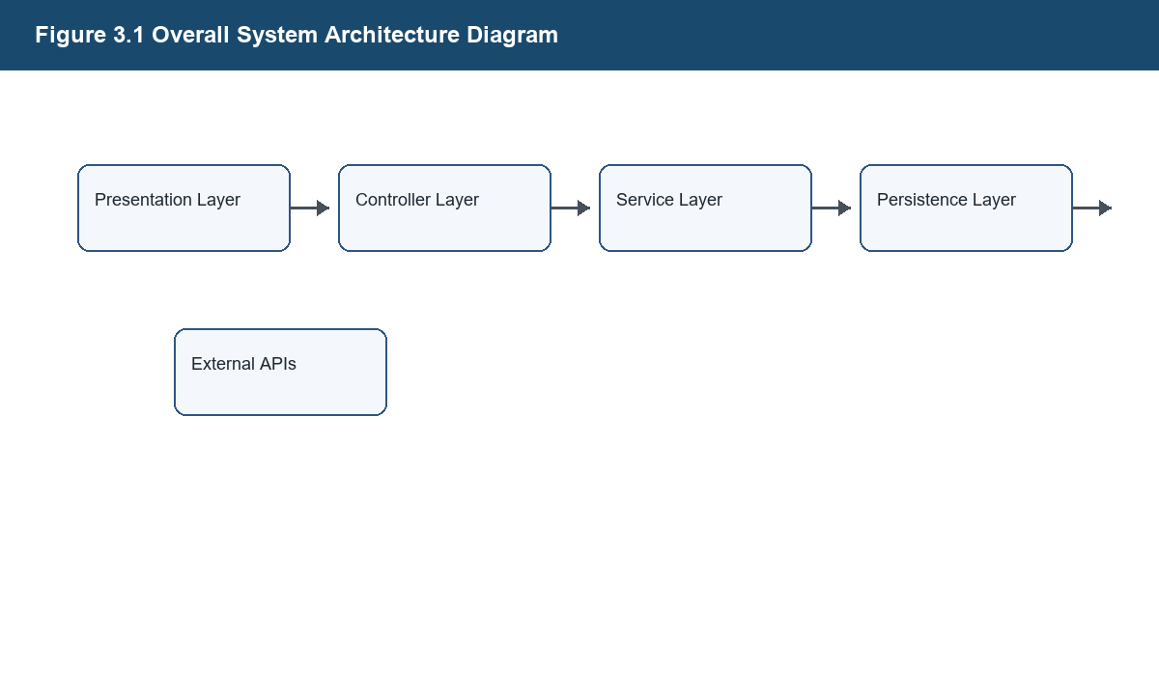
Figure 3.1 Overall System Architecture Diagram

This section explains the corresponding part of the Smart Campus Navigation Web system according to the implemented project. The writing should stay close to the real technology stack and avoid adding functions that are not present in the codebase.

3.4.1 Presentation Layer Design
This section explains the corresponding part of the Smart Campus Navigation Web system according to the implemented project. The writing should stay close to the real technology stack and avoid adding functions that are not present in the codebase.

3.4.2 Controller Layer Design
This section explains the corresponding part of the Smart Campus Navigation Web system according to the implemented project. The writing should stay close to the real technology stack and avoid adding functions that are not present in the codebase.

3.4.3 Service Layer Design
This section explains the corresponding part of the Smart Campus Navigation Web system according to the implemented project. The writing should stay close to the real technology stack and avoid adding functions that are not present in the codebase.

3.4.4 Persistence Layer Design
This section explains the corresponding part of the Smart Campus Navigation Web system according to the implemented project. The writing should stay close to the real technology stack and avoid adding functions that are not present in the codebase.

3.4.5 Third-Party Service Interaction Design
This section explains the corresponding part of the Smart Campus Navigation Web system according to the implemented project. The writing should stay close to the real technology stack and avoid adding functions that are not present in the codebase.

3.5 System Functional Structure Design
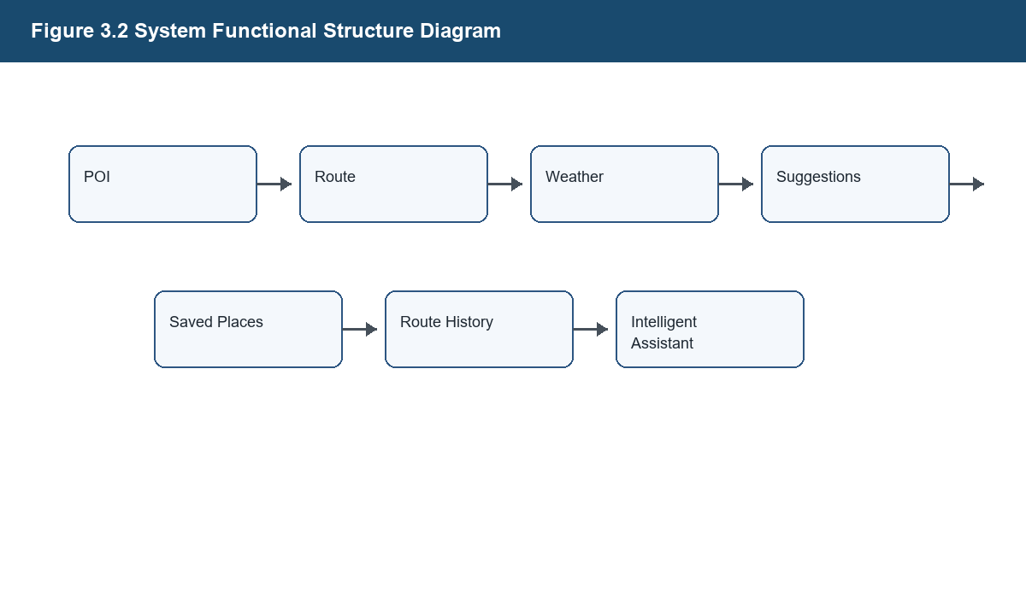
Figure 3.2 System Functional Structure Diagram

This section explains the corresponding part of the Smart Campus Navigation Web system according to the implemented project. The writing should stay close to the real technology stack and avoid adding functions that are not present in the codebase.

3.5.1 POI Retrieval and Place Detail Module
The POI module retrieves campus place data from MySQL through MyBatis and displays search results and place details in the frontend sidebar. Place detail rendering includes name, type, description, opening hours, status, and coordinate-based map location display.

3.5.2 Route Planning Module
Route planning is implemented by validating the selected start point, optional waypoints, and destination, invoking AMap route services, parsing the returned route data, and rendering the route result on the frontend map. The thesis must not describe this function as a self-developed A*, Dijkstra, or route optimization algorithm.

3.5.3 Weather Display and Travel Suggestion Module
The weather-related module obtains current weather data from QWeather API through backend request processing. The system converts weather conditions into practical campus travel prompts and provides exception fallback when the third-party weather service is unavailable.

3.5.4 Saved Places Module
The Saved Places module supports adding, displaying, renaming, and deleting saved campus places. These records are persisted in MySQL as a shared dataset rather than as user-specific favorites.

3.5.5 Route History Records Module
Route History Records store route-related information such as title, mode, start point, destination, optional waypoint data, distance, and duration. The system supports listing, reusing, deleting, and clearing these shared route history records.

3.5.6 Intelligent Assistant Module
The Intelligent Assistant is described only as backend proxy invocation, campus scenario context construction, answer display, and exception prompt. The project does not train a large model, build a knowledge base system, use vector retrieval, or implement RAG.

3.6 Database Design
The database design is based on the implemented tables poi, saved_place, route_history, and covered_path_node. The current design does not introduce a user table because the project does not implement a user account system.

3.6.1 Conceptual Structure Design
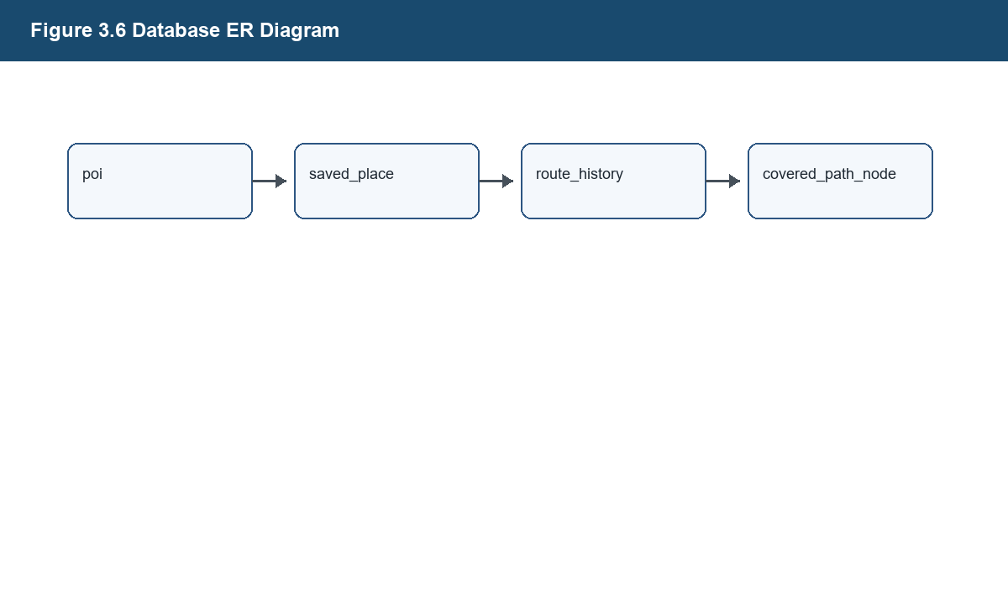
Figure 3.6 Database ER Diagram

This section explains the corresponding part of the Smart Campus Navigation Web system according to the implemented project. The writing should stay close to the real technology stack and avoid adding functions that are not present in the codebase.

3.6.2 Logical Structure Design
This section explains the corresponding part of the Smart Campus Navigation Web system according to the implemented project. The writing should stay close to the real technology stack and avoid adding functions that are not present in the codebase.

3.6.3 Description of Main Data Tables
Table 3.3 Main Database Table Description
Table Name | Description
poi | Campus POI master data
saved_place | Shared Saved Places data
route_history | Shared Route History Records
covered_path_node | Sheltered path auxiliary data

The database design is based on the implemented tables poi, saved_place, route_history, and covered_path_node. The current design does not introduce a user table because the project does not implement a user account system.

3.6.4 Description of Data Table Relationships
The database design is based on the implemented tables poi, saved_place, route_history, and covered_path_node. The current design does not introduce a user table because the project does not implement a user account system.

3.7 Core Business Process Design
This section explains the corresponding part of the Smart Campus Navigation Web system according to the implemented project. The writing should stay close to the real technology stack and avoid adding functions that are not present in the codebase.

3.7.1 POI Query Process Design
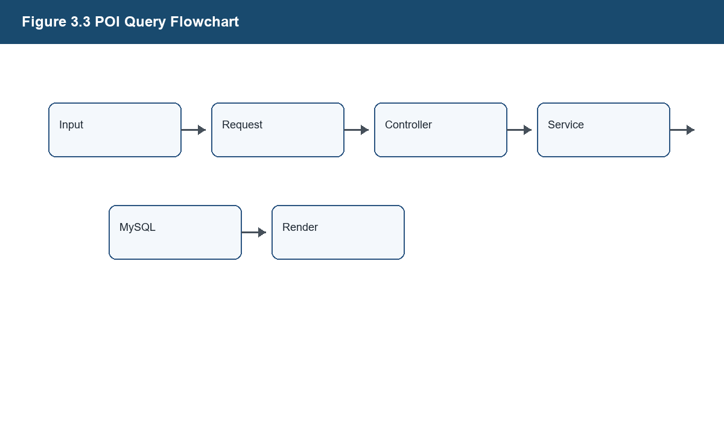
Figure 3.3 POI Query Flowchart

The POI module retrieves campus place data from MySQL through MyBatis and displays search results and place details in the frontend sidebar. Place detail rendering includes name, type, description, opening hours, status, and coordinate-based map location display.

3.7.2 Route Planning Process Design
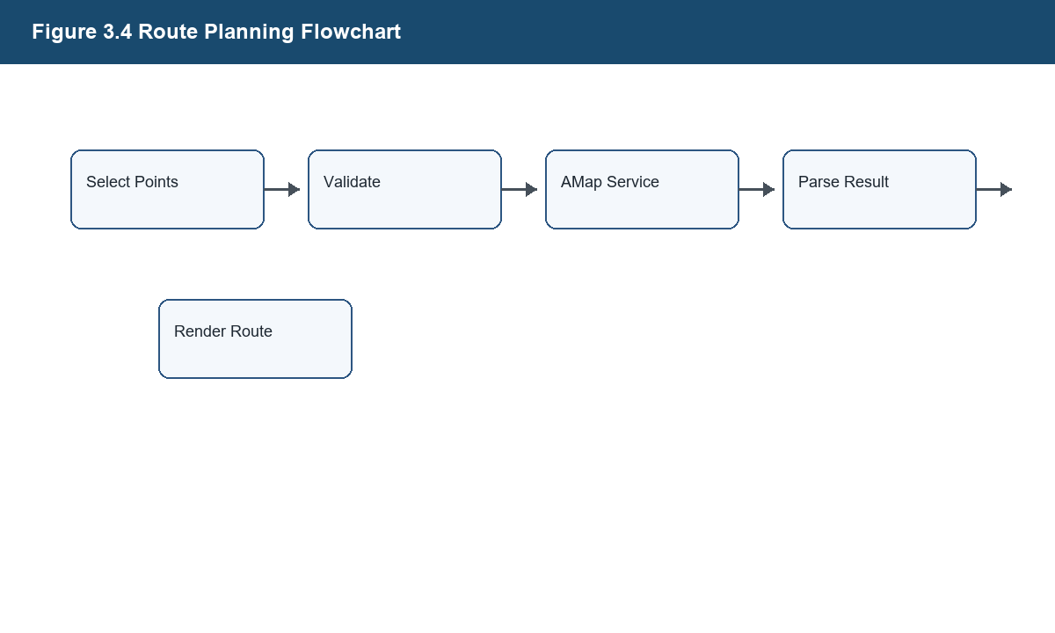
Figure 3.4 Route Planning Flowchart

Route planning is implemented by validating the selected start point, optional waypoints, and destination, invoking AMap route services, parsing the returned route data, and rendering the route result on the frontend map. The thesis must not describe this function as a self-developed A*, Dijkstra, or route optimization algorithm.

3.7.3 Weather-Aware Travel Suggestion Process Design
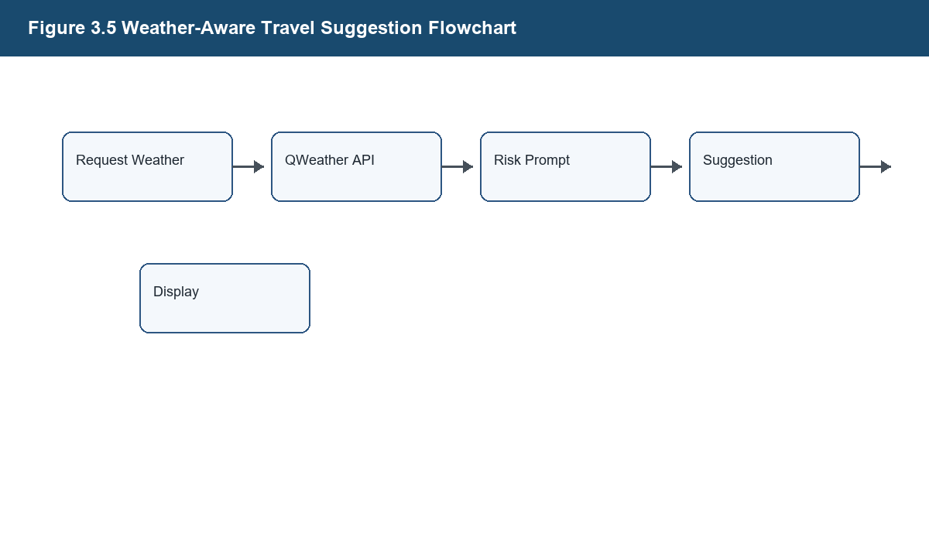
Figure 3.5 Weather-Aware Travel Suggestion Flowchart

The weather-related module obtains current weather data from QWeather API through backend request processing. The system converts weather conditions into practical campus travel prompts and provides exception fallback when the third-party weather service is unavailable.

3.7.4 Intelligent Assistant Q&A Process Design
The Intelligent Assistant is described only as backend proxy invocation, campus scenario context construction, answer display, and exception prompt. The project does not train a large model, build a knowledge base system, use vector retrieval, or implement RAG.

3.8 System Interface Design
Interface paths must be checked against the real Controller classes before final submission. The interface table in this draft uses implemented Controller paths only and should be rechecked after any code change.

3.8.1 POI-Related Interfaces
The POI module retrieves campus place data from MySQL through MyBatis and displays search results and place details in the frontend sidebar. Place detail rendering includes name, type, description, opening hours, status, and coordinate-based map location display.

3.8.2 Route Planning Interfaces
Route planning is implemented by validating the selected start point, optional waypoints, and destination, invoking AMap route services, parsing the returned route data, and rendering the route result on the frontend map. The thesis must not describe this function as a self-developed A*, Dijkstra, or route optimization algorithm.

3.8.3 Weather and Suggestion Interfaces
The weather-related module obtains current weather data from QWeather API through backend request processing. The system converts weather conditions into practical campus travel prompts and provides exception fallback when the third-party weather service is unavailable.

3.8.4 Saved Places and Route History Records Interfaces
The Saved Places module supports adding, displaying, renaming, and deleting saved campus places. These records are persisted in MySQL as a shared dataset rather than as user-specific favorites.

3.8.5 Intelligent Assistant Interface
The Intelligent Assistant is described only as backend proxy invocation, campus scenario context construction, answer display, and exception prompt. The project does not train a large model, build a knowledge base system, use vector retrieval, or implement RAG.

3.8.6 Main System Interface Description Table
Table 3.4 Main System Interface Description
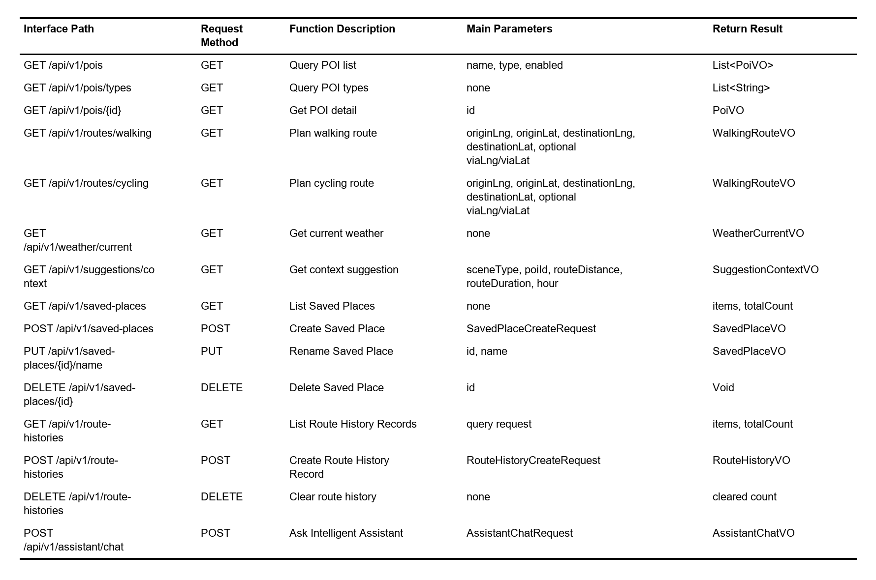

Interface paths must be checked against the real Controller classes before final submission. The interface table in this draft uses implemented Controller paths only and should be rechecked after any code change.

3.9 Chapter Summary
This chapter summary reviews the main points of the chapter and connects them with the following chapter. It should remain concise and should not introduce new functions that are not implemented in the project.

Chapter 4 System Implementation

4.1 Engineering Structure Description
This section explains the corresponding part of the Smart Campus Navigation Web system according to the implemented project. The writing should stay close to the real technology stack and avoid adding functions that are not present in the codebase.

4.1.1 Project Directory Structure
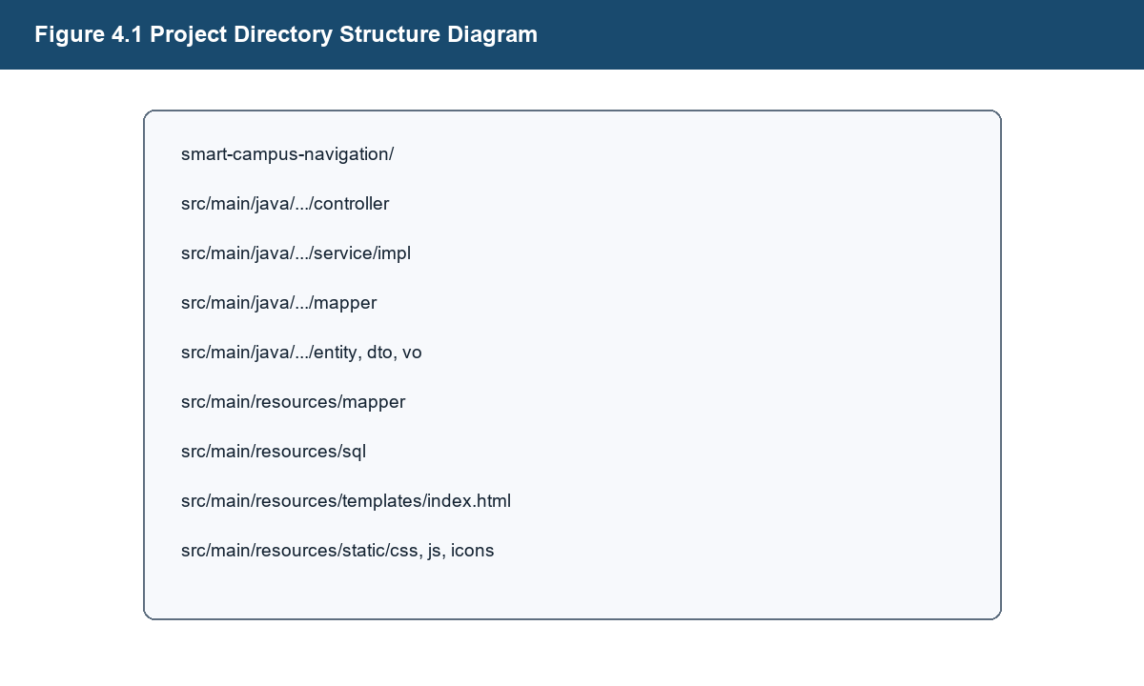
Figure 4.1 Project Directory Structure Diagram

This section explains the corresponding part of the Smart Campus Navigation Web system according to the implemented project. The writing should stay close to the real technology stack and avoid adding functions that are not present in the codebase.

4.1.2 Main Package Responsibilities
This section explains the corresponding part of the Smart Campus Navigation Web system according to the implemented project. The writing should stay close to the real technology stack and avoid adding functions that are not present in the codebase.

4.1.3 Resource File Organization
This section explains the corresponding part of the Smart Campus Navigation Web system according to the implemented project. The writing should stay close to the real technology stack and avoid adding functions that are not present in the codebase.

4.2 Home Page and Map Initialization Implementation
This section explains the corresponding part of the Smart Campus Navigation Web system according to the implemented project. The writing should stay close to the real technology stack and avoid adding functions that are not present in the codebase.

4.2.1 Home Page Layout Design
This section explains the corresponding part of the Smart Campus Navigation Web system according to the implemented project. The writing should stay close to the real technology stack and avoid adding functions that are not present in the codebase.

4.2.2 Map Container Initialization
This section explains the corresponding part of the Smart Campus Navigation Web system according to the implemented project. The writing should stay close to the real technology stack and avoid adding functions that are not present in the codebase.

4.2.3 Campus Center Point and Map Component Loading
The POI module retrieves campus place data from MySQL through MyBatis and displays search results and place details in the frontend sidebar. Place detail rendering includes name, type, description, opening hours, status, and coordinate-based map location display.

4.2.4 Home Page Running Effect
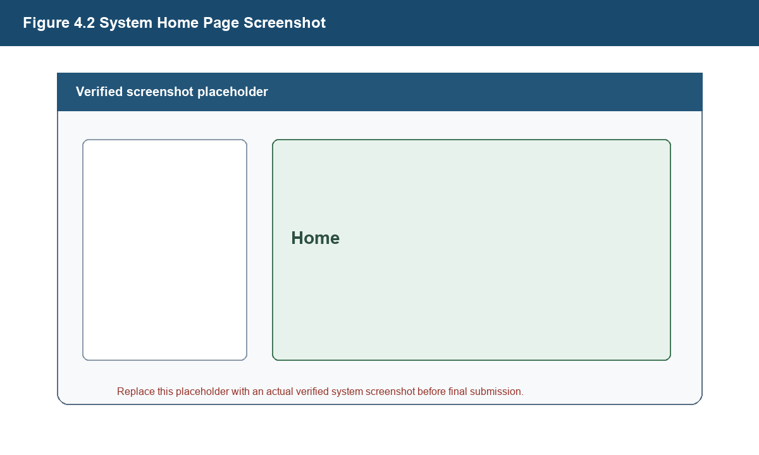
Figure 4.2 System Home Page Screenshot

This section explains the corresponding part of the Smart Campus Navigation Web system according to the implemented project. The writing should stay close to the real technology stack and avoid adding functions that are not present in the codebase.

4.3 POI Retrieval and Place Detail Implementation
The POI module retrieves campus place data from MySQL through MyBatis and displays search results and place details in the frontend sidebar. Place detail rendering includes name, type, description, opening hours, status, and coordinate-based map location display.

4.3.1 Search Box and Result List Interaction
This section explains the corresponding part of the Smart Campus Navigation Web system according to the implemented project. The writing should stay close to the real technology stack and avoid adding functions that are not present in the codebase.

4.3.2 POI Query Request Processing
The POI module retrieves campus place data from MySQL through MyBatis and displays search results and place details in the frontend sidebar. Place detail rendering includes name, type, description, opening hours, status, and coordinate-based map location display.

4.3.3 Place Detail Data Rendering
The POI module retrieves campus place data from MySQL through MyBatis and displays search results and place details in the frontend sidebar. Place detail rendering includes name, type, description, opening hours, status, and coordinate-based map location display.

4.3.4 Map Marker and Location Display
This section explains the corresponding part of the Smart Campus Navigation Web system according to the implemented project. The writing should stay close to the real technology stack and avoid adding functions that are not present in the codebase.

4.3.5 POI Retrieval Running Effect
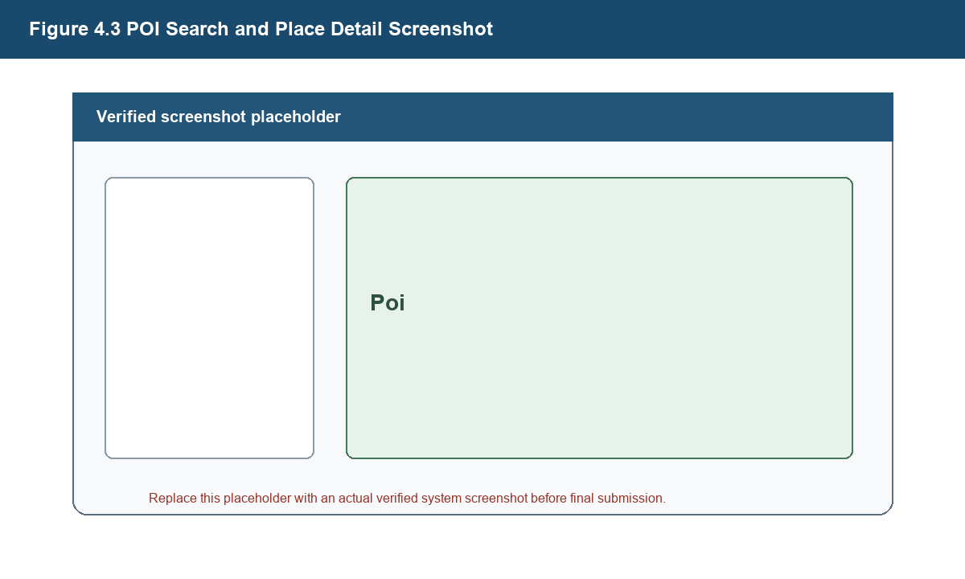
Figure 4.3 POI Search and Place Detail Screenshot

The POI module retrieves campus place data from MySQL through MyBatis and displays search results and place details in the frontend sidebar. Place detail rendering includes name, type, description, opening hours, status, and coordinate-based map location display.

4.4 Route Planning Implementation
Route planning is implemented by validating the selected start point, optional waypoints, and destination, invoking AMap route services, parsing the returned route data, and rendering the route result on the frontend map. The thesis must not describe this function as a self-developed A*, Dijkstra, or route optimization algorithm.

4.4.1 Start Point, Waypoint, and Destination Selection
The POI module retrieves campus place data from MySQL through MyBatis and displays search results and place details in the frontend sidebar. Place detail rendering includes name, type, description, opening hours, status, and coordinate-based map location display.

4.4.2 Route Planning Request Construction
Route planning is implemented by validating the selected start point, optional waypoints, and destination, invoking AMap route services, parsing the returned route data, and rendering the route result on the frontend map. The thesis must not describe this function as a self-developed A*, Dijkstra, or route optimization algorithm.

4.4.3 AMap Route Service Invocation
Route planning is implemented by validating the selected start point, optional waypoints, and destination, invoking AMap route services, parsing the returned route data, and rendering the route result on the frontend map. The thesis must not describe this function as a self-developed A*, Dijkstra, or route optimization algorithm.

4.4.4 Route Result Parsing and Frontend Map Rendering
This section explains the corresponding part of the Smart Campus Navigation Web system according to the implemented project. The writing should stay close to the real technology stack and avoid adding functions that are not present in the codebase.

4.4.5 Route Planning Running Effect
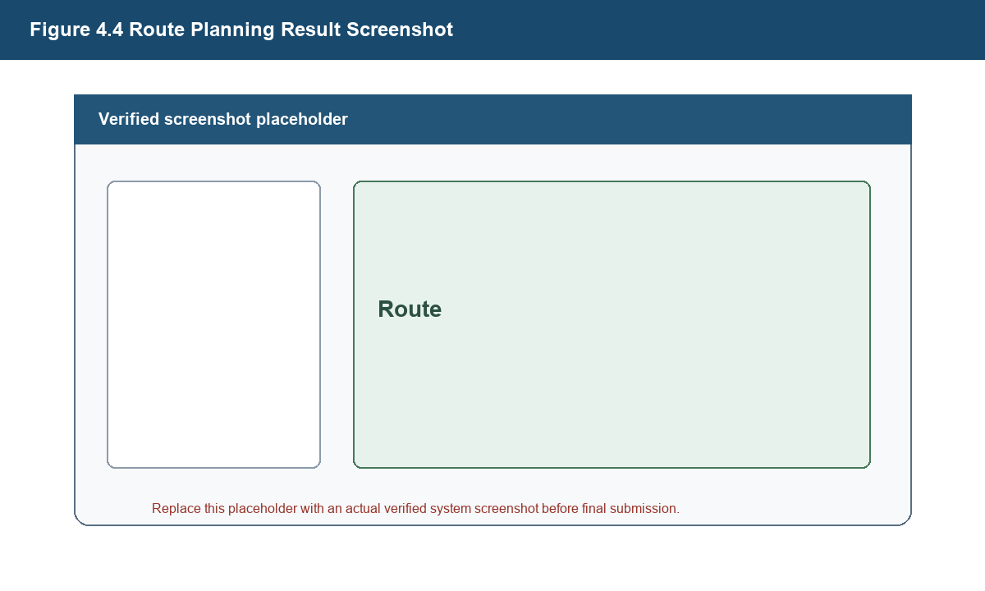
Figure 4.4 Route Planning Result Screenshot

Route planning is implemented by validating the selected start point, optional waypoints, and destination, invoking AMap route services, parsing the returned route data, and rendering the route result on the frontend map. The thesis must not describe this function as a self-developed A*, Dijkstra, or route optimization algorithm.

4.5 Weather Display and Weather Risk Prompt Implementation
The weather-related module obtains current weather data from QWeather API through backend request processing. The system converts weather conditions into practical campus travel prompts and provides exception fallback when the third-party weather service is unavailable.

4.5.1 Weather Information Display Area Design
The weather-related module obtains current weather data from QWeather API through backend request processing. The system converts weather conditions into practical campus travel prompts and provides exception fallback when the third-party weather service is unavailable.

4.5.2 QWeather API Request Processing
The weather-related module obtains current weather data from QWeather API through backend request processing. The system converts weather conditions into practical campus travel prompts and provides exception fallback when the third-party weather service is unavailable.

4.5.3 Weather Risk Prompt Logic
The weather-related module obtains current weather data from QWeather API through backend request processing. The system converts weather conditions into practical campus travel prompts and provides exception fallback when the third-party weather service is unavailable.

4.5.4 Weather Information Exception Fallback
The weather-related module obtains current weather data from QWeather API through backend request processing. The system converts weather conditions into practical campus travel prompts and provides exception fallback when the third-party weather service is unavailable.

4.5.5 Weather Display Running Effect
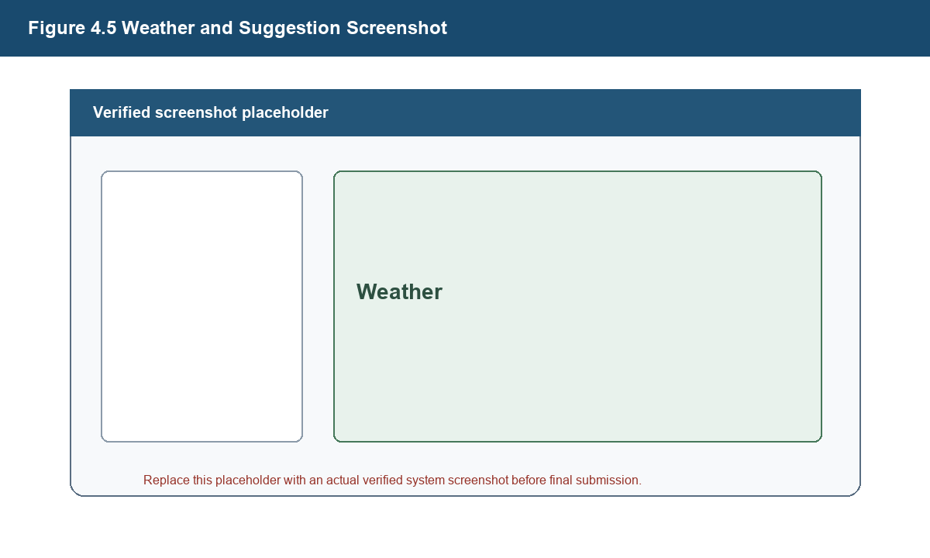
Figure 4.5 Weather and Suggestion Screenshot

The weather-related module obtains current weather data from QWeather API through backend request processing. The system converts weather conditions into practical campus travel prompts and provides exception fallback when the third-party weather service is unavailable.

4.6 Travel Suggestion Implementation
This section explains the corresponding part of the Smart Campus Navigation Web system according to the implemented project. The writing should stay close to the real technology stack and avoid adding functions that are not present in the codebase.

4.6.1 Scenario-Based Suggestion Rules
This section explains the corresponding part of the Smart Campus Navigation Web system according to the implemented project. The writing should stay close to the real technology stack and avoid adding functions that are not present in the codebase.

4.6.2 Combination of Route and Weather Information
The weather-related module obtains current weather data from QWeather API through backend request processing. The system converts weather conditions into practical campus travel prompts and provides exception fallback when the third-party weather service is unavailable.

4.6.3 Assisted Processing of Sheltered Path Data
This section explains the corresponding part of the Smart Campus Navigation Web system according to the implemented project. The writing should stay close to the real technology stack and avoid adding functions that are not present in the codebase.

4.6.4 Frontend Rendering of Suggestion Results
This section explains the corresponding part of the Smart Campus Navigation Web system according to the implemented project. The writing should stay close to the real technology stack and avoid adding functions that are not present in the codebase.

4.6.5 Travel Suggestion Running Effect
This section explains the corresponding part of the Smart Campus Navigation Web system according to the implemented project. The writing should stay close to the real technology stack and avoid adding functions that are not present in the codebase.

4.7 Saved Places Implementation
The Saved Places module supports adding, displaying, renaming, and deleting saved campus places. These records are persisted in MySQL as a shared dataset rather than as user-specific favorites.

4.7.1 Adding Saved Places
The Saved Places module supports adding, displaying, renaming, and deleting saved campus places. These records are persisted in MySQL as a shared dataset rather than as user-specific favorites.

4.7.2 Saved Places List Display
The Saved Places module supports adding, displaying, renaming, and deleting saved campus places. These records are persisted in MySQL as a shared dataset rather than as user-specific favorites.

4.7.3 Saved Place Name Editing
This section explains the corresponding part of the Smart Campus Navigation Web system according to the implemented project. The writing should stay close to the real technology stack and avoid adding functions that are not present in the codebase.

4.7.4 Saved Place Deletion and Data Persistence
This section explains the corresponding part of the Smart Campus Navigation Web system according to the implemented project. The writing should stay close to the real technology stack and avoid adding functions that are not present in the codebase.

4.7.5 Saved Places Running Effect
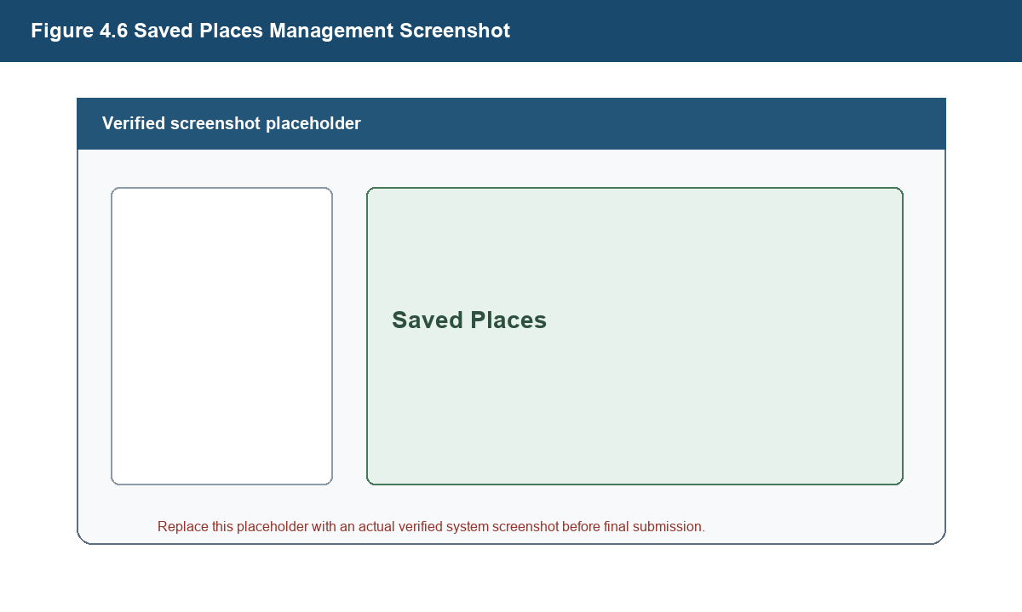
Figure 4.6 Saved Places Management Screenshot

The Saved Places module supports adding, displaying, renaming, and deleting saved campus places. These records are persisted in MySQL as a shared dataset rather than as user-specific favorites.

4.8 Route History Records Implementation
Route History Records store route-related information such as title, mode, start point, destination, optional waypoint data, distance, and duration. The system supports listing, reusing, deleting, and clearing these shared route history records.

4.8.1 Route History Record Storage
Route History Records store route-related information such as title, mode, start point, destination, optional waypoint data, distance, and duration. The system supports listing, reusing, deleting, and clearing these shared route history records.

4.8.2 Route History Records List Display
Route History Records store route-related information such as title, mode, start point, destination, optional waypoint data, distance, and duration. The system supports listing, reusing, deleting, and clearing these shared route history records.

4.8.3 Route History Record Reuse
Route History Records store route-related information such as title, mode, start point, destination, optional waypoint data, distance, and duration. The system supports listing, reusing, deleting, and clearing these shared route history records.

4.8.4 Route History Record Deletion and Cleanup
Route History Records store route-related information such as title, mode, start point, destination, optional waypoint data, distance, and duration. The system supports listing, reusing, deleting, and clearing these shared route history records.

4.8.5 Route History Records Running Effect
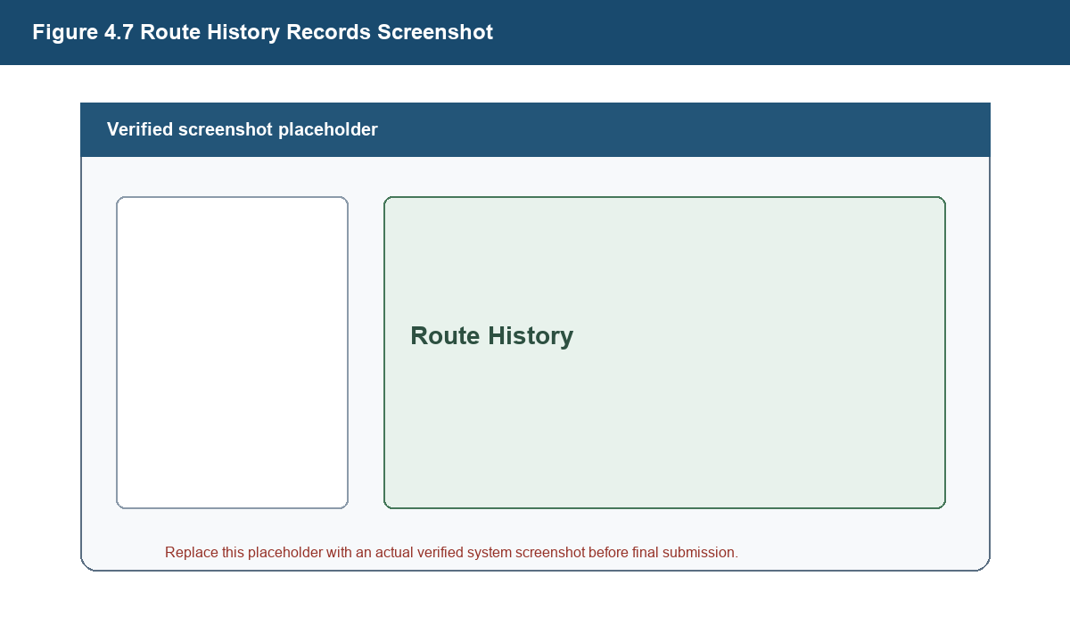
Figure 4.7 Route History Records Screenshot

Route History Records store route-related information such as title, mode, start point, destination, optional waypoint data, distance, and duration. The system supports listing, reusing, deleting, and clearing these shared route history records.

4.9 Intelligent Assistant Implementation
The Intelligent Assistant is described only as backend proxy invocation, campus scenario context construction, answer display, and exception prompt. The project does not train a large model, build a knowledge base system, use vector retrieval, or implement RAG.

4.9.1 Q&A Entry and Message Display
This section explains the corresponding part of the Smart Campus Navigation Web system according to the implemented project. The writing should stay close to the real technology stack and avoid adding functions that are not present in the codebase.

4.9.2 Campus Scenario Context Construction
This section explains the corresponding part of the Smart Campus Navigation Web system according to the implemented project. The writing should stay close to the real technology stack and avoid adding functions that are not present in the codebase.

4.9.3 Backend Proxy Interface Invocation
Interface paths must be checked against the real Controller classes before final submission. The interface table in this draft uses implemented Controller paths only and should be rechecked after any code change.

4.9.4 Answer Display and Exception Prompt
This section explains the corresponding part of the Smart Campus Navigation Web system according to the implemented project. The writing should stay close to the real technology stack and avoid adding functions that are not present in the codebase.

4.9.5 Intelligent Assistant Running Effect
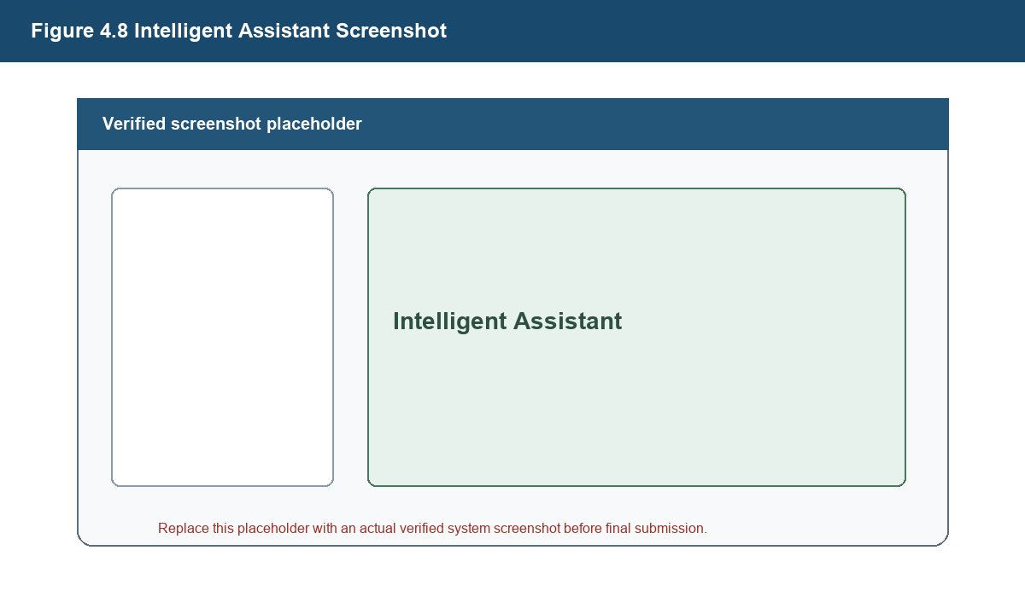
Figure 4.8 Intelligent Assistant Screenshot

The Intelligent Assistant is described only as backend proxy invocation, campus scenario context construction, answer display, and exception prompt. The project does not train a large model, build a knowledge base system, use vector retrieval, or implement RAG.

4.10 Frontend and Backend Exception Handling
This section explains the corresponding part of the Smart Campus Navigation Web system according to the implemented project. The writing should stay close to the real technology stack and avoid adding functions that are not present in the codebase.

4.10.1 Backend Unified Response Structure
This section explains the corresponding part of the Smart Campus Navigation Web system according to the implemented project. The writing should stay close to the real technology stack and avoid adding functions that are not present in the codebase.

4.10.2 Global Exception Handling
This section explains the corresponding part of the Smart Campus Navigation Web system according to the implemented project. The writing should stay close to the real technology stack and avoid adding functions that are not present in the codebase.

4.10.3 Frontend Request Timeout Handling
This section explains the corresponding part of the Smart Campus Navigation Web system according to the implemented project. The writing should stay close to the real technology stack and avoid adding functions that are not present in the codebase.

4.10.4 User Prompt Message Display
This section explains the corresponding part of the Smart Campus Navigation Web system according to the implemented project. The writing should stay close to the real technology stack and avoid adding functions that are not present in the codebase.

4.11 Key Problems and Solutions
This section explains the corresponding part of the Smart Campus Navigation Web system according to the implemented project. The writing should stay close to the real technology stack and avoid adding functions that are not present in the codebase.

4.11.1 Handling Third-Party Weather Interface Failures
The weather-related module obtains current weather data from QWeather API through backend request processing. The system converts weather conditions into practical campus travel prompts and provides exception fallback when the third-party weather service is unavailable.

4.11.2 Synchronization Between Map Interaction and Sidebar State
This section explains the corresponding part of the Smart Campus Navigation Web system according to the implemented project. The writing should stay close to the real technology stack and avoid adding functions that are not present in the codebase.

4.11.3 Selection and Search Result Refill of Start Point, Waypoint, and Destination
The POI module retrieves campus place data from MySQL through MyBatis and displays search results and place details in the frontend sidebar. Place detail rendering includes name, type, description, opening hours, status, and coordinate-based map location display.

4.11.4 Migration of Saved Places from localStorage to MySQL Persistence
The Saved Places module supports adding, displaying, renaming, and deleting saved campus places. These records are persisted in MySQL as a shared dataset rather than as user-specific favorites.

4.11.5 Backend Encapsulation of External API Keys
This section explains the corresponding part of the Smart Campus Navigation Web system according to the implemented project. The writing should stay close to the real technology stack and avoid adding functions that are not present in the codebase.

4.12 Chapter Summary
This chapter summary reviews the main points of the chapter and connects them with the following chapter. It should remain concise and should not introduce new functions that are not implemented in the project.

Chapter 5 System Testing

5.1 Testing Environment
Testing focuses on functional behavior, interface responses, and exception scenarios. Test case tables use the fields test ID, test module, test content, input data, expected result, actual result, and pass or fail.

5.1.1 Hardware Environment
This section explains the corresponding part of the Smart Campus Navigation Web system according to the implemented project. The writing should stay close to the real technology stack and avoid adding functions that are not present in the codebase.

5.1.2 Software Environment
This section explains the corresponding part of the Smart Campus Navigation Web system according to the implemented project. The writing should stay close to the real technology stack and avoid adding functions that are not present in the codebase.

5.1.3 Database Environment
The database design is based on the implemented tables poi, saved_place, route_history, and covered_path_node. The current design does not introduce a user table because the project does not implement a user account system.

5.2 Testing Methods
Testing focuses on functional behavior, interface responses, and exception scenarios. Test case tables use the fields test ID, test module, test content, input data, expected result, actual result, and pass or fail.

5.2.1 Functional Testing
Testing focuses on functional behavior, interface responses, and exception scenarios. Test case tables use the fields test ID, test module, test content, input data, expected result, actual result, and pass or fail.

5.2.2 Interface Testing
Interface paths must be checked against the real Controller classes before final submission. The interface table in this draft uses implemented Controller paths only and should be rechecked after any code change.

5.2.3 Exception Testing
Testing focuses on functional behavior, interface responses, and exception scenarios. Test case tables use the fields test ID, test module, test content, input data, expected result, actual result, and pass or fail.

5.3 Functional Testing
Table 5.1 Functional Test Case Table
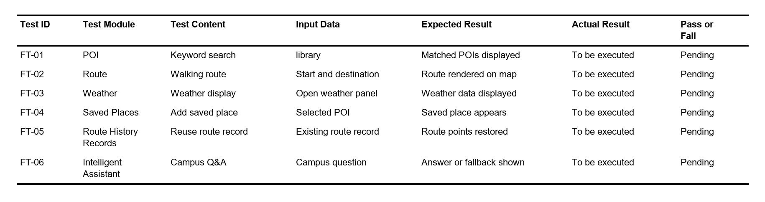

Testing focuses on functional behavior, interface responses, and exception scenarios. Test case tables use the fields test ID, test module, test content, input data, expected result, actual result, and pass or fail.

5.3.1 POI Query and Place Detail Testing
The POI module retrieves campus place data from MySQL through MyBatis and displays search results and place details in the frontend sidebar. Place detail rendering includes name, type, description, opening hours, status, and coordinate-based map location display.

5.3.2 Route Planning Testing
Route planning is implemented by validating the selected start point, optional waypoints, and destination, invoking AMap route services, parsing the returned route data, and rendering the route result on the frontend map. The thesis must not describe this function as a self-developed A*, Dijkstra, or route optimization algorithm.

5.3.3 Weather Display and Travel Suggestion Testing
The weather-related module obtains current weather data from QWeather API through backend request processing. The system converts weather conditions into practical campus travel prompts and provides exception fallback when the third-party weather service is unavailable.

5.3.4 Saved Places Testing
The Saved Places module supports adding, displaying, renaming, and deleting saved campus places. These records are persisted in MySQL as a shared dataset rather than as user-specific favorites.

5.3.5 Route History Records Testing
Route History Records store route-related information such as title, mode, start point, destination, optional waypoint data, distance, and duration. The system supports listing, reusing, deleting, and clearing these shared route history records.

5.3.6 Intelligent Assistant Testing
The Intelligent Assistant is described only as backend proxy invocation, campus scenario context construction, answer display, and exception prompt. The project does not train a large model, build a knowledge base system, use vector retrieval, or implement RAG.

5.4 Exception Testing
Table 5.2 Exception Test Case Table
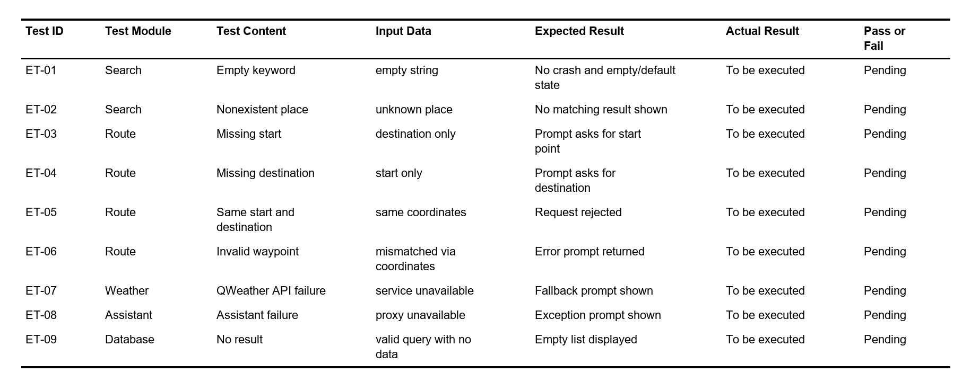

Testing focuses on functional behavior, interface responses, and exception scenarios. Test case tables use the fields test ID, test module, test content, input data, expected result, actual result, and pass or fail.

5.4.1 Search Exception Testing
Testing focuses on functional behavior, interface responses, and exception scenarios. Test case tables use the fields test ID, test module, test content, input data, expected result, actual result, and pass or fail.

5.4.2 Route Parameter Exception Testing
Testing focuses on functional behavior, interface responses, and exception scenarios. Test case tables use the fields test ID, test module, test content, input data, expected result, actual result, and pass or fail.

5.4.3 Third-Party Interface Exception Testing
Interface paths must be checked against the real Controller classes before final submission. The interface table in this draft uses implemented Controller paths only and should be rechecked after any code change.

5.4.4 No Database Query Result Testing
Testing focuses on functional behavior, interface responses, and exception scenarios. Test case tables use the fields test ID, test module, test content, input data, expected result, actual result, and pass or fail.

5.5 Interface Testing
Interface paths must be checked against the real Controller classes before final submission. The interface table in this draft uses implemented Controller paths only and should be rechecked after any code change.

5.5.1 POI Interface Testing
The POI module retrieves campus place data from MySQL through MyBatis and displays search results and place details in the frontend sidebar. Place detail rendering includes name, type, description, opening hours, status, and coordinate-based map location display.

5.5.2 Route Planning Interface Testing
Route planning is implemented by validating the selected start point, optional waypoints, and destination, invoking AMap route services, parsing the returned route data, and rendering the route result on the frontend map. The thesis must not describe this function as a self-developed A*, Dijkstra, or route optimization algorithm.

5.5.3 Weather and Suggestion Interface Testing
The weather-related module obtains current weather data from QWeather API through backend request processing. The system converts weather conditions into practical campus travel prompts and provides exception fallback when the third-party weather service is unavailable.

5.5.4 Saved Places and Route History Records Interface Testing
The Saved Places module supports adding, displaying, renaming, and deleting saved campus places. These records are persisted in MySQL as a shared dataset rather than as user-specific favorites.

5.5.5 Intelligent Assistant Interface Testing
The Intelligent Assistant is described only as backend proxy invocation, campus scenario context construction, answer display, and exception prompt. The project does not train a large model, build a knowledge base system, use vector retrieval, or implement RAG.

5.6 Test Result Analysis
Testing focuses on functional behavior, interface responses, and exception scenarios. Test case tables use the fields test ID, test module, test content, input data, expected result, actual result, and pass or fail.

5.7 Chapter Summary
This chapter summary reviews the main points of the chapter and connects them with the following chapter. It should remain concise and should not introduce new functions that are not implemented in the project.

Chapter 6 Conclusion and Future Work

6.1 Conclusion
This section explains the corresponding part of the Smart Campus Navigation Web system according to the implemented project. The writing should stay close to the real technology stack and avoid adding functions that are not present in the codebase.

6.1.1 System Completion Summary
This chapter summary reviews the main points of the chapter and connects them with the following chapter. It should remain concise and should not introduce new functions that are not implemented in the project.

6.1.2 Main Implementation Results
This section explains the corresponding part of the Smart Campus Navigation Web system according to the implemented project. The writing should stay close to the real technology stack and avoid adding functions that are not present in the codebase.

6.1.3 System Limitations
This section explains the corresponding part of the Smart Campus Navigation Web system according to the implemented project. The writing should stay close to the real technology stack and avoid adding functions that are not present in the codebase.

6.2 Future Work
This section explains the corresponding part of the Smart Campus Navigation Web system according to the implemented project. The writing should stay close to the real technology stack and avoid adding functions that are not present in the codebase.

6.2.1 Continuous Improvement of Campus POI Data
The POI module retrieves campus place data from MySQL through MyBatis and displays search results and place details in the frontend sidebar. Place detail rendering includes name, type, description, opening hours, status, and coordinate-based map location display.

6.2.2 Mobile Adaptation Optimization
This section explains the corresponding part of the Smart Campus Navigation Web system according to the implemented project. The writing should stay close to the real technology stack and avoid adding functions that are not present in the codebase.

6.2.3 Extension to Indoor Navigation and More Fine-Grained Path Services
This section explains the corresponding part of the Smart Campus Navigation Web system according to the implemented project. The writing should stay close to the real technology stack and avoid adding functions that are not present in the codebase.

References
[1] Nanjing University of Information Science and Technology. Undergraduate Thesis Writing Specification and Template[Z]. 2026.
[2] Spring. Spring Boot Reference Documentation[EB/OL]. https://docs.spring.io/spring-boot/ . Accessed 2026-04-25.
[3] MyBatis. MyBatis 3 User Guide[EB/OL]. https://mybatis.org/mybatis-3/ . Accessed 2026-04-25.
[4] Oracle. Java Platform Documentation[EB/OL]. https://docs.oracle.com/en/java/ . Accessed 2026-04-25.
[5] Apache Maven Project. Maven Documentation[EB/OL]. https://maven.apache.org/guides/ . Accessed 2026-04-25.
[6] MySQL. MySQL Reference Manual[EB/OL]. https://dev.mysql.com/doc/ . Accessed 2026-04-25.
[7] Thymeleaf. Thymeleaf Documentation[EB/OL]. https://www.thymeleaf.org/documentation.html . Accessed 2026-04-25.
[8] AMap Open Platform. JavaScript API Documentation[EB/OL]. https://lbs.amap.com/ . Accessed 2026-04-25.
[9] QWeather. QWeather API Documentation[EB/OL]. https://dev.qweather.com/en/docs/ . Accessed 2026-04-25.
[10] Pressman R S, Maxim B R. Software Engineering: A Practitioner’s Approach[M]. 9th ed. New York: McGraw-Hill Education, 2019.

Acknowledgements
This section should be completed by the student before final submission. It may thank the supervisor and others who provided guidance, testing assistance, or data support during the graduation design process.

Appendix
Appendix materials may include selected API examples, additional test records, or supplementary database initialization notes.

