  - OPERATOR + ADMINISTRATOR EDITION

VAS
User Guide
  - Clear tasks. Real interface evidence. Explicit verification limits.
Version 5.0.0 | English | 07 October 2026
33 task walkthroughs • 71 discovered capabilities
Genuine browser screenshots with editable numbered annotations
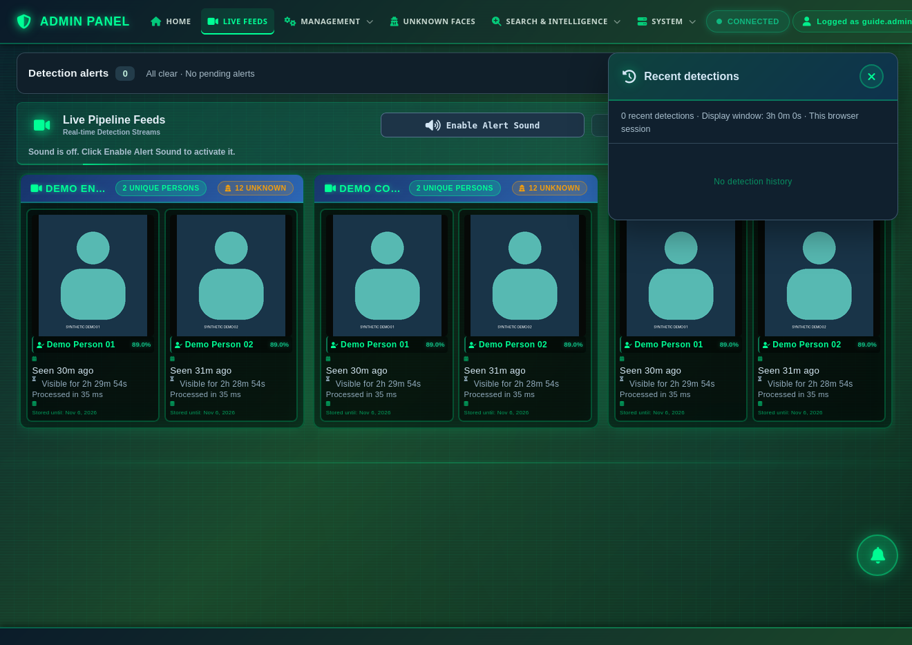
Prepared using an isolated local VAS instance and synthetic records. No real people, production data, passwords or tokens appear in this guide.
Read first “Tested” refers only to the stated demonstration. This guide does not certify recognition accuracy, GPU capacity, production security, backup recovery or model deployment.

Contents
1. Introduction, audience and prerequisites ................................ 5
2. Login and role differences ................................ 7
3. Interface orientation ................................ 12
4. Quick-start workflow ................................ 18
5. Everyday operator tasks ................................ 19
6. Advanced and administrator tasks ................................ 59
7. Troubleshooting and common mistakes ................................ 121
8. Capability coverage and remaining gaps ................................ 125
Use the task finder on the following pages to jump directly to an individual workflow. Orange numbered arrows match that workflow’s numbered instructions; numbering restarts for each task.
Some figures show a control that was inspected but intentionally not activated. The verification label and limitations beside each task state exactly what was exercised.

Task finder
W01 Sign in securely · p. 8
W02 Complete first-login password rotation · p. 10
W03 Find the correct workspace · p. 13
W04 Read Home and camera summaries · p. 15
W05 Review live detection feeds · p. 20
W06 Filter unknown identities and open evidence · p. 23
W07 Follow a recorded movement journey · p. 26
W08 Find and rename a known-person record · p. 30
W09 Prepare enrollment or identity review · p. 33
W09E Prepare a photo enrollment · p. 36
W10 Submit an image search and handle a quality failure · p. 38
W11 Filter search history and export CSV · p. 42
W12 Create a watchlist · p. 45
W13 Add an identity to a watchlist and check membership · p. 48
W14 Create, inspect and pause a live-alert rule · p. 53
W15 Save a camera’s display location · p. 60
W16 Create a camera-scoped user · p. 65

Task finder — continued
W17 Issue an ingest credential for an authorized sender · p. 71
W18 Edit a setting and verify its application timing · p. 75
W19 Preview retention cleanup without deleting data · p. 79
W20 Review chatbot query audit · p. 82
W20L Filter application logs · p. 85
W21 Build a social relationship graph · p. 87
W22 Review suspicious-pattern output · p. 90
W23 Check anomalies and recover from insufficient history · p. 93
W24 Assess threat evidence and provenance · p. 97
W25 Check advanced analytics readiness · p. 100
W26 Diagnose a missing map · p. 104
W27 Follow the ML service lifecycle and readiness gate · p. 107
W28 Locate database and notebook inspection tools · p. 111
W29 Check similarity-model readiness · p. 113
W30 Use assistant help and recognize degraded mode · p. 116
W31 Read the in-app tutorial · p. 119

1. Introduction, audience and prerequisites
VAS supports review of face-related observations, identity histories, relationship analysis and operational administration. This guide separates what the application displayed from what was actually completed in a controlled demonstration.

Who should use this guide
- Operators: review assigned camera feeds, identity evidence and searches.
- Analysts: interpret relationships, patterns and risk evidence within granted access.
- Administrators: manage accounts, locations, credentials, settings and service readiness.

Before you begin
- Obtain the approved VAS HTTPS address and an active account from your administrator. Server addresses are intentionally omitted here.
- Confirm your assigned cameras and permitted tasks. A visible navigation item does not grant permission to every action.
- Use approved demonstration images when learning. Do not enroll, export or alert on real people without organizational authorization.
- Ask the administrator to confirm ingestion and required services are healthy. A running page does not establish that cameras, maps, training workers or the assistant are available.

How to read the evidence
Status | Meaning
Tested | The specified action and result were exercised in the isolated instance; read any qualifier.
Observed / untested | The control or screen was visible, but its consequential completion was not exercised.
Unavailable / blocked | A dependency, permission or usable dataset prevented completion in this run.
Not found | No dedicated capability was discovered in the reviewed VAS interface.

Validation environment and boundaries
Application Runtime version 5.0.0; tutorial reports backend build 817b58e9460749bf53ef3a6fc12e024a6693d231 (development).
Frontend Current repository working tree: 52135d8-dirty. This is not a clean release-tag certification.
Isolation Separate database, cache, storage and internal container network; deployed API image reused with current checkout frontend. CPU execution. No production configuration was changed.
Fixture 3 demonstration cameras, 14 synthetic identities and 210 seeded observations. Flat silhouette avatars are not face photographs. Similarities and detections are seeded examples, not model measurements.
Accounts Synthetic administrator and camera-scoped standard user. Password rotation and restricted access were tested. Observer and Analyzer roles were visible but not fully exercised.
Missing dependencies No training worker, offline basemap service or functioning assistant language model in this instance. No live RTSP source or sender ingestion test.
Time Browser display used Asia/Beirut. Dataset inspector explicitly uses UTC. Match the field’s stated timezone before interpreting ranges.
Security TLS and synthetic credentials were used for the private test. The test-only certificate setup is not a production installation recommendation.
Screenshots preserve the actual interface, including genuine limitations. Password fields and one-time credentials were permanently raster-redacted before annotation. Original sanitized captures, focus crops, editable SVG overlays and JSON coordinates are included in the asset package.

2. Login and role differences
Start at the approved VAS address. First login may require a password change. After rotation, verify the workspace and camera scope before continuing.
Role shown in Create New User | Evidence and practical boundary
ADMINISTRATOR - Full Access | Visible but disabled for assignment in this form. Existing synthetic administrator tested.
OBSERVER - Read-Only Access | Visible option; full permission matrix not exercised.
USER - Standard Access | Created with one assigned camera; restricted listing and administrator-route redirect verified.
ANALYZER - Analysis Access | Visible option; complete role workflow not exercised.
Pipeline access and Chatbot access are separate controls. The system account is protected and is not an interactive user. Logout is available in the header; sign out when ending your session.

W01 Sign in securely
Accomplish Open your permitted VAS workspace.
Permissions / prerequisites An active VAS account
Start /signin
Verification Tested
1. Enter your issued Username. The demonstration account shown is not a production login.
2. Enter your Password. It is case sensitive.
3. Select Continue securely. Follow Change Password if your account requires rotation.
Expected result / verify An authenticated workspace or the required password-change screen opens. The test administrator reached Change Password.
Errors / recovery For a security block, ask the administrator to check the allowed HTTPS origin and account status. Use the approved server address; do not disable browser security.

W01 / Sign in securely
Figure 01. Steps 1, 2, 3. Open your permitted VAS workspace.
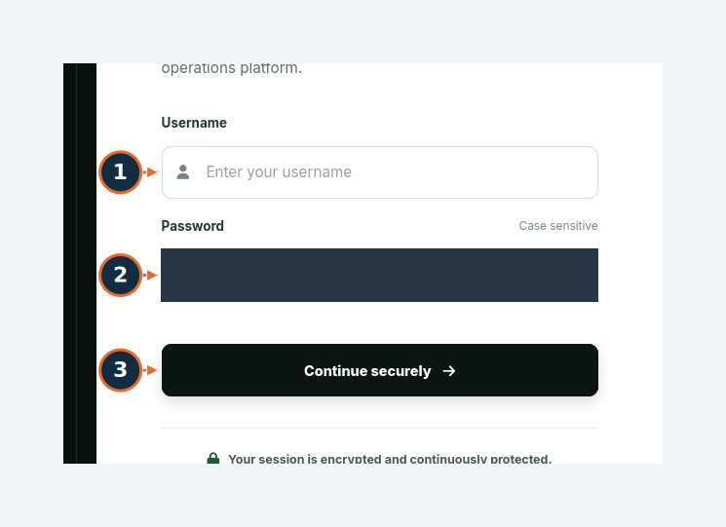
Orange numbers refer to this task’s written steps. Synthetic demonstration data.

W02 Complete first-login password rotation
Accomplish Replace the administrator-issued password before continuing.
Permissions / prerequisites Authenticated account requiring rotation
Start /change-password
Verification Tested
1. Enter CURRENT PASSWORD: the password just used to sign in.
2. Enter NEW PASSWORD. The screen requires at least 12 characters and at least 6 different characters.
3. Re-enter it in CONFIRM NEW PASSWORD.
4. Select CHANGE PASSWORD. If a success message appears, acknowledge it.
Expected result / verify The workspace opens; the new password works on the next login. Both the synthetic administrator and standard user completed rotation.
Errors / recovery If confirmation does not match, correct both new-password fields. Rotation signs out other sessions; sign back in there.

W02 / Complete first-login password rotation
Figure 02. Steps 1, 2, 3, 4. Replace the administrator-issued password before continuing.
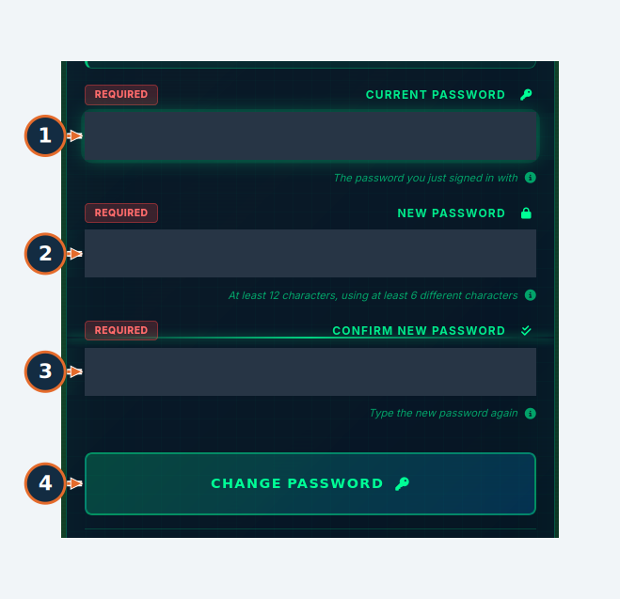
Orange numbers refer to this task’s written steps. Synthetic demonstration data.

3. Interface orientation
Navigation | Purpose
HOME | System and camera summaries
LIVE FEEDS | Latest stored detections and recent-detection panel
MANAGEMENT | People, users and pipeline administration
UNKNOWN FACES | Unrecognized identity records and evidence
SEARCH & INTELLIGENCE | Image search, history, relationship and security analysis
SYSTEM | Configuration, service operations and help
Menus vary with authorization. “Live Pipeline Feeds” is a VAS detection display; these screenshots do not establish continuous video playback. VMS camera streaming and RTSP setup belong to a separate system.

W03 Find the correct workspace
Accomplish Use the actual navigation instead of guessing page addresses.
Permissions / prerequisites Administrator; standard users see fewer links
Start /home, with the shared navigation visible
Verification Tested
1. Open MANAGEMENT to reveal its menu.
2. Select Known Faces to open the people directory. Use the equivalent entries under SEARCH & INTELLIGENCE or SYSTEM for their workspaces.
Expected result / verify The selected page opens and the active navigation changes. HOME is administrator-only; LIVE FEEDS is the operator detection view.
Errors / recovery Missing menu items can reflect permissions. A direct administrator URL redirected the tested standard user to Live Pipeline Feeds.
Boundary LAF-AI is a separate application link. Its SSO launch was not tested.

W03 / Find the correct workspace
Figure 03. Steps 1, 2. Use the actual navigation instead of guessing page addresses.
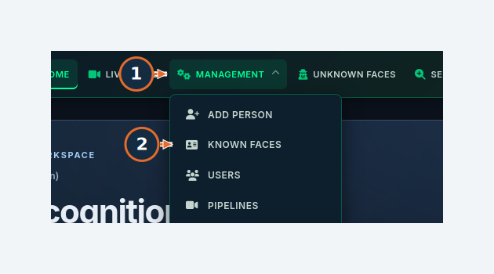
Orange numbers refer to this task’s written steps. Synthetic demonstration data.

W04 Read Home and camera summaries
Accomplish Check the overview and focus on a registered camera.
Permissions / prerequisites Administrator
Start /home
Verification Tested
1. Select Refresh to reload the summary.
2. Choose a camera in the pipeline selector further down the page.
Expected result / verify Counts and the selected camera context are displayed. Synthetic cameras and observations were visible in the overview.
Errors / recovery If a camera is absent, check that its sender has registered it through ingestion and that data falls within the visible scope.

W04 / Read Home and camera summaries
Figure 04. Steps 1. Check the overview and focus on a registered camera.
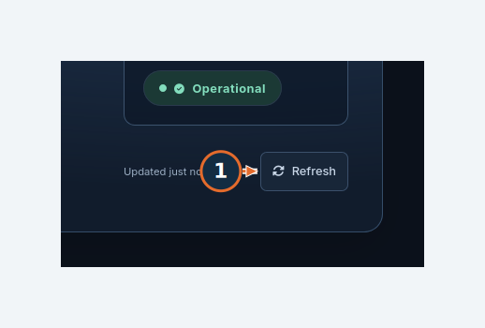
Orange numbers refer to this task’s written steps. Synthetic demonstration data.

W04 / Read Home and camera summaries
Figure 05. Steps 2. Check the overview and focus on a registered camera.
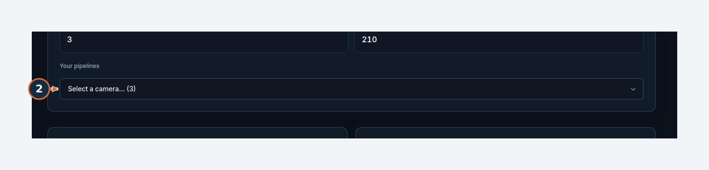
Orange numbers refer to this task’s written steps. Synthetic demonstration data.

4. Quick-start workflow
First-session route: sign in → confirm camera scope → inspect an identity → review its recorded journey → verify the evidence. This quick start links to the exact annotated tasks; it does not create new cameras or train a model.
Sign in and complete required password rotation → W01
Review Home and the camera selector → W04
Open Unknown Faces and apply a camera filter → W06
Open VIEW & ALERT and inspect the recorded movement journey → W07
Review image search prerequisites and quality checks → W10
Create a watchlist only when authorized → W12

Successful first session
You can access the intended camera scope, open an identity record and follow timestamped appearances. Confirm the displayed camera and time at each step. A silhouette, empty result, stale feed or insufficient-baseline message is evidence to investigate, not evidence of a successful recognition or analysis.

Administrator handoff
Provide users with the approved address, initial account, assigned cameras and support contact. Verify the sender-to-VAS ingestion path, storage access and optional dependencies separately before operational use. Use W16 for camera-scoped account creation and W25–W29 for analytics readiness.

5. Everyday operator tasks
Use the following tasks to review evidence, find identities, organize watchlists and configure an authorized alert rule. Always read the task’s verification boundary before reproducing a write action.

W05 Review live detection feeds
Accomplish Review the latest stored detections for accessible cameras.
Permissions / prerequisites Active account; permitted pipelines for non-administrators
Start /dashboard
Verification Tested — stored display
1. Select Open recent detections to expand the recent-detection area.
Expected result / verify Detection cards show snapshots, names or unknown status, similarity and timing. The restricted user saw only the assigned demonstration camera.
Errors / recovery CONNECTED describes the page connection, not camera/model health. If cards are stale, check upstream VMS publishing and ingest health before changing recognition thresholds.
Boundary No physical camera stream or newly recognized face was used. This page is a detection/snapshot feed, not a verified continuous-video player. Sound controls were observed; audio and notification delivery were not tested.

W05 / Review live detection feeds
Figure 06. Steps 1. Review the latest stored detections for accessible cameras.
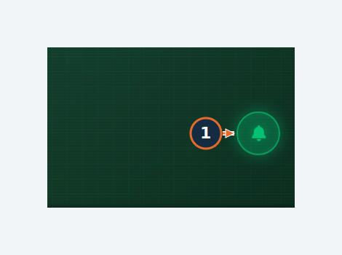
Orange numbers refer to this task’s written steps. Synthetic demonstration data.

W05 / Review live detection feeds
Figure 07. Observed result / screen context. Review the latest stored detections for accessible cameras.
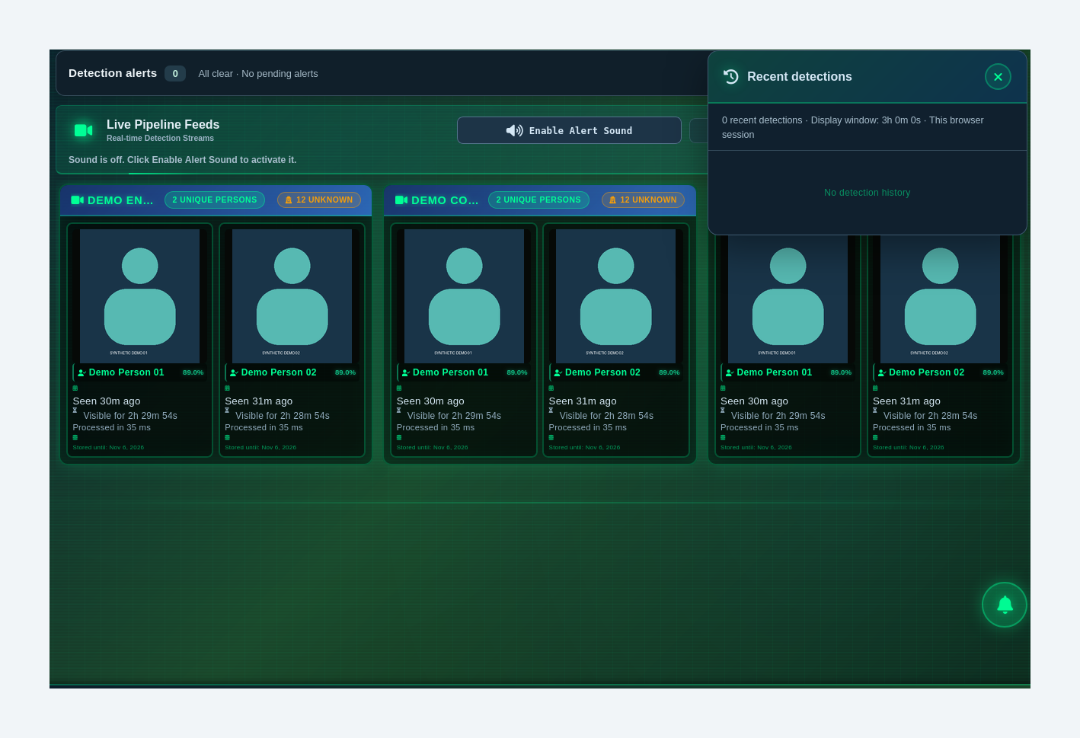
Orange numbers refer to this task’s written steps. Synthetic demonstration data.

W06 Filter unknown identities and open evidence
Accomplish Find an unknown record in the correct camera scope.
Permissions / prerequisites Administrator or permitted pipeline user
Start /admin/unknown
Verification Tested
1. Choose Pipeline. The example uses the demonstration entrance camera.
2. Set Min Appearances. Leave 1 to include records with at least one appearance.
3. Select Apply filters.
4. Select VIEW & ALERT on the desired identity card.
Expected result / verify The list is restricted to the chosen camera and Identity Details opens. Date From/Date To further narrow the scope; Reset filters restores the form.
Errors / recovery Check the date range, pipeline and minimum count before concluding that data is missing. SHOW ALL (>24h hidden) broadens the normal recent listing.

W06 / Filter unknown identities and open evidence
Figure 08. Steps 1, 2, 3. Find an unknown record in the correct camera scope.
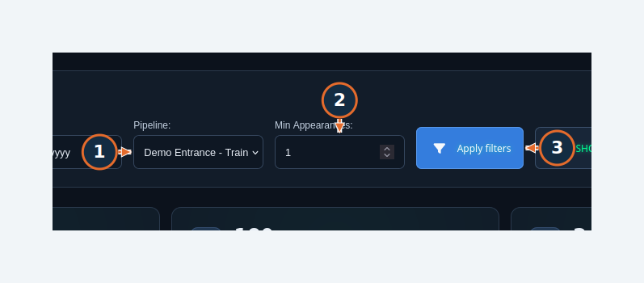
Orange numbers refer to this task’s written steps. Synthetic demonstration data.

W06 / Filter unknown identities and open evidence
Figure 09. Steps 4. Find an unknown record in the correct camera scope.
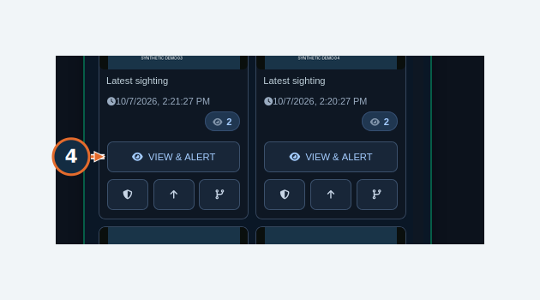
Orange numbers refer to this task’s written steps. Synthetic demonstration data.

W07 Follow a recorded movement journey
Accomplish Connect camera visits to the corresponding saved photos.
Permissions / prerequisites Account permitted to view the identity
Start Identity Details or /admin/identity/{identity_id}
Verification Tested
1. Select Journey overview to see visit groups and time gaps.
2. Select Every sighting · camera lanes to switch to individual observations.
3. Select a numbered sighting to update the linked photo and timestamp.
4. Use Next sighting (the right-arrow control) to advance one observation.
5. Select Enlarge on the photo.
6. Use Next → in the photo viewer to review another stored appearance.
7. Select Close × to return to the journey.
Expected result / verify The selected number, camera, time and photo change together. Fifteen seeded sightings across three cameras were navigated in the test.
Errors / recovery A gap is time without a recorded sighting. It does not show where the person was. A missing image should be checked against storage and retention.
Boundary This is recorded-sighting review, not recorded-video playback, continuous GPS tracking or evidence of motion between cameras. Review sequence advances still images.

W07 / Follow a recorded movement journey
Figure 10. Steps 1, 2. Connect camera visits to the corresponding saved photos.
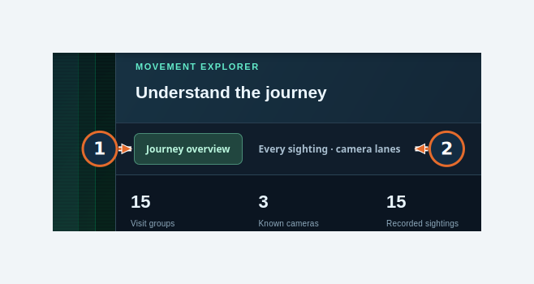
Orange numbers refer to this task’s written steps. Synthetic demonstration data.

W07 / Follow a recorded movement journey
Figure 11. Steps 3, 4, 5. Connect camera visits to the corresponding saved photos.
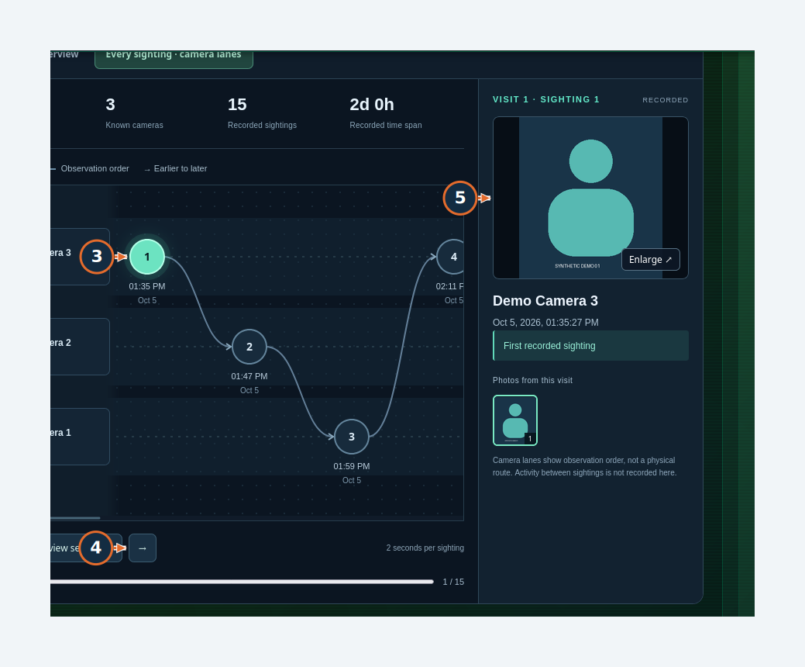
Orange numbers refer to this task’s written steps. Synthetic demonstration data.

W07 / Follow a recorded movement journey
Figure 12. Steps 6, 7. Connect camera visits to the corresponding saved photos.
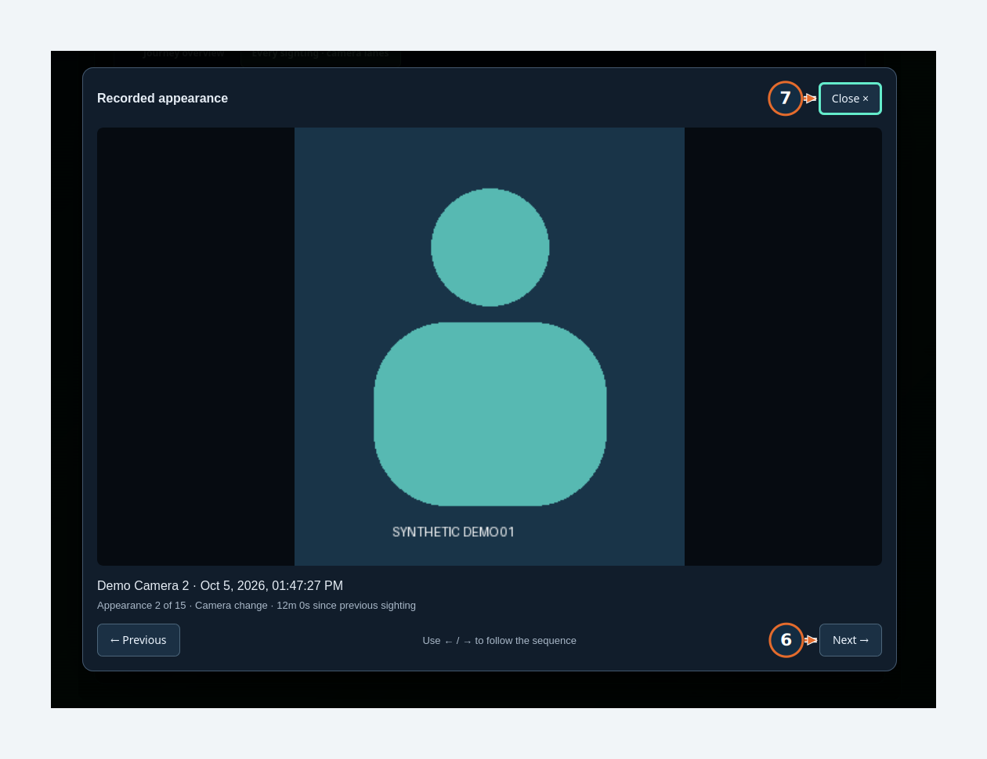
Orange numbers refer to this task’s written steps. Synthetic demonstration data.

W08 Find and rename a known-person record
Accomplish Update a display name and verify the identity profile.
Permissions / prerequisites Administrator
Start /admin/known
Verification Tested
1. Enter the name or person ID in Search directory.
2. Select Manage person on the matching card.
3. Edit the name field.
4. Select Save name and acknowledge any success message.
5. Select Open full profile to verify the saved name and identity details.
Expected result / verify The profile showed Demo Person 01 - Training after saving. The identity UUID and history remain associated with the same record.
Errors / recovery Use the stable identity ID when names are similar. Add photo, Deactivate person and Permanently delete are separate operations; renaming does not perform them.

W08 / Find and rename a known-person record
Figure 13. Steps 1, 2. Update a display name and verify the identity profile.
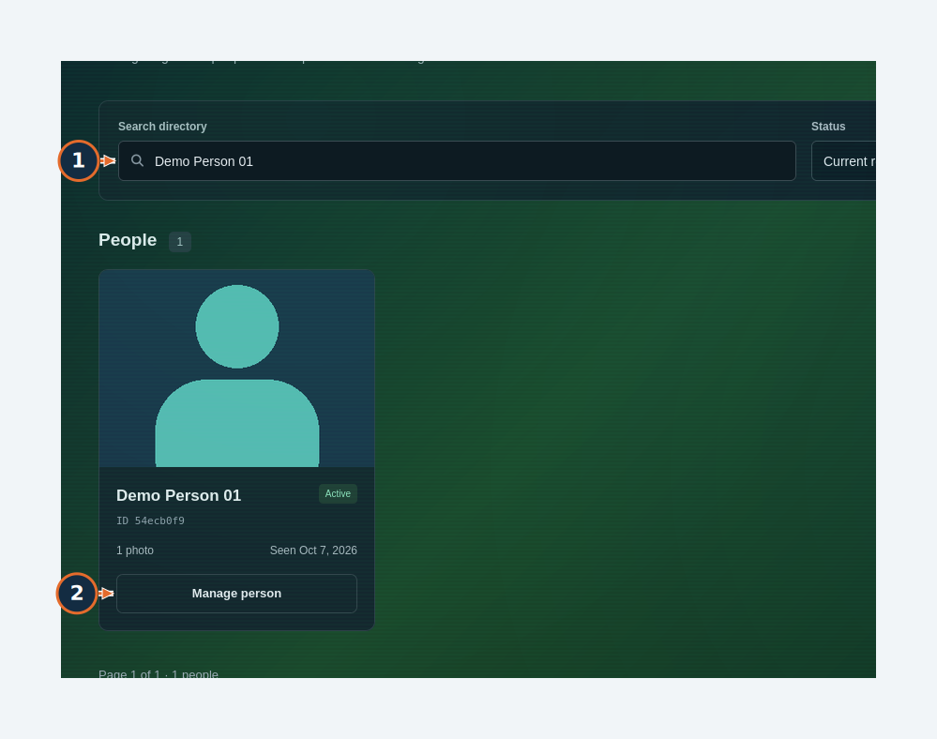
Orange numbers refer to this task’s written steps. Synthetic demonstration data.

W08 / Find and rename a known-person record
Figure 14. Steps 3, 4, 5. Update a display name and verify the identity profile.
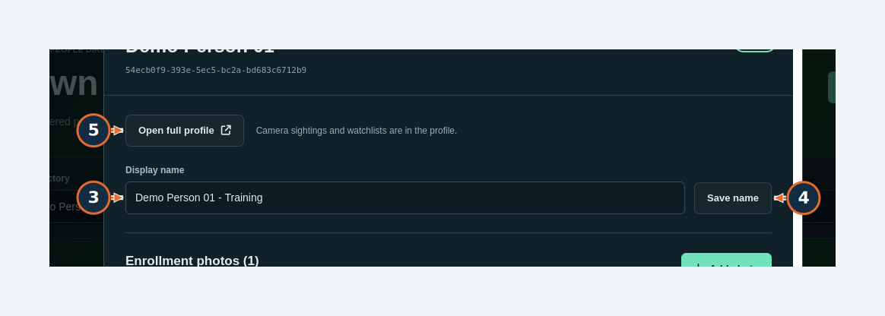
Orange numbers refer to this task’s written steps. Synthetic demonstration data.

W09 Prepare enrollment or identity review
Accomplish Understand the available review controls before an identity-changing action.
Permissions / prerequisites Administrator
Start Known faces → Add person; or an unknown identity’s detail dialog
Verification Observed; completion untested
1. From an unknown detail dialog, open PROMOTE TO KNOWN to inspect the review form.
2. Use MERGE only when reviewing records already confirmed to represent the same person; review the proposed source and survivor before any submission.
Expected result / verify Promotion review was opened. Add person was also observed. Successful photo enrollment, promotion and merge were not executed for this guide.
Errors / recovery Use approved face images for enrollment. A matching score or similar-looking card is not identity confirmation. Cancel an uncertain decision.
Boundary The demonstration avatars are deliberately not face photographs. No real person was identified. Merge suggestions, bulk merge, image replacement, deactivation and permanent deletion remain unexecuted.

W09 / Prepare enrollment or identity review
Figure 15. Steps 1, 2. Understand the available review controls before an identity-changing action.
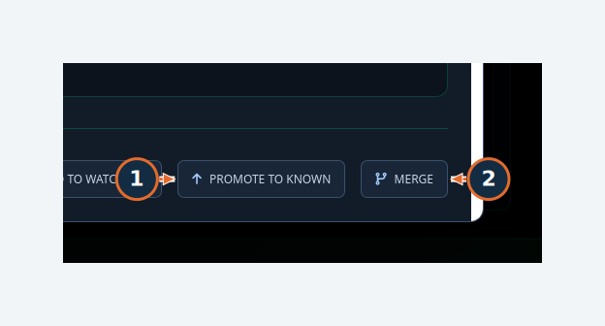
Orange numbers refer to this task’s written steps. Synthetic demonstration data.

W09 / Prepare enrollment or identity review
Figure 16. Observed result / screen context. Understand the available review controls before an identity-changing action.
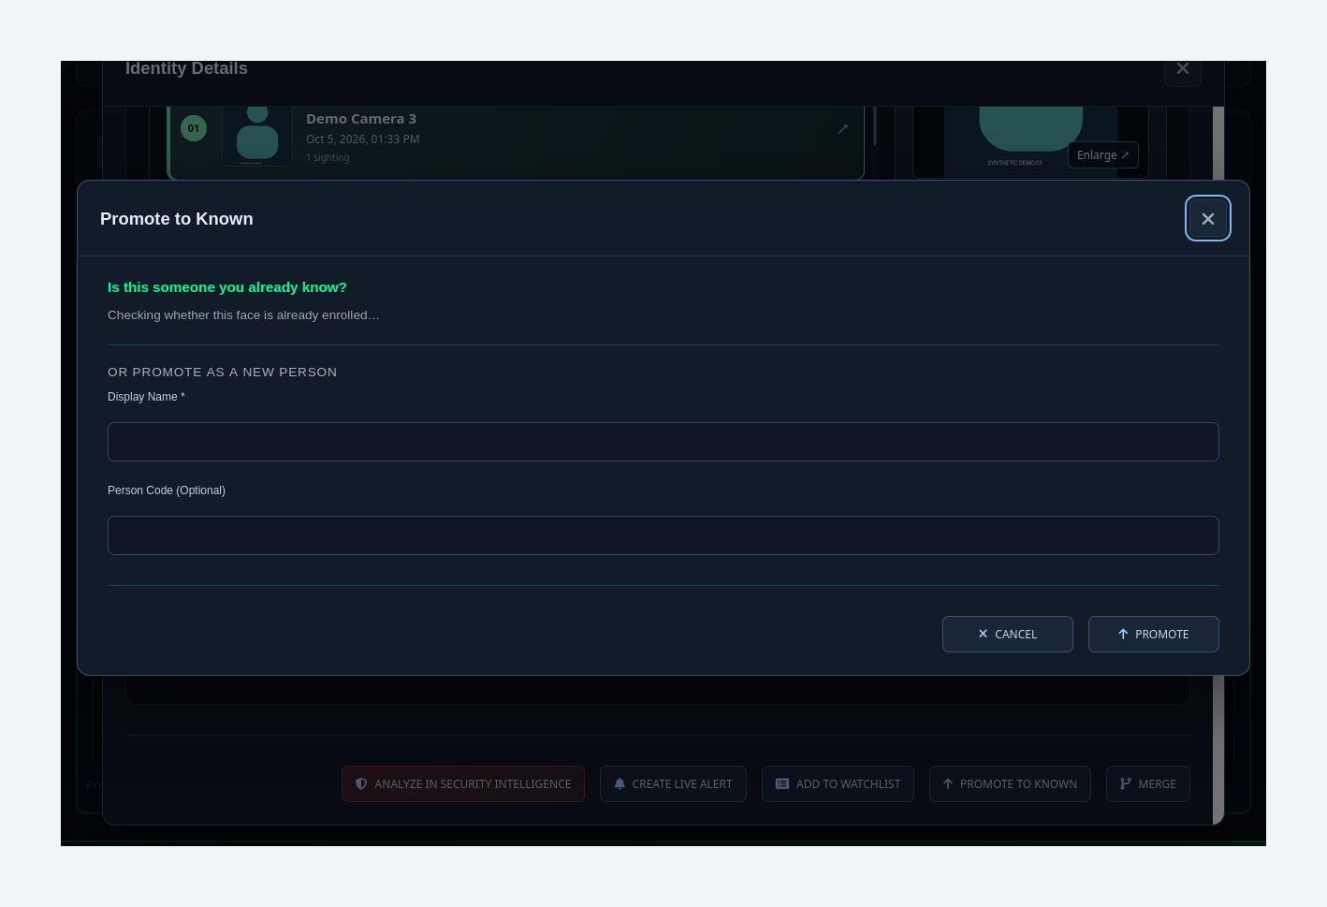
Orange numbers refer to this task’s written steps. Synthetic demonstration data.

W09E Prepare a photo enrollment
Accomplish Understand the required enrollment inputs without bypassing review.
Permissions / prerequisites Administrator; approved face image
Start Known faces → Add person
Verification Observed — enrollment not executed
1. Enter PERSON NAME.
2. Choose PHOTO or drag an approved image onto the upload area. The dialog accepts JPEG, JPG, PNG and WEBP up to 10 MB.
3. Use THIS IS A FACE IMAGE (ALREADY CROPPED) only for a genuine cropped face; otherwise leave it unchecked.
4. Select UPLOAD PERSON only after validating the inputs and authorization.
Expected result / verify A successful enrollment should complete its review and appear in Known faces with a usable photo. This guide did not submit an enrollment or claim that success.
Errors / recovery For no-face or quality errors, provide a suitable approved photo. Do not use the cropped-face option to bypass an invalid image.
Boundary The synthetic avatars are unsuitable biometric enrollment images. Final candidate/duplicate review and recognition were not verified.

W09E / Prepare a photo enrollment
Figure 17. Steps 1, 2, 3, 4. Understand the required enrollment inputs without bypassing review.
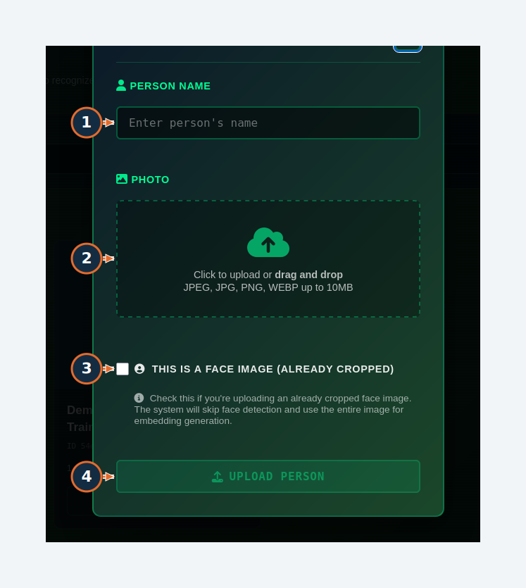
Orange numbers refer to this task’s written steps. Synthetic demonstration data.

W10 Submit an image search and handle a quality failure
Accomplish Set image-search scope and distinguish invalid input from no matches.
Permissions / prerequisites Administrator; approved reference photo
Start /admin/search
Verification Tested — negative input
1. Choose the reference image using the upload area.
2. Select Search Scope.
3. Set Max Results Per Face.
4. Select Quality Check to inspect whether the image is usable.
5. Select Search only with a usable approved image.
Expected result / verify The synthetic avatar produced “Quality check failed: No face was detected in the image.” A search completed with zero detected faces and zero results, and appeared in Search History.
Errors / recovery Replace a no-face image with an approved, clear face photo. Broaden overly restrictive camera/date filters only when appropriate. Do not interpret invalid input as proof that a person is absent.
Boundary Positive biometric matching, batch success, result-image export and recognition accuracy were not validated.

W10 / Submit an image search and handle a quality failure
Figure 18. Steps 1. Set image-search scope and distinguish invalid input from no matches.
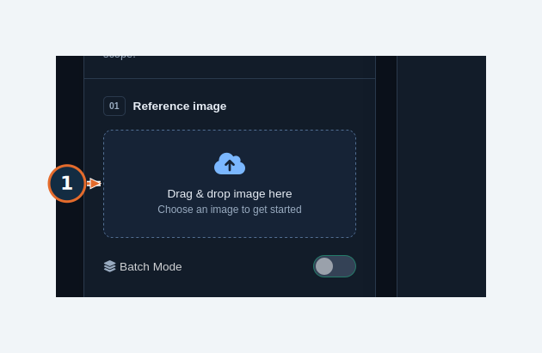
Orange numbers refer to this task’s written steps. Synthetic demonstration data.

W10 / Submit an image search and handle a quality failure
Figure 19. Steps 2, 3, 4, 5. Set image-search scope and distinguish invalid input from no matches.
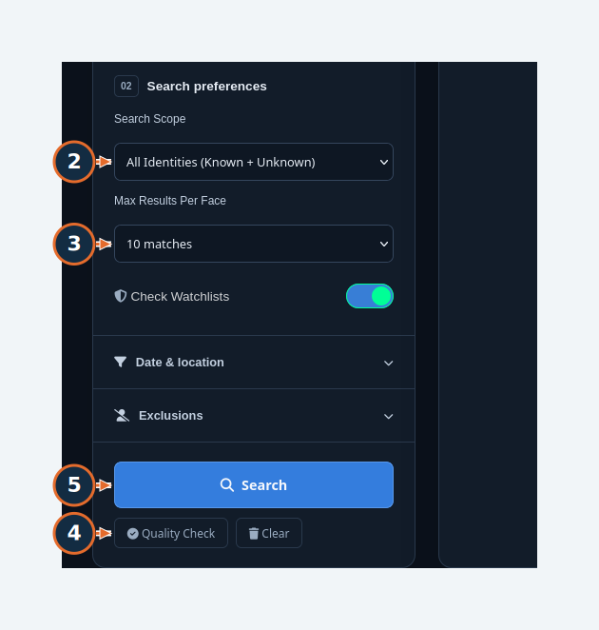
Orange numbers refer to this task’s written steps. Synthetic demonstration data.

W10 / Submit an image search and handle a quality failure
Figure 20. Synthetic silhouette submitted for a negative quality test. No real face or positive recognition match was used.
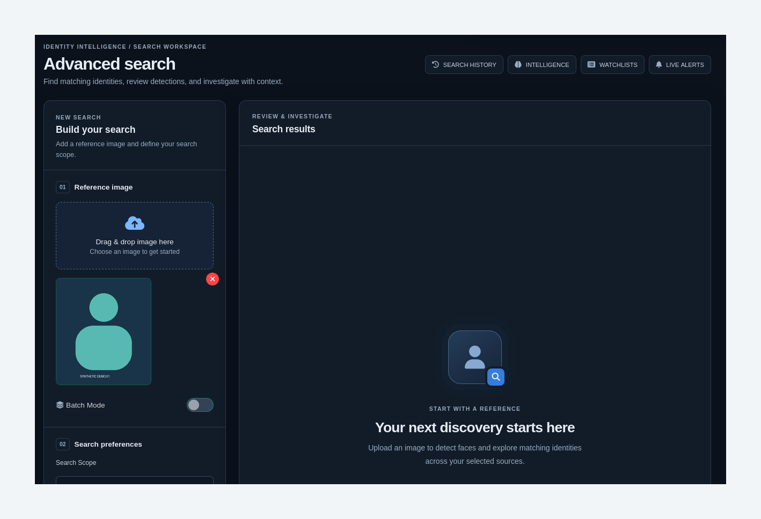
Orange numbers refer to this task’s written steps. Synthetic demonstration data.

W11 Filter search history and export CSV
Accomplish Review prior searches and download an authorized history file.
Permissions / prerequisites Administrator; authorization to export the selected records
Start /admin/search-history
Verification Tested
1. Choose Search Type.
2. Select the Days Back range.
3. Select APPLY FILTERS.
4. Select EXPORT to open Export Search History.
5. Choose CSV under EXPORT FORMAT and review DATE RANGE.
6. Select EXPORT in the dialog.
Expected result / verify The browser downloaded a CSV and VAS displayed “History exported successfully!” The test file contained synthetic search history only.
Errors / recovery Check the browser download area if no file appears. Verify format, date range and row content before sharing. Clear history changes stored history and was not used.

W11 / Filter search history and export CSV
Figure 21. Steps 1, 2, 3, 4. Review prior searches and download an authorized history file.
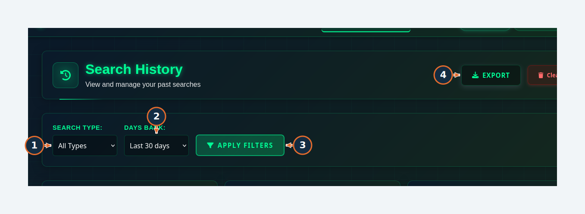
Orange numbers refer to this task’s written steps. Synthetic demonstration data.

W11 / Filter search history and export CSV
Figure 22. Steps 5, 6. Review prior searches and download an authorized history file.
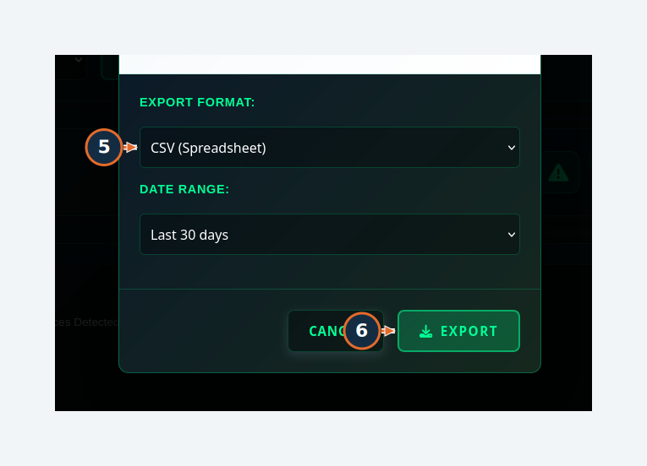
Orange numbers refer to this task’s written steps. Synthetic demonstration data.

W12 Create a watchlist
Accomplish Create a named monitoring list.
Permissions / prerequisites Administrator
Start Watchlist Management → Create New Watchlist
Verification Tested
1. Enter Name, for example Demo Review List.
2. Enter a Description explaining its approved purpose.
3. Select Alert Level. The example uses Info (Low Priority).
4. Select Save Watchlist.
Expected result / verify The list appeared with its name and active state. Search, level, status and sort controls help find it later.
Errors / recovery A name alone does not enroll members. Use the identity’s Add to Watchlist workflow. Alert level expresses urgency, not a probability of wrongdoing.

W12 / Create a watchlist
Figure 23. Steps 1, 2, 3, 4. Create a named monitoring list.
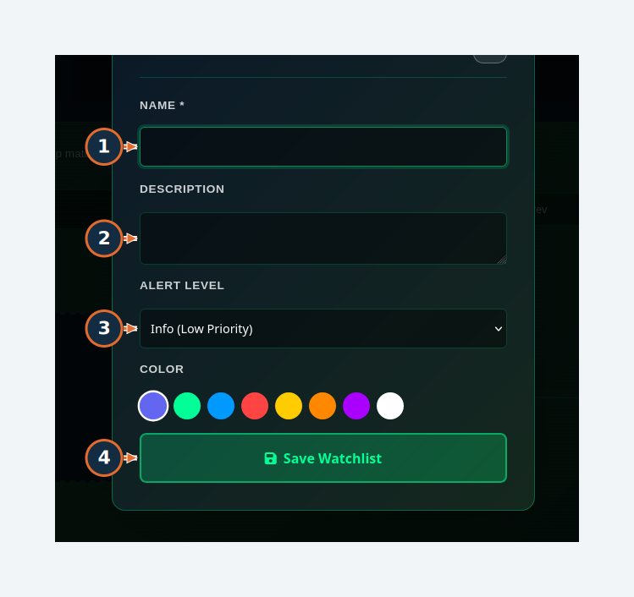
Orange numbers refer to this task’s written steps. Synthetic demonstration data.

W12 / Create a watchlist
Figure 24. Observed result / screen context. Create a named monitoring list.
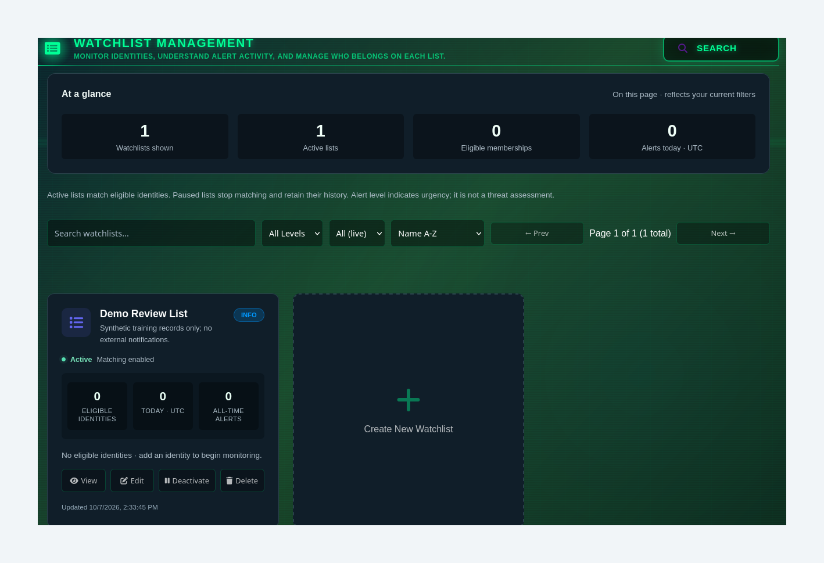
Orange numbers refer to this task’s written steps. Synthetic demonstration data.

W13 Add an identity to a watchlist and check membership
Accomplish Save membership with review context.
Permissions / prerequisites Administrator; existing identity and watchlist
Start Identity profile → ADD TO WATCHLIST
Verification Tested — display limitation
1. Choose Select Watchlist.
2. Select Priority.
3. Enter Notes.
4. Enter Action Instructions, if appropriate.
5. Select Add to Watchlist.
6. Reload the profile and inspect WATCHLISTS; also verify the member inside the named watchlist’s View panel.
Expected result / verify The membership save returned success and the named list’s member view contained the synthetic identity. The profile chip displayed “Untitled watchlist” in this build.
Errors / recovery If the chip is untitled, verify the member in Watchlist Management instead of repeatedly adding it. Report the display issue with the identity/list IDs.

W13 / Add an identity to a watchlist and check membership
Figure 25. Steps 1, 2, 3, 4. Save membership with review context.
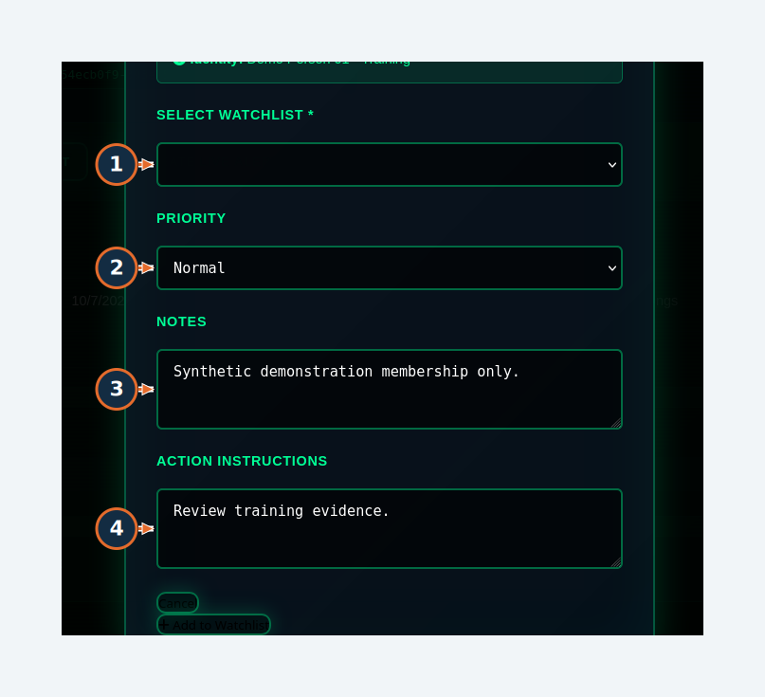
Orange numbers refer to this task’s written steps. Synthetic demonstration data.

W13 / Add an identity to a watchlist and check membership
Figure 26. Steps 5. Save membership with review context.
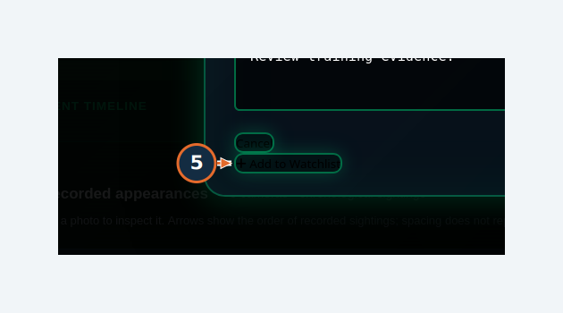
Orange numbers refer to this task’s written steps. Synthetic demonstration data.

W13 / Add an identity to a watchlist and check membership
Figure 27. Observed display defect: the profile shows “Untitled watchlist”; membership was separately verified inside the named list.
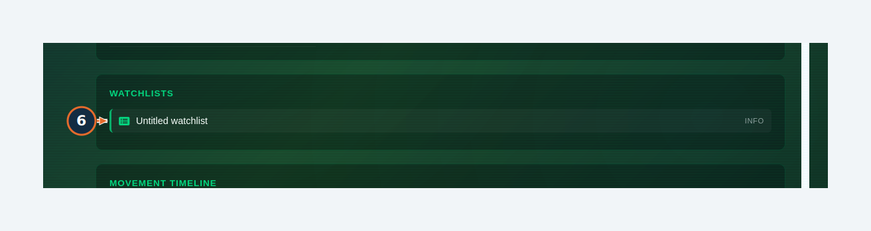
Orange numbers refer to this task’s written steps. Synthetic demonstration data.

W13 / Add an identity to a watchlist and check membership
Figure 28. Observed result / screen context. Save membership with review context.
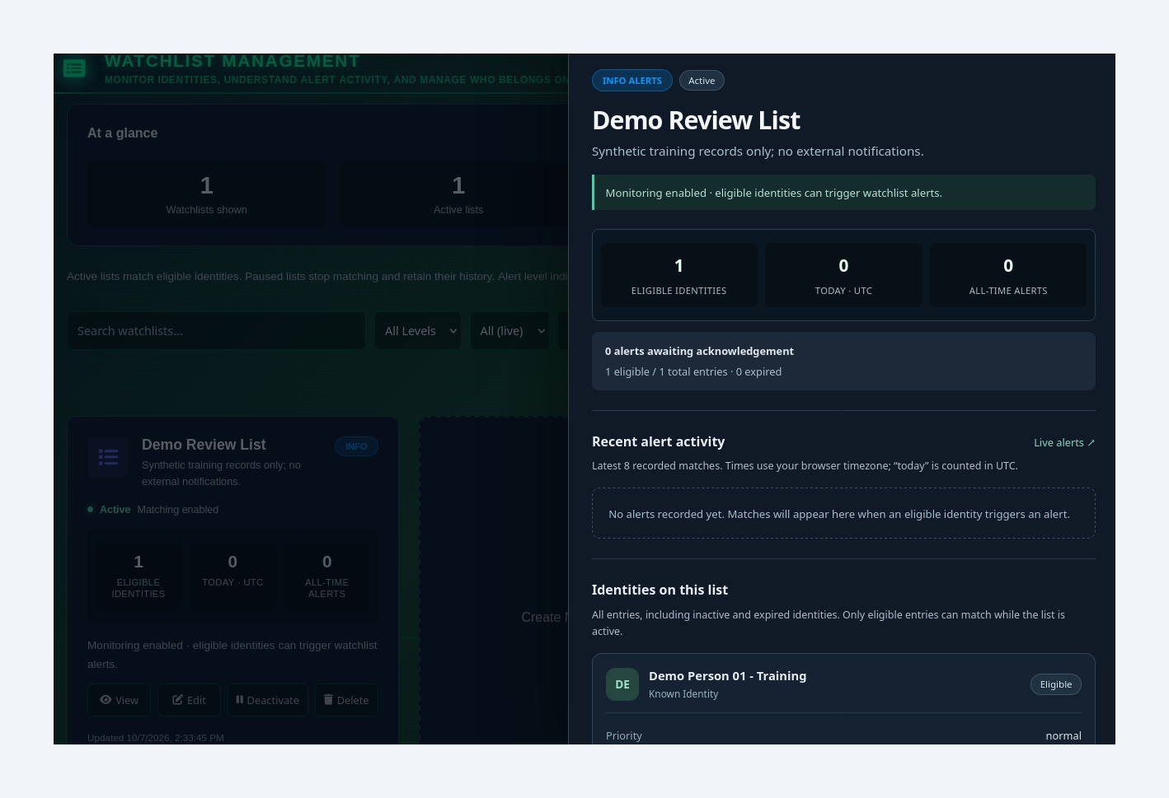
Orange numbers refer to this task’s written steps. Synthetic demonstration data.

W14 Create, inspect and pause a live-alert rule
Accomplish Save a rule, inspect readiness, and pause it without sending a test notification.
Permissions / prerequisites Administrator for this tested workflow; permitted identity
Start Identity profile → CREATE LIVE ALERT
Verification Tested — rule lifecycle only
1. Enter Alert Name.
2. Select Alert severity.
3. Set Minimum Similarity for the approved use case.
4. Review Notify on dashboard, Sound alert and Auto-capture snapshot. Sound was disabled in the demonstration.
5. Select Create Alert.
6. Open Live Alerts and select Health on the saved rule.
7. Select Pause when the demonstration is complete.
Expected result / verify The rule was created; Health showed channel and identity checks; Pause changed the saved state to PAUSED and offered Resume.
Errors / recovery Health reported SNAPSHOT EXISTS: PROBLEM in the isolated fixture, although the profile photo rendered. Investigate that check before relying on delivery. Test can send notifications and was not used.
Boundary No alert trigger, browser audio, acknowledgement, email or SMS delivery was tested. Cameras displayed All in this form’s saved rule; do not assume a camera selector exists here.

W14 / Create, inspect and pause a live-alert rule
Figure 29. Steps 1, 2, 3, 4. Save a rule, inspect readiness, and pause it without sending a test notification.
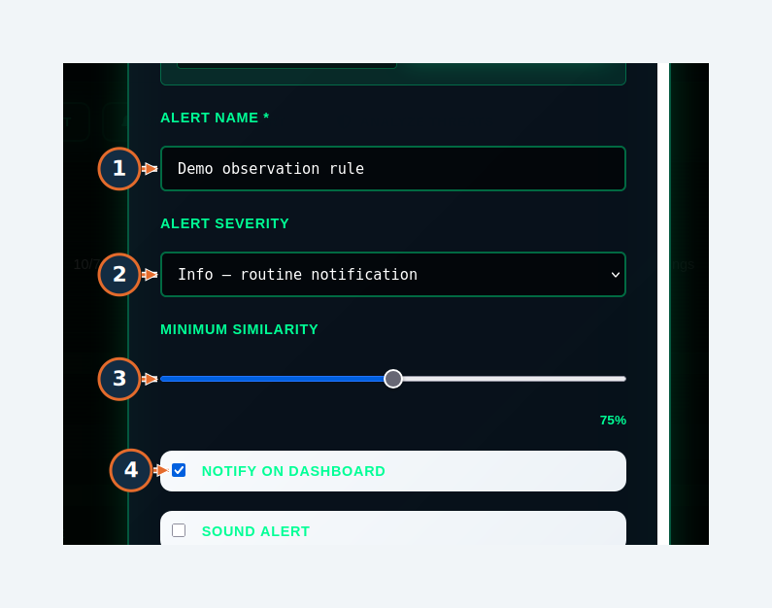
Orange numbers refer to this task’s written steps. Synthetic demonstration data.

W14 / Create, inspect and pause a live-alert rule
Figure 30. Steps 5. Save a rule, inspect readiness, and pause it without sending a test notification.
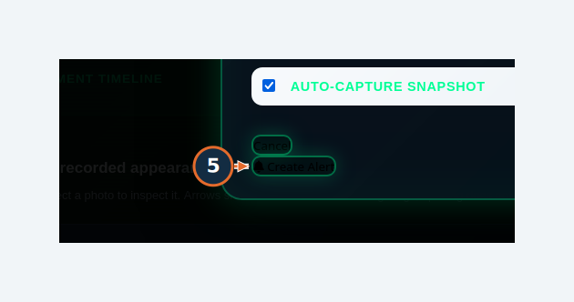
Orange numbers refer to this task’s written steps. Synthetic demonstration data.

W14 / Create, inspect and pause a live-alert rule
Figure 31. Steps 6, 7. Save a rule, inspect readiness, and pause it without sending a test notification.
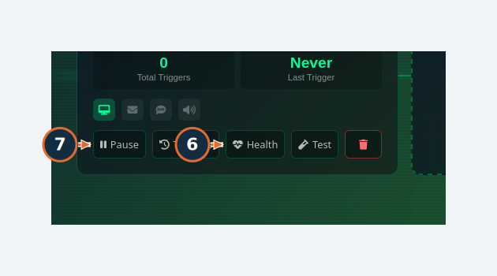
Orange numbers refer to this task’s written steps. Synthetic demonstration data.

W14 / Create, inspect and pause a live-alert rule
Figure 32. Observed result / screen context. Save a rule, inspect readiness, and pause it without sending a test notification.
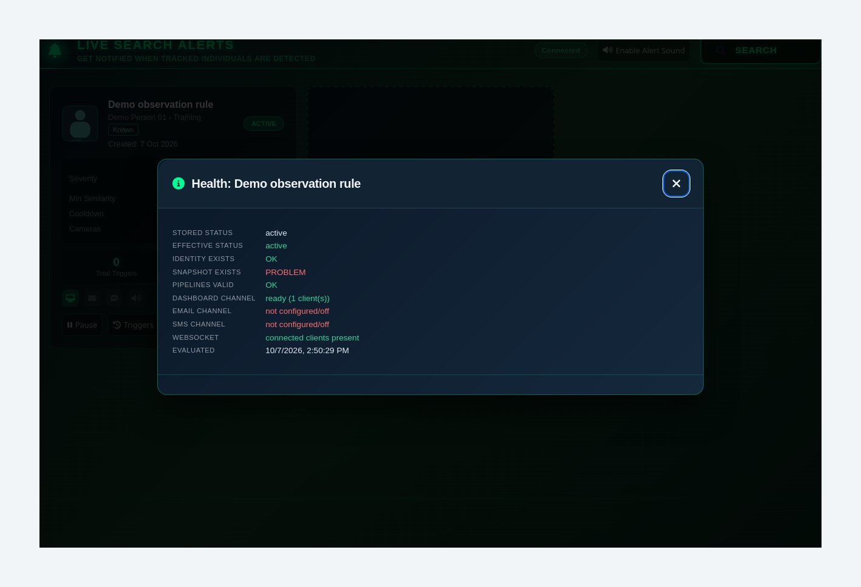
Orange numbers refer to this task’s written steps. Synthetic demonstration data.

W14 / Create, inspect and pause a live-alert rule
Figure 33. Observed result / screen context. Save a rule, inspect readiness, and pause it without sending a test notification.
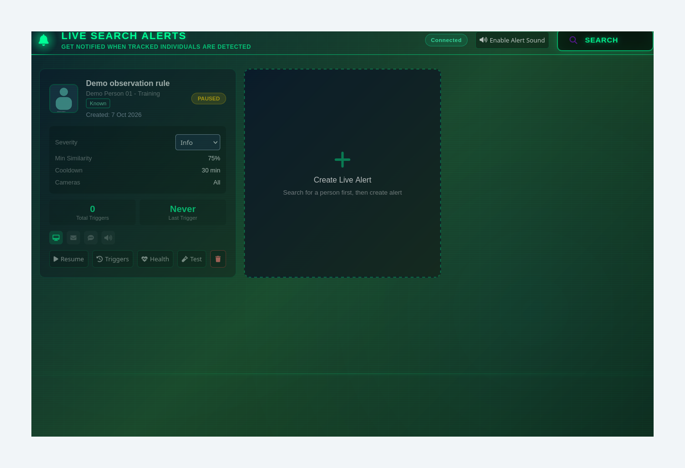
Orange numbers refer to this task’s written steps. Synthetic demonstration data.

6. Advanced and administrator tasks
Administrator and analysis workflows follow. Do not infer administrator privileges from the /admin URL prefix alone: access depends on your account and camera scope. Settings and service changes require the applicable operational authorization.

W15 Save a camera’s display location
Accomplish Maintain the location used in investigation and map views.
Permissions / prerequisites Administrator; camera already registered by ingestion
Start /admin/pipelines
Verification Tested
1. Select Edit Location on the intended pipeline.
2. Enter Location Name.
3. Enter Latitude between -90 and 90.
4. Enter Longitude between -180 and 180.
5. Select Save Location.
6. Select Refresh and verify the same location remains.
Expected result / verify The demonstration name persisted after refresh. Coordinates can be entered even when the basemap is unavailable.
Errors / recovery VAS pipelines are registered by ingestion; this page is not an RTSP camera-discovery wizard. Rename changes the pipeline identifier and keeps an alias; that operation was not exercised.

W15 / Save a camera’s display location
Figure 34. Steps 1. Maintain the location used in investigation and map views.
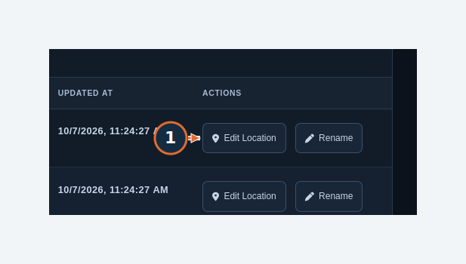
Orange numbers refer to this task’s written steps. Synthetic demonstration data.

W15 / Save a camera’s display location
Figure 35. Steps 2. Maintain the location used in investigation and map views.
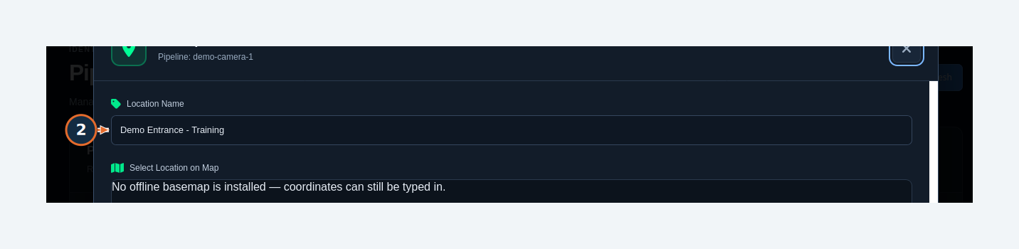
Orange numbers refer to this task’s written steps. Synthetic demonstration data.

W15 / Save a camera’s display location
Figure 36. Steps 3, 4, 5. Maintain the location used in investigation and map views.
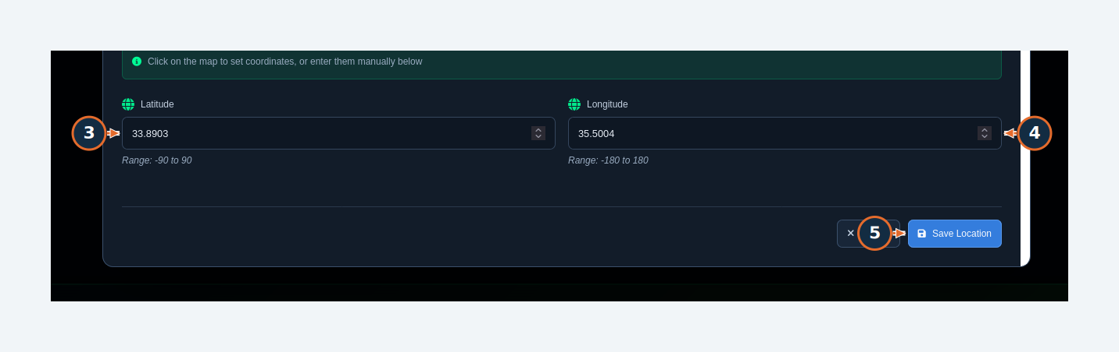
Orange numbers refer to this task’s written steps. Synthetic demonstration data.

W15 / Save a camera’s display location
Figure 37. Steps 6. Maintain the location used in investigation and map views.
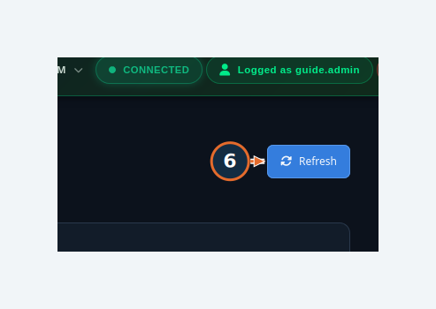
Orange numbers refer to this task’s written steps. Synthetic demonstration data.

W16 Create a camera-scoped user
Accomplish Create a standard account with explicitly assigned camera access.
Permissions / prerequisites Administrator
Start /admin/users
Verification Tested — standard user
1. Select Create New User.
2. Enter Username.
3. Enter Email address; the demonstration uses the reserved example.test domain.
4. Enter a temporary Password that meets policy.
5. Select Role. USER - Standard Access was tested.
6. Select only the required Pipeline access checkboxes. Keep the account active; grant Chatbot access only when needed.
7. Select Save user and acknowledge the confirmation.
8. Check the saved row, role, pipeline count and MUST CHANGE PASSWORD indicator.
Expected result / verify The synthetic user logged in, rotated its password and saw only its assigned camera. Opening /admin/users as that user returned it to Live Pipeline Feeds.
Errors / recovery Administrator assignment was disabled in this form. Observer and Analyzer options were visible but their full permission boundaries were not tested. The system account is protected and non-login.

W16 / Create a camera-scoped user
Figure 38. Steps 1. Create a standard account with explicitly assigned camera access.
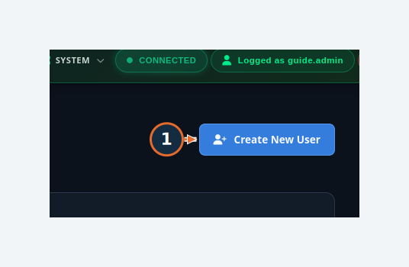
Orange numbers refer to this task’s written steps. Synthetic demonstration data.

W16 / Create a camera-scoped user
Figure 39. Steps 2, 3, 4, 5, 6, 7. Create a standard account with explicitly assigned camera access.
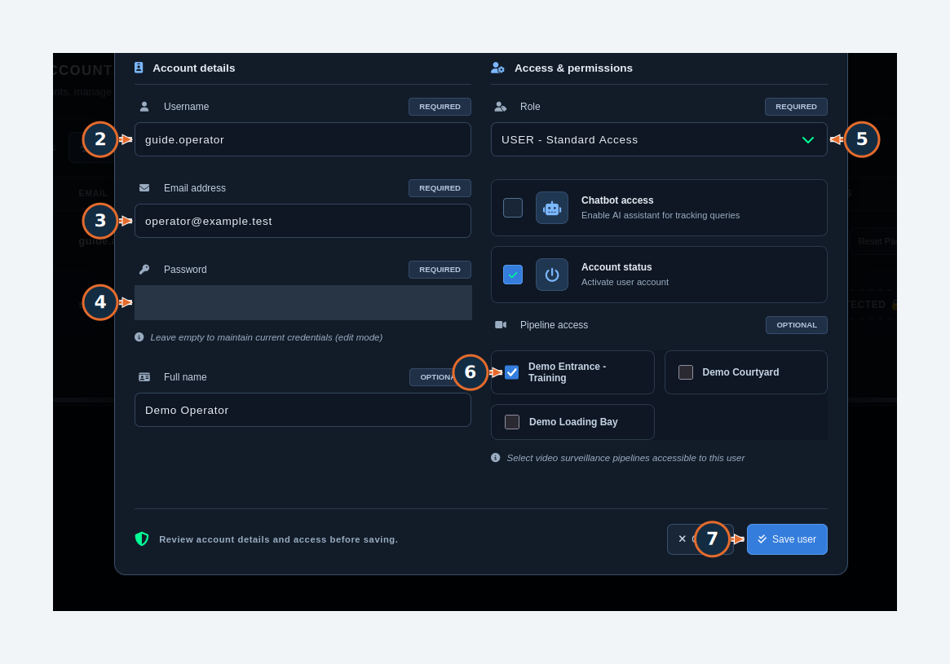
Orange numbers refer to this task’s written steps. Synthetic demonstration data.

W16 / Create a camera-scoped user
Figure 40. Steps 8. Create a standard account with explicitly assigned camera access.
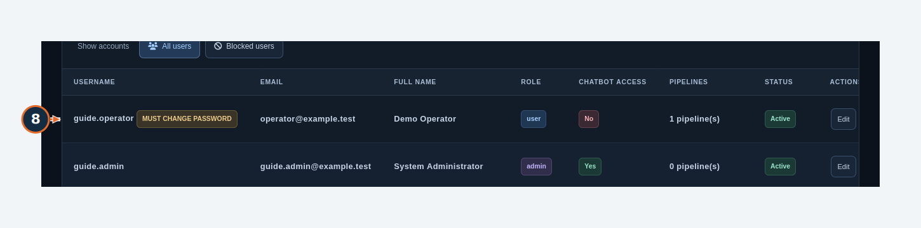
Orange numbers refer to this task’s written steps. Synthetic demonstration data.

W16 / Create a camera-scoped user
Figure 41. Camera-scoped standard-user filter controls; scope was verified separately in the displayed results.
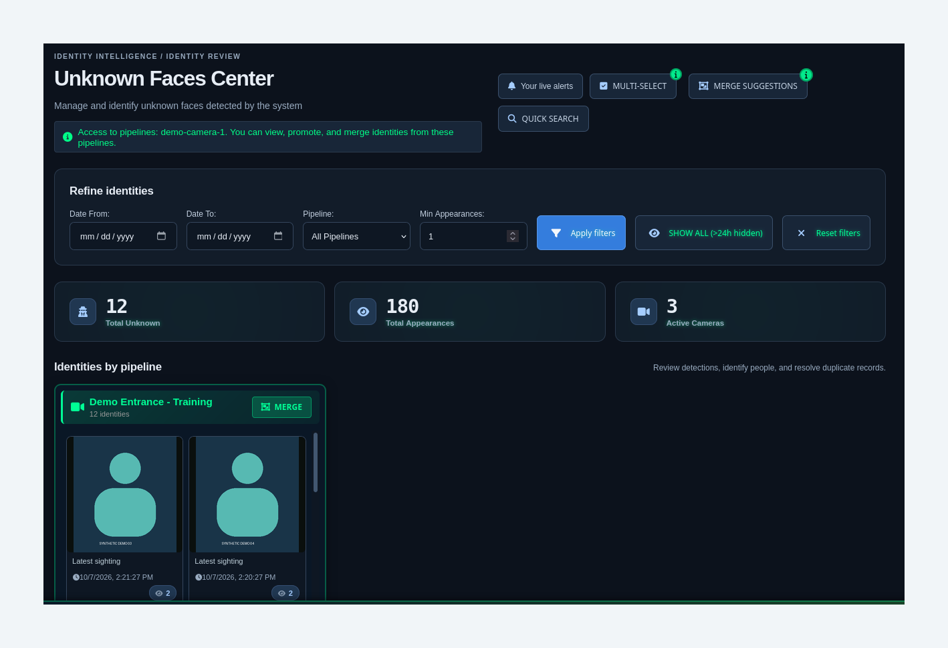
Orange numbers refer to this task’s written steps. Synthetic demonstration data.

W16 / Create a camera-scoped user
Figure 42. Standard-user result: an administrator URL redirects to the permitted Live Pipeline Feeds workspace.
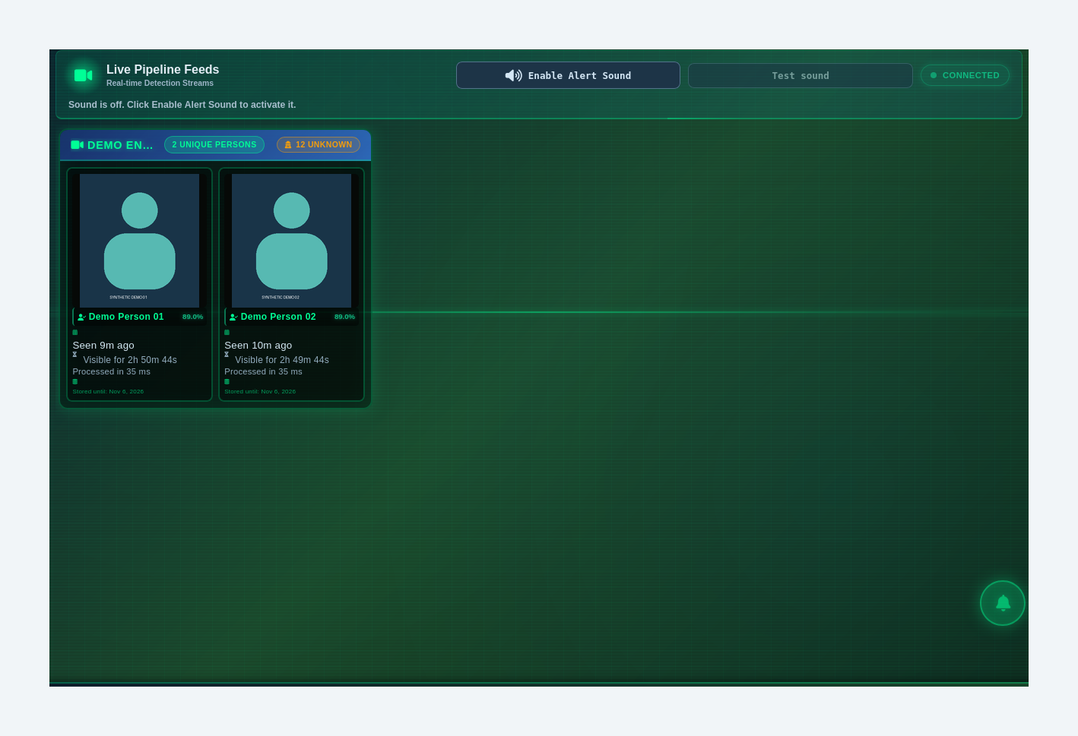
Orange numbers refer to this task’s written steps. Synthetic demonstration data.

W17 Issue an ingest credential for an authorized sender
Accomplish Create a sender-specific credential and preserve it securely.
Permissions / prerequisites Administrator; approved sender configuration
Start /admin/ingest-credentials
Verification Tested — issuance; clipboard transfer untested
1. Enter the sender name in the credential-name field.
2. Select Issue token.
3. Use Copy token to transfer the one-time token to the authorized sender’s secret store. The token is permanently redacted in this guide.
4. Dismiss the token dialog only after securing it.
5. Check the sender’s row in Issued credentials.
Expected result / verify A synthetic sender credential was issued and appeared in the list. The full token is shown once; the guide does not contain it.
Errors / recovery If the token is lost, follow the administrator’s replacement/revocation procedure. Last-used timestamps can lag; absence of a recent time is not immediate proof of failure.
Boundary No real sender was configured; webhook delivery and revocation were not tested. Static legacy ingest keys and sender-specific bearer tokens are different authentication methods.

W17 / Issue an ingest credential for an authorized sender
Figure 43. Steps 1, 2. Create a sender-specific credential and preserve it securely.
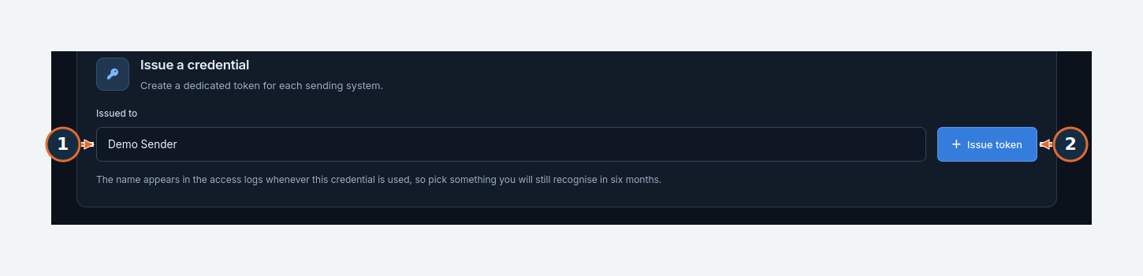
Orange numbers refer to this task’s written steps. Synthetic demonstration data.

W17 / Issue an ingest credential for an authorized sender
Figure 44. One-time credential controls. The actual token is permanently redacted in the underlying screenshot.
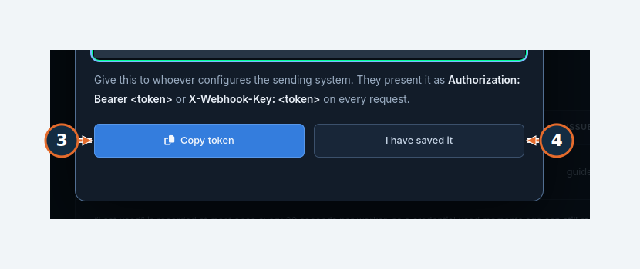
Orange numbers refer to this task’s written steps. Synthetic demonstration data.

W17 / Issue an ingest credential for an authorized sender
Figure 45. Steps 5. Create a sender-specific credential and preserve it securely.
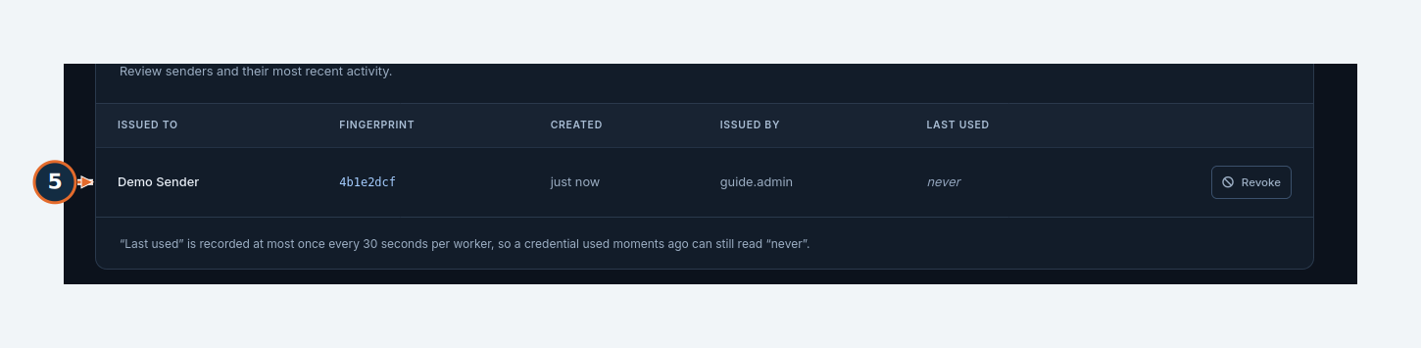
Orange numbers refer to this task’s written steps. Synthetic demonstration data.

W18 Edit a setting and verify its application timing
Accomplish Change one permitted value and verify the reported result.
Permissions / prerequisites Administrator
Start /admin/settings
Verification Tested
1. Search for Search history retention.
2. Select Edit on the matching setting.
3. Enter NEW VALUE. The example extends the period from 90 to 120 days in the isolated instance.
4. Enter CHANGE REASON.
5. Select Save Changes.
6. Select REFRESH and check the value and application hint.
Expected result / verify The setting showed 120 days after refresh. The editor states that this setting applies at the next scheduled job run.
Errors / recovery Saved does not always mean immediately effective. Read In use, saved-value differences and restart/next-job hints. Security-critical settings may be read-only.

W18 / Edit a setting and verify its application timing
Figure 46. Steps 1, 2. Change one permitted value and verify the reported result.
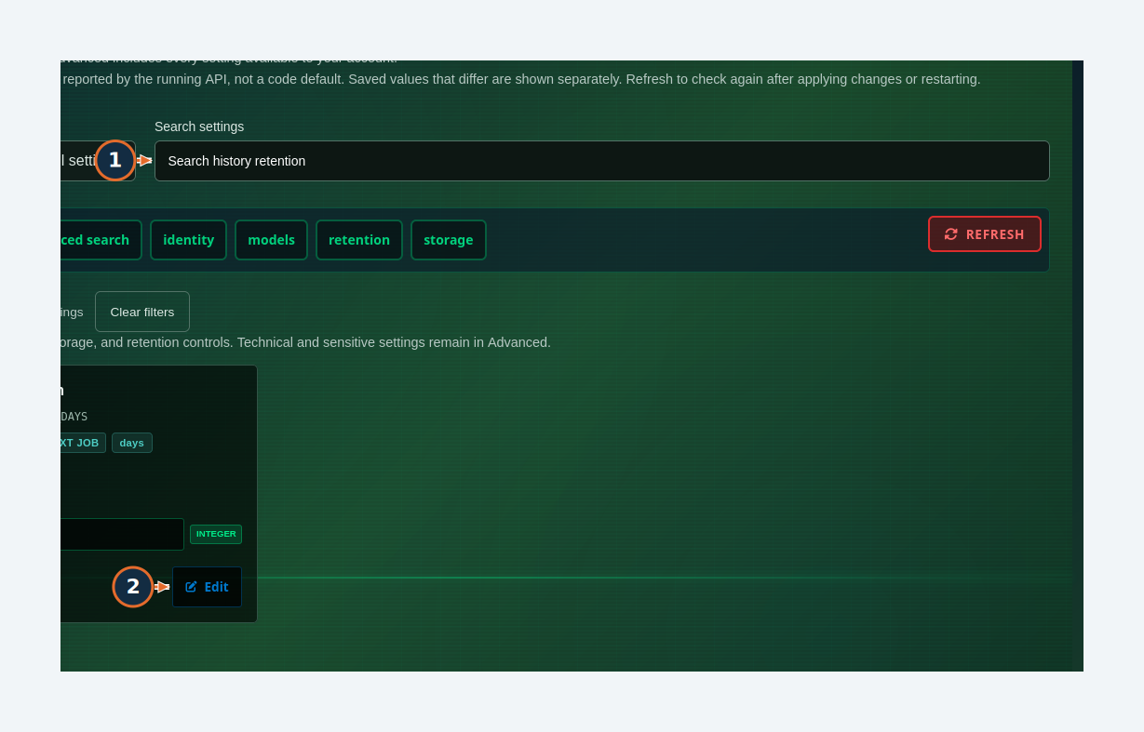
Orange numbers refer to this task’s written steps. Synthetic demonstration data.

W18 / Edit a setting and verify its application timing
Figure 47. Steps 3, 4, 5. Change one permitted value and verify the reported result.
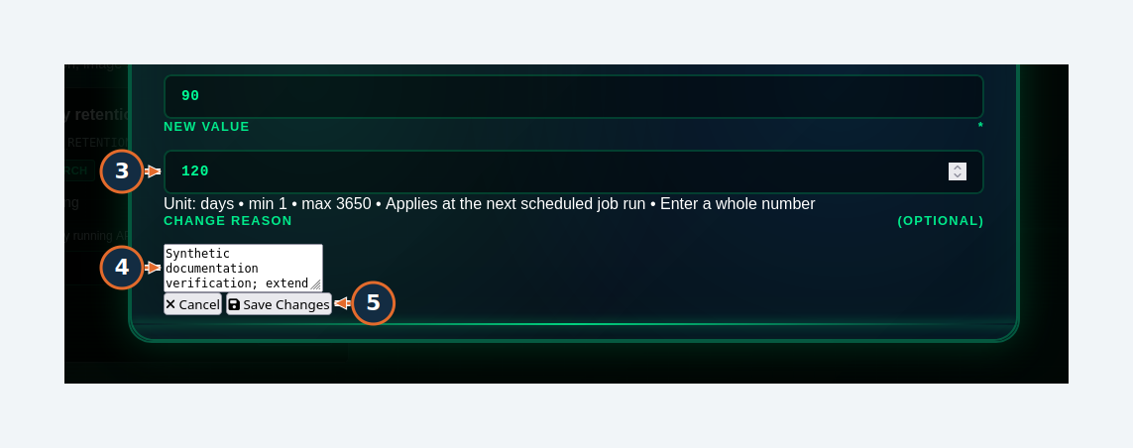
Orange numbers refer to this task’s written steps. Synthetic demonstration data.

W18 / Edit a setting and verify its application timing
Figure 48. Steps 6. Change one permitted value and verify the reported result.
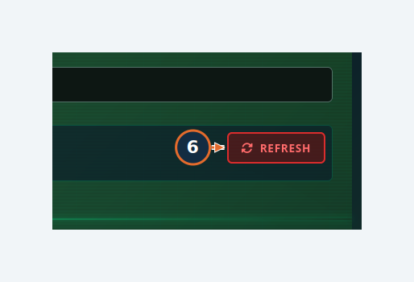
Orange numbers refer to this task’s written steps. Synthetic demonstration data.

W19 Preview retention cleanup without deleting data
Accomplish Estimate eligible cleanup and verify job completion.
Permissions / prerequisites Administrator
Start /admin/background-tasks → Retention Management
Verification Tested
1. Select Refresh Retention Status.
2. Select Run Retention Dry Test.
3. Filter Execution history with “retention” and open the completed dry-run task if further detail is needed.
Expected result / verify Data Retention Dry Run reached COMPLETED. It counts what would be deleted and does not delete records.
Errors / recovery A submitted job is not a completed job: wait for its final state. Do not choose Run Retention Now for a preview. Retention age and cleanup interval mean different things.

W19 / Preview retention cleanup without deleting data
Figure 49. Steps 1, 2. Estimate eligible cleanup and verify job completion.
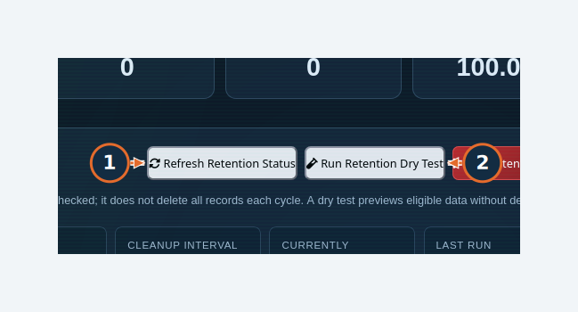
Orange numbers refer to this task’s written steps. Synthetic demonstration data.

W19 / Preview retention cleanup without deleting data
Figure 50. Execution-history filter used to locate the completed retention dry run; no destructive cleanup was initiated.
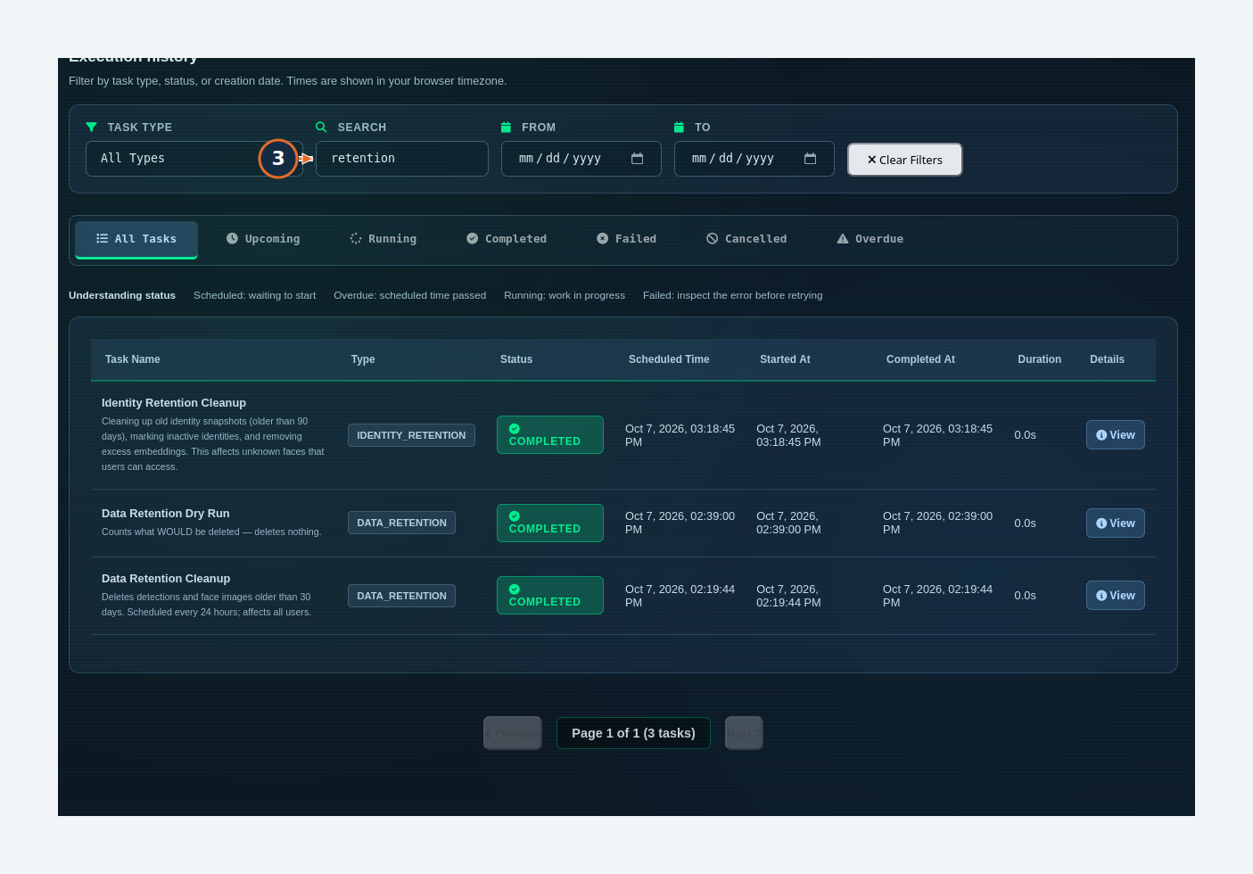
Orange numbers refer to this task’s written steps. Synthetic demonstration data.

W20 Review chatbot query audit
Accomplish Narrow investigation evidence without clearing it.
Permissions / prerequisites Administrator
Start /admin/audit, then /admin/logs
Verification Tested — navigation and filtering
1. Choose USERNAME in Refine activity.
2. Choose STATUS.
3. Select Apply filters.
4. Choose Rows per page at the bottom of the table.
5. Select Next only when another page is available.
Expected result / verify The page displayed Chatbot audit log and no query records in the isolated run. This page audits chatbot queries and responses, not every administrative action.
Errors / recovery Check user, date and status filters. An empty query log is expected when no assistant query has completed.
Boundary Query-detail and response inspection could not be verified without completed assistant queries.

W20 / Review chatbot query audit
Figure 51. Steps 1, 2, 3. Narrow investigation evidence without clearing it.
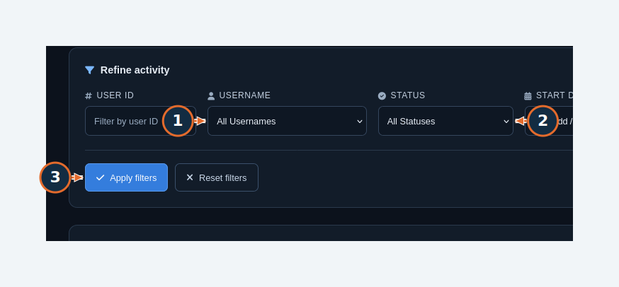
Orange numbers refer to this task’s written steps. Synthetic demonstration data.

W20 / Review chatbot query audit
Figure 52. Steps 4, 5. Narrow investigation evidence without clearing it.
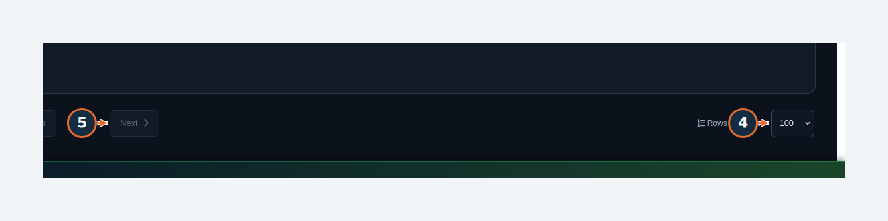
Orange numbers refer to this task’s written steps. Synthetic demonstration data.

W20L Filter application logs
Accomplish Narrow the loaded log records without clearing them.
Permissions / prerequisites Administrator
Start /admin/logs
Verification Tested — filtering
1. Choose LOG LEVEL, for example ERROR.
2. Select Apply Filters.
3. Use Find on this page to narrow the loaded records.
Expected result / verify The ERROR query returned No logs found in the scanned scope. Source, dates and Per Page change that scope.
Errors / recovery Reset overly narrow filters and select Refresh. An empty filtered page does not prove the absence of errors. Do not clear logs needed for investigation.
Boundary Sensitive log export and log clearing were not performed.

W20L / Filter application logs
Figure 53. Steps 1, 2, 3. Narrow the loaded log records without clearing them.
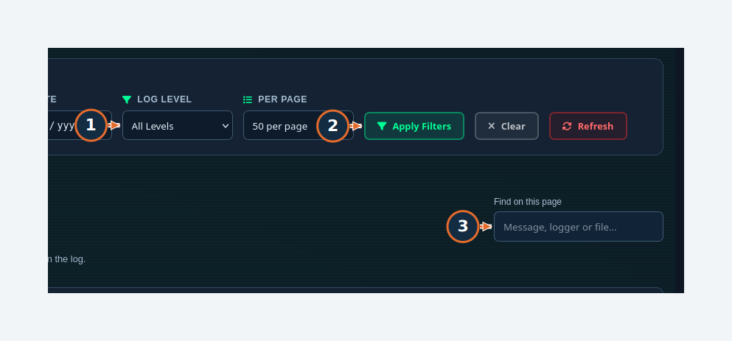
Orange numbers refer to this task’s written steps. Synthetic demonstration data.

W21 Build a social relationship graph
Accomplish Inspect coappearance connections and their provenance.
Permissions / prerequisites Administrator; observations for the selected scope
Start /admin/security-intelligence → Social Network
Verification Tested
1. Set DAYS BACK; leave identities empty only when analysis of every accessible identity is intended.
2. Select ANALYZE NETWORK.
3. Inspect the graph, node/connection counts and provenance.
Expected result / verify The synthetic dataset returned 14 nodes, 91 connections and one cluster. The result identified the rules/co-occurrence engine.
Errors / recovery Open Select Identities to restrict the analysis. A connection means observed coappearance under the selected rules, not proof of a personal relationship or coordination.

W21 / Build a social relationship graph
Figure 54. Steps 1, 2. Inspect coappearance connections and their provenance.
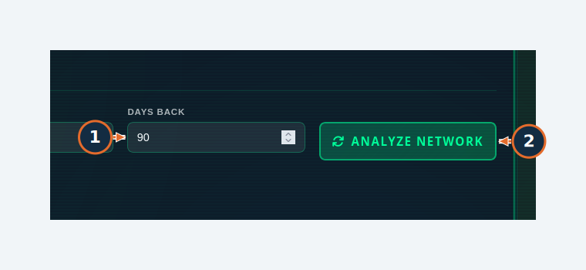
Orange numbers refer to this task’s written steps. Synthetic demonstration data.

W21 / Build a social relationship graph
Figure 55. Steps 3. Inspect coappearance connections and their provenance.
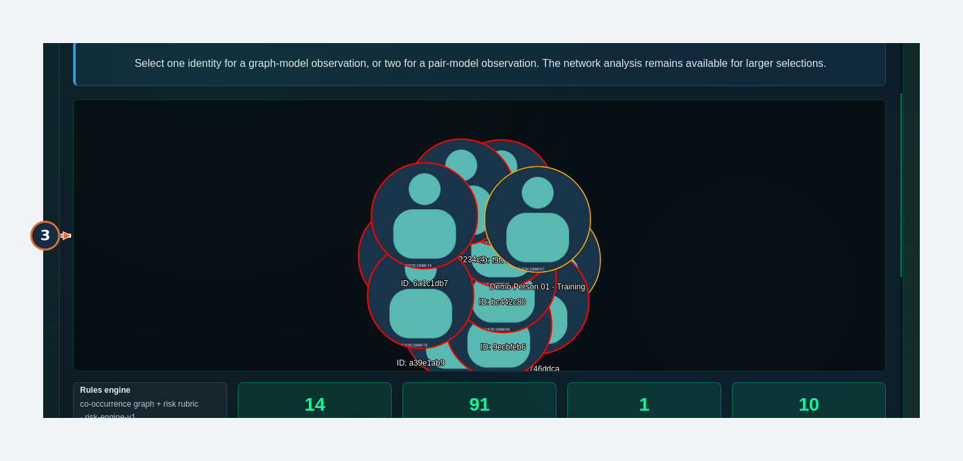
Orange numbers refer to this task’s written steps. Synthetic demonstration data.

W22 Review suspicious-pattern output
Accomplish Scope pattern detection and inspect the returned evidence.
Permissions / prerequisites Administrator; relevant camera history
Start /admin/security-intelligence → Suspicious Patterns
Verification Tested — result generation; detail review limited
1. Choose the pipeline scope.
2. Set DAYS BACK; review MIN GROUP SIZE.
3. Select DETECT PATTERNS.
4. Review the returned cards and use VIEW DETAILS when investigating a specific result.
Expected result / verify The synthetic history produced group-activity cards with locations, times and identity counts.
Errors / recovery Large groups in demonstration data are manufactured examples. Empty output, scores and “confidence” labels require evidence review; they are not validated probabilities of misconduct.

W22 / Review suspicious-pattern output
Figure 56. Steps 1, 2, 3. Scope pattern detection and inspect the returned evidence.
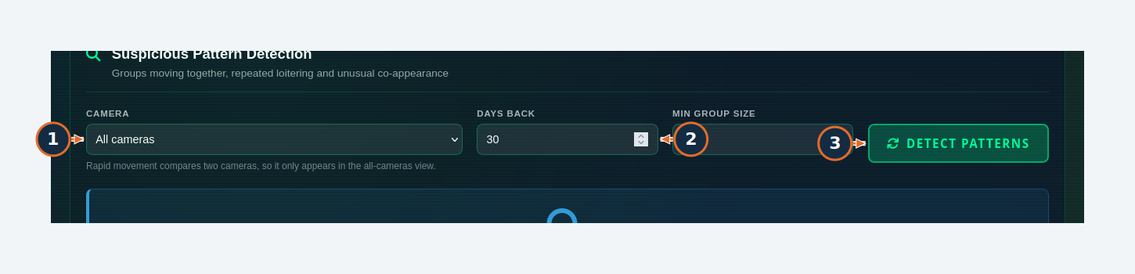
Orange numbers refer to this task’s written steps. Synthetic demonstration data.

W22 / Review suspicious-pattern output
Figure 57. Steps 4. Scope pattern detection and inspect the returned evidence.
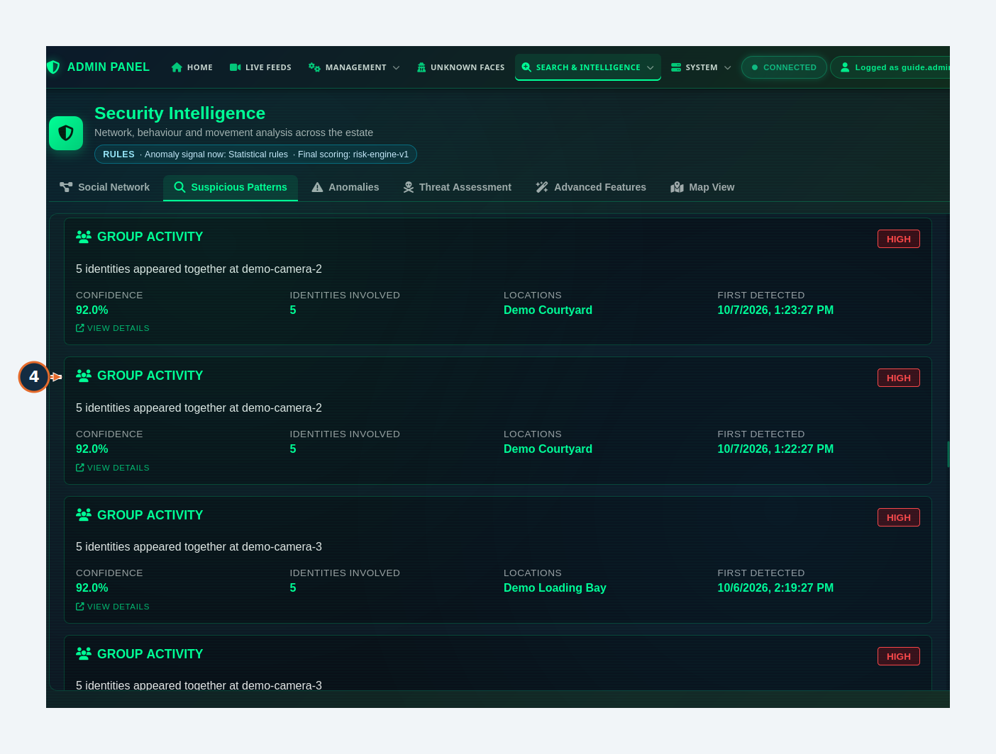
Orange numbers refer to this task’s written steps. Synthetic demonstration data.

W23 Check anomalies and recover from insufficient history
Accomplish Choose a subject and test whether a usable baseline exists.
Permissions / prerequisites Administrator; identity observations
Start /admin/security-intelligence → Anomalies → Select Identity
Verification Tested — readiness failure
1. In the picker, search by name or ID.
2. Select the intended result.
3. Set DAYS BACK.
4. Select DETECT ANOMALIES.
5. Read the baseline/evidence message before interpreting the output.
Expected result / verify The test returned “Insufficient baseline”: all 15 appearances were inside the 90-day window, leaving zero earlier appearances; at least five were required.
Errors / recovery Use a shorter window only when it leaves sufficient earlier observations, or collect more history. Do not treat a baseline failure as “no anomalies”.

W23 / Check anomalies and recover from insufficient history
Figure 58. Steps 1, 2. Choose a subject and test whether a usable baseline exists.
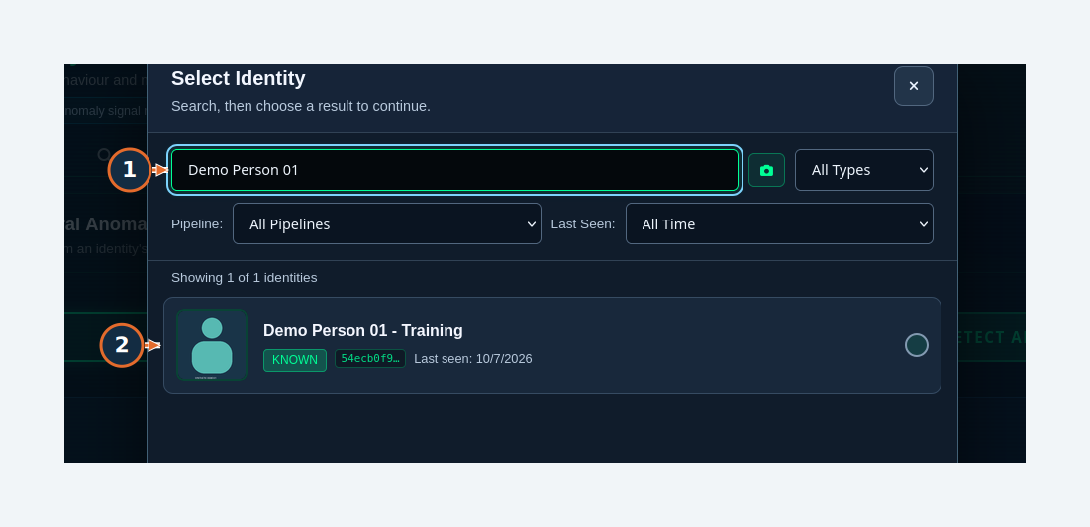
Orange numbers refer to this task’s written steps. Synthetic demonstration data.

W23 / Check anomalies and recover from insufficient history
Figure 59. Steps 3, 4. Choose a subject and test whether a usable baseline exists.
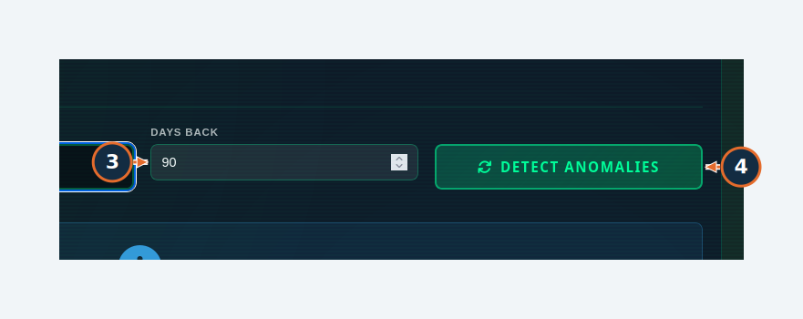
Orange numbers refer to this task’s written steps. Synthetic demonstration data.

W23 / Check anomalies and recover from insufficient history
Figure 60. Steps 5. Choose a subject and test whether a usable baseline exists.
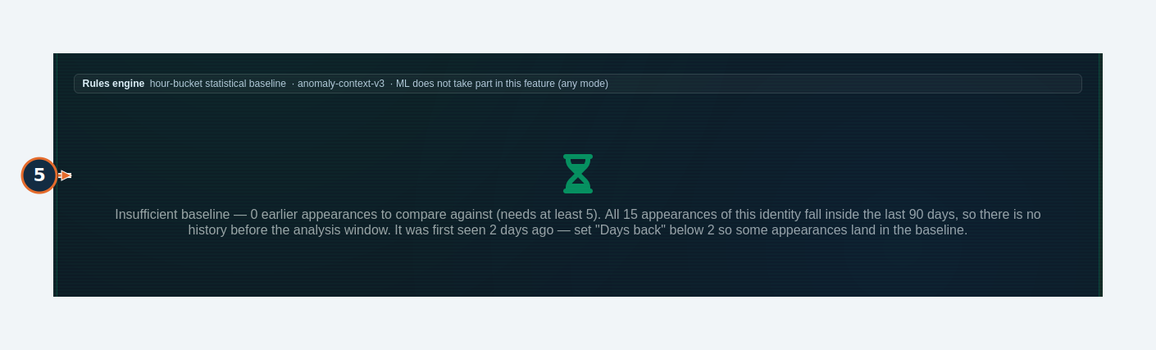
Orange numbers refer to this task’s written steps. Synthetic demonstration data.

W24 Assess threat evidence and provenance
Accomplish Read a persisted rules-based assessment with its limitations.
Permissions / prerequisites Administrator; selected demonstration identity
Start /admin/security-intelligence → Threat Assessment
Verification Tested
1. Choose the intended identity.
2. Select ASSESS THREAT.
3. Review risk factors, baseline warnings, Requested mode, Executed mode and Final scoring.
Expected result / verify The test returned a moderate score of 25.0 from connection count, with an insufficient-anomaly-baseline warning and rules provenance.
Errors / recovery The interface explicitly describes risk-engine-v1 as a heuristic score, not a probability. Record outcome creates a consequential review label and was not used.

W24 / Assess threat evidence and provenance
Figure 61. Steps 1, 2. Read a persisted rules-based assessment with its limitations.
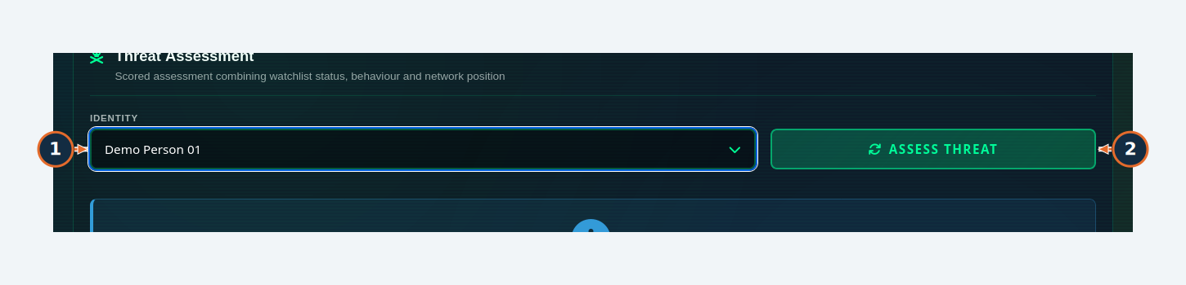
Orange numbers refer to this task’s written steps. Synthetic demonstration data.

W24 / Assess threat evidence and provenance
Figure 62. Steps 3. Read a persisted rules-based assessment with its limitations.
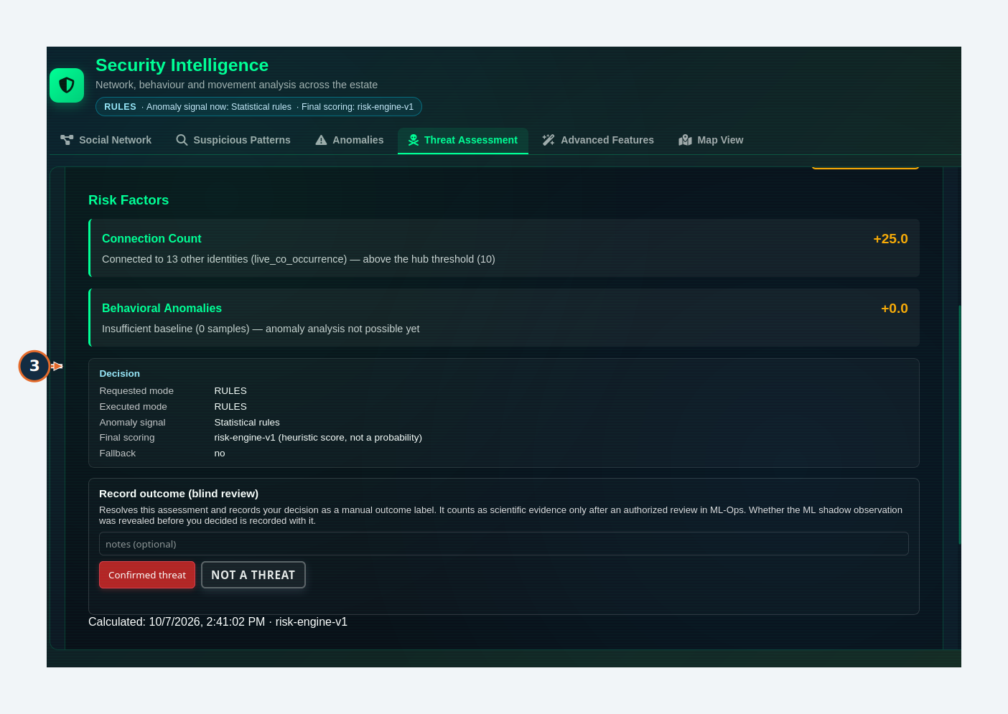
Orange numbers refer to this task’s written steps. Synthetic demonstration data.

W25 Check advanced analytics readiness
Accomplish Distinguish enabled controls from working dependencies and sufficient evidence.
Permissions / prerequisites Administrator
Start /admin/security-intelligence → Advanced Features
Verification Tested — status and threshold review
1. Use Review saved thresholds to inspect existing candidates rather than learning or activating new ones.
2. Select CHECK FEATURE STATUS.
3. Read the per-feature readiness details.
Expected result / verify The report showed ready network/pattern/anomaly/threat functions, threshold learning with a worker unavailable, and unavailable security zones/maps. Trajectory and correlation were available subject to per-case evidence.
Errors / recovery Enabled does not mean usable for every identity. Trajectory requires at least three outgoing sessions; correlation is heuristic association. Threshold candidates need separate review and activation.
Boundary Learning/activating thresholds, trajectory execution, correlation execution and Learn All Camera Thresholds were not completed.

W25 / Check advanced analytics readiness
Figure 63. Steps 1. Distinguish enabled controls from working dependencies and sufficient evidence.
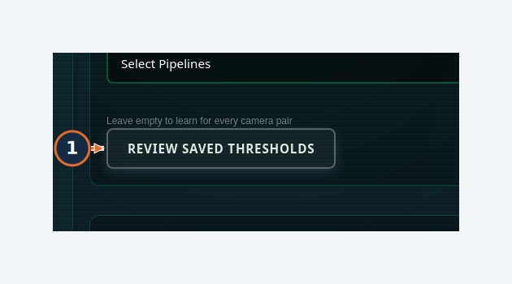
Orange numbers refer to this task’s written steps. Synthetic demonstration data.

W25 / Check advanced analytics readiness
Figure 64. Steps 2. Distinguish enabled controls from working dependencies and sufficient evidence.
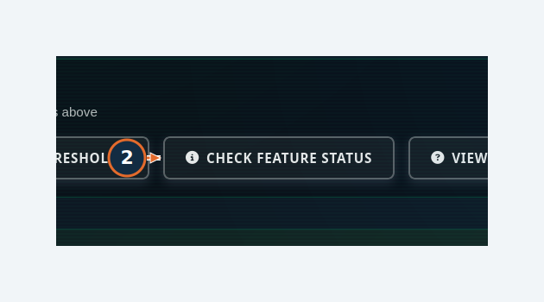
Orange numbers refer to this task’s written steps. Synthetic demonstration data.

W25 / Check advanced analytics readiness
Figure 65. Steps 3. Distinguish enabled controls from working dependencies and sufficient evidence.
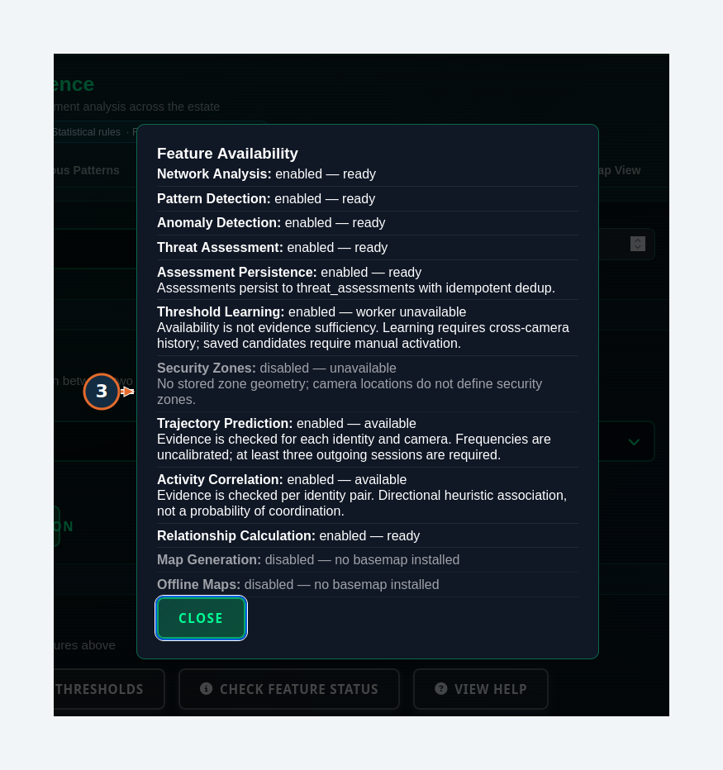
Orange numbers refer to this task’s written steps. Synthetic demonstration data.

W26 Diagnose a missing map
Accomplish Load spatial evidence or identify the missing basemap dependency.
Permissions / prerequisites Administrator; identity and camera locations
Start /admin/security-intelligence → Map View
Verification Tested — unavailable dependency
1. Select the identity.
2. Choose MAP STYLE from the available styles.
3. Select LOAD MAP.
Expected result / verify The isolated instance reported missing/unavailable basemap support. Camera coordinates could still be saved separately.
Errors / recovery Ask the administrator to verify installed offline map archives, content checks and the map service. No coordinates should be invented to make an empty map look populated.
Boundary Basemap rendering, terrain/satellite layers, zones, heatmaps and continuous route accuracy were not verified.

W26 / Diagnose a missing map
Figure 66. Steps 1, 2, 3. Load spatial evidence or identify the missing basemap dependency.
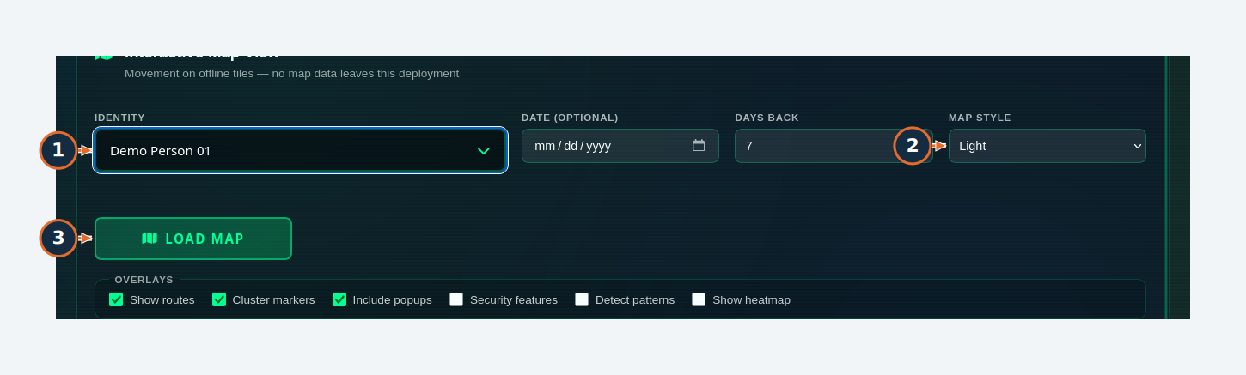
Orange numbers refer to this task’s written steps. Synthetic demonstration data.

W26 / Diagnose a missing map
Figure 67. Points or lines may render on an empty canvas; no geographic basemap was installed in the isolated instance.
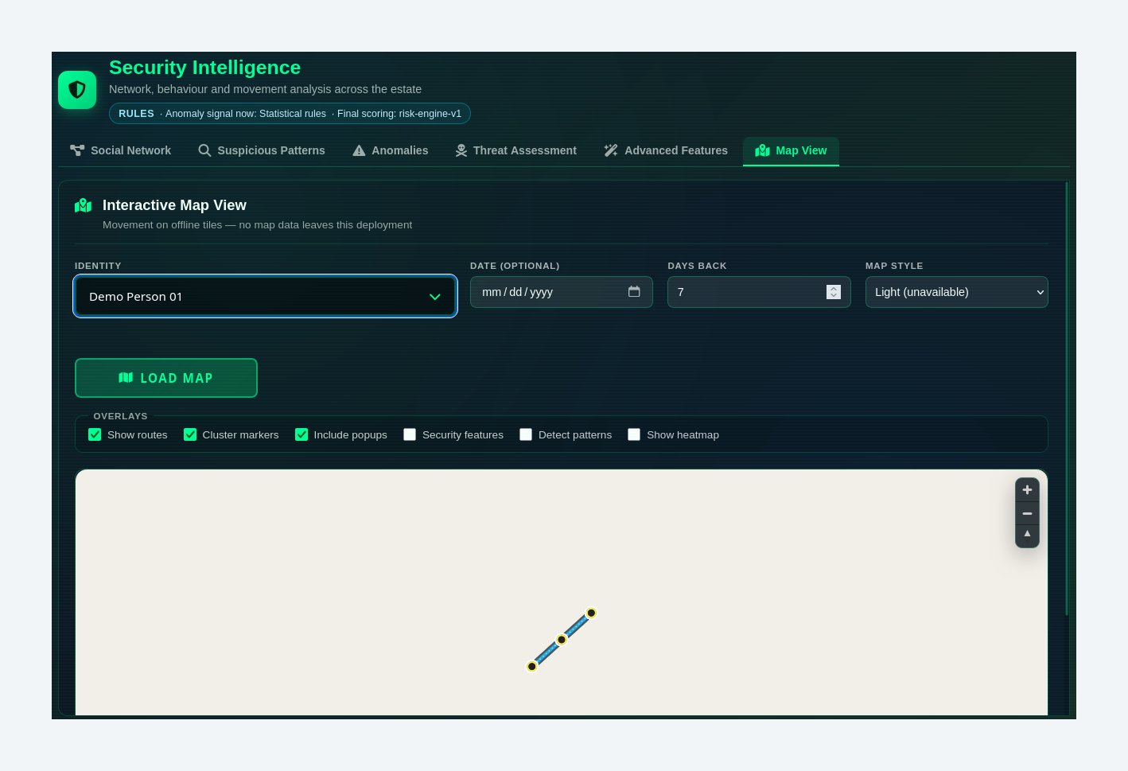
Orange numbers refer to this task’s written steps. Synthetic demonstration data.

W27 Follow the ML service lifecycle and readiness gate
Accomplish Use the current four-stage service workflow.
Permissions / prerequisites Administrator; healthy worker and suitable data for actual training
Start /admin/ml-ops
Verification Observed — training blocked
1. Choose Service: Behavior assessment, Pair relationships, Social network, Analyst review queue or Numeric experiments.
2. Inspect Prepare & train and the readiness message before submitting a run.
3. Expand Inspect data & notebook to locate the service’s inspection controls. Availability of a control does not prove a notebook was executed.
Expected result / verify The interface exposes Train → Review → Connect → Monitor. In this isolated instance the worker was unavailable and training remained disabled.
Errors / recovery Use Refresh status and Advanced tools & troubleshooting to diagnose worker/data requirements. A prepared dataset or candidate is not an active production decision model.
Boundary Training, metrics, tuning, model connection, drift and notebook execution were not completed. Current visible provenance says rules make live decisions; model observations must not be described as autonomous threat decisions.

W27 / Follow the ML service lifecycle and readiness gate
Figure 68. Steps 1, 2. Use the current four-stage service workflow.
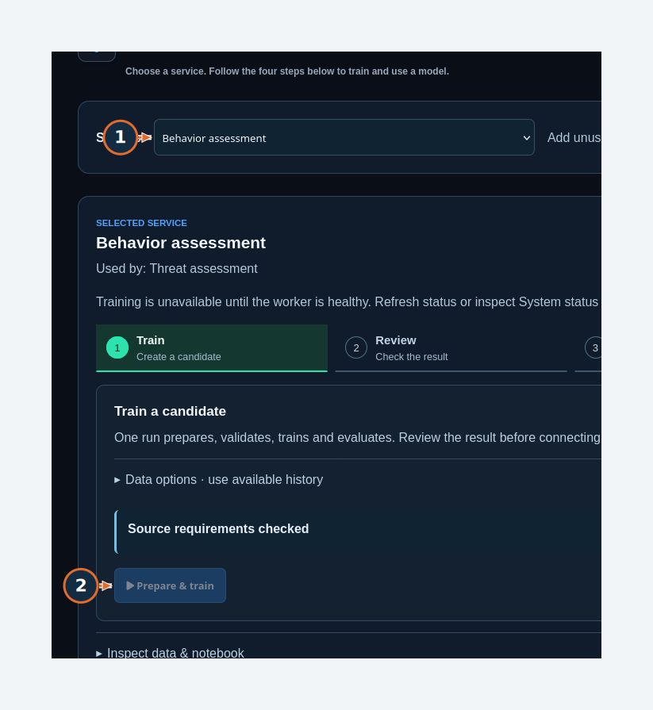
Orange numbers refer to this task’s written steps. Synthetic demonstration data.

W27 / Follow the ML service lifecycle and readiness gate
Figure 69. Worker unavailable: training remains gated. This is readiness evidence, not a completed training run.
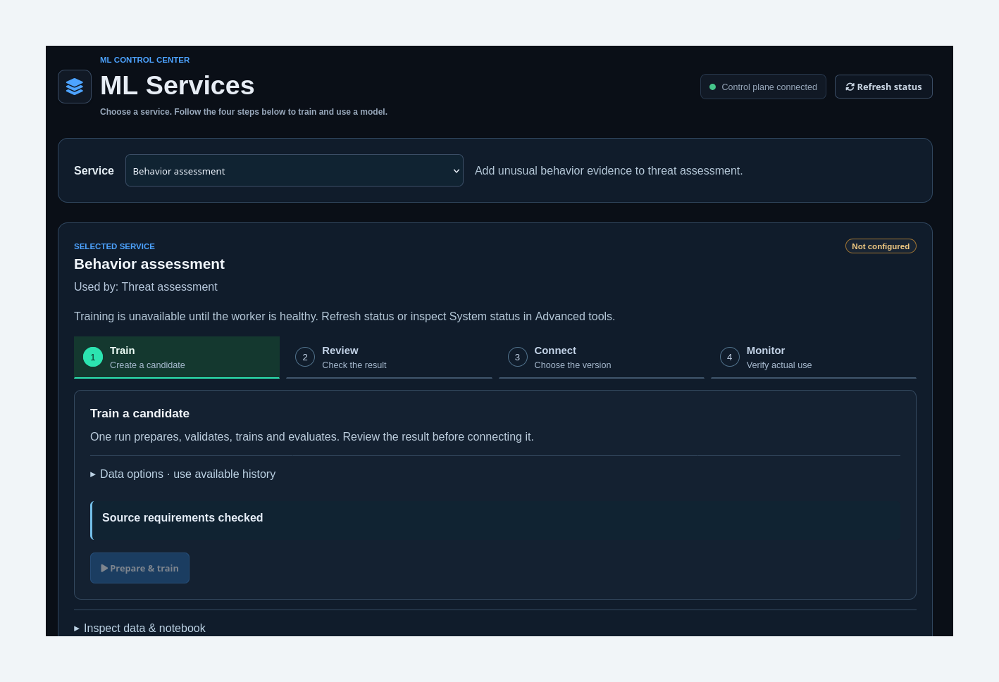
Orange numbers refer to this task’s written steps. Synthetic demonstration data.

W27 / Follow the ML service lifecycle and readiness gate
Figure 70. Steps 3. Use the current four-stage service workflow.
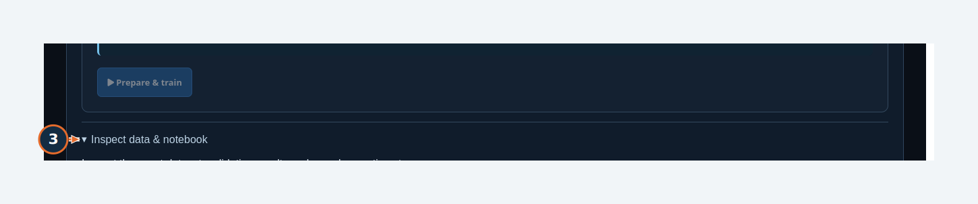
Orange numbers refer to this task’s written steps. Synthetic demonstration data.

W28 Locate database and notebook inspection tools
Accomplish Locate evidence-inspection controls and understand the current gap.
Permissions / prerequisites Administrator
Start ML Operations → Advanced tools & troubleshooting → Inspect a dataset or model → Inspect existing database data
Verification Observed — preview unavailable
1. Choose Data, such as Recognition observations or Identity sightings.
2. Enter Start (UTC).
3. Enter End (UTC), keeping the interval at most seven days; select the intended cameras when available.
4. Select Preview existing data.
Expected result / verify Expected in a working inspector: source rows/counts and an inspection-notebook download. In this run camera choices and default dates did not populate and Preview returned no visible result.
Errors / recovery Report the initialization/dependency issue; do not claim that extraction or training succeeded. Inspect data & notebook for the selected ML service also requires actual dataset/run evidence.
Boundary The guide does not supply a fabricated executed notebook or label synthetic fixture counts as an extracted training dataset.

W28 / Locate database and notebook inspection tools
Figure 71. Steps 1, 2, 3, 4. Locate evidence-inspection controls and understand the current gap.
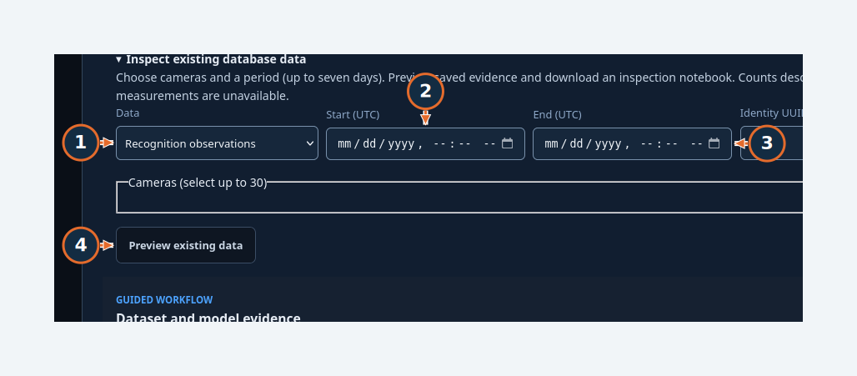
Orange numbers refer to this task’s written steps. Synthetic demonstration data.

W29 Check similarity-model readiness
Accomplish Read the supervised merge-feedback requirements.
Permissions / prerequisites Administrator
Start /admin/ml-model
Verification Tested — readiness display
1. Select Refresh.
2. Read the disabled training control and Dataset Readiness checks.
Expected result / verify The test showed Not Trained, Runtime Loaded: No, 0/50 samples, 0/5 approved, 0/5 rejected and 0/10 unique pairs.
Errors / recovery Collect and review legitimate feedback in the approved process. Do not approve/reject pairs just to fill training counts. The page describes a heuristic or legacy fallback until a candidate is activated.

W29 / Check similarity-model readiness
Figure 72. Steps 1. Read the supervised merge-feedback requirements.
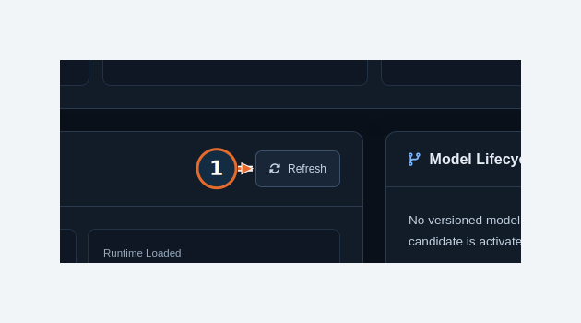
Orange numbers refer to this task’s written steps. Synthetic demonstration data.

W29 / Check similarity-model readiness
Figure 73. Steps 2. Read the supervised merge-feedback requirements.
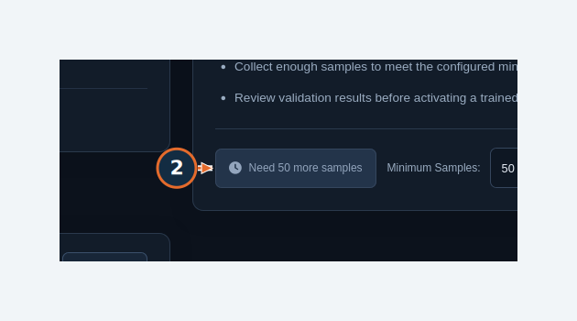
Orange numbers refer to this task’s written steps. Synthetic demonstration data.

W30 Use assistant help and recognize degraded mode
Accomplish Locate the conversational interface and verify service readiness.
Permissions / prerequisites Account with Chatbot access
Start /tracking-people
Verification Observed — model response unavailable
1. Enter a question in Message Surveillance AI only when the assistant is ready.
2. Use Send message to submit an approved query; this was not exercised against an available language model.
3. Select Help for the built-in instructions.
Expected result / verify The interface and Help opened, but the test displayed Assistant degraded. No model answer was represented as verified.
Errors / recovery Ask the administrator to check configured model availability and read-only query dependencies. Review factual answers against underlying records before acting.
Boundary Conversation generation, branching, feedback and generated report artifacts were not completed. No external assistant service was contacted.

W30 / Use assistant help and recognize degraded mode
Figure 74. Steps 1, 2, 3. Locate the conversational interface and verify service readiness.
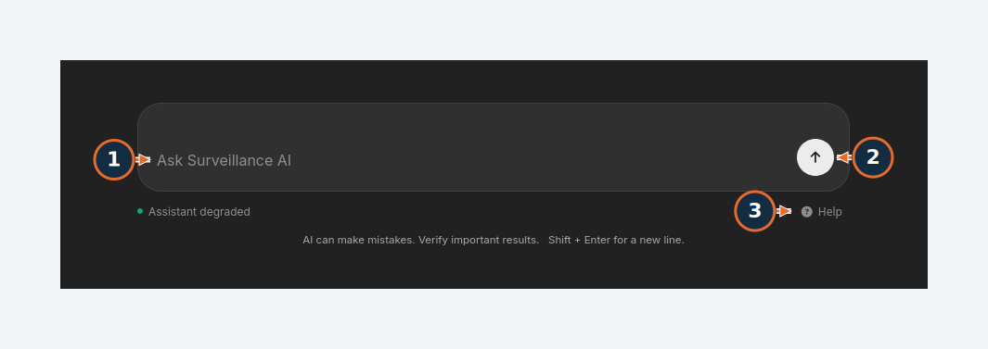
Orange numbers refer to this task’s written steps. Synthetic demonstration data.

W30 / Use assistant help and recognize degraded mode
Figure 75. Assistant interface/help entry in degraded mode; no language-model answer was validated.
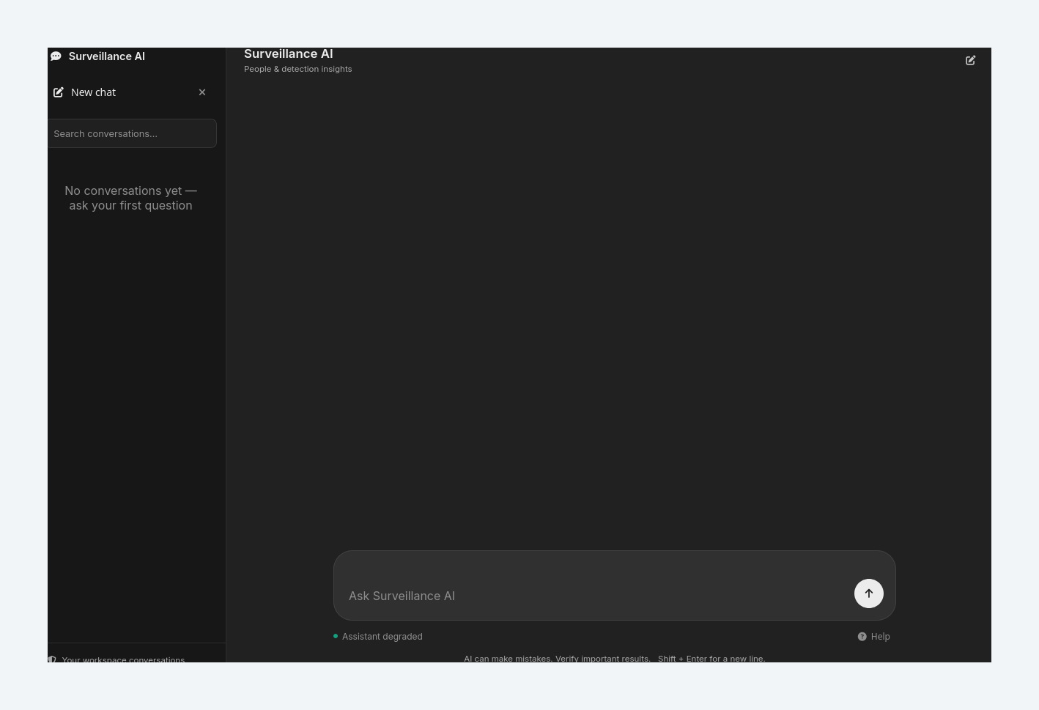
Orange numbers refer to this task’s written steps. Synthetic demonstration data.

W31 Read the in-app tutorial
Accomplish Find guidance delivered by the running build.
Permissions / prerequisites Administrator
Start /admin/tutorial
Verification Tested — navigation
1. Select SYSTEM WORKFLOW or the relevant tutorial topic.
Expected result / verify The tutorial opened and reported application version 5.0.0. Topic navigation is available in the running interface.
Errors / recovery Some Further reading entries refer to legacy document filenames. Use this guide’s verified workflow and current documentation index if a referenced file is absent.

W31 / Read the in-app tutorial
Figure 76. Steps 1. Find guidance delivered by the running build.
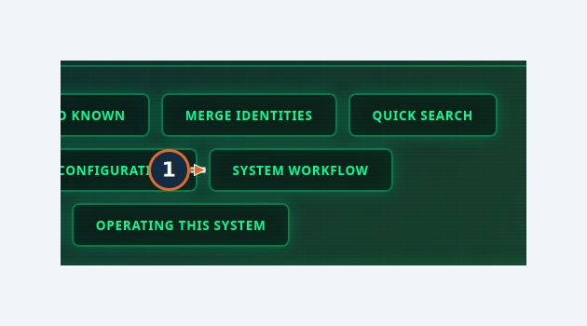
Orange numbers refer to this task’s written steps. Synthetic demonstration data.

7. Troubleshooting and common mistakes

Login blocked or repeated sign-in
Confirm the approved HTTPS address, account status and required rotation. Ask the administrator to inspect origin/session policy. Never publish passwords in screenshots.
Related task: W01–W02

A page redirects or cameras are missing
Check role and Pipeline access. The tested standard user was redirected away from user administration and saw only assigned camera evidence.
Related task: W16

A feed looks empty or stale
Confirm ingestion, latest observation time and assigned camera. VAS stored detection display does not prove that the VMS browser video transport is healthy.
Related task: W05

Image is rejected or search returns no faces
Use an approved clear face image and Quality Check. Synthetic silhouette input correctly produced “No face was detected in the image.” Positive matching was not tested.
Related task: W10

Troubleshooting — continued

Dialog action labels have poor contrast
Some watchlist and alert submit controls rendered dark text on a dark background. The enlarged figures point to their actual positions; this UI defect needs a separate application fix.
Related task: W13–W14

A saved watchlist looks unnamed
The profile chip showed “Untitled watchlist” in this run. Verify the identity in the named watchlist’s View panel before concluding the write failed.
Related task: W13

Alert rule exists but no alert arrives
Inspect Health, rule state, similarity and delivery settings. Rule save/pause was tested; triggering, sound, email and SMS were not. The fixture snapshot health check reported a problem.
Related task: W14

Anomaly detection has insufficient baseline
The comparison interval needs enough earlier observations. The 90-day example had no earlier baseline; gather valid history or use a justified shorter interval. Do not weaken validation merely to obtain a score.
Related task: W23

Troubleshooting — continued

Threat score seems decisive
Read Requested mode, Executed mode, risk factors and scoring provenance. The demonstrated rules score is not a probability that someone is a threat.
Related task: W24

Map is blank
Confirm offline basemap installation and service availability. Coordinates or trajectory lines alone do not establish a functioning map or security-zone geometry.
Related task: W26

Prepare & train is disabled
Restore worker availability and satisfy source/dataset readiness. Keep minimum rows, split, null and leakage checks. Do not treat a ready page as a deployed model.
Related task: W27

Dataset preview does not load
The isolated inspector had no camera choices and no preview output. Report the affected service, range and screen state; no notebook execution was validated here.
Related task: W28

Troubleshooting — continued

Similarity training asks for more samples
Collect approved and rejected feedback for sufficient distinct pairs. The displayed baseline was 0/50 samples, 0/5 approved, 0/5 rejected and 0/10 pairs.
Related task: W29

Assistant says degraded
Ask the administrator to check its model service and permissions. No assistant answer was tested in this instance.
Related task: W30

Retention change appears delayed
Read the apply timing. The tested retention setting applied at the next scheduled cleanup; use the dry test to preview eligibility without deletion.
Related task: W18–W19

8. Capability coverage and remaining gaps
The companion Capability-coverage.csv contains the full feature inventory: purpose, location, permission, verification status, task reference, screenshot evidence and remaining limitations. The following register includes every discovered capability from that inventory.

What was established
Verified demonstrations include authentication and rotation, camera-scoped access, location and name updates, filtering and identity journeys, watchlist creation/membership, alert save/health/pause, CSV export, credential issuance, settings persistence, a completed retention dry run, relationship/pattern generation and analysis-readiness behavior.

What remains unverified
- Positive face recognition, real-photo enrollment, merge and promotion completion; live ingestion and camera throughput.
- Triggered notifications and external delivery; destructive cleanup, record deletion, credential revocation and recovery from backups.
- End-to-end ML training, notebook execution, hyperparameter tuning, drift monitoring and model connection to consuming services.
- Working basemaps/security-zone geometry and assistant answers; complete Observer/Analyzer permission coverage.

Features not discovered as dedicated VAS screens
Continuous video playback or recording archive, vehicle/license-plate operations, multi-site orchestration and a general report builder were not found. Search-history CSV export and timestamped face appearances do exist. Do not substitute those for a video archive or validated reporting subsystem.

Interpretation
The inventory is an evidence record for this application state, not a claim that every listed capability is production ready. Re-run the affected tasks after releases, configuration changes or dependency restoration.

Capability register · 1–4

C01 Sign in / logout
Authenticate and end a session
Location / permission /signin; LOGOUT | Active account
Status / guide Tested | 2 / W01
Limit Synthetic administrator and standard user only.
Capture evidence: 01-signin

C02 Required password rotation
Replace a temporary password
Location / permission /change-password | Account requiring rotation
Status / guide Tested | 2 / W02
Capture evidence: 02-password

C03 Role-scoped navigation and cameras
Restrict access to assigned sources
Location / permission Navigation; /dashboard; /admin/unknown | Role and pipeline assignment
Status / guide Tested | 2; W16
Limit Standard user verified; not an exhaustive authorization audit.
Capture evidence: 08-operator; 09-access-denied

C04 Observer and Analyzer roles
Choose additional assignable roles
Location / permission Users role selector | Administrator
Status / guide Observed, untested completion | 2; W16
Limit Options observed; their complete privilege boundaries were not exercised.
Capture evidence: 06-user-form

Capability register · 5–8

C05 Administrator assignment
Assign a full-access administrator
Location / permission Users role selector | Administrator
Status / guide Inaccessible or unavailable in this run | 2; W16
Limit Administrator option shown as not assignable here.
Capture evidence: 06-user-form

C06 Protected system account
Attribute automated actions
Location / permission /admin/users | Administrator
Status / guide Observed, untested completion | 2; W16
Limit Non-login protected principal; not a normal human account.
Capture evidence: 07-user-saved

C07 Home overview / camera selector
Read overview and source summaries
Location / permission /home | Administrator
Status / guide Tested | 3 / W04
Capture evidence: 56-home; 56b-home-camera

C08 Shared navigation / open menus
Find feature workspaces
Location / permission Header menus | Role-dependent
Status / guide Tested | 3 / W03
Capture evidence: 57-navigation

Capability register · 9–12

C09 Live detection cards
Review recent snapshots and timing
Location / permission /dashboard | Active account with permitted pipelines
Status / guide Tested | 5 / W05
Limit Stored synthetic observations; no real-time camera ingest measured.
Capture evidence: 71-live-feeds; 09-access-denied

C10 Recent detections drawer
Inspect recent records
Location / permission /dashboard | Active account with permitted pipelines
Status / guide Tested | 5 / W05
Capture evidence: 72-recent-detections

C11 WebSocket updates
Receive new application events
Location / permission CONNECTED badges | Authenticated session
Status / guide Observed, untested completion | 5 / W05
Limit Connection observed; new camera detection delivery was not tested.
Capture evidence: 71-live-feeds

C12 Alert sound / browser notifications
Notify an operator
Location / permission Dashboard; Live Alerts; Background Tasks | Browser permission and permitted events
Status / guide Observed, untested completion | 5 / W05, W14
Limit Audio permission and delivery not exercised.
Capture evidence: 40-alert-saved

Capability register · 13–16

C13 Unknown identity filters
Find records by camera/count/date
Location / permission /admin/unknown | Administrator or assigned-pipeline user
Status / guide Tested | 5 / W06
Limit Camera/count flow tested; every date/SHOW ALL combination was not tested.
Capture evidence: 12-unknown-filter

C14 Unknown identity detail
Inspect appearance evidence
Location / permission VIEW & ALERT | Permission to view identity
Status / guide Tested | 5 / W06
Capture evidence: 13-unknown-open; 14-journey

C15 Journey overview / camera lanes
Review recorded movement
Location / permission Identity detail / profile | Permission to view identity
Status / guide Tested | 5 / W07
Limit Observation order, not measured continuous movement.
Capture evidence: 48-journey-overview; 49-journey-lanes

C16 Linked photo viewer
Navigate appearance images
Location / permission Identity movement timeline | Permission to view identity
Status / guide Tested | 5 / W07
Limit Synthetic placeholder photos.
Capture evidence: 50-photo-viewer

Capability register · 17–20

C17 Review sequence animation
Advance still sightings automatically
Location / permission Movement explorer | Permission to view identity
Status / guide Observed, untested completion | 5 / W07
Limit Control observed; still-image review, not video playback.
Capture evidence: 49-journey-lanes

C18 Known directory search / profile
Find registered records
Location / permission /admin/known | Administrator
Status / guide Tested | 5 / W08
Capture evidence: 15-known-directory; 36-full-profile

C19 Rename known person
Save a display name
Location / permission Manage person → Save name | Administrator
Status / guide Tested | 5 / W08
Capture evidence: 16-known-profile; 36-full-profile

C20 Enrollment / Add photo
Create or extend an enrollment
Location / permission Known faces → Add person / Manage person | Administrator
Status / guide Observed, untested completion | 5 / W09E
Limit No approved face photograph used; successful enrollment not verified.
Capture evidence: 65-enrollment

Capability register · 21–24

C21 Deactivate / delete known person
Manage person lifecycle
Location / permission Manage person | Administrator
Status / guide Observed, untested completion | 5 / W09
Limit No records deactivated or permanently deleted.
Capture evidence: 16-known-profile

C22 Promotion review
Review an unknown-to-known change
Location / permission Unknown detail → PROMOTE TO KNOWN | Administrator
Status / guide Observed, untested completion | 5 / W09
Limit Final promotion not submitted.
Capture evidence: 66-review-actions; 67-promote-review

C23 Manual / bulk identity merge
Consolidate confirmed duplicates
Location / permission Unknown detail / MULTI-SELECT | Administrator
Status / guide Observed, untested completion | 5 / W09
Limit No merge executed; preview/survivor confirmation not certified.
Capture evidence: 66-review-actions; P04-unknown

C24 Merge suggestions and feedback
Review proposed duplicate pairs
Location / permission MERGE SUGGESTIONS | Administrator
Status / guide Observed, untested completion | 5 / W09; W29
Limit Approval/rejection changes evidence; neither submitted.
Capture evidence: P04-unknown

Capability register · 25–28

C25 Image quality check
Validate a reference image
Location / permission /admin/search | Administrator
Status / guide Tested | 5 / W10
Limit Negative test: synthetic avatar produced no-face error.
Capture evidence: 42-search-quality

C26 Image search and history creation
Search identities from a reference
Location / permission /admin/search | Administrator
Status / guide Tested | 5 / W10
Limit Zero-face/zero-result run only; positive matching unverified.
Capture evidence: 41b-search-settings; 51-search-history

C27 Batch / quick / photo-picker search
Use alternate search entry points
Location / permission Search Batch Mode; QUICK SEARCH; picker photo button | Feature-specific access
Status / guide Observed, untested completion | 5 / W10; gaps
Limit Positive searches and batch completion not exercised.
Capture evidence: P05-search; P04-unknown; 21-picker

C28 Search scope / exclusions / date-location filters
Narrow candidate matching
Location / permission Advanced search preferences | Administrator
Status / guide Observed, untested completion | 5 / W10
Limit Controls observed; filter matrix not comprehensively exercised.
Capture evidence: 41b-search-settings

Capability register · 29–32

C29 Search history filters
Review prior runs
Location / permission /admin/search-history | Administrator
Status / guide Tested | 5 / W11
Capture evidence: 51-search-history

C30 CSV history export
Download authorized history
Location / permission Search History → EXPORT | Administrator and data-export authority
Status / guide Tested | 5 / W11
Limit Two synthetic rows and nine columns verified in download.
Capture evidence: 52-history-export

C31 Result export / reports
Export matching-result evidence
Location / permission Search results; assistant artifacts | Feature-specific access
Status / guide Inaccessible or unavailable in this run | 5 / W10; gaps
Limit No positive matches or available language model; result PDF/JSON and generated reports not verified.
Capture evidence: P05-search; 58-assistant

C32 Watchlist creation
Create a monitoring list
Location / permission /admin/watchlists | Administrator
Status / guide Tested | 5 / W12
Capture evidence: 10-watchlist-form; 11-watchlist-saved

Capability register · 33–36

C33 Watchlist membership / detail
Save and inspect membership
Location / permission Profile ADD TO WATCHLIST; list View | Administrator
Status / guide Tested | 5 / W13
Limit Profile chip showed Untitled watchlist; list member view verified the save.
Capture evidence: 37-membership; 61-watchlist-members

C34 Watchlist pause / restore / expiry / removal
Manage monitoring lifecycle
Location / permission Watchlist cards and detail | Administrator
Status / guide Observed, untested completion | 5 / W12–W13; gaps
Limit No list/member deletion or restoration was performed.
Capture evidence: 61-watchlist-members

C35 Live alert creation / health / pause
Manage a saved person rule
Location / permission Profile → CREATE LIVE ALERT; /admin/live-alerts | Administrator in this run
Status / guide Tested | 5 / W14
Limit Snapshot readiness problem in fixture; no notification sent.
Capture evidence: 39-alert-form; 63-alert-health; 64-alert-paused

C36 Trigger history and acknowledgements
Review and acknowledge alerts
Location / permission Live Alerts → Triggers | Permitted alert owner/scope
Status / guide Observed, untested completion | 5 / W14; gaps
Limit No trigger generated, so acknowledgement completion not verified.
Capture evidence: 40-alert-saved

Capability register · 37–40

C37 Email/SMS/Test delivery
Send notifications
Location / permission Alert Health / Test | Configured channels and authorized operator
Status / guide Inaccessible or unavailable in this run | 5 / W14; gaps
Limit Email/SMS not configured; Test deliberately not clicked.
Capture evidence: 63-alert-health

C38 Pipeline status / location editing
Maintain camera metadata
Location / permission /admin/pipelines | Administrator
Status / guide Tested | 6 / W15
Capture evidence: 03-camera-list; 04b-camera-saved

C39 Pipeline rename / alias
Change pipeline identifier
Location / permission Pipeline Management → Rename | Administrator
Status / guide Observed, untested completion | 6 / W15
Limit Identifier change not executed.
Capture evidence: 03-camera-list

C40 User creation / pipeline assignment
Provision scoped access
Location / permission /admin/users | Administrator
Status / guide Tested | 6 / W16
Capture evidence: 05-users; 06-user-form; 07-user-saved

Capability register · 41–44

C41 User reset / block / delete
Manage account lifecycle
Location / permission User rows; Blocked users | Administrator
Status / guide Observed, untested completion | 6 / W16; gaps
Limit Reset, unblock, disable and delete were not exercised.
Capture evidence: 07-user-saved

C42 Sender credential issuance
Create a scoped sender secret
Location / permission /admin/ingest-credentials | Administrator
Status / guide Tested | 6 / W17
Limit Secret permanently redacted; sender use and revocation untested.
Capture evidence: 43-credential-issue; 44-credential-once; 45-credential-saved

C43 Settings search / save / history
Manage allowed runtime values
Location / permission /admin/settings | Administrator
Status / guide Tested | 6 / W18
Limit One retention value tested; not every setting or restart-dependent consumer.
Capture evidence: 33-settings-search; 35-settings-saved

C44 Retention status / dry run
Preview cleanup eligibility
Location / permission Settings / Background Tasks | Administrator
Status / guide Tested | 6 / W19
Limit Dry-run completion verified; no manual destructive cleanup.
Capture evidence: 31-retention; 62-retention-complete

Capability register · 45–48

C45 Retention Run now
Perform eligible cleanup
Location / permission Run Retention Now | Administrator
Status / guide Observed, untested completion | 6 / W19; gaps
Limit Not executed.
Capture evidence: 31-retention

C46 Background job monitor
Inspect status and history
Location / permission /admin/background-tasks | Administrator
Status / guide Tested | 6 / W19
Limit Dry-run completed; monitoring does not prove unrelated jobs succeeded.
Capture evidence: 62-retention-complete

C47 Chatbot audit log
Inspect stored query/response activity
Location / permission /admin/audit | Administrator
Status / guide Tested | 6 / W20
Limit Zero query rows; this page is not an all-actions security audit.
Capture evidence: 46-audit

C48 Application log filters
Narrow available log records
Location / permission /admin/logs | Administrator
Status / guide Tested | 6 / W20L
Limit ERROR filter returned no records in the scanned scope.
Capture evidence: 47-logs

Capability register · 49–52

C49 Intelligence related/temporal/cross-camera analysis
Investigate an identity
Location / permission /admin/intelligence | Administrator
Status / guide Observed, untested completion | 6; gaps
Limit Workspace observed; tab/selector walkthrough not completed. Profile journey verified separately.
Capture evidence: P16-intelligence

C50 Social network analysis
Compute coappearance graph
Location / permission Security Intelligence → Social Network | Administrator
Status / guide Tested | 6 / W21
Capture evidence: 17-security-network; 18-network-result

C51 Suspicious patterns
Review derived pattern cards
Location / permission Security Intelligence → Suspicious Patterns | Administrator
Status / guide Tested | 6 / W22
Limit Result generation verified; patterns are synthetic.
Capture evidence: 19-pattern-input; 20-pattern-result

C52 Behavioral anomalies
Compare against an earlier baseline
Location / permission Security Intelligence → Anomalies | Administrator
Status / guide Tested | 6 / W23
Limit Insufficient-baseline behavior verified; positive anomaly validation untested.
Capture evidence: 22-anomaly-result

Capability register · 53–56

C53 Threat assessment / persisted provenance
Read rules and risk factors
Location / permission Security Intelligence → Threat Assessment | Administrator
Status / guide Tested | 6 / W24
Limit Heuristic, not calibrated probability. Manual outcome labels not submitted.
Capture evidence: 24-threat-result

C54 Saved threshold review / feature status
Check evidence and dependencies
Location / permission Advanced Features | Administrator
Status / guide Tested | 6 / W25
Limit No threshold activation or learning.
Capture evidence: 25-advanced; 26-feature-status

C55 Threshold learning / activation
Create and approve learned thresholds
Location / permission Advanced Features | Administrator and healthy worker
Status / guide Inaccessible or unavailable in this run | 6 / W25; gaps
Limit Worker unavailable in the isolated instance.
Capture evidence: 26-feature-status

C56 Trajectory / activity correlation
Estimate next-camera associations
Location / permission Advanced Features | Administrator and sufficient evidence
Status / guide Observed, untested completion | 6 / W25
Limit Status available; computation and calibration not verified.
Capture evidence: 26-feature-status

Capability register · 57–60

C57 Offline maps / spatial layers
Display camera-linked spatial evidence
Location / permission Map View and location picker | Administrator and verified map assets
Status / guide Inaccessible or unavailable in this run | 6 / W26
Limit No map service/assets in the isolated instance; not a finding about production map availability.
Capture evidence: 28-map-unavailable

C58 Security-zone geometry
Define spatial security zones
Location / permission Feature Availability | Administrator
Status / guide Inaccessible or unavailable in this run | 6 / W25; gaps
Limit Runtime reported no stored zone geometry; camera points are not zones.
Capture evidence: 26-feature-status

C59 ML service lifecycle
Train, review, connect, monitor a model
Location / permission /admin/ml-ops | Administrator and healthy ML worker
Status / guide Observed, untested completion | 6 / W27
Limit Five services shown; training disabled in this run.
Capture evidence: 29-ml-service

C60 ML dataset inspection / notebook
Preview actual source/training evidence
Location / permission Inspect data & notebook; Advanced tools | Administrator
Status / guide Inaccessible or unavailable in this run | 6 / W28
Limit No camera population or preview output in advanced inspector; notebook download/execution not verified.
Capture evidence: 54-data-preview

Capability register · 61–64

C61 ML tuning, metrics, drift, deployment audit
Evaluate and operate candidates
Location / permission Advanced ML tools | Administrator and prerequisites
Status / guide Observed, untested completion | 6 / W27; gaps
Limit No trained candidate, live connection or drift measurement produced.
Capture evidence: P19-ml-ops

C62 Merge-feedback similarity model
Train a similarity model from reviewed pairs
Location / permission /admin/ml-model | Administrator
Status / guide Tested | 6 / W29
Limit Readiness display verified; no training or activation.
Capture evidence: 70-similarity-readiness

C63 Assistant UI / help
Ask about workspace evidence
Location / permission /tracking-people | Chatbot access
Status / guide Observed, untested completion | 6 / W30
Limit Assistant degraded; no model answer validated.
Capture evidence: 58-assistant; 59-assistant-help

C64 Assistant conversations / generated artifacts
Manage chat history and outputs
Location / permission Assistant workspace | Chatbot access
Status / guide Inaccessible or unavailable in this run | 6 / W30; gaps
Limit No available language model in isolated run.
Capture evidence: 58-assistant

Capability register · 65–68

C65 Tutorial topics
Read build-provided help
Location / permission /admin/tutorial | Administrator
Status / guide Tested | 6 / W31
Limit Some Further reading links refer to legacy filenames.
Capture evidence: 60-tutorial

C66 Storage configuration / backup and restore
Persist and recover application data
Location / permission Deployment configuration; Settings storage/retention | System administrator
Status / guide Observed, untested completion | 6 operational notes; gaps
Limit No restore drill or storage migration performed; installation guide is a separate deliverable.
Capture evidence: P15-settings

C67 Recorded video playback / video archive
Review video recordings
Location / permission No dedicated VAS workflow observed | Not established
Status / guide Inaccessible or unavailable in this run | 8 exclusions
Limit Sighting/photo history is available; continuous recording/playback belongs to separate source systems if configured.
Capture evidence: Navigation and repository review

C68 Vehicle / license-plate analytics
Vehicle or plate recognition
Location / permission No VAS interface observed | Not established
Status / guide Inaccessible or unavailable in this run | 8 exclusions
Limit No user workflow invented; upstream VMS is separate.
Capture evidence: Navigation and repository review

Capability register · 69–71

C69 Dedicated multi-site management
Manage site hierarchies
Location / permission No site-administration workflow observed | Not established
Status / guide Inaccessible or unavailable in this run | 8 exclusions
Limit Camera locations are present; multi-site orchestration was not established.
Capture evidence: Camera location UI

C70 LAF-AI SSO / external integrations
Open a separate connected application
Location / permission MANAGEMENT menu | Integration configuration
Status / guide Observed, untested completion | 3; gaps
Limit No external launch or cross-application workflow exercised.
Capture evidence: 57-navigation

C71 API explorer
Browse generated API documentation
Location / permission /docs link | Deployment configuration
Status / guide Inaccessible or unavailable in this run | 8 exclusions
Limit Explorer intentionally disabled in test settings; no API guide inferred from a visible link.
Capture evidence: Test ENABLE_API_DOCS=false

Maintaining this guide
Edit source/workflows.json and source/coverage.json when behavior changes. Retest against an authorized isolated instance; replace screenshots with sanitized genuine captures. JSON annotation coordinates and SVG groups are editable. Re-render the Word file to PDF and inspect every page after edits.
Keep status qualifiers. A screenshot of a disabled button, an empty table or an unavailable dependency is useful evidence, but it is not a completed workflow.
Delivery contents: editable DOCX, matching PDF, sanitized screenshot folder, annotated PNGs, self-contained editable SVGs, annotation JSON, capability CSV, canonical content JSON, build scripts and the verification report.

