Rproject setup

Tran Thai Hung

Last version: December 04, 2024

Abstract

Quick note to setup Rproject

Table of contents

# 1. Steps to setup Rproject

1. **Open Rstudio**  
   In the menu, File -> New project...

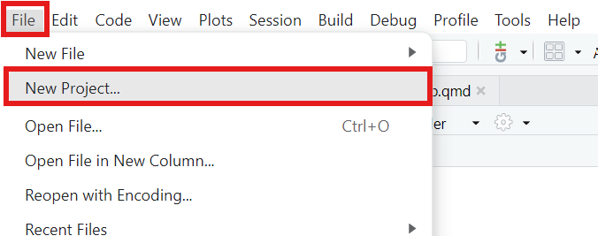

Create New project

1. **Choose Existing Directory**.

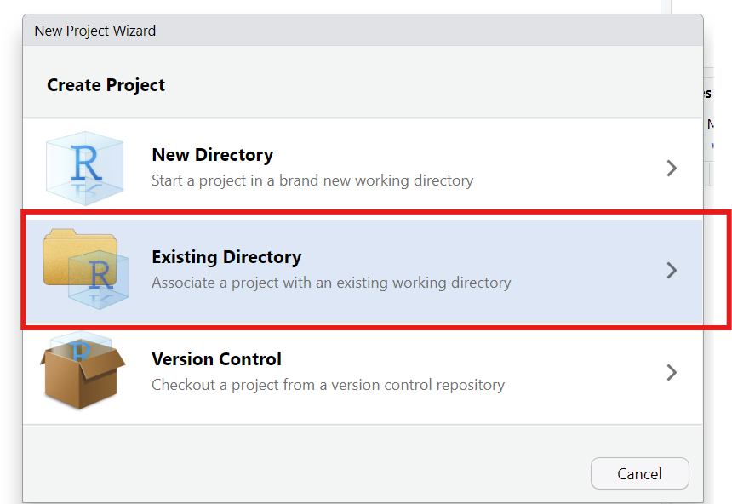

Existing Directory

1. **Create project at prefered directory**
   * Click Browse and select your project directory
   * Then click Create project

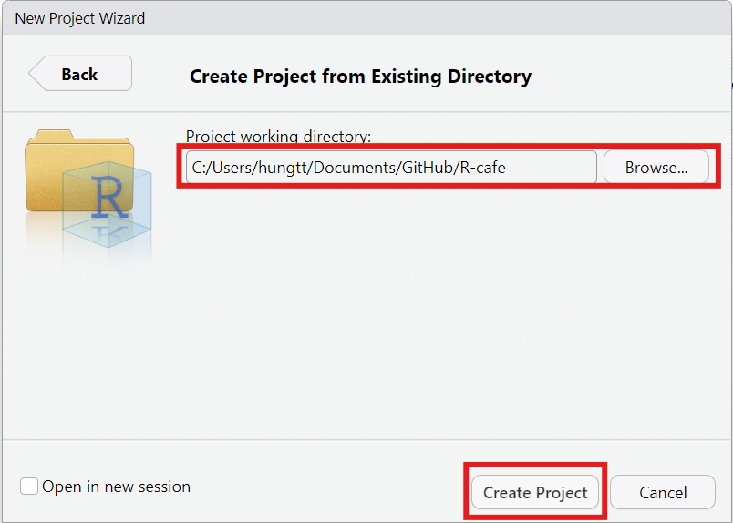

Select the directory

1. **Check your Rproject**
   * Your Rproject will be at your directory

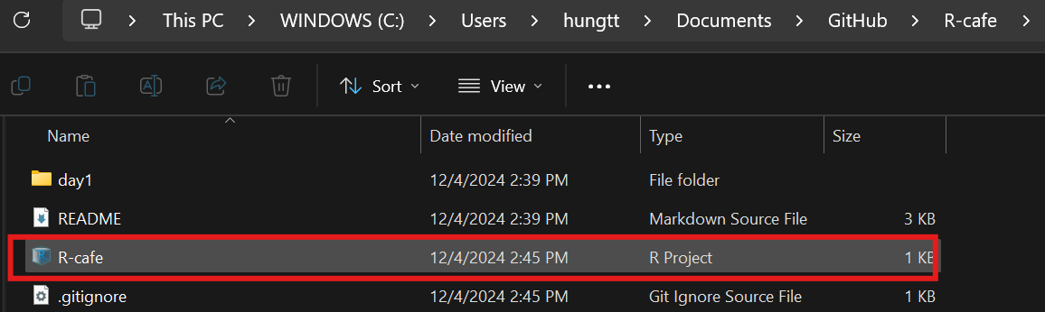

Rproject