1. **Scenario: B.3.14.0600.100 Save and Stay  
   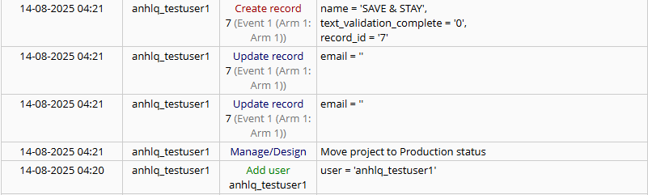**
2. **Scenario: B.3.14.0600.200 Save & Go To Next Form  
   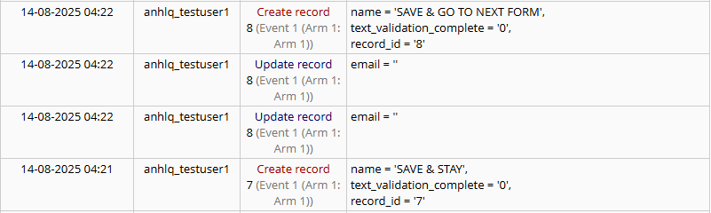**
3. **Scenario: B.3.14.0600.300 Save & Mark as Complete  
   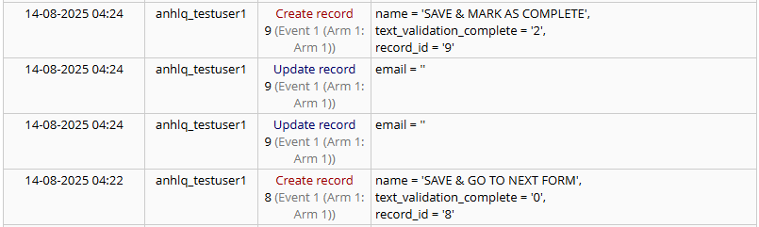**
4. **Scenario: B.3.14.0600.400 Save & Exit Form  
   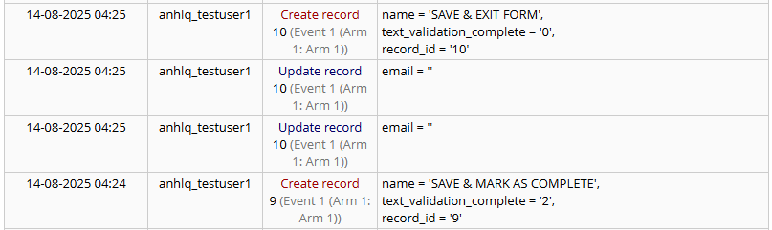**
5. **Scenario: B.3.14.0600.500 Save & Exit Record  
   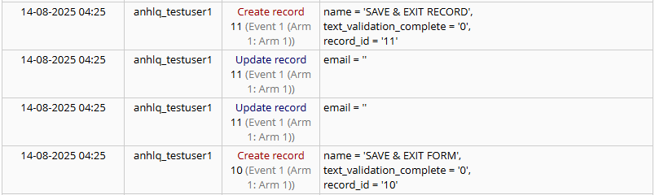**
6. **Scenario: B.3.14.0600.600 Save & Go To Next Record  
   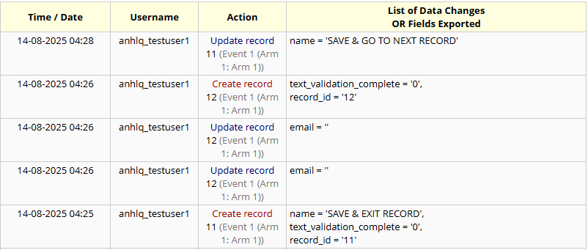**
7. **Scenario: B.3.14.0600.700 Cancel  
   