1. **Scenario: B.3.16.0100.100 data import template**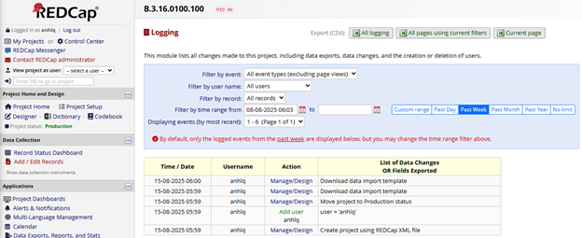[*B3160100100_ImportTemplate_2025-08-15.csv*](https://oucruaap-my.sharepoint.com/:x:/g/personal/lichbt_oucru_org/EWLmNeYfkvtBtnPtP57Pf9QBetNcbxr9_VboqCHvtrjvYw?e=Jp8nJ0)

[*B3160100100_ImportTemplate_Column_2025-08-15.csv*](https://oucruaap-my.sharepoint.com/:x:/g/personal/lichbt_oucru_org/EVriw5FIqyhIjWtg3g4cWMsB4EAejzu1hCc6KyOyz0mbtQ?e=8W3dfK)