1. **Scenario: B.3.16.0700.100 Import requires the event name**- Import failed with B316700100_DATA_INACCURATE.csv 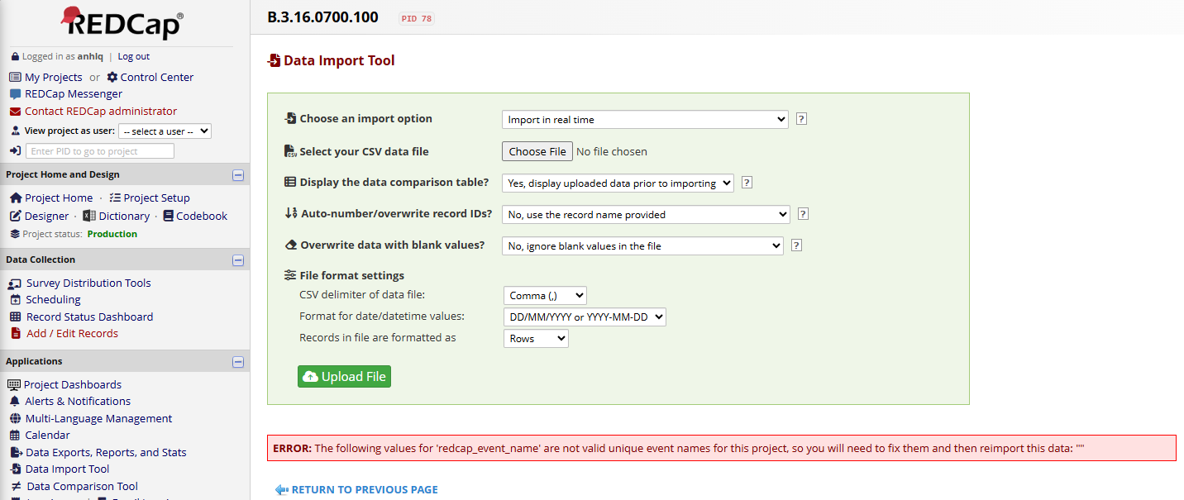  
   - Import successfully with B316700100_DATA_ACCURATE.csv  
   