1. **Scenario: B.3.16.0800.100 Import requires the repeating instrument and instance number**- Import Failed with B316800100_W_REPEATS.csv 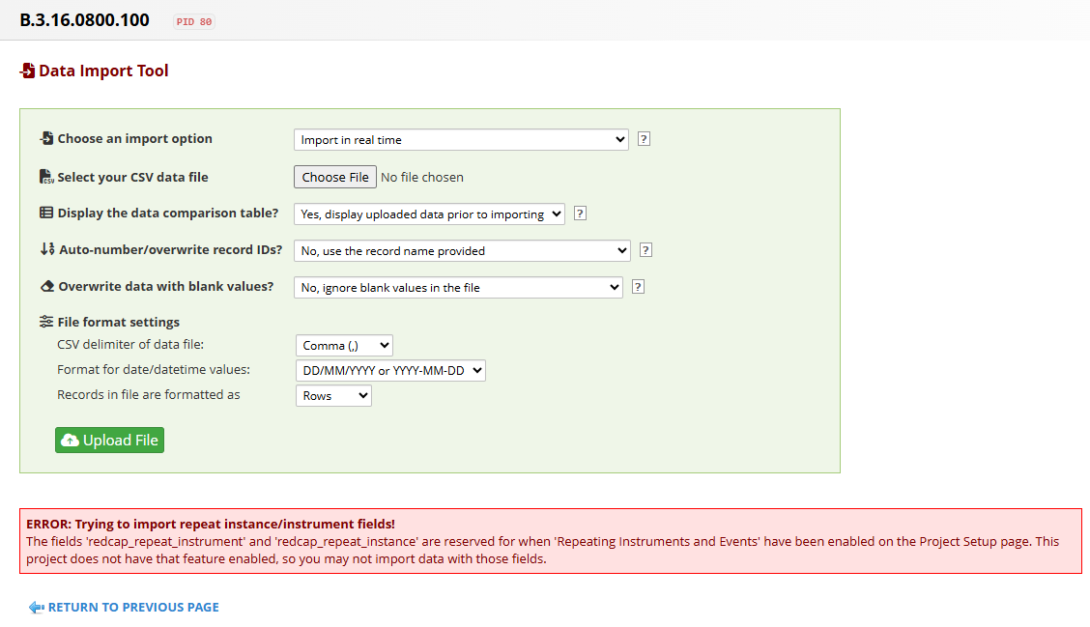  
   - Import failed with B316800100_WOUT_REPEATS.csv  
   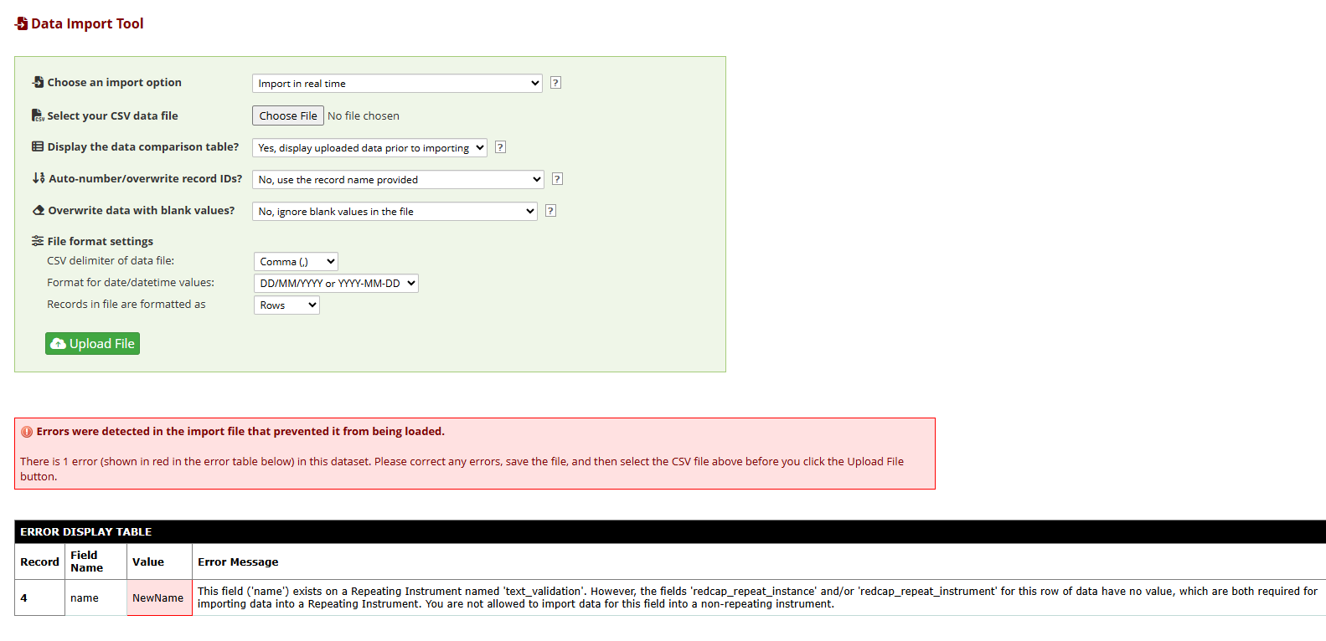  
   - Import successfully with B316800100_W_REPEATS.csv 