1. **Scenario: B.3.16.1400.100 Background Data Import  
   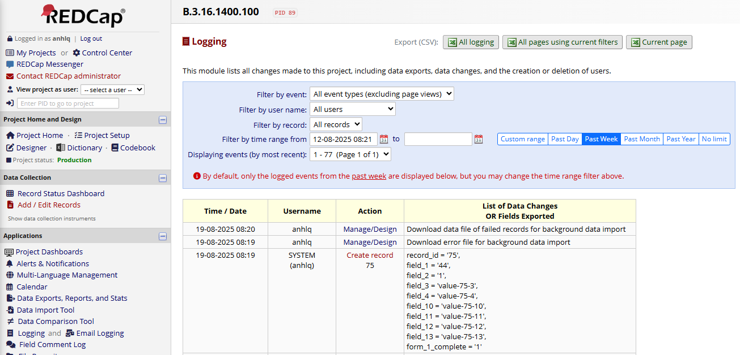**

[DataImport1_PID89_20250819_081712.csv](https://oucruaap-my.sharepoint.com/:x:/g/personal/lichbt_oucru_org/EXxnaT_MSVlJog2fS-dRYHABh0qlAi-dhBtqKs7JLOGWSw?e=TaroFf)

[DataImportErrors1_PID89_20250819_081712.csv](https://oucruaap-my.sharepoint.com/:x:/g/personal/lichbt_oucru_org/EQVuNvcCEthHj09VCxCQED8BUPRJXRCNl-UkPbPK_HMRww?e=hsTmSP)