1. **Scenario: B.3.32.0200.100: Bulk Delete Records Using Custom List  
   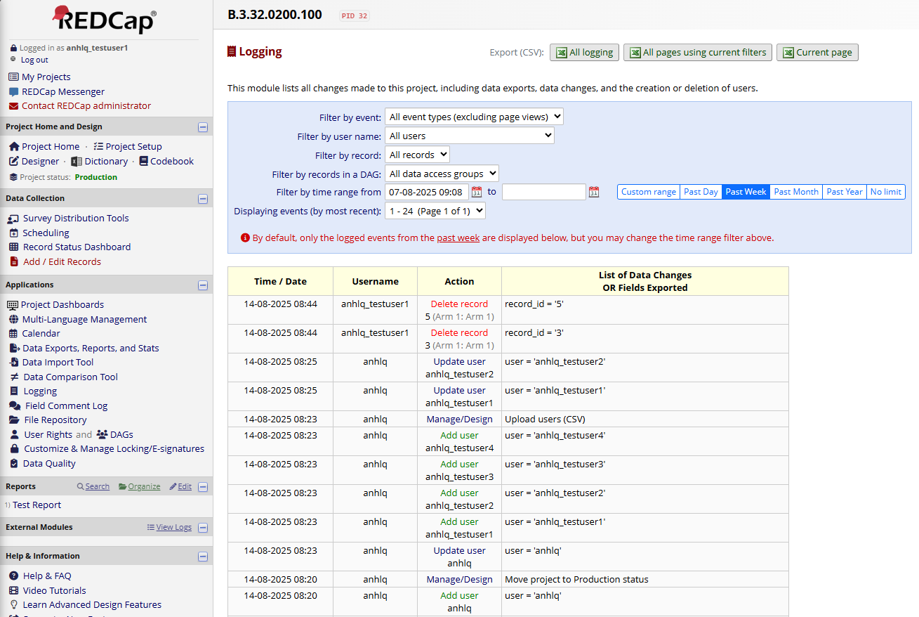**
2. **Scenario: B.3.32.0200.200: Bulk Delete Records Using Select Records from List  
   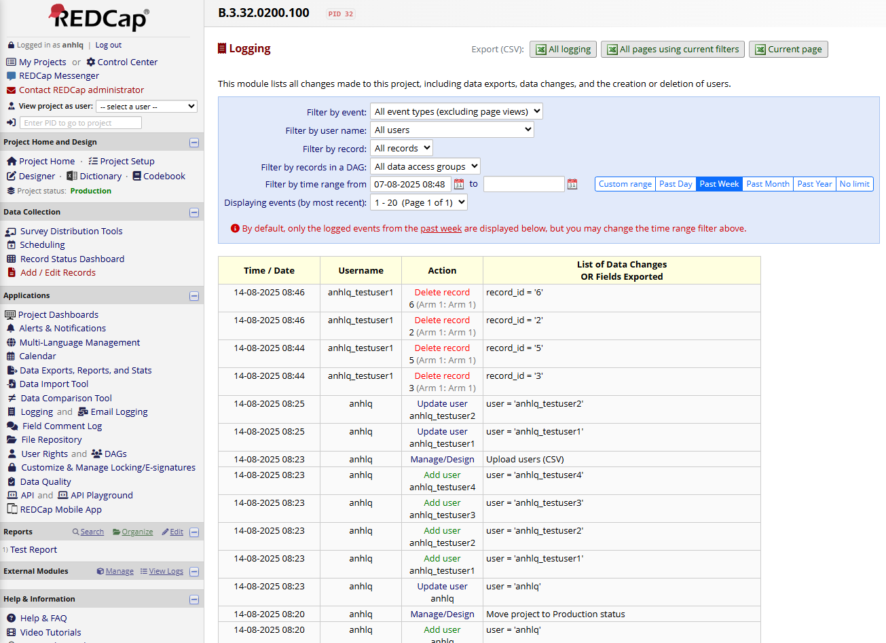**
3. **Scenario: B.3.32.0200.300: Bulk Delete Partial Records Using Custom List  
   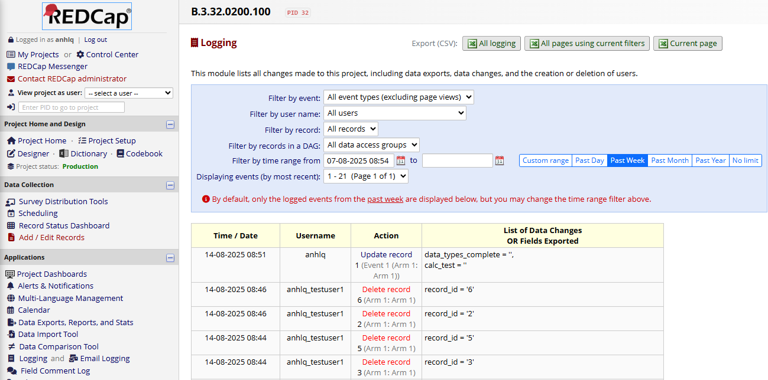**
4. **Scenario: B.3.32.0200.400: Bulk Delete Partial Records Using Select Records from List  
   