**A.3.30.0100. - Randomization system enable**

**#A.3.30.0100.0100: Enabled at system level allows randomization module option at the project level.**

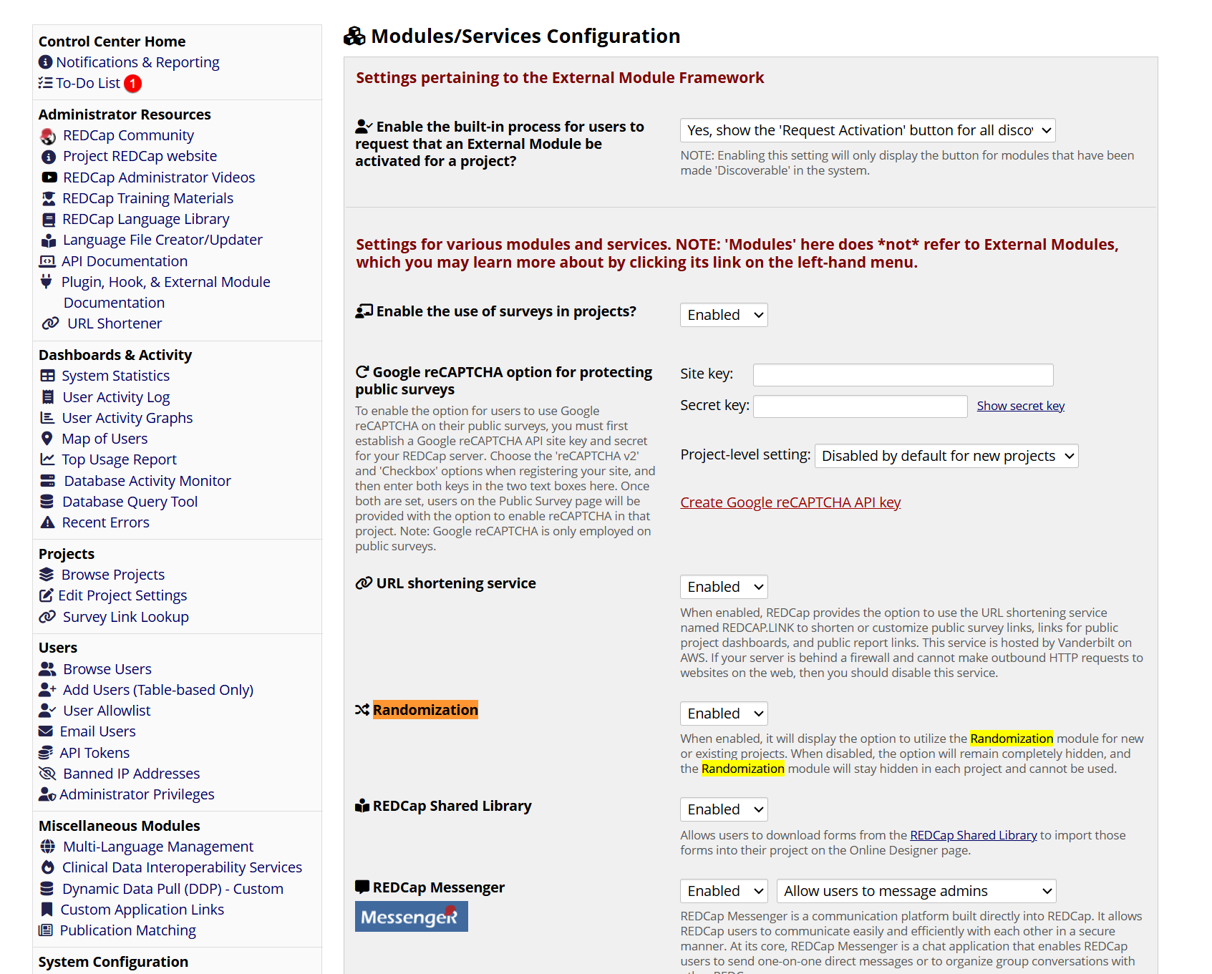

**Scenario: A.3.30.0100.0200. Disable randomization at system level**

