**C.3.26.0300. User Interface: The system shall support the storage, organization, and sharing of project files for permanent folders: (Data Export | e-Consent PDFs | Recycle Bin | Custom Create folder / Sub-folder)**

**C.3.26.300.100 Automatic uploading of data export logs into the data export folder**

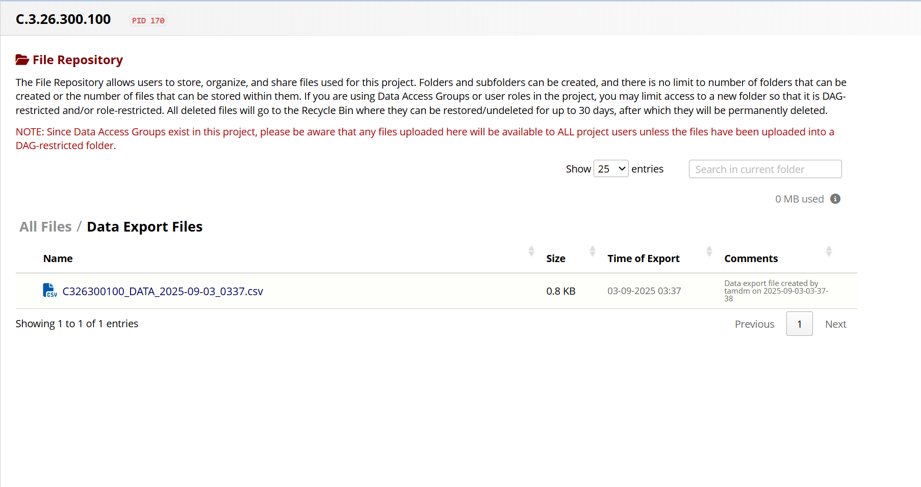

**Scenario: C.3.26.300.300 Recycle bin function - permanently force delete**

