**C.3.30.0200. - Randomization project enable**

**C.3.30.0200.0100. Enabling adds randomization module to project setup + C.3.30.0200.0200. Enabling adds randomization module to application box + Scenario: C.3.30.0200.0400. Disabling removes randomization module from project setup**

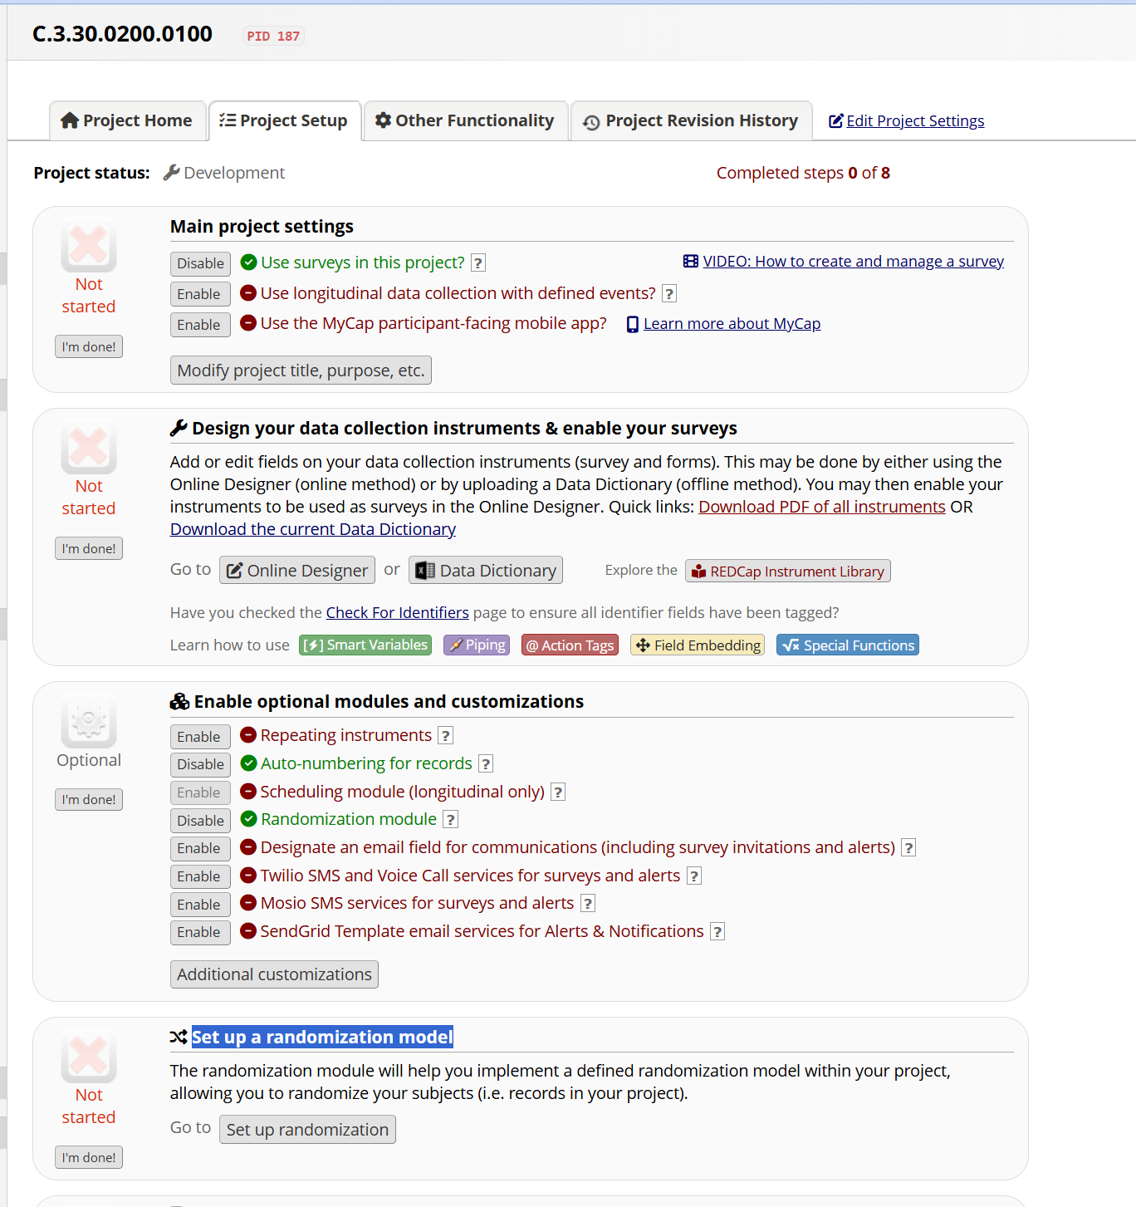

**C.3.30.0200.0300. Enabling adds randomization module options Setup, Dashboard, and Randomize to user rights privilege setup page.**

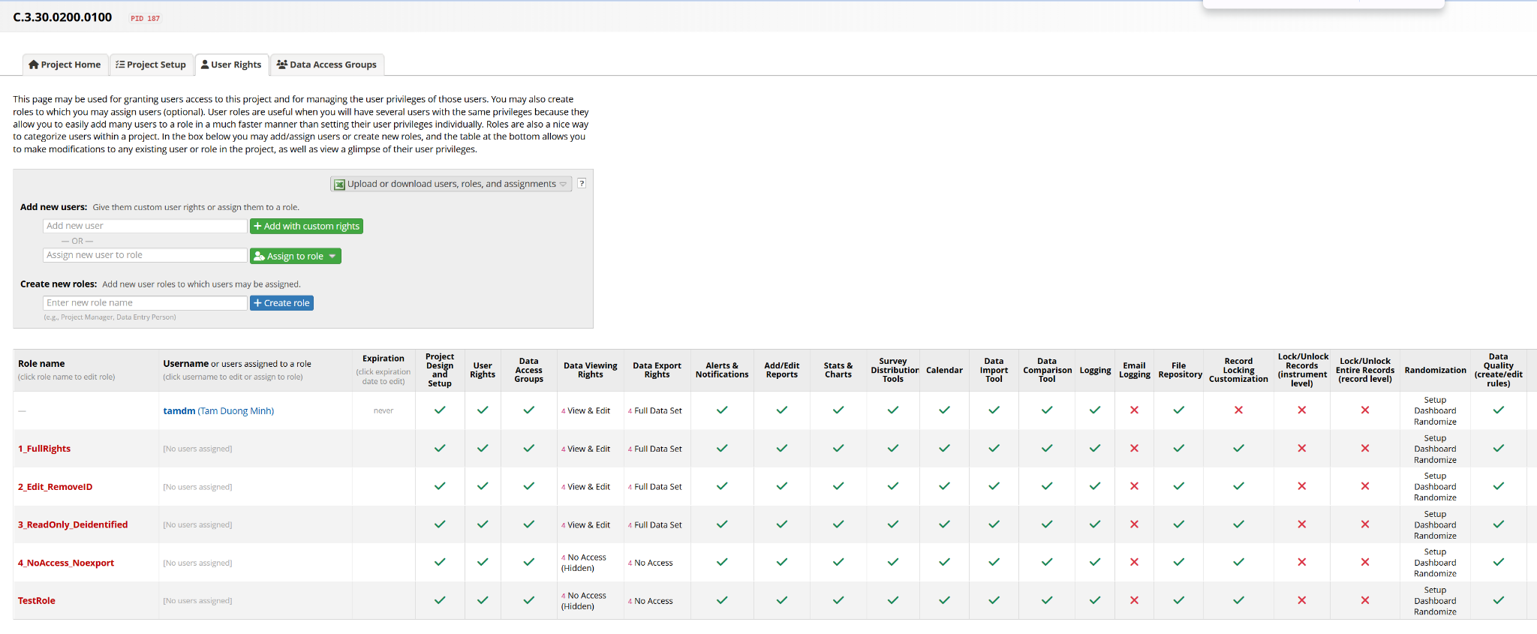

**C.3.30.0300.0100. User with Randomization Setup rights can use Randomization Module Setup Configuration page.**

**C.3.30.0400.0100. User with Randomization Dashboard rights can use Randomization Module Dashboard page.**

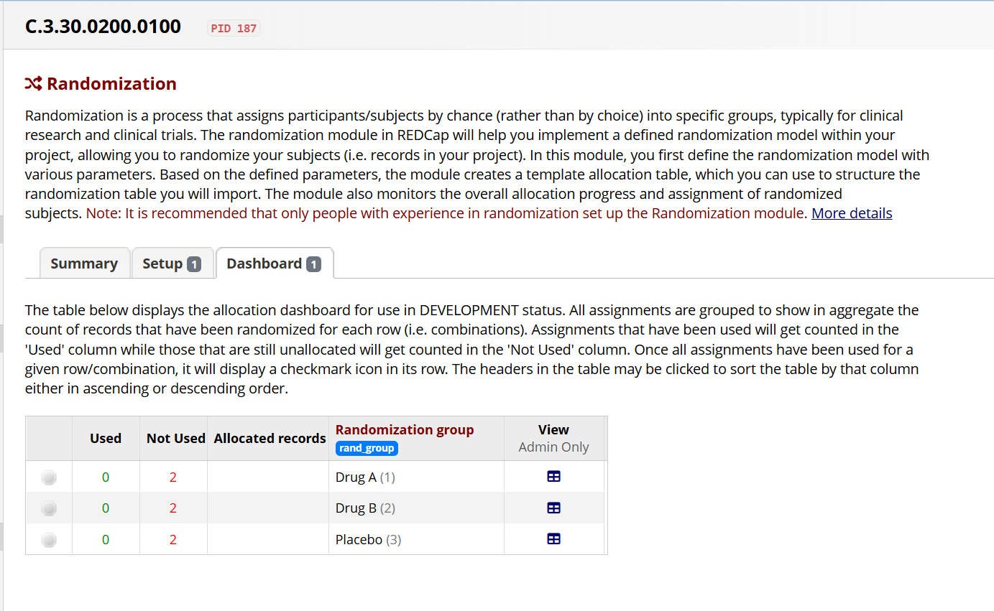

**Scenario: Disable Randomization Dashboard**

**#C.3.30.0200.0600. Disabling removes randomization module options Setup, Dashboard, and Randomize to user rights privilege setup page.**

**#C.3.30.0400.0200. User without Randomization Dashboard rights cannot use Randomization Module Dashboard page.**

