**C.3.30.0500. - Randomization rights randomize**

**Scenario: C.3.30.0500.0100. User with Randomization Randomize rights can Randomize.**

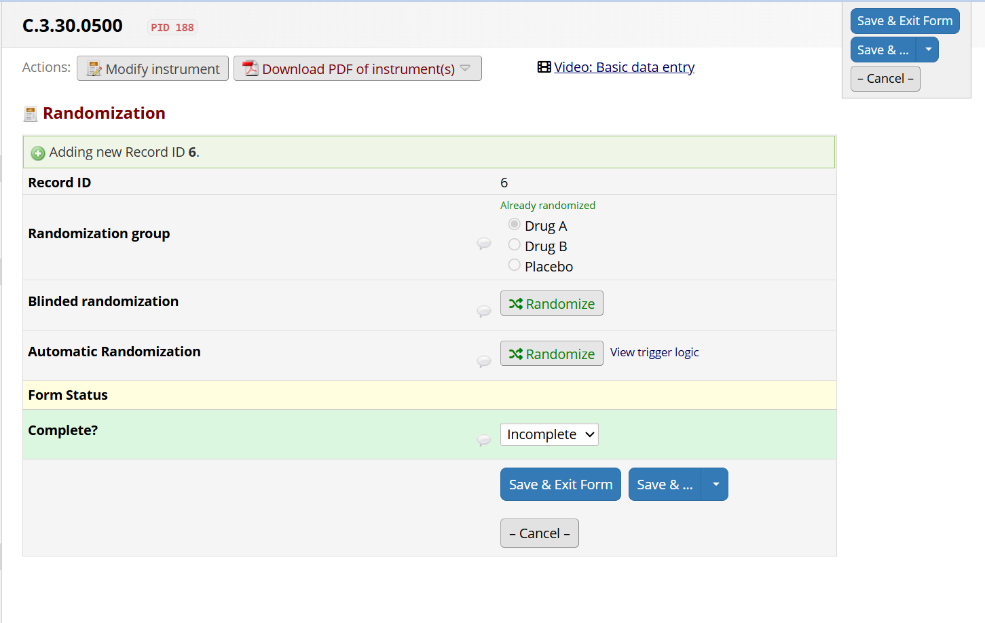

**Scenario: C.3.30.0500.0200. User without Randomization Randomize rights cannot Randomize.**

