Scenario: #FUNCTIONAL_REQUIREMENT C.3.30.0600.0100. Users within a DAG can randomize records only within their assigned DAG, ensuring they cannot view or randomize records outside their group.

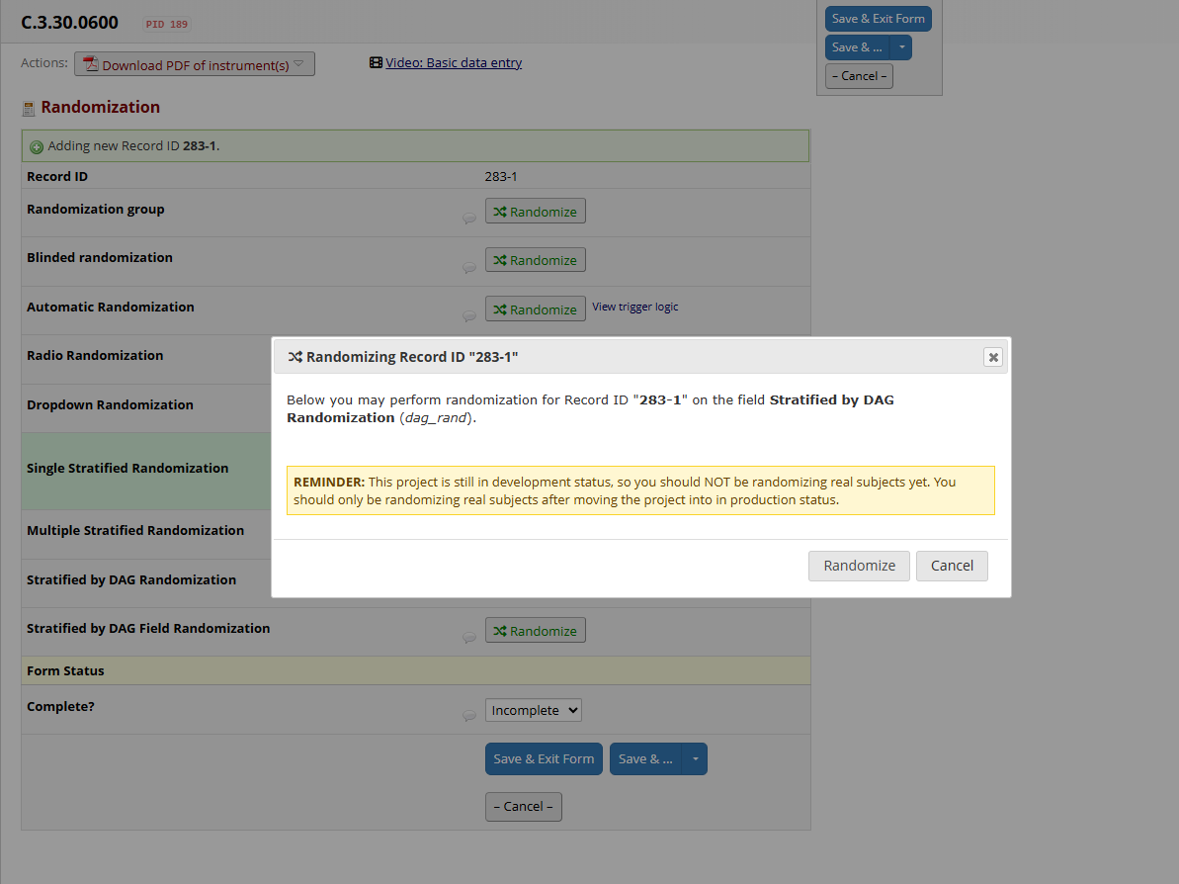

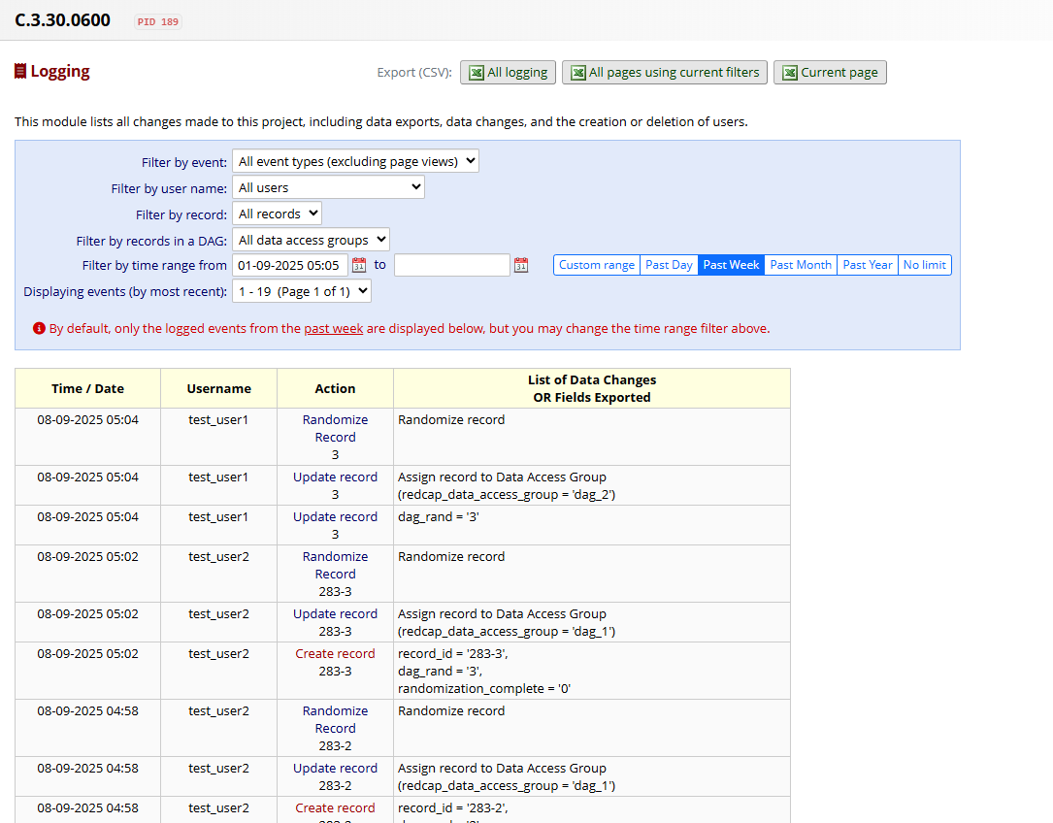

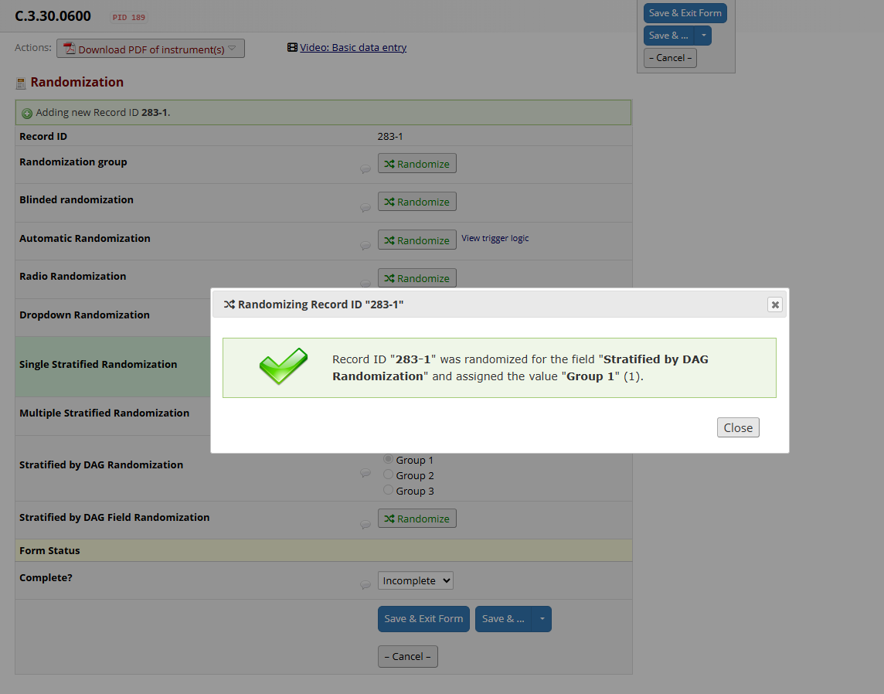

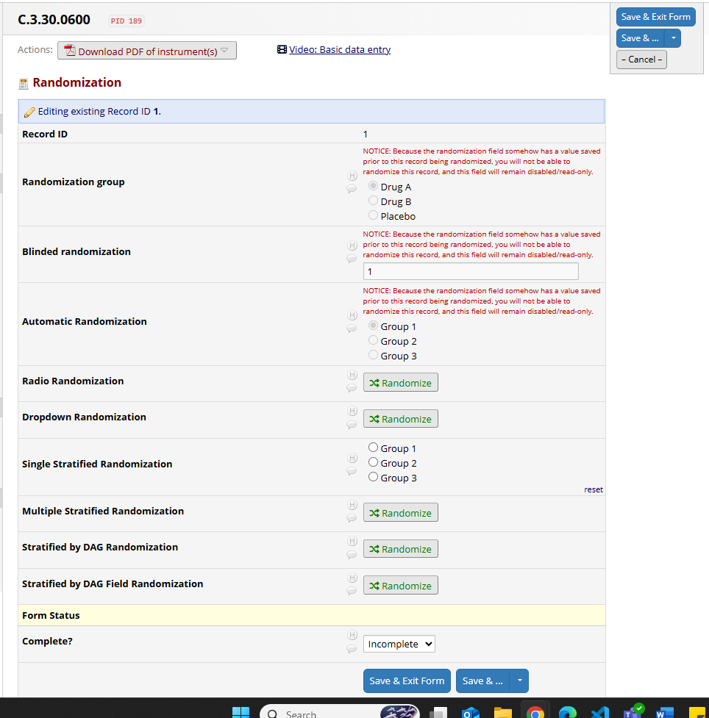

Scenario: #FUNCTIONAL_REQUIREMENT C.3.30.0600.0200: The randomization model shall support stratification by DAG, allowing independent randomization assignments within each DAG.