# A.2.2.0100.100 System-level User Settings Create Users

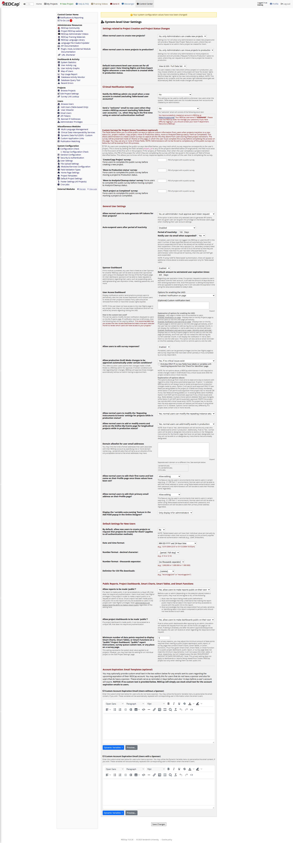



# A.2.2.0100.200 Create a Table-based user

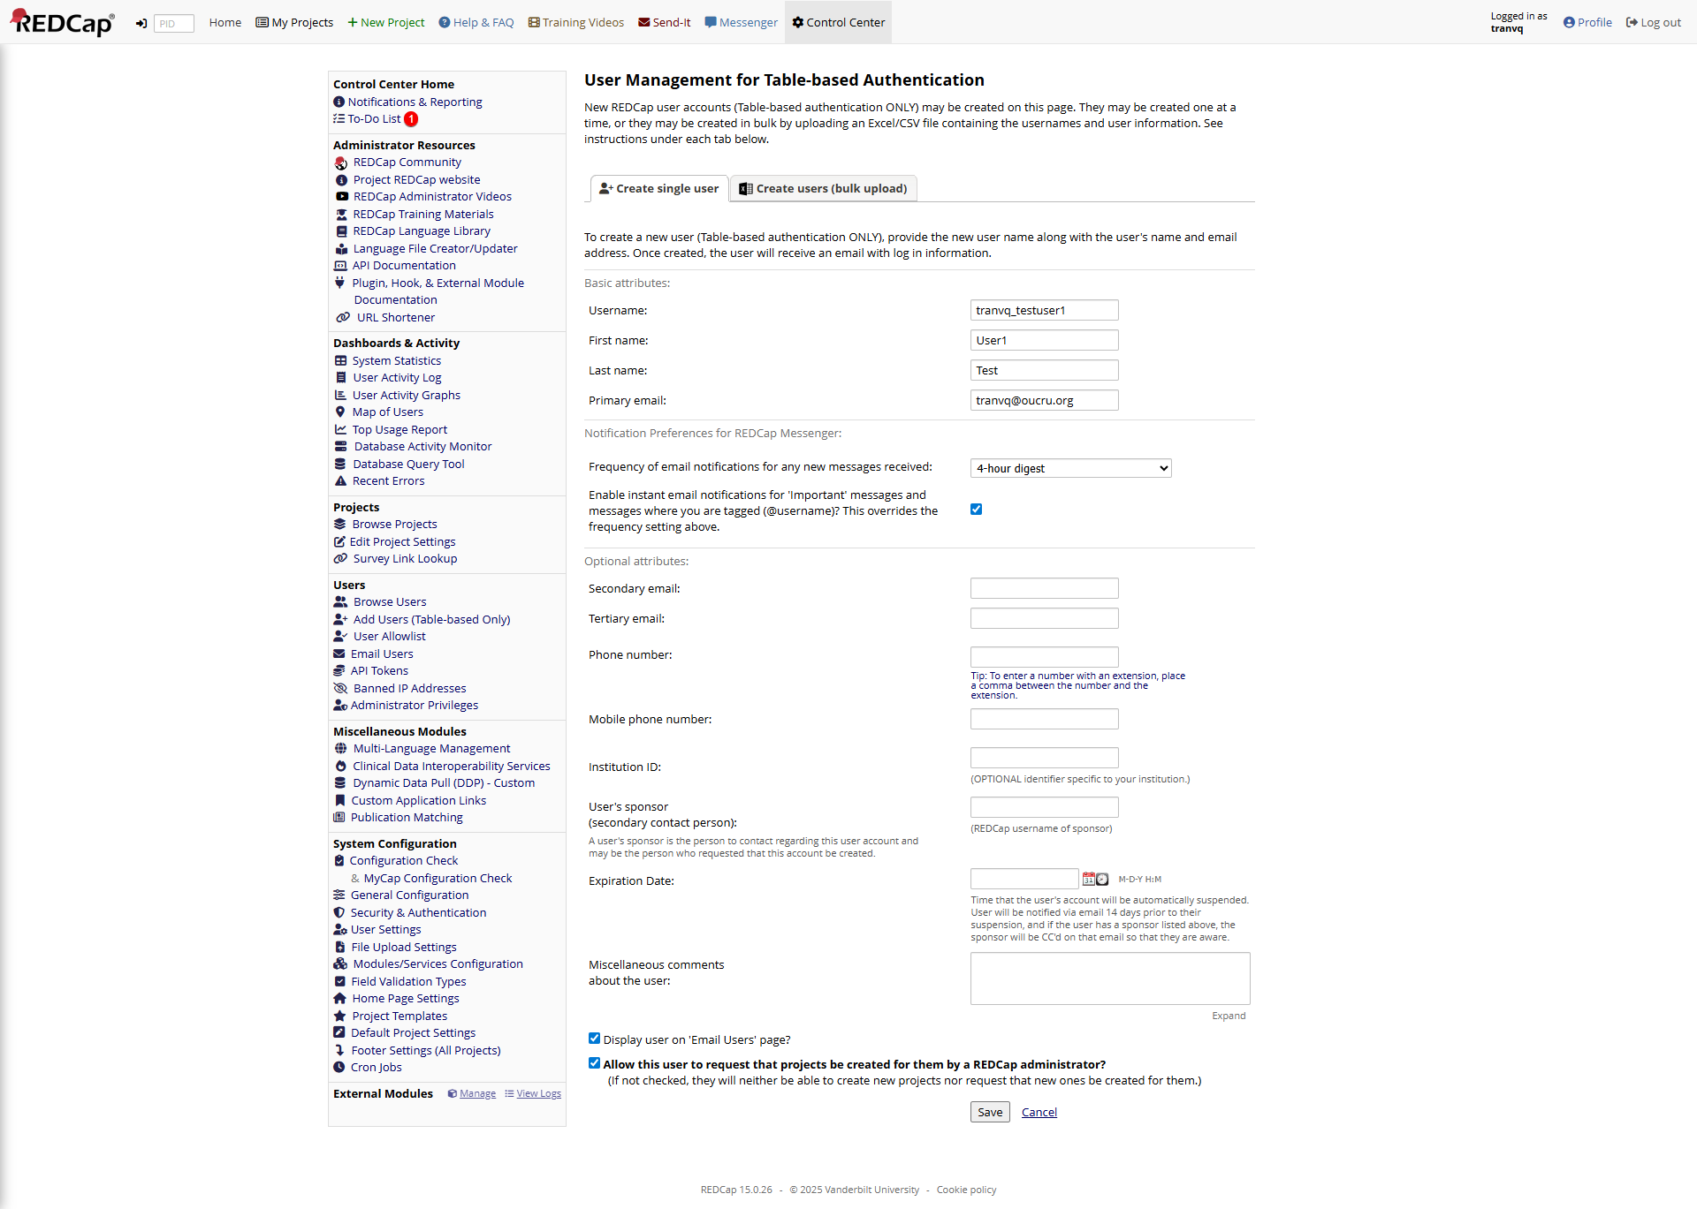

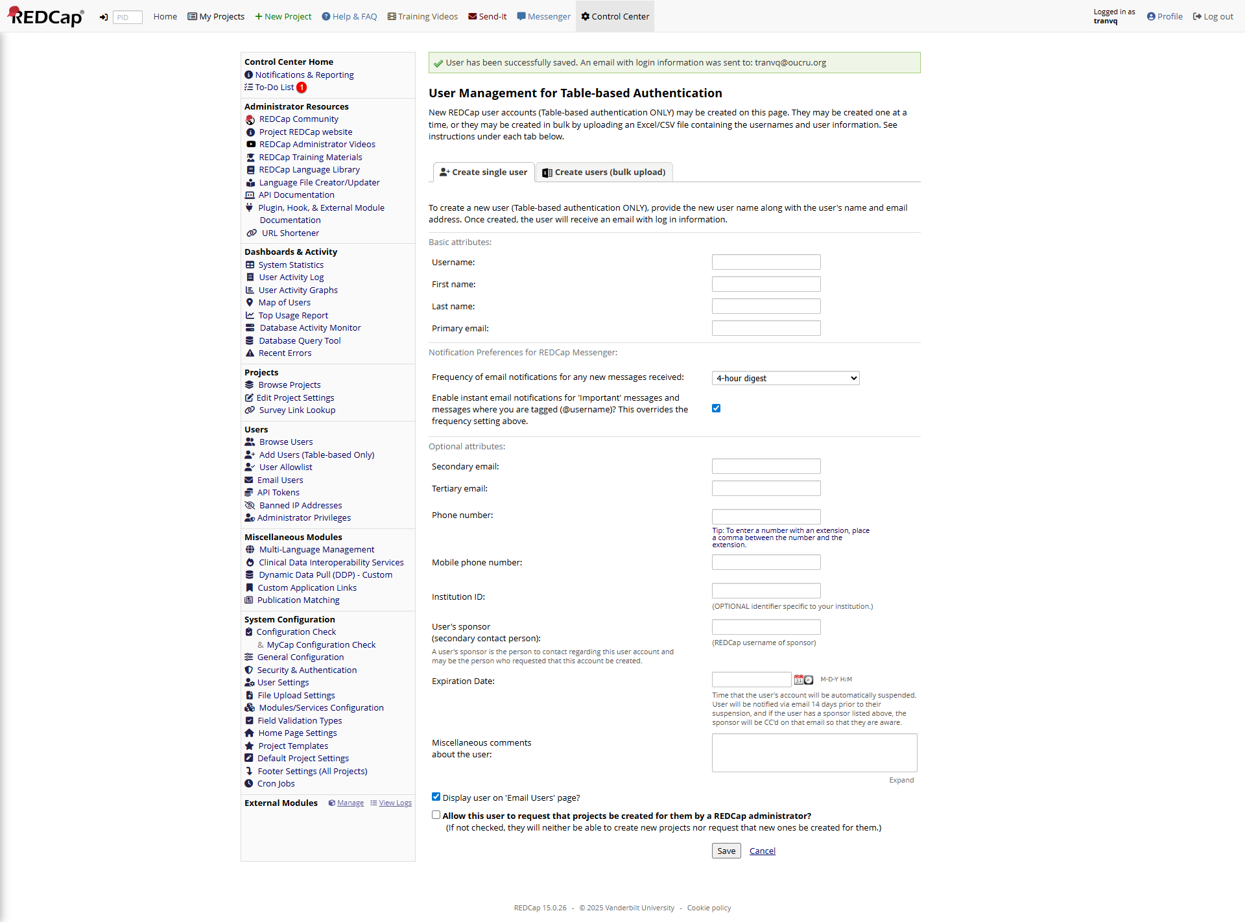

# A.2.2.0100.300 Create Table-based users via bulk upload

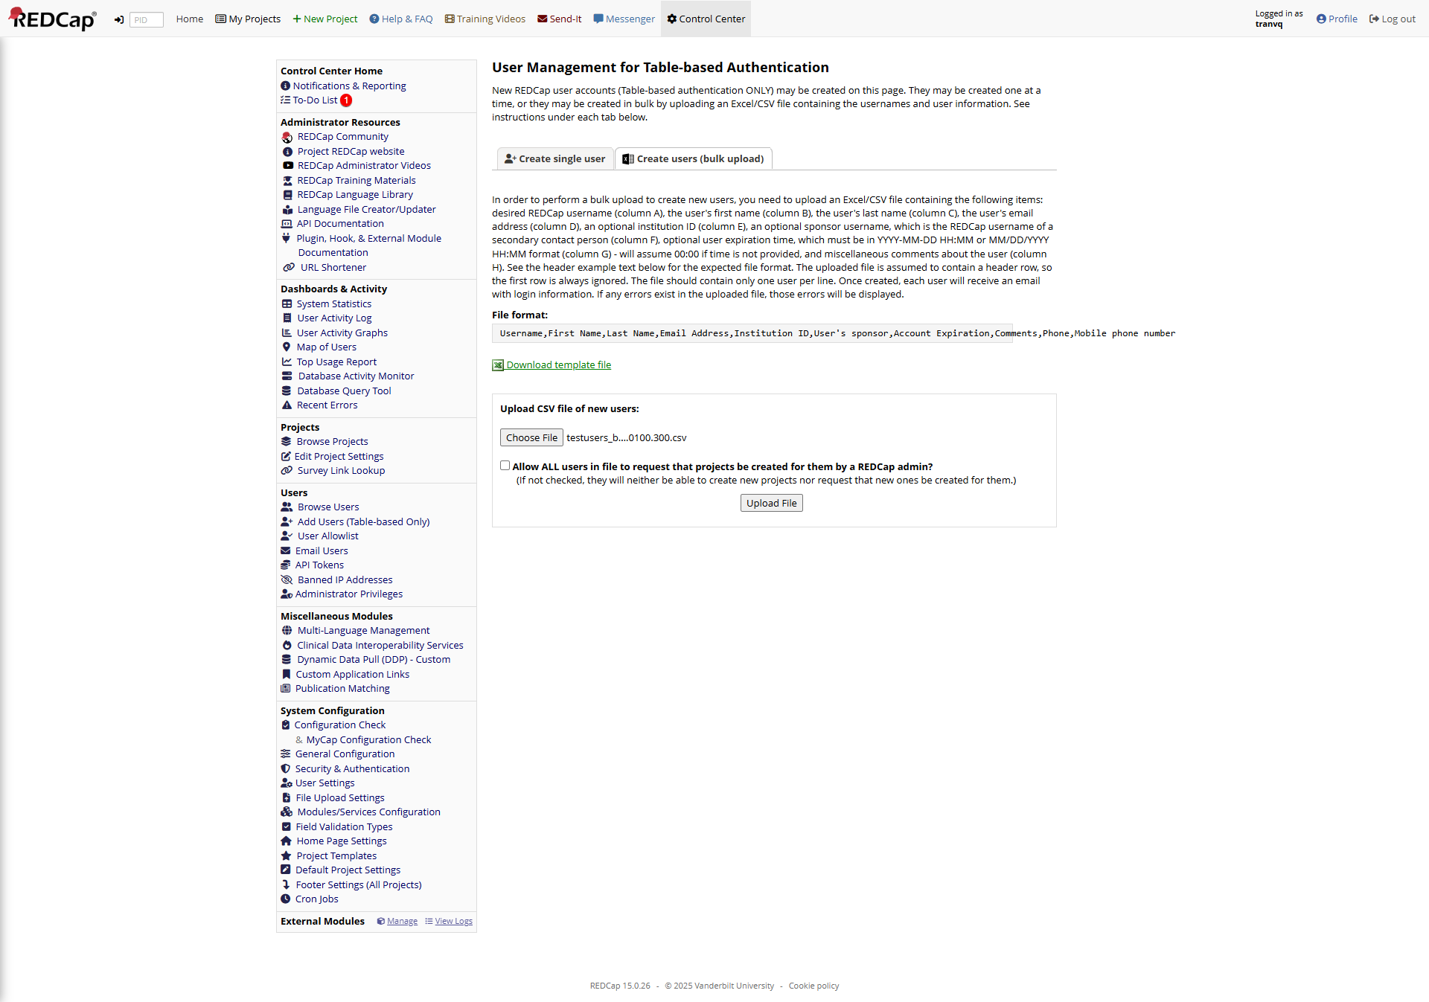

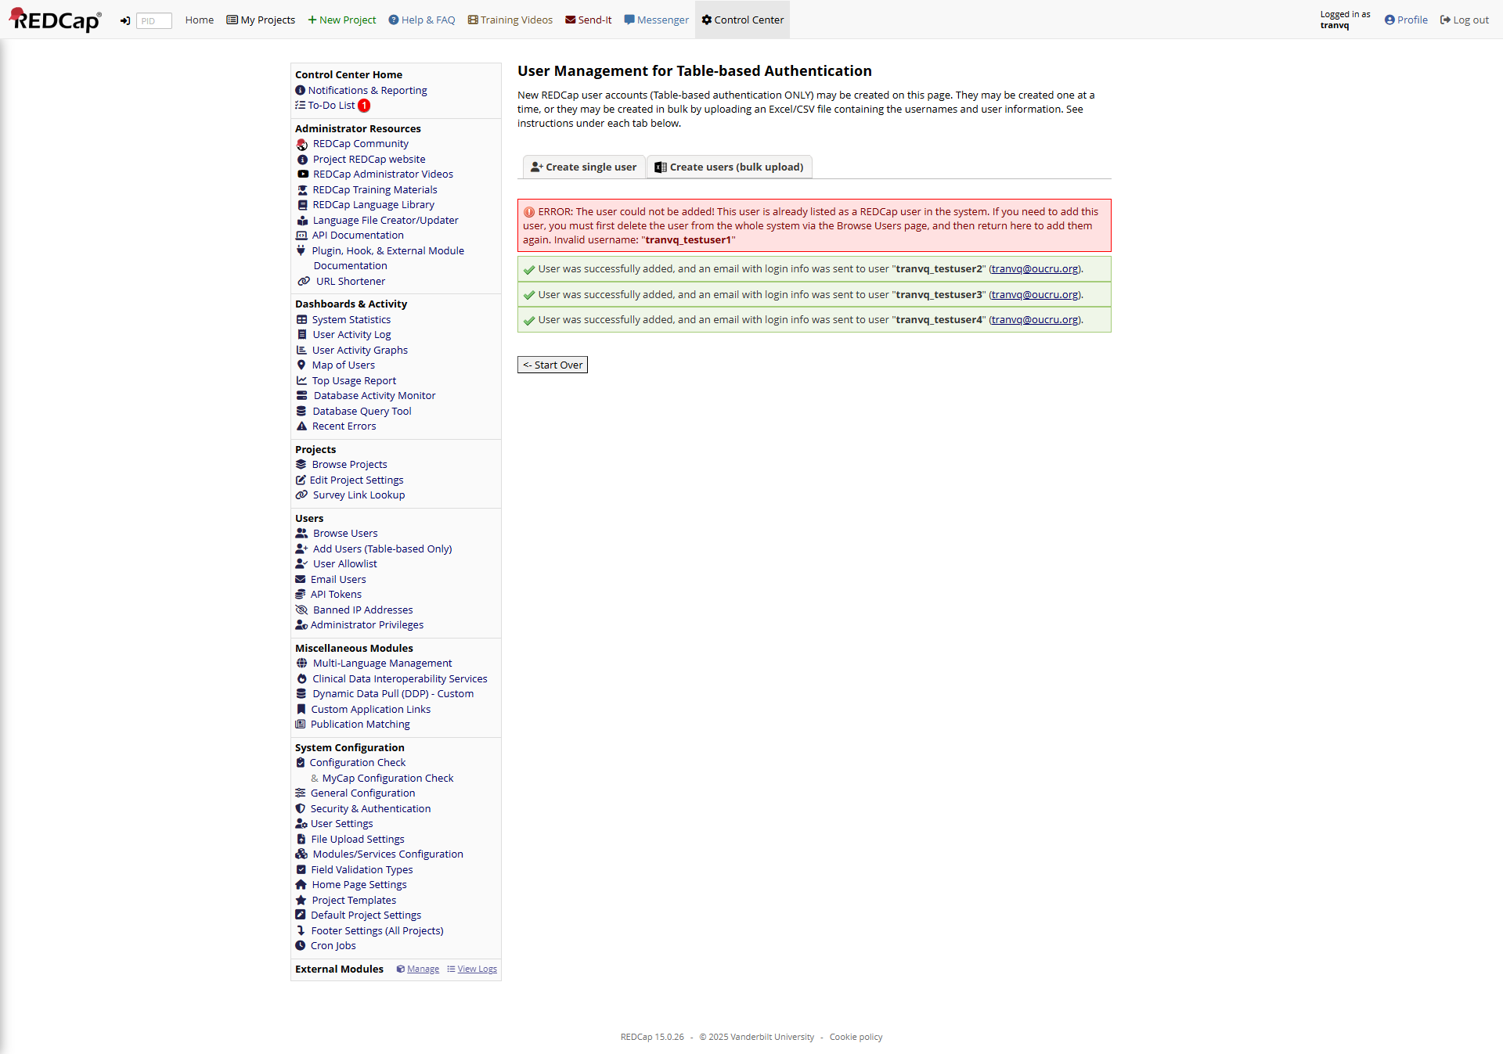

# A.2.2.0100.400 Prevent a Second User with the Same Username

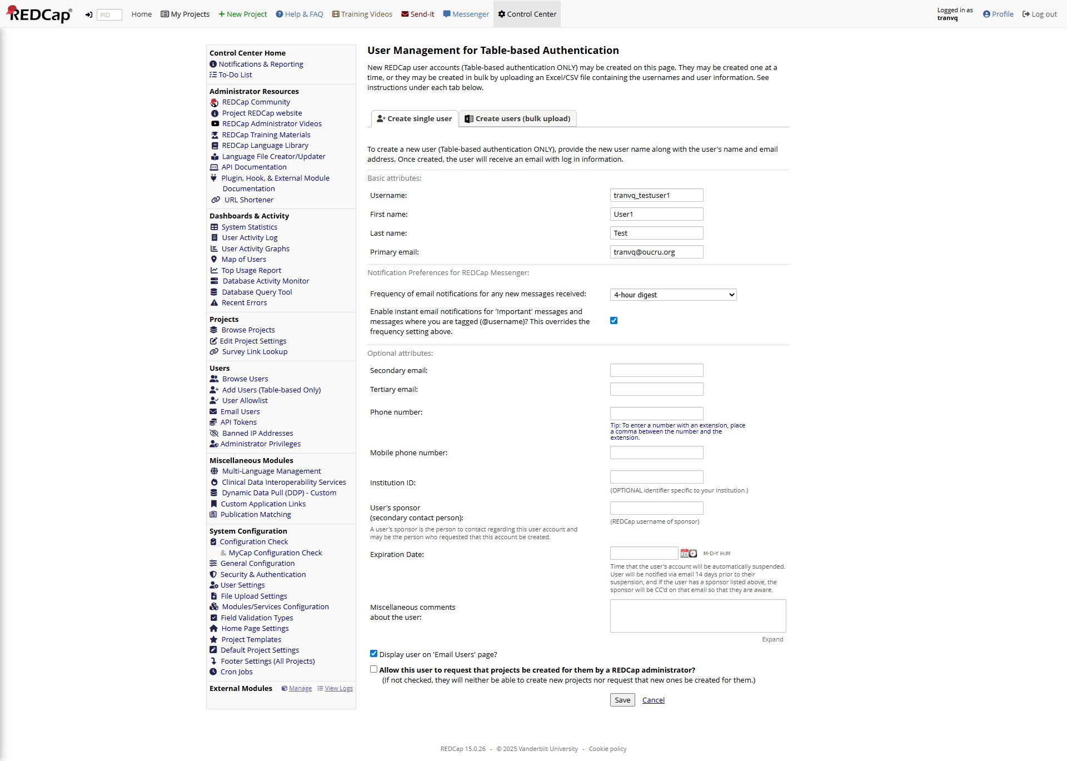

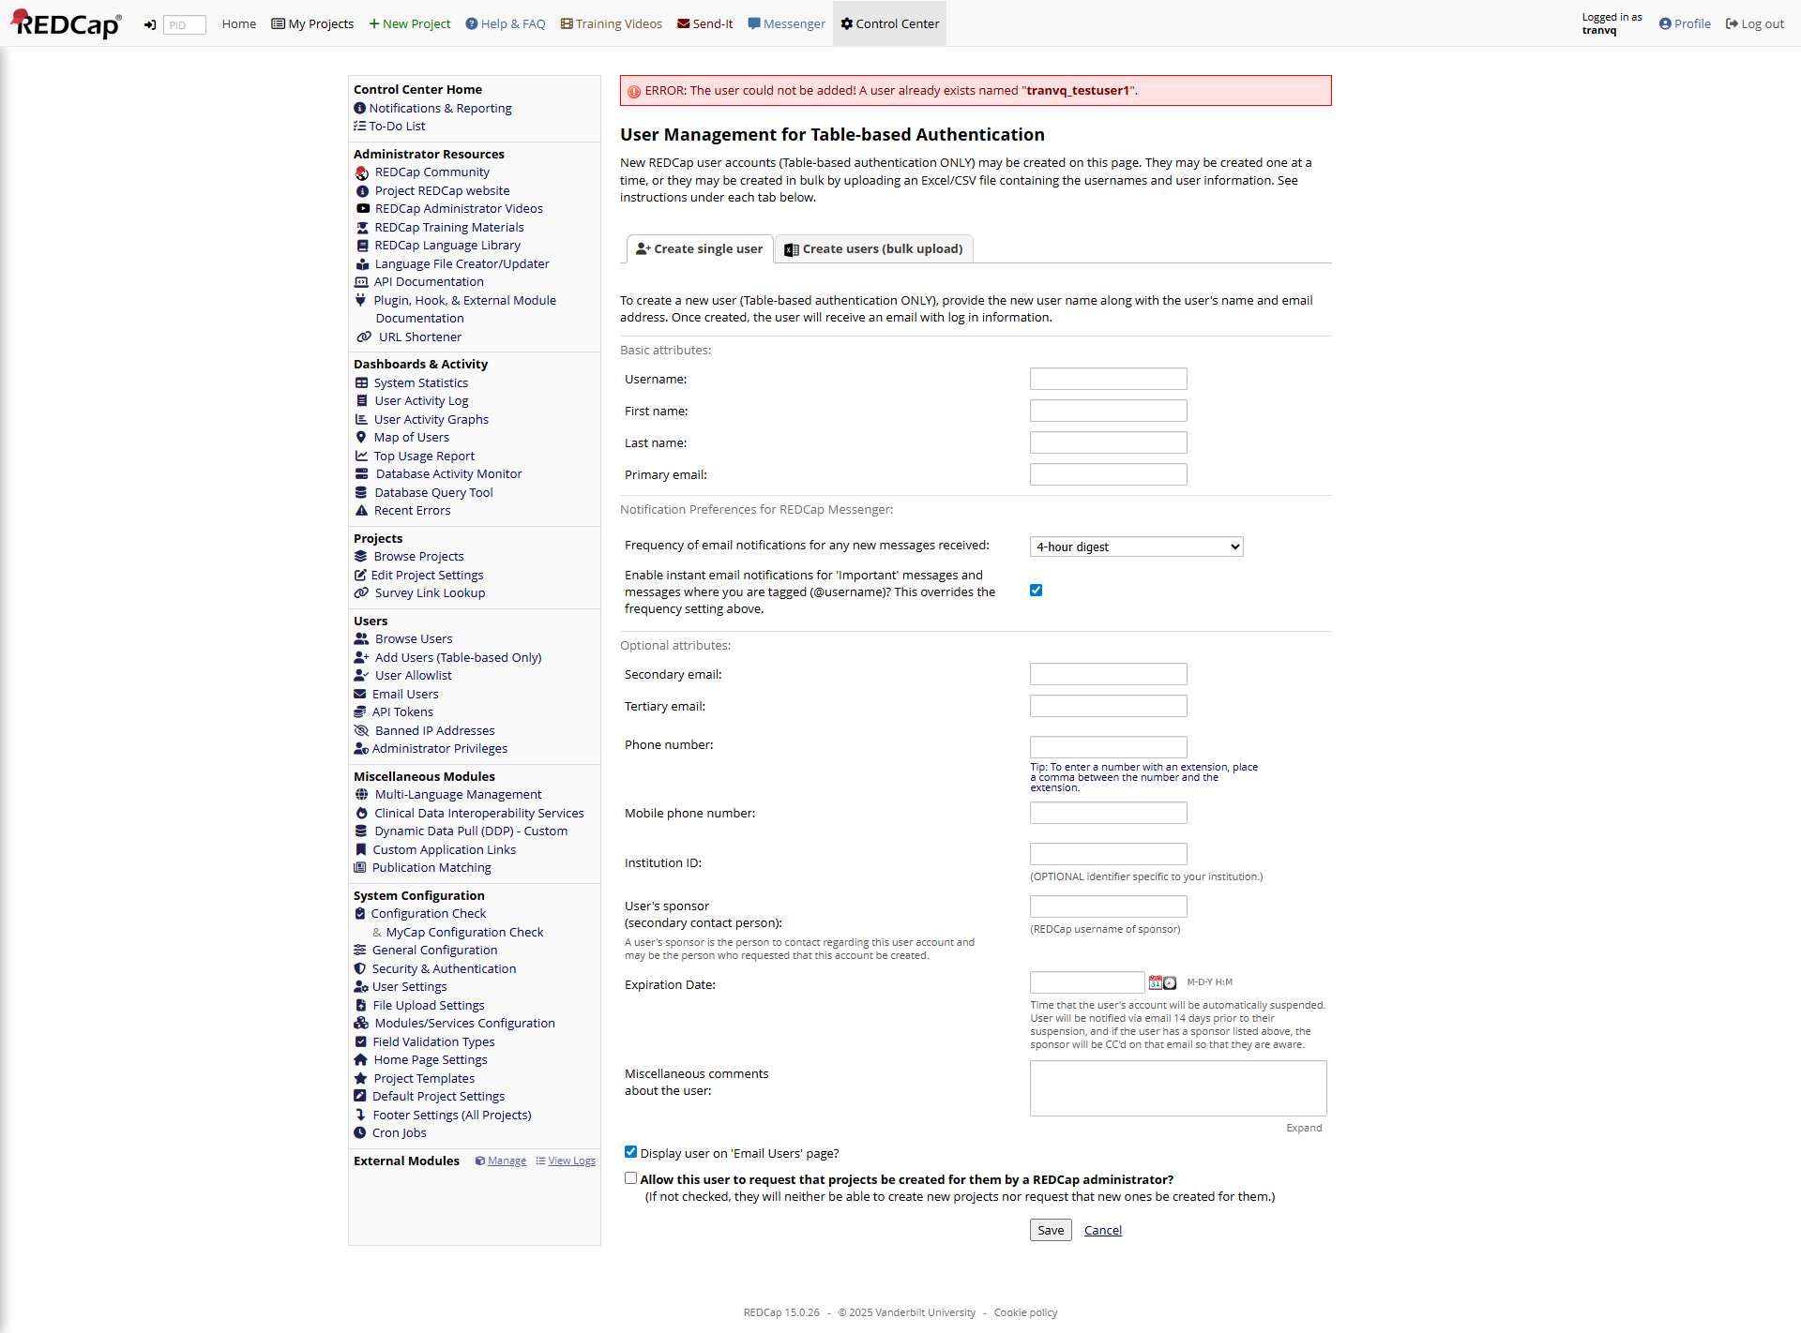

# A.2.2.0100.500 Search a Table-based user

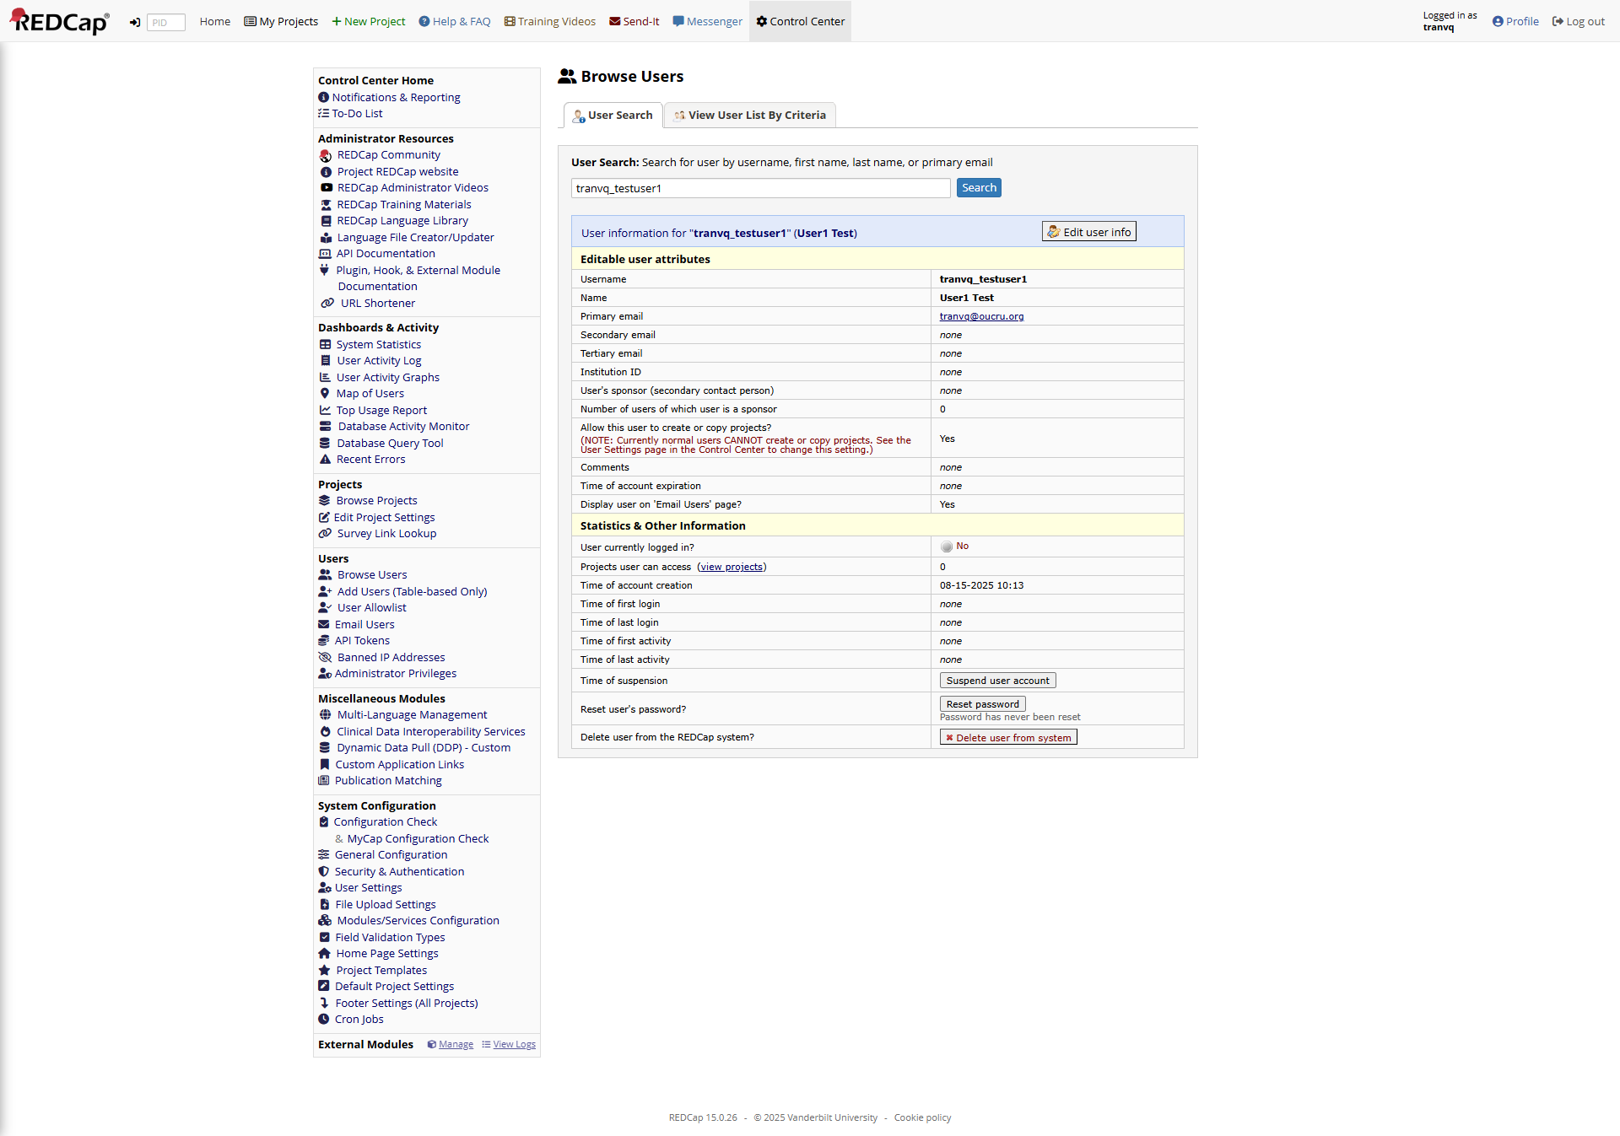

# A.2.2.0100.600 User has no control center access

