**一个之前AffairServlet里的例子:**

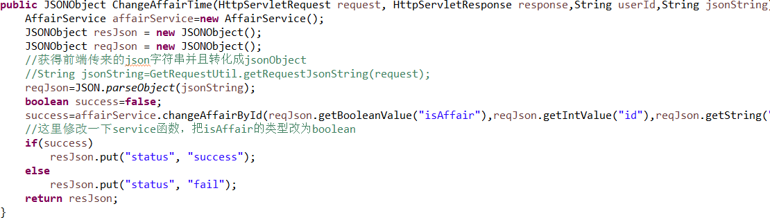

**需要写的SheetServlet中函数：**

1. 获取日报表基本信息（饼状图）

**public** JSONObject GetDailySheet (HttpServletRequest request, HttpServletResponse response,String userId,String jsonString)**throws** ServletException, IOException{}

1. 获取周报表信息饼状图

**public** JSONObject GetWeeklySheet (HttpServletRequest request, HttpServletResponse response,String userId,String jsonString)**throws** ServletException, IOException{}

1. 获取周报表折线图
2. **public** JSONObject GetWeeklyChange (HttpServletRequest request, HttpServletResponse response,String userId,String jsonString)**throws** ServletException, IOException{}