Information

Name: Wong Tik San (OUID: 11181021)

Team: dot

Project: Dominion of City: Real Time Strategy Location-based Mobile Game

Supervisor: Li Tak Sing

Declaration

I, Wong Tik San (OUID: 11181021), certify that the work is original and I have utilized guidance of our supervisor in completing this project, and that the content which is not our own has been attributed and referenced properly. There should be no copyrighted content without permission to use. There should be no confidential data.

______________________________________

Signature and Date

Task

I am responsible for development of *Satellite Hack*, the augmented reality mini game in the project. Later on I will work on game creation and participation, and chat room at the same time. Lastly, Tim and I will cooperate to manage user accounts, including login and register functions.

*Satellite Hack* development is slower than expected (60% done) but not unsatisfactory. It is still supposed to be on time. Game creation development will begin as scheduled in later February.

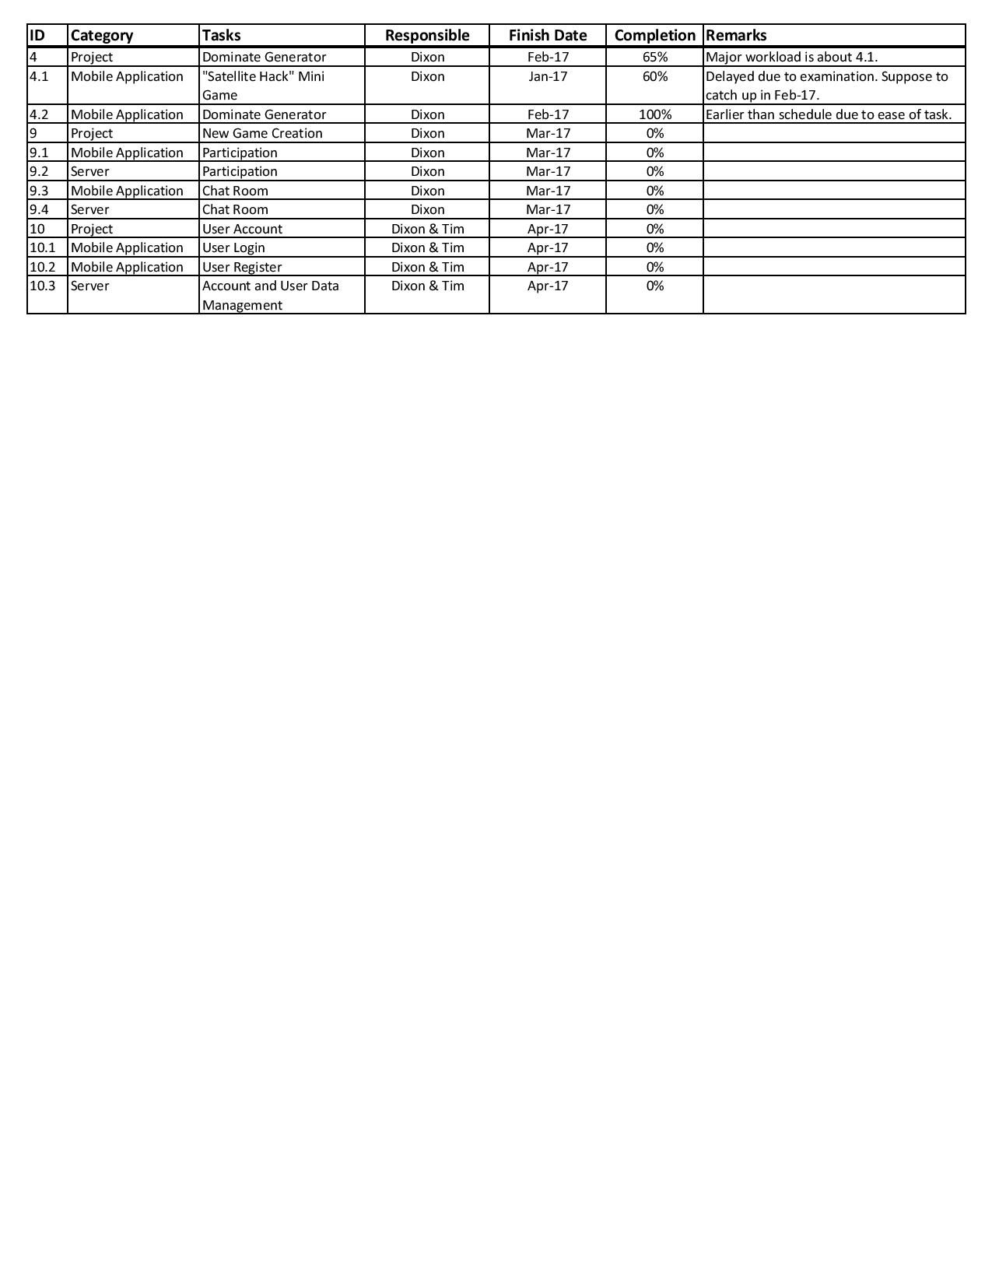

Key Success and Failure

We was developing a mini game that highly relied on augmented reality. We then discussed the game background and developed another idea of the mini game related to that. However, the mini game is not applying high-level vision-based augmented reality technology. It is my key failure that decrease the interaction between reality and the game. Besides, the time studying AR development tools is wasted.

In contrast, the project plan is clearer as the narrative is decided. The mini game is also considered less important than exploring the city. The lower technical requirement also shorten the development time.