Overview

To drive citizens to step out to the street and meet other people, this project will create a mobile game. The game, Dominion of City, is to occupy generators (real locations) in the city to gain points or form the bridge (BINGO of generator).

New Age had come when an intern in a TSP accidentally contacted the aliens who have much advanced technology and complicated culture. They developed interplanetary channels to share information, resources and even population. However, there are 2 major kinds of view on the development of the entire universe which form 2 camps. A war was brewing that nobody can stay away from. The intense argument of supporting each party happens everywhere on the Earth. When the war finally happened near Solar System, some people on the Earth tried to support the allies by occupying the energy generator to form the channel but it requires the effort of every one of us.

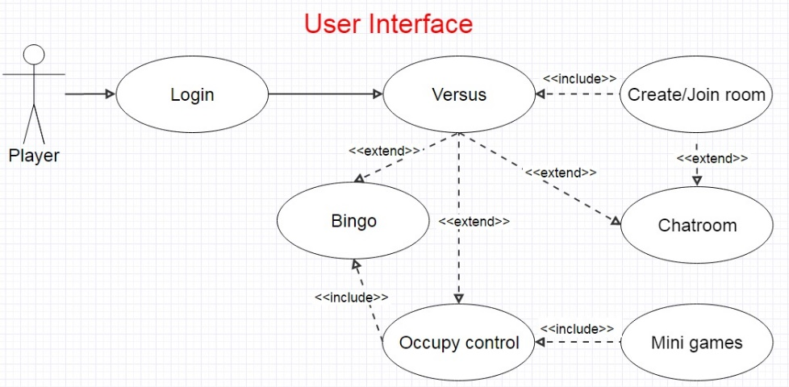Users have to create account and open a room for 2 teams of players to race against each other. After randomly create a bridge for the generators, players have to head to those places and occupy them by playing *Satellite Hack*, an augmented reality mini game that players move their smartphone until its camera points at the GPS satellite within time limit. The generators will increase scores for the team that occupy them. When the time is up or one of the team form the bridge (a straight line on BINGO map of generators), extra points for the bridge winner are rewarded and the game is ended. The team with higher score will win this game.

