CAN bases LVGL User Interface.
This project shows a few different areas of interest.
1. Usage of LVGL on I.MX RT1060 EVKB
2. Use of NXP FSL libraries

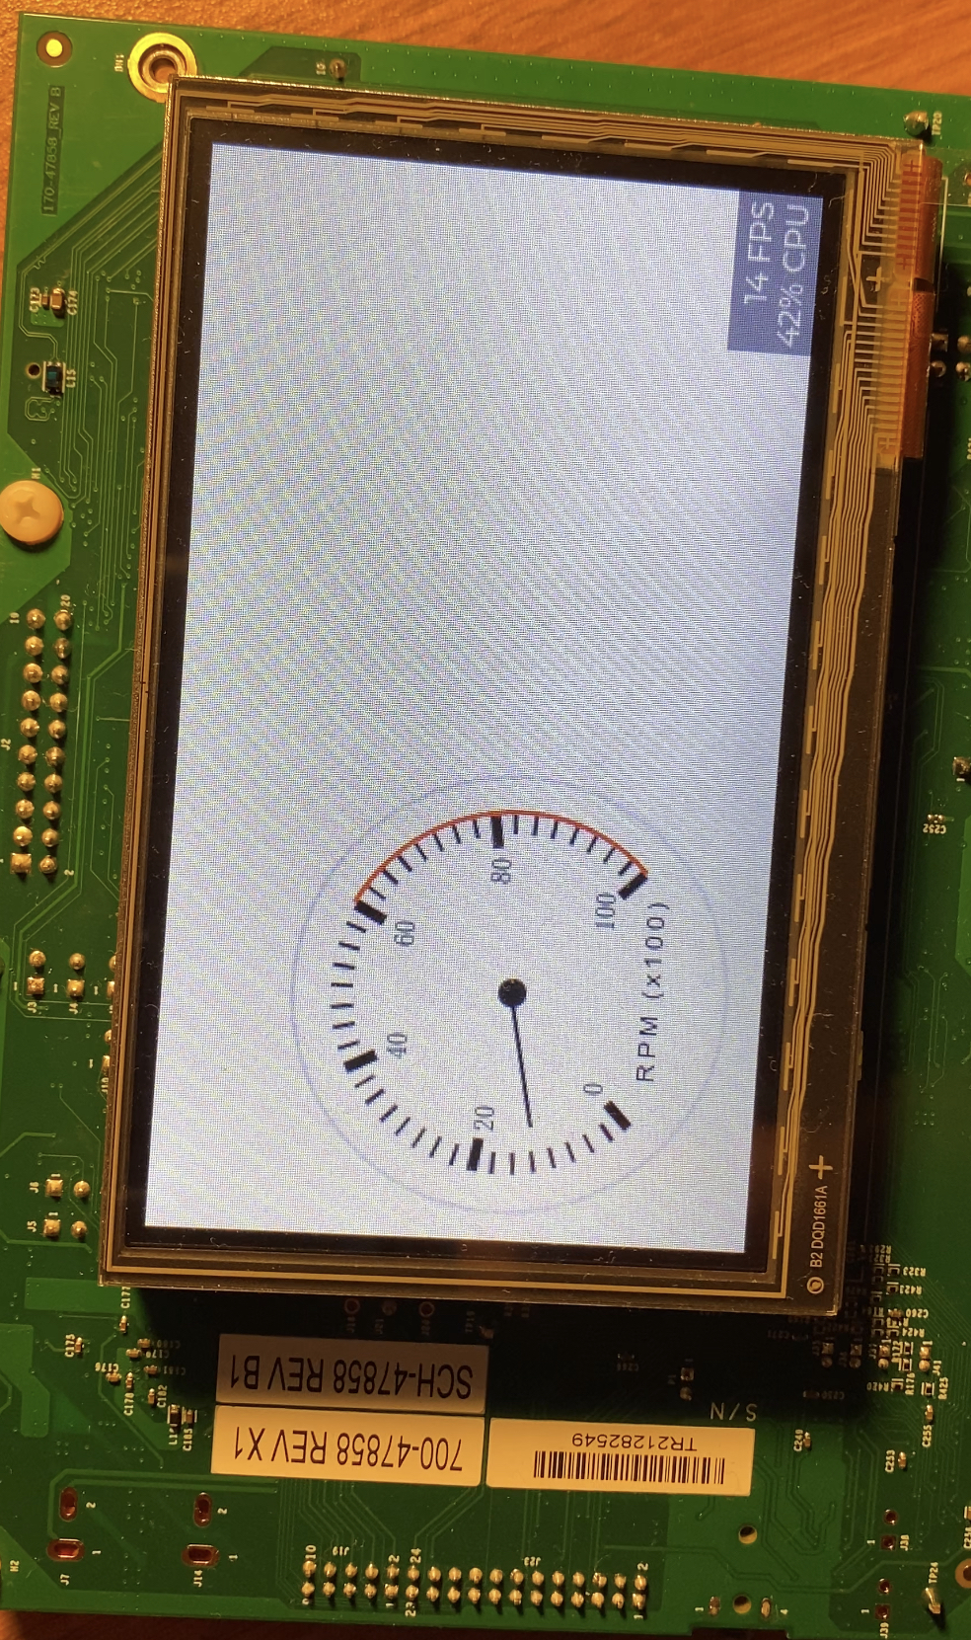
The goal of these instructions is to download, install, and create a basic program that provides the following features:
- Uses RT-Thread
- LVGL support for graphics display
- Provides a way to receive CAN bus data and display it on the screen.

Table of Contents
Installation 1
RT-Thread Studio 1
Setup 1
Hardware 1
Software Configuration 2
Create a starter RT-Thread project 2
Create a starter GUI Guider project. 2
Integrate the GUI Guider project into the RT-Thread Project 2

Installation

RT-Thread Studio
- Download and Installation RT-Thread Studio per the installation instructions.
  - RT-Thread | Resource-Studio
- Install GUI Guider per installation instructions.
  - GUI Guider | NXP Semiconductors

Setup

Hardware
- Modifications for JLink debug
  - Modifying Debug Firmware on i.MX RT10xx Boards Featuring An LPC4322-based Debug Probe (nxp.com)
  - Jump R97 with a 10k if you want to power the board from the Debugger using VUSB.
    - The JLINK firmware does not enable the "POWER_EN" pin
- CAN Bus:
  - Populate J42 with either a 0.1” header, or wiring to allow connection of CAN_High and CAN_Low.

Software Configuration

Create a starter RT-Thread project
This provides the basics we need to create the project.
- Get the latest RT-Thread code
  - Download the latest RT-Thread from GitHub
    - https://github.com/RT-Thread/rt-thread.git
    - to your path of choice, we will refer to this directory as <RT-THREAD> though out this document.
- Create the starting project for RT-Thread
  - RT-Thread RTOS — LVGL documentation
    - Follow this section: “Import a BSP project into RT-Thread Studio” in the link below.
    - https://docs.lvgl.io/master/get-started/os/rt-thread.html#import-a-bsp-project-into-rt-thread-studio
    - The path to the BSP
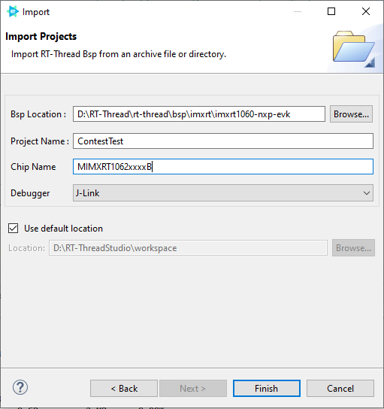
      - <RT-THREAD>\bsp\imxrt\imxrt1060-nxp-evk\
      - Build the project to ensure that it succeeds and that your build tools are working. If everything is working you should see the output below in your build console.
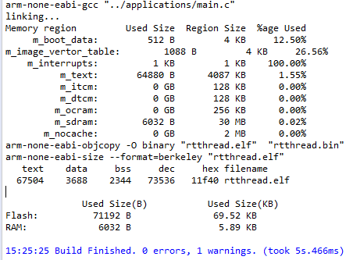
      - Now debug the example project.
        - Select the debug configuration:
        - Confirm that the debug settings are correct and that you are using the latest Jlink tools.
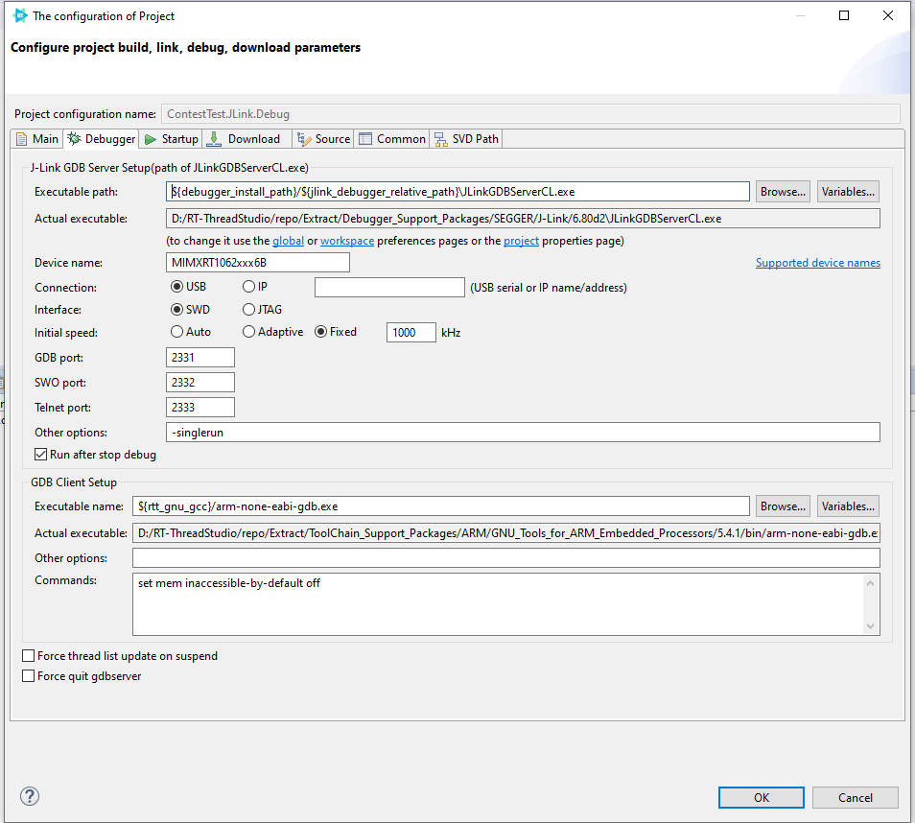
        - Plug a USB cable into the board using the Debug Port, marked J1 on my board.
        - Hit the debug button.
        - You may be asked to acknowledge the use of JLINK software. There is a checkbox at the bottom left that won’t ask again today. This box will timeout and report a failure on the debug console. If you have multiple monitors check the other ones to see if the pop-up window opened there.
        - If you get the following error message see step 7.
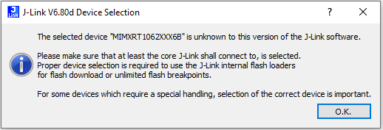
        - The current version of RT-Thread Studio is bundled with an older version of J-Link tools. Specifically version 6.80d. This version does not have the MCU I am using in it. To overcome this issue do the following.
          - Go to SEGGER - The Embedded Experts - Downloads - J-Link / J-Trace
          - Download and install the version for your appropriate system.
            - Mine was J-Link Version V7.66e.
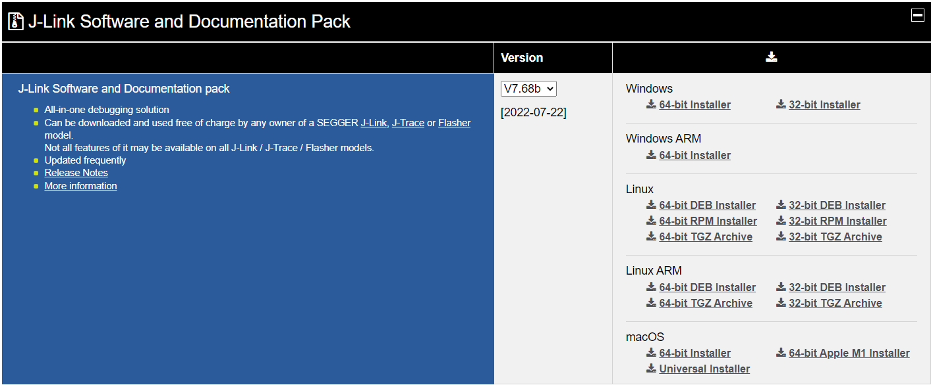
          - Take note of the install location as it is needed later for updating the configuration.
          - Once the install is complete update the J-Link executable settings in on the debug settings page.
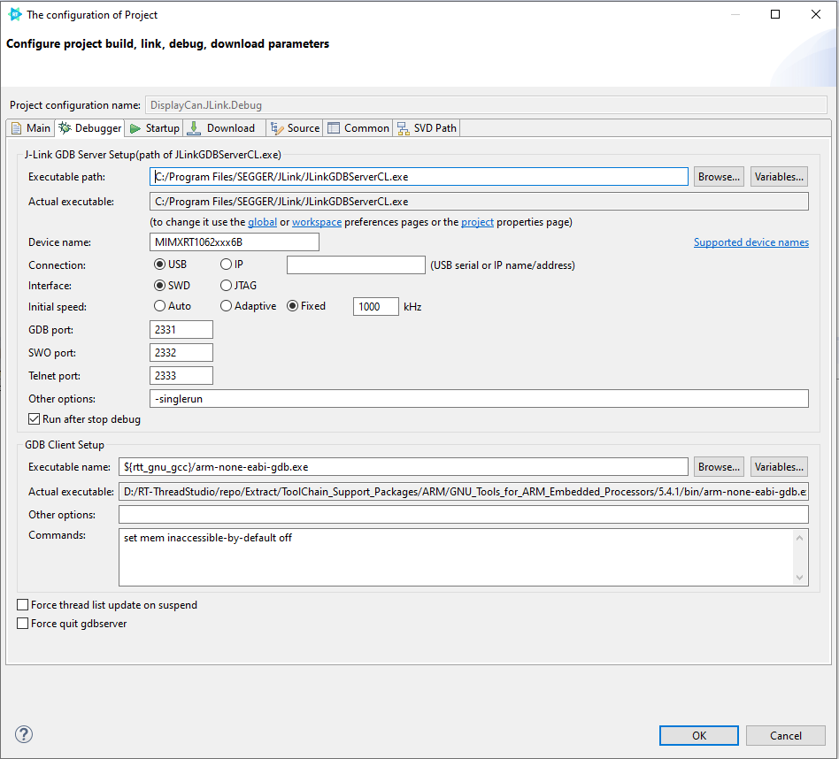
          - Once the connection of the debugger to the process is successful you should see a break point and the code is running. You will see a green highlight and an arrow on the left in of the window pane indication which instruction is the next to execute.
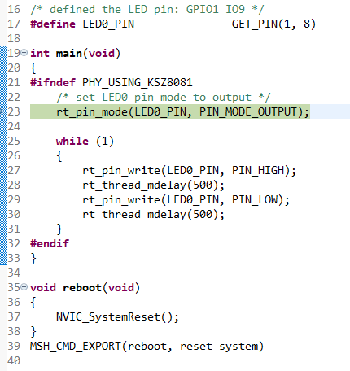
          - You can look up the debug controls as they are common, or hover the mouse over and a description will be displayed in a tooltip.
          - We are going to allow the processor to continue execution so that we can observe continuous execution.
          - We are now able to connect and debug the board.
- Now let’s create an LVGL application
  - Open the “RT-Thread Settings” file.
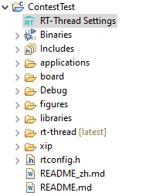
  - This will open the RT-Thread Soft Package Center page.
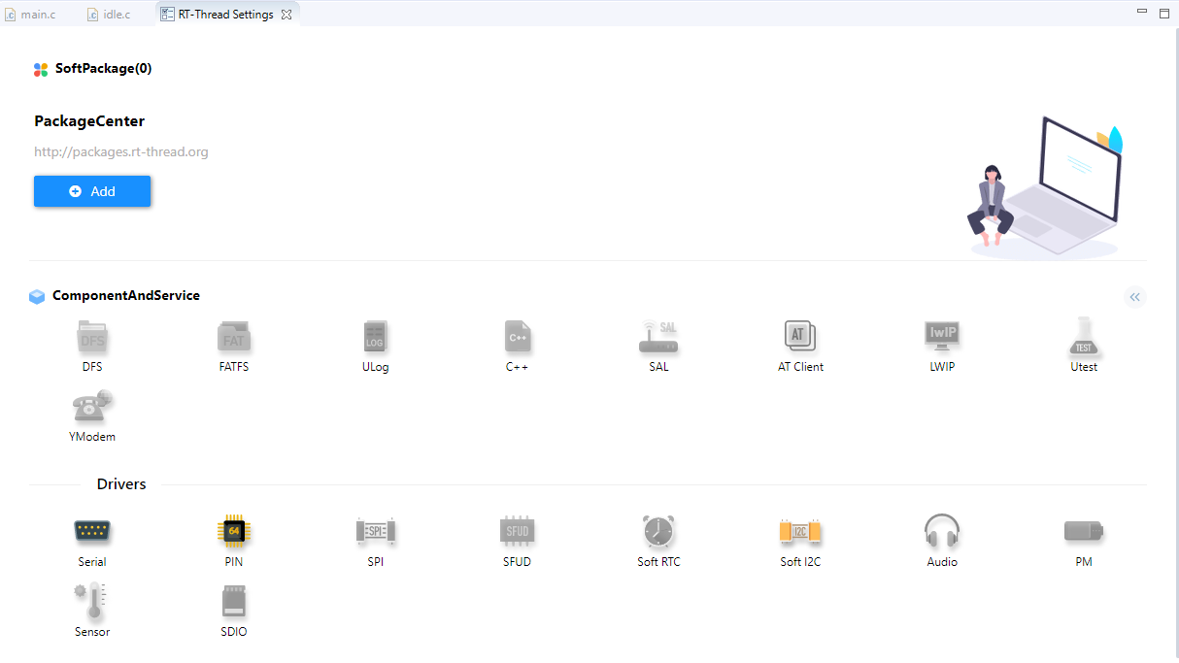
  - Select the back arrows “<<”
  - Select the “Hardware” tab on the next page.
    - Enable the items shown below. (Red Arrow)
    - Confirm the display specifics are the same as in your GUI Guider project. (Green Arrow)
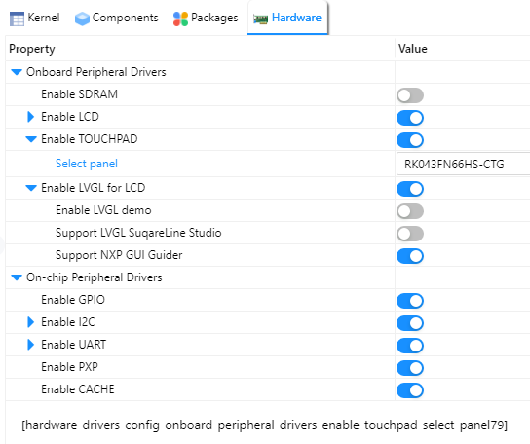
  - Select the “Packages” tab
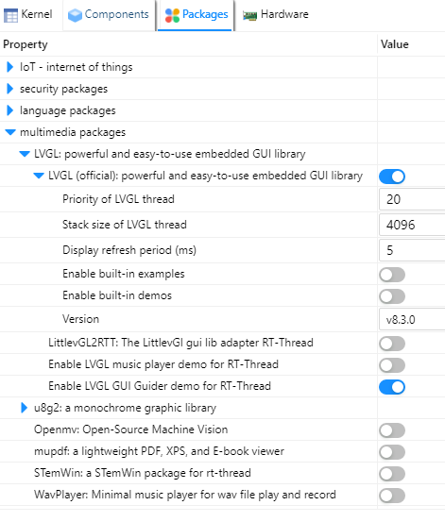
  - Select the “Enable LVGL GUI Guider demo for RT-Thread” (Red Arrow)
    - Confirm that the Version of LVGL matches the same major version selected in Gui Guider. (Green Arrow)
  - We need to enable Touch Control, if we want to be able to provide input to the LCD.The LCD I am using has a “GT911” CTP chip. So I will need to select it from the list of available touch controllers.
  - Scroll Down on the “Packages” page to “Peripheral libraries and drivers” and expand the list.
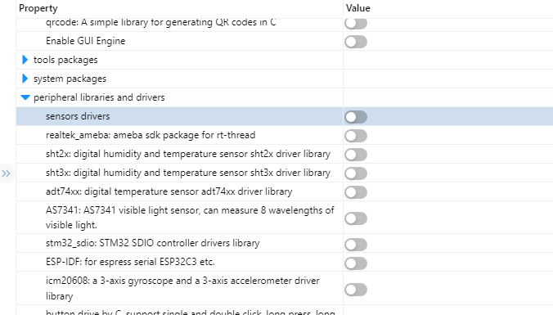
  - Now scroll to the “Touch Drivers” Option and select it.
  - Then scroll down to the particular chip that your LCD display provides and select it.
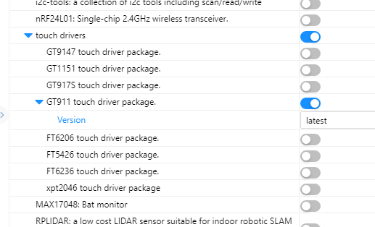
  - We need to enable touch support under the “Components” tab as well.
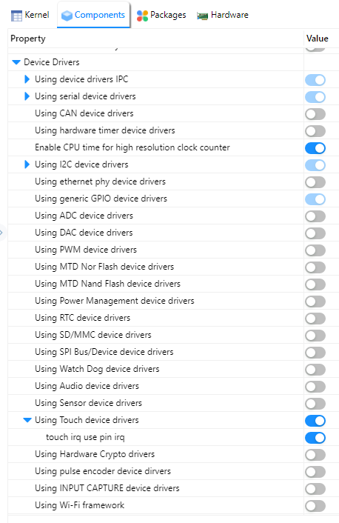

  - At this point build the application and then debug. To confirm that the code builds and we can use the display.
  - If you get this error.
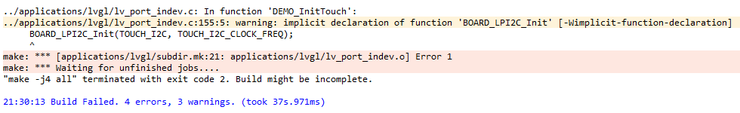
    - put "#include "touchpad.h"” near the top of “application\lvgl\lv_port_indev.c”
- Now we need to create some gui code.

Create a starter GUI Guider project.
- Download and Install the latest GUI guider from www.nxp.com
- Launch GUI Guider.
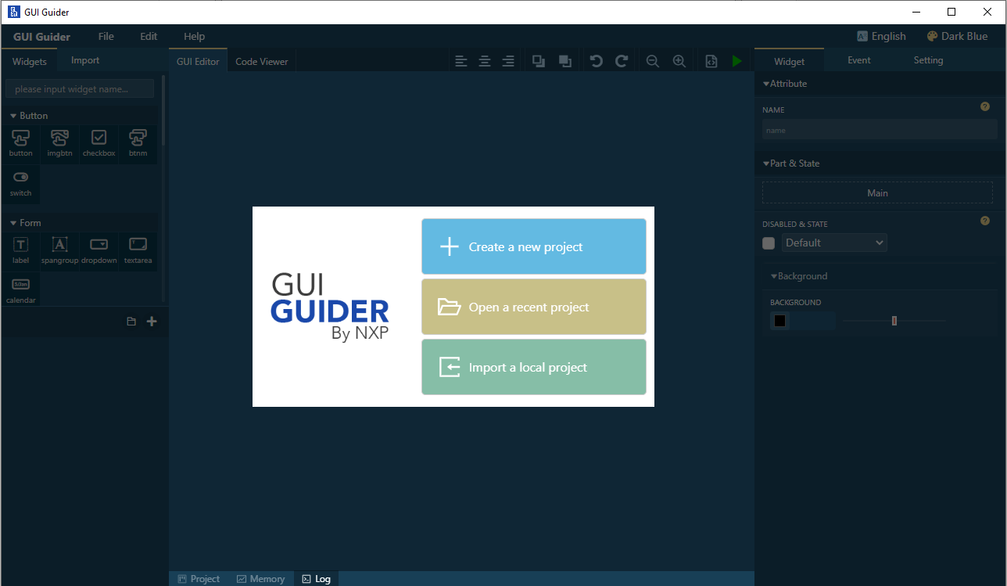
- Select “Create a new project”
- This will open a selection for which version of LVGL you would like to use in the project.
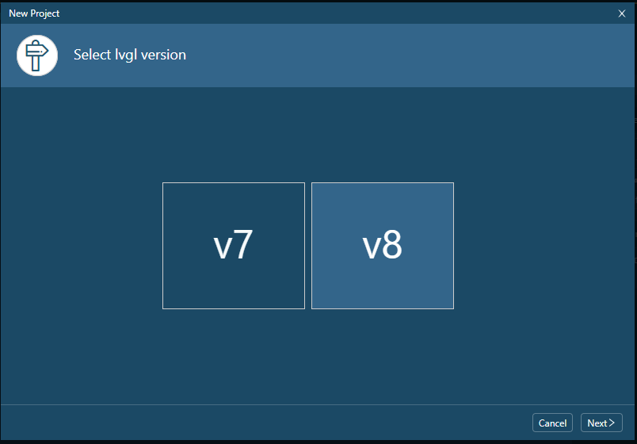
- Select “Next”
- This will open the “Select a Board Template” screen. Select “i.MX RT” tab at the top.
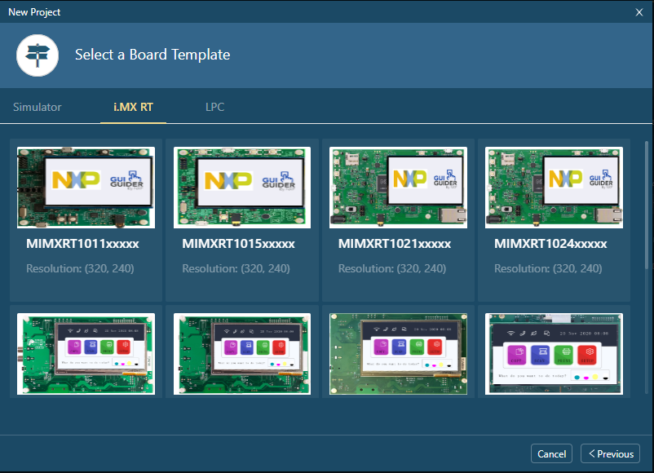
- Select your board.
  - The evaluation board I am using is a MIMXRT1060-EVKB with the details below.
    - Processor is a MIMXRT1062DVL6B
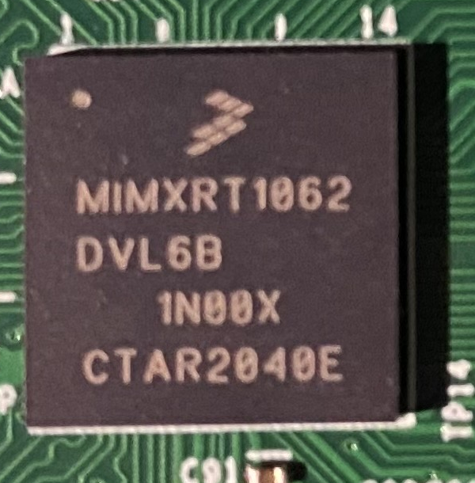
      - Note this is a B type and we will need to account for that later when we want to debug the processor. We will need to update the JLINK configuration to tell the JLINKGDBServer which processor we want to debug.
    - Screen is a RockTech Displays, RK043FN66HS-CTG
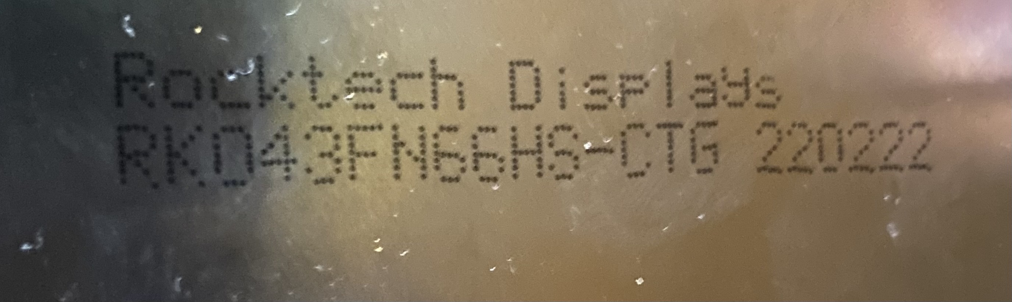
  - So I will select the one highlighted below.
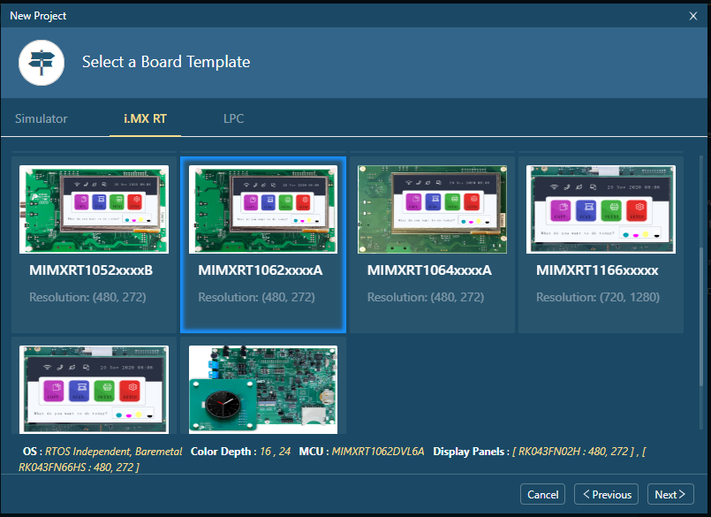
    - **NOTE: This is not the exact processor that we will use the one shows in the selection list is MIMXRT1062xxxxA and the board I am using is a MIMXRT1062xxxxB. For this example though, this isn’t an issue. You will need to verify that everything works for YOUR particular application.
- I want a single page to add a couple of gauges so I will select the template below.
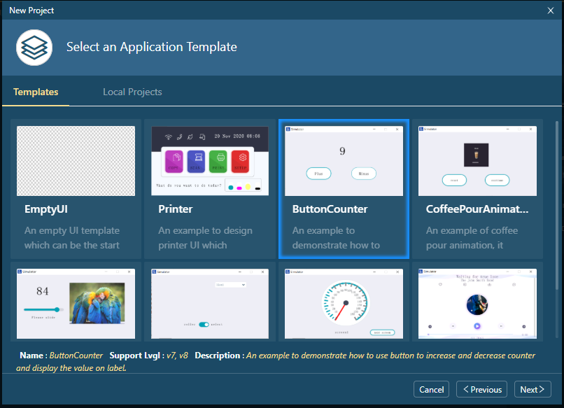
- This will bring up a summary screen with a few key final selections.
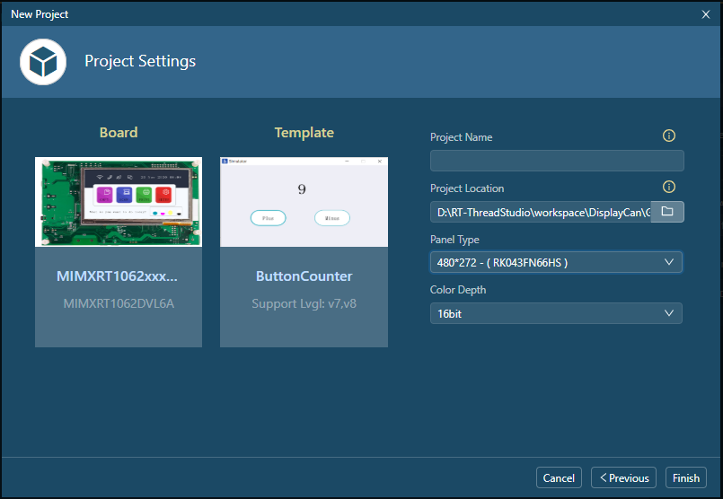
- Final Settings.
  - “Project Name” and “Project Location”
    - Give your project a meaningful name, we will treating this as a separate project for now and only using the output files from GUI Guider. So put this project in a place where you can find it later.
  - “Panel Type”
    - Select the panel to match the one you have. I had to open the list and select mine from there. You could also specify a custom panel if you wanted.
- This completes the initial creation of the project. Now we can start adapting it to our needs.
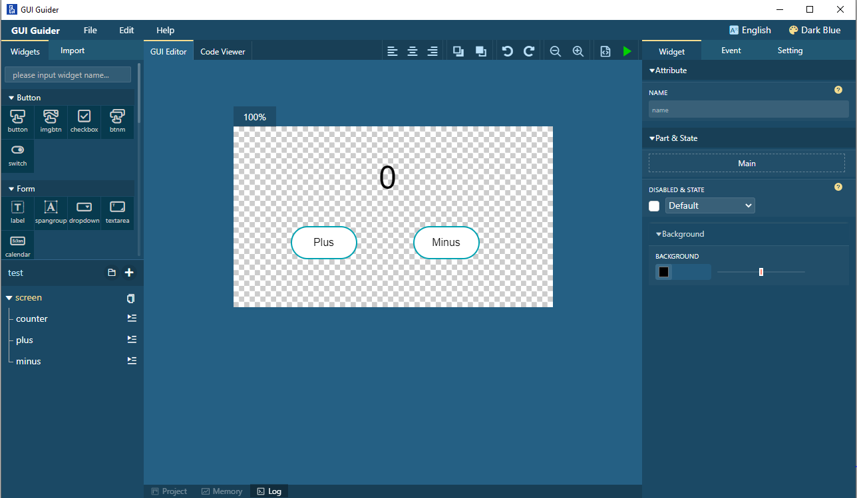
- We will make all the changes necessary to get the graphics we want.

Integrate the GUI Guider project into the RT-Thread Project

Generate GUI Guider output files
- In GUI Guider, Select the “Generate Files” button.
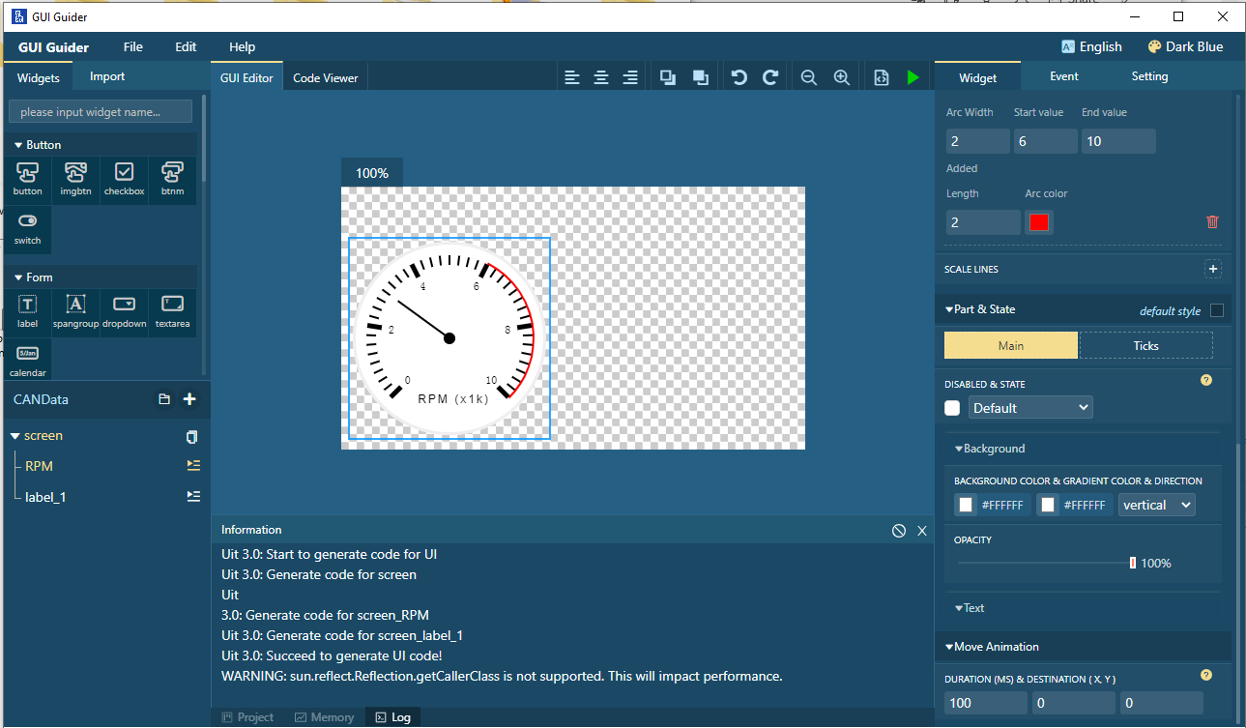
- This will generate the C Code files necessary to create this image.
- The output files are placed in the “generated” folder in the project path.
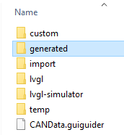
- We need these files from that path.
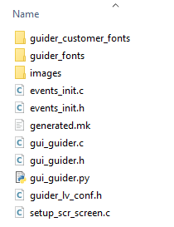
- We will copy the contents of the “generated” folder to the RT-Thread project path.
- These files from the GUI Guider → Generated folder will be placed inside the applications folder and we will create a new “generated” folder like this.

- Some files will need adjusted. Specifically those that port the files together. For these files will will use the ones created when creating a GUI Guider project from MCUXpresso by NXP.
- If a file in the generated folder fails to find “lvgl/lvgl.h” replace the path with “lvgl.h
- On the
  - extern lv_font_t lv_font_arial_48;
  - extern lv_font_t lv_font_arial_16;
  - extern lv_font_t lv_font_arial_12;
- Under “packages→gui_guider_demo-latest → generated” Remove from build.

Notes:

To add a folder to the build sometimes means we must un-exclude it from the build.
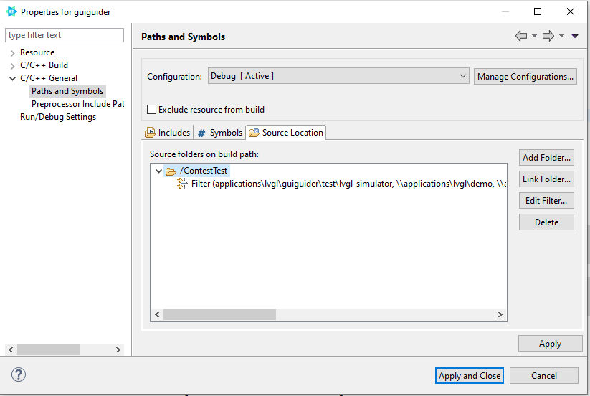
You also need to remove the package files from the include path.
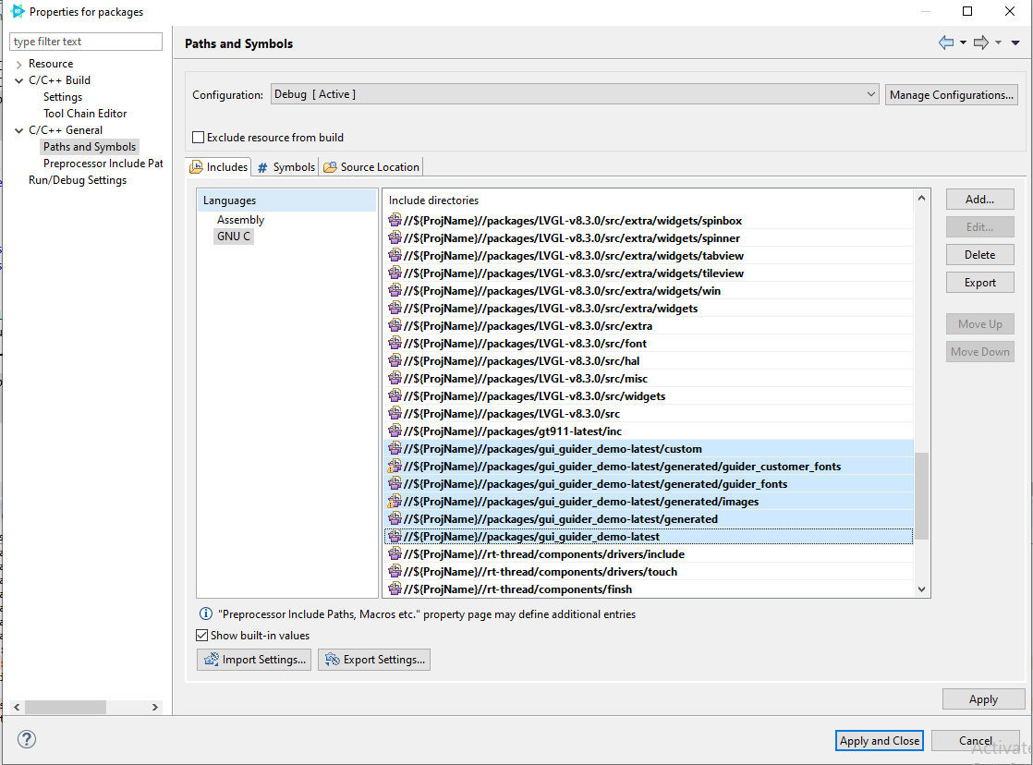
To enable the FSL CAN Drivers remove it from the exclusion list.
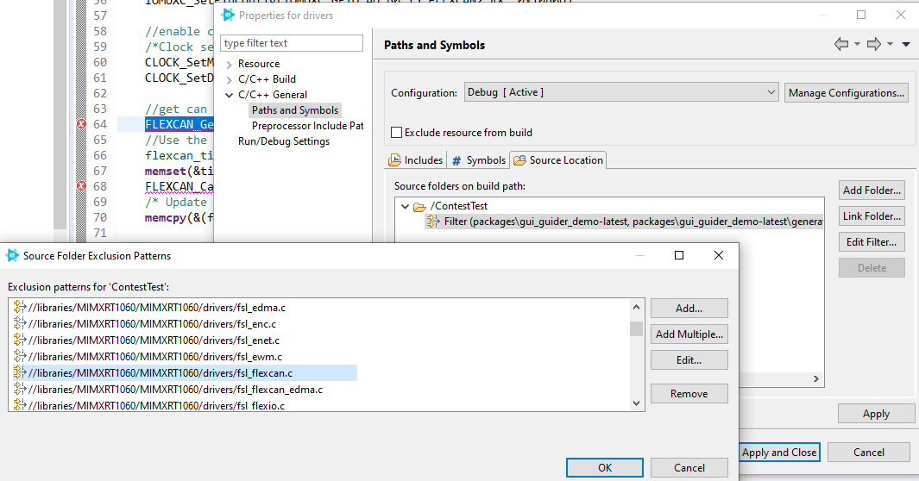

At this point we are able to create a LVGL project, include that code into an RT-Thread project, and use NXP based FSL driver code.

