INTERACTIVE ROOM BOOKING SYSTEM
A Project Report
Submitted in partial fulfilment of the
requirements for the award of the Degree of
BACHELOR OF SCIENCE (INFORMATION TECHNOLOGY)
By
Noorshama Ansari
Seat Number: _______________
Under the esteemed guidance of
Ms. Swarupa Gogate
Assistant Professor, Department of Information Technology
And Data Science


DEPARTMENT OF INFORMATION TECHNOLOGY AND DATA SCIENCE
VIDYALANKAR SCHOOL OF INFORMATION TECHNOLOGY
(Affiliated to University of Mumbai)
MUMBAI, 400 037
MAHARASHTRA
2025 - 2026
VIDYALANKAR SCHOOL OF INFORMATION TECHNOLOGY
(Affiliated to University of Mumbai)
MUMBAI-MAHARASHTRA-400037
DEPARTMENT OF INFORMATION TECHNOLOGY
AND DATA SCIENCE

CERTIFICATE
This is to certify that the project entitled, " INTERACTIVE ROOM BOOKING SYSTEM", is bonafied work of NOORSHAMA ANSARI bearing Seat No: 23302B0044 submitted in partial fulfilment of the requirements for the award of degree of BACHELOR OF SCIENCE in INFORMATION TECHNOLOGY from University of Mumbai.

Internal Guide Coordinator

Internal Examiner External Examiner

Date: College Seal Principal
- COMPANY CERTIFICATE (for LIVE Project)
- Avishkar/ Tantravihar/ Project Exhibition CERTIFICATE
- Vsearch/ National/ International level Conference CERTIFICATE
- RESEARCH PAPER

ABSTRACT

In the rapidly evolving landscape of educational and corporate administration, the efficient management of physical resources is paramount. Traditional methods of room reservation, often reliant on manual registers, oral communication, or disjointed spreadsheet systems, have proven increasingly inadequate. These archaic processes are susceptible to critical operational failures, including inadvertent double bookings, lack of real-time transparency, significant administrative overhead, and inefficient utilization of valuable spatial resources. As institutions grow in size and complexity, the need for a centralized, automated, and intelligent solution becomes undeniable.

This project, titled "Interactive Room Booking System," proposes and implements a comprehensive web-based solution designed to revolutionize the way academic and corporate spaces are managed. The system is engineered using a robust, modern full-stack development architecture that prioritizes security, scalability, and user experience. The backend is powered by the Django Framework (Python), selected for its rapid development capabilities, "batteries-included" approach to security, and powerful Object-Relational Mapping (ORM). Data persistence is handled by SQLite, offering a lightweight yet reliable relational database management system ideal for streamlined deployments. The frontend interface is constructed using React and Tailwind CSS, delivering a responsive, single-page application (SPA) usage experience that ensures seamless interaction across various devices and screen sizes.

The core functionality of the system revolves around a sophisticated booking engine that enforces strict conflict resolution protocols, ensuring that no two events can claim the same resource simultaneously. The application features a granular Role-Based Access Control (RBAC) system, delineating distinct privileges for Administrators and Faculty/Users. Administrators are empowered with comprehensive control over the system's master data, including the management of room blocks, individual room details, and user accounts. Faculty members are provided with an intuitive dashboard to view real-time availability via interactive calendars and blueprints, request reservations, and manage their booking history.

By transitioning from manual workflows to this digital platform, institutions can expect a drastic reduction in scheduling conflicts, a decrease in administrative paperwork, and a significant enhancement in the overall user experience for staff and students. This project not only solves immediate logistical problems but also lays the groundwork for a scalable digital infrastructure capable of adapting to future requirements such as advanced analytics and institutional integration.
ACKNOWLEDGEMENT

I would also wish to show my deep appreciation to my project guide, Ms. Swarupa Gogate, who has been invaluably helpful, encouraging, and supportive throughout the period of this project. Her knowledge, advice on issues, and positive criticism were critical in moulding the course of my work and assisting me to overcome difficulties in the process of development.
I would like to say my deepest gratitude to the Head of Department, Dr. Pushpa Mahapatro, whose Name, gave me the chance and means to undertake this project. I also owe all the faculty members of the Department of Information Technology to their encouragement, technical contribution, and constant provision of motivation that prompted me to do my best.
I would also like to mention the assistance and cooperation of my friends and colleagues. Their useful consultations and recommendations, as well as help in revising and testing the system were very helpful and made the project process more interactive and enjoyable.
Lastly, I would like to say that I owe my family a thousand thank-you because they have been giving me all the encouragement, patience and unconditional support. They have believed in me, and this has been a constant point of strength and motivation that has helped me achieve success in this project.

DECLARATION
I hereby declare that the project entitled, “Interactive Room Booking System” done at Vidyalankar School of Information Technology, has not been in any case duplicated to submit to any other universities for the award of any degree. To the best of my knowledge other than me, no one has submitted to any other university.

The project is done in partial fulfilment of the requirements for the award of degree of BACHELOR OF SCIENCE (INFORMATION TECHNOLOGY) to be submitted as final semester project as part of our curriculum.

Name and Signature of the Student

Table of Contents
Chapter 1 Introduction 10
1.1 Background 10
1.2 Objectives 10
1.3 Purpose, Scope, Applicability (Feasibility Study) 11
Applicability: 12
Chapter 2 Survey of Technologies 13
Chapter 3 Requirements and Analysis 16
3.1 Problem Definition 16
3.2 Requirement Specification 16
3.3 Planning and Scheduling 17
3.4 Software and Hardware Requirement 20
Chapter 4 System Design 21
4.1 Basic Modules 21
4.2 Data Design (Table Design) 22
4.2.1 Schema Design 22
4.2.2 Data Integrity and Constraints 23
4.3 Diagrams 24
4.3.1 E-R Diagram 25
4.3.2 Class Diagram 26
4.3.3 Use Case Diagram 27
4.3.4 Sequence Diagram 27
4.3.5 Activity Diagram 28
4.3.6 Component Diagram 29
4.3.7 Menu Tree 29
4.3.8 Event Table 30
4.3.9 User Interface Design 31
4.3.10 Security Issues 31
4.3.11 Test Cases Design 32
References 33
Bibliography 34
Website Used 34
Glossary 35
Appendices 35
Summary 37
Further Reading 38
Plagiarism Report 39

List of Tables

Table 1: Software Requirement 20
Table 2: Hardware Requirement 20
Table 3: User 22
Table 4: Room_block 22
Table 5: Rooms 22
Table 6: Booking 23
Table 7: Event Table 30
Table 8: Test Case Design 32

List of Figures

Figure 1: Gantt Chart 19
Figure 2: Pert Chart 19
Figure 3: E-R Diagram 25
Figure 4: Class Diagram 26
Figure 5: Use Case Diagram 27
Figure 6: Sequence Diagram 27
Figure 7: Activity Diagram 28
Figure 8: Component Diagram 29
Figure 9: Menu Tree 29
Figure 10: Login Page 31
Figure 11: Dashboard 31
Figure 12: Security Issues 31

Chapter 1 Introduction

Background
In the current age, resource management has been a requirement of the academic institutions as well as corporate institutions. Lecture halls, seminars, meetings, and events are some of the crucial resources in such settings. This has traditionally been done by hand, either at the location of the office or by using phone calls or spreadsheets.
Although these approaches are easy to use, they are also likely to cause human mistakes like the possibility of double bookings, improper management and lack of transparency. Such problems normally cause tensions, time wastage, and inefficiency in use of the available facilities.
As technology has improved, automation, precision, and user-friendliness have been achieved by substituting some of the more conventional work processes with computerized ones. The system is a Room Booking System that offers an online solution to bookings, cancellations, and availability checks. It incorporates the role of users (including administrators and faculty) and provides role-based information access, which is secure.

Objectives

The key aims of the project are as follows:
- To plan and create an online system of room booking.
- To check the availability in real time to avoid Conflicts.
- To automate the room booking and cancellation system and hence minimise paperwork.
- To allow administrators to maintain room information and create usage reports.
- To develop a role-based access control system that is secure and accountable.
- To provide users with an easy-to-use web interface.
- To reduce human mistakes and enhance resource exploitation.

Purpose, Scope, Applicability (Feasibility Study)

Purpose:
The primary objective of this project is to design and deploy a comprehensive digital solution that effectively mitigates the inherent limitations of traditional, manual room booking methodologies. By automating the reservation workflow, the system ensures an efficient, accurate, and transparent allocation of institutional resources. It eliminates the risk of scheduling conflicts by empowering users to verify real-time room availability before making reservations, while simultaneously granting administrators total control over resource management and usage oversight.
Furthermore, the project aims to significantly reduce administrative overhead, minimize manual intervention, and provide a centralized, easy-to-maintain platform. Ultimately, the system is designed to enhance overall operational efficiency, optimizing both performance and resource utilization within academic and corporate environments.
Scope:
The scope of this project is defined by the development of a robust, web-based Room Booking System that leverages a modern technology stack. This includes Django as the high-performance backend framework, SQLite as the reliable relational database management system, and a dynamic frontend built with React and Tailwind CSS.
- Administrator: Empowered to manage room inventories, update booking details, oversee master data, and monitor system usage.
- Faculty/User: Enabled to check real-time availability, initiate booking requests, cancel reservations, and strictly manage their own schedules.
Key characteristics of the system include secure, role-based login authentication, conflict-free booking logic, interactive availability calendars, and intuitive room management tools. The current scope is designed for extensibility, allowing for future enhancements such as automated SMS/Email notifications, advanced utilization analytics, and seamless integration with institutional intranets or Learning Management Systems (LMS)
Applicability:

The proposed Interactive Room Booking System possesses a versatile architectural design, making it highly adaptable across diverse operational sectors:

- Academic Institutions: Facilitates the precise scheduling of lecture halls, laboratories, and seminar rooms, effectively eliminating timetable conflicts and optimizing campus resource utilization.
- Corporate Organizations: Streamlines the administration of conference rooms, collaborative workspaces, and training centers, providing employees with real-time access and booking capabilities.
- Event Management Firms: Enhances the management of large-scale venues such as auditoriums and convention centers, ensuring seamless coordination for complex event schedules.

This inherent flexibility positions the system as a universal solution, capable of being customized to meet the specific logistical requirements of various organizational structures.

Chapter 2 Survey of Technologies

2.1 Backend Technologies:

Python
- Usage: High level, object-oriented, programming language, which is employed in server-side programming and back-end development.
- Advantages: Simple to use, massive community support, enormous libraries to incorporate web and databases.
- Benefit: It guarantees rapid development, simpler debugging, and high reliability.

Django Framework
- Usage: A Web framework written in Python and designed to create secure, scalable and maintainable web applications.
- Advantages: Authentication is inbuilt, ORM of databases, modularity, and extreme security. Project
- Benefit: Less time to develop, strong user authentication, and eliminates most of the typical security threats such as SQL injections or xss.

  - Database Technology

SQLite
- Usage: A self-contained, serverless, and zero-configuration Relational Database Management System (RDBMS) utilized for efficient, local data storage and management.
- Advantages: Extremely lightweight, ACID-compliant, reliable, and requires no separate server administration or complex setup.
- Benefit: Provides seamless integration with Django’s ORM, ensures rapid development cycles, and offers simplified portability for the application.

  - Frontend Technologies
React.js
Usage: A leading JavaScript library for building dynamic, component-driven user interfaces and complex single-page applications (SPAs).
- Advantages: Features a Virtual DOM for high performance, a modular component-based architecture, and a rich ecosystem.
- Benefit: Delivers a highly responsive user experience, promotes code reusability, and facilitates efficient state management.
- Tailwind CSS
- Usage: A utility-first CSS framework that streamlines the styling process by allowing developers to apply design tokens directly in the markup.
- Advantages: Facilitates rapid prototyping, ensures design consistency, and is inherently responsive and mobile-first.
- Benefit: Drastically reduces custom CSS bloat, accelerates UI development, and results in a modern, professional aesthetic.
- HTML5 & TypeScript (TSX)
- Usage: HTML5 provides the semantic structural layer, while TypeScript adds static typing and enhanced tooling to standard JavaScript.
- Advantages: TypeScript offers superior type safety, better IDE support, and early error detection compared to vanilla JavaScript.
- Benefit: Significantly improves code maintainability, reduces runtime errors, and ensures a robust frontend codebase.
- 2.4 Development Tools
- DB Browser for SQLite
- Usage: An open-source, visual tool used to create, design, and edit database files compatible with SQLite.
- Advantages: Provides a user-friendly GUI for browsing data, executing SQL queries, and visualizing the database schema.
- Benefit: Simplifies the process of database management, debugging, and schema verification without requiring complex command-line interaction.
- Visual Studio Code (VS Code)
- Usage: A powerful, lightweight source code editor used for writing, debugging, and managing the entire codebase.
- Advantages: Features intelligent code completion (IntelliSense), an extensive extension library, and built-in Git version control.
- Benefit: Enhances developer productivity, ensures code quality through linting, and provides a unified environment for full-stack development.
- Warp Terminal
- Usage: A next-generation terminal that modernizes the command-line interface with AI-driven assistance and modern UI paradigms.
- Advantages: Offers smart autocomplete, block-based output, and integrated workflows for faster command execution.
- Benefit: Optimizes the developer experience by reducing command-line friction and speeding up routine tasks like server startup and version control

Chapter 3 Requirements and Analysis

3.1 Problem Definition
Currently, most institutions use manual registers or simple spreadsheets for managing room bookings. This often leads to scheduling conflicts, lack of proper monitoring, and inefficient usage of resources. Therefore, there is a need for an automated system that provides real-time availability and streamlined booking processes.

3.2 Requirement Specification

Functional Requirements:
- Admin will be able to administer rooms, users and bookings.
- Faculty has the option of seeing availability.
- System eliminates the possibility of a double booking.
- Reports can be generated.
Non-Functional Requirements:
- Security: Authorization and encryption.
- Usability: Easy interface.
- Scalability: Multiple user support
- Performance: Fast and responsive

3.3 Planning and Scheduling
The Room Booking System project was developed in a systematic and organized way to achieve quality results and timely completion of the project. The project was separated into different stages:
1. Requirement Analysis
Duration: Week (1-2)
Tasks:
- Gather faculty and user system requirements.
- Determine role (Admin, Faculty/User).
- State functional and non-functional requirements.

2. System and Database Design
Duration: Week (3-4)
Tasks:
- Create ER diagram, class diagram & system architecture.
- Schema Design database (User, Room, Booking, Block).
- Storage and plan data flow mechanisms.

3. Backend Development
Duration: Week (5-7)
Tasks:
- Create backend using Django framework.
- Install models, APIs and authentication system.
- Connect MySQL database by using ORM

4. Frontend Development
Duration: Week (8-9)
Tasks:
- Writing responsive UI in Node.js with Tailwind CSS.
- Install login, booking and cancellation forms.
- Show calendar and booking status of availability.

5. Integration
Duration: Week 10
Tasks:
- connectivity between frontend and backend APIs.
- Make sure that there is a flow of data and real-time updated data.

6. Testing
Duration: Week (11 –12)
Tasks:
- Carry out unit testing, integration testing and validation.
- Identify and fix bugs.

7. Deployment & Documentation
Duration: Week 13
Tasks:
- Install system on institution/local server network.
- Train passengers and make paperwork.
- Include after improving section (notifications, analytics).

3.3.1 Gantt Chart

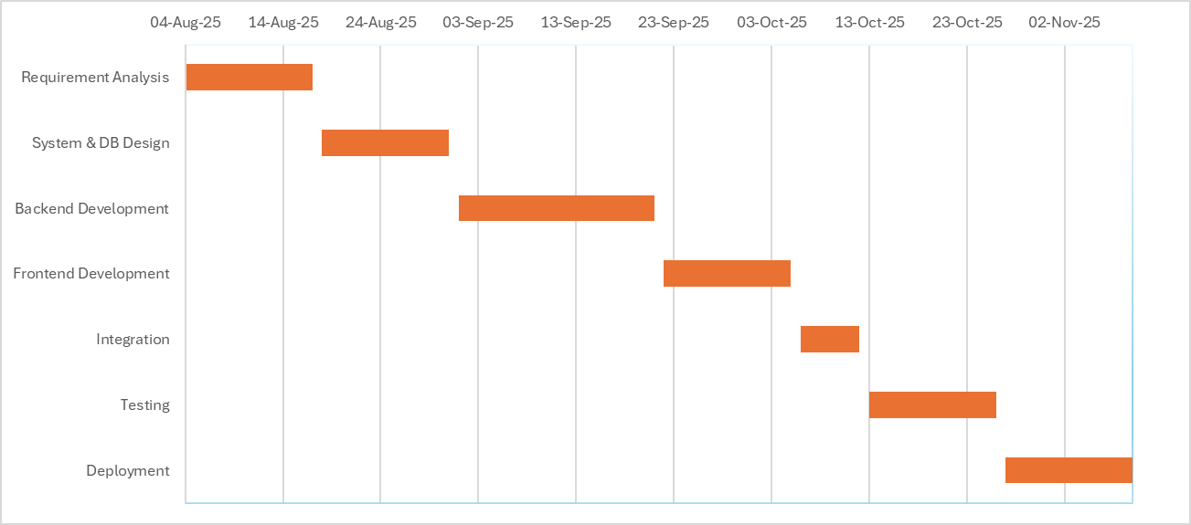
Figure 1: Gantt Chart

3.3.2 PERT Chart

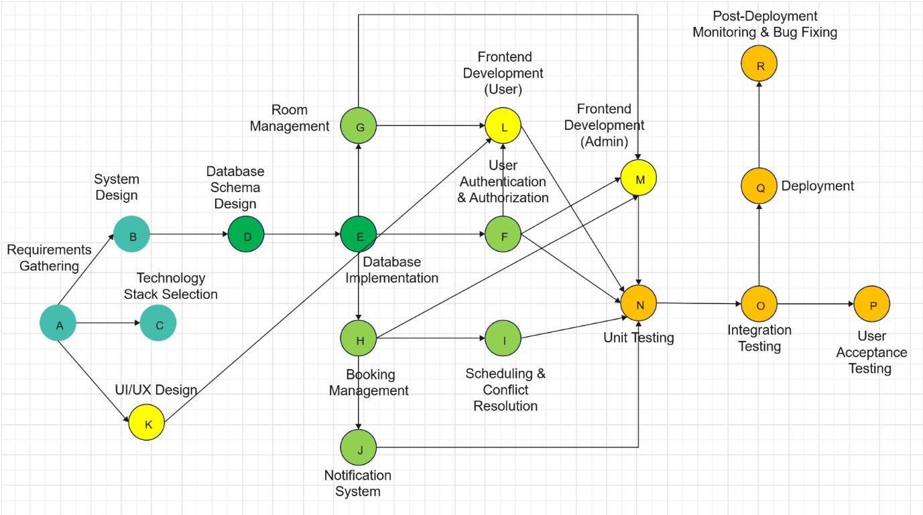
Figure 2: Pert Chart

3.4 Software and Hardware Requirement

3.4.1 Software Requirement:
Software | Requirement / Version
Operating System | Windows 10 or higher / Linux (Ubuntu 20.04+) / macOS Monterey or higher
Programming Language | Python 3.10 or higher
Frameworks | Django 4.x, Node.js 18.x
Frontend Technologies | Tailwind CSS 3.x, HTML5, CSS3, JavaScript
Database | MySQL 8.x
Development Environment | VS Code
Version Control | Git
Additional Libraries/Modules | Required Python/Node.js packages (e.g., pymysql, Django-  crispy forms)
Table 1: Software Requirement

3.4.2 Hardware Requirement:

Hardware | Minimum Requirement | Recommended
Processor | Intel i3 or equivalent | Intel i5 or higher
RAM | 4 GB | 8 GB or higher
Storage | 10 GB free space | 20 GB or higher
Internet Connection | Required for installing packages, updates, and remote database access | Stable broadband connection
Table 2: Hardware Requirement

Chapter 4 System Design

4.1 Basic Modules

Describe the primary functionality elements in the system. In Room Booking System, the modules are:
1. User Module:
- Register/Login
- Profile management
- View booking history
2. Room Management Module:
- Add/Edit/Delete rooms
- Check room availability
- Details of a room (capacity, type, facilities)
3. Booking Module:
- Book a room
- Cancel a booking
- View upcoming bookings
4. Admin Module:
- Approve/Reject bookings
- Manage users Generate reports
5. Notification Module:
- Send email notifications on booking confirmation, cancellation, or booking reminding.
6. Search Module:
- Date search, capacity search and facilities search.

4.2 Data Design (Table Design)

4.2.1 Schema Design

Field Name | Data Type | Constraint
id | INT | PK, Auto Inc
username | VARCHAR(50) | Unique, Not Null
password | VARCHAR(128) | Not Null
first_name | VARCHAR(50) | —
last_name | VARCHAR(50) | —
email | VARCHAR(100) | Unique
role | VARCHAR(20) | —
is_active | BOOLEAN | Default True
date_joined | DATETIME | —
Table 3: User
Field Name | Data Type | Constraint
id | INT | PK
name | VARCHAR(50) | Unique, Not Null
Table 4: Room_block
Field Name | Data Type | Constraint
id | INT | PK
room_number | VARCHAR(20) | Not Null
room_type | VARCHAR(30) | —
block_id | INT | FK → rooms_block(id)
capacity | INT | —
Table 5: Rooms

Field Name | Data Type | Constraint
id | INT | PK
date | DATE | Not Null
start_date | DATETIME | Not Null
end_date | DATETIME | Not Null
purpose | VARCHAR(255) | —
status | VARCHAR(20) | —
room_id | INT | FK → rooms_room(id)
user_id | INT | FK → users_user(id)
Table 6: Booking

4.2.2 Data Integrity and Constraints

Data integrity makes sure that the information in the database stays accurate, consistent, and reliable during the system's operations. Constraints are rules added at the database level to maintain this integrity and avoid invalid or inconsistent data entry. In the Room Booking System, several integrity constraints are used:
1. Primary Key Constraints:
Each table has a Primary Key (PK) that uniquely identifies each record.
Example:
- user.id: uniquely identifies each user.
- Room_block.id: identifies each block.
- room.id: uniquely identifies each room.
- booking.id: uniquely identifies each booking.

2. Foreign Key Constraints:
Foreign Keys (FKs) make sure references between tables are valid.
Example:
- booking room id refers to room.id.
- booking user id refers to user.id.
This prevents orphan records, such as a booking without a valid user or room.

3. Datatype:
This ensures the data entered matches the correct type and range.
Examples:
- capacity in room must be a positive integer.
- status in booking is limited to values like Pending, Confirmed, and Cancelled.
- email in user must follow a valid email format.

4. Null Constraints:
Certain fields are marked as NOT NULL to ensure completeness.
Examples:
- username and password in user.
- date, start date, and end date in booking.

5. Unique Constraints:
Fields like username and email in the user table are unique, so there are no duplicates.

6. Check Constraints:
These restrict values to logical ranges.
Example:
- capacity must be greater than 0 in room table.
- end date must be after start date in booking table.

4.3 Diagrams

4.3.1 E-R Diagram
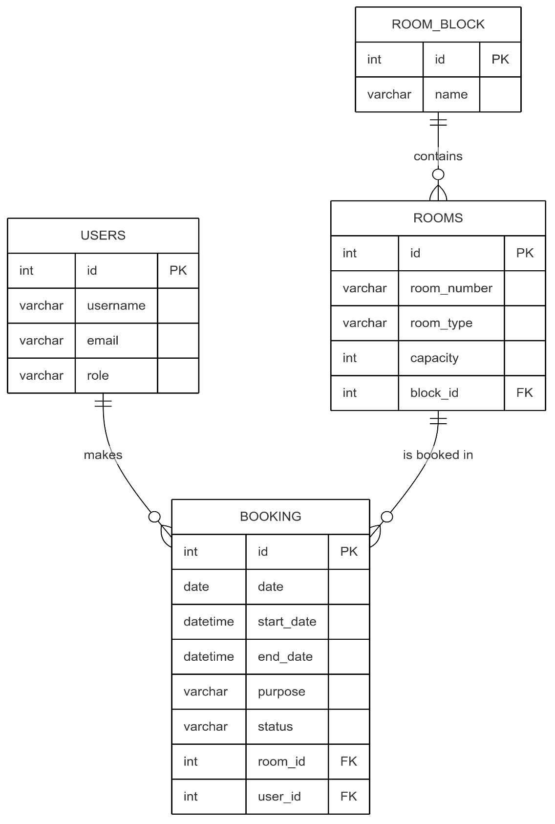
Figure 3: E-R Diagram

4.3.2 Class Diagram
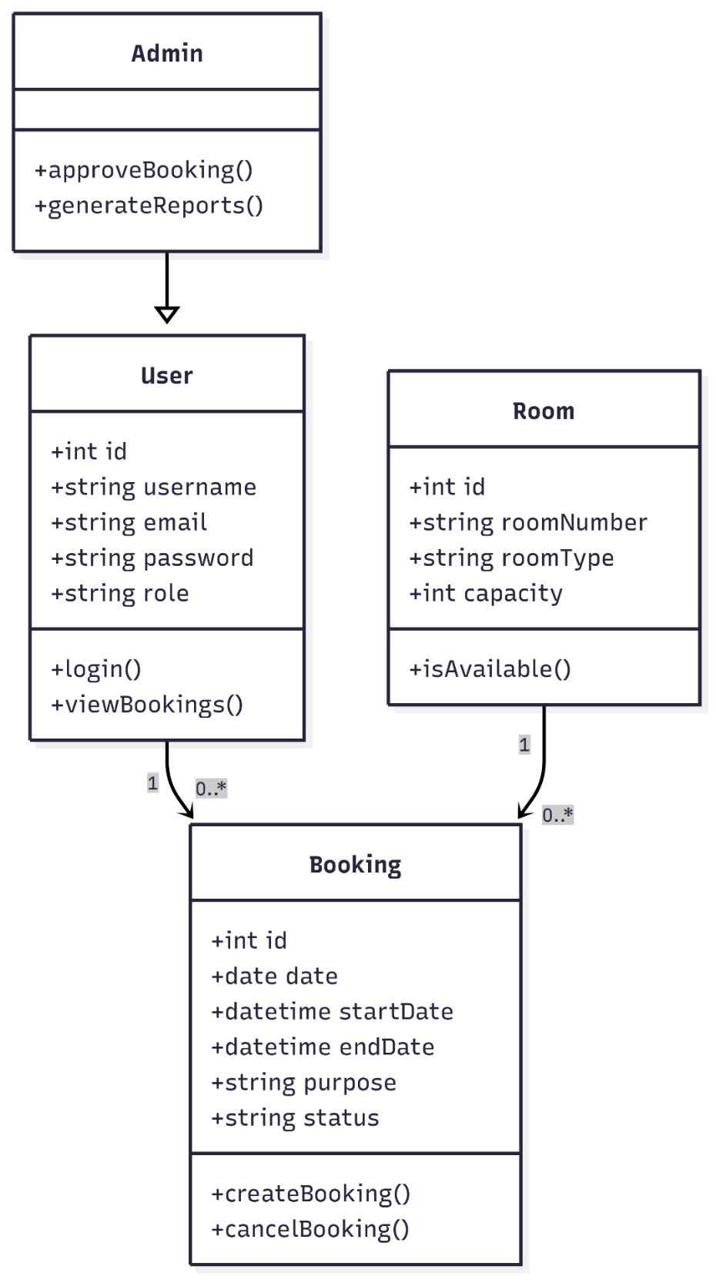
Figure 4: Class Diagram

4.3.3 Use Case Diagram
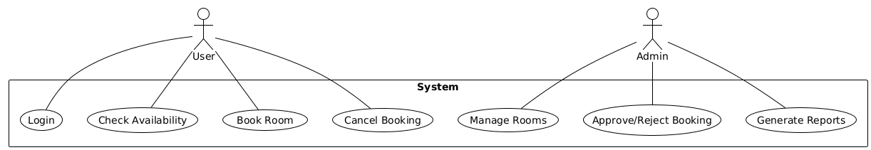
Figure 5: Use Case Diagram

4.3.4 Sequence Diagram
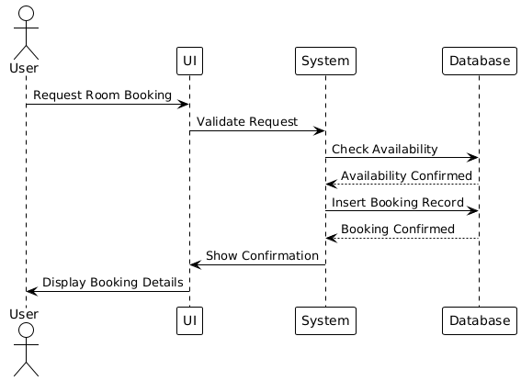
Figure 6: Sequence Diagram

4.3.5 Activity Diagram
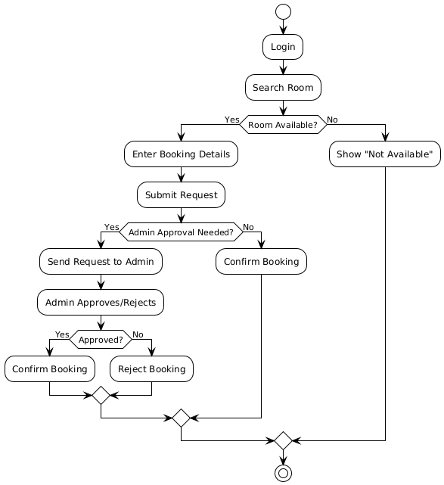
Figure 7: Activity Diagram

4.3.6 Component Diagram
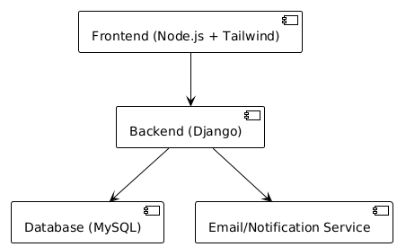
Figure 8: Component Diagram

4.3.7 Menu Tree

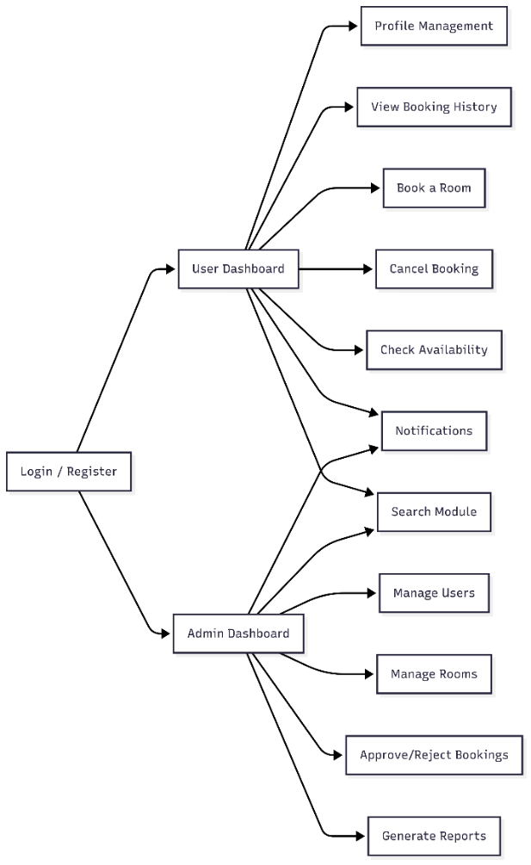
Figure 9: Menu Tree

4.3.8 Event Table
Event ID | Event Name | Description | Trigger | Actor | System Response
1 | User Registration | A user registers for an account to access the system. | User submits a registration form. | User | System creates a user account.
2 | Room Search | A user searches for an available room based on specific criteria. | User enters search criteria (e.g., date, capacity, facilities). | User | System displays a calendar showing room availability.
3 | Room Booking | A user books a room for a specific time and purpose. | User selects a room and submits a booking request. | User | System checks for availability and confirms the booking.
4 | Booking Approval | An administrator reviews and approves or rejects a booking request. | An admin receives a booking request. | Admin | System approves or rejects the booking request.
5 | Booking Confirmation Notification | The system sends a notification to a user about the status of their booking. | A booking is confirmed or cancelled. | System | User receives an email notification.
6 | Booking Cancellation | A user cancels a previously made booking. | User submits a cancellation request. | User | System cancels the booking and frees up the room.
7 | Room Management | An administrator adds, edits, or deletes room information. | Admin performs an action on a room record. | Admin | System updates room information in the database.
8 | Report Generation | An administrator generates reports on room usage and bookings. | Admin selects criteria and requests a report. | Admin | System generates and displays a report.
9 | Login Authentication | A user logs into the system with their credentials. | User enters username and password. | User | System validates credentials and grants access based on user role.
Table 7: Event Table

4.3.9 User Interface Design

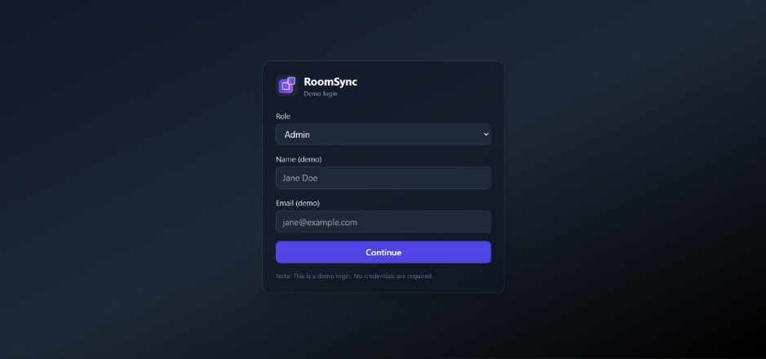
Figure 10: Login Page
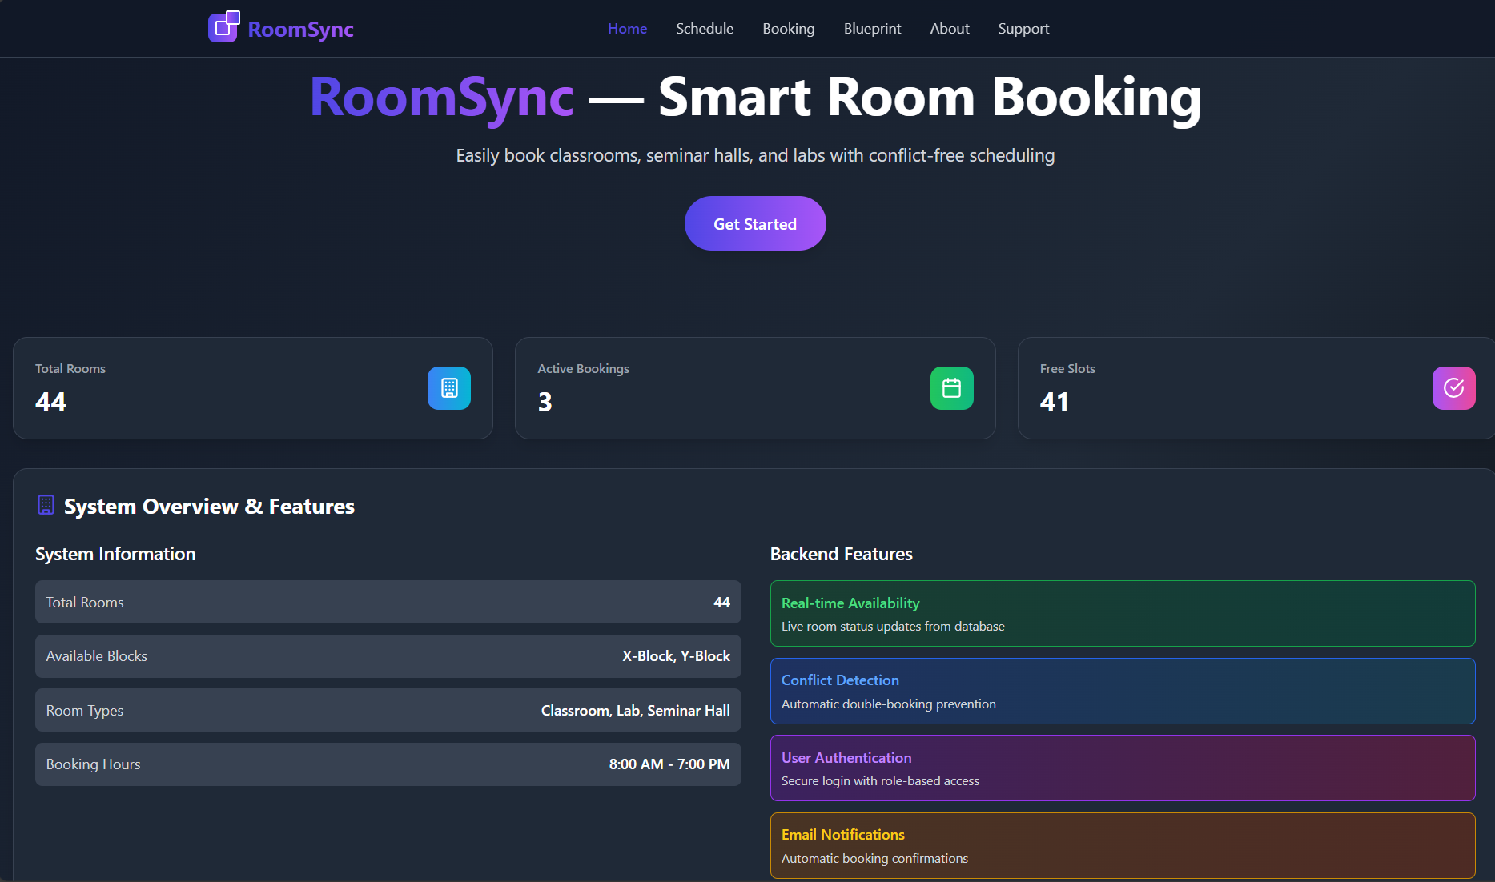
Figure 11: Dashboard

4.3.10 Security Issues

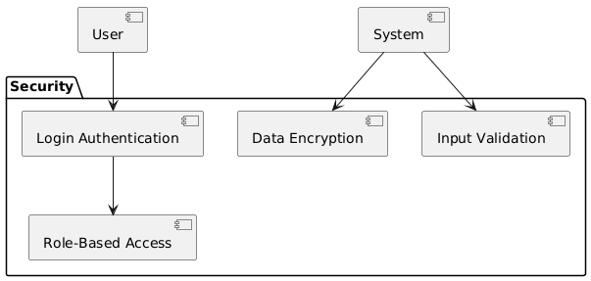
Figure 12: Security Issues

4.3.11 Test Cases Design

Test Case | Description | Trigger | Actor | Expected System Response | Verification
1 | Verify a new user can successfully register. | User submits registration form. | User | System creates a user account. | Log in with the new credentials to confirm the account is active.
2 | Verify a user can search for available rooms. | User enters search criteria. | User | System displays available rooms. | Confirm the displayed rooms match the search criteria.
3 | Verify a user can reserve a room. | User selects a room and dates. | User | System confirms the reservation. | A confirmation message appears and the room is marked as booked in the system.
4 | Verify the system processes payment for a reservation. | User submits payment details. | User | System processes payment. | The user receives a payment success message.
5 | Verify the system confirms a reservation after payment. | Payment is processed successfully. | System | User receives a confirmation email. | Check the user's email inbox for the confirmation email.
6 | Verify a user can check out a room. | User arrives for pickup. | User | System updates room status. | The room status changes from 'booked' to 'checked-out' in the system.
7 | Verify a user can return a room. | User returns the room. | User | System updates room status. | The room status changes from 'checked-out' to 'available' in the system.
8 | Verify the system sends a notification for a late return. | Room not returned by due time. | System | Sends notification to user. | The user receives a notification about the late return.
9 | Verify the system saves feedback. | User fills out feedback form. | User | System saves feedback. | An administrator can view the submitted feedback in the system.
Table 8: Test Case Design

References

- Sommerville, Ian. Software Engineering. Pearson, 10th Edition, 2016.
- Pressman, Roger S. Software Engineering a Practitioner Approach. McGraw-Hill, 8th Edition, 2015.
- Begg, Carolyn, Thomas and Connolly. Database Systems a Practical Approach to Design, Implementation and Management. Pearson, 6th Edition, 2015.
- Fowler, Martin. UML Distilled: A Tiny Tutorial of the Standard Object Modeling Language. Addison-Wesley, 3rd Edition, 2004.
- Bass, Len, Clements, Paul, & Rick Kazam. Software architecture in practice . Addison‑Wesley 4th Edition, 2021.
- Date, C. J. (2003). 8th edition: An Introduction to Database Systems. Pearson, 8th Edition, 2003.
- Django Software Foundation. Django Documentation. It is available on the following websites: https://docs.djangoproject.com
- MySQL Documentation. MySQL Reference Manual. Oracle, 2023. It is available on the following websites: https://dev.mysql.com/doc
- Node.js Foundation. Node.js Documentation. It is available on the following websites: https://nodejs.org/en/docs
- Tailwind Labs. Tailwind CSS Documentation. It is available on the following websites: https://tailwindcss.com/docs

Bibliography

- Vidyalankar Institute of Technology – Project Reports Archive.
- ESoft Metro Campus Student Project Reports.
- Middle East College Research Papers (Software Engineering domain).
- University of Westminster – IT Systems Case Studies.
- Asia Pacific University College of Technology and Innovation – IT Capstone Projects.
- Shari Lawrence Pfleeger, Joanne M. Atlee. Software Engineering: Theory and Practice. Pearson, 4th Edition, 2010.
- Martin Kleppmann. Designing Data-Intensive Applications. O’Reilly Media, 2017.
- IEEE Standards Association. IEEE Standard for Software and System Test Documentation. IEEE, 2013

Website Used

- http://escholar.umt.edu.pk:8080/jspui/bitstream/123456789/3092/1/summary.pdf
- https://wiki.nycresistor.com/wiki/LAMP_Programming_in_PHP
- https://pdfcoffee.com/vegetable-store-management-systempdf-pdf-free.html
- https://www.coursehero.com/file/141947541/documentationdocx/
- https://slidelegend.com/software-process-improvement-and-lifecycle-models-in automotive-_59b845121723dd6c73420f86.html
- http://www.vivek-college.org/Syllabuspdf/BScIT%20Sem%20V%20and%20Sem%20VI.pdf
- http://www.site.uottawa.ca/~pfark013/scribe/CEG4131_SCR_Scheduling.doc

Glossary

- ER Diagram - This is an entity relationship diagram that is utilized to model database structures.
- ORM - Object Relational Mapping is a database access method of programming.
- CRUD - Create, Read, Update, Delete of the database.
- API - Application Programming Interface Set of functions for software communication.
- UI/UX- User Interface / User Experience design.
- LMS - Learning Management System, course management system for courses and resources.
- DBMS - Database Management System (DBMS)

Appendices

Appendix A: User Interfaces
- Login Page - Admin and Faculty can login in and have roles that are authenticated.
- Dashboard - Shows booking, future events, and navigation.
- Booking Form - This is where a user types in room number, date, time, and purpose of booking.
- Admin Panel - Approves booking, manages the user, and generates reports.
Appendix B: Database Schema.
- User Table - It contains the user details of usernames, email, password, and role.
- Room & Room Block Tables - Provide information about rooms such as block name, room number, capacity, and type.
- Booking Table - Documents all the booking requests and status (Pending, Approved, Cancelled).
Appendix C: Test Cases
- User Registration Test - This is to ensure that new user can be registered successfully.
- Room Booking Test - This makes sure that the room can be booked after ensuring that the room is available in the first place.
- Conflict Resolution Test - Check’s system rejection of a double-booking.
- Cancellation Test - Enhances the possibility of a user to cancel existing bookings and release rooms.
- Notification Test - A test to ensure that booking confirmations/ cancellations are sent to the user.
Appendix D: Project Planning Documents.
- Gantt Chart - List’s project coming elements in analysis of requirements and deployment.
- PERT Chart - Visualizes the dependencies and critical path to complete the tasks.
- Task Breakdown- requirement analysis, system design, backend and frontend development, integration, testing and deployment.
Appendix E: More References.
- ER Diagrams - Represent system entities and relationships among users, rooms and bookings.
- Activity and Use Case Diagrams- Explain action sequence and interaction between users.
- Event Table - Events in the system (registration, booking, approval, cancellation, reporting) are summarized.
- Test Case Design Table - lists structured validation of functionality and reliability of system.

Summary
This project is a showcase for the conception and development of a web-based Interactive Room Booking System that works beyond the limitations of manual booking methods such as double bookings, inefficient management, and a lack of openness. The new system takes advantage of cutting-edge tech like Django for the backend, MySQL for the database, and Node.js with Tailwind CSS for the front-end. Together, these instruments build a platform that is safer, more scalable, and user-friendlier, thus greatly easing the reservation procedure.
The software architecture is designed in such a way that it comprises basic modules such as user login, role-based access control, room management, booking, cancellation, accessibility calendars, and conflict detection. The users who have administrative rights are equipped with tools to control users, take decisions on bookings whether to give the green light or not, and print the reports of usage, whereas end users are proposed a hassle-free interface for both viewing available time slots and making reservations. Through the process of automation, the system accomplishes a reduction in paperwork, the occurrence of human errors is brought down to a minimum, and, above all, efficient utilization of resources is guaranteed.
The project was realised by going through the stages of the Requirement Analysis, System Design, Coding, and Testing in a very methodical and standard manner. The structure implemented here is adaptable and can accommodate more functionalities in the future, e.g., email/SMS notifications, detailed analytics, and institutional portal integration. To sum up, the Interactive Room Booking System is a potent instrument for educational institutions, corporate offices, and event managers that allows them to practice efficient resource management, transparency, and enjoy a modern booking journey.

Further Reading

- Bass, Len, Paul Clements, and Rick Kazman. Software Architecture in Practice. Addison-Wesley, 4th Edition, 2021.
- Date, C.J. An Introduction to Database Systems. Pearson, 8th Edition, 2003.
- Shari Lawrence Pfleeger, Joanne M. Atlee. Software Engineering: Theory and Practice. Pearson, 4th Edition, 2010.
- IEEE Standards Association. IEEE Standard for Software and System Test Documentation.
- Martin Kleppmann. Designing Data-Intensive Applications. O’Reilly Media, 2017.

Plagiarism Report
