**Diffraction volume tracking and macroscopic strain measurement using Digital Image Correlation**

This documentation provides instructions for the digital image correlation (DIC) scripts that can be used to track a diffraction volume during an in-situ experiment.

There are four Matlab m-files in the folder.

* “cpcorr_APS.m” – modified version of the “cpcorr.m” file to allow subpixel resolution.
* “DIC_disp_strain.m” – script that loads, analyzes, and determines the displacement of the region of interest (ROI) and the macroscopic strain.
* “Findpeak_APS.m” – modified version of the “Findpeak.m” file to allow subpixel resolution.
* “ViewDIC.m” – script that loads and visualizes pixel movement. Most of the features in this script are available in “DIC_disp_strain.m”. This script will be discontinued as the scripts and functions are organized and developed further.

There are three subdirectories in this folder.

* “DIC” – digital image correlation images from Michigan State University (MSU) in-situ experiments.
* “References” – some background information and relevant papers.
* “smallTensileYield” – digital image correlation images provided by Professor A. Beaudoin at UIUC.

Readers are encouraged to look at the references.

* Chu, T.C. et al., “Applications of Digital-Image-Correlation Techniques to Experimental Mechanics”, Experimental Mechanics, 1985.

There are several others in the “references” folder.

**ViewDIC.m**

This script allows the user to compare two images to determine the displacement.

Before making many changes, it is suggested that the user run the script to get a feel for how the script runs.

Modify the following.

* “pname” – path name of the folder where the DIC images are located.
* “fname0” – file name of the reference DIC image.
* “fname” – file name the DIC image of interest that will be compared to the reference DIC image.
* “ri” – starting row number of the ROI.
* “rf” – end row number of the ROI.
* “ci” – starting column number of the ROI.
* “cf” – end column number of the ROI.

With appropriate changes, the script should generate at least one figure with two subplots, one showing the ROI in the reference DIC image and one showing the same ROI in the DIC image of interest.

**DIC_disp_strain.m**

This script allows the user to designate a series of DIC images so that they are all analyzed to produce a displacement and strain history.

Note that the images are loaded as is. If the camera was positioned such that the displacement was along the horizontal, displacement in the horizontal direction should show the largest displacement.

Before making many changes, it is suggested that the user run the script to get a feel for how the script runs.

Modify the following.

* “pname” – path name of the folder where the DIC images are located.
* “froot” – root file name or file naming pattern used to take the DIC images.
* “ext” – DIC image file extension.
* “ndigits” – number of digits in the file naming pattern.
* “fini” – start number of the DIC file series.
* “ffin” – end number of the DIC file series.
* “finc” – DIC file series number increment step.
* “delta_h” –spacing between control points in horizontal direction in the DIC images.
* “delta_v” – spacing between control points in vertical direction in the DIC images.
* “Hctr” – center point in horizontal direction.
* “Vctr” – center point in vertical direction.
* “ws_h” – number of control points in the horizontal direction spaced by “delta_h”
* “ws_v” – number of control points in the vertical direction spaced by “delta_v”

It is advised that the “return” command in the vicinity of line 170 (after generating figure(1)) is commented in to check the ROI before going ahead with the full analysis.

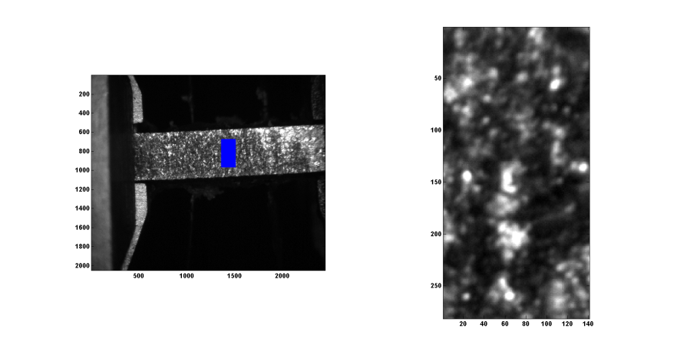

Figure 1 - An example of the ROI figure (figure (1) in the Matlab script).

Once the ROI looks reasonable, comment out the “return” command to proceed.

When the MSU DIC images the analyzed, two images show up at the end (they get updated at each step in the for-loop). The first is the Displacement field map. This shows the displacement determined through DIC method. The arrows point in the direction of the displacement.

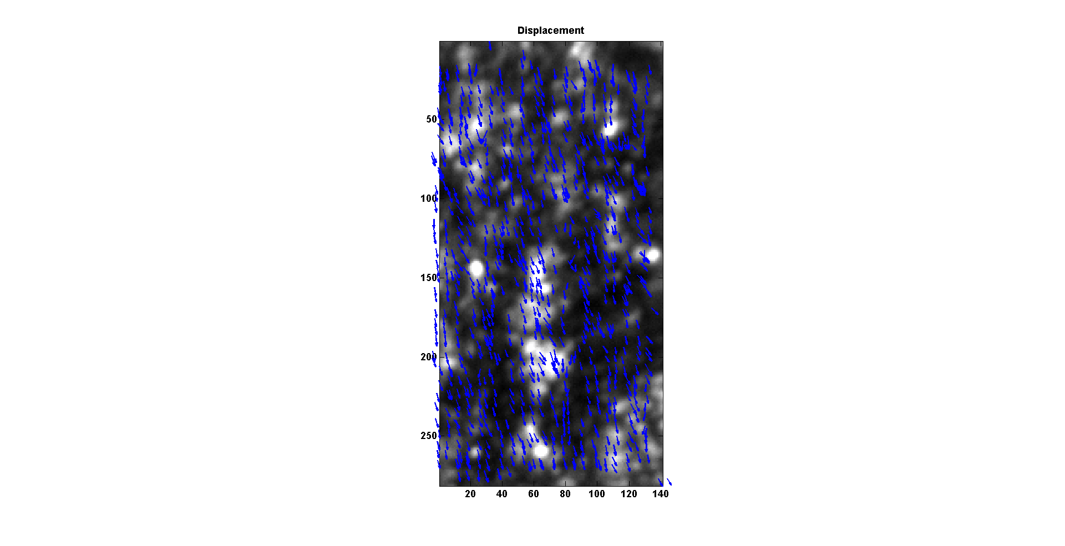

Figure 2 - Displacement field figure for the last loat step in the in-situ experiment. In this figure, the displacement is pointing down indicating that the sample was translating in the transverse direction.

The second is the displacement vs. image number, partials vs. image number, and deviation vs. image number plots. The displacement usually shows only two data sets: average u and average v displacements. In this case, there is a third data set (samY), which is the motor record of the actual samY motor movement that the MSU users performed to correct for the diffraction volume movement. Note that the blue line (the horizontal movement) tracks the samY movement reasonably well. The constant offset needs to be investigated (user error?, conversion error?, ???). Checking the displacement in blue with the actual images shows that the horizontal displacement shown in blue is consistent with the actual pixel movements.

The partials are related to the strains. In this case, the strains are engineering strains obtained from a least squares fit of the displacement data. This needs to be further developed for proper strain measurement.

The errors are related to how well the least squares fit worked with the data. This again needs further development.

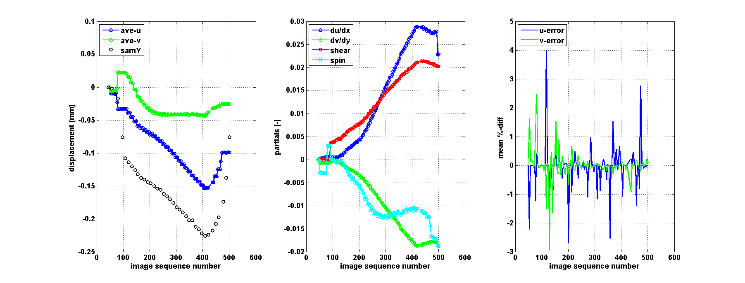

Figure 3 - Second figure generated by the script.