**TENSEGRITY ROBOT PROTOTYPE**

***Investigation of Human-Robot Interaction with Tensegrity Robots***

**General Description**

The tensegrity robot prototype is a passive robotic device whose structure is designed based on tensegrity principles. The structure is composed of 6 carbon fiber tube rods [See label A] that are suspended in equilibrium via the tension of 24 cable elements [See label B/C]. The cable elements are composed of string and metal extension springs connected in series. The resulting structure is compliant and light in order to facilitate intrinsically robust and safe physical interaction with both humans and the environment. The robot has no form of actuation, so the entire system is completely passive. On each of the ends (or nodes) of the rigid carbon fiber rods, there are small assemblies that are integrated with force sensors that capture data on physical interaction. Each node is capped with a 3D printed compliant plastic bumper. In the center of the robotic device, a 3D printed compliant plastic payload is suspended that houses electronics for data storage and transmission [See label D]. All total, the entire system weighs less than 1kg and is designed to be conducive to contact of all forms. The figure below shows the tensegrity robot prototype along with labeled subsystems. If there are anymore questions regarding this system, please contact Andrew Barkan at [andrew_barkan@berkeley.edu](mailto:andrew_barkan@berkeley.edu).

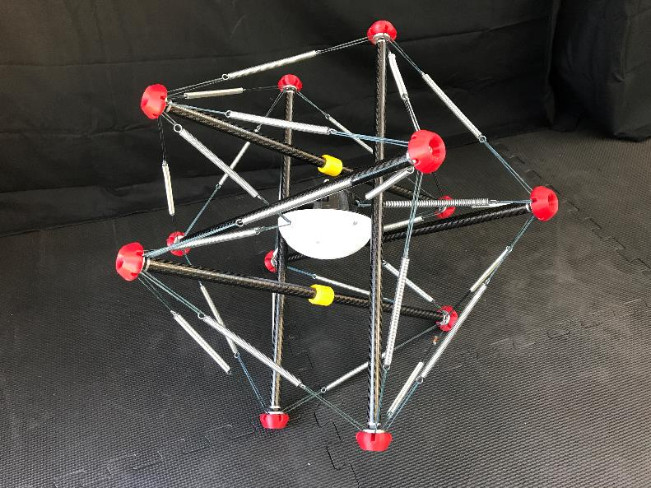

A

B

C

D