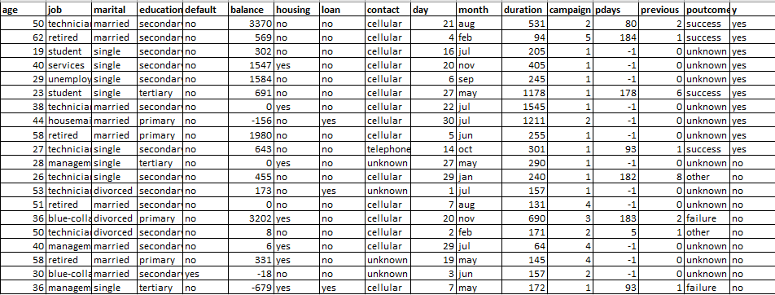

**X = (age=”54”, job = “technician”, marital = “single”, education = “secondary”, default = “no”, balance = “300”, housing= “no”, loan = “no”, contact = “cellular”, day=”10”, month= “aug”, duration = “135”, campaign =”1”, pdays = “-1”, previous = “0”, poutcome = “unknown”)**

P(Ci): P(y = “yes”) = 10/20 = 0,5

P(y = “no”) = 10/20 = 0,5

**Tính P(X|Ci) trên mỗi lớp**

P(job =”technician”|y = “yes”) = 3/10

P(job =”technician”|y = “no”) = 3/10

P(marital =”single”|y = “yes”) = 5/10

P(marital =”single”|y = “no”) = 3/10

P(education =”secondary”| y =”yes”) = 7/10

P(education =”secondary”| y =”no”) = 6/10

P(default = “no”|y = “yes”) = 10/10

P(default = “no”|y = “no”) = 9/10

P(housing = “no”|y = “yes”) = 8/10

P(housing = “no”|y = “no”) = 5/10

P(loan = “no”| y = “yes”)= 9/10

P(loan = “no”| y = “no”)= 8/10

P(contact = “cellular”| y = ”yes”) = 9/10

P(contact = “cellular”| y =”no”) = 6/10

P(month = “aug”| y = “yes”) = 1/10

P(month = “aug”| y = “no”) = 1/10

P(poutcome = “unknown” | y = “yes”) = 6/10

P(poutcome = “unknown” | y = “no”) = 6/10

P(age = “54”| y = “yes”) = 0.0161

P(age = “54”| y = “no”) = 0.0179

P(balance = “300”| y =”yes”) = 2.9048*10^-4

P(balance = “300”| y =”no”) = 3.1063*10^-4

P(day = “10”| y = “yes”) = 0.0338

P(day = “10”| y = “no”) = 0.0320

P(duration =”135”| y = “yes”)=5.1797*10^-4

P(duration =”135”| y = “no”) = 2.0134 *10^-3

P(campaign = “1”| y =”yes”) = 0.2818

P(campaign = 1| y =”no”) = 0.1860

P(pdays = “-1” | y =”yes”) = 4.0703*10^-3

P(pdays = “-1” | y =”no”) = 4.2310*10^-3

P(previous = “0”| y = “yes”) = 0.1838

P(previous = “0”| y = “no”) = 0.1428



**Tính P(X|Ci) :**

**P(X|y = yes)** =3/10 * 5/10 * 7/10 * 10/10 * 8/10 * 9/10 * 9/10 * 1/10 * 6/10 * 0.0161 * 2.9048*10^-4 * 0.0338 * 5.1797*10^-4 * 0.2818 * 4.0703*10^-3 * 0.1838

= 7.0467e-17

**P(X|y = no)**  = 3/10 * 3/10 * 6/10* 9/10 * 5/10 * 8/10 *6/10 * 1/10 * 6/10 * 0.0179 * 3.1063*10^-4 * 0.0320 * 2.0134 *10^-3 * 0.1860 * 4.2310*10^-3 * 0.1428

= 2.8174e-17

**P(X|Ci)*P(Ci): P(X|y = “yes”) * P(y = “yes”) =** 7.0467e-17 * 0.5 = 3.5233e-17

**P(X|y = “no ”) * P(y = “no”)** = 2.8174e-17 * 0.5 = 1.4087e-17

**Vậy, X thuộc lớp có nhãn “Y = yes”.**