[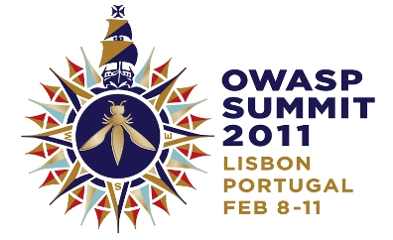](http://www.owasp.org/index.php/Summit_2011_Logo_Explained)

HELLO WORLD!

**OWASP SUMMIT 2011 KICKS OFF MASSIVE APPLICATION SECURITY OUTREACH PROGRAM**

*“I saw the ‘blossoming’ of OWASP in Portugal’s Spring. From an external viewpoint, OWASP has moved from niche to widely relevant, from localized to global, from pentesting to SDLC, from server to every component of the application’s delivery and use, from infosec to business process relevance.” – Colin Watson*

PRESS RELEASE

**Hello World! OWASP Summit 2011 Kicks Off Massive Outreach Program**

**Lisbon, Portugal**, February 15, 2011 - The Open Web Application Security Project (OWASP) today announced the results from its 2011 OWASP Summit. Over 180 application security experts from over 120 companies and 30 different countries joined forces to plan, build, and execute programs to improve the security of the world’s software applications.  The Summit was a significant step towards OWASP’s mission to ensure all types of organizations are empowered to build, select, and use software applications securely.

OWASP launched and advanced dozens of concrete initiatives to bring application security to governments, educational institutions, browser vendors, standards bodies, software development teams, and mobile platform vendors. Delegates gathered outside Lisbon, Portugal for a week of interactive working sessions and discussions. OWASP Summits are unlike conferences with static presentations. Instead, working sessions are used to author documents, create software, draft standards, and forge lasting relationships.

**Some highlights from the 2011 OWASP Summit include:**

* **OWASP-Portugal Partnership** – OWASP has been working to establish relationships with various governments around the world, particularly the United States, Brazil, Portugal, and Greece. At the Summit, OWASP representatives worked directly with senior Portuguese IT officials to establish a protocol for working with Portugal to improve their application security capabilities.
* **OWASP Outreach to Educational Institutions** – Reaching students is a unique opportunity to reach developers early in their development. At the Summit, delegates drafted an OWASP Code of Conduct for Educational Institutions, created a detailed plan for OWASP Student Chapters and continued development of the OWASP “Academies” Portal with extensive education and training materials.
* **OWASP Industry Outreach** – OWASP resolved to develop industry working sessions to be held at major OWASP conferences starting with OWASP EU 2011 in Dublin, Ireland. The objective of these sessions will be to solicit feedback from industry players to help better focus OWASP efforts and make sure OWASP deliverables are relevant to industry concerns.
* **OWASP Browser Security** **Project** – The Summit brought representatives from browser vendors Mozilla, Google, and Microsoft together with leading security researchers to discuss, and strategize about browser security issues. Several new OWASP initiatives were launched, including a browser security scorecard project based on OWASP’s recently created browser testing framework. There were extensive discussions on browser initiatives such as Mozilla’s Content Security Policy (CSP) and browser sandboxes.
* **OWASP-Apache Partnership** – OWASP forged a relationship with the Apache Software Foundation (ASF) to start the process of sharing OWASP software projects with the ASF with the intention of including OWASP-provided code in Apache projects. The intention of this collaboration is to improve the security of the widely-used ASF Open Source software, as well to improve visibility for OWASP efforts.
* **OWASP Mobile Security Initiative** – OWASP made progress on their upcoming Top 10 Mobile Vulnerabilities and Top 10 Mobile Defenses lists. In addition, OWASP resolved to reach out to mobile platform vendors to work with them on integrating better security into their environments.
* **OWASP Governance Expansion** – OWASP updated its Charter and worked out procedures for the upcoming Board elections. These governance updates will help best support the dynamic and growing OWASP community.
* **International Focus** – OWASP reaffirmed a commitment to be a truly international organization. Delegations from several countries and regions around the world including Asia-Pacific and South America participated in outreach workshops. Addition focus has been given to expanding international representation on OWASP’s Board and Global Committees.
* **Application Security Programs** – To help organizations actually implement application security programs, we are mapping OWASP projects to all major approaches, including OWASP OpenSAMM, Microsoft’s SDL, and BSIMM.
* **Application Security Certification** – OWASP reaffirmed its commitment to avoid becoming a certification body. Instead, it created the OWASP Code of Conduct for Certification Bodies that defines what application security certification program should entail.

The full results of the Summit will be captured and released as an OWASP Report. The results will be released for comment and then ratified as a final deliverable. For more information, including notes, video, pictures, and other deliverables, please visit www.owasp.org.

**About OWASP**

The Open Web Application Security Project (OWASP) is a worldwide free and open community dedicated to improving the security of application software worldwide. OWASP’s mission is to make application security visible so that people and organizations can make informed decisions about application security risks.  Everyone is free to participate in OWASP and all of materials are available under a free and open software license.  The OWASP Foundation is a 501c3 not-for-profit charitable organization that ensures the ongoing availability and support for our work. Find out more at www.owasp.org.

**Reader Contact Information:**

OWASP Foundation, 9175 Guilford Road, Suite #300; Columbia, MD 21046, Tel: (301) 275-9403, Fax: (301) 604-8033, www.owasp.org, kate.hartmann@owasp.org

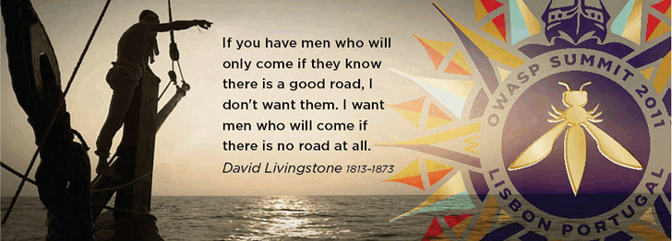ABOUT THE OWASP SUMMIT

OWASP Summits are where application security experts can meet in a neutral non-commercial setting to discuss plans, projects and solutions for the future of application security.

**The Summit is NOT a conference** - there are no talks or training seminars. This is an opportunity to do actual work to further the field of application security. Participants will stay in shared accommodations and collaborate to produce tangible progress towards influencing standards, establishing roadmaps, and setting the tone for OWASP and application security for the coming years.

Anyone can attend the Summit! OWASP community members, application security experts, industry players, and developers are all welcome at the Summit. Attendees come ready to work and produce deliverables that advance the state-of-the-art in application security.

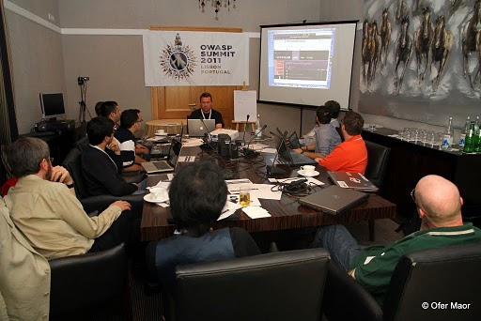 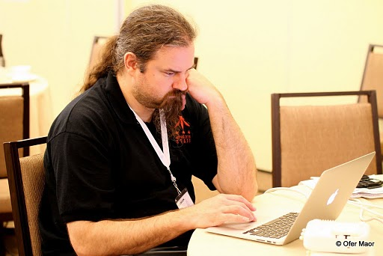

Many of the working sessions were created “dynamically” by the attendees. Anyone can propose a new working session, sign up for a room and time slot, and meet to work with other interested parties. Many of the main sessions ended up spawning multiple dynamic sessions to accomplish particular goals.

Much of the work that goes on at the Summit is at meals, social events, or hallways. We live together, eat together, and play together. We work hard and play hard for a solid week focused on application security. Even the OWASP Band is free and open for anyone to participate.

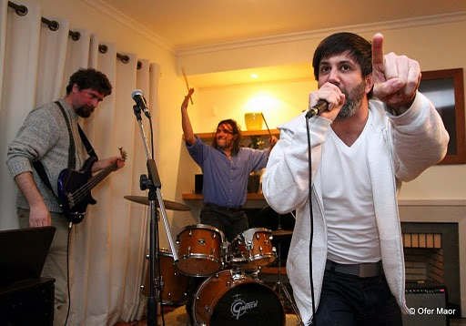

SUMMIT QUOTES

* *“I never would have found myself in a meaningful dialog with Google had it not been for this conference.” – Robert Hansen (RSnake)*
* *“I needed to discuss complex security problems that required input from a number of different people to solve it. At OWASP Summit we brought things together!” -- Tobias Gondrom, IETF*
* *“Seeing and meeting the world’s best-known security professionals at one place! Great party!” – Achim Huffmann*
* *“The Summit had an intense feeling of activity, information exchange, and planning” – Chris Wysopal, Veracode*
* *“It was interesting to see how much work got done in less than a week!” – Vishal Garg, AppSecureLabs*
* *“I’d like to say that the Summit has been absolutely a great experience. It’s the most useful security event that I’ve been to in the last few years. This most definitely was one of those events where things actually got done!” – Edward Bonver*

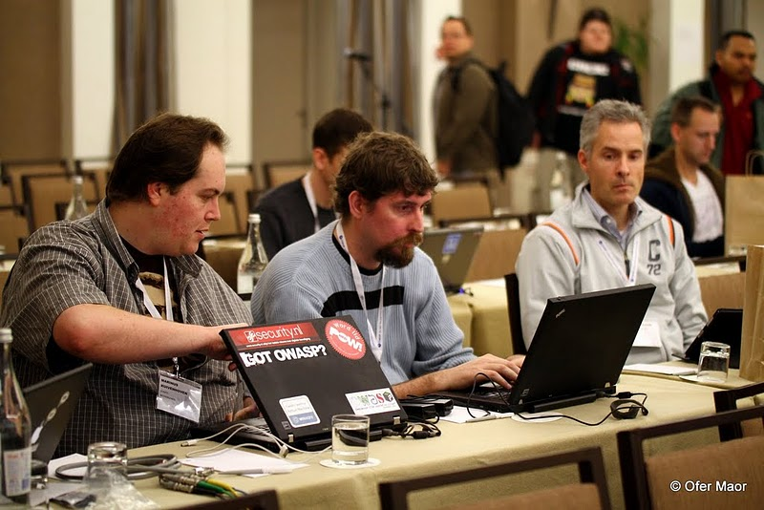

* *“The Summit is THE place to come together and transform great ideas into reality” – Cecil Su, Grant Thornton*
* *“Browser Security Track has made great progress in terms of outreach, involvement, and cross-company collaboration. Other groups should replicate this behaviour.”*

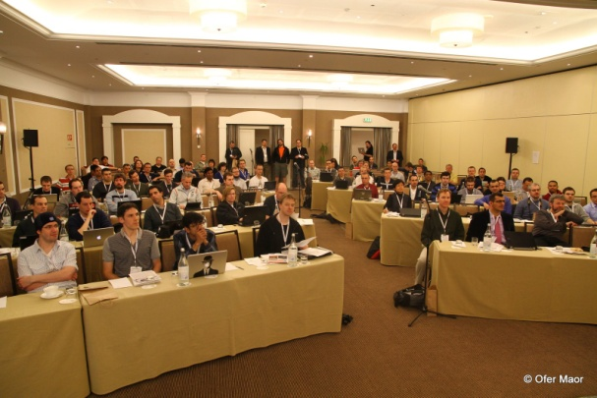

* *“The system really works! The process is transparent and OWASPers are very committed in having a more secure world” – L. Gustavo C. Barbato - Dell*
* *“I saw the ‘blossoming’ of OWASP in Portugal’s Spring. From an external viewpoint, OWASP has moved from niche to widely relevant, from localized to global, from pentesting to SDLC, from server to every component of the application’s delivery and use, from infosec to business process relevance.” – Colin Watson, Watson Hall*
* *“I enjoyed the sheer energy of the group”*
* *“I really liked the format of many sessions that were panel and open discussion around looking at problems and finding solutions”*
* *“It was a great summit and one of the best security event in the world” – Mohd Fazli Aaran – USDCMY*
* *“It worked democratically and made everyone give idea, complaint, planning, critic, and opinion” – Mohd Fazli Aaran – USDCMY*
* *“The small working groups got the conversation flowing between many people of different viewpoints” – Chris Wysopal, Veracode*
* *“It was so cool to get all these security experts under the same roof and you could pickup anybody’s brain about any security issue”*

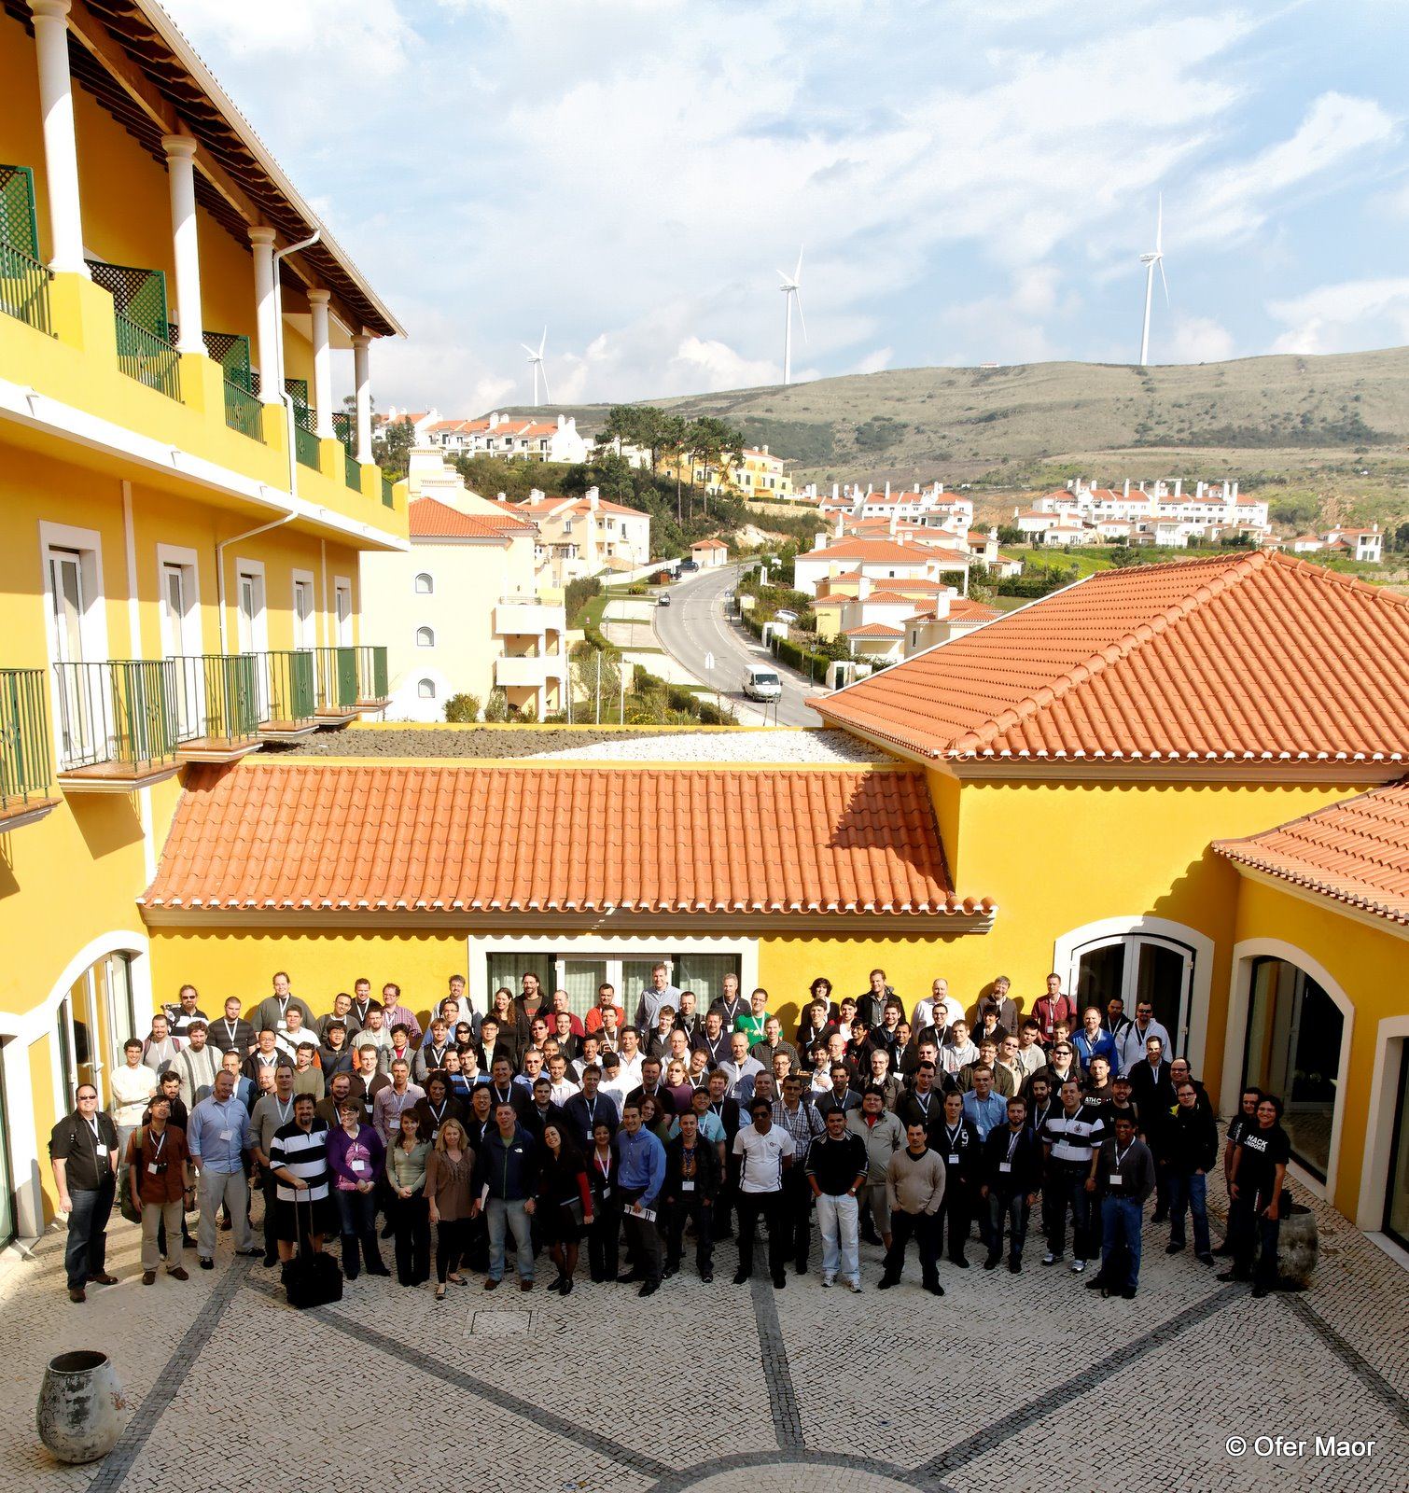

* *“For those who missed the Summit: you missed out, try to make the next one”*
* *“It is a great way to meet and exchange experience with some of the most important IT professionals of the world” – Massimo Biagiotti – Business.E*
* *“The best thing was the exceptional discussions generated from the main topics and continued into the late evenings.” – Steve Schwartz, Stack and Liu*
* *“There were great discussions both inside and outside working sessions. I can’t wait to see the results of the seeds planted.” Juan Carlos Calderon, Softtek Mexico.*
* *“The best was to see how ‘linking’ frameworks for education, government, and third-parties is taking shape and finally seems that it can materialize. It will be a huge enabler for OWASP mission.” Juan Carlos Calderon, Softtek Mexico.*
* *“Best part was being able to gather and talk with the best security minds in the world to solve difficult security problems.” – Abraham Kang*

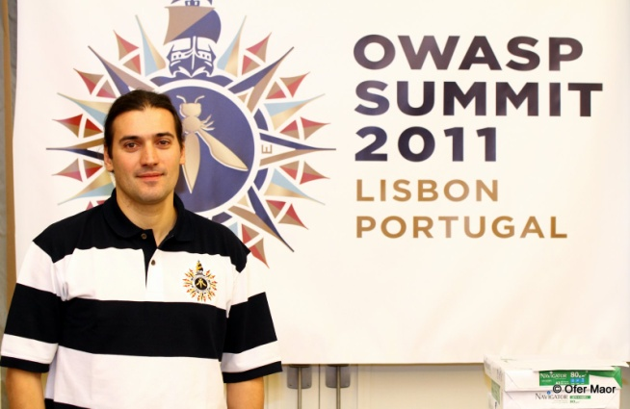

* *“Attending the Summit was a unique experience because it was not about presentations, but actually having an active contribution to the discussions, knowing that all your contributions are going to make a difference to the future of OWASP.” – Vishal Garg, AppSecureLabs*
* *“The evening sessions are great. Highly productive, relaxed atmosphere, laughing, and beer.” –Bart De Win*
* *“The best experience was seeing so many companies like Microsoft, Google, Mozilla, etc… send large contingents to Portugal to participate in our Summit” – Dave Wichers, Aspect Security*

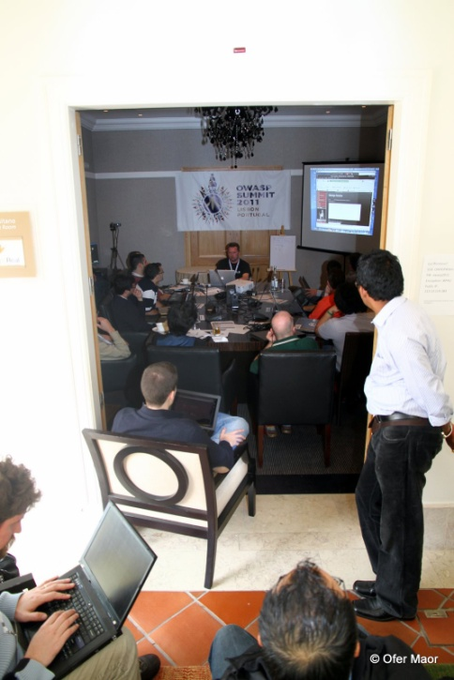

* *“We arrived, we were impressed, and we were inspired!” – Cecil Su, Grant Thornton*
* *“The Summit is a place to work hard, play hard, and get things done.” – Abraham Kang*
* *“Bringing together the best security experts and leaders from around the world and discussing solutions for the future of web application security” – Tobias Gondrom, IETF*
* *“Get to know and listen to the best of breed in app security in the world” – L.A. Vilares Da Silva, Open*

[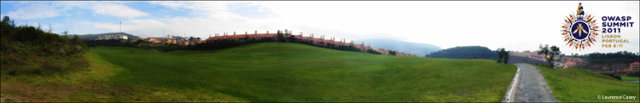](http://www.owasp.org/index.php?title=Summit_2011)COMPANIES PARTICIPATING IN OWASP SUMMIT

# Summit_Company_Logos.png

WORKING SESSIONS

The Working Sessions are how we actually produce results at the OWASP Summit. Each working session meets in a room where everyone participates to discuss, argue, collaborate, and most importantly produce a deliverable.

**FIXED WORKING SESSIONS**

**Tuesday, February 8**  
XSS and the Frameworks  
XSS - Awareness, Resources, and Partnerships  
OWASP Training  
OWASP Academies  
WAF Mitigations for XSS  
Virtual Patching Best Practices  
OWASP Exams  
University Outreach  
Risk Metrics  
Metrics and Labeling  
Government Outreach  
Counting & scoring application security defects  
OWASP Secure Coding Practices Project  
Enterprise Web Defense Roundtable  
Threat Modeling  
  
**Wednesday , February 9**  
Protecting Information Stored Client-Side  
Common structure and numbering for all guides  
OWASP Common vulnerability list  
Providing Access to Persisted Data  
OWASP Testing Guide  
Site Security Policy  
OWASP Industry Outreach  
Microsoft's SDL in 16 steps (and lessons learned)  
OWASP Projects  
DOM Sandboxing  
Overhauling the OWASP Website  
  
**Thursday, February 10**  
Contextual Output Encoding  
ESAPI-CORE  
OWASP Board/Committee Governance  
Board Structure  
ESAPI for Ruby  
Applying ESAPI Input Validation  
Professionalize OWASP  
OWASP funding and CEO discussion  
EcmaScript 5 Security  
OWASP Certification  
HTML5 Security  
What is an OWASP Leader?  
Tracking OWASP Participation  
Mobile Security  
OWASP Licensing

**DYNAMIC WORKING SESSIONS**

**Tuesday, February 8**  
OWASP vs Government vs Universities  
Building the OWASP Brazilian Leaders Group  
Common structure and numbering for all guides  
OWASP Board/Committee Governance  
XSS and the Frameworks  
OWASP Academy Portal  
Browser Security meet up  
  
**Wednesday, February 9**  
Formal Risk Assessment Methods  
OWASP TOP 10 online training in Hacking-Lab  
Defining AppSensor Detection Points  
OWASP Asia/Pacific working group  
Development Guide  
Defining a minimal appsec program for universities, governments, and standards bodies  
OWASP Portuguese Language Project  
ASVS Project  
Secure development guidelines for smartphone developers  
Privacy - Personal Data/PII, Legislation and OWASP  
Mobile Security  
Should OWASP work directly with PCI-DSS?  
OpenSAMM  
Threat Modeling  
Governance Part Two  
  
**Thursday , February 10**  
How can OWASP reach/talk/engage with auditors  
Hackademic Challenges  
OWASP Java Project  
OWASP Exams  
Industry - Healthcare  
Industry - Banking/Finance  
Developer Outreach  
Scaling Web Application Security Testing  
The future of OpenSAMM  
Corporations at the Summit & funding opportunities  
Conferences - Improving Conference Planner Support  
OWASP College Chapter Program  
Vulnerability Disclosure Policies  
Global Conferences Committee Monthly Meeting  
Planning South America/Central America AppSec  
Chapters  
O2 Platform  
ESAPI framework integration  
Education

ATTENDEES

Adamski, Lucas

Agarwal, Anurag

Aguilera, Vicente

Agustini, Alexandre

Akhmad, Zaki

Alamri, Lorna

AlBasha, Talal

Angal, Rajeev

Aniceto, Alexandre

Aryavalli, Gandhi

Barbato, L. Gustavo C.

Barnett, Ryan

Baso, Sarah

Batista, Marco

Bergling,Mattias

Bernik, Joe

Biagiotti, Massimo

Bonver, Edward

Booth, Rex

Brennan, Tom

Brewer, Deb

Bristow, Mark

Brzozowski, Daniel

Buetler, Ivan

Calderon, Juan Carlos

Campbell, David

Casey, Larry

Causey, Brad

Chalmers, Matthew

Chandra, Pravir

Cheng, Steven

Clarke, Justin

Coates, Michael

Coimbra, Paulo

Cornell, Dan

Corry, Bil

Cruz, Dinis

Cruz, Sarah

Dawson,Isaac

De Win, Bart

Deleersnyder, Seba

DiPaola, Stefano

Donovan, Fred

Durkee, Ralph

Dworakowski, Wojciech

Elias, Wagner

Eng,Chris

Evans, Arian

Falkenberg, Andreas

Fazli Azran, Mohd

Fedon, Giorgio

Ferraz, Felipe

Ferreira, Lucas C.

Fette, Ian

Fitzgerald, Alexis

Fitzhugh, Justin

Flores, Mauro

Fontes, Antonio

Fort, Julio Cesar

Fortuna, Pedro

Frosch,Tilman

Galvao, Pedro

Gao, Helen

Garrancho, Bruno

Garg, Vishal

Gomes, Leandro

Gondrom, Tobias

Hansen, Robert

Hartmann, Kate

Heiderich, Mario

Heyes, Gareth

Hinojosa, Kuai

Hodges, Jeff

Hoff, Jerry

Hoffman, Achim

Hofmann, Chris

Hogben, Giles

Ichnowski, Jeff

Jorge, Eduardo

Jimenez, Juan Jose Rider

Kang, Abraham

Keary, Eoin

Knobloch, Martin

Kosturjak, Vlatko

Koussa, Sherif

Kuivenhoven, Marinus

Kumar, Nishi

Lacerda, Filipe

Lauritão, Rogério

Li, Jason

Lindsay, David

Long, Jeremy

Loureiro, Nuno

Luptak, Pavol

Lyon, Chris

Manico, Jim

Maor, Ofer

Mancini, Lucilla

Martinez, Mateo

Martorella, Christian

Matatall, Neil

Melo, Ricardo

Mendo, Tiago

Meucci, Matteo

Nagra, Jasvir

Neaves, Tom

Paiva, Sandra

Papapanagiotou, Konstantinos (Kostas)

Pegorelli, Marta

Perego, Paolo

Potjes, Linda

Reinhart, Ralf

Richler, Heiko

Rohr, Mathias

Ross, David

Roth-Mandutz, Elke

Saario, Mikko

Samuel, Michael

Schmidt, Chris

Schuh, Justin

Schwartz, Stephen

Searle, Justin

Secker, Tanya

Serrao, Carlos

Stasinopoulos, Anastasios

Sterne, Brandon

Steven, John

Su, Cecil

Tasar, Vehbi

Taylor, Jason

Tesauro, Matt

Thomas, Mark

Tomhave, Benjamin

Turpin, Keith

Tusha, Ervis

UcedaVelez, Tony

Uhley, Peleus

van der Baan, Steven

Vasilopoulos, Kyprianos

Vela, Eduardo

Vilares Da Silva, Luis

Vlachos, Vasileios

Vroom, Ferdinand

Watson, Colin

Weston, David

Wichers, Dave

Wilander, John

Williams, Jeff

Wilson, Doug

Wuensch, Stefan

Wysopal, Chris

Yeo, John

Zusman, Mike