OWASP Global AppSec Conference Sponsorship
Open Web Application Security Project (OWASP) is an open-source application security project made up of corporations, educational organizations, and individuals from around the world. Providing free, vendor-neutral, practical, cost-effective application security guidelines, the organization has fast become the defacto standards body for Web AppSec.

OWASP Global AppSec Conferences are the flagship of the OWASP outreach effort. Each year OWASP hosts four Global AppSec conferences around the globe in North America, South America, Europe and Asia. Global AppSec Conferences include multiple days of multi-track plenary sessions in addition to pre-conference training offerings with many opportunities to converse with attending government, education and industry leaders. In a new effort for 2011 OWASP is offing exclusive Global AppSec Sponsorships to OWASP Member organization the streamlining the planning process of our most supportive organizations.

The Global AppSec Conferences Sponsorship Program is exclusive to current OWASP Corporate Members. Participants will enjoy the benefits of sponsoring FOUR Global AppSec Conferences in one coordinated effort. Global AppSec Sponsorships will get top billing in each sponsorship level, first choice of booth space at Global AppSec Conferences and be provided opportunities for individual event sponsorships before they are made generally available. Sponsors will also get special recognition on the OWASP Website and in both Global and Regional conference programs around the world greatly expanding your exposure.
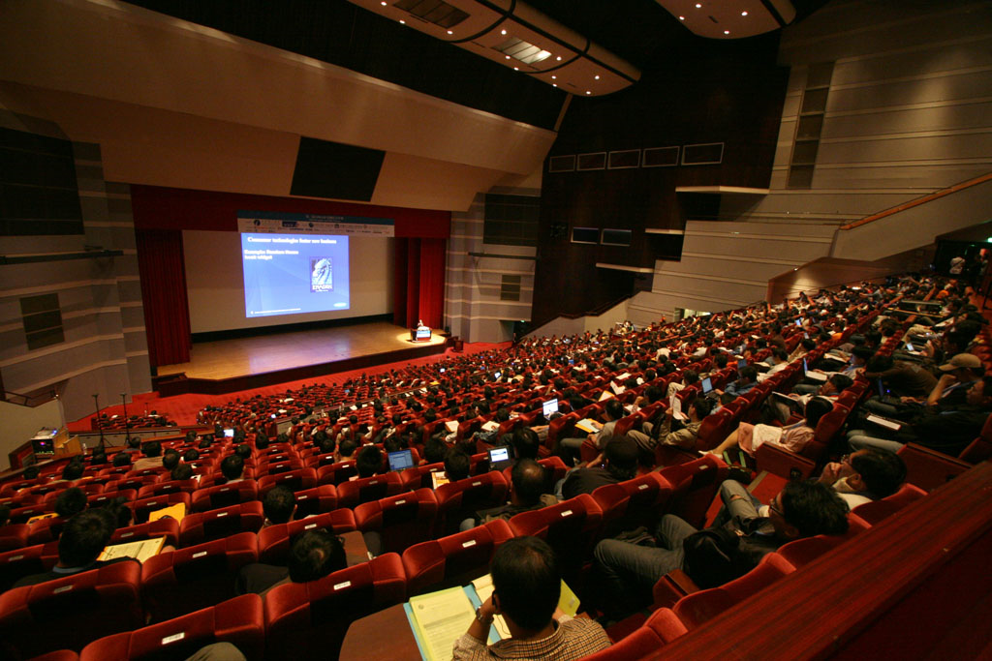
OWASP Global AppSec Conferences Draw over 1500 Global Attendees Annually

All proceeds from sponsorship support the mission of the OWASP Foundation (501c3 Not-For-Profit), driving funding for conferences, research grants, tools and documents, local chapters, and more.
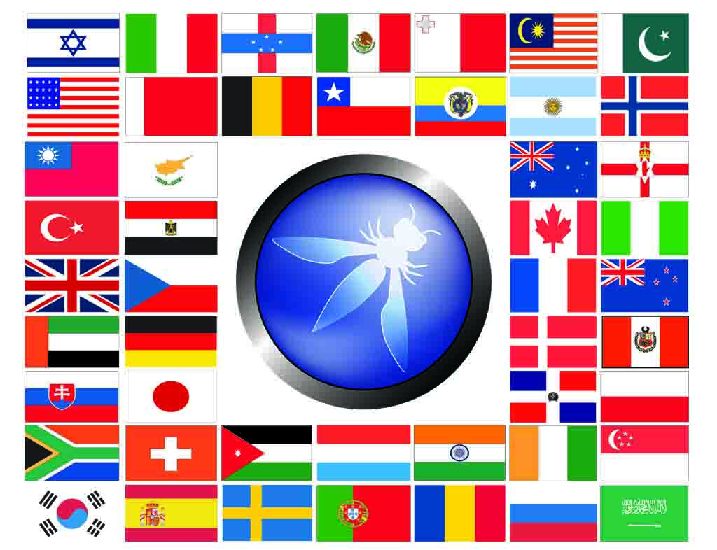
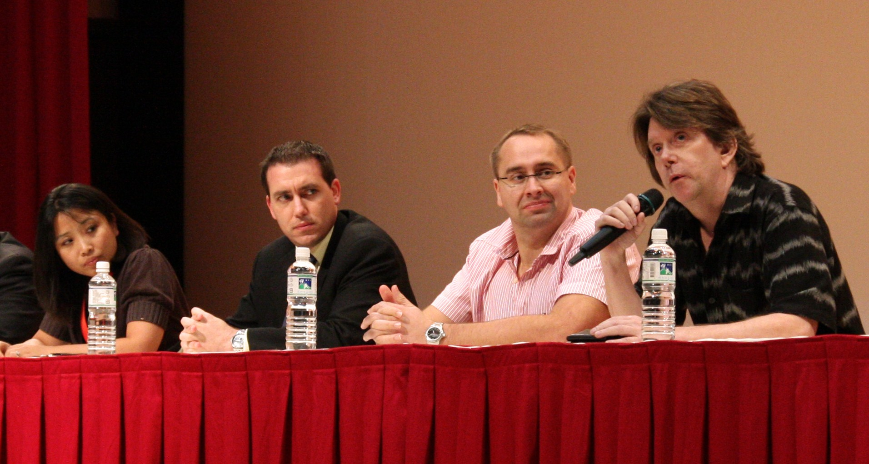  International experts share their insights | 2011 Global AppSec Conference Schedule
  AppSec North America | Minneapolis, MN, USA | Sep 19th – Sep 23rd
  AppSec Europe | Ireland | June 2011
  AppSec South America | Porto Alegre, Brazil | Oct 11th – Oct 14th
  AppSec Asia | TBD | Q3 2011
Contact us today or visit http://www.owasp.org/membership for more information:
Mark Bristow, OWASP Global Conferences Committee Chair – Mark.Bristow@owasp.org, (703) 596-5175
Kate Hartmann, OWASP Operations – Kate.Hartmann@owasp.org

 | Global Diamond (1 position) | Global Platinum (3 positions) | Global Gold
Expo Space | - First choice of expo space (10’x10’ Table provided or similar)  - Extra Adjacent Booth slot for $3000 USD/Con (10’x10’ Table provided or similar) | - Ability to select space immediately after Global Diamond/Diamond sponsors  - (10’x10’ Table provided or similar) | - Ability to select space before conference Gold sponsors  - (10’x10’ Table provided or similar)
Advertising Opportunities | - Print Campaign– Premium placement of company logo placed in any print conference promotion  - Press Announcements – Your company name will be included in any Conference pre-show press announcement as a Diamond Level Sponsor. | - Print Campaign– Premium placement of company logo placed in any print conference promotion  - Press Announcements – Your company name will be included in any Conference pre-show press announcement as a Platinum Level Sponsor. | - Print Campaign– Premium placement of company logo placed in any print conference promotion  - Press Announcements – Your company name will be included in any Conference pre-show press announcement as a Gold Level Sponsor.
Logo placement | - OWASP Main Page as Global AppSec Sponsor  - OWASP Conference website  - Pre-Conference Literature  - Conference Brochure  - At Conference Entrance  - At Entrance to all tracks | - OWASP Main Page as Global AppSec Sponsor  - OWASP Conference website  - Pre-Conference Literature  - Conference Brochure  - Prominent placement at entrance to 1 conference track | - OWASP Main Page as Global AppSec Sponsor  - OWASP Conference website  - Pre-Conference Literature  - Conference Brochure  - Entrance to 1 conference track
Company description Placement | - Premium placed, one full-page, four-color advertisement in Conference Bulletin  - Premium logo placement in the official Conference brochure | - One half-page, four-color advertisement in Conference Bulletin  - Premium logo placement in the official Conference brochure | - One quarter-page, four-color advertisement in Conference Bulletin  - Premium logo placement in the official Conference brochure
Company Literature Placement | - Attendee packs  - Information Desk | - Attendee packs  - Information Desk | - Attendee packs  - Information Desk
Conference Attendee Passes | 5 per Conference | 5 per Conference | 2 per Conference
Expo Passes  (for booth staff) | 4 per Conference | 2 per Conference | 2 per Conference
Cost | $100,000 USD | $75,000 USD | $50,000 USD

Insert page of pictures here…. TOOOO big for sending around…..

Become a proud sponsor of the OWASP mission!

